DATA WAREHOUSING AND MINING

MINI-PROJECT

**TE CMPN B**

Data Visualization

Submitted By

|  |  |  |
| --- | --- | --- |
| Sr. No | Roll No | Name |
| 1 | 20102B0069 | Dhruva Ludbe |
| 2 | 21102B2007 | Harsh Chheda |

Under the Guidance of

Prof. Kavita Shrisat

Department of Computer Engineering

Vidyalankar Institute of Technology Wadala(E), Mumbai 400 037



**University of Mumbai**

2022-23

**ABSTRACT**

**Project Title**:

Perform data visualization by histogram, scatter plot, bar graph, line graph.

**Project Focus:**

To use various methods of visualization to visualize the dataset.

**Project Description:**

In this project, We can upload the dataset in (.csv file) through frontend and for this using we have used the py-script tool (python) and so, the dataset can be explored using various techniques to visualize the dataset.

**Description of Dataset:**

The dataset columns must contain the numerical values then only it can be implemented for various data visualizations.

**Attribute Information:**

* Egg
* Fruits
* Language
* Score

**SCREENSHOTS:**

**GUI Screenshots**

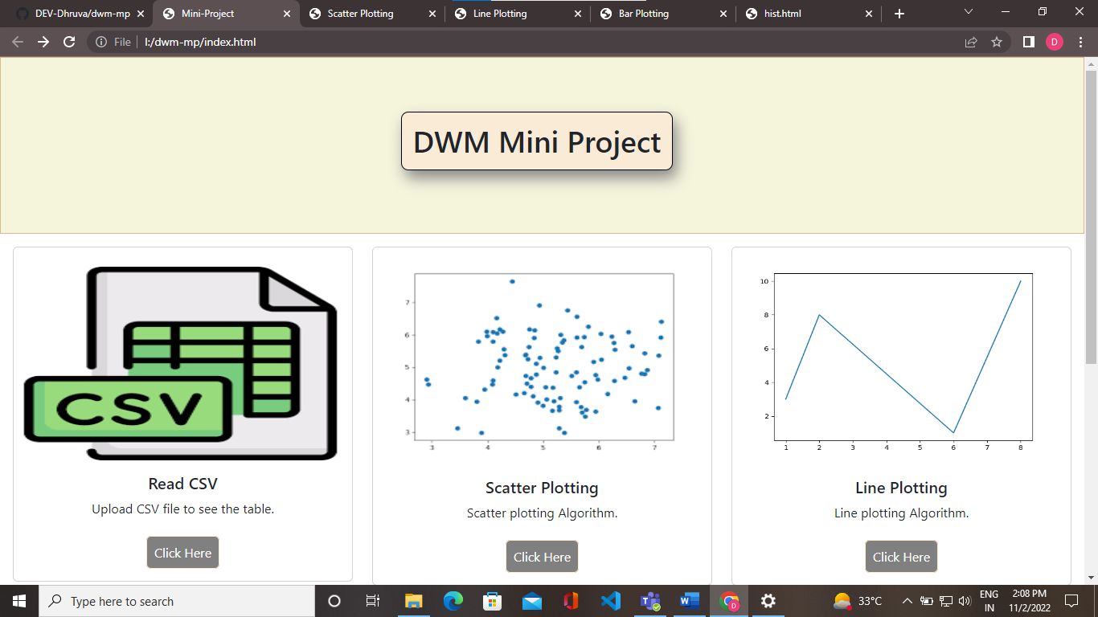

**CONCLUSION**

Good data visualization should communicate a data set clearly and effectively by using graphics. The best visualizations make it easy to comprehend data at a glance. They take complex information and break it down in a way that makes it simple for the target audience to understand and on which to base their decisions.