Vidzemes Augstskola

Inženierzinātņu fakultāte

**ĢEOMETRISKAIS KALKULATORS**

Gada Projekts

Autors: Ralfs Markuss Pīlāgs

Stud. apl. Nr. IT19037

Darba vadītājs:

Mg.Sc.Comp Andris Fjodorovs

Valmiera 2021

Saturs

**1.** **PROGRAMMAS APRAKSTS** 3

1.1. PROGRAMMAS VISPĀRĪGAIS APRAKSTS 3

1.2. FUNKCIJAS BLOKU APRAKSTS 3

**2.** **IZMANTOTO BIBLIOTĒKU APRAKSTS** 5

**3.** **IZMANTOTO BIBLIOTĒKU PIELIETOŠANA PROGRAMMĀ** 6

**4.** **TESTA PIEMĒRI, PROGRAMMAS DARBĪBAS DEMONSTRĀCIJA** 8

**5.** **KOMENTĒTS PROGRAMMAS TEKSTS** 12

**Izmantotie literatūras avoti** 26

# **PROGRAMMAS APRAKSTS**

Programma izstrādāta kursa “Programmēšana (C++)” ietvaros.

1.1. PROGRAMMAS VISPĀRĪGAIS APRAKSTS

Programma strādā, kā ģeometriskais kalkulators, piedāvājot izvēli starp trīs figūrām – trīsstūris, četrstūris, riņķis. Izvēloties vienu no piedāvātajām figūrām, programma parāda izvēlētās figūras satura lapu. Katra figūras specifiskā lapa satur divas aprēķinu pogas, kuras dara noteiktu darbību, kā arī ļauj ievadīt figūras parametrus, lai varētu veikt aprēķinus.

# 1.2. FUNKCIJAS BLOKU APRAKSTS

Programma sākās *MyForm(void)* metodē, kur tiek izsaukta funkcija *InitializeComponet();* kas uz ekrāna uzsāk programmu un izveido visu grafisko dizainu, kā arī tiek izsaukta metode *Hide();* trīs paneļiem – *PanelTriangle, PanelSquare, PanelCircle.* Šī metode paslēpj visus trīs no šiem paneļiem, kā arī visus komponentus.

Autora rakstītās funkcijas var sadalīt divos funkciju blokos – funkcijas, kuras ir nepieciešamas, lai parādītu ekrānu ar visiem dizaina elementiem un funkcijas, kas piešķir šiem elementiem funkcionalitāti.

**Funkcijas, kas nepieciešamas, lai parādītu ekrānu un dizaina elementus:**

* *MyForm(void)*
* *InitializeComponet();*
* *void InitializeComponet(void);*

**Funkcijas, kas nepieciešamas, lai piešķirtu šiem elementiem funkcionalitāti:**

* *private : System::Void button1_Click* parāda *PanelTriangle*, kas satur programmas komponentus saistībā ar trīsstūri, paslēpjot paneļus - *PanelSquare* un *PanelCircle.*
* *private : System::Void button2_Click* parāda *PanelSquare*, kas satur programmas komponentus saistībā ar četrstūri, paslēpjot paneļus - *PanelTriangle* un *PanelCircle.*
* *private : System::Void button3_Click* parāda *PanelCircle,* kas satur programmas komponentus saistībā ar riņķi, paslēpjot paneļus – *PanelTriangle* un *PanelSquare.*
* *private : System::Void button4_Click* strādā kā viena no trīsstūra paneļa pogām, kura paņem katra *textBox* ievadīto mainīgo, pārvēršot to skaitļa veidā un tad veic aprēķinu, aprēķinot kāda tipa trīsstūris tiek izveidots no ievadītajiem skaitļiem. Tad pēc aprēķiniem pārvērš skaitļus teksta formātā un izvada tos uz specifiskiem *textBox,* kas novietoti uz paneļa.
* *private : System::Void button5_Click* strādā kā viena no trīsstūra paneļa pogām, kura paņem katra *textBox* ievadīto mainīgo, pārvēršot to skaitļa veidā un tad veic aprēķinu, aprēķinot trīsstūra mediānas. Tad pēc aprēķiniem pārvērš skaitļus teksta formātā un izvada tos uz specifiskiem *textBox,* kas novietoti uz paneļa.
* *private : System::Void button6_Click* strādā kā viena no četrstūra paneļa pogām, kura paņem katra *textBox* ievadīto mainīgo, pārvēršot to skaitļa veidā un tad veic aprēķinu, aprēķinot kāda tipa četrstūris tiek izveidots no ievadītajiem skaitļiem. Tad pēc aprēķiniem pārvērš skaitļus teksta formātā un izvada tos uz specifiskiem *textBox,* kas novietoti uz paneļa.
* *private : System::Void button7_Click* strādā kā viena no četrstūra paneļa pogām, kura paņem katra *textBox* ievadīto mainīgo, pārvēršot to skaitļa veidā un tad veic aprēķinu, aprēķinot četrstūra garāko malu. Tad pēc aprēķiniem pārvērš skaitļus teksta formātā un izvada tos uz specifiskiem *textBox,* kas novietoti uz paneļa.
* *private : System::Void button8_Click* strādā kā viena no riņķa paneļa pogām, kura paņem katra *textBox* ievadīto mainīgo, pārvēršot to skaitļa veidā un tad veic aprēķinu, aprēķinot riņķa laukumu. Tad pēc aprēķiniem pārvērš skaitļus teksta formātā un izvada tos uz specifiskiem *textBox,* kas novietoti uz paneļa.
* *private : System::Void button9_Click* strādā kā viena no riņķa paneļa pogām, kura paņem katra *textBox* ievadīto mainīgo, pārvēršot to skaitļa veidā un tad veic aprēķinu, aprēķinot riņķa mazāko un lielāko segmentu, izsaucot funkciju *float segments(float radius, float angle)* kurā apreiķina sektora un trīsstūra laukumus, atgriežot to iznākumu atņemot katru no katra Tad pēc aprēķiniem pārvērš skaitļus teksta formātā un izvada tos uz specifiskiem *textBox,* kas novietoti uz paneļa.

# **IZMANTOTO BIBLIOTĒKU APRAKSTS**

Programmā izmantotas divas bibliotēkas – *STL*/*CLR,* *math.h.*

2.1. STL/CLR – STANDARTA ŠABLONU BIBLIOTĒKA

Programmā tiek izmantota standarta šablonu bibliotēka. Tam ir daudz priekšrocību salīdzinājumā ar salīdzināmām bibliotēkām, kā piemēram,*.NET Framework* kolekcijām, kuras sniedz lietotājiem noteiktas garantijas par algoritmu darbību un tas atdala algoritmus no datiem. Jauna bibliotēka STL / CLR nodrošina šīs priekšrocības pārvaldītā koda izstrādātājam un piedāvā alternatīvu *.NET Framework* kolekcijas klasēm, piemēram, Saraksts, Vārdnīca un tā tālāk. STL / CLR ir STL atkārtota ieviešana C ++ / CLI, taču tā pievieno arī dažas papildu funkcionalitātes, lai atvieglotu sadarbošanos ar *.NET* kolekcijām (Hogenson, 2008).

2.2. *MATH.H* BIBLIOTĒKA

*Bibliotēkā math.h* ir noteiktas dažādas matemātiskās funkcijas. Visas šajā bibliotēkā pieejamās funkcijas tiek argumentētas kā dubultas un rezultātā tiek atgrieztas dubultas (Tutorialpoint, 2021).

1. **IZMANTOTO BIBLIOTĒKU PIELIETOŠANA PROGRAMMĀ**

3.1. STL/CLR – STANDARTA ŠABLONU BIBLIOTĒKAS PIELIEROŠANA

No bibliotēkas STL/CLR, kā jau minēts, programmā tiek izmantoti vektori un konteineri. Lai izveidotu grafisku lietotāju interfeisu. Ar šīs bibliotēkas palīdzību tiek izveidoti teksta laukumi, bildes, definēti loga parametri un izveidotas pogas.

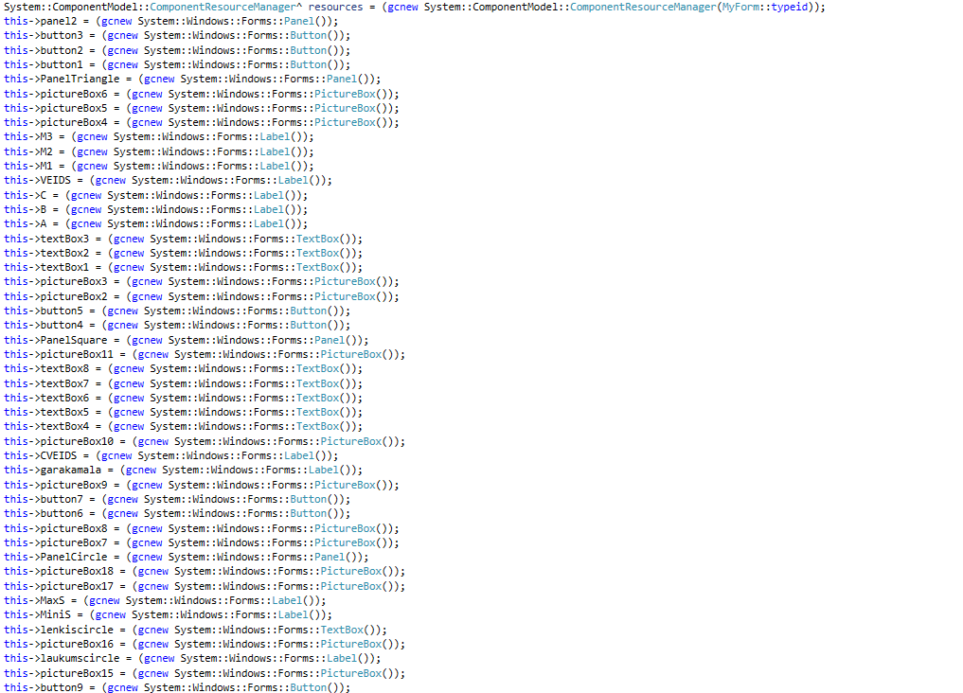

**1. attēls:** Koda piemērs STL/CLR bibliotēkas izmantošanai

* 1. *MATH.H* BIBLIOTĒKAS PIELIETOŠANA

Bibliotēka *math.h* tiek izmantota, lai veiktu sarežģītus matemātiskus aprēķinus, piemēram noteikt, kāda veida trīsstūris sanāk no ievadītajiem mainīgajiem.

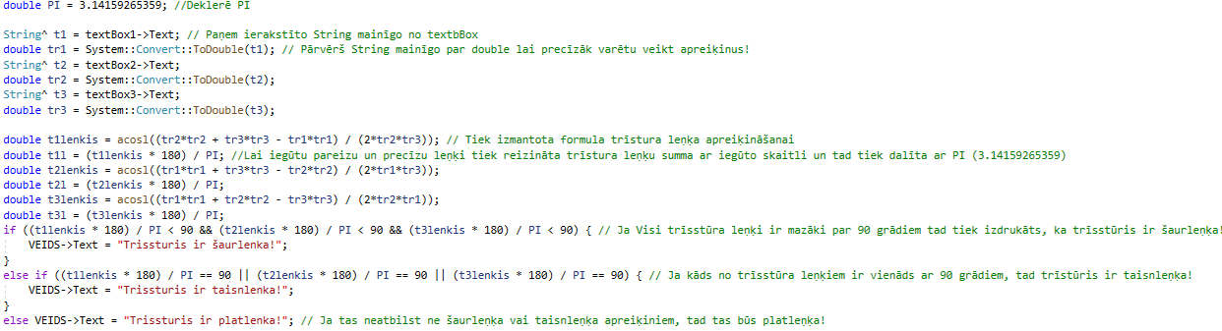

**2. attēls:** Koda piemērs *<math.h>* bibliotēkas izmantošanai

Trīsstūra mediānas noteikšanai



**3. attēls:** Koda piemērs *<math.h>* bibliotēkas izmantošanai

# **TESTA PIEMĒRI, PROGRAMMAS DARBĪBAS DEMONSTRĀCIJA**

Šajā nodaļā autors demonstrēs programmas darbību ar ekrānšāviņiem, kas veikti programmas testēšanas laikā.

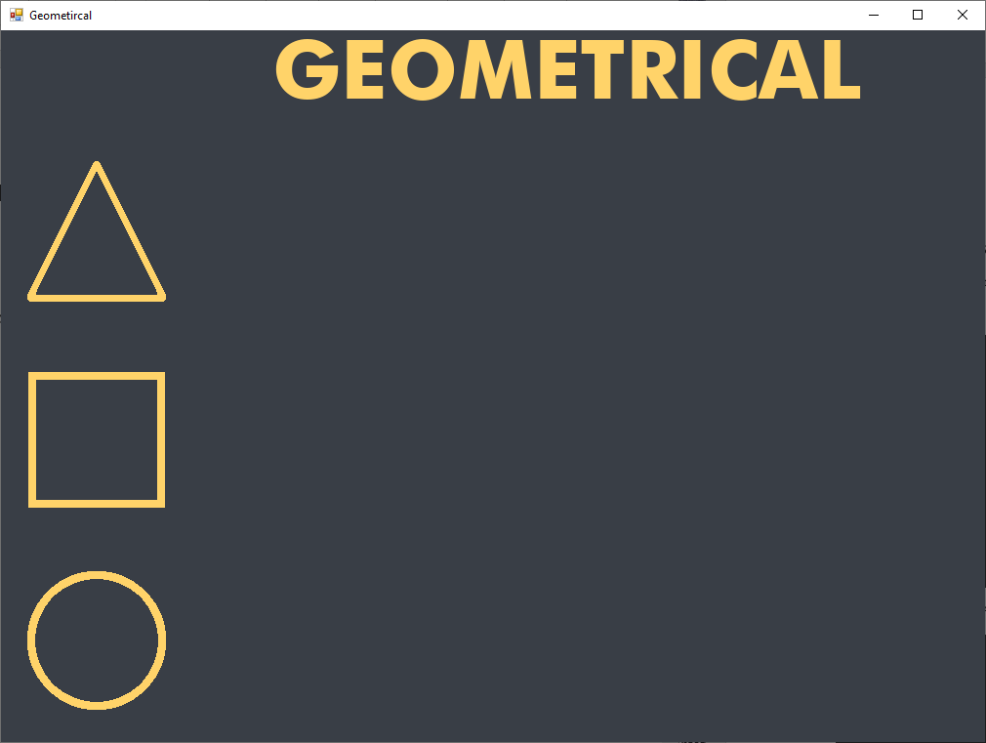

**4. attēls:** Sākuma logs programmas uzsākšanā.

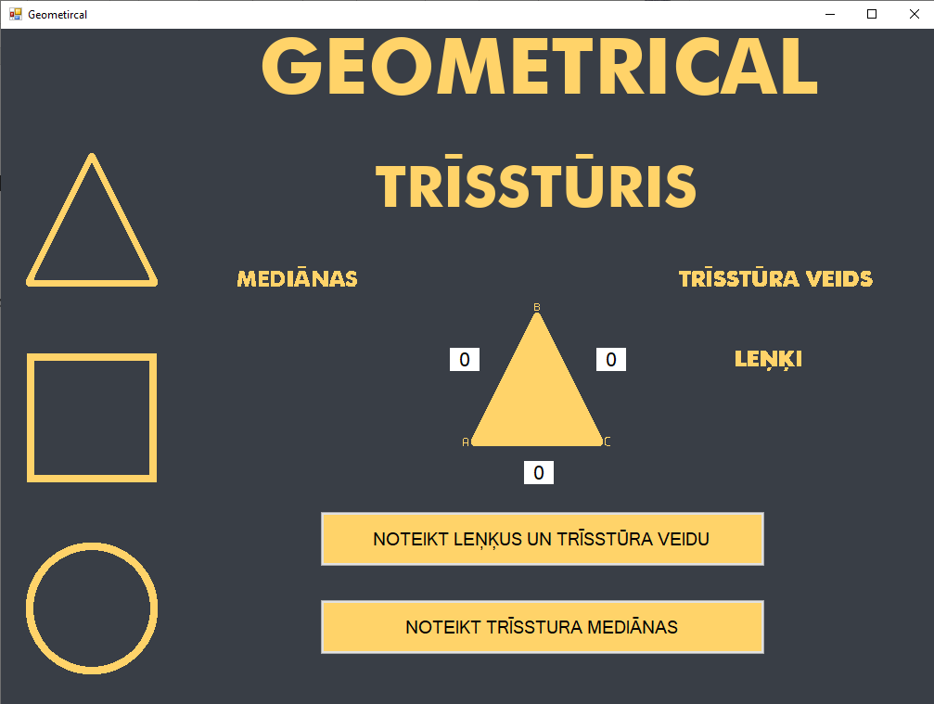

**5. attēls:** Trīsstūra logs.

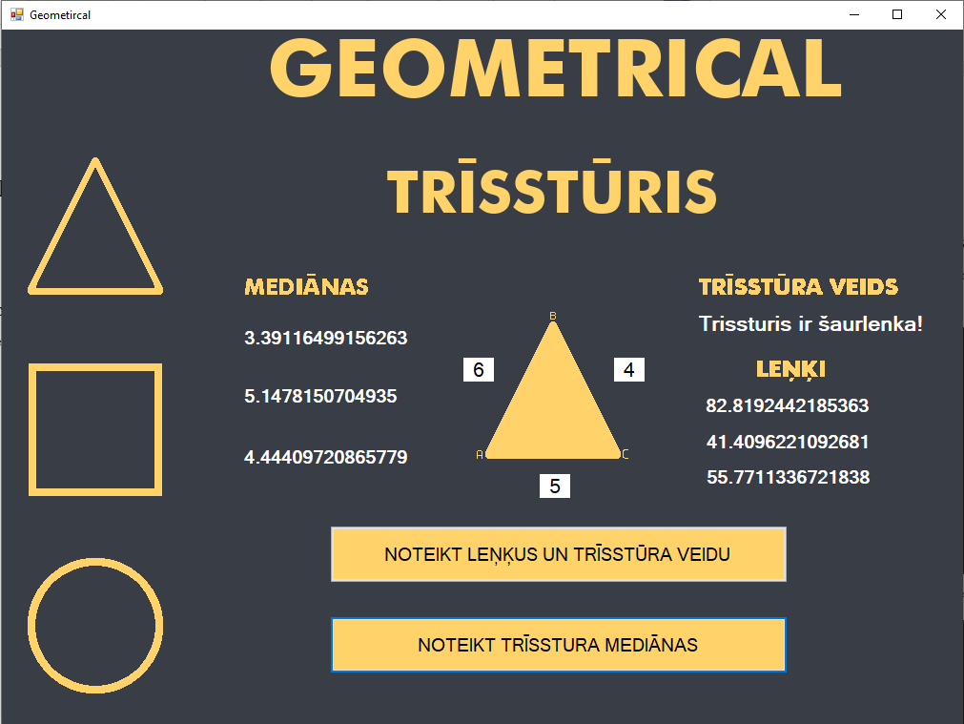

**6. attēls:** Trīsstūra funkcijas.

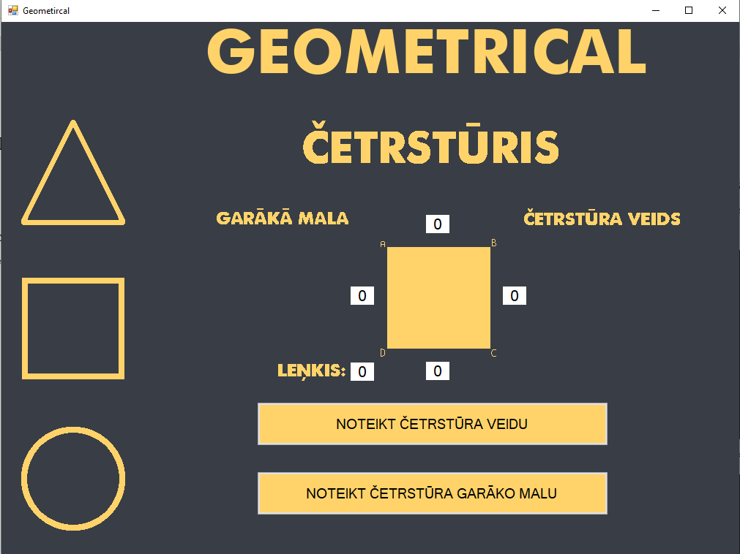

**7. attēls:** Četrstūra logs.

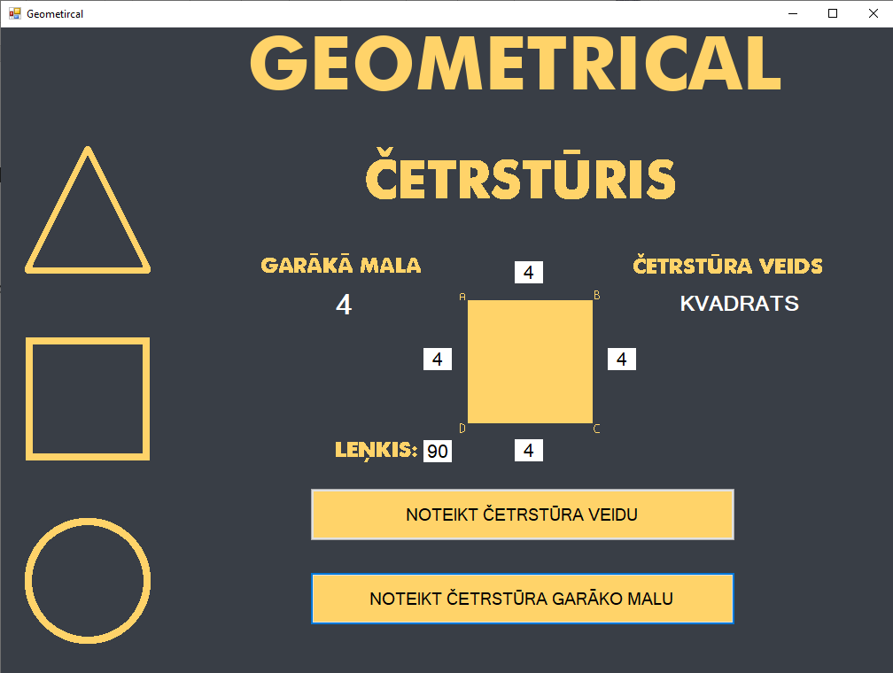

**8. attēls:** Četrstūra funkcijas.

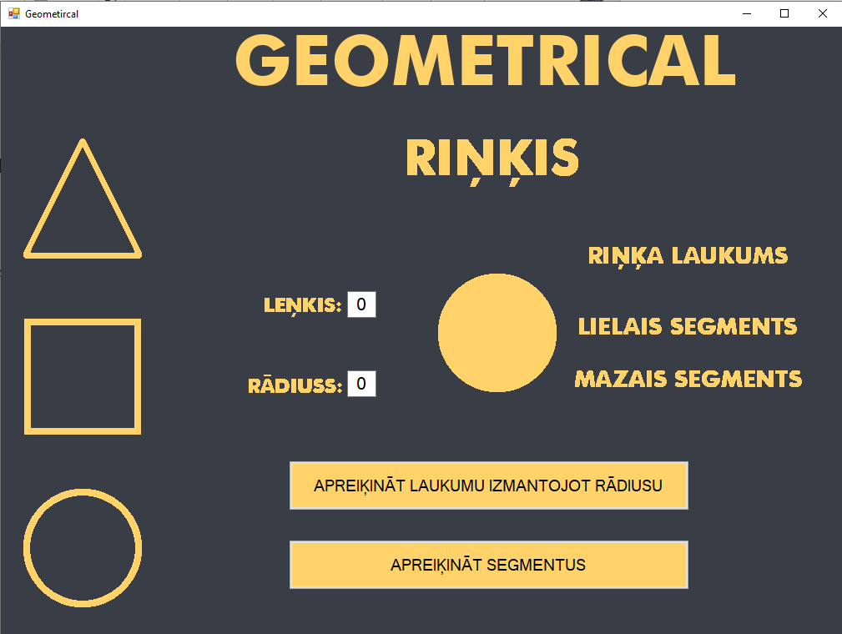

**9. attēls:** Riņķa logs.

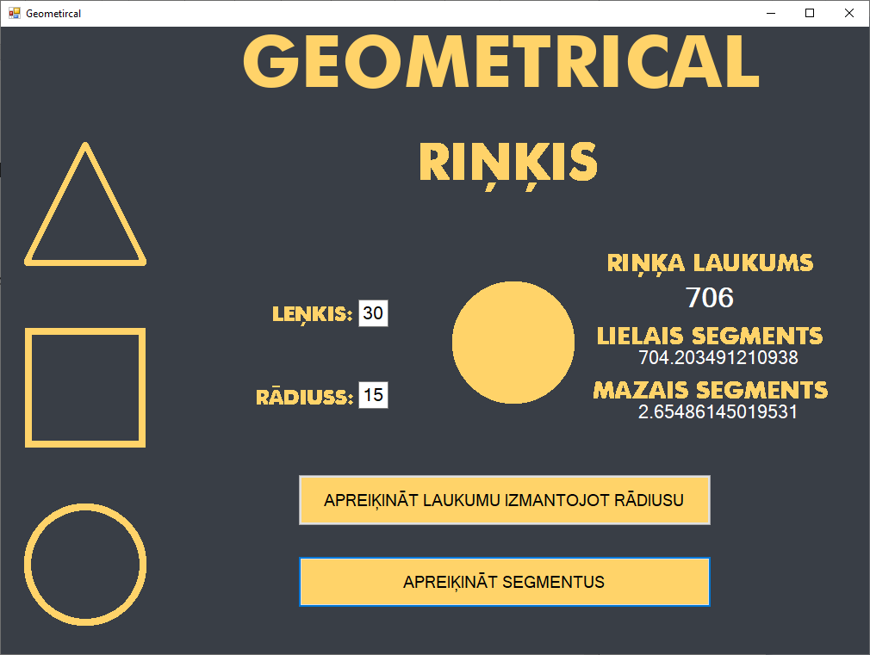

**10. attēls:** Riņķa funkcijas.

# **KOMENTĒTS PROGRAMMAS TEKSTS**

MyForm.cpp

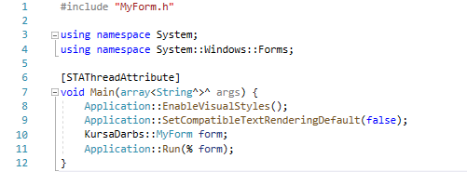

MyForm.h

#pragma once

#include <math.h>

namespace KursaDarbs {

using namespace System;

using namespace System::ComponentModel;

using namespace System::Collections;

using namespace System::Windows::Forms;

using namespace System::Data;

using namespace System::Drawing;

float segments(float radius, float angle) { // Funkcija lai apreiķinātu min un max segmentus!

double PI = 3.14159265359; //Deklerē PI

float sector = PI * (radius * radius) * (angle / 360); // Apreiķina sektora laukumu

float triangle = (float)1 / 2 * (radius * radius) * sin((angle * PI) / 180); // Apreiķina trīstura laukumu

return sector - triangle; // Atgriež sectora laukumu - trīstura laukumu!

}

/// <summary>

/// Summary for MyForm

/// </summary>

public ref class MyForm : public System::Windows::Forms::Form

{

public:

MyForm(void)

{

InitializeComponent();

PanelTriangle->Hide(); //Programmas sākumā paslēpj visus paneļus, kuri parādās tikai tad ja malā uzpiež uz kādas no figurām!

PanelSquare->Hide();

PanelCircle->Hide();

//

//TODO: Add the constructor code here

//

}

protected:

/// <summary>

/// Clean up any resources being used.

/// </summary>

~MyForm()

{

if (components)

{

delete components;

}

}

private: System::Windows::Forms::Panel^ panel2;

protected:

private: System::Windows::Forms::Button^ button3;

private: System::Windows::Forms::Button^ button2;

private: System::Windows::Forms::Button^ button1;

private: System::Windows::Forms::Panel^ PanelTriangle;

private: System::Windows::Forms::Panel^ PanelSquare;

private: System::Windows::Forms::Panel^ PanelCircle;

private: System::Windows::Forms::PictureBox^ pictureBox1;

private: System::Windows::Forms::Button^ button5;

private: System::Windows::Forms::Button^ button4;

private: System::Windows::Forms::PictureBox^ pictureBox2;

private: System::Windows::Forms::TextBox^ textBox1;

private: System::Windows::Forms::PictureBox^ pictureBox3;

private: System::Windows::Forms::TextBox^ textBox3;

private: System::Windows::Forms::TextBox^ textBox2;

private: System::Windows::Forms::Label^ A;

private: System::Windows::Forms::Label^ C;

private: System::Windows::Forms::Label^ B;

private: System::Windows::Forms::Label^ VEIDS;

private: System::Windows::Forms::Label^ M3;

private: System::Windows::Forms::Label^ M2;

private: System::Windows::Forms::Label^ M1;

private: System::Windows::Forms::PictureBox^ pictureBox4;

private: System::Windows::Forms::PictureBox^ pictureBox5;

private: System::Windows::Forms::PictureBox^ pictureBox6;

private: System::Windows::Forms::Button^ button6;

private: System::Windows::Forms::PictureBox^ pictureBox8;

private: System::Windows::Forms::PictureBox^ pictureBox7;

private: System::Windows::Forms::Button^ button7;

private: System::Windows::Forms::PictureBox^ pictureBox9;

private: System::Windows::Forms::Label^ CVEIDS;

private: System::Windows::Forms::Label^ garakamala;

private: System::Windows::Forms::PictureBox^ pictureBox10;

private: System::Windows::Forms::TextBox^ textBox7;

private: System::Windows::Forms::TextBox^ textBox6;

private: System::Windows::Forms::TextBox^ textBox5;

private: System::Windows::Forms::TextBox^ textBox4;

private: System::Windows::Forms::TextBox^ textBox8;

private: System::Windows::Forms::PictureBox^ pictureBox11;

private: System::Windows::Forms::PictureBox^ pictureBox13;

private: System::Windows::Forms::PictureBox^ pictureBox12;

private: System::Windows::Forms::PictureBox^ pictureBox14;

private: System::Windows::Forms::PictureBox^ pictureBox15;

private: System::Windows::Forms::Button^ button9;

private: System::Windows::Forms::Button^ button8;

private: System::Windows::Forms::TextBox^ radiuscircle;

private: System::Windows::Forms::Label^ laukumscircle;

private: System::Windows::Forms::TextBox^ lenkiscircle;

private: System::Windows::Forms::PictureBox^ pictureBox16;

private: System::Windows::Forms::Label^ MiniS;

private: System::Windows::Forms::Label^ MaxS;

private: System::Windows::Forms::PictureBox^ pictureBox18;

private: System::Windows::Forms::PictureBox^ pictureBox17;

protected:

private:

/// <summary>

/// Required designer variable.

/// </summary>

System::ComponentModel::Container^ components;

#pragma region Windows Form Designer generated code

/// <summary>

/// Required method for Designer support - do not modify

/// the contents of this method with the code editor.

/// </summary>

void InitializeComponent(void)

{

System::ComponentModel::ComponentResourceManager^ resources = (gcnew System::ComponentModel::ComponentResourceManager(MyForm::typeid));

this->panel2 = (gcnew System::Windows::Forms::Panel());

this->button3 = (gcnew System::Windows::Forms::Button());

this->button2 = (gcnew System::Windows::Forms::Button());

this->button1 = (gcnew System::Windows::Forms::Button());

this->PanelTriangle = (gcnew System::Windows::Forms::Panel());

this->pictureBox6 = (gcnew System::Windows::Forms::PictureBox());

this->pictureBox5 = (gcnew System::Windows::Forms::PictureBox());

this->pictureBox4 = (gcnew System::Windows::Forms::PictureBox());

this->M3 = (gcnew System::Windows::Forms::Label());

this->M2 = (gcnew System::Windows::Forms::Label());

this->M1 = (gcnew System::Windows::Forms::Label());

this->VEIDS = (gcnew System::Windows::Forms::Label());

this->C = (gcnew System::Windows::Forms::Label());

this->B = (gcnew System::Windows::Forms::Label());

this->A = (gcnew System::Windows::Forms::Label());

this->textBox3 = (gcnew System::Windows::Forms::TextBox());

this->textBox2 = (gcnew System::Windows::Forms::TextBox());

this->textBox1 = (gcnew System::Windows::Forms::TextBox());

this->pictureBox3 = (gcnew System::Windows::Forms::PictureBox());

this->pictureBox2 = (gcnew System::Windows::Forms::PictureBox());

this->button5 = (gcnew System::Windows::Forms::Button());

this->button4 = (gcnew System::Windows::Forms::Button());

this->PanelSquare = (gcnew System::Windows::Forms::Panel());

this->pictureBox11 = (gcnew System::Windows::Forms::PictureBox());

this->textBox8 = (gcnew System::Windows::Forms::TextBox());

this->textBox7 = (gcnew System::Windows::Forms::TextBox());

this->textBox6 = (gcnew System::Windows::Forms::TextBox());

this->textBox5 = (gcnew System::Windows::Forms::TextBox());

this->textBox4 = (gcnew System::Windows::Forms::TextBox());

this->pictureBox10 = (gcnew System::Windows::Forms::PictureBox());

this->CVEIDS = (gcnew System::Windows::Forms::Label());

this->garakamala = (gcnew System::Windows::Forms::Label());

this->pictureBox9 = (gcnew System::Windows::Forms::PictureBox());

this->button7 = (gcnew System::Windows::Forms::Button());

this->button6 = (gcnew System::Windows::Forms::Button());

this->pictureBox8 = (gcnew System::Windows::Forms::PictureBox());

this->pictureBox7 = (gcnew System::Windows::Forms::PictureBox());

this->PanelCircle = (gcnew System::Windows::Forms::Panel());

this->pictureBox18 = (gcnew System::Windows::Forms::PictureBox());

this->pictureBox17 = (gcnew System::Windows::Forms::PictureBox());

this->MaxS = (gcnew System::Windows::Forms::Label());

this->MiniS = (gcnew System::Windows::Forms::Label());

this->lenkiscircle = (gcnew System::Windows::Forms::TextBox());

this->pictureBox16 = (gcnew System::Windows::Forms::PictureBox());

this->laukumscircle = (gcnew System::Windows::Forms::Label());

this->pictureBox15 = (gcnew System::Windows::Forms::PictureBox());

this->button9 = (gcnew System::Windows::Forms::Button());

this->button8 = (gcnew System::Windows::Forms::Button());

this->radiuscircle = (gcnew System::Windows::Forms::TextBox());

this->pictureBox14 = (gcnew System::Windows::Forms::PictureBox());

this->pictureBox13 = (gcnew System::Windows::Forms::PictureBox());

this->pictureBox12 = (gcnew System::Windows::Forms::PictureBox());

this->pictureBox1 = (gcnew System::Windows::Forms::PictureBox());

this->panel2->SuspendLayout();

this->PanelTriangle->SuspendLayout();

(cli::safe_cast<System::ComponentModel::ISupportInitialize^>(this->pictureBox6))->BeginInit();

(cli::safe_cast<System::ComponentModel::ISupportInitialize^>(this->pictureBox5))->BeginInit();

(cli::safe_cast<System::ComponentModel::ISupportInitialize^>(this->pictureBox4))->BeginInit();

(cli::safe_cast<System::ComponentModel::ISupportInitialize^>(this->pictureBox3))->BeginInit();

(cli::safe_cast<System::ComponentModel::ISupportInitialize^>(this->pictureBox2))->BeginInit();

this->PanelSquare->SuspendLayout();

(cli::safe_cast<System::ComponentModel::ISupportInitialize^>(this->pictureBox11))->BeginInit();

(cli::safe_cast<System::ComponentModel::ISupportInitialize^>(this->pictureBox10))->BeginInit();

(cli::safe_cast<System::ComponentModel::ISupportInitialize^>(this->pictureBox9))->BeginInit();

(cli::safe_cast<System::ComponentModel::ISupportInitialize^>(this->pictureBox8))->BeginInit();

(cli::safe_cast<System::ComponentModel::ISupportInitialize^>(this->pictureBox7))->BeginInit();

this->PanelCircle->SuspendLayout();

(cli::safe_cast<System::ComponentModel::ISupportInitialize^>(this->pictureBox18))->BeginInit();

(cli::safe_cast<System::ComponentModel::ISupportInitialize^>(this->pictureBox17))->BeginInit();

(cli::safe_cast<System::ComponentModel::ISupportInitialize^>(this->pictureBox16))->BeginInit();

(cli::safe_cast<System::ComponentModel::ISupportInitialize^>(this->pictureBox15))->BeginInit();

(cli::safe_cast<System::ComponentModel::ISupportInitialize^>(this->pictureBox14))->BeginInit();

(cli::safe_cast<System::ComponentModel::ISupportInitialize^>(this->pictureBox13))->BeginInit();

(cli::safe_cast<System::ComponentModel::ISupportInitialize^>(this->pictureBox12))->BeginInit();

(cli::safe_cast<System::ComponentModel::ISupportInitialize^>(this->pictureBox1))->BeginInit();

this->SuspendLayout();

//

// panel2

//

this->panel2->BackgroundImage = (cli::safe_cast<System::Drawing::Image^>(resources->GetObject(L"panel2.BackgroundImage")));

this->panel2->Controls->Add(this->button3);

this->panel2->Controls->Add(this->button2);

this->panel2->Controls->Add(this->button1);

this->panel2->Dock = System::Windows::Forms::DockStyle::Left;

this->panel2->Location = System::Drawing::Point(0, 0);

this->panel2->Margin = System::Windows::Forms::Padding(2);

this->panel2->Name = L"panel2";

this->panel2->Size = System::Drawing::Size(202, 729);

this->panel2->TabIndex = 1;

//

// button3

//

this->button3->BackgroundImage = (cli::safe_cast<System::Drawing::Image^>(resources->GetObject(L"button3.BackgroundImage")));

this->button3->Cursor = System::Windows::Forms::Cursors::Hand;

this->button3->FlatAppearance->BorderSize = 0;

this->button3->FlatStyle = System::Windows::Forms::FlatStyle::Flat;

this->button3->Location = System::Drawing::Point(26, 553);

this->button3->Margin = System::Windows::Forms::Padding(2);

this->button3->Name = L"button3";

this->button3->Size = System::Drawing::Size(144, 144);

this->button3->TabIndex = 2;

this->button3->UseVisualStyleBackColor = true;

this->button3->Click += gcnew System::EventHandler(this, &MyForm::button3_Click);

//

// button2

//

this->button2->BackgroundImage = (cli::safe_cast<System::Drawing::Image^>(resources->GetObject(L"button2.BackgroundImage")));

this->button2->BackgroundImageLayout = System::Windows::Forms::ImageLayout::Center;

this->button2->Cursor = System::Windows::Forms::Cursors::Hand;

this->button2->FlatAppearance->BorderSize = 0;

this->button2->FlatStyle = System::Windows::Forms::FlatStyle::Flat;

this->button2->Location = System::Drawing::Point(26, 347);

this->button2->Margin = System::Windows::Forms::Padding(2);

this->button2->Name = L"button2";

this->button2->Size = System::Drawing::Size(144, 144);

this->button2->TabIndex = 1;

this->button2->UseVisualStyleBackColor = true;

this->button2->Click += gcnew System::EventHandler(this, &MyForm::button2_Click);

//

// button1

//

this->button1->BackColor = System::Drawing::Color::Transparent;

this->button1->BackgroundImage = (cli::safe_cast<System::Drawing::Image^>(resources->GetObject(L"button1.BackgroundImage")));

this->button1->BackgroundImageLayout = System::Windows::Forms::ImageLayout::Center;

this->button1->Cursor = System::Windows::Forms::Cursors::Hand;

this->button1->FlatAppearance->BorderSize = 0;

this->button1->FlatStyle = System::Windows::Forms::FlatStyle::Flat;

this->button1->Location = System::Drawing::Point(26, 134);

this->button1->Margin = System::Windows::Forms::Padding(2);

this->button1->Name = L"button1";

this->button1->Size = System::Drawing::Size(144, 144);

this->button1->TabIndex = 0;

this->button1->TextImageRelation = System::Windows::Forms::TextImageRelation::ImageAboveText;

this->button1->UseVisualStyleBackColor = false;

this->button1->Click += gcnew System::EventHandler(this, &MyForm::button1_Click);

//

// PanelTriangle

//

this->PanelTriangle->BackgroundImage = (cli::safe_cast<System::Drawing::Image^>(resources->GetObject(L"PanelTriangle.BackgroundImage")));

this->PanelTriangle->Controls->Add(this->pictureBox6);

this->PanelTriangle->Controls->Add(this->pictureBox5);

this->PanelTriangle->Controls->Add(this->pictureBox4);

this->PanelTriangle->Controls->Add(this->M3);

this->PanelTriangle->Controls->Add(this->M2);

this->PanelTriangle->Controls->Add(this->M1);

this->PanelTriangle->Controls->Add(this->VEIDS);

this->PanelTriangle->Controls->Add(this->C);

this->PanelTriangle->Controls->Add(this->B);

this->PanelTriangle->Controls->Add(this->A);

this->PanelTriangle->Controls->Add(this->textBox3);

this->PanelTriangle->Controls->Add(this->textBox2);

this->PanelTriangle->Controls->Add(this->textBox1);

this->PanelTriangle->Controls->Add(this->pictureBox3);

this->PanelTriangle->Controls->Add(this->pictureBox2);

this->PanelTriangle->Controls->Add(this->button5);

this->PanelTriangle->Controls->Add(this->button4);

this->PanelTriangle->Font = (gcnew System::Drawing::Font(L"Microsoft Sans Serif", 1, System::Drawing::FontStyle::Bold));

this->PanelTriangle->ForeColor = System::Drawing::Color::White;

this->PanelTriangle->Location = System::Drawing::Point(202, 84);

this->PanelTriangle->Name = L"PanelTriangle";

this->PanelTriangle->Size = System::Drawing::Size(784, 649);

this->PanelTriangle->TabIndex = 1;

this->PanelTriangle->Paint += gcnew System::Windows::Forms::PaintEventHandler(this, &MyForm::PanelTriangle_Paint);

//

// pictureBox6

//

this->pictureBox6->Image = (cli::safe_cast<System::Drawing::Image^>(resources->GetObject(L"pictureBox6.Image")));

this->pictureBox6->Location = System::Drawing::Point(589, 263);

this->pictureBox6->Name = L"pictureBox6";

this->pictureBox6->Size = System::Drawing::Size(73, 22);

this->pictureBox6->TabIndex = 18;

this->pictureBox6->TabStop = false;

//

// pictureBox5

//

this->pictureBox5->Image = (cli::safe_cast<System::Drawing::Image^>(resources->GetObject(L"pictureBox5.Image")));

this->pictureBox5->Location = System::Drawing::Point(529, 172);

this->pictureBox5->Name = L"pictureBox5";

this->pictureBox5->Size = System::Drawing::Size(209, 22);

this->pictureBox5->TabIndex = 17;

this->pictureBox5->TabStop = false;

//

// pictureBox4

//

this->pictureBox4->Image = (cli::safe_cast<System::Drawing::Image^>(resources->GetObject(L"pictureBox4.Image")));

this->pictureBox4->Location = System::Drawing::Point(52, 172);

this->pictureBox4->Name = L"pictureBox4";

this->pictureBox4->Size = System::Drawing::Size(131, 22);

this->pictureBox4->TabIndex = 16;

this->pictureBox4->TabStop = false;

//

// M3

//

this->M3->AutoSize = true;

this->M3->BackColor = System::Drawing::Color::Transparent;

this->M3->Font = (gcnew System::Drawing::Font(L"Microsoft Sans Serif", 14, System::Drawing::FontStyle::Bold));

this->M3->ForeColor = System::Drawing::Color::White;

this->M3->Location = System::Drawing::Point(48, 352);

this->M3->Name = L"M3";

this->M3->Size = System::Drawing::Size(0, 24);

this->M3->TabIndex = 15;

//

// M2

//

this->M2->AutoSize = true;

this->M2->BackColor = System::Drawing::Color::Transparent;

this->M2->Font = (gcnew System::Drawing::Font(L"Microsoft Sans Serif", 14, System::Drawing::FontStyle::Bold));

this->M2->ForeColor = System::Drawing::Color::White;

this->M2->Location = System::Drawing::Point(48, 288);

this->M2->Name = L"M2";

this->M2->Size = System::Drawing::Size(0, 24);

this->M2->TabIndex = 14;

this->M2->TextAlign = System::Drawing::ContentAlignment::TopRight;

//

// M1

//

this->M1->AutoSize = true;

this->M1->BackColor = System::Drawing::Color::Transparent;

this->M1->Font = (gcnew System::Drawing::Font(L"Microsoft Sans Serif", 14, System::Drawing::FontStyle::Bold));

this->M1->ForeColor = System::Drawing::Color::White;

this->M1->Location = System::Drawing::Point(48, 227);

this->M1->Name = L"M1";

this->M1->Size = System::Drawing::Size(0, 24);

this->M1->TabIndex = 13;

//

// VEIDS

//

this->VEIDS->AutoSize = true;

this->VEIDS->BackColor = System::Drawing::Color::Transparent;

this->VEIDS->Font = (gcnew System::Drawing::Font(L"Microsoft Sans Serif", 16, System::Drawing::FontStyle::Bold));

this->VEIDS->ForeColor = System::Drawing::Color::White;

this->VEIDS->Location = System::Drawing::Point(524, 211);

this->VEIDS->Name = L"VEIDS";

this->VEIDS->Size = System::Drawing::Size(0, 26);

this->VEIDS->TabIndex = 11;

//

// C

//

this->C->AutoSize = true;

this->C->BackColor = System::Drawing::Color::Transparent;

this->C->Font = (gcnew System::Drawing::Font(L"Microsoft Sans Serif", 14, System::Drawing::FontStyle::Bold));

this->C->Location = System::Drawing::Point(533, 373);

this->C->Name = L"C";

this->C->Size = System::Drawing::Size(0, 24);

this->C->TabIndex = 10;

//

// B

//

this->B->AutoSize = true;

this->B->BackColor = System::Drawing::Color::Transparent;

this->B->Font = (gcnew System::Drawing::Font(L"Microsoft Sans Serif", 14, System::Drawing::FontStyle::Bold));

this->B->ForeColor = System::Drawing::Color::White;

this->B->Location = System::Drawing::Point(533, 336);

this->B->Name = L"B";

this->B->Size = System::Drawing::Size(0, 24);

this->B->TabIndex = 9;

//

// A

//

this->A->AutoSize = true;

this->A->BackColor = System::Drawing::Color::Transparent;

this->A->Font = (gcnew System::Drawing::Font(L"Microsoft Sans Serif", 14, System::Drawing::FontStyle::Bold));

this->A->ForeColor = System::Drawing::Color::White;

this->A->Location = System::Drawing::Point(532, 298);

this->A->Name = L"A";

this->A->Size = System::Drawing::Size(0, 24);

this->A->TabIndex = 8;

//

// textBox3

//

this->textBox3->BackColor = System::Drawing::SystemColors::Window;

this->textBox3->BorderStyle = System::Windows::Forms::BorderStyle::None;

this->textBox3->Font = (gcnew System::Drawing::Font(L"Microsoft Sans Serif", 16));

this->textBox3->Location = System::Drawing::Point(362, 382);

this->textBox3->MaxLength = 4;

this->textBox3->Name = L"textBox3";

this->textBox3->Size = System::Drawing::Size(32, 25);

this->textBox3->TabIndex = 7;

this->textBox3->Text = L"0";

this->textBox3->TextAlign = System::Windows::Forms::HorizontalAlignment::Center;

this->textBox3->TextChanged += gcnew System::EventHandler(this, &MyForm::textBox3_TextChanged);

//

// textBox2

//

this->textBox2->BackColor = System::Drawing::SystemColors::Window;

this->textBox2->BorderStyle = System::Windows::Forms::BorderStyle::None;

this->textBox2->Font = (gcnew System::Drawing::Font(L"Microsoft Sans Serif", 16));

this->textBox2->Location = System::Drawing::Point(440, 260);

this->textBox2->MaxLength = 4;

this->textBox2->Name = L"textBox2";

this->textBox2->Size = System::Drawing::Size(32, 25);

this->textBox2->TabIndex = 6;

this->textBox2->Text = L"0";

this->textBox2->TextAlign = System::Windows::Forms::HorizontalAlignment::Center;

this->textBox2->TextChanged += gcnew System::EventHandler(this, &MyForm::textBox2_TextChanged);

//

// textBox1

//

this->textBox1->BackColor = System::Drawing::SystemColors::Window;

this->textBox1->BorderStyle = System::Windows::Forms::BorderStyle::None;

this->textBox1->Font = (gcnew System::Drawing::Font(L"Microsoft Sans Serif", 16));

this->textBox1->Location = System::Drawing::Point(282, 260);

this->textBox1->MaxLength = 4;

this->textBox1->Name = L"textBox1";

this->textBox1->Size = System::Drawing::Size(32, 25);

this->textBox1->TabIndex = 5;

this->textBox1->Text = L"0";

this->textBox1->TextAlign = System::Windows::Forms::HorizontalAlignment::Center;

this->textBox1->TextChanged += gcnew System::EventHandler(this, &MyForm::textBox1_TextChanged);

//

// pictureBox3

//

this->pictureBox3->Image = (cli::safe_cast<System::Drawing::Image^>(resources->GetObject(L"pictureBox3.Image")));

this->pictureBox3->Location = System::Drawing::Point(202, 50);

this->pictureBox3->Name = L"pictureBox3";

this->pictureBox3->Size = System::Drawing::Size(346, 60);

this->pictureBox3->TabIndex = 4;

this->pictureBox3->TabStop = false;

//

// pictureBox2

//

this->pictureBox2->Image = (cli::safe_cast<System::Drawing::Image^>(resources->GetObject(L"pictureBox2.Image")));

this->pictureBox2->Location = System::Drawing::Point(294, 211);

this->pictureBox2->Name = L"pictureBox2";

this->pictureBox2->Size = System::Drawing::Size(164, 164);

this->pictureBox2->TabIndex = 3;

this->pictureBox2->TabStop = false;

//

// button5

//

this->button5->BackgroundImage = (cli::safe_cast<System::Drawing::Image^>(resources->GetObject(L"button5.BackgroundImage")));

this->button5->Font = (gcnew System::Drawing::Font(L"Microsoft Sans Serif", 14));

this->button5->ForeColor = System::Drawing::Color::Black;

this->button5->Location = System::Drawing::Point(142, 531);

this->button5->Name = L"button5";

this->button5->Size = System::Drawing::Size(480, 60);

this->button5->TabIndex = 2;

this->button5->Text = L"NOTEIKT TRĪSSTURA MEDIĀNAS";

this->button5->UseVisualStyleBackColor = true;

this->button5->Click += gcnew System::EventHandler(this, &MyForm::button5_Click);

//

// button4

//

this->button4->BackgroundImage = (cli::safe_cast<System::Drawing::Image^>(resources->GetObject(L"button4.BackgroundImage")));

this->button4->Font = (gcnew System::Drawing::Font(L"Microsoft Sans Serif", 14));

this->button4->ForeColor = System::Drawing::Color::Black;

this->button4->Location = System::Drawing::Point(142, 436);

this->button4->Name = L"button4";

this->button4->Size = System::Drawing::Size(480, 60);

this->button4->TabIndex = 1;

this->button4->Text = L"NOTEIKT LEŅĶUS UN TRĪSSTŪRA VEIDU";

this->button4->UseVisualStyleBackColor = true;

this->button4->Click += gcnew System::EventHandler(this, &MyForm::button4_Click);

//

// PanelSquare

//

this->PanelSquare->BackgroundImage = (cli::safe_cast<System::Drawing::Image^>(resources->GetObject(L"PanelSquare.BackgroundImage")));

this->PanelSquare->Controls->Add(this->pictureBox11);

this->PanelSquare->Controls->Add(this->textBox8);

this->PanelSquare->Controls->Add(this->textBox7);

this->PanelSquare->Controls->Add(this->textBox6);

this->PanelSquare->Controls->Add(this->textBox5);

this->PanelSquare->Controls->Add(this->textBox4);

this->PanelSquare->Controls->Add(this->pictureBox10);

this->PanelSquare->Controls->Add(this->CVEIDS);

this->PanelSquare->Controls->Add(this->garakamala);

this->PanelSquare->Controls->Add(this->pictureBox9);

this->PanelSquare->Controls->Add(this->button7);

this->PanelSquare->Controls->Add(this->button6);

this->PanelSquare->Controls->Add(this->pictureBox8);

this->PanelSquare->Controls->Add(this->pictureBox7);

this->PanelSquare->Location = System::Drawing::Point(202, 84);

this->PanelSquare->Name = L"PanelSquare";

this->PanelSquare->Size = System::Drawing::Size(784, 649);

this->PanelSquare->TabIndex = 2;

//

// pictureBox11

//

this->pictureBox11->Image = (cli::safe_cast<System::Drawing::Image^>(resources->GetObject(L"pictureBox11.Image")));

this->pictureBox11->Location = System::Drawing::Point(176, 384);

this->pictureBox11->Name = L"pictureBox11";

this->pictureBox11->Size = System::Drawing::Size(93, 23);

this->pictureBox11->TabIndex = 29;

this->pictureBox11->TabStop = false;

//

// textBox8

//

this->textBox8->BackColor = System::Drawing::SystemColors::Window;

this->textBox8->BorderStyle = System::Windows::Forms::BorderStyle::None;

this->textBox8->Font = (gcnew System::Drawing::Font(L"Microsoft Sans Serif", 16));

this->textBox8->Location = System::Drawing::Point(275, 382);

this->textBox8->MaxLength = 4;

this->textBox8->Name = L"textBox8";

this->textBox8->Size = System::Drawing::Size(32, 25);

this->textBox8->TabIndex = 28;

this->textBox8->Text = L"0";

this->textBox8->TextAlign = System::Windows::Forms::HorizontalAlignment::Center;

//

// textBox7

//

this->textBox7->BackColor = System::Drawing::SystemColors::Window;

this->textBox7->BorderStyle = System::Windows::Forms::BorderStyle::None;

this->textBox7->Font = (gcnew System::Drawing::Font(L"Microsoft Sans Serif", 16));

this->textBox7->Location = System::Drawing::Point(275, 278);

this->textBox7->MaxLength = 4;

this->textBox7->Name = L"textBox7";

this->textBox7->Size = System::Drawing::Size(32, 25);

this->textBox7->TabIndex = 27;

this->textBox7->Text = L"0";

this->textBox7->TextAlign = System::Windows::Forms::HorizontalAlignment::Center;

//

// textBox6

//

this->textBox6->BackColor = System::Drawing::SystemColors::Window;

this->textBox6->BorderStyle = System::Windows::Forms::BorderStyle::None;

this->textBox6->Font = (gcnew System::Drawing::Font(L"Microsoft Sans Serif", 16));

this->textBox6->Location = System::Drawing::Point(378, 381);

this->textBox6->MaxLength = 4;

this->textBox6->Name = L"textBox6";

this->textBox6->Size = System::Drawing::Size(32, 25);

this->textBox6->TabIndex = 26;

this->textBox6->Text = L"0";

this->textBox6->TextAlign = System::Windows::Forms::HorizontalAlignment::Center;

//

// textBox5

//

this->textBox5->BackColor = System::Drawing::SystemColors::Window;

this->textBox5->BorderStyle = System::Windows::Forms::BorderStyle::None;

this->textBox5->Font = (gcnew System::Drawing::Font(L"Microsoft Sans Serif", 16));

this->textBox5->Location = System::Drawing::Point(483, 278);

this->textBox5->MaxLength = 4;

this->textBox5->Name = L"textBox5";

this->textBox5->Size = System::Drawing::Size(32, 25);

this->textBox5->TabIndex = 25;

this->textBox5->Text = L"0";

this->textBox5->TextAlign = System::Windows::Forms::HorizontalAlignment::Center;

//

// textBox4

//

this->textBox4->BackColor = System::Drawing::SystemColors::Window;

this->textBox4->BorderStyle = System::Windows::Forms::BorderStyle::None;

this->textBox4->Font = (gcnew System::Drawing::Font(L"Microsoft Sans Serif", 16));

this->textBox4->Location = System::Drawing::Point(378, 180);

this->textBox4->MaxLength = 4;

this->textBox4->Name = L"textBox4";

this->textBox4->Size = System::Drawing::Size(32, 25);

this->textBox4->TabIndex = 24;

this->textBox4->Text = L"0";

this->textBox4->TextAlign = System::Windows::Forms::HorizontalAlignment::Center;

//

// pictureBox10

//

this->pictureBox10->Image = (cli::safe_cast<System::Drawing::Image^>(resources->GetObject(L"pictureBox10.Image")));

this->pictureBox10->Location = System::Drawing::Point(210, 51);

this->pictureBox10->Name = L"pictureBox10";

this->pictureBox10->Size = System::Drawing::Size(349, 59);

this->pictureBox10->TabIndex = 23;

this->pictureBox10->TabStop = false;

//

// CVEIDS

//

this->CVEIDS->AutoSize = true;

this->CVEIDS->BackColor = System::Drawing::Color::Transparent;

this->CVEIDS->Font = (gcnew System::Drawing::Font(L"Microsoft Sans Serif", 18, System::Drawing::FontStyle::Bold));

this->CVEIDS->ForeColor = System::Drawing::Color::White;

this->CVEIDS->Location = System::Drawing::Point(559, 213);

this->CVEIDS->Name = L"CVEIDS";

this->CVEIDS->Size = System::Drawing::Size(0, 29);

this->CVEIDS->TabIndex = 22;

//

// garakamala

//

this->garakamala->AutoSize = true;

this->garakamala->BackColor = System::Drawing::Color::Transparent;

this->garakamala->Font = (gcnew System::Drawing::Font(L"Microsoft Sans Serif", 24, System::Drawing::FontStyle::Bold));

this->garakamala->ForeColor = System::Drawing::Color::White;

this->garakamala->Location = System::Drawing::Point(169, 211);

this->garakamala->Name = L"garakamala";

this->garakamala->Size = System::Drawing::Size(0, 37);

this->garakamala->TabIndex = 21;

//

// pictureBox9

//

this->pictureBox9->Image = (cli::safe_cast<System::Drawing::Image^>(resources->GetObject(L"pictureBox9.Image")));

this->pictureBox9->Location = System::Drawing::Point(91, 171);

this->pictureBox9->Name = L"pictureBox9";

this->pictureBox9->Size = System::Drawing::Size(182, 23);

this->pictureBox9->TabIndex = 20;

this->pictureBox9->TabStop = false;

//

// button7

//

this->button7->BackgroundImage = (cli::safe_cast<System::Drawing::Image^>(resources->GetObject(L"button7.BackgroundImage")));

this->button7->Font = (gcnew System::Drawing::Font(L"Microsoft Sans Serif", 14));

this->button7->ForeColor = System::Drawing::Color::Black;

this->button7->Location = System::Drawing::Point(147, 531);

this->button7->Name = L"button7";

this->button7->Size = System::Drawing::Size(480, 60);

this->button7->TabIndex = 19;

this->button7->Text = L"NOTEIKT ČETRSTŪRA GARĀKO MALU";

this->button7->UseVisualStyleBackColor = true;

this->button7->Click += gcnew System::EventHandler(this, &MyForm::button7_Click);

//

// button6

//

this->button6->BackgroundImage = (cli::safe_cast<System::Drawing::Image^>(resources->GetObject(L"button6.BackgroundImage")));

this->button6->Font = (gcnew System::Drawing::Font(L"Microsoft Sans Serif", 14));

this->button6->ForeColor = System::Drawing::Color::Black;

this->button6->Location = System::Drawing::Point(147, 436);

this->button6->Name = L"button6";

this->button6->Size = System::Drawing::Size(480, 60);

this->button6->TabIndex = 19;

this->button6->Text = L"NOTEIKT ČETRSTŪRA VEIDU";

this->button6->UseVisualStyleBackColor = true;

this->button6->Click += gcnew System::EventHandler(this, &MyForm::button6_Click);

//

// pictureBox8

//

this->pictureBox8->Image = (cli::safe_cast<System::Drawing::Image^>(resources->GetObject(L"pictureBox8.Image")));

this->pictureBox8->Location = System::Drawing::Point(512, 171);

this->pictureBox8->Name = L"pictureBox8";

this->pictureBox8->Size = System::Drawing::Size(214, 23);

this->pictureBox8->TabIndex = 1;

this->pictureBox8->TabStop = false;

//

// pictureBox7

//

this->pictureBox7->Image = (cli::safe_cast<System::Drawing::Image^>(resources->GetObject(L"pictureBox7.Image")));

this->pictureBox7->Location = System::Drawing::Point(313, 211);

this->pictureBox7->Name = L"pictureBox7";

this->pictureBox7->Size = System::Drawing::Size(164, 164);

this->pictureBox7->TabIndex = 0;

this->pictureBox7->TabStop = false;

//

// PanelCircle

//

this->PanelCircle->BackgroundImage = (cli::safe_cast<System::Drawing::Image^>(resources->GetObject(L"PanelCircle.BackgroundImage")));

this->PanelCircle->BackgroundImageLayout = System::Windows::Forms::ImageLayout::Center;

this->PanelCircle->Controls->Add(this->pictureBox18);

this->PanelCircle->Controls->Add(this->pictureBox17);

this->PanelCircle->Controls->Add(this->MaxS);

this->PanelCircle->Controls->Add(this->MiniS);

this->PanelCircle->Controls->Add(this->lenkiscircle);

this->PanelCircle->Controls->Add(this->pictureBox16);

this->PanelCircle->Controls->Add(this->laukumscircle);

this->PanelCircle->Controls->Add(this->pictureBox15);

this->PanelCircle->Controls->Add(this->button9);

this->PanelCircle->Controls->Add(this->button8);

this->PanelCircle->Controls->Add(this->radiuscircle);

this->PanelCircle->Controls->Add(this->pictureBox14);

this->PanelCircle->Controls->Add(this->pictureBox13);

this->PanelCircle->Controls->Add(this->pictureBox12);

this->PanelCircle->Cursor = System::Windows::Forms::Cursors::Hand;

this->PanelCircle->Location = System::Drawing::Point(202, 84);

this->PanelCircle->Name = L"PanelCircle";

this->PanelCircle->Size = System::Drawing::Size(784, 649);

this->PanelCircle->TabIndex = 3;

//

// pictureBox18

//

this->pictureBox18->BackgroundImage = (cli::safe_cast<System::Drawing::Image^>(resources->GetObject(L"pictureBox18.BackgroundImage")));

this->pictureBox18->Location = System::Drawing::Point(485, 265);

this->pictureBox18->Name = L"pictureBox18";

this->pictureBox18->Size = System::Drawing::Size(273, 20);

this->pictureBox18->TabIndex = 28;

this->pictureBox18->TabStop = false;

//

// pictureBox17

//

this->pictureBox17->BackgroundImage = (cli::safe_cast<System::Drawing::Image^>(resources->GetObject(L"pictureBox17.BackgroundImage")));

this->pictureBox17->Location = System::Drawing::Point(485, 328);

this->pictureBox17->Name = L"pictureBox17";

this->pictureBox17->Size = System::Drawing::Size(273, 20);

this->pictureBox17->TabIndex = 27;

this->pictureBox17->TabStop = false;

//

// MaxS

//

this->MaxS->AutoSize = true;

this->MaxS->BackColor = System::Drawing::Color::Transparent;

this->MaxS->Font = (gcnew System::Drawing::Font(L"Microsoft Sans Serif", 16));

this->MaxS->ForeColor = System::Drawing::Color::White;

this->MaxS->Location = System::Drawing::Point(533, 287);

this->MaxS->Name = L"MaxS";

this->MaxS->Size = System::Drawing::Size(0, 26);

this->MaxS->TabIndex = 26;

//

// MiniS

//

this->MiniS->AutoSize = true;

this->MiniS->BackColor = System::Drawing::Color::Transparent;

this->MiniS->Font = (gcnew System::Drawing::Font(L"Microsoft Sans Serif", 16));

this->MiniS->ForeColor = System::Drawing::Color::White;

this->MiniS->Location = System::Drawing::Point(533, 350);

this->MiniS->Name = L"MiniS";

this->MiniS->Size = System::Drawing::Size(0, 26);

this->MiniS->TabIndex = 25;

//

// lenkiscircle

//

this->lenkiscircle->Font = (gcnew System::Drawing::Font(L"Microsoft Sans Serif", 16));

this->lenkiscircle->Location = System::Drawing::Point(213, 233);

this->lenkiscircle->Name = L"lenkiscircle";

this->lenkiscircle->Size = System::Drawing::Size(35, 32);

this->lenkiscircle->TabIndex = 24;

this->lenkiscircle->Text = L"0";

this->lenkiscircle->TextAlign = System::Windows::Forms::HorizontalAlignment::Center;

this->lenkiscircle->TextChanged += gcnew System::EventHandler(this, &MyForm::lenkiscircle_TextChanged);

//

// pictureBox16

//

this->pictureBox16->BackgroundImage = (cli::safe_cast<System::Drawing::Image^>(resources->GetObject(L"pictureBox16.BackgroundImage")));

this->pictureBox16->Location = System::Drawing::Point(114, 241);

this->pictureBox16->Name = L"pictureBox16";

this->pictureBox16->Size = System::Drawing::Size(93, 23);

this->pictureBox16->TabIndex = 23;

this->pictureBox16->TabStop = false;

//

// laukumscircle

//

this->laukumscircle->AutoSize = true;

this->laukumscircle->BackColor = System::Drawing::Color::Transparent;

this->laukumscircle->Font = (gcnew System::Drawing::Font(L"Microsoft Sans Serif", 24, System::Drawing::FontStyle::Bold));

this->laukumscircle->ForeColor = System::Drawing::Color::White;

this->laukumscircle->Location = System::Drawing::Point(585, 213);

this->laukumscircle->Name = L"laukumscircle";

this->laukumscircle->Size = System::Drawing::Size(0, 37);

this->laukumscircle->TabIndex = 22;

this->laukumscircle->Click += gcnew System::EventHandler(this, &MyForm::laukumscircle_Click);

//

// pictureBox15

//

this->pictureBox15->Image = (cli::safe_cast<System::Drawing::Image^>(resources->GetObject(L"pictureBox15.Image")));

this->pictureBox15->Location = System::Drawing::Point(503, 180);

this->pictureBox15->Name = L"pictureBox15";

this->pictureBox15->Size = System::Drawing::Size(238, 27);

this->pictureBox15->TabIndex = 21;

this->pictureBox15->TabStop = false;

//

// button9

//

this->button9->BackgroundImage = (cli::safe_cast<System::Drawing::Image^>(resources->GetObject(L"button9.BackgroundImage")));

this->button9->Font = (gcnew System::Drawing::Font(L"Microsoft Sans Serif", 14));

this->button9->ForeColor = System::Drawing::Color::Black;

this->button9->Location = System::Drawing::Point(143, 531);

this->button9->Name = L"button9";

this->button9->Size = System::Drawing::Size(480, 60);

this->button9->TabIndex = 20;

this->button9->Text = L"APREIĶINĀT SEGMENTUS";

this->button9->UseVisualStyleBackColor = true;

this->button9->Click += gcnew System::EventHandler(this, &MyForm::button9_Click);

//

// button8

//

this->button8->BackgroundImage = (cli::safe_cast<System::Drawing::Image^>(resources->GetObject(L"button8.BackgroundImage")));

this->button8->Font = (gcnew System::Drawing::Font(L"Microsoft Sans Serif", 14));

this->button8->ForeColor = System::Drawing::Color::Black;

this->button8->Location = System::Drawing::Point(143, 436);

this->button8->Name = L"button8";

this->button8->Size = System::Drawing::Size(480, 60);

this->button8->TabIndex = 19;

this->button8->Text = L"APREIĶINĀT LAUKUMU IZMANTOJOT RĀDIUSU";

this->button8->UseVisualStyleBackColor = true;

this->button8->Click += gcnew System::EventHandler(this, &MyForm::button8_Click);

//

// radiuscircle

//

this->radiuscircle->Font = (gcnew System::Drawing::Font(L"Microsoft Sans Serif", 16));

this->radiuscircle->Location = System::Drawing::Point(213, 328);

this->radiuscircle->Name = L"radiuscircle";

this->radiuscircle->Size = System::Drawing::Size(35, 32);

this->radiuscircle->TabIndex = 3;

this->radiuscircle->Text = L"0";

this->radiuscircle->TextAlign = System::Windows::Forms::HorizontalAlignment::Center;

//

// pictureBox14

//

this->pictureBox14->Image = (cli::safe_cast<System::Drawing::Image^>(resources->GetObject(L"pictureBox14.Image")));

this->pictureBox14->Location = System::Drawing::Point(95, 333);

this->pictureBox14->Name = L"pictureBox14";

this->pictureBox14->Size = System::Drawing::Size(112, 22);

this->pictureBox14->TabIndex = 2;

this->pictureBox14->TabStop = false;

//

// pictureBox13

//

this->pictureBox13->Image = (cli::safe_cast<System::Drawing::Image^>(resources->GetObject(L"pictureBox13.Image")));

this->pictureBox13->Location = System::Drawing::Point(321, 211);

this->pictureBox13->Name = L"pictureBox13";

this->pictureBox13->Size = System::Drawing::Size(144, 144);

this->pictureBox13->TabIndex = 1;

this->pictureBox13->TabStop = false;

//

// pictureBox12

//

this->pictureBox12->Image = (cli::safe_cast<System::Drawing::Image^>(resources->GetObject(L"pictureBox12.Image")));

this->pictureBox12->Location = System::Drawing::Point(285, 50);

this->pictureBox12->Name = L"pictureBox12";

this->pictureBox12->Size = System::Drawing::Size(205, 58);

this->pictureBox12->TabIndex = 0;

this->pictureBox12->TabStop = false;

//

// pictureBox1

//

this->pictureBox1->Image = (cli::safe_cast<System::Drawing::Image^>(resources->GetObject(L"pictureBox1.Image")));

this->pictureBox1->Location = System::Drawing::Point(277, 4);

this->pictureBox1->Name = L"pictureBox1";

this->pictureBox1->Size = System::Drawing::Size(608, 72);

this->pictureBox1->TabIndex = 4;

this->pictureBox1->TabStop = false;

this->pictureBox1->Click += gcnew System::EventHandler(this, &MyForm::pictureBox1_Click);

//

// MyForm

//

this->AutoScaleDimensions = System::Drawing::SizeF(6, 13);

this->AutoScaleMode = System::Windows::Forms::AutoScaleMode::Font;

this->BackgroundImage = (cli::safe_cast<System::Drawing::Image^>(resources->GetObject(L"$this.BackgroundImage")));

this->ClientSize = System::Drawing::Size(1008, 729);

this->Controls->Add(this->pictureBox1);

this->Controls->Add(this->PanelCircle);

this->Controls->Add(this->PanelTriangle);

this->Controls->Add(this->PanelSquare);

this->Controls->Add(this->panel2);

this->Margin = System::Windows::Forms::Padding(2);

this->Name = L"MyForm";

this->StartPosition = System::Windows::Forms::FormStartPosition::CenterScreen;

this->Text = L"Geometircal";

this->Load += gcnew System::EventHandler(this, &MyForm::MyForm_Load);

this->panel2->ResumeLayout(false);

this->PanelTriangle->ResumeLayout(false);

this->PanelTriangle->PerformLayout();

(cli::safe_cast<System::ComponentModel::ISupportInitialize^>(this->pictureBox6))->EndInit();

(cli::safe_cast<System::ComponentModel::ISupportInitialize^>(this->pictureBox5))->EndInit();

(cli::safe_cast<System::ComponentModel::ISupportInitialize^>(this->pictureBox4))->EndInit();

(cli::safe_cast<System::ComponentModel::ISupportInitialize^>(this->pictureBox3))->EndInit();

(cli::safe_cast<System::ComponentModel::ISupportInitialize^>(this->pictureBox2))->EndInit();

this->PanelSquare->ResumeLayout(false);

this->PanelSquare->PerformLayout();

(cli::safe_cast<System::ComponentModel::ISupportInitialize^>(this->pictureBox11))->EndInit();

(cli::safe_cast<System::ComponentModel::ISupportInitialize^>(this->pictureBox10))->EndInit();

(cli::safe_cast<System::ComponentModel::ISupportInitialize^>(this->pictureBox9))->EndInit();

(cli::safe_cast<System::ComponentModel::ISupportInitialize^>(this->pictureBox8))->EndInit();

(cli::safe_cast<System::ComponentModel::ISupportInitialize^>(this->pictureBox7))->EndInit();

this->PanelCircle->ResumeLayout(false);

this->PanelCircle->PerformLayout();

(cli::safe_cast<System::ComponentModel::ISupportInitialize^>(this->pictureBox18))->EndInit();

(cli::safe_cast<System::ComponentModel::ISupportInitialize^>(this->pictureBox17))->EndInit();

(cli::safe_cast<System::ComponentModel::ISupportInitialize^>(this->pictureBox16))->EndInit();

(cli::safe_cast<System::ComponentModel::ISupportInitialize^>(this->pictureBox15))->EndInit();

(cli::safe_cast<System::ComponentModel::ISupportInitialize^>(this->pictureBox14))->EndInit();

(cli::safe_cast<System::ComponentModel::ISupportInitialize^>(this->pictureBox13))->EndInit();

(cli::safe_cast<System::ComponentModel::ISupportInitialize^>(this->pictureBox12))->EndInit();

(cli::safe_cast<System::ComponentModel::ISupportInitialize^>(this->pictureBox1))->EndInit();

this->ResumeLayout(false);

}

private : System::Void button1_Click(System::Object^ sender, System::EventArgs^ e) {

PanelTriangle->Show(); //Parāda paneli ar trīsstūri paslēpjot pārejos

PanelSquare->Hide(); // Paslēpj paneli ar kvadrātu

PanelCircle->Hide(); // Paslēpj paneli ar riņķi

}

private: System::Void button2_Click(System::Object^ sender, System::EventArgs^ e) {

PanelSquare->Show(); //Parāda paneli ar kvadrātu paslēpjot pārejos

PanelTriangle->Hide(); // Paslēpj paneli ar trīsstūri

PanelCircle->Hide(); // Paslēpj paneli ar riņķi

}

private: System::Void button3_Click(System::Object^ sender, System::EventArgs^ e) {

PanelTriangle->Hide();// Paslēpj paneli ar trīstūri

PanelSquare->Hide(); // Paslēpj paneli ar kvadrātu

PanelCircle->Show(); //Parāda paneli ar riņķi paslēpjot pārejos

}

private: System::Void MyForm_Load(System::Object^ sender, System::EventArgs^ e) {

}

private: System::Void pictureBox1_Click(System::Object^ sender, System::EventArgs^ e) {

}

private: System::Void PanelTriangle_Paint(System::Object^ sender, System::Windows::Forms::PaintEventArgs^ e) {

}

private: System::Void textBox1_TextChanged(System::Object^ sender, System::EventArgs^ e) {

}

private: System::Void textBox2_TextChanged(System::Object^ sender, System::EventArgs^ e) {

}

private: System::Void textBox3_TextChanged(System::Object^ sender, System::EventArgs^ e) {

}

private: System::Void button4_Click(System::Object^ sender, System::EventArgs^ e) {

double PI = 3.14159265359; //Deklerē PI

String^ t1 = textBox1->Text; // Paņem ierakstīto String mainīgo no textbBox

double tr1 = System::Convert::ToDouble(t1); // Pārvērš String mainīgo par double lai precīzāk varētu veikt apreiķinus!

String^ t2 = textBox2->Text;

double tr2 = System::Convert::ToDouble(t2);

String^ t3 = textBox3->Text;

double tr3 = System::Convert::ToDouble(t3);

double t1lenkis = acosl((tr2*tr2 + tr3*tr3 - tr1*tr1) / (2*tr2*tr3)); // Tiek izmantota formula trīstura leņķa apreiķināšanai

double t1l = (t1lenkis * 180) / PI; //Lai iegūtu pareizu un precīzu leņķi tiek reizināta trīstura leņķu summa ar iegūto skaitli un tad tiek dalīta ar PI (3.14159265359)

double t2lenkis = acosl((tr1*tr1 + tr3*tr3 - tr2*tr2) / (2*tr1*tr3));

double t2l = (t2lenkis * 180) / PI;

double t3lenkis = acosl((tr1*tr1 + tr2*tr2 - tr3*tr3) / (2*tr2*tr1));

double t3l = (t3lenkis * 180) / PI;

if ((t1lenkis * 180) / PI < 90 && (t2lenkis * 180) / PI < 90 && (t3lenkis * 180) / PI < 90) { // Ja Visi trīsstūra leņķi ir mazāki par 90 grādiem tad tiek izdrukāts, ka trīsstūris ir šaurleņķa!

VEIDS->Text = "Trissturis ir šaurlenka!";

}

else if ((t1lenkis * 180) / PI == 90 || (t2lenkis * 180) / PI == 90 || (t3lenkis * 180) / PI == 90) { // Ja kāds no trīsstūra leņķiem ir vienāds ar 90 grādiem, tad trīstūris ir taisnleņķa!

VEIDS->Text = "Trissturis ir taisnlenka!";

}

else VEIDS->Text = "Trissturis ir platlenka!"; // Ja tas neatbilst ne šaurleņķa vai taisnleņķa apreiķiniem, tad tas būs platleņķa!

t1 = System::Convert::ToString(t1l); //Pēc apreiķiniem pārvērš Intidžer mainīgos atpakaļ String mainīgajos lai varētu izdrukāt teksta veidā izmantojot label tools!

t2 = System::Convert::ToString(t2l);

t3 = System::Convert::ToString(t3l);

A->Text = t1; // Tiek izdrukāti apreiķini noteiktajās etiķetēs (lable) kurus var noteikt pēc padotā vārda!

B->Text = t2;

C->Text = t3;

}

private: System::Void button5_Click(System::Object^ sender, System::EventArgs^ e) {

String^ m1 = textBox1->Text; // Paņem ierakstīto String mainīgo no textBox

int me1 = System::Convert::ToInt16(m1); // Pārvērš String mainīgo par intidžeri lai precīzāk varētu veikt apreiķinus!

String^ m2 = textBox2->Text;

int me2 = System::Convert::ToInt16(m2);

String^ m3 = textBox3->Text;

int me3 = System::Convert::ToInt16(m3);

double Mediana1 = sqrt(2 * (me2 * me2 + me3 * me3) - me1 * me1) / 2; // Tiek izmantota formula trīsstura mediānu apreiķināšanai

double Mediana2 = sqrt(2 * (me1 * me1 + me3 * me3) - me2 * me2) / 2;

double Mediana3 = sqrt(2 * (me2 * me2 + me1 * me1) - me3 * me3) / 2;

m1 = System::Convert::ToString(Mediana1); //Pēc apreiķiniem pārvērš Intidžer mainīgos atpakaļ String mainīgajos lai varētu izdrukāt teksta veidā izmantojot label tools!

m2 = System::Convert::ToString(Mediana2);

m3 = System::Convert::ToString(Mediana3);

M1->Text = m1; // Tiek izdrukāti apreiķini noteiktajās etiķetēs (lable) kurus var noteikt pēc padotā vārda!

M2->Text = m2;

M3->Text = m3;

}

private: System::Void button6_Click(System::Object^ sender, System::EventArgs^ e) {

String^ c1 = textBox4->Text; // Paņem ierakstīto String mainīgo no textbBox

int ce1 = System::Convert::ToInt16(c1); // Pārvērš String mainīgo par intidžeri lai precīzāk varētu veikt apreiķinus!

String^ c2 = textBox5->Text;

int ce2 = System::Convert::ToInt16(c2);

String^ c3 = textBox6->Text;

int ce3 = System::Convert::ToInt16(c3);

String^ c4 = textBox7->Text;

int ce4 = System::Convert::ToInt16(c4);

String^ l1 = textBox8->Text;

int le1 = System::Convert::ToInt16(l1);

if (ce1 == ce2 && ce2 == ce3 && ce3 == ce4 && le1 == 90) CVEIDS->Text = "KVADRATS"; // Pārbauda un noskaidro vai četrstūris ir KVADRATS, ROMBS, TAISNSTURIS vai PARALELOGRAMS!

else if (ce1 == ce2 && ce2 == ce3 && ce3 == ce4) CVEIDS->Text = "ROMBS";

else if (ce1 == ce3 && ce2 == ce4 && le1 == 90

|| ce1 == ce2 && ce3 == ce4 && le1 == 90) CVEIDS->Text = "TAISNSTURIS";

else if (ce1 != ce3 && ce2 != ce4 || ce1 == ce2

&& ce3 == ce4) CVEIDS->Text = "PARALELOGRAMS";

else

CVEIDS->Text = "NEVAR NOTEIKT!";// Ja ievadītais leņķis un malu garumi nesakrīt ar nevienu no šiem veidiem tad tiek izvadīts ka NEVAR NOTEIKT!

c1 = System::Convert::ToString(ce1); //Pēc apreiķiniem pārvērš Intidžer mainīgos atpakaļ String mainīgajos lai varētu izdrukāt teksta veidā izmantojot label tools!

c2 = System::Convert::ToString(ce2);

c3 = System::Convert::ToString(ce3);

c4 = System::Convert::ToString(ce4);

l1 = System::Convert::ToString(le1);

}

private: System::Void button7_Click(System::Object^ sender, System::EventArgs^ e) {

String^ c1 = textBox4->Text; // Paņem ierakstīto String mainīgo no textbBox

int ce1 = System::Convert::ToInt16(c1); // Pārvērš String mainīgo par intidžeri lai precīzāk varētu veikt apreiķinus!

String^ c2 = textBox5->Text;

int ce2 = System::Convert::ToInt16(c2);

String^ c3 = textBox6->Text;

int ce3 = System::Convert::ToInt16(c3);

String^ c4 = textBox7->Text;

int ce4 = System::Convert::ToInt16(c4);

int garaka; // Deklerē garāko malu

String^ c5; // Deklerē String mainīgo ko pēc tam var izmantot izvadei

garaka = ce1; // Iet cauri visiem ievadītajiem skaitļiem salīdzinot tos un izvēlas lielāko skaitli kuru izmantot kā izvadi garākajai malai!

if (garaka < ce2)

garaka = ce2;

if (garaka < ce3)

garaka = ce3;

if (garaka < ce4)

garaka = ce4;

c1 = System::Convert::ToString(ce1); //Pēc apreiķiniem pārvērš Intidžer mainīgos atpakaļ String mainīgajos lai varētu izdrukāt teksta veidā izmantojot label tools!

c2 = System::Convert::ToString(ce2);

c3 = System::Convert::ToString(ce3);

c4 = System::Convert::ToString(ce4);

c5 = System::Convert::ToString(garaka);

garakamala->Text = c5; // Tiek izdrukāti apreiķini noteiktajās etiķetēs (lable) kurus var noteikt pēc padotā vārda!

}

private: System::Void button8_Click(System::Object^ sender, System::EventArgs^ e) {

String^ r1 = radiuscircle->Text; // Paņem ierakstīto String mainīgo no textbBox

int ri1 = System::Convert::ToInt16(r1); // Pārvērš String mainīgo par intidžeri lai precīzāk varētu veikt apreiķinus!

double PI = 3.14159265359; //Deklerē PI

ri1 = PI * ri1 * ri1; // Tiek apreiķināts riņķa laukums!

r1 = System::Convert::ToString(ri1); //Pēc apreiķiniem pārvērš Intidžer mainīgos atpakaļ String mainīgajos lai varētu izdrukāt teksta veidā izmantojot label tools!

laukumscircle->Text = r1; // Tiek izdrukāti apreiķini noteiktajās etiķetēs (lable) kurus var noteikt pēc padotā vārda!

}

private: System::Void laukumscircle_Click(System::Object^ sender, System::EventArgs^ e) {

}

private: System::Void button9_Click(System::Object^ sender, System::EventArgs^ e) {

double PI = 3.14159265359; //Deklerē PI

String^ r1 = radiuscircle->Text; // Paņem ierakstīto String mainīgo no textbBox

int ri1 = System::Convert::ToInt16(r1); // Pārvērš String mainīgo par intidžeri lai precīzāk varētu veikt apreiķinus!

String^ lc1 = lenkiscircle->Text;

int lci1 = System::Convert::ToInt16(lc1);

double SEC = segments(ri1, lci1);// Izsauc funkciju segments padodot lietotāja ievadīto leņķi un rādiusu!

double TRIS = segments(ri1, (360 - lci1)); // Izsauc funkciju segments padodot lietotāja ievadīto leņķi un rādiusu! Tikai šoreiz skatoties pēc

//formulas lai apreiķinātu trīstura laukumu/segmentu no 360 grādiem jāatņem ievadītais segments

String^ S; // Deklerē String mainīgo ko pēc tam var izmantot izvadei

String^ T; // Deklerē String mainīgo ko pēc tam var izmantot izvadei

S = System::Convert::ToString(SEC); //Pēc apreiķiniem pārvērš Intidžer mainīgos atpakaļ String mainīgajos lai varētu izdrukāt teksta veidā izmantojot label tools!

T = System::Convert::ToString(TRIS);

MiniS->Text = S; // Tiek izdrukāti apreiķini noteiktajās etiķetēs (lable) kurus var noteikt pēc padotā vārda!

MaxS->Text = T; // Tiek izdrukāti apreiķini noteiktajās etiķetēs (lable) kurus var noteikt pēc padotā vārda!

}

private: System::Void lenkiscircle_TextChanged(System::Object^ sender, System::EventArgs^ e) {

}

};

}

# **Izmantotie literatūras avoti**

Hogenson G. (2008) An itroduction to the STL/CLR Libary. Pieejams: <https://link.springer.com/chapter/10.1007/978-1-4302-1024-5_12>. Aplūkots: 26/4/2021

Tutorialpoint. (2021) C Libary - <math.h>. Pieejams: <https://www.tutorialspoint.com/c_standard_library/math_h.htm>. Aplūkots: 26/4/2021