Splunk Internal Monitoring Dashboard Report

1. Introduction

In modern cybersecurity operations, continuous monitoring and log analysis play a critical role in detecting anomalies, performance issues, and potential security incidents. As part of hands-on learning and practical exposure, a monitoring dashboard was designed and implemented using Splunk Enterprise to analyze internal system logs.
This report documents the design, implementation, and outcomes of a Splunk-based internal monitoring dashboard, demonstrating practical understanding of log analysis, SPL querying, and dashboard visualization—skills essential for entry-level cybersecurity and SOC analyst roles.

2. Objective

The primary objectives of this activity were:
• To understand Splunk’s data indexing and search mechanism
• To analyze internal system logs using SPL (Search Processing Language)
• To create meaningful visualizations for monitoring system health
• To design a professional dashboard suitable for SOC-style monitoring
• To gain hands-on experience relevant to cybersecurity operations

3. Data Source

The dashboard utilizes Splunk’s built-in _internal index, which contains logs generated by Splunk itself. These logs provide insights into system activity, log severity levels, component-wise event generation, and event trends over time.

4. Tools and Technologies Used

• Splunk Enterprise (Local Installation)
• SPL (Search Processing Language)
• Classic Splunk Dashboards
• Data Visualization (Bar, Line, Pie, Single Value)

5. Dashboard Design and Implementation

A centralized dashboard titled “Splunk Internal Monitoring Dashboard” was created with the following panels:

5.1 Log Level Summary Panel
Query:
index=_internal | stats count by log_level
Visualization: Bar Chart
Purpose: Displays distribution of log events by severity level.

5.2 Events Trend Over Time Panel
Query:
index=_internal | timechart count
Visualization: Line Chart
Purpose: Identifies spikes or unusual activity trends.

5.3 Top Splunk Components Panel
Query:
index=_internal | stats count by component | sort -count | head 10
Visualization: Pie Chart
Purpose: Identifies components generating maximum logs.

5.4 Total Internal Events (KPI Panel)
Query:
index=_internal | stats count as total_events
Visualization: Single Value with Sparkline
Purpose: Acts as a KPI for overall system activity.

6. Cybersecurity Relevance

The dashboard aligns with SOC monitoring use cases such as anomaly detection, system health analysis, and root cause investigation.

7. Conclusion

This project demonstrates hands-on experience in log analysis, monitoring, and dashboard creation using industry-standard SIEM tools, showcasing readiness for junior cybersecurity roles.

Dashboard Screenshot
The following screenshot represents the implemented Splunk Internal Level Monitoring Dashboard. It visually demonstrates real-time monitoring of Splunk internal logs, including total event count, log severity distribution, event trends, component-level insights, and KPI-based system health metrics.
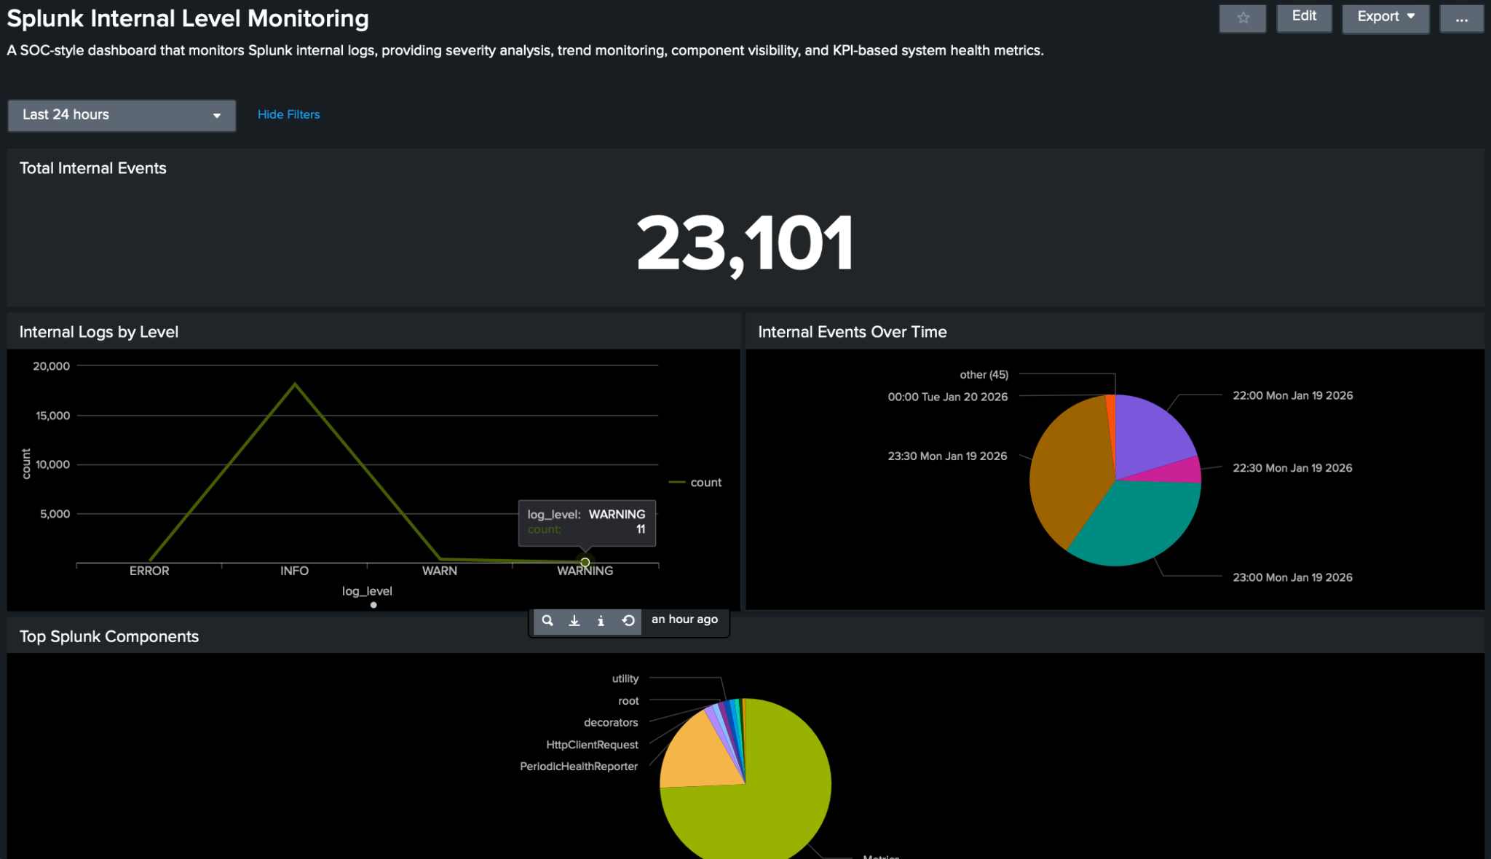
Figure 1: Splunk Internal Level Monitoring Dashboard showing KPI, severity analysis, trend monitoring, and component visibility.

