**1.(a) Mention the role of ionophores as uncoupler.**

Certainly! Let’s explore each of these topics:

**(a) Role of Ionophores as Uncouplers:** Ionophores are chemical compounds that disrupt oxidative phosphorylation in prokaryotes, mitochondria, or photophosphorylation in chloroplasts and cyanobacteria. They achieve this by dissociating the reactions of ATP synthesis from the electron transport chain. Here’s how they work:

* **Uncoupling ATP Synthesis:** Ionophores uncouple the energy transfer process. The cell expends energy to generate a proton-motive force, but this force dissipates before ATP synthase can recapture it for ATP production. [Uncouplers stimulate cellular metabolism by uncoupling ATP synthesis from electron transport](https://en.wikipedia.org/wiki/Uncoupler)[1](https://en.wikipedia.org/wiki/Uncoupler).
* **Examples of Classical Uncouplers:**
  + 2,4-dinitrophenol (DNP)
  + Carbonyl cyanide phenylhydrazone (CCP)
  + Triclosan
  + [And more](https://en.wikipedia.org/wiki/Uncoupler)[1](https://en.wikipedia.org/wiki/Uncoupler).
* **(b) Comment on the dual activity of ‘Rubisco’.**

**(b) Dual Activity of Rubisco:** Rubisco (Ribulose-1,5-bisphosphate carboxylase/oxygenase) plays a crucial role in photosynthesis. However, it has a dual nature:

1. **Carboxylase Activity:**
   * Under normal conditions (high CO₂), Rubisco acts as a carboxylase, incorporating CO₂ into an organic molecule during the Calvin cycle for sugar production.
2. **Oxygenase Activity (Photorespiration):**
   * In hot and dry conditions (high O₂), Rubisco can mistakenly bind to oxygen instead of CO₂.
   * This initiates photorespiration, where Rubisco converts ribulose-1,5-bisphosphate (RuBP) to phosphoglycerate and phosphoglycolate.
   * [Photorespiration wastes energy and decreases sugar synthesis](https://en.wikipedia.org/wiki/Uncoupler)[2](https://bio.libretexts.org/Bookshelves/Introductory_and_General_Biology/General_Biology_1e_%28OpenStax%29/2%3A_The_Cell/07%3A_Cellular_Respiration/7.4%3A_Oxidative_Phosphorylation).

**(c) Mention the role of leghaemoglobin in biological nitrogen fixation.**

**© Role of Leghemoglobin in Biological Nitrogen Fixation:** Leghemoglobin (Lb) is essential for nitrogen fixation in legumes. It:

* Protects nitrogenase from oxygen exposure.
* Supplies oxygen to bacteria for respiration.
* Occurs within infected cells, not in the peri-bacteroid membrane.
* [Is metabolically degraded to choleglobin and biliverdin](https://en.wikipedia.org/wiki/Uncoupler)[3](https://link.springer.com/chapter/10.1007/978-3-319-64982-5_15).

**(d) Define allosteric enzyme with example.**

**(d) Allosteric Enzyme:** Allosteric enzymes have an additional binding site (allosteric site) for effectors (inhibitors or activators) other than the active site. Binding induces conformational changes, altering catalytic properties. [Examples include hemoglobin and phosphoenolpyruvate carboxylase (PEPC) in CAM plants](https://en.wikipedia.org/wiki/Uncoupler)[4](https://byjus.com/neet/allosteric-enzyme/).

**(e) Name the primary and secondary CO2 fixing enzymes in CAM plants.**

**(e) Primary and Secondary CO₂ Fixing Enzymes in CAM Plants:**

* **Primary Fixation:** Phosphoenolpyruvate carboxylase (PEPC) fixes CO₂ using HCO₃⁻ during the night.
* [**Secondary Fixation:** Ribulose-1,5-bisphosphate carboxylase/oxygenase (RuBisCO) fixes CO₂ during the day](https://en.wikipedia.org/wiki/Uncoupler)[5](https://academic.oup.com/plcell/article/29/10/2314/6100435).

**(F) Which enzyme combines ammonium with glutamate? write down the reaction.**

**(F) Enzyme Combining Ammonium with Glutamate:** The enzyme is **glutamine synthetase**. The reaction is:

\text{Glutamate} + \text{NH}_4^+ + \text{ATP} \rightarrow \text{Glutamine} + \text{ADP} + \text{Pi}Glutamate+NH4+​+ATP→Glutamine+ADP+Pi

**(g) what is calmodulin.**

[**(g) Calmodulin:** Calmodulin is a calcium-binding protein that regulates various cellular processes by modulating target proteins in response to calcium levels6](https://biologyreader.com/allosteric-site.html).

**(h) What are the two components of nitrogenase enzyme complex.**

**(h) Components of Nitrogenase Enzyme Complex:** The nitrogenase enzyme complex consists of two components:

1. **Dinitrogenase (MoFe protein):** Binds and reduces N₂.
2. [**Dinitrogenase reductase (Fe protein):** Transfers electrons from ferredoxin to dinitrogenase7](https://academic.oup.com/pcp/article/23/1/85/1893138)[.](https://en.wikipedia.org/wiki/Uncoupler)[5](https://academic.oup.com/plcell/article/29/10/2314/6100435)

**2. Answer any two questions.**

**(a) Mention the role of G protein in signal transduction.**

**G proteins play a crucial role in signal transduction, which is the process by which extracellular signals are transmitted into the cell to elicit a response. Here’s how G proteins function in this process:**

**1. **Receptor Activation:** Signal transduction begins when an extracellular ligand (such as a hormone or neurotransmitter) binds to and activates a specific receptor on the cell membrane. This binding induces a conformational change in the receptor.**

**2. **G Protein Activation:** The activated receptor interacts with and activates a G protein that is bound to the inner surface of the cell membrane. G proteins are heterotrimeric proteins consisting of three subunits: alpha (α), beta (β), and gamma (γ).**

**3. **Signal Amplification:** Upon activation by the receptor, the G protein undergoes a conformational change, causing the GDP bound to the α subunit to be exchanged for GTP (guanosine triphosphate). This activation step leads to dissociation of the GTP-bound α subunit from the βγ complex.**

**4. **Effector Activation:** Both the GTP-bound α subunit and the βγ complex can modulate the activity of effector proteins in the cell membrane or cytoplasm. Examples of effectors include enzymes such as adenylyl cyclase, phospholipase C, and ion channels.**

**5. **Second Messenger Production:** The activated effectors catalyze the production of second messengers such as cyclic AMP (cAMP), diacylglycerol (DAG), and inositol trisphosphate (IP3) inside the cell. These second messengers relay the signal from the receptor to downstream targets, amplifying the initial signal.**

**6. **Response Initiation:** The second messengers then activate downstream signaling pathways, which ultimately lead to cellular responses such as changes in gene expression, enzyme activity, ion channel conductance, or cell proliferation.**

**7. **Termination of Signal:** The G protein-mediated signaling is terminated through several mechanisms, including hydrolysis of GTP to GDP on the α subunit (catalyzed by the intrinsic GTPase activity of the α subunit) and reassociation of the α subunit with the βγ complex, restoring the inactive GDP-bound heterotrimeric G protein.**

**In summary, G proteins act as molecular switches that transduce extracellular signals from cell surface receptors to intracellular effectors, thereby initiating a variety of cellular responses essential for physiological processes such as hormone action, neurotransmission, sensory perception, and immune response.**

**Or//**

1. **G-Protein Coupled Receptors (GPCRs):**
   * GPCRs are integral membrane proteins that span the plasma membrane seven times (7TM receptors).
   * They respond to various extracellular signals, including hormones, neurotransmitters, and odorants.
   * Upon ligand binding (e.g., adrenaline or serotonin), GPCRs undergo conformational changes.
   * These conformational changes activate intracellular signaling pathways.
2. **G-Proteins:**
   * G-proteins are heterotrimeric complexes composed of three subunits: α (alpha), β (beta), and γ (gamma).
   * The α subunit can bind either GDP (inactive state) or GTP (active state).
   * When a ligand activates a GPCR, the G-protein is recruited.
   * The α subunit exchanges GDP for GTP, leading to its dissociation from the βγ dimer.
   * Both α-GTP and βγ can modulate downstream effectors.
3. **Downstream Signaling:**
   * The α-GTP subunit or βγ dimer interacts with various effector proteins (e.g., adenylyl cyclase, phospholipase C, ion channels).
   * These effectors generate second messengers (e.g., cAMP, IP₃, DAG) that propagate the signal.
   * Ultimately, cellular responses (e.g., gene expression, ion flux, enzyme activation) occur.

In summary, G-proteins act as intermediaries, transmitting signals from GPCRs to downstream effectors, orchestrating diverse cellular responses. 🌟🔍🧬.

**(b) what is the significance of pentose phosphate pathway?**

**The pentose phosphate pathway (PPP), also known as the phosphogluconate pathway or hexose monophosphate shunt, is a metabolic pathway parallel to glycolysis that plays several significant roles in cellular metabolism. Here are the key aspects of its significance:**

**1. **Production of NADPH:\*\***

**One of the primary functions of the pentose phosphate pathway is the generation of nicotinamide adenine dinucleotide phosphate (NADPH). NADPH is crucial for:**

**- Reductive biosynthesis: It serves as a reducing agent in biosynthetic pathways, including fatty acid synthesis, cholesterol synthesis, and steroid hormone synthesis.**

**- Cellular defense against oxidative stress: NADPH is essential for maintaining cellular antioxidant systems, such as the glutathione and thioredoxin systems, which protect cells from oxidative damage caused by reactive oxygen species (ROS).**

**2. **Synthesis of Ribose-5-Phosphate:\*\***

**The pentose phosphate pathway produces ribose-5-phosphate, which is a precursor for the synthesis of nucleotides (purines and pyrimidines). Nucleotides are essential components of DNA, RNA, and other nucleotide derivatives (e.g., ATP, GTP).**

**3. **Regulation of Glycolytic Intermediates:\*\***

**The PPP helps regulate the levels of glycolytic intermediates by converting excess glucose-6-phosphate (from glycolysis) into ribose-5-phosphate and other intermediates. This ensures a balanced flow of carbon through different metabolic pathways depending on the cellular needs.**

**4. **Generation of Glycolytic Intermediates:\*\***

**Besides ribose-5-phosphate, the pentose phosphate pathway also produces other glycolytic intermediates such as fructose-6-phosphate and glyceraldehyde-3-phosphate. These intermediates can be used for glycolysis or other biosynthetic pathways, depending on cellular requirements.**

**5. **Support for Anabolic Processes:\*\***

**By providing NADPH and ribose-5-phosphate, the pentose phosphate pathway supports various anabolic processes essential for cell growth, proliferation, and repair. These include lipid biosynthesis, nucleotide biosynthesis, and the synthesis of certain amino acids.**

**6. **Integration with Other Metabolic Pathways:\*\***

**The PPP is interconnected with other metabolic pathways, such as glycolysis, gluconeogenesis, and the tricarboxylic acid (TCA) cycle. This integration allows for flexibility in the utilization of carbon sources and adaptation to changing metabolic demands.**

**In summary, the pentose phosphate pathway is crucial for maintaining cellular redox balance (via NADPH production), providing precursors for nucleotide synthesis, regulating glycolytic intermediates, and supporting anabolic processes. Its activities are vital for cellular homeostasis, growth, and adaptation to metabolic challenges, making it a fundamental pathway in cellular metabolism.**

**Or//**

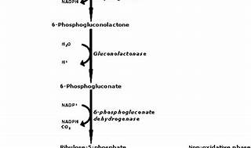

Certainly! The **Pentose Phosphate Pathway (PPP)**, also known as the **hexose monophosphate shunt**, plays a crucial role in cellular metabolism. Let’s explore its significance:

1. **NADPH Production:**
   * The PPP generates **NADPH** (nicotinamide adenine dinucleotide phosphate), a vital reducing agent.
   * NADPH is essential for:
     + **Biosynthesis:** It provides reducing power for the synthesis of fatty acids, cholesterol, and nucleotides (DNA and RNA).
     + **Antioxidant Defense:** NADPH supports the regeneration of reduced glutathione, protecting cells from oxidative damage.
     + **Detoxification:** NADPH powers reactions that detoxify drugs and harmful compounds.
2. **Ribose-5-Phosphate Production:**
   * The PPP produces **ribose-5-phosphate**, a 5-carbon sugar.
   * Ribose-5-phosphate serves as a precursor for:
     + **RNA and DNA Synthesis:** It contributes to the formation of nucleotides (adenine, guanine, cytosine, thymine, and uracil).
     + **Coenzymes and Co-factors:** Ribose-5-phosphate is involved in the synthesis of coenzymes like ATP and NAD+.
3. **Erythrose-4-Phosphate:**
   * The PPP generates **erythrose-4-phosphate**, another 4-carbon intermediate.
   * Erythrose-4-phosphate participates in the biosynthesis of **amino acids**.

In summary, the PPP ensures a balance between energy production (glycolysis) and the synthesis of essential molecules needed for growth, repair, and defense. [🌟🧬🔍](https://www.khanacademy.org/test-prep/mcat/biomolecules/carbohydrate-metabolism/a/pentose-phosphate-pathway)[1](https://www.khanacademy.org/test-prep/mcat/biomolecules/carbohydrate-metabolism/a/pentose-phosphate-pathway)[2](https://biologynotesonline.com/pentose-phosphate-pathway/)[3](https://microbenotes.com/pentose-phosphate-pathway/).

**(c) Distinguish between action spectrum and absorption spectrum.**

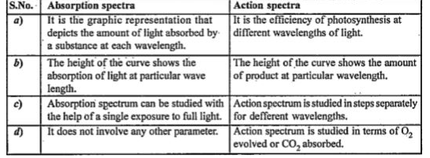

**3. Answer any three question.**

**(a) Write down the compartmentalized reaction steps of the photorespiratory pathway in flow chart mentioning the relevant enzymes in each step. ‘Photorespiration is also called peroxidomal respiration’- comment. Do you think the process is totally wasteful to the plants?**

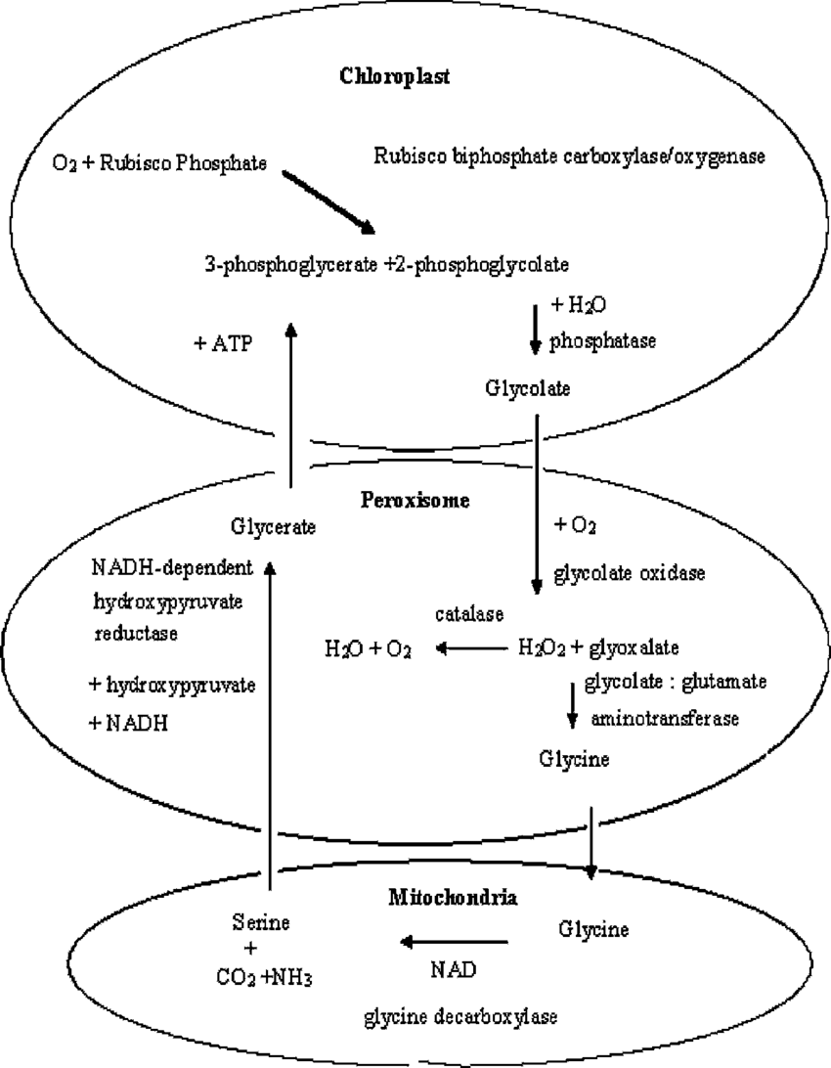

**The photorespiratory pathway is a series of reactions that occur in different cellular compartments (chloroplast, peroxisome, and mitochondria) in plants. Here's a compartmentalized flow chart of the photorespiratory pathway, along with the relevant enzymes involved in each step:**

**1. **Chloroplast:\*\***

**- **Step 1:** Oxygenation of ribulose-1,5-bisphosphate (RuBP)**

**- **Enzyme:** Rubisco (Ribulose-1,5-bisphosphate carboxylase/oxygenase)**

**- **Reaction:** RuBP + O2 → 3-phosphoglycerate (3-PGA) + 2-phosphoglycolate (2-PG)**

**2. **Peroxisome:\*\***

**- **Step 2:** Conversion of 2-phosphoglycolate (2-PG) to glycolate**

**- **Enzyme:** Glycolate oxidase**

**- **Reaction:** 2-PG + O2 → glycolate + H2O2**

**- **Step 3:** Conversion of glycolate to glyoxylate**

**- **Enzyme:** Glycolate oxidase**

**- **Reaction:** glycolate + O2 → glyoxylate + H2O2**

**- **Step 4:** Conversion of glyoxylate to glycine**

**- **Enzyme:** Glyoxylate reductase**

**- **Reaction:** glyoxylate + NADPH + H+ → glycine + NADP+ + H2O**

**3. **Mitochondria:\*\***

**- **Step 5:** Conversion of glycine to serine**

**- **Enzyme:** Serine hydroxymethyltransferase**

**- **Reaction:** glycine + tetrahydrofolate (THF) → serine + 5,10-methylenetetrahydrofolate (5,10-MTHF)**

**- **Step 6:** Conversion of serine back to glycerate**

**- **Enzyme:** Serine-glyoxylate aminotransferase**

**- **Reaction:** serine + glyoxylate → hydroxypyruvate + glycine**

**- **Step 7:** Conversion of hydroxypyruvate to glycerate**

**- **Enzyme:** Hydroxypyruvate reductase**

**- **Reaction:** hydroxypyruvate + NADH + H+ → glycerate + NAD+**

**- **Step 8:** Conversion of glycerate to 3-phosphoglycerate (3-PGA)**

**- **Enzyme:** Phosphoglycerate kinase**

**- **Reaction:** glycerate + ATP → 3-PGA + ADP**

**The overall outcome of the photorespiratory pathway is the conversion of 2-phosphoglycolate produced by Rubisco oxygenation in the chloroplast into 3-phosphoglycerate, which can re-enter the Calvin cycle for CO2 fixation. This pathway involves several enzymes located in different cellular compartments and plays a crucial role in minimizing the impact of oxygenation by Rubisco and in maintaining carbon and nitrogen balance in plants.**

**The statement that "photorespiration is also called peroxidomal respiration" is inaccurate. Photorespiration and peroxisomal respiration are distinct processes in plant metabolism with different functions and locations within the cell.**

**\*\*Photorespiration:\*\***

**- **Definition:** Photorespiration is a metabolic pathway in plants that occurs when the enzyme Rubisco oxygenates ribulose-1,5-bisphosphate (RuBP) instead of carboxylating it during photosynthesis.**

**- **Consequence:** This leads to the formation of 2-phosphoglycolate (2-PG), which is subsequently metabolized through a series of reactions in different cellular compartments (chloroplasts, peroxisomes, and mitochondria).**

**- **Purpose:** While traditionally viewed as wasteful because it consumes ATP and produces no useful organic compounds or energy, photorespiration plays a role in preventing the build-up of toxic intermediates and balancing carbon and nitrogen metabolism.**

**\*\*Peroxisomal Respiration:\*\***

**- **Definition:** Peroxisomal respiration refers to the oxidative metabolic processes that occur within peroxisomes, such as fatty acid oxidation and detoxification of reactive oxygen species (ROS).**

**- **Function:** Peroxisomes contribute to various metabolic pathways essential for cellular function and maintenance, distinct from the specific processes of photorespiration.**

**\*\*Is Photorespiration Totally Wasteful to Plants?\*\***

**- **Considerations:\*\***

**1. **Energy Consumption:** Photorespiration consumes ATP and reduces the efficiency of photosynthesis by diverting energy that could otherwise be used for biomass production.**

**2. **CO2 Loss:** It results in the release of CO2, which counteracts the CO2 fixation achieved during normal photosynthesis.**

**3. **Environmental Adaptation:** In certain conditions, such as high temperatures or drought, photorespiration can increase as a protective mechanism against oxidative stress and carbon imbalance.**

**4. **Evolutionary Perspective:** Despite its apparent inefficiency, photorespiration may have evolutionary benefits by providing a means to cope with changing environmental conditions and balancing metabolic processes.**

**\*\*Conclusion:\*\***

**While photorespiration is energetically costly and can be seen as wasteful in terms of energy and carbon utilization, it serves important roles in plant metabolism, including maintaining cellular redox balance and preventing toxicity from reactive oxygen species. From an evolutionary standpoint, it reflects adaptations to environmental challenges and plays a complex role in the overall physiology of plants. Therefore, while not completely wasteful, it represents a compromise between the benefits and costs of metabolic adaptations in plants.**

**(b) Schematically represent the Z-scheme of light reaction in photosynthesis. explain the ‘S’ state model in oxygen evolving complex in photosynthesis.**

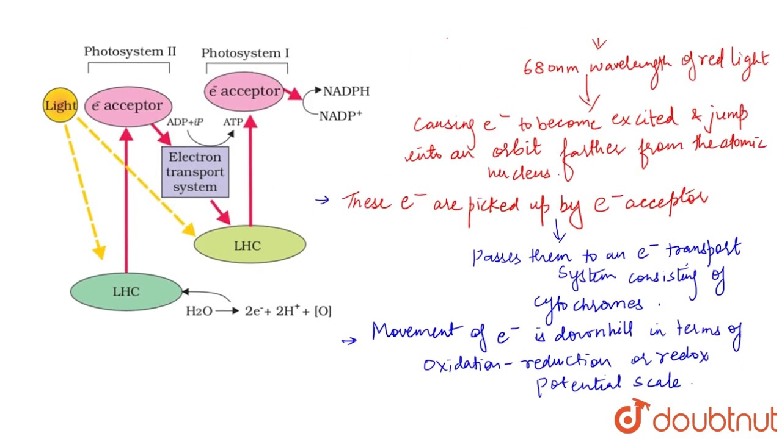

**Explanation:**

1. **Photosystem II (PSII):**
   * PSII absorbs photons and uses them to split water molecules (H2O) into protons (H+), oxygen (O2), and electrons (e-).
   * The electrons are transferred through the electron transport chain (via Plastoquinone (PQ) and Cytochrome b6f complex), leading to the pumping of protons (H+) across the thylakoid membrane (creating a proton gradient).
2. **Photosystem I (PSI):**
   * PSI absorbs photons of a slightly different wavelength and uses the electrons it receives from the electron transport chain (via plastocyanin, PC) to re-energize them.
   * The energized electrons are then transferred to Ferredoxin (Fd).
3. **Generation of ATP and NADPH:**
   * The electrons transferred from PSI through Ferredoxin (Fd) are used to reduce NADP+ to NADPH.
   * Concurrently, the proton gradient generated by PSII and the Cytochrome b6f complex is used by ATP synthase to produce ATP through chemiosmosis.
4. **Overall Flow:**
   * Electrons move from water (H2O) to PSII, then through the electron transport chain (ETC) to PSI and finally to NADP+ to form NADPH.
   * Protons are pumped across the thylakoid membrane from the stroma into the thylakoid lumen, creating a proton gradient.
   * The flow of electrons through PSII and PSI forms a zigzag (Z) shape, hence the name "Z-scheme."

This schematic representation illustrates how light energy is converted into chemical energy (ATP and NADPH) through the sequential action of Photosystem II and Photosystem I, linked by an electron transport chain and ATP synthase.

The 'S' state model refers to the sequential oxidation states of manganese (Mn) ions within the oxygen-evolving complex (OEC) of Photosystem II (PSII) during the process of water oxidation in photosynthesis. This complex process occurs in the thylakoid membranes of chloroplasts and is essential for the production of molecular oxygen (O2).

Here's an explanation of the 'S' state model:

1. **Structure of the Oxygen-Evolving Complex (OEC):**
   * The OEC is a cluster of manganese ions (typically four Mn ions) and calcium ions (Ca^2+) bound to protein subunits in PSII.
   * It is located on the lumenal (inside) side of the thylakoid membrane and is involved in catalyzing the oxidation of water to molecular oxygen during the light-dependent reactions of photosynthesis.
2. **Sequential Oxidation States (S-states):**
   * The 'S' states refer to the different oxidation states of the Mn ions within the OEC as they sequentially undergo oxidation during the water-splitting process.
   * The cycle of oxidation states is denoted as S0, S1, S2, S3, and S4.
3. **S0 State:**
   * In the S0 state, the OEC is in a resting or ground state where it is ready to accept electrons from the oxygen-evolving complex proteins (OEC proteins) and a substrate water molecule.
4. **Catalytic Cycle (S1 to S4 States):**
   * Upon absorption of light energy by PSII, the OEC initiates a series of oxidation reactions:
     + **S1 State:** One electron is transferred to the OEC from the photosystem, leading to the formation of the S1 state. This state involves a radical pair formation with a bridging oxygen atom.
     + **S2 State:** Another light-driven electron transfer results in the formation of the S2 state, where a water molecule is bound to the Mn cluster and oxygen evolution begins. This state involves the storage of one oxygen atom as an intermediate.
     + **S3 State:** Further oxidation results in the S3 state, where a second water molecule is bound to the Mn cluster, facilitating the release of O2 and providing further oxygen evolution.
     + **S4 State:** In the final S4 state, the OEC has fully oxidized the Mn cluster and released molecular oxygen (O2). This state is unstable and quickly transitions back to the S0 state to restart the cycle.
5. **Calcium (Ca^2+) and Structural Stability:**
   * Calcium ions (Ca^2+) stabilize the Mn cluster and are crucial for maintaining the structural integrity of the OEC during the catalytic cycle.
   * The exact role of calcium includes providing structural support and facilitating electron transfer within the OEC.
6. **Overall Function:**
   * The 'S' state model explains how the OEC sequentially oxidizes water molecules, releasing electrons and protons (H+) into the thylakoid lumen, which contributes to the generation of a proton gradient used to synthesize ATP through ATP synthase.
   * Molecular oxygen (O2) is released as a byproduct of this water-splitting process, providing the atmosphere with oxygen essential for aerobic life on Earth.

In summary, the 'S' state model describes the sequential oxidation states of manganese ions in the oxygen-evolving complex of Photosystem II during the process of water oxidation in photosynthesis. This model helps to elucidate the mechanism by which plants and other photosynthetic organisms produce molecular oxygen and generate chemical energy in the form of ATP.

Or//

Certainly! Let’s dive into the detailed explanation of the **“S-state model”** in the **oxygen-evolving complex (OEC)** during photosynthesis:

1. **Oxygen-Evolving Complex (OEC):**
   * The OEC is a critical component of **photosystem II (PSII)**, which is part of the **light-dependent reactions** in photosynthesis.
   * Its primary function is to **catalyze the splitting of water molecules** into electrons, protons (H⁺), and molecular oxygen (O₂).
   * The OEC contains a cluster of **four manganese (Mn) ions** and a **calcium (Ca) ion**, collectively referred to as the **Mn₄CaO₅ cluster**.
   * This cluster undergoes a series of redox reactions during the water oxidation process.
2. **The S-State Cycle:**
   * The OEC transitions through five different oxidation states, denoted as **S₀, S₁, S₂, S₃, and S₄**. These states represent the number of oxidizing equivalents (electrons) associated with the Mn₄CaO₅ cluster.
   * Each S-state corresponds to a specific arrangement of the manganese ions and their oxidation states.
   * The cycle begins with the most reduced state (S₀) and progresses to the most oxidized state (S₄).
3. **S₀ State (Most Reduced):**
   * In the S₀ state, all four manganese ions are in their lowest oxidation state (Mn²⁺).
   * The OEC is ready to accept electrons from the water molecules.
4. **S₁ State:**
   * One electron is added to the OEC, resulting in the S₁ state.
   * The Mn ions undergo changes in oxidation states (e.g., Mn²⁺ → Mn³⁺).
   * A water molecule is bound to the cluster.
5. **S₂ State:**
   * Another electron is added, leading to the S₂ state.
   * The Mn ions continue to change oxidation states (e.g., Mn³⁺ → Mn⁴⁺).
   * The bound water molecule is further oxidized, releasing molecular oxygen (O₂) and a proton (H⁺).
6. **S₃ State:**
   * The OEC accumulates a third electron, reaching the S₃ state.
   * The Mn ions continue their oxidation state changes.
   * Another water molecule is bound and partially oxidized.
7. **S₄ State (Most Oxidized):**
   * The final electron is added, resulting in the S₄ state.
   * The Mn ions are fully oxidized (Mn⁴⁺).
   * The bound water molecule is completely oxidized, releasing another O₂ molecule and a proton.
   * The OEC now returns to the S₀ state to start the cycle again.
8. **Overall Reaction:**
   * The complete water-splitting reaction involves the transition from S₀ to S₄:

2H₂O → 4e^- + 4H^+ + O₂2H2​O→4e−+4H++O2​

In summary, the S-state model describes the dynamic changes in the OEC during water oxidation, providing essential electrons for the photosynthetic electron transport chain. 🌿🌞🔬🌊.

Top of Form

Bottom of Form

**(C) (i) Describe the process of nitrate assimilation in plants.**

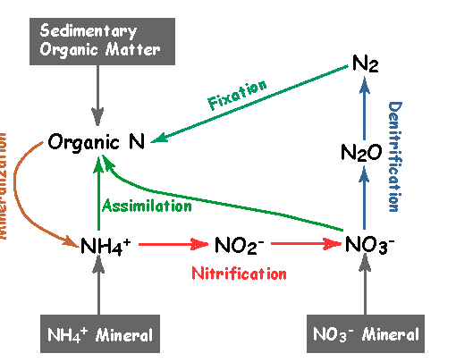

Nitrate assimilation in plants is the process by which plants convert inorganic nitrate (NO3-) from the soil into organic nitrogen compounds, primarily amino acids, which are essential building blocks for proteins and other nitrogen-containing molecules. Here's a detailed description of the process:

1. **Nitrate Uptake:**
   * Plants absorb nitrate (NO3-) from the soil through specialized transporter proteins located on the surface of root cells. Nitrate is one of the major forms of nitrogen available to plants for uptake.
2. **Reduction of Nitrate to Nitrite:**
   * Once inside the root cells, nitrate is first reduced to nitrite (NO2-) in a two-step process:
     + **Step 1:** Nitrate reductase enzyme reduces nitrate to nitrite using NAD(P)H as a source of reducing power.
     + **Step 2:** Nitrite reductase enzyme further reduces nitrite to ammonium (NH4+) using more NAD(P)H.
3. **Ammonium Assimilation:**
   * Ammonium produced from nitrate reduction is assimilated into organic compounds, primarily amino acids. This process occurs in several steps:
     + **Glutamine Synthesis:** Glutamine synthetase enzyme catalyzes the ATP-dependent synthesis of glutamine from glutamate and ammonium. Glutamine is a key nitrogen carrier in plants.
     + **Glutamate Synthesis:** Glutamine is then converted to glutamate by glutamate synthase enzyme, which also generates another molecule of glutamine for further nitrogen assimilation.
     + **Amino Acid Synthesis:** Glutamate serves as a precursor for the synthesis of other amino acids via various transamination and amidotransferase reactions. These amino acids are crucial for protein synthesis and various metabolic processes in plants.
4. **Distribution of Nitrogen Compounds:**
   * Amino acids synthesized through nitrate assimilation are transported to various plant tissues, where they are used for protein synthesis, enzyme production, and other nitrogen-containing molecules.
5. **Regulation and Feedback Inhibition:**
   * The process of nitrate assimilation is tightly regulated in response to nitrogen availability and plant metabolic needs.
   * Feedback inhibition by nitrogen-containing compounds (e.g., glutamine) regulates the activity of nitrate reductase and other enzymes involved in nitrogen assimilation to maintain nitrogen homeostasis in plants.
6. **Integration with Metabolic Pathways:**
   * Nitrogen assimilated from nitrate is integrated into various metabolic pathways, including the synthesis of nucleotides, chlorophyll, hormones, and secondary metabolites, contributing to overall plant growth, development, and defense.

In summary, nitrate assimilation in plants involves the uptake of nitrate from the soil, its reduction to ammonium, and subsequent incorporation into organic compounds, primarily amino acids. This process is essential for plant growth, development, and productivity, as nitrogen is a critical element for the synthesis of proteins and other important molecules in plants.

Top of Form

Bottom of Form

**(ii) Describe in brief the oxidation of cytosolic NADH + H +.**

The oxidation of cytosolic NADH + H+ (reduced nicotinamide adenine dinucleotide) is an essential process in cellular metabolism, particularly in the cytosol of eukaryotic cells and the cytoplasm of prokaryotic cells. Here's a brief description of this process:

1. **NADH as a Reducing Agent:**
   * NADH is a coenzyme that serves as a carrier of electrons (and protons) during cellular respiration and other metabolic pathways.
   * It is generated during glycolysis, the citric acid cycle (Krebs cycle), and fatty acid oxidation, where it accepts electrons from substrates as they are oxidized.
2. **Oxidation of NADH:**
   * In the cytosol or cytoplasm, NADH can be oxidized back to NAD+ (nicotinamide adenine dinucleotide) through the activity of various enzymes.
   * The oxidation of NADH typically involves the transfer of electrons and protons (H+) to an electron acceptor molecule, such as a dehydrogenase enzyme or the mitochondrial electron transport chain (if in eukaryotic cells).
3. **Examples of Oxidative Enzymes:**
   * **Lactate Dehydrogenase:** Catalyzes the oxidation of lactate to pyruvate, transferring electrons from NADH to NAD+ in the process.
   * **Alcohol Dehydrogenase:** Catalyzes the oxidation of ethanol to acetaldehyde (or other alcohols to their respective aldehydes or ketones), transferring electrons from NADH to NAD+.
   * **Malate Dehydrogenase:** Catalyzes the oxidation of malate to oxaloacetate, transferring electrons from NADH to NAD+ in the cytosol or mitochondria.
4. **Role in Cellular Energy Production:**
   * The oxidation of NADH to NAD+ is coupled with the reduction of electron acceptors, generating energy in the form of ATP through oxidative phosphorylation (in mitochondria) or substrate-level phosphorylation (in glycolysis and the citric acid cycle).
   * This process maintains the balance of redox reactions within the cell, ensuring the continuous availability of NAD+ for further metabolic processes.
5. **Regulation and Cellular Metabolism:**
   * The oxidation of NADH is tightly regulated to meet the energy demands and metabolic requirements of the cell.
   * The availability of NADH and the activity of oxidative enzymes are influenced by metabolic conditions, such as nutrient availability, oxygen levels, and cellular signaling pathways.

In summary, the oxidation of cytosolic NADH + H+ is a fundamental process in cellular metabolism that involves the transfer of electrons and protons to generate energy and maintain redox balance. This process occurs through the action of specific dehydrogenase enzymes, contributing to the overall efficiency and regulation of cellular energy production.

**(D) Diagrammatically represent KREBs cycle mentioning enzyme and coenzymes (where required) of each step. mention the sites of decarboxylation in the cycle. state the amphibolic roles of TCA cycle.**

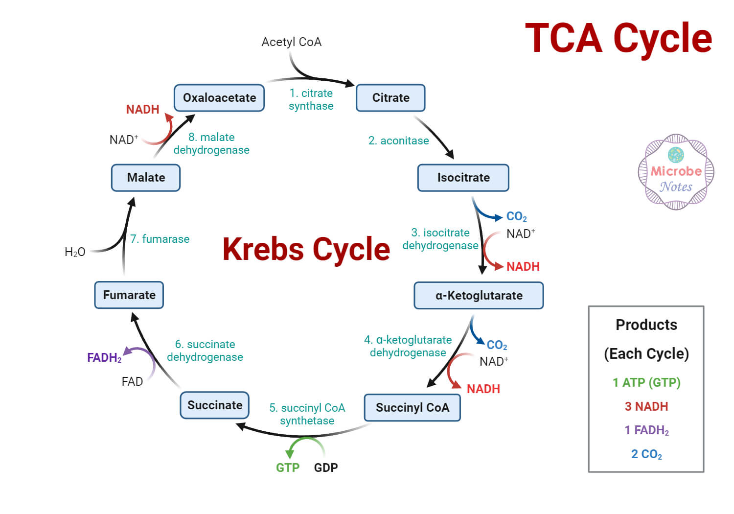

In the Krebs cycle (citric acid cycle or TCA cycle), decarboxylation occurs at two specific sites:

1. **Conversion of α-Ketoglutarate to Succinyl-CoA:**
   * α-Ketoglutarate (5-carbon) is oxidatively decarboxylated to form succinyl-CoA (4-carbon).
   * Enzyme: α-Ketoglutarate dehydrogenase complex.
   * This is the first site of decarboxylation in the cycle.
2. **Conversion of Malate to Oxaloacetate:**
   * Malate (4-carbon) is oxidized to oxaloacetate (4-carbon).
   * Enzyme: Malate dehydrogenase.
   * This is the second site of decarboxylation in the cycle.

Decarboxylation reactions release carbon dioxide (CO2) and produce reduced coenzymes (NADH), which are essential for energy production through oxidative phosphorylation. These reactions play a crucial role in the Krebs cycle by generating energy-rich molecules and intermediates for cellular metabolism.

The Tricarboxylic Acid (TCA) cycle exhibits amphibolic roles by:

1. **Catabolic Functions:**
   * Breaking down acetyl-CoA to generate ATP through oxidative phosphorylation.
2. **Anabolic Functions:**
   * Providing intermediates for biosynthesis of amino acids, fatty acids, and heme.
3. **Regulating Metabolic Flux:**
   * Integrating inputs from various metabolic pathways to meet cellular energy demands.
4. **Maintaining Redox Balance:**
   * Generating NADH and FADH2 for ATP production and ensuring cellular redox homeostasis.

Overall, the TCA cycle serves as a central hub in cellular metabolism, balancing energy production with the synthesis of essential molecules needed for growth, maintenance, and function.

**(e) What is gluconeogenesis? what is its role during seed germination? how does alpha oxidation differ from beta oxidation of fatty acid.**

**Gluconeogenesis** is a metabolic pathway that allows organisms to synthesize glucose from non-carbohydrate precursors, such as amino acids, lactate, glycerol, and certain TCA cycle intermediates (like oxaloacetate). This pathway is essentially the reverse of glycolysis, with some variations in the enzymes involved to overcome the irreversible steps of glycolysis.

During seed germination, gluconeogenesis plays a pivotal role in ensuring the successful transition from seed dormancy to active seedling growth. Here's a more detailed exploration of its role:

1. **Energy Supply:**
   * **Initiation of Metabolism:** When a seed begins germination, stored reserves such as starch and lipids are broken down into smaller molecules like amino acids and fatty acids. Gluconeogenesis converts these non-carbohydrate precursors into glucose, which serves as a primary energy source for various metabolic processes.
   * **ATP Production:** Glucose generated through gluconeogenesis enters glycolysis to produce ATP, which is crucial for driving biochemical reactions required for cell division, elongation, and tissue differentiation during seedling growth.
2. **Metabolic Flexibility:**
   * **Adaptation to Variable Conditions:** Germinating seeds encounter diverse environmental conditions. Gluconeogenesis provides metabolic flexibility by allowing the seedling to synthesize glucose from different substrates, such as amino acids, glycerol, and TCA cycle intermediates, depending on the availability of stored reserves and external factors like temperature and light.
   * **Sustaining Growth:** This flexibility ensures a continuous supply of glucose, essential for sustaining seedling growth and development even under suboptimal environmental conditions.
3. **Transition to Autotrophic Growth:**
   * **Establishment of Photosynthesis:** Initially, the germinating seedling relies on stored reserves and gluconeogenesis for energy. As photosynthetic machinery develops in the emerging leaves, glucose produced via photosynthesis gradually replaces gluconeogenesis-derived glucose as the primary energy source.
   * **Shift in Energy Source:** Gluconeogenesis facilitates this transition by providing a steady supply of glucose until the seedling can fully sustain itself through autotrophic (self-feeding) growth.
4. **Regulation of Seedling Growth:**
   * **Coordination of Metabolic Pathways:** Gluconeogenesis integrates with other metabolic pathways, including glycolysis, TCA cycle, and oxidative phosphorylation, to ensure efficient energy production and utilization.
   * **Optimization of Growth:** By maintaining glucose levels through gluconeogenesis, the seedling optimizes its metabolic processes, leading to rapid and healthy growth during the critical early stages of development.

In summary, gluconeogenesis during seed germination serves as a vital metabolic pathway that provides energy, metabolic intermediates, and flexibility to support seedling growth and adaptation to changing environmental conditions. It bridges the gap between stored reserves and autonomous growth through photosynthesis, ensuring the successful establishment of a new plant.

Certainly! Here's a succinct comparison between alpha oxidation and beta oxidation of fatty acids:

**Alpha Oxidation:**

- **Location:** Primarily in peroxisomes.

- **Substrate:** Branched-chain fatty acids (e.g., phytanic acid).

- **Oxidation Site:** Alpha carbon (next to the carboxyl group).

- **Enzyme:** Alpha-hydroxylase enzymes.

- **Coenzyme:** Uses oxygen and NAD+ or NADP+.

- **Products:** Forms dicarboxylic acids.

**Beta Oxidation:**

- **Location:** Mainly in mitochondria (also in peroxisomes for very-long-chain fatty acids).

- **Substrate:** Straight-chain fatty acids.

- **Oxidation Site:** Beta carbon (third carbon from the carboxyl end).

- **Enzyme:** Acyl-CoA dehydrogenase, enoyl-CoA hydratase, etc.

- **Coenzyme:** Utilizes FAD and NAD+.

- **Products:** Produces acetyl-CoA and generates NADH and FADH2.

**Key Difference:**

- **Alpha oxidation** is specific to branched-chain fatty acids, occurring in peroxisomes, and oxidizes the carbon adjacent to the carboxyl group.

- **Beta oxidation** is the main pathway for straight-chain fatty acids, occurs in mitochondria, and sequentially oxidizes the third carbon from the carboxyl end to produce acetyl-CoA.

These pathways illustrate adaptations in fatty acid metabolism to handle different types of fatty acid structures efficiently, contributing to cellular energy production and metabolic balance.

Top of Form

Bottom of Form