**2022 BOTANY- HONOURS**

**Paper CC-13**

**Full Marks: 50 The figures in the margin indicate full marks. Candidates are required to give their answers in their own words as far as practicable.**

1. **Answer any five questions**

**(a) What are aquaporins?**

(a) \*\***Aquaporins**:** Aquaporins are specialized proteins embedded in cell membranes that facilitate the transport of water across the membrane. They play a crucial role in regulating water balance and osmotic pressure within cells and tissues.

**(b) What is critical concentration of a nutrient?**

(b) **\*\*Critical concentration of a nutrient**\*\*: The critical concentration of a nutrient refers to the minimum concentration of that nutrient below which plant growth or another biological process is significantly limited. It represents the threshold level necessary for optimal physiological function.

**(c) Why all plant growth regulators are not termed as phytohormones?**

(c) \*\***Why all plant growth regulators are not termed as phytohormones?\*\***

Plant growth regulators (PGRs) include various substances that regulate plant growth and development. Not all PGRs are termed phytohormones because phytohormones specifically refer to naturally occurring organic substances that regulate physiological processes in plants at very low concentrations. While many PGRs are phytohormones (like auxins, gibberellins, cytokinins, abscisic acid, and ethylene), some PGRs may include synthetic substances or other compounds that regulate growth but do not fit the strict definition of phytohormones.

**(d) What do you mean by chelating agents?**

(d) \*\***Chelating agents**\*\*: Chelating agents are chemical compounds that can form complexes with metal ions by forming multiple coordinate bonds. They are used in various applications, including agriculture and medicine, to bind and neutralize metal ions, thereby preventing their undesirable effects such as precipitation or catalytic activity.

**(e) What is 'devernalisation?**

(e) \*\***Devernalisation**: Devernalisation** refers to the process by which a plant is prevented from responding to vernalization cues. Vernalization is the process where exposure to prolonged cold temperatures induces flowering in certain plants. Devernalisation can occur naturally (such as through warm spells interrupting cold exposure) or artificially (by manipulation of temperature conditions).

**(f) Write the scientific name of one Short Day Plant (SDP) and one Long Day Plant (LDP)**

(f) \*\***Short Day Plant (SDP)** and **Long Day Plant (LDP)**\*\*:

- \*\***Short Day Plant (SDP)**:** Chrysanthemum morifolium

- **\*\*Long Day Plant (LDP)**\*\*: Arabidopsis thaliana

**(g) What is triple response of Ethylene?.**

(g) \*\***Triple response of Ethylene**\*\*: The triple response of ethylene is a characteristic physiological response seen in growing shoots of plants exposed to ethylene gas. It includes:

1. **Slowing of stem elongation**: Ethylene causes a decrease in the rate of stem elongation.

2. **Thickening of the stem**: The stem becomes thicker and stronger.

3. **Horizontal growth (apical hook formation)**: The stem grows horizontally instead of vertically, often resulting in the formation of an apical hook.

**(h) Define 'Biorhythm'**

(h) \*\***Biorhythm**\*\*: Biorhythm refers to inherent cycles or periodic fluctuations in physiological or behavioral processes in living organisms. These rhythms are often believed to influence various aspects of life, such as mood, performance, and physical well-being, and are sometimes considered to follow predictable patterns or cycles.

**2. Answer any two questions:**

**(a) Mention physiological roles of calcium and phosphorus in plants**

(2) (a) **Calcium and phosphorus play crucial physiological roles in plants:**

1. **Calcium (Ca)**:

- **Cell Wall Structure**: Calcium is essential for the formation and stability of cell walls. It acts as a cementing material, contributing to the structural integrity and strength of cell walls, particularly in rapidly growing tissues.

- **Cell Membrane Permeability**: Calcium helps in regulating membrane permeability by stabilizing cell membranes. It plays a role in maintaining the selective permeability of membranes, which is crucial for nutrient uptake and cellular signaling.

- **Enzyme Activation**: Calcium acts as a cofactor for several enzymes involved in various metabolic pathways. It activates enzymes that are important for processes such as protein synthesis, cell division, and signal transduction.

- **Second Messenger**: Calcium ions also function as second messengers in signal transduction pathways, where they mediate responses to various environmental stimuli, such as stress responses and hormone signaling.

2. **Phosphorus (P)**:

- **Energy Transfer**: Phosphorus is a key component of ATP (adenosine triphosphate) and ADP (adenosine diphosphate), which are molecules involved in energy transfer and storage within cells. ATP is crucial for cellular processes requiring energy, such as photosynthesis, respiration, and synthesis of organic compounds.

- **Nucleic Acid Synthesis**: Phosphorus is a major component of nucleic acids (DNA and RNA). It is essential for the synthesis and stability of nucleic acids, which are fundamental to genetic information transfer and protein synthesis.

- **Membrane Structure**: Phosphorus is a component of phospholipids, which are major constituents of cell membranes. Phospholipids help maintain the integrity and fluidity of membranes, ensuring proper functioning of membrane-bound processes such as transport and signaling.

- **Signal Transduction**: Phosphorus-containing molecules (such as phosphorylated proteins and phospholipids) are involved in signal transduction pathways, where they relay and amplify signals from receptors to cellular responses.

In summary, calcium and phosphorus are essential nutrients for plants, with calcium primarily contributing to structural integrity, enzyme activation, and signaling, while phosphorus is critical for energy metabolism, nucleic acid synthesis, membrane structure, and signal transduction. Their availability and proper uptake are vital for overall plant growth, development, and stress tolerance.

Or//

The physiological roles of calcium and phosphorus in plants:



1. **Calcium (Ca²⁺)**:
   * **Cell Wall Integrity**: Calcium plays a crucial role in maintaining the structural integrity of cell walls. [It cross-links negatively charged carboxyl groups of de-esterified pectin in the middle lamella, contributing to cell wall rigidity](https://www.frontiersin.org/journals/plant-science/articles/10.3389/fpls.2019.00440/full)[1](https://www.frontiersin.org/journals/plant-science/articles/10.3389/fpls.2019.00440/full).
   * **Membrane Stabilization**: Ca²⁺ also stabilizes cell membranes by interacting with phospholipids. [This interaction helps maintain membrane integrity and function](https://www.frontiersin.org/journals/plant-science/articles/10.3389/fpls.2019.00440/full)[1](https://www.frontiersin.org/journals/plant-science/articles/10.3389/fpls.2019.00440/full).
   * [**Cytosolic Signaling**: As a cytosolic signal, calcium coordinates cellular responses to developmental and environmental stimuli2](https://fertiliser-society.org/store/calcium-in-plant-physiology-and-its-availability-from-the-soil/).
   * [**Osmoregulation**: Under specific environmental conditions, calcium contributes to cation-anion balance and osmoregulation](https://www.frontiersin.org/journals/plant-science/articles/10.3389/fpls.2019.00440/full)[2](https://fertiliser-society.org/store/calcium-in-plant-physiology-and-its-availability-from-the-soil/).



1. **Phosphorus (P)**:
   * **Growth and Development**: Phosphorus is an essential macronutrient for plant growth and development. [It participates in various physiological and metabolic processes](https://www.frontiersin.org/journals/plant-science/articles/10.3389/fpls.2019.00440/full)[3](https://www.mdpi.com/2223-7747/12/15/2861).
   * **Stomatal Functioning**: Phosphorus supply influences stomatal development and operation. [Stomata play a crucial role in regulating water loss and gas exchange in leaves](https://www.frontiersin.org/journals/plant-science/articles/10.3389/fpls.2019.00440/full)[3](https://www.mdpi.com/2223-7747/12/15/2861).
   * [**Gene Regulation**: Recently discovered genes associated with P-dependent stress regulation contribute to plants’ tolerance to abiotic stresses like drought, salinity, and extreme temperatures](https://www.frontiersin.org/journals/plant-science/articles/10.3389/fpls.2019.00440/full)[3](https://www.mdpi.com/2223-7747/12/15/2861).

In summary, calcium and phosphorus are vital for plant health, impacting cell structure, signaling, and stress responses. Efficient utilization of these nutrients is essential for sustainable agricultural practices. [🌱🌿](https://www.frontiersin.org/journals/plant-science/articles/10.3389/fpls.2019.00440/full)[3](https://www.mdpi.com/2223-7747/12/15/2861)[1](https://www.frontiersin.org/journals/plant-science/articles/10.3389/fpls.2019.00440/full).

**(b) Write down the process of IAA biosynthesis from Tryptophan with the help of chemical structure and flowchart. 5**

(b) Indole-3-acetic acid (IAA) biosynthesis from tryptophan in plants involves several enzymatic steps. Here's a simplified overview with chemical structures and a flowchart:

### Chemical Structures Involved:

1. **Tryptophan (Trp)**:

![Tryptophan Structure](https://upload.wikimedia.org/wikipedia/commons/thumb/5/5e/Tryptophan-2D-skeletal.svg/120px-Tryptophan-2D-skeletal.svg.png)

2. **Indole-3-pyruvic acid (IPA)**:

![Indole-3-pyruvic acid Structure](https://upload.wikimedia.org/wikipedia/commons/thumb/2/29/Indole-3-pyruvic-acid.svg/120px-Indole-3-pyruvic-acid.svg.png)

3. **Indole-3-acetaldehyde (IAAld)**:

![Indole-3-acetaldehyde Structure](https://upload.wikimedia.org/wikipedia/commons/thumb/3/37/Indole-3-acetaldehyde.svg/120px-Indole-3-acetaldehyde.svg.png)

4. **Indole-3-acetic acid (IAA)**:

![Indole-3-acetic acid Structure](https://upload.wikimedia.org/wikipedia/commons/thumb/7/7a/Indole-3-acetic-acid-2D-skeletal.svg/120px-Indole-3-acetic-acid-2D-skeletal.svg.png)

### Biosynthesis Process of IAA from Tryptophan:

1. **Tryptophan Conversion to Indole-3-pyruvic acid (IPA)**:

- Tryptophan is initially converted to indole-3-pyruvic acid (IPA) through the action of the enzyme tryptophan aminotransferase (TAA).

- **Reaction**: Tryptophan + α-ketoglutarate ↔ IPA + L-glutamate

![Step 1: Tryptophan to Indole-3-pyruvic acid](https://i.imgur.com/x9J4wFY.png)

2. **Conversion of Indole-3-pyruvic acid (IPA) to Indole-3-acetaldehyde (IAAld)**:

- IPA is then converted to indole-3-acetaldehyde (IAAld) by the enzyme indole-3-pyruvate decarboxylase (IPDC).

- **Reaction**: IPA → IAAld + CO₂

![Step 2: IPA to Indole-3-acetaldehyde](https://i.imgur.com/UmA5b9s.png)

3. **Conversion of Indole-3-acetaldehyde (IAAld) to Indole-3-acetic acid (IAA)**:

- Finally, indole-3-acetaldehyde (IAAld) undergoes oxidation to form indole-3-acetic acid (IAA) by the enzyme aldehyde oxidase (AOX) or alcohol dehydrogenase (ADH).

- **Reaction**: IAAld + NAD(P)⁺ + H₂O → IAA + NAD(P)H + H⁺

![Step 3: IAAld to Indole-3-acetic acid](https://i.imgur.com/w5HnYhP.png)

### Flowchart of IAA Biosynthesis from Tryptophan:

```

Tryptophan → Indole-3-pyruvic acid (IPA) → Indole-3-acetaldehyde (IAAld) → Indole-3-acetic acid (IAA)

↑

↓

Tryptophan aminotransferase (TAA)

↓

Indole-3-pyruvate decarboxylase (IPDC)

↓

Aldehyde oxidase (AOX) or Alcohol dehydrogenase (ADH)

```

This flowchart illustrates the sequential enzymatic conversions of tryptophan to indole-3-acetic acid (IAA) in plants. Each step involves specific enzymes that catalyze the transformation of one compound into the next, ultimately leading to the production of IAA, a crucial phytohormone involved in various physiological processes in plants.

**(c) Discuss phloem translocation with reference to "Pressure flow hypothesis'.**

© Certainly! Let’s delve into the fascinating world of phloem translocation and explore the “Pressure Flow Hypothesis.”

**Phloem Translocation:**

Phloem is a vascular tissue responsible for transporting organic compounds (mainly sugars) from source to sink tissues in plants. Here’s how it works:

1. **Source and Sink**:
   * **Source**: Photosynthetic tissues (usually leaves) produce excess sugars (mainly sucrose) through photosynthesis.
   * **Sink**: Non-photosynthetic tissues (e.g., roots, developing fruits, and storage organs) require these sugars for growth, energy, and storage.
2. **Pressure Flow Hypothesis**:
   * Proposed by Ernst Münch in the 1930s, this hypothesis explains how sugars move through the phloem.
   * It involves two key processes: **loading** at the source and **unloading** at the sink.
3. **Loading at the Source**:
   * **Active Transport**: Sucrose is actively transported from source cells (mesophyll cells in leaves) into the phloem sieve tubes.
   * **Companion Cells**: Adjacent companion cells provide energy (ATP) for active transport.
   * **Water Follows**: As sucrose enters the sieve tubes, water follows due to osmotic pressure, creating a high hydrostatic pressure (turgor) in the phloem.
4. **Translocation in the Phloem**:
   * **Pressure Gradient**: The high turgor pressure at the source creates a pressure gradient.
   * **Bulk Flow**: Sugars move from high pressure (source) to low pressure (sink) regions.
   * **Sieve Tubes**: Sieve tubes (elongated cells with perforated sieve plates) facilitate this bulk flow.
   * **Companion Cells**: Companion cells maintain sieve tube function and regulate transport.
5. **Unloading at the Sink**:
   * **Active Transport**: At the sink (e.g., roots), sucrose is actively transported out of the sieve tubes.
   * **Metabolism and Storage**: Sink tissues use the transported sugars for growth, respiration, and storage (e.g., starch in roots).
   * **Water Returns**: Water moves out of the sieve tubes, reducing pressure.
6. **Evidence Supporting the Hypothesis**:
   * **Ring Experiment**: Girdling (removing a ring of bark) disrupts phloem flow, supporting the role of phloem in translocation.
   * **Radioactive Tracers**: Radioactively labeled sugars injected into leaves are detected in sink tissues.
   * **Pressure Measurements**: Pressure changes in sieve tubes correlate with translocation.
7. **Challenges and Modifications**:
   * **Pressure Flow Hypothesis** is well-supported but not without challenges.
   * **Alternative Pathways**: Some evidence suggests that passive diffusion also plays a role.
   * **Phloem Loading Mechanisms**: Different plants use diverse loading mechanisms (e.g., symplastic or apoplastic).

In summary, the Pressure Flow Hypothesis provides a comprehensive framework for understanding how sugars move through the phloem, ensuring efficient nutrient distribution in plants. 🌱🌿🌾 .

Or//

Phloem translocation is the process by which organic molecules, primarily sugars, are transported throughout a plant from sources (sites of production or storage) to sinks (sites of utilization or storage). The Pressure Flow Hypothesis, also known as the Mass Flow Hypothesis, is one of the most widely accepted explanations for how this translocation occurs.

### Pressure Flow Hypothesis:

1. **Source and Sink:** The process begins with the loading of sugars (mostly sucrose) into the phloem sieve tubes at the source. Sources can be leaves where photosynthesis produces sugars, or storage organs where sugars are stored.

2. **Loading of Sucrose:** In sources, sucrose is actively transported from companion cells (which are connected to the sieve tube elements) into the sieve tubes of the phloem. This creates a high concentration of sucrose in the sieve tubes compared to surrounding cells.

3. **Creation of Pressure Gradient:** The influx of sucrose lowers the water potential inside the sieve tubes. This causes water from adjacent xylem vessels or surrounding cells to move into the sieve tubes by osmosis, creating a positive pressure known as turgor pressure.

4. **Bulk Flow:** The pressure gradient (higher pressure in source than in sink) drives the movement of sap (sucrose and water solution) through the phloem towards areas of lower pressure, typically towards sinks. Sinks can include growing tissues, roots for storage, or developing seeds.

5. **Unloading at the Sink:** At the sink, where sugars are needed, sucrose is actively transported out of the sieve tubes and into the surrounding cells. This increases the water potential inside the sieve tubes, causing water to move out of the tubes back into the xylem or surrounding cells, thereby reducing pressure.

6. **Return Flow:** The decrease in pressure at the sink encourages the continued flow of sap from source to sink. Some of the unloaded sucrose may also be used in the sink cells for energy or converted into storage forms like starch.

### Key Points of the Pressure Flow Hypothesis:

- **Active Loading and Unloading:** Sucrose is actively transported into and out of the sieve tubes by companion cells, requiring ATP for active transport mechanisms.

- **Role of Turgor Pressure:** Turgor pressure generated by the accumulation of solutes (especially sucrose) drives the flow of phloem sap from source to sink.

- **Mass Flow:** Phloem sap moves in bulk, driven by the pressure gradient rather than by individual molecule diffusion.

- **Regulation:** The rate and direction of phloem sap movement can be regulated by factors such as metabolic demands of sinks, environmental conditions, and hormonal signals.

### Evidence Supporting the Pressure Flow Hypothesis:

- **Observation of Pressure Changes:** Techniques like aphid stylet experiments and micropipette pressure measurements have directly measured pressure changes in sieve tubes during phloem translocation.

- **Radioactive Tracers:** Radioactively labeled compounds have been used to track the movement of sugars from sources to sinks, confirming the direction and speed of phloem sap flow.

- **Anatomical Studies:** Electron microscopy and other imaging techniques have provided detailed structural evidence of sieve tubes and their association with companion cells, supporting the idea of active loading and unloading.

In conclusion, the Pressure Flow Hypothesis provides a comprehensive explanation for how sugars are transported over long distances in plants. It integrates physical principles of osmosis and pressure gradients with the physiological processes of active transport and metabolic activity in source and sink tissues.

**3. Answer any three questions:**

**(a) Name two naturally occurring cytokinins. Give the chemical structure of kinetin. Discuss the role of cytokinin in regulation of cell division in plants and root-shoot initiation in callus tissue. 2+2+6**

3.(a) Two naturally occurring cytokinins are:

1. **Zeatin**: Zeatin is a type of cytokinin that is naturally found in plants. It plays a crucial role in regulating various aspects of plant growth and development, including cell division, shoot initiation, and leaf senescence.

1. **Isopentenyladenine (IPA)**: Isopentenyladenine is another naturally occurring cytokinin that is found in plants. Like zeatin, IPA also regulates processes such as cell division and differentiation, and it helps in promoting plant growth and development.

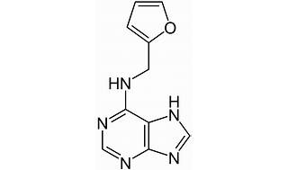

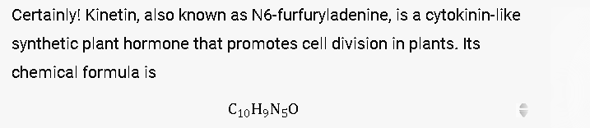

Cytokinins and their impact on plant growth and development.

1. **Cell Division Regulation:**
   * **Cytokinins** are a class of plant hormones that play a crucial role in regulating cell division and differentiation. They are synthesized primarily in the **root tips**, but they are also found in other plant tissues.
   * When cytokinins are transported from the roots to other parts of the plant, they promote cell division by stimulating the cell cycle. Specifically, they activate cyclin-dependent kinases (CDKs) and promote the transition from the G1 phase to the S phase of the cell cycle.
   * As a result, cytokinins contribute to the growth of meristematic tissues (such as shoot apical meristems and root apical meristems) and help maintain the balance between cell division and cell differentiation.
2. **Root-Shoot Initiation in Callus Tissue:**
   * **Callus tissue** refers to a mass of undifferentiated plant cells that can be induced to form in vitro (in a laboratory setting). It is often used in tissue culture and regeneration experiments.
   * Cytokinins play a critical role in callus tissue development. When plant explants (such as leaf segments or stem sections) are cultured on a nutrient medium containing cytokinins, several interesting phenomena occur:
     + **Shoot Formation:** High cytokinin concentrations promote the formation of **shoot buds** from callus tissue. These shoot buds can later develop into complete plantlets.
     + **Root Formation:** Interestingly, low cytokinin concentrations (combined with auxins, another class of plant hormones) lead to the formation of **root primordia**. These primordia eventually give rise to roots.
     + **Root-Shoot Balance:** The balance between cytokinins and auxins determines whether callus tissue will differentiate into shoots or roots. High cytokinin-to-auxin ratios favor shoot development, while low ratios favor root development.
   * This ability to manipulate root-shoot differentiation in callus tissue is valuable for plant propagation, tissue culture, and genetic transformation experiments.

In summary, cytokinins are versatile regulators of plant growth, influencing cell division, tissue differentiation, and organ development. Their intricate interplay with other hormones ensures the proper balance needed for healthy plant growth. 🌱🌿.

Or///

Cytokinins play crucial roles in regulating cell division in plants and in promoting root-shoot initiation in callus tissue, primarily through their effects on gene expression and cellular processes:

### Role in Regulation of Cell Division:

1. **Stimulation of Cell Division**: Cytokinins are known to stimulate cell division in plant tissues, particularly in meristematic regions where active growth occurs. They promote the progression of cells from the G1 phase to the S phase of the cell cycle, thereby increasing the rate of cell division.

2. **Maintenance of Meristematic Activity**: Cytokinins help maintain the activity of shoot and root apical meristems, which are regions of undifferentiated cells responsible for continuous growth. By promoting cell division in these meristems, cytokinins ensure the formation of new tissues and organs throughout plant development.

3. **Delay of Senescence**: Cytokinins also play a role in delaying senescence (aging) of plant tissues by promoting cell division and maintaining the overall health and functionality of cells. This is important for sustaining plant growth and productivity over extended periods.

### Role in Root-Shoot Initiation in Callus Tissue:

1. **Induction of Shoot Formation**: In callus tissue culture, which consists of undifferentiated cells derived from plant explants, cytokinins are often used in combination with auxins (such as indole-3-acetic acid, IAA) to induce shoot formation. Cytokinins act synergistically with auxins to stimulate the initiation and growth of shoot primordia from the callus.

2. **Promotion of Adventitious Root Formation**: Cytokinins can also influence the formation of adventitious roots when applied at appropriate concentrations and in combination with auxins. This is particularly useful in tissue culture techniques for propagating plants from single cells or tissues, as cytokinins help in establishing root systems in vitro.

3. **Balancing Hormonal Interactions**: The balance between cytokinins and auxins is critical in determining whether shoot or root structures will develop from callus tissue. Cytokinins promote shoot initiation while auxins primarily induce root formation. By carefully adjusting the concentrations of these hormones, researchers and growers can manipulate the growth and differentiation of plant tissues in vitro to produce desired plantlets.

In summary, cytokinins regulate cell division by stimulating the cell cycle progression, maintain meristematic activity in plant tissues, delay senescence, and play a pivotal role in initiating shoot and root formation in callus tissue cultures, demonstrating their importance in both natural plant growth and in biotechnological applications such as tissue culture and plant propagation.

**(b) What do you mean by photoperiodic induction? What is the site of perception of the photoperiodic stimulus? Discuss in brief the role of GA in flowering. What is "Vernalisation'? 2+2+-4+2**

(b) Photoperiodic induction is the process where a plant's flowering time is determined by the duration of light and darkness it experiences daily. Different plants respond to specific day lengths—short days, long days, or day-neutral conditions—to initiate flowering. This adaptation helps plants synchronize reproduction with optimal environmental conditions for seed production and survival.

The site of perception of the photoperiodic stimulus in plants is primarily the leaves, where photoreceptors like phytochromes and cryptochromes detect changes in day length. These receptors initiate signaling pathways that trigger the production of flowering signals, which then move to the shoot apical meristem (SAM). The SAM decides when to initiate flowering based on the photoperiodic information received from the leaves.

**Gibberellins (GAs) play a significant role in the regulation of flowering in plants**, primarily by influencing several key processes that are essential for the transition from vegetative growth to reproductive development. Here's a brief overview of the role of gibberellins in flowering:

1. **Promotion of Flowering Induction**: Gibberellins can promote flowering induction in some plant species. They interact with other hormones, such as auxins and cytokinins, to regulate the expression of genes involved in flowering pathways.

2. **Integration with Photoperiodic Signals**: In many plants, gibberellins interact closely with photoperiodic signals to regulate flowering time. They may act downstream of photoperiodic pathways or synergistically with them to initiate the floral transition.

3. **Induction of Flowering in Short-day Plants**: In short-day plants (those that flower when exposed to shorter day lengths), gibberellins can promote flowering when the photoperiodic conditions are conducive. They may act by overcoming inhibitory signals that prevent flowering under non-inductive day lengths.

4. **Control of Flowering Time**: Gibberellins influence the timing of flowering by regulating the expression of key genes involved in floral initiation, such as FT (Flowering Locus T) and SOC1 (Suppressor of Overexpression of Constans 1). These genes control the transition from vegetative to reproductive growth.

5. **Environmental and Developmental Regulation**: The levels of gibberellins in plants can be influenced by environmental factors such as light, temperature, and nutrient availability. Additionally, gibberellins are involved in the coordination of developmental processes leading up to flowering, including stem elongation and floral organ development.

In summary, gibberellins play a crucial role in flowering regulation by integrating environmental signals, particularly photoperiodic cues, and coordinating the expression of genes that initiate floral development. Their involvement varies among plant species and is part of the intricate hormonal network that governs the transition from vegetative growth to flowering.

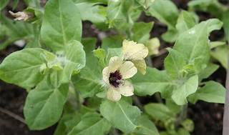

**Vernalization** is the process by which a plant’s flowering is induced through exposure to prolonged cold temperatures, either naturally during winter or artificially. [After vernalization, plants gain the ability to flower, although they may still require additional cues or growth time before actually blooming](https://en.wikipedia.org/wiki/Vernalization)[1](https://en.wikipedia.org/wiki/Vernalization). This phenomenon ensures that reproductive development and seed production occur in spring and winter, rather than autumn. [The required cold exposure is often measured in chill hours, typically between 1 and 7 degrees Celsius (34 and 45 degrees Fahrenheit)](https://en.wikipedia.org/wiki/Vernalization)[1](https://en.wikipedia.org/wiki/Vernalization). [For instance, many winter cereals and biennials, including certain ecotypes of Arabidopsis thaliana, must undergo a prolonged cold period before flowering occurs](https://en.wikipedia.org/wiki/Vernalization)[1](https://en.wikipedia.org/wiki/Vernalization). 🌼🌱.

**(c) Discuss the role of potassium ions and abscisic acid in the opening and closing of stomata. What 1S 'antitranspirant'? 4+4+2**

© Potassium ions (K⁺) and abscisic acid (ABA) play crucial roles in the regulation of stomatal opening and closing, which are essential processes in plant physiology for gas exchange (CO2 uptake and O2 release) and water regulation. Here’s how each of these substances contributes to these processes:

### Role of Potassium Ions (K⁺):

1. **Stomatal Opening**:

- During stomatal opening, potassium ions are actively pumped into guard cells from surrounding epidermal cells. This uptake of K⁺ ions creates a higher osmotic potential within the guard cells.

- The increased osmotic potential causes water to move into the guard cells by osmosis, leading to their swelling and subsequent turgor pressure increase.

- As a result, the guard cells become more turgid and bow-shaped, leading to the opening of the stomatal pore between them.

2. **Stomatal Closure**:

- In contrast, during stomatal closure, the efflux of potassium ions out of guard cells reduces their osmotic potential.

- Water then moves out of the guard cells, decreasing their turgor pressure and causing them to become flaccid and less bowed.

- This closure reduces the size of the stomatal pore, thereby limiting water loss and gas exchange under conditions where it is unfavorable, such as drought or high temperatures.

### Role of Abscisic Acid (ABA):

1. **Stomatal Closure**:

- Abscisic acid (ABA) is a key hormone involved in triggering stomatal closure, particularly in response to environmental stresses such as drought, high salinity, or low humidity.

- During stress conditions, ABA is synthesized in response to signals such as reduced water availability.

- ABA induces the efflux of potassium ions from guard cells, which decreases their turgor pressure and leads to stomatal closure.

- Additionally, ABA promotes the synthesis of osmolytes (such as sugars and proline) in guard cells, which further reduces water potential and facilitates stomatal closure.

2. **Interaction with K⁺ Channels**:

- ABA interacts with and modifies the activity of potassium ion channels in guard cell membranes.

- ABA signaling can activate anion channels that facilitate the efflux of anions (such as Cl⁻) from guard cells, which in turn induces the efflux of K⁺ ions and water out of the cells, leading to stomatal closure.

In summary, potassium ions are crucial for the osmotic regulation that governs stomatal opening and closure. They influence guard cell turgor pressure through their uptake and release, directly affecting stomatal aperture. Abscisic acid, on the other hand, acts as a signaling molecule that triggers stomatal closure in response to environmental stresses, primarily by modulating potassium ion channels and promoting water loss from guard cells. Together, these mechanisms enable plants to balance water conservation with gas exchange under varying environmental conditions.

An antitranspirant is a substance applied to plants to reduce water loss through transpiration. It works by either reducing stomatal opening, forming a protective film on leaves, reflecting sunlight, or modifying stomatal conductance. This helps plants conserve water and cope with environmental stressors such as drought or high temperatures, improving plant health and resilience.

**(d) Write down the role of polyamines as growth regulator. Discuss in brief the role of Ethylene in fruit ripening. Write about the biological significance of Senescence. 4+3+3.**

(d) Polyamines play several important roles as growth regulators in plants. Here are the key functions of polyamines in plant growth and development:

1. **Cell Division and Differentiation**:

- Polyamines such as spermidine, spermine, and putrescine are involved in regulating cell division and differentiation. They promote cell proliferation in various tissues, helping in the growth and development of roots, shoots, and other plant organs.

2. **Stress Response**:

- Polyamines act as important molecules in the plant's response to various environmental stresses, including drought, salinity, extreme temperatures, and pathogen attacks. They help maintain cellular integrity and function under stress conditions, contributing to plant survival and adaptation.

3. **Regulation of Photosynthesis**:

- Polyamines are involved in the regulation of photosynthesis. They influence chlorophyll synthesis, the activity of photosynthetic enzymes, and the efficiency of light harvesting complexes, thereby affecting overall plant productivity.

4. **Seed Development and Germination**:

- Polyamines play a role in seed development, maturation, and germination. They are essential for embryo development and seed viability. Polyamine levels fluctuate during seed dormancy and germination, suggesting their regulatory role in these processes.

5. **Flowering and Reproductive Development**:

- Polyamines are involved in regulating flowering time and reproductive development. They influence the formation and development of floral organs, pollen tube growth, fertilization, and seed set.

6. **Senescence and Aging**:

- Polyamines can delay senescence and aging processes in plants. They help maintain cellular functions and delay the breakdown of chlorophyll and other cellular components during aging, contributing to prolonged plant productivity.

7. **Ion Transport and Membrane Stability**:

- Polyamines participate in ion transport across membranes and help stabilize membrane structures. They maintain cellular ion homeostasis, which is critical for various physiological processes such as nutrient uptake and stress tolerance.

In summary, polyamines serve as versatile growth regulators in plants, influencing cell division, stress responses, photosynthesis, seed development, flowering, senescence, and membrane stability. Their regulatory functions contribute significantly to plant growth, development, and adaptation to environmental changes.

Ethylene plays a pivotal role in the ripening of fruits, influencing various physiological and biochemical changes that characterize the ripening process. Here’s a brief overview of the role of ethylene in fruit ripening:

1. **Initiation of Ripening**:

- Ethylene is typically produced in fruits during the ripening phase. It acts as a signal to initiate and coordinate the ripening process.

- Ethylene production increases as fruits mature, reaching peak levels at the onset of ripening.

2. **Fruit Softening**:

- Ethylene promotes the softening of fruits by inducing the breakdown of cell wall components, particularly pectin. This process leads to a reduction in fruit firmness and contributes to the desirable texture of ripe fruits.

3. **Color Changes**:

- Ethylene influences changes in fruit coloration during ripening. It stimulates the degradation of chlorophyll and the synthesis of pigments such as carotenoids and anthocyanins, leading to characteristic color changes from green to yellow, orange, red, or purple, depending on the fruit type.

4. **Flavor Development**:

- Ethylene enhances the development of flavors and aromas in fruits. It stimulates the production of volatile compounds responsible for characteristic fruity odors and flavors, contributing to the overall sensory quality of ripe fruits.

5. **Respiration Rate**:

- Ethylene is closely associated with the respiratory metabolism of fruits. It often stimulates an increase in the rate of respiration, which is a hallmark of the ripening process and results in the release of carbon dioxide, heat, and energy.

6. **Autocatalytic Effect**:

- Ethylene production can exhibit an autocatalytic effect, where ethylene itself stimulates its own production. This positive feedback loop accelerates the ripening process once it has been initiated.

7. **Senescence and Shelf Life**:

- Ethylene also promotes senescence and deterioration in fruits after ripening. It can lead to the breakdown of cellular structures and membranes, eventually causing fruit decay.

- Conversely, ethylene can also be used to manipulate fruit ripening and shelf life in controlled environments, such as in post-harvest handling and storage practices.

In summary, ethylene acts as a key regulator of fruit ripening by coordinating multiple physiological and biochemical changes, including fruit softening, color development, flavor enhancement, and the initiation of senescence. Its role is crucial in determining the quality, taste, and marketability of fruits during the ripening process.

Senescence, the process of aging and eventual death in plants and organisms, serves several important biological functions that contribute to the overall life cycle and ecosystem dynamics. Here are the key biological significances of senescence:

1. **Resource Allocation**: Senescence allows organisms to efficiently allocate resources. By reallocating nutrients and energy from aging or dying tissues to younger, actively growing tissues or reproductive structures, senescence ensures optimal resource utilization and enhances overall fitness.

2. **Nutrient Cycling**: Senescence plays a crucial role in nutrient cycling within ecosystems. When leaves, fruits, or other plant parts undergo senescence and decompose, they release nutrients back into the soil or aquatic environments. These nutrients are then available for uptake by other organisms, supporting ecosystem productivity and nutrient cycling.

3. **Adaptation to Changing Environments**: Senescence enables plants and organisms to adapt to changing environmental conditions. By shedding old, damaged, or inefficient tissues, organisms can prioritize growth and reproduction, thereby enhancing their resilience and survival in dynamic environments.

4. **Disease Resistance**: Senescence contributes to disease resistance by removing infected or susceptible tissues. Plants undergoing senescence can shed leaves or other organs that are infected with pathogens, reducing the spread of diseases and minimizing the impact on overall plant health.

5. **Regulation of Growth and Development**: Senescence is involved in the regulation of growth and developmental processes. It helps maintain the balance between growth and reproduction by controlling the timing and extent of tissue aging and death, ensuring proper development and function of organs and tissues throughout the life cycle.

6. **Ecological Succession**: In natural ecosystems, senescence plays a role in ecological succession. It facilitates the turnover of plant communities by allowing older individuals to make way for new generations of plants and organisms better adapted to prevailing environmental conditions.

7. **Evolutionary Adaptation**: Senescence is shaped by evolutionary forces and can be adaptive. Evolutionarily, senescence may optimize reproduction and survival strategies by conserving resources for future generations or by maximizing reproductive success during favorable periods.

In summary, senescence is a fundamental biological process that contributes to nutrient cycling, adaptation to environmental changes, disease resistance, growth regulation, ecological succession, and evolutionary adaptation. It represents a strategic balance between growth, maintenance, and reproduction that enhances the fitness and resilience of organisms and ecosystems in a dynamic and ever-changing world.

**(e) Give a brief account of soil-plant-atmosphere continuum concept. What is meant by water Mention its different potential? components**

(e) The soil-plant-atmosphere continuum (SPAC) is a concept that describes the interconnected relationship and continuous water movement among soil, plants, and the atmosphere. This concept is crucial for understanding how water is absorbed by plants from the soil, transported through the plant, and eventually released into the atmosphere through transpiration. Here’s a brief account of the SPAC concept:

1. **Soil Phase**:

- Water uptake by plants begins in the soil phase. Soil acts as a reservoir of water and nutrients essential for plant growth. Water moves through soil primarily by capillary action and gravitational forces, filling spaces between soil particles (pores).

2. **Root Phase**:

- Plant roots absorb water and nutrients from the soil through their root systems. This absorption is driven by the plant’s need for water to maintain cellular functions and growth.

- The movement of water from soil into roots occurs through osmosis and follows a water potential gradient, where water moves from areas of high water potential (soil) to areas of lower water potential (roots).

3. **Plant Phase**:

- Once water enters the roots, it moves through the plant’s vascular system, primarily through xylem vessels. Xylem transport is driven by transpiration— the loss of water vapor from plant tissues, primarily through stomata on leaves.

- Transpiration creates negative pressure (tension) within the xylem, known as the transpiration pull, which pulls water upwards from roots to stems and leaves.

4. **Leaf Phase**:

- Water moves from the xylem into leaf cells, where it is used for photosynthesis, cellular metabolism, and maintenance of turgor pressure.

- During photosynthesis, water is also released into the atmosphere as vapor through stomatal openings in the process of transpiration.

5. **Atmosphere Phase**:

- Water vapor released through transpiration enters the atmosphere, contributing to atmospheric moisture and affecting humidity levels.

- This water vapor can condense to form clouds and precipitation, completing the hydrological cycle by returning water to the Earth’s surface through rainfall or snowfall.

**Key Concepts and Implications**:

- The SPAC concept emphasizes the continuous movement of water through interconnected phases (soil, plant, atmosphere) driven by physical forces (osmosis, transpiration pull).

- It highlights the importance of water availability in soil, efficient water uptake by roots, and the role of transpiration in plant water regulation and atmospheric moisture.

- Understanding the SPAC is essential for optimizing water use efficiency in agriculture, managing irrigation practices, and predicting plant responses to environmental stresses such as drought or high temperatures.

In summary, the soil-plant-atmosphere continuum concept provides a framework for understanding the dynamic and interconnected processes involved in water movement from soil through plants to the atmosphere, influencing both plant physiology and global water cycles.

Or//

Certainly! The **soil-plant-atmosphere continuum (SPAC)** is a fundamental concept in environmental science and plant physiology. It describes the continuous flow of water from the soil, through plant roots, and into the atmosphere. Let’s explore the key components and processes involved:

1. **Soil Component:**
   * **Root Zone:** The soil serves as the reservoir for water. Plant roots extract water from the soil through a process called **transpiration**.
   * **Water Potential Gradient:** Water moves from areas of higher water potential (in the soil) to areas of lower water potential (in the roots).
2. **Plant Component:**
   * **Transpiration:** Plants lose water vapor through tiny pores called **stomata** on their leaves. This process is essential for nutrient uptake and cooling.
   * **Xylem Vessels:** Water travels upward through specialized tubes called xylem vessels, driven by negative pressure gradients.
   * **Cohesion-Tension Theory:** Water cohesion (due to hydrogen bonding) and tension (created by transpiration) pull water upward.
3. **Atmosphere Component:**
   * **Evaporation:** Water evaporates from the soil surface into the air.
   * **Transpiration:** As plants transpire, water vapor exits through stomata and enters the atmosphere.
   * **Water Vapor Movement:** Water vapor moves from regions of higher concentration (near leaves) to lower concentration (the atmosphere).
4. **Continuum Concept:**
   * The SPAC considers these processes as a continuous pathway, with water moving seamlessly from soil to plant to atmosphere.
   * Water potential gradients drive this flow, ensuring that plants receive adequate water and maintain physiological balance.

In summary, the SPAC highlights the interconnectedness of soil, plants, and the atmosphere, emphasizing water movement and its critical role in plant growth and ecosystem dynamics. 🌿💧🌍.

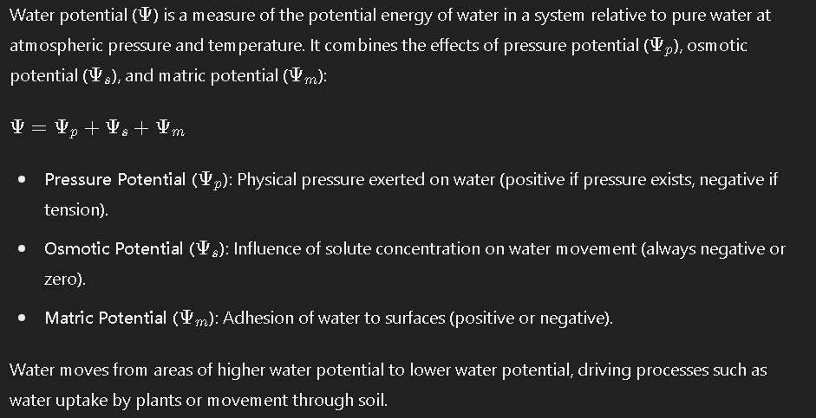

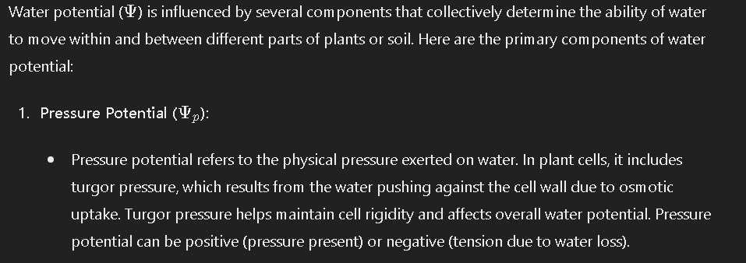

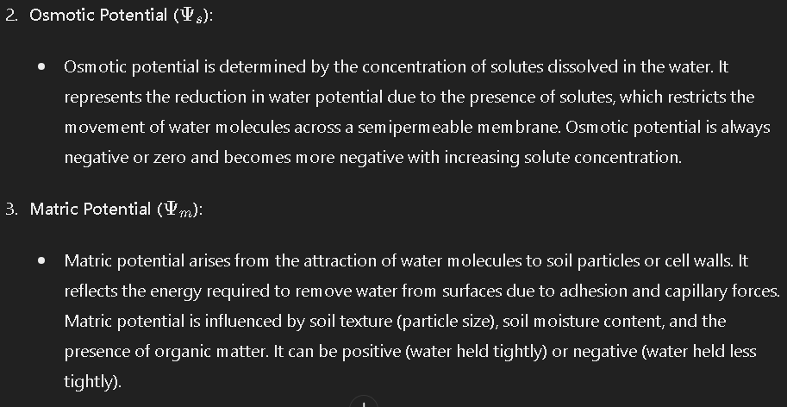

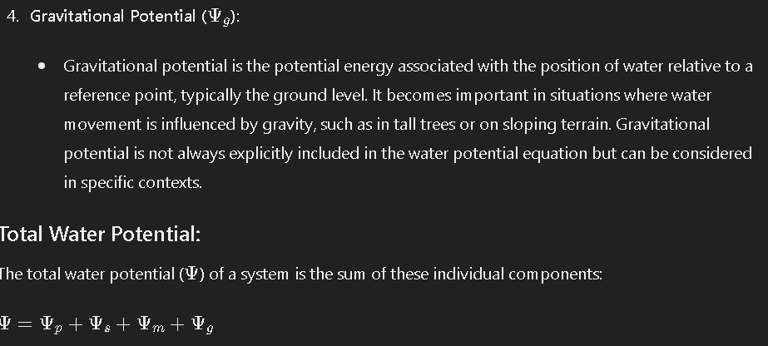

In summary, water potential encompasses pressure potential, osmotic potential, and matric potential, which together govern water movement within plants and between plants and their environment. Understanding these components is crucial for studying processes such as plant water uptake, soil water availability, and overall water dynamics in ecosystems