Wondrous Journey App: Software Requirement Specification

By: DEV320 Group 1
Nam Le • Giecel Tumbaga • Vitoria Resende • Breshna Naim

Github: https://github.com/DEV320-Group-1/WondrousJourney

GP8 Version SRS Update Summary
This revision changes member’s roles and WBS tasks owner to correctly reflect project contribution, added more unit test result. Update to Class Diagram, System Integration Status, and modified Future Development. The team charter is separated into another document per submission requirement

Our Purpose
Have you ever wondered about the amazing historical structures around the world? How they were built? Its purpose? Well Wondrous Journeys provides many different locations around the world where you can explore and learn about these amazing sites. Just choose a location that you wish to learn or visit provided with some educational information, plan your trip, and enjoy the experience of these historical places!
Wondrous Journeys purpose is to aim for those who love history and always dreamed of seeing the real thing in person. With this application people can not only learn about the wonders of the world but also plan a trip to see the site!

Project Proposal
System Summary
The Woundrous Journey Web App is an educational and trip-planning platform that allows users to explore famous world wonders from around the globe. Using public API data, the system provides concise summaries, historical details such as build year, and geographic location information for each wonder. In addition to learning about these landmarks, users can plan future trips by viewing external travel resources and saving selected locations to a personal list. The system is designed to support curiosity, learning, and travel inspiration in a simple and accessible web experience.

Functional Narrative
The Wondrous Journey web application allows users to explore famous world wonders through an educational and travel-inspiration experience. When a user opens the application, they are presented with a list of world wonders retrieved from a public World Wonders API. Users can browse or search through the available wonders and select an item to view more detailed information, including a brief description, historical background, and geographic location.
The application supports user interaction by allowing users to save selected wonders to a personal favorites list using local storage. This enables users to revisit locations they are interested in without creating an account. The system also provides links to external travel resources so users can learn more about visiting each location. The overall process focuses on simple exploration, learning, and lightweight trip planning, offering an accessible and intuitive experience across devices.

System Scope
The full system envisions a comprehensive global exploration platform where users can browse, search, and compare world wonders and other culturally significant landmarks. The system would support advanced filtering, interactive maps, personalized travel itineraries, user accounts, and saved preferences across devices. Additional features could include multilingual support, expanded educational content, media galleries, reviews, and deeper integration with travel services for booking, scheduling, and recommendations. The system is intended to scale as a long-term educational and travel companion for users worldwide.

Project Scope
We are building a responsive web app that connects to the World Wonders public API to fetch and display data. Users will browse and search wonders, view basic details, and save selected items using local storage. The app will be accessible on any internet-connected device, follow basic ADA guidelines, and use simple responsive layouts. Advanced features like accounts or full trip planning will not be included in this iteration.

Wireframe
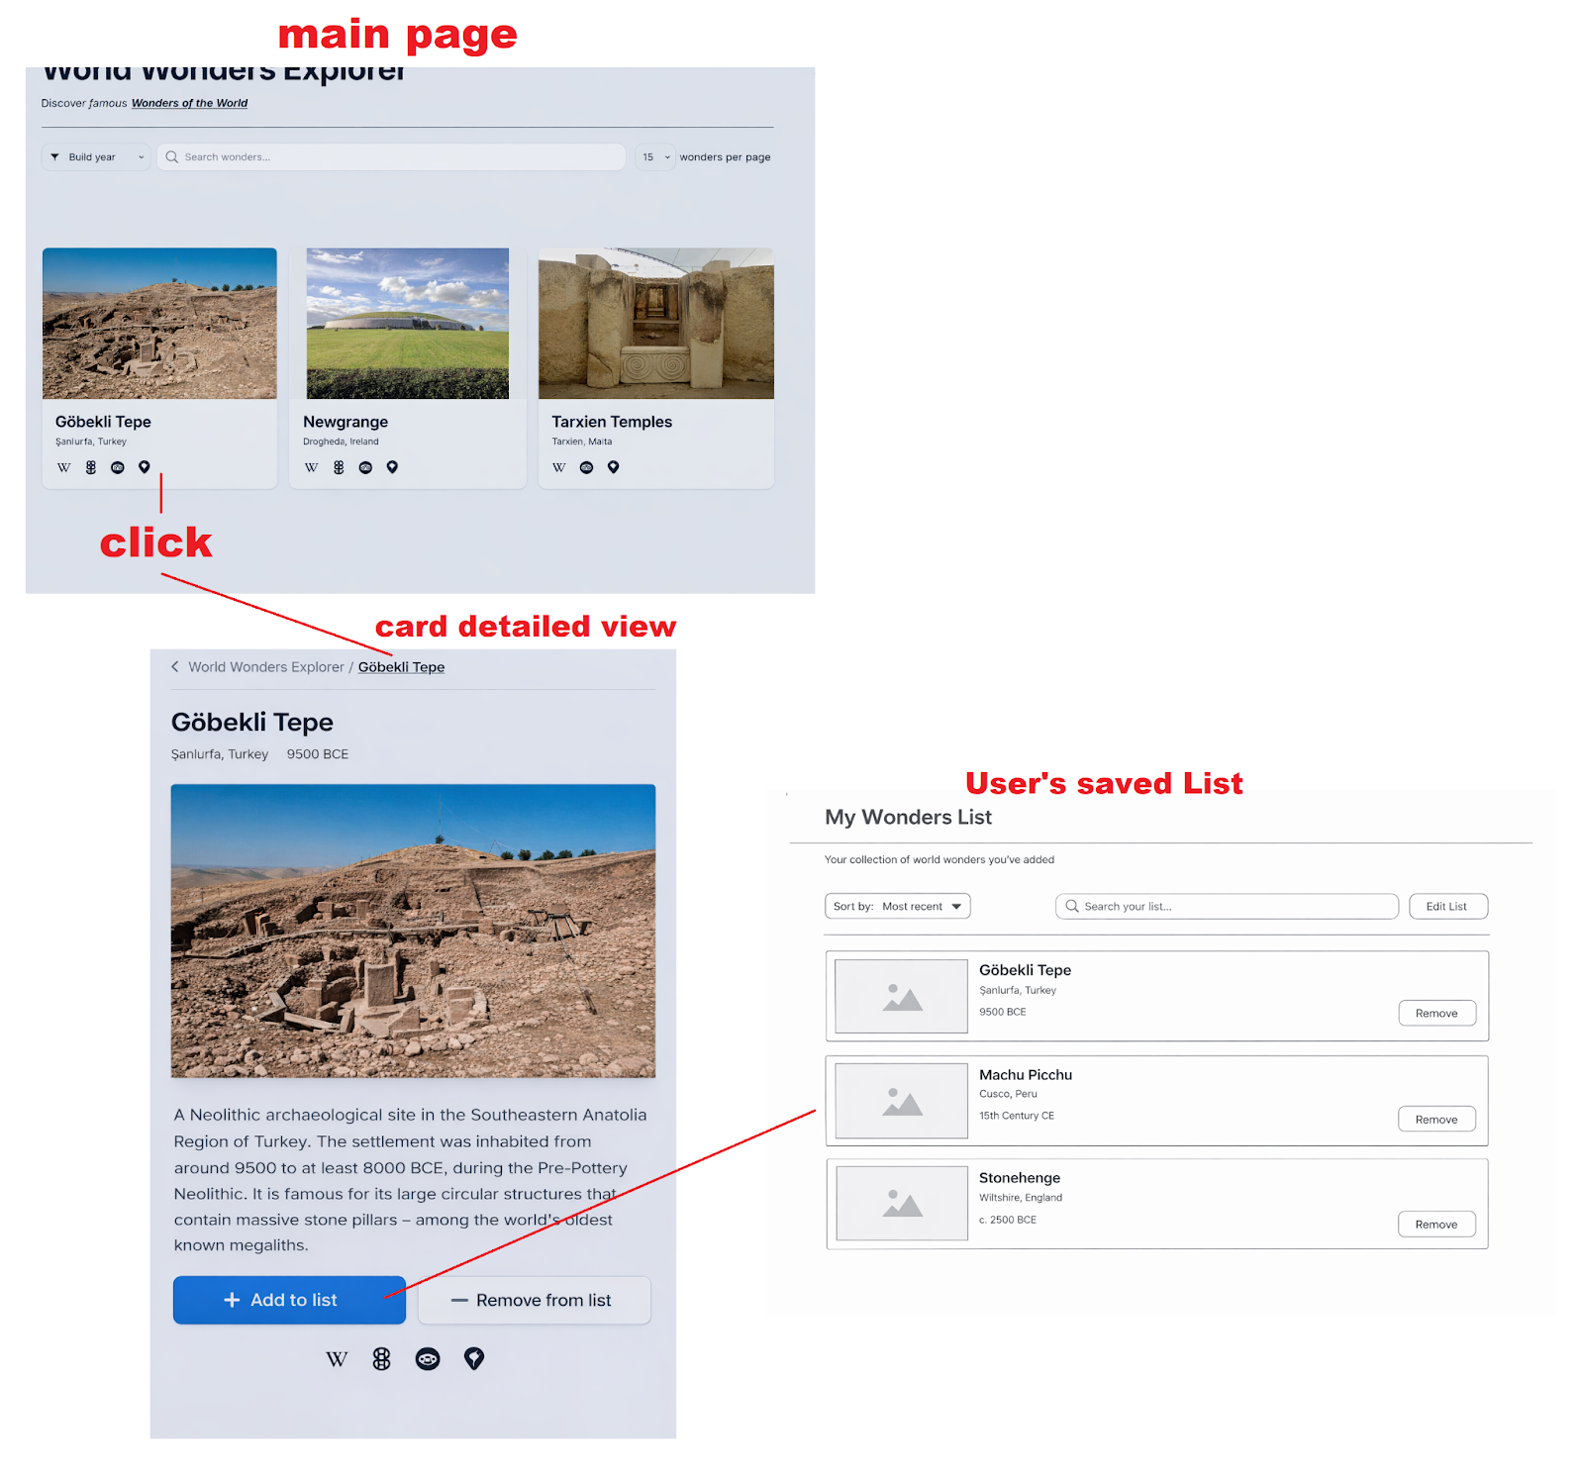

Use Case Scenario
A group of friends who are beginner hikers use the World Wonders Web App to look for destinations that offer scenic hiking experiences without advanced difficulty. They open the app and browse world wonders, reading summaries and location details to understand each destination. The group reviews available information and external travel resources to see what other visitors recommend and whether the location is suitable for beginners. After comparing options, they save a few selected places to a personal list to revisit later while planning their trip.

Assumptions
- The application will be accessed through a modern web browser on desktop or mobile devices.
- Users have an active internet connection to retrieve data from the World Wonders public API.
- The API will remain publicly available and return valid data in the expected format.
- User data such as saved favorites will be stored locally in the browser using local storage.
- No user authentication or account management is required for this version of the app.
- The application will follow basic ADA accessibility guidelines such as readable text, contrast, and keyboard navigation.
- The system is designed for educational and planning purposes only and does not handle bookings or payments.

User Stories
- As a user, I want to browse a list of world wonders so that I can discover interesting historical locations.
- As a user, I want to search for a specific wonder so that I can quickly find information about it.
- As a user, I want to view details about a selected wonder so that I can learn its history and location.
- As a user, I want to save my favorite wonders so that I can revisit them later.
- As a user, I want to view my saved favorites so that I can plan future trips.
- As a user, I want to access external travel resources so that I can learn more about visiting a location.

List of Steps
- User opens the Wondrous Journey web application.
- System requests world wonder data from the public API.
- System displays a list of world wonders.
- User browses or searches the list.
- User selects a world wonder.
- System displays detailed information for the selected wonder.
- User chooses to save the wonder to favorites.
- System stores the wonder in local storage.
- User navigates to the favorites page.
System displays the list of saved wonders.

Acceptance Tests
- Given the user opens the app, when the API responds successfully, then a list of world wonders is displayed.
- Given the user selects a world wonder, when the detail page loads, then the system displays the correct description and location.
- Given the user clicks the save button, when the action completes, then the wonder is stored in local storage.
- Given the user navigates to favorites, when saved items exist, then the favorites list is displayed.
- Given the user refreshes the page, when local storage is available, then saved favorites persist.

Use Case Diagram
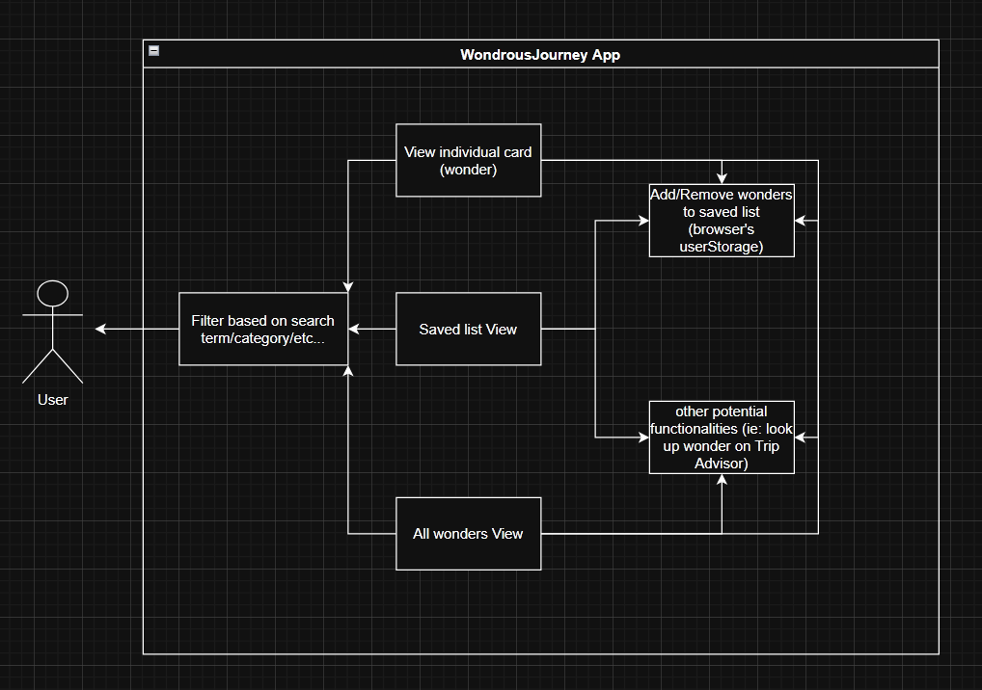

Activity Diagram
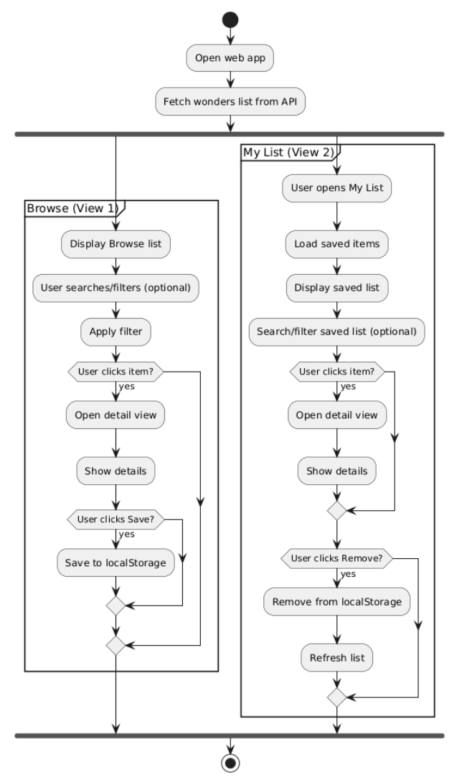

Non-Functional Requirements
The Wondrous Journey web application is designed to be simple, accessible, and reliable for users across different devices, the system must be responsive and function properly on both desktop and mobile browsers. Basic ADA accessibility guidelines will be followed, including readable text, sufficient color contrast, and support for keyboard navigation.
The application should load world wonder data within a reasonable amount of time when the public API is available. If the API is unavailable or returns an error, the system should display a clear and user-friendly message instead of failing silently. User-selected favorites must be stored using browser localStorage so saved wonders persist after page refreshes. The system does not require user accounts, authentication, or password storage. The application is intended for educational and planning purposes only and does not process payments or bookings.

Sequence Diagram
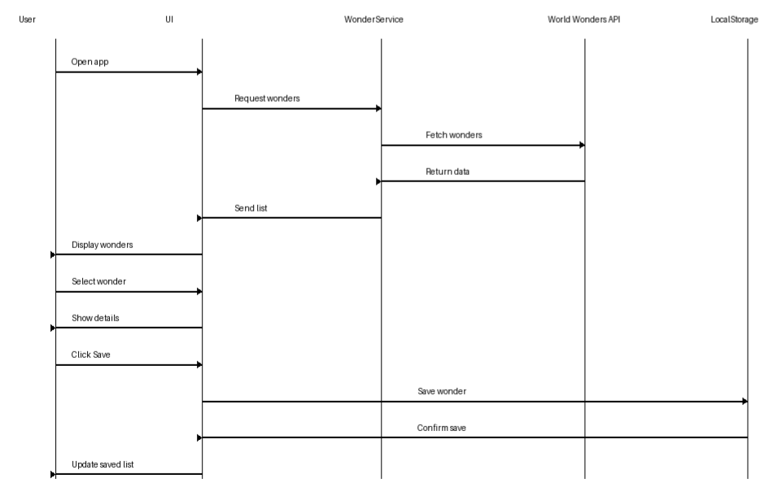

CRC
Class | Responsibilities | Collaborators
Wonder | Store wonder data (id, name, location, year, image). Provide data for display. | WonderService, WonderList
WonderService | Fetch wonders (API/local JSON). Filter and sort wonders. Return search results. | Wonder, SearchBar
WonderList | Add wonder to list. Remove wonder from list. Save to localStorage. | Wonder, MyListPage
MyListPage | Display saved wonders. Show remove button. Handle empty state. | WonderList, Wonder
SearchBar | Capture user input. Send search term to parent/service. | WonderService

TOR

Task | Object Responsible | Responsibilities
Add Wonder to List | WonderList | Check for duplicates. Add wonder. Update localStorage. Refresh UI.
Remove Wonder from List | WonderList | Remove by id. Update localStorage. Refresh UI.
Search Wonders | WonderService | Receive search term. Filter wonders. Return results.
Display User List Page | MyListPage | Retrieve saved wonders. Render wonder cards. Show remove buttons.

Entity Relationship Diagram (ERD)

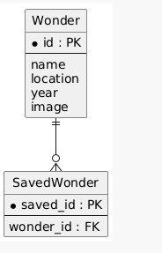

Class Diagram

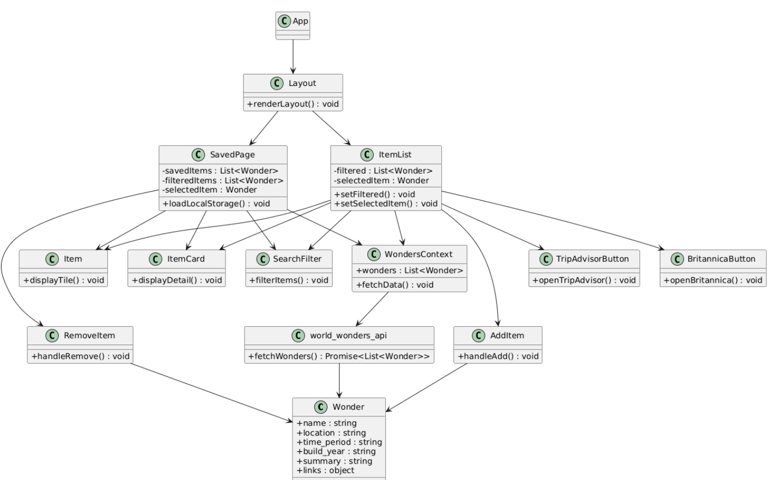

Test Plan and API Documentation
Test Cases
The following test cases validate core application functionality. User Acceptance Tests are derived from user stories, while Unit Tests validate internal system logic.

User Acceptance Tests
Test ID | User Story | Steps | Expected Result
UAT-1 | Browse world wonders | Open application | List of world wonders is displayed
UAT-2 | Search for a wonder | Enter text in search bar | Filtered wonders appear
UAT-3 | Save wonder to favorites | Click 'Add to list' | Wonder saved in localStorage
UAT-4 | View saved favorites | Open favorites page | Saved wonders are displayed

Unit Tests
Test ID | Component | Test Description | Expected Result
UT-1 | WonderService | Fetch API data | Returns list of wonders
UT-2 | WonderService | Search filter logic | Correct filtered results returned
UT-3 | WonderList | Add wonder to favorites | Item saved in localStorage
UT-4 | WonderList | Remove wonder from favorites | Item removed from localStorage

API Endpoints and Data Models
The application retrieves world wonder data from a public API. The following describes the endpoints and expected payload structure.
Endpoint | Method | Description
/wonders | GET | Retrieve list of world wonders
/wonders/{id} | GET | Retrieve detailed information for a specific wonder

Example Data Payload (from actual world-wonders-api):
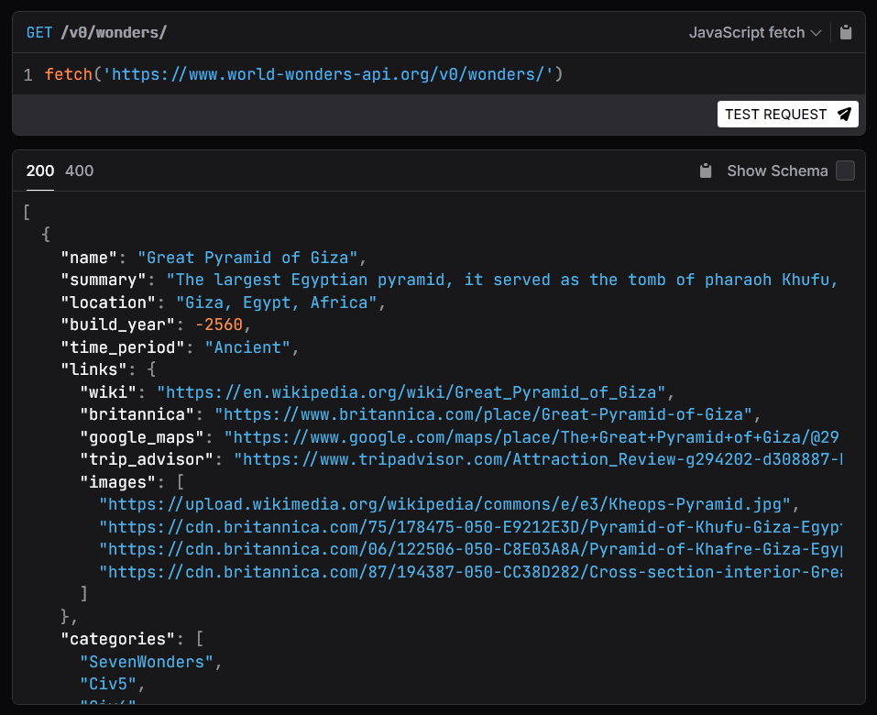
Preliminary Work Breakdown Structure (WBS)
Set up API connection and data fetching layer + data context provider
Owner: Nam Le
Design application layout and user interface
Owner: Nam Le, Breshna, Giecel
Build item list view + search and filter component
Owner: Breshna
Implement detailed item view screen + localStorage JSON download component
Owner: Nam Le
Implement local storage for saving favorites/ Favorite page
Owner: Giecel
Create button component linking to Britannica and Trip advisor
Owner: Nam Le
Testing and debugging API data flow
Owner: Vitoria
Final integration and polish + styling
Owner: Entire team

System Integration Status
At this stage, the core components of the application are integrated and functioning together. The standard layout is connected to the main item list view, and data retrieval from the API is successfully managed through the context provider for shared state access across components. The detailed item card view is implemented and allows users to view individual wonder information. External resource buttons linking to TripAdvisor and Britannica are also integrated within item displays. Basic localStorage functionality for saving selected wonders has been added, along with a feature to export saved lists as a JSON file. Initial unit testing using React Testing Library and Vitest confirms that key components render correctly and respond to basic user interactions. Further enhancements such as JSON import functionality and additional UI refinements are planned.

Test Results
Unit testing was conducted using React Testing Library and Vitest to simulate basic user interaction and validate component rendering behavior. Test case was implemented for:
- ItemList, Item, ItemCard, TripAdvisorButton, BritannicaButton
Result:
System functionality was verified through unit and basic integration testing during development. Core components rendered correctly, and interactive elements such as navigation, external links, and saved item handling behaved as expected.
Acceptance testing confirmed that users can browse wonders, view detailed information, access external resources, and manage saved items. These features meet the primary user requirements defined in the use cases.

Future Development / Next Phase
The next phase of development will focus on implementing a JSON-based import system that allows users to upload a saved wonders list file and restore their previously selected locations. This feature will support continuity across devices and browser sessions beyond the current localStorage approach. Additional improvements will include enhancing user interaction for managing saved items and refining the overall user interface. Further testing and usability adjustments will be conducted as these enhancements are integrated into the system.

