

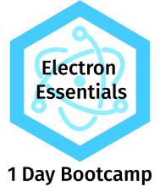

Build cross platform desktop apps with JavaScript, HTML, and CSS

Welcome to Electron Essentials by DEV6!

This document is provided to you for recording notes during training sessions with the course instructor. Additionally, it also contains a lab guide. At the end of the course you will know the basics of Electron and how to develop applications using it.

This course covers the following topics:

1. Introduction & Installation
2. Understanding Electron Application Architecture
3. Electron Features
4. Electron API’s
5. Electron Userland
6. Native Addons