An
INTERNSHIP REPORT
On
EMBEDDED SYSTEMS + EDGE AI
Submitted in partial fulfillment of the requirements for the award of the degree of

BACHELOR OF TECHNOLOGY
in

ELECTRICAL AND ELECTRONICS ENGINEERING
By

G DEVA MUNI SAI

(Roll No. 24AK5A0215)

under the Mentorship of
Dr.S.SIVAPRASAD
Associate Professor, EEE Department


DEPARTMENT OF ELECTRICAL AND ELECTRONICS ENGINEERING

ANNAMACHARYA INSTITUTE OF TECHNOLOGY AND SCIENCES,TIRUPATI (AUTONOMOUS)
Approved by AICTE, New Delhi & Permanent Affiliation to JNTUA,Anantapuramu. Five B.Tech Programmes ( ECE, CSE, EEE, CE, ME)are accredited by NBA,NewDelhi. Accredited by NAAC with 'A' Grade,Bangalore.Accredited by Institution of Engineers(India)KOLKATA.
A-grade awarded by AP Knowledge Mission. Recognized under sections2(f)&12(B) of UGC Act 1956. Venkatapuram(V),Renigunta(M),Tirupati,Tirupati District,Andhra Pradesh–517520.
2026-2027
ANNAMACHARYA INSTITUTE OF TECHNOLOGY AND SCIENCES,TIRUPATI (AUTONOMOUS)

DEPARTMENT OF ELECTRICAL AND ELECTRONICS ENGINEERING

CERTIFICATE

This is to certify that G DEVA MUNI SAI (24AK5A0215) has carried out Virtual Internship on “EMBEDDED SYSTEMS + EDGE AI” and submitted to the Department of Electrical and Electronics Engineering of Annamacharya Institute of Technology and sciences, Tirupati, in partial fulfilment of the requirements for the award of the Degree of Bachelor of Technology in Electrical and Electronics Engineering is meeting the Academic Regulations.

Signature of the Internship Mentor Signature of the HOD
DECLARATION

I am, G DEVA MUNI SAI (24AK5A0215), Studying final year B.Tech in Electrical and Electronics Engineering at Annamacharya Institute of Technology and Sciences, here by I declare that this Internship titled “EMBEDDED SYSTEMS + EDGE AI” has been done by me. The Internship work carried out is original and has not been submitted to any other University or Institution for the award of any credits. I promise to meet all the mandatory requirements as specified by the Academic regulations

Date: Signature of the Student

ACKNOWLEDGEMENTS

It is my insightful duty and pleasure to express my gratitude to all those who helped me in competition of this work successfully.
I would like to express my deepest appreciation to Andhra Pradesh State Council of Higher Education (APSCHE) for their commitment to the betterment of technical education and the opportunities they have made available to our students.
I would like to express my deepest appreciation to All India Council for Technical Education (AICTE) for their commitment to the betterment of technical education and the opportunities they have made available to our students.
I look forward to the continued collaboration between SKILLDZIRE with AICTE and APSCHE to provide more student Internships to gain hands-on experience and become better- prepared professionals.
I would like to extend my heartfelt thanks to Principal Dr. C. NadhamuniReddy for his constant encouragement and support during the Internship period.
I would like to express my heartfelt thanks to Dr. K. BALAJI NANDA KUMAR REDDY, Associate Professor & HOD, Department of EEE, during the progress of Internship for her timely suggestions and help in spite of her busy schedule.
My heartfelt thanks to my Internship Mentor Dr.S.SIVAPRASAD, Associate Professor, Department of EEE, for his valuable guidance and suggestions in analysis and testing throughout the period, till the end of Internship work completion.
Finally, I would like to express my sincere thanks to faculty members of EEE Department, Lab Technicians, Internship company trainers and friends, one and all that has helped me to complete the Internship successfully.

G DEVA MUNI SAI
(Roll Number: 24AK5A0215)


ABSTRACT

This internship report presents the learning, design approach, and technical study carried out in the field of Embedded Systems and Edge Artificial Intelligence (Edge AI), with particular focus on the integration of embedded hardware, sensors, microcontrollers, and AI-based data processing. The project addresses the need for intelligent, fast, and reliable systems capable of processing data locally without depending entirely on cloud-based services.
The study covers embedded system architecture, microcontroller programming, sensor interfacing, communication protocols, data acquisition, real-time processing, and Edge AI model deployment. The system is designed to collect data through sensors, process the data using an embedded platform, and use AI techniques to identify patterns, make decisions, or generate appropriate outputs. Edge AI technology is considered to reduce latency, improve privacy, and enable real-time decision-making.
The internship also provided exposure to Arduino/ESP32-based systems, embedded C/C++ programming, GPIO and peripheral interfacing, IoT concepts, machine learning fundamentals, model optimization, and deployment of lightweight AI models on edge devices. Practical learning included circuit development, sensor integration, debugging, testing, hardware-software integration, and performance analysis of embedded applications.
The report combines the internship learning with the study of Embedded Systems and Edge AI, demonstrating how AI capabilities can be integrated with resource-constrained embedded devices to develop intelligent and efficient real-time applications.
The work demonstrates how proper hardware selection, efficient programming, sensor integration, AI model optimization, and real-time processing contribute to the development of reliable and intelligent embedded systems for modern applications.

LIST OF CONTENTS
CHAPTER | CONTENT | PAGE NO
1 | Internship training Overview | 4
2 | Overview of embedded systems | 5
3 | Hardware Architecture &Microcontroller | 6
4 | Real time operating system | 7
5 | Key Components | 8-9
6 | Comparission Between Embedded And Edge Ai | 10
7 | Selection and Sizing of Edge AI Systems | 11
8 | Design Deployment of Edge AI | 12
9 | Preparation of Bill of Quantities | 13-14
10 | Testing ,optimization and maintenance plan | 15-16
11 | Emerging Trends in Edge AI&TinyML Technology | 17
12 | Conclusion | 18
13 | Verifiable credentials | 19

LIST OF FIGURES

FIG NO | TITLE | PAGE NO
1 | Embedded Microcontroller Hardware Architecture | 5
2 | Hardware Interfacing Of Sensors And Actuators | 9
3 | Edge Ai Model Optimization And Development Pipeline | 9
4 | Real Time Data Flow And Edge Neutral Network Inference Process | 14

CHAPTER-1

INTERNSHIP TRAINING OVERVIEW

The Embedded Systems and Edge AI internship provided a structured introduction to the development of intelligent embedded systems, covering embedded programming fundamentals, hardware interfacing, sensor integration, real-time processing, and the application of Artificial Intelligence at the edge. The training focused on both theoretical concepts and practical implementation using embedded platforms and Edge AI techniques.
The internship covered the complete development cycle of embedded and Edge AI applications, including microcontroller programming, peripheral interfacing, data acquisition, communication protocols, machine learning model development, model optimization, and deployment on resource-constrained edge devices. The training was undertaken under

1.1 Major Learning Areas
• Introduction to embedded systems and their applications.
• Fundamentals of microcontrollers, processors, and embedded hardware.
• Embedded C/C++ programming and firmware development.
• GPIO, ADC, PWM, timers, interrupts, and peripheral interfacing.
• Interfacing of sensors, actuators, displays, and communication modules.
• Serial communication protocols such as UART, SPI, and I²C.
• Introduction to real-time operating systems (RTOS) and task management.
• Fundamentals of Artificial Intelligence and Machine Learning for edge applications.
• Introduction to Edge AI and TinyML concepts.
• Data collection, preprocessing, and feature extraction for embedded AI applications.
Period | Training Focus | Major Outcomes
Month 1 | Introduction to embedded systems, microcontrollers, embedded C/C++, GPIO, sensors, actuators, and communication protocols. | Understanding of embedded system architecture, microcontroller peripherals, hardware interfacing, and basic firmware development.
Month 2 | Introduction to AI/ML for edge devices, data preprocessing, lightweight model development, TinyML/Edge AI concepts, and model deployment. | Ability to develop and deploy optimized AI models on resource-constrained embedded devices and perform real-time inference.

CHAPTER-2

OVERVIEW OF EMBEDDED SYSTEM

Embedded systems are specialized computing systems designed to perform specific functions within electronic devices and applications. They combine hardware and software to monitor, control, and process data in real time. Embedded systems are widely used in industries such as automotive, healthcare, manufacturing, consumer electronics, robotics, communication systems, and automation.
An embedded system generally consists of a microcontroller or processor, memory, input and output interfaces, sensors, actuators, and communication modules. The system software, commonly known as firmware, controls the hardware and enables the system to perform its intended functions. Embedded systems are designed with considerations such as real-time operation, low power consumption, reliability, memory limitations, and efficient resource utilization.
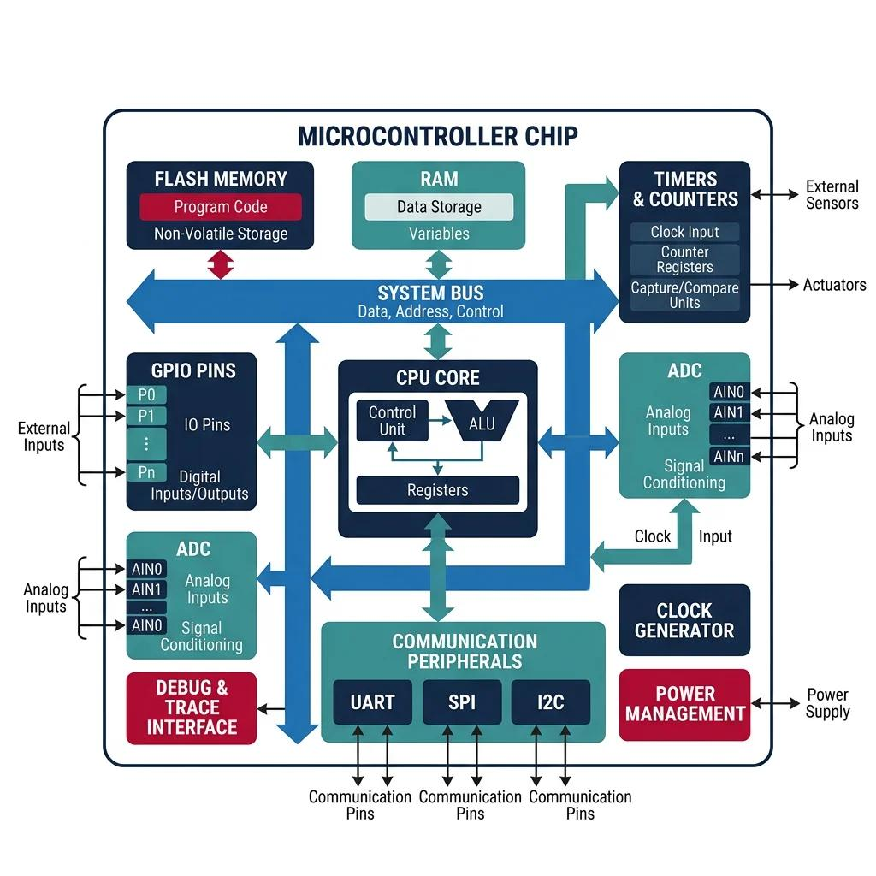
With the advancement of Artificial Intelligence, embedded systems are increasingly being integrated with AI capabilities. Edge AI refers to the execution of Artificial Intelligence and Machine Learning algorithms directly on edge devices rather than sending all data to a remote cloud server..

Fig.1 Embedded Microcontroller Hardware Architecture

CHAPTER-3

HARDWARE ARCHITECTURE & MICROCONTROLLER

3.1 Introduction
Embedded systems are designed by integrating hardware and software components to perform specific tasks efficiently and reliably. The hardware architecture of an embedded system generally consists of a microcontroller or processor, memory, input and output interfaces, sensors, actuators, communication modules, and power supply units.The microcontroller acts as the central processing unit of an embedded system. It receives data from sensors or other input devices, processes the information according to the programmed instructions, and generates appropriate outputs. Microcontrollers are widely used because of their low power consumption, compact size, real-time processing capability, and cost-effectiveness.
In Edge AI applications, embedded hardware is combined with Artificial Intelligence and Machine Learning capabilities to process data locally. Instead of transferring all collected data to a remote cloud server, the edge device can perform AI inference directly on the device. This enables faster response, reduced network dependency, lower latency, and improved data privacy.

3.2 Hardware Components and Architecture
• Microcontroller/Processor: Acts as the main processing unit and controls the operation of the embedded system.
• Memory: Stores program instructions, sensor data, AI models, and intermediate processing results.
• Sensors: Collect real-world information such as temperature, humidity, motion, light, sound, or images.
• Actuators: Perform physical actions based on the decisions generated by the embedded system.

3.3 Future Scope
The combination of embedded systems and Edge AI is expected to support the development of increasingly intelligent and autonomous devices. Improvements in microcontroller performance, memory capacity, specialized AI accelerators, and low-power technologies will enable more complex AI models to run directly on edge devices.

CHAPTER-4

REAL TIME OPERATING SYSTEM

4.1 Introduction
Embedded systems are dedicated computing systems designed to perform specific functions within electronic devices and applications. They consist of hardware and software components such as microcontrollers, processors, memory, sensors, actuators, and communication interfaces. Embedded systems are widely used in consumer electronics, automobiles, healthcare, industrial automation, robotics, and smart devices.

4.2 Working Principle
• Data Collection: Sensors or input devices collect data such as temperature, images, sound, motion, or other physical parameters.
• Data Processing: The embedded processor or microcontroller receives and preprocesses the collected data.
• AI Model Execution: A trained and optimized Machine Learning model runs directly on the edge device to analyze the input data.
• Decision Making: The Edge AI model produces an output or prediction based on the processed data.
• Action/Output: The embedded system responds to the AI decision by controlling an actuator, displaying information, generating an alert, or performing another predefined operation..

4.3 Benefits
• Real-time processing and faster decision-making.
• Reduced latency compared with cloud-dependent processing.
• Reduced network bandwidth requirements.
• Improved privacy because data can be processed locally.
• Reliable operation even with limited or intermittent internet connectivity.
• Lower computational and communication requirements for suitable applications.
• Efficient operation on low-power embedded devices.

CHAPTER-5

KEY COMPONENTS
An embedded system consists of hardware and software components designed to perform specific tasks efficiently and reliably. In Edge AI applications, these components work together to collect data, process information locally, execute AI models, and generate real-time outputs. Each component must be selected according to processing requirements, memory capacity, power consumption, communication needs, and application requirements.

5.1 Microcontroller / Processing Unit
The microcontroller or processor acts as the main processing unit of an embedded system. It executes the firmware, processes sensor data, controls peripherals, and performs required computations. Common platforms include ESP32, STM32, Arduino, Raspberry Pi, and NVIDIA Jetson, depending on the complexity of the application.

5.2 Sensors and Input Devices
Sensors collect information from the surrounding environment and provide input to the embedded system. Temperature, humidity, motion, light, sound, proximity, and camera sensors can be used depending on the application. The collected data can be processed locally and supplied to an Edge AI model for analysis.

5.3 Memory and Storage
Memory is required to store firmware, sensor data, configuration parameters, and AI models. Embedded systems commonly use RAM, Flash memory, EEPROM, SD cards, or other storage technologies. Adequate memory is important for running AI models and handling real-time data processing.

5.4 Edge AI / Machine Learning Model
The Edge AI model is responsible for analyzing input data and generating predictions or classifications directly on the embedded device. Models used for edge applications are generally optimized to reduce memory usage and computational requirements. Techniques such as quantization, pruning, and model compression can be used to make AI models suitable for resource-constrained devices.

5.5 Communication Interfaces
Communication interfaces allow the embedded system to exchange data with sensors, peripherals, other devices, or networks. Common interfaces include UART, SPI, I²C, GPIO, Wi-Fi, and Bluetooth. The selection of a communication interface depends on data rate, distance, power consumption, and application requirements.

5.6 Actuators and Output Devices
Actuators and output devices perform physical or visual actions based on the decisions made by the embedded system or Edge AI model. Examples include motors, relays, LEDs, buzzers, displays, and robotic mechanisms. These components allow the system to interact with the physical environment and respond to real-time inputs.

5.7 Power Supply and Power Management
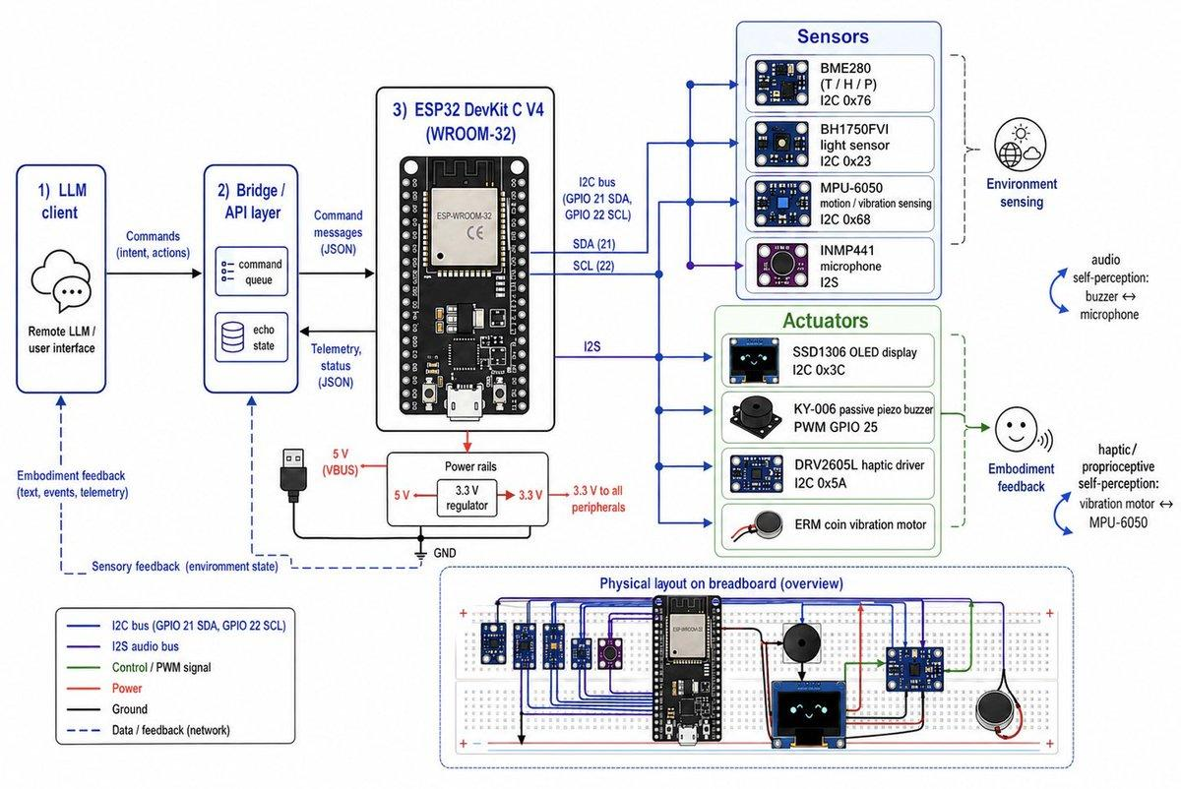
Power management is an important aspect of embedded and Edge AI systems, particularly for battery-operated devices. The power supply provides the required voltage and current to the processor, sensors, communication modules, and other peripherals. Efficient power-management techniques help reduce energy consumption and increase the operating time of portable embedded devices.

Fig.2 Hardware Interfacing Of Sensors And Actuators
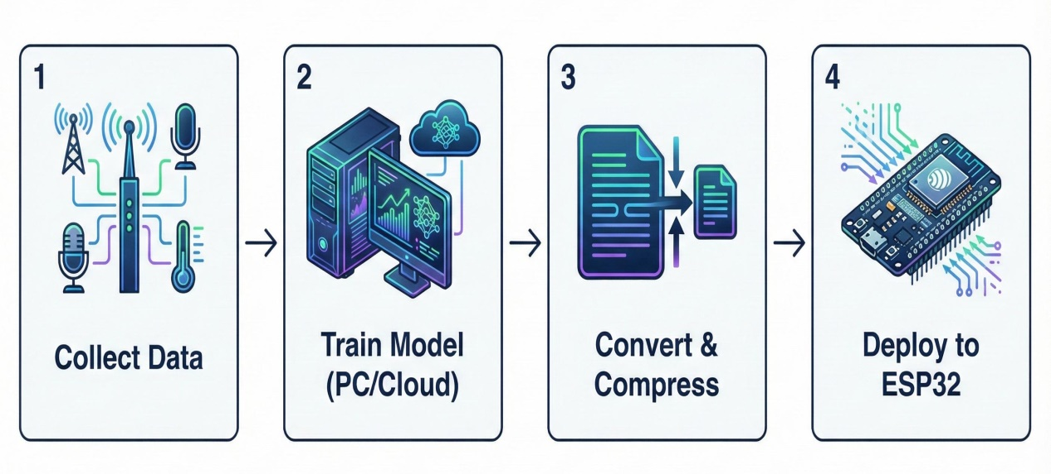

Fig.3 Edge Ai Model Optimization And Development Pipeline

CHAPTER-6

COMPARISON: EMBEDDED SYSTEM VS EDGE AI
Embedded systems and Edge AI are closely related technologies. Embedded systems are designed to perform dedicated tasks on hardware devices, while Edge AI adds artificial intelligence capabilities by processing data locally on the device instead of relying on the cloud. The choice depends on application requirements, processing power, latency, power consumption, and connectivity.
Feature | EMBEDDED SYSTEMS | EDGE AI SYSTEM
Definition | Dedicated hardware/software for a specific task. | Embedded system with AI/ML processing at the edge.
Data Processing | Processes predefined logic. | Processes AI models and real-time data locally.
Internet Dependency | May or may not require internet. | Works without continuous cloud connection.
Latency | Low. | Very low for AI decisions.
Power Consumption | Generally low. | Slightly higher due to AI computation.
Applications | Home appliances, automotive, medical devices. | Smart cameras, drones, autonomous vehicles, IoT.
Cost | Lower hardware cost. | Higher due to AI accelerators/processors.
Definition | Dedicated hardware/software for a specific task. | Embedded system with AI/ML processing at the edge.
Data Processing | Processes predefined logic. | Processes AI models and real-time data locally.
Internet Dependency | May or may not require internet. | Works without continuous cloud connection.

6.1 Advantages and Disadvantages
Embedded Systems
- Advantages: Low power consumption, reliable operation, cost-effective, and fast for dedicated tasks.
- Disadvantages: Limited processing power, memory, and flexibility for complex AI applications.
Edge AI
- Advantages: Real-time processing, low latency, improved privacy, and reduced cloud dependency.

6.2 Selection Considerations
• Choose Embedded Systems for simple, dedicated control applications with low power and cost requirements.
• Choose Edge AI for intelligent applications requiring real-time decision-making, image recognition, speech processing, and predictive analytics on the device itself.

CHAPTER-7

SELECTION & SIZING OF EDGE AI SYSTEMS
Proper sizing of processors, memory, sensors, AI accelerators, and power supply is essential for reliable Embedded System and Edge AI applications. The sizing process depends on application workload, AI model size, memory requirements, power consumption, and real-time performance.

7.1 Processor Selection
Choose a microcontroller or processor based on application complexity, processing speed, and AI computation requirements.

7.2 Memory Sizing
Memory (RAM and Flash) should be sufficient to store the program, AI model, and real-time data during execution.

7.3 AI Accelerator Sizing
Select an AI accelerator (NPU/GPU/TPU) according to the AI model size, inference speed, and power efficiency needed.

7.4 Sensor and Communication Module Sizing
Choose sensors and communication modules based on the required data accuracy, sampling rate, and connectivity (Wi-Fi, Bluetooth, Zigbee, or LoRa).

7.5 Power Supply Sizing
The power supply and battery capacity should meet the total power consumption of the embedded device and Edge AI components while ensuring continuous operation.

CHAPTER-8

DESIGN DEVELOPMENT OF EDGE AI
An Embedded System with Edge AI is designed to collect sensor data, process it locally using AI models, and make real-time decisions without depending on the cloud. The design includes hardware selection, AI model deployment, communication, power management, and monitoring.

8.1 Design Flow
- Identify the application and system requirements.
- Select the microcontroller or processor.
- Choose sensors and communication modules.
- Develop and train the AI model.
- Deploy the AI model on the edge device.
- Connect actuators/output devices.
- Test real-time performance and optimize power usage.
- Monitor and maintain the system.

8.2 Reference Embedded systems & Edge AI configuration
Parameter | Reference Configuration
  Parameter | Reference Configuration
  Parameter | Reference Configuration
  Processor | ARM Cortex-A53 / ESP32 / Raspberry Pi
  Processor | ARM Cortex-A53 / ESP32 / Raspberry Pi
  AI Framework | TensorFlow Lite / Edge Impulse
  AI Framework | TensorFlow Lite / Edge Impulse
  Memory | 512 MB RAM, 4–16 GB Storage
  Memory | 512 MB RAM, 4–16 GB Storage
  Sensors | Camera, Temperature, Motion, Humidity
  Sensors | Camera, Temperature, Motion, Humidity
  Communication | Wi-Fi, Bluetooth, Zigbee, LoRa
  Communication | Wi-Fi, Bluetooth, Zigbee, LoRa
  Power Supply | 5V/12V DC with Battery Backup
  Power Supply | 5V/12V DC with Battery Backup

8.3 System Operation
The sensors collect real-time data, the embedded processor runs the Edge AI model locally, decisions are made instantly, and the output is sent to connected devices while minimizing latency and cloud dependency.

CHAPTER-9

PREPARATION OF BILL OF QUANTITIES (BoQ)
A Bill of Quantities (BoQ) identifies the materials, components, quantities, and associated requirements needed for the installation of the proposed 10 kW off-grid solar PV system.

S.No | Item | Specification | Qty | Unit
1 | Edge AI Processor Board | Raspberry Pi 5 / NVIDIA Jetson Nano | 1 | Nos
2 | Microcontroller | ESP32 / STM32 | 1 | Nos
3 | Camera Module | 5 MP/8 MP AI Camera | 1 | Nos
4 | Sensors | Temperature, Humidity, Motion Sensors | 3 | Nos
5 | AI Accelerator (Optional) | Google Coral USB TPU | 1 | Nos
6 | Memory Card/Storage | 32 GB microSD | 1 | Nos
7 | Wi-Fi/Bluetooth Module | Built-in ESP32 or External Module | 1 | Nos
8 | Power Supply | 5V/12V DC Adapter | 1 | Nos
9 | Battery Backup | 12V Li-ion Battery | 1 | Nos
10 | Connecting Cables | USB, GPIO, Jumper Wires | 1 | Set
11 | PCB/Breadboard | Prototype Board | 1 | Set
12 | Cooling Fan/Heat Sink | For Processor Cooling | 1 | Nos
13 | Enclosure | Protective Case | 1 | Nos
14 | Monitoring Display (Optional) | LCD/OLED Display | 1 | Nos
15 | Installation Accessories | Screws, Connectors, Mounting Kit | 1 | Set

9.1 Key Considerations
- Use a processor with AI support for faster inference.
- Select compatible sensors based on the application.
- Ensure sufficient memory and storage for AI models.
- Provide a stable power supply and battery backup for reliable operation.

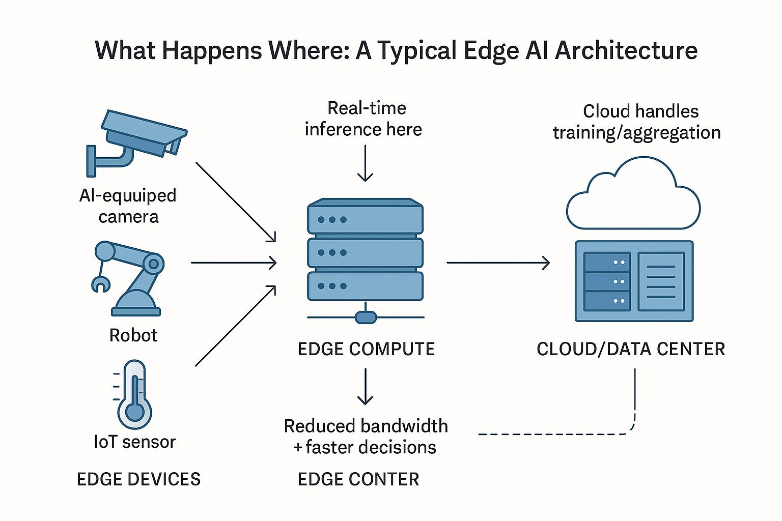

Fig.4 Real Time Data Flow And Edge Neutral Network Inference Process

CHAPTER-10

TESTING OPTIMIZATION & MAINTAINANCE PLAN
Proper installation and preventive maintenance are essential for reliable performance, low power consumption, and long service life of Embedded System and Edge AI devices.

10.1 Installation Steps
- System Assessment and Preparation: Select the application, processor, sensors, and power source.
- Hardware Assembly: Mount the microcontroller/processor, sensors, and communication modules securely.
- Power Supply Connection: Connect the power adapter or battery with correct voltage and polarity.
- Sensor and Device Wiring: Connect sensors and actuators using GPIO, I2C, SPI, or UART interfaces.
- Software Installation: Install the operating system, drivers, and Edge AI framework (TensorFlow Lite/Edge Impulse).
- AI Model Deployment: Upload the trained AI model to the edge device and configure inference settings.
- Testing and Calibration: Verify sensor readings, AI predictions, connectivity, and system response.
- System Monitoring: Enable logging and monitor performance for reliable operation.

10.2 Maintenance Plann
Maintenance Task | Frequency
Check power supply and battery | Monthly
Clean sensors and camera module | Monthly
Update firmware and AI model | Every 3–6 months
Test communication modules | Monthly
Check wiring and connectors | Every 3 months
Monitor system performance and logs | Weekly

10.3 Safety Practices
- Use a stable power supply and proper grounding.
- Protect devices from heat, dust, and moisture.
- Regularly back up software and AI models.
- Replace damaged cables or faulty components immediately.

10.4 Routine Maintenance Schedule
Task | Frequency | Description
Sensor Cleaning | Monthly | Remove dust from sensors and camera for accurate readings.
Battery Health Check | Monthly | Check battery voltage, charge level, and temperature.
Wiring & Connections | Quarterly | Inspect cables and connectors for damage or loose connections.
Software & Firmware Update | Quarterly | Update firmware and Edge AI models for better performance.
Processor Cooling Check | Semi-Annually | Clean heat sink/fan and ensure proper ventilation.
Communication Module Check | Annually | Test Wi-Fi, Bluetooth, Zigbee, or LoRa connectivity.
System Performance Monitoring | Ongoing | Monitor CPU usage, memory, AI inference speed, and power consumption.

10.5 Common Maintenance Issues and Solutions
Issue | Possible Cause | Solution
Sensor not detecting data | Dust or faulty connection | Clean sensor and check wiring.
AI model giving inaccurate results | Outdated or incorrect model | Update and retrain the AI model.
Device overheating | Poor ventilation or high workload | Clean cooling fan and improve airflow.
Wi-Fi/Bluetooth not working | Signal or configuration issue | Restart module and verify settings.
System restarting frequently | Low power supply or battery issue | Check power adapter and battery health.

10.6 Safety Considerations
- Switch off the power before maintenance.
- Use insulated tools and safety equipment.
- Keep devices away from water, dust, and excessive heat.
- Ensure correct wiring and grounding before powering the system.
- Regularly back up software and AI model files.

CHAPTER-11

EMERGING TRENDS IN EDGE AI & TINYML TECHNOLOGY
Embedded Systems and Edge AI are rapidly evolving with advancements in AI processors, IoT connectivity, low-power computing, and real-time intelligent applications. These technologies improve automation, efficiency, security, and decision-making at the edge.

11.1 TinyML and Low-Power AI
TinyML enables AI models to run on low-power microcontrollers, reducing energy consumption and enabling intelligent IoT devices.

11.2 AI-Enabled IoT Devices
Edge AI combined with IoT allows smart devices to process sensor data locally for faster and more reliable responses.

11.3 AI Accelerators in Embedded Systems
Dedicated AI hardware such as NPUs, GPUs, and TPUs improves inference speed while reducing power consumption.

11.4 Real-Time Edge Intelligence
Edge AI performs real-time image recognition, speech processing, anomaly detection, and predictive maintenance without cloud dependency.

11.5 Smart Robotics and Autonomous Systems
Embedded Edge AI is increasingly used in robots, drones, autonomous vehicles, and industrial automation for intelligent decision-making.

11.6 5G and Edge Computing Integration
5G connectivity enables faster communication between edge devices and cloud services while maintaining low latency.

CHAPTER-12

CONCLUSION
The Embedded Systems and Edge AI project demonstrates how intelligent computing can be performed directly on embedded devices for real-time decision-making with low latency and reduced cloud dependency.
The project combines embedded hardware, sensors, communication modules, and Edge AI models to create a smart, efficient, and reliable system for IoT and automation applications. It highlights the importance of processor selection, memory sizing, power management, AI model deployment, and system integration.
Proper installation, testing, and preventive maintenance improve the performance, reliability, and lifespan of Embedded System and Edge AI devices. Emerging technologies such as TinyML, AI accelerators, 5G, and Edge Computing are further expanding the capabilities of intelligent embedded systems.
Overall, this project provides a strong foundation for designing, developing, and implementing Embedded Systems with Edge AI in applications such as smart healthcare, smart agriculture, industrial automation, smart cities, and intelligent surveillance.

CHAPTER-13
VERIFIABLE CREDENTIALS

