Scientific Paper Discovery

Using Rag | arXiv

-Deva H

Project link :

https://huggingface.co/spaces/Devaharibabu/Arxiv_RAG_Scientific_Paper_Discovery

Scientific Paper Discovery using RAG

|  |  |
| --- | --- |
| S.No | Contents |
| 1 | Introduction |
| 2 | Scope of the Project |
| 3 | System Architecture |
| 4 | Modules Explanation |
| 5 | Sample Outputs |
| 6 | Conclusion |
| 7 | Reference |

# 1. Introduction

Welcome to Scientific Paper Discovery (RAG + Evaluation)! 🚀  
  
This tool lets users enter any research topic and fetch relevant, real-time scientific papers from arXiv. It uses a Retrieval-Augmented Generation (RAG) pipeline to answer questions and summarize content from the papers.  
  
Built with:  
- 🔎 ArXiv API for live paper fetching  
- 🧠 RAG using Transformers  
- 📊 Evaluation of summary & retrieval quality  
- 🧑‍💻 Gradio UI for a friendly interface

# 2. Scope of the Project

- Research Topic Exploration: Users enter a topic or keyword to fetch relevant arXiv papers.  
- Real-Time Retrieval: Dynamically pulls the latest papers using the arXiv API.  
- Summarization & Answer Generation: Summarizes insights from retrieved papers.  
- Quality Evaluation: Evaluates summary relevance and accuracy.  
- No-Code Interface: Gradio UI for easy use.  
- Extensible: Can be expanded to other scholarly APIs or domain-specific filters.  
  
This acts as a smart assistant for faster literature review and research discovery.

# 4. System Architecture Diagram

Below is a conceptual diagram of the system architecture used:

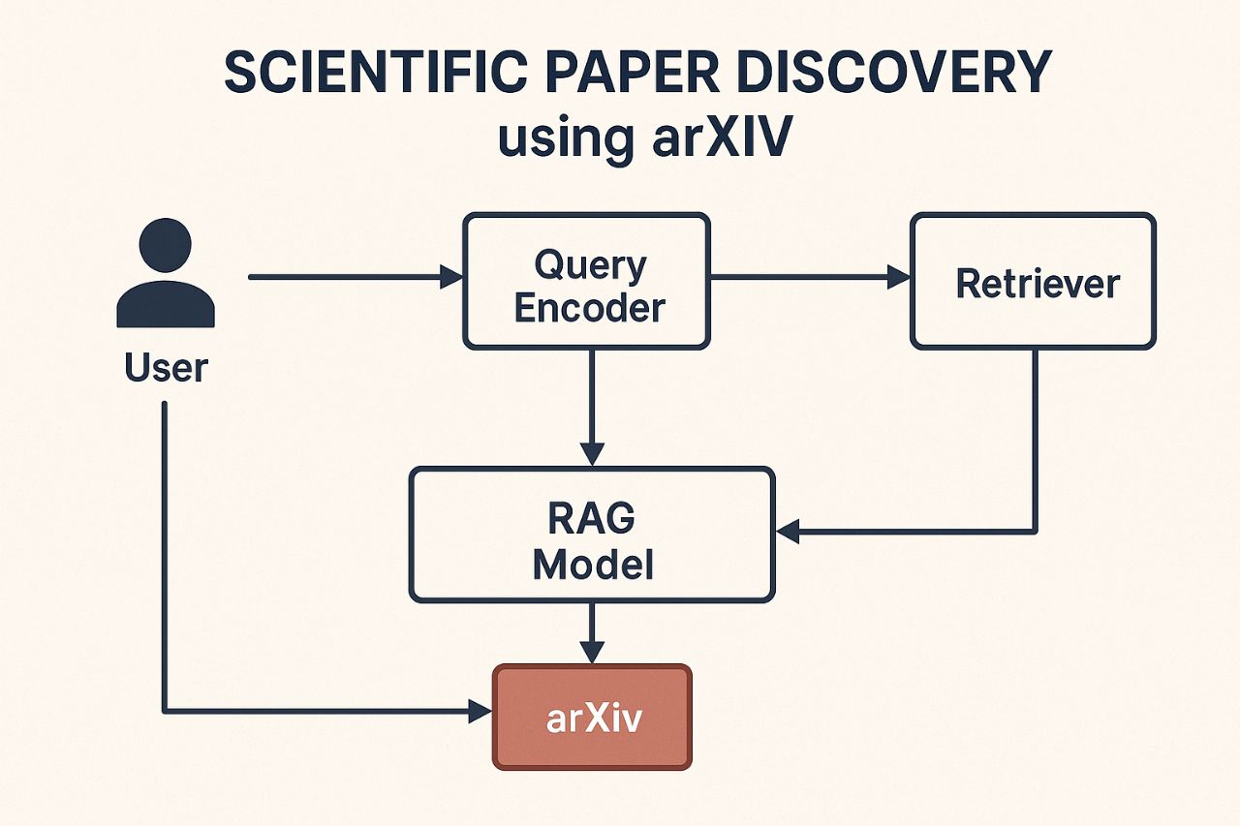

# 5. Modules Explanation

1. User Interface Module (Gradio): Accepts research topic input and displays results.  
2. ArxivLoader: Fetches the most recent papers based on user query.  
3. Embedding & Retrieval Module: Embeds abstracts using sentence-transformers, then finds relevant papers.  
4. RAG Model Pipeline: Performs question answering and summarization from the retrieved data.  
5. Evaluation Module: Uses similarity metrics to assess summary and retrieval quality.

# 6. Sample Outputs

Example: Entering query 'quantum computing' returns latest arXiv papers and generates a summary. It also answers custom questions like 'What are the latest methods in quantum computing?'

6.(a) Sample Output page [i]



6.(a) Sample Output page [ii]



6.(a) Sample Output page [iii]



# 7. Conclusion

This project delivers a powerful and user-friendly platform for discovering, retrieving, and understanding scientific papers from arXiv using Retrieval-Augmented Generation (RAG). With live fetching, summarization, and evaluation — it simplifies the literature review process and empowers researchers with quick, insightful overviews.

# 8. References

- arXiv API: https://arxiv.org/help/api  
- Hugging Face Transformers: https://huggingface.co/transformers  
- Gradio: https://www.gradio.app  
- Sentence-Transformers: https://www.sbert.net/