RailGuard
Railway Safety and Predictive Maintenance System
Project Report
Deep Learning-Based Railway Track Defect Detection and Maintenance Recommendation System

This report consolidates the project proposal, literature survey, system architecture, implementation methodology, and evaluation results for RailGuard — a deep learning system combining YOLOv8 object detection, CNN-based classification, and autoencoder-based anomaly detection for automated railway track inspection.

Table of Contents
1. Introduction & Problem Statement
2. Objectives
3. Literature Survey
4. Proposed System & Scope
5. System Architecture
6. Methodology
7. Technologies Used
8. Implementation Details
9. Evaluation & Results
10. Discussion: Limitations & Honest Assessment
11. Comparison with Real-World Systems
12. Conclusion & Future Work
13. References

1. Introduction & Problem Statement
Railway tracks are conventionally inspected manually or at scheduled intervals using visual walkthroughs, ultrasonic testing, or geometry measurement vehicles. While effective to a degree, these methods are slow, labor-intensive, and prone to inconsistency between inspectors. Undetected defects — cracks, broken rails, corrosion, or loose fasteners — can escalate into serious safety incidents if not caught early.
RailGuard proposes an automated, deep learning-based alternative: a system that analyzes railway track images to detect defects, classify their severity, flag unusual anomalies, and recommend a maintenance action — reducing dependence on manual inspection while improving detection consistency and speed.

Problem Statement
Manual and traditional sensor-based inspection methods face three core limitations:
- Inconsistency — detection quality depends on inspector experience and attentiveness.
- Limited frequency — inspections happen on a schedule, not continuously, leaving gaps where defects can develop unnoticed.
- Cost — specialized equipment (ultrasonic rigs, geometry cars) is expensive and cannot be deployed everywhere.
RailGuard addresses this by using computer vision and deep learning to automate defect detection from ordinary track images, making inspection faster, more consistent, and less dependent on specialized hardware.

2. Objectives
- Automatically detect railway track defects from images.
- Classify detected defects by severity / type (defective vs. non-defective).
- Detect unusual or previously unseen abnormalities using unsupervised learning.
- Recommend an appropriate maintenance action based on combined model outputs.
- Present results through an accessible dashboard for end users.

3. Literature Survey

3.1 Object Detection for Rail Surface Defects
A substantial body of research has applied YOLO-family object detectors to rail defect detection, motivated by the need for real-time, single-pass inference over two-stage detectors like R-CNN, which tend to be too slow for continuous track monitoring.
Yanan et al. proposed a YOLOv3-based method for rail surface defect detection, resizing input images and using dimensional clustering to predict defect bounding boxes; a related improved YOLOv5s variant reported very high average precision on rail surface defects, demonstrating the general viability of YOLO architectures for this task.
A systematic literature review of machine-vision-based railway defect inspection surveyed techniques including a YOLO-plus-image-processing pipeline for detecting missing clamps in rail fastening systems, achieving very high detection accuracy even under difficult imaging conditions such as overexposure and tilt — illustrating that hybrid pipelines can be effective when labeled data is limited, a constraint RailGuard also faces.
A study using an improved YOLOv4 with a MobileNetV3 backbone significantly reduced parameter count and model size while improving detection speed, showing that lightweight backbones (the same category as MobileNetV2, used in RailGuard's CNN) are well suited to resource-constrained defect detection tasks.
An IJERT-published study comparing CNN, R-CNN, Faster R-CNN, and GCN-based approaches against YOLO concluded that while CNNs classify well, they struggle to localize defects precisely, and two-stage detectors are too slow for real-time monitoring — a key reason YOLO was chosen as RailGuard's localization component.
A broader review of ensembled CNN-based railway defect detection compiled reported accuracies: deep CNN classifiers achieving roughly 92–97% accuracy on rail defect classification, and YOLOv3/MobileNet-plus-YOLO detection approaches achieving 87–97% accuracy — a useful benchmark against which RailGuard's own YOLO results (constrained by a much smaller 51-image training set) can be honestly compared.

3.2 CNN-Based Classification for Track Defects
Deep convolutional neural networks have been widely used as image classifiers for distinguishing defective from non-defective rail conditions. Reported accuracies in the reviewed literature commonly fall in the 92–97% range, somewhat higher than RailGuard's CNN result (81.82% test accuracy) — a gap attributable to RailGuard's smaller dataset (~300 images) compared to larger proprietary datasets used in published research.
Transfer learning — reusing a network pretrained on a large general-purpose dataset and fine-tuning only a small classification head — is a well-established technique for achieving reasonable accuracy on small, domain-specific datasets. RailGuard applies this directly, using a frozen MobileNetV2 backbone with a lightweight custom classification head.

3.3 Autoencoder-Based Anomaly Detection
Autoencoder-based anomaly detection is a well-studied unsupervised technique across industrial inspection domains, motivated by a common challenge: defective examples are typically rare compared to normal examples, making supervised classification data imbalanced or insufficient.
Industrial inspection research has explored dual-autoencoder GAN architectures for sample imbalance, skip-connection autoencoders combined with deep feature extraction, and convolutional autoencoders combined with one-class deep feature classification using reconstruction-error anomaly maps.
The common principle — training exclusively on “normal” examples and using reconstruction error as an anomaly signal — is exactly the approach RailGuard applies to healthy track images, with the threshold tuned empirically by comparing detection rate against false-positive rate.

3.4 Deployed Industrial Systems
- L&T's TrackEi — edge-AI hardware (NVIDIA Jetson) with high-resolution cameras and laser profiling for broken rail and misalignment detection at high speed.
- Rail Labs' Arista (India) — combines ultrasonic flaw detection with AI vision, logging defects with GPS tags.
- IBM Research + Bane NOR — Maximo Visual Inspection-based system classifying multiple rail defect types from inspection-cart imagery.
- Union Pacific — Automated Track Geometry Measurement System and Digital Track Inspection using laser/sensor-equipped locomotives and camera portals with a large suite of in-house AI algorithms.
These systems rely on specialized sensor hardware and very large proprietary training datasets — resources unavailable in a student project context. RailGuard's contribution is to demonstrate the same underlying architectural pattern using open datasets and free computational resources, not to match these systems in scale or accuracy.

3.5 Positioning of RailGuard
Compared to the reviewed literature, RailGuard's distinguishing design choice is combining all three paradigms — supervised object detection (YOLOv8), supervised whole-image classification (CNN), and unsupervised anomaly detection (Autoencoder) — into a single pipeline, rather than relying on a single model type as most reviewed studies do individually.

4. Proposed System & Scope
RailGuard combines three deep learning models, each targeting a different aspect of the inspection problem, with outputs merged through a rule-based recommendation layer producing one of three verdicts: Continue Monitoring, Schedule Maintenance, or Immediate Repair.
Model | Task | Technique
YOLOv8n | Defect localization | Object detection (transfer learning from COCO)
CNN (MobileNetV2) | Defective / Non-defective classification | Transfer learning, binary classification
Autoencoder | Anomaly detection | Unsupervised reconstruction-based learning

Scope
This project is developed as a proof-of-concept using publicly available datasets (Kaggle's Railway Track Fault Detection dataset and a Roboflow rail-defect object detection dataset), given the constraints of a student project. The system demonstrates the architectural approach and pipeline design used in commercial railway inspection systems, at a scale appropriate for academic evaluation.

5. System Architecture
The diagram below shows the end-to-end flow: an uploaded track image passes through preprocessing, then through all three models in parallel/sequence, before combined logic produces a final maintenance recommendation displayed on the dashboard.
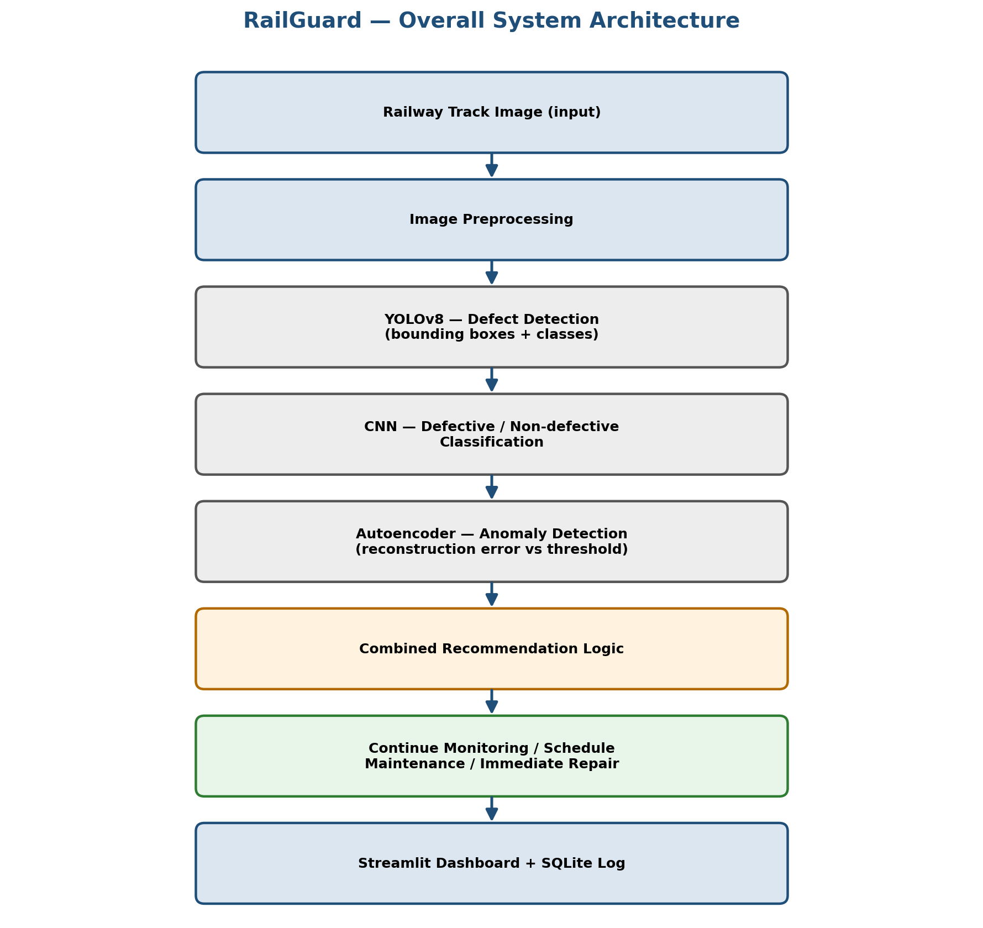
Figure 1: Overall RailGuard system architecture

5.1 CNN Architecture
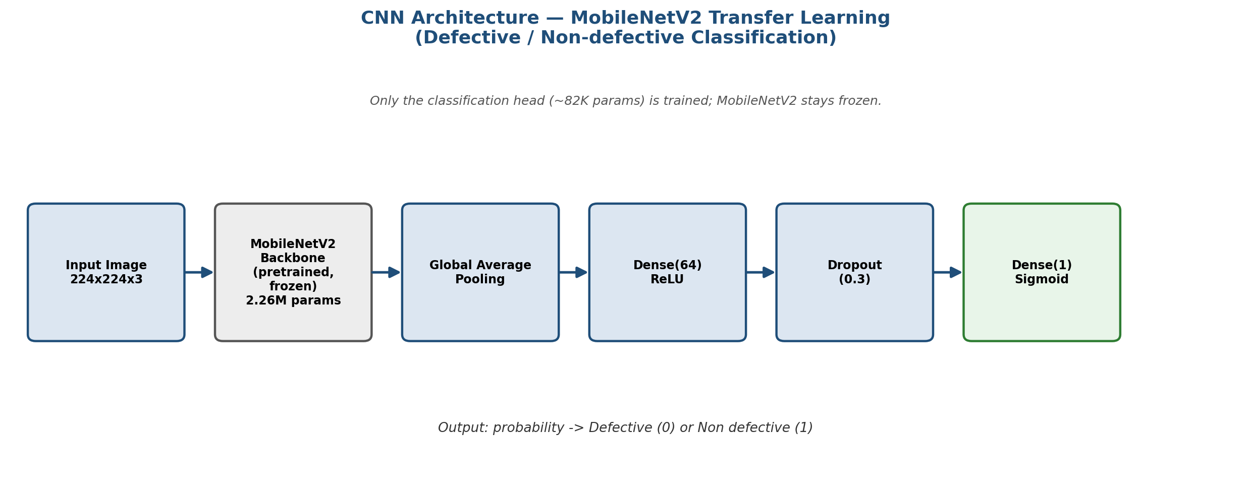
Figure 2: CNN (MobileNetV2 transfer learning) architecture

5.2 YOLOv8 Architecture
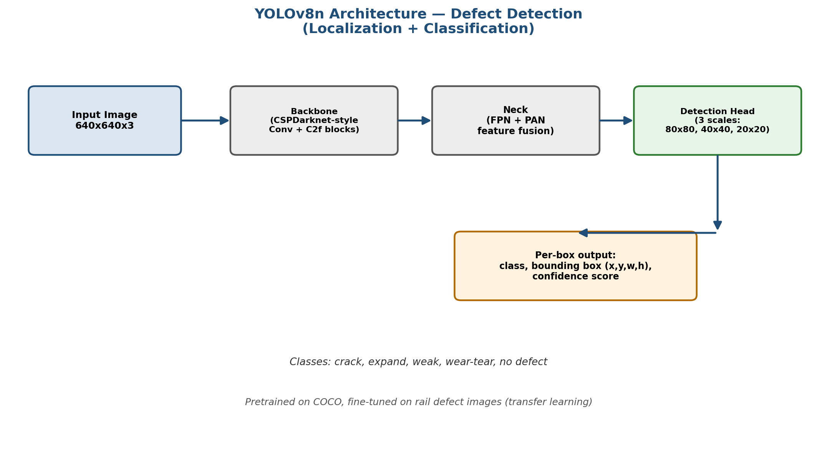
Figure 3: YOLOv8n architecture for defect detection

5.3 Autoencoder Architecture
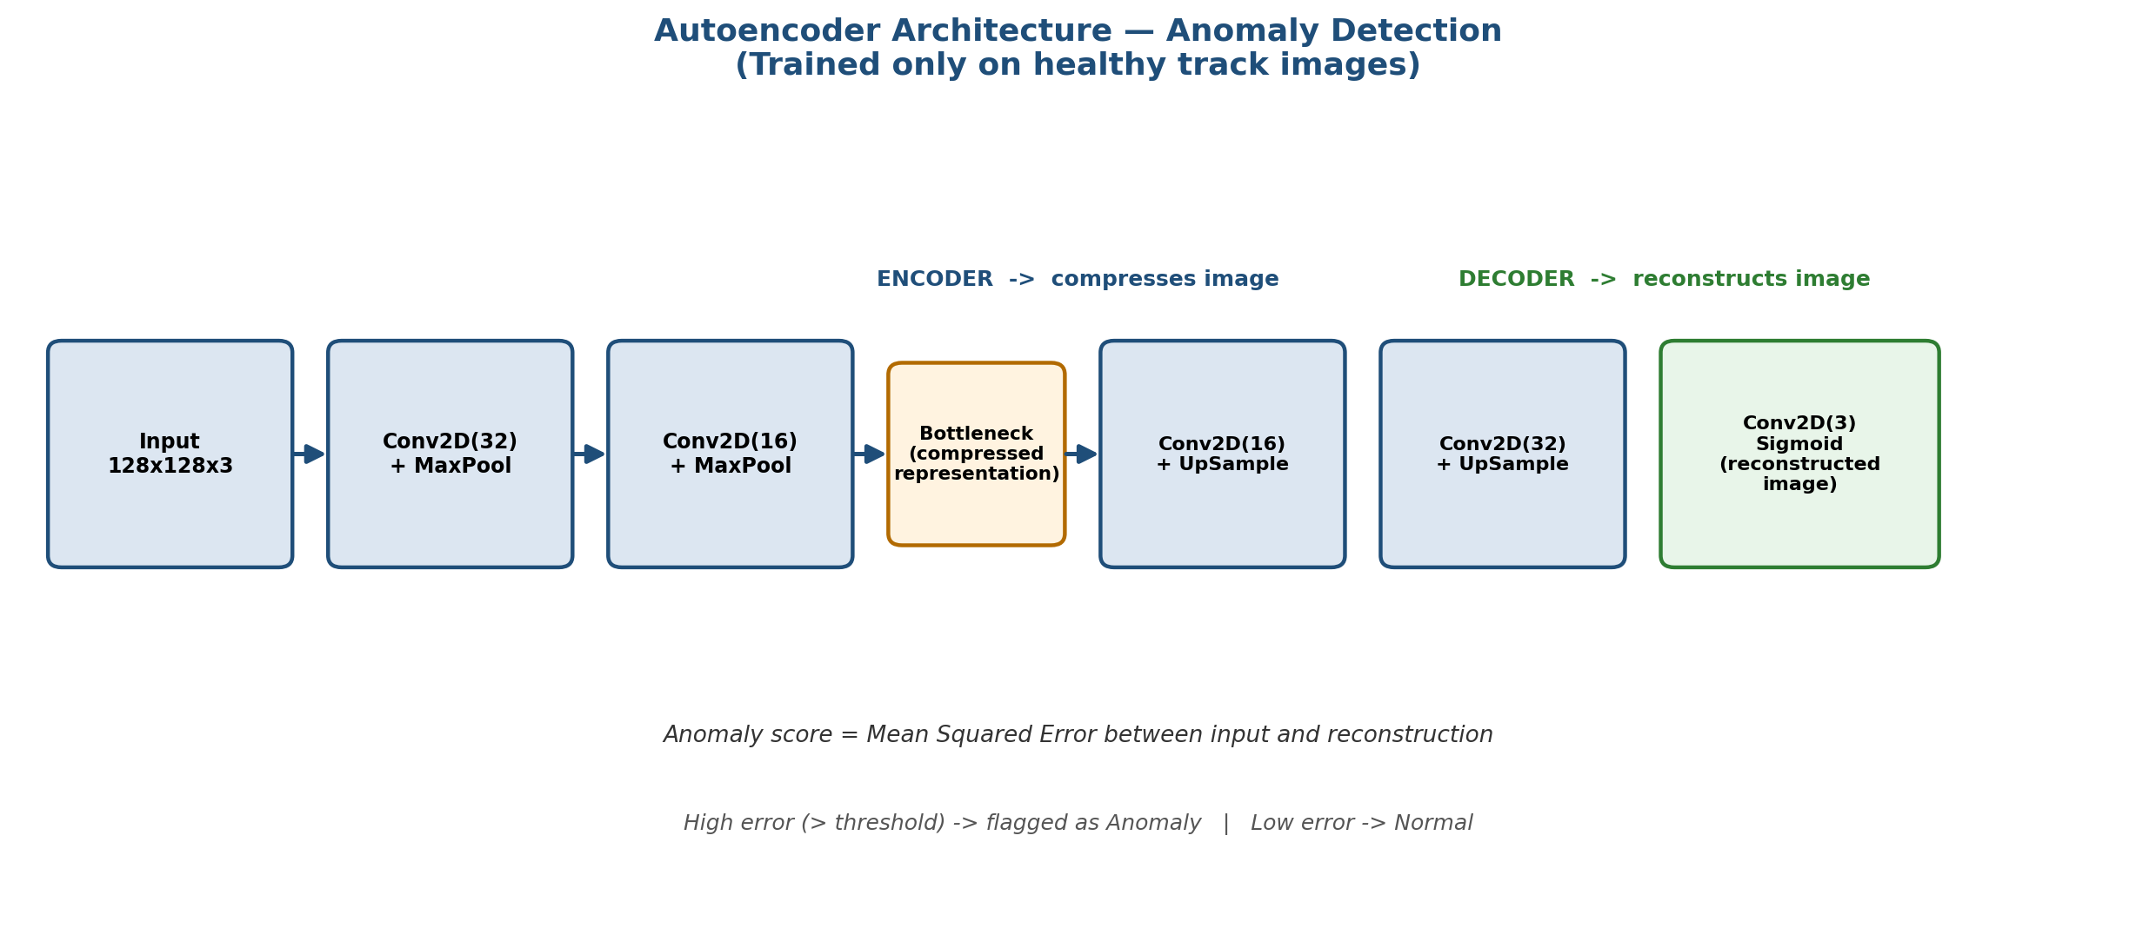
Figure 4: Autoencoder architecture for anomaly detection

6. Methodology

6.1 Data Acquisition
Two datasets were used, since no single public dataset covered both classification and bounding-box-annotated detection needs:
- Kaggle “Railway Track Fault Detection” dataset — Defective / Non defective labeled images, pre-split into Train (150/150), Validation (31/31), and Test (11/11) sets. Used for the CNN and Autoencoder.
- Roboflow “rail-track-defect” dataset (v1) — 51 images with bounding-box annotations across 5 classes (crack, expand, weak, wear-tear, no defect), split into Train (36), Validation (10), and Test (5). Used for YOLOv8.

6.2 CNN Training
A MobileNetV2 backbone pretrained on ImageNet was used with its weights frozen. A custom classification head (GlobalAveragePooling → Dense(64, ReLU) → Dropout(0.3) → Dense(1, Sigmoid)) was added and trained on the labeled dataset. An initial training run overfit (95.6% train accuracy vs. 71% validation accuracy by the final epoch); this was corrected by introducing EarlyStopping (patience=5, monitoring validation accuracy), ModelCheckpoint (saving only the best-performing weights), and stronger data augmentation (rotation, zoom, shift, flip, brightness variation).

6.3 Autoencoder Training
A convolutional autoencoder (Conv2D + MaxPooling encoder, Conv2D + UpSampling decoder) was trained exclusively on 150 “Non defective” images, using Mean Squared Error (MSE) reconstruction loss. After training, reconstruction error statistics were computed on healthy validation images, and an anomaly threshold was selected by comparing detection rate against false-positive rate across several standard-deviation multipliers (k = 0.5, 1.0, 1.5, 2.0), settling on k = 1.0 as the best practical balance.

6.4 YOLOv8 Training
A YOLOv8n model, pretrained on the COCO dataset, was fine-tuned on the Roboflow rail-defect dataset for 50 epochs. An initial dataset version was found to contain only 8 total images (an annotation/versioning issue on Roboflow's end) which produced a misleadingly perfect validation score on a single image; this was caught and corrected by switching to dataset version 1, which had a proper 36/10/5 split across 51 images.

6.5 Pipeline Integration
A single analyze_image() function was implemented to run an input image through all three models, aggregate their outputs, and apply combined recommendation logic: if the Autoencoder flags an anomaly or the CNN classifies the image as Defective with high confidence, the system recommends Immediate Repair; a lower-confidence Defective classification triggers Schedule Maintenance; otherwise, Continue Monitoring is recommended.

6.6 Dashboard Development
A Streamlit-based dashboard was built to provide an interactive interface: users upload a track image and receive the original image alongside YOLO's annotated detection, CNN classification with confidence, Autoencoder anomaly status, and the final maintenance recommendation. Each inspection is logged to a local SQLite database and displayed as history in the sidebar.

7. Technologies Used
Component | Technology
Programming Language | Python
Object Detection | YOLOv8 (Ultralytics)
Classification | CNN — MobileNetV2 (TensorFlow/Keras)
Anomaly Detection | Convolutional Autoencoder (TensorFlow/Keras)
Image Processing | OpenCV, Pillow
Dashboard | Streamlit
Database | SQLite
Training Environment | Google Colab (GPU)
Dataset Sources | Kaggle, Roboflow Universe

8. Implementation Details

8.1 CNN Model Summary
Total parameters: 2,340,033 | Trainable parameters: 82,049 (classification head only) | Non-trainable parameters: 2,257,984 (frozen MobileNetV2 backbone).

8.2 Autoencoder Model Summary
Total parameters: 13,347 (all trainable). Lightweight architecture chosen given the small healthy-image training set (150 images).

8.3 YOLOv8 Model Summary
Model: YOLOv8n | 130 layers | 3,011,823 parameters | 8.2 GFLOPs. Trained for 50 epochs at image size 640x640.

8.4 Recommendation Logic
The combined decision logic implemented in the integration pipeline:
- If Autoencoder flags anomaly OR CNN confidence for “Defective” > 0.8 → Immediate Repair
- Else if CNN classifies as “Defective” (lower confidence) → Schedule Maintenance
- Else → Continue Monitoring

9. Evaluation & Results

9.1 CNN Results
Evaluated on 22 held-out test images never seen during training or validation:
Metric | Value
Test Accuracy | 81.82%
Test Loss | 0.3955
Best Validation Accuracy | 80.65%

Validation accuracy (80.65%) and test accuracy (81.82%) are close to each other, indicating the model generalizes consistently rather than performing well on one split by chance.

9.2 Autoencoder Results
Threshold tuning results comparing detection rate against false-positive rate:
k (std multiplier) | Threshold | Healthy False Positives | Defects Caught
0.5 | 0.0156 | 7 / 31 (23%) | 16 / 31 (52%)
1.0 (selected) | 0.0178 | 3 / 31 (10%) | 13 / 31 (42%)
1.5 | 0.0200 | 2 / 31 (6%) | 10 / 31 (32%)
2.0 | 0.0222 | 2 / 31 (6%) | 8 / 31 (26%)

k = 1.0 was selected as the best practical balance: a meaningful 42% anomaly-detection rate at a low 10% false-positive rate on healthy images.

9.3 YOLOv8 Results
Overall: Precision = 0.979, Recall = 0.083, mAP50 = 0.096, mAP50-95 = 0.062
Class | Images | Instances | Precision | Recall | mAP50
crack | 1 | 1 | 1.000 | 0.000 | 0.0065
expand | 3 | 3 | 0.916 | 0.333 | 0.344
weak | 4 | 5 | 1.000 | 0.000 | 0.0222
wear-tear | 4 | 4 | 1.000 | 0.000 | 0.0108

High precision but very low recall means that when the model does draw a bounding box, it is usually correct — but it misses the large majority of actual defects, a direct consequence of the very small number of training images per class.

9.4 Cross-Model Summary
Model | Task | Key Metric | Result
CNN (MobileNetV2) | Binary classification | Test Accuracy | 81.82%
Autoencoder | Anomaly detection | Detection Rate @ 10% FPR | 42%
YOLOv8n | Object detection | mAP50 | 9.6%

10. Discussion: Limitations & Honest Assessment
This section addresses the project's limitations directly rather than obscuring them, consistent with good engineering and academic practice.

10.1 YOLOv8 Recall Limitation
The YOLOv8 detector's low recall (8.3% overall) is primarily attributable to the small training dataset — 36 images spread across 5 classes, often fewer than 10 examples per class. Object detection is a substantially harder learning task than classification, requiring many more labeled examples per class to learn robust localization. This is a data-scale limitation consistent with findings across the reviewed literature, not a flaw in the training methodology. The model is presented as a proof-of-concept demonstrating the detection pipeline rather than a production-ready detector.

10.2 Dataset Scale Compared to Industry/Research Benchmarks
Published research typically reports CNN classification accuracies of 92–97% and YOLO-based detection accuracies of 87–97%, achieved on substantially larger and often proprietary datasets. RailGuard's more modest results (81.82% CNN accuracy, low YOLO recall) reflect the realistic constraints of a student project using free, publicly available datasets rather than a shortcoming in model choice or implementation.

10.3 Autoencoder Threshold Tradeoff
The chosen anomaly threshold (k=1.0) reflects a deliberate precision/recall tradeoff rather than an attempt to maximize any single metric — a design decision consistent with standard practice in anomaly detection, where false positives and false negatives carry different practical costs.

11. Comparison with Real-World Systems
RailGuard is a proof-of-concept demonstrating the same core deep learning techniques (YOLO-based detection, CNN classification, and autoencoder-based anomaly detection) used in commercial systems like L&T's TrackEi or IBM's Maximo Visual Inspection deployment with Bane NOR, but built at student scale with open datasets.
It is not a production-ready replacement for these systems, which rely on specialized sensors (laser profiling, ultrasonic rigs) and millions of training images collected by dedicated inspection hardware. RailGuard's contribution is demonstrating understanding of the underlying multi-model architecture pattern used across the industry — particularly the combination of supervised and unsupervised learning for more robust anomaly coverage, which most single-model commercial systems do not explicitly combine.

12. Conclusion & Future Work
RailGuard successfully demonstrates an end-to-end deep learning pipeline for railway track inspection, combining three complementary model types into a single system with a working dashboard and inspection logging. The CNN and Autoencoder components produced reliable, well-evaluated results, while the YOLOv8 component, though limited by dataset size, demonstrates the full detection pipeline and provides a foundation for future improvement.

Future Enhancements
- Live video monitoring using CCTV or drone footage
- Predictive defect growth modeling using LSTM
- Cloud-based database for centralized monitoring across multiple sites
- Mobile application for railway inspectors in the field
- GPS-based defect location mapping
- Retraining YOLOv8 on a larger, more balanced bounding-box dataset to improve recall
- Expanding CNN classification to multi-class severity levels (Minor/Moderate/Severe) given a suitably labeled dataset

13. References
- Yanan, S., Hui, Z., Li, L., Hang, Z. “Rail Surface Defect Detection Method Based on YOLOv3 Deep Learning Networks.” IEEE Conference Publication, IEEE Xplore.
- “Automated Railway Track Defect Detection System using YOLO Deep Learning Algorithm.” International Journal of Engineering Research & Technology (IJERT), 2025.
- “A Study on Railway Surface Defects Detection Based on Machine Vision.” PMC, National Center for Biotechnology Information.
- “A systematic literature review of defect detection in railways using machine vision-based inspection methods.” ScienceDirect, 2024.
- “A Reusable AI-Enabled Defect Detection System for Railway Using Ensembled CNN.” arXiv:2311.14824.
- Chen, Z., Wang, Q., Yang, K., Yu, T., Yao, J., Liu, Y., Wang, P., He, Q. “Deep Learning for the Detection and Recognition of Rail Defects in Ultrasound B-Scan Images.” Transportation Research Record, 2021.
- “Anomaly Detection Neural Network with Dual Auto-Encoders GAN and Its Industrial Inspection Applications.” PMC, 2020.
- Tang, T-W., Hsu, H., Huang, W-R., Li, K-M. “Industrial Anomaly Detection with Skip Autoencoder and Deep Feature Extractor.” Sensors, 2022. DOI: 10.3390/s22239327.
- “Anomaly Detection for Industrial Inspection using Convolutional Autoencoder and Deep Feature-based One-class Classification.” ResearchGate, 2022.
- Industry sources: L&T TrackEi, Rail Labs Arista, IBM Research / Bane NOR Maximo Visual Inspection deployment, Union Pacific Automated Track Geometry Measurement System — summarized from publicly available company and press reporting.
- Kaggle “Railway Track Fault Detection” dataset: kaggle.com/datasets/salmaneunus/railway-track-fault-detection
- Roboflow Universe “rail-track-defect” dataset: universe.roboflow.com/rail-defect/rail-track-defect

