Supply Chain Operations Analysis Report
Prepared By: Devakivada Bhavana Sandhya & Pandala Pravalika
Project ID: PTID – CDA – 1168

Executive Summary
This project analyzes supplier performance and supply chain operations to identify delivery inefficiencies, defect risks, and operational bottlenecks. Supplier 3 was identified as the highest operational risk due to long lead times and higher defect rates, while Supplier 1 emerged as the best-performing supplier.

Project Objective
The objective of this project is to determine which suppliers should be prioritized to reduce delivery delays without increasing defect rates.

Methodology
- Data Cleaning
- KPI Development
- DAX Measures
- Dashboard Design
- Risk Analysis

Key Performance Indicators
• Profit: ₹519K
• Profit Margin: 89.92%
• Average Shipping Time: 5.75 days
• Average Defect Rate: 2.28%
• Top Performing Supplier: Supplier 1

Operations Analysis
The dashboard of operations revealed that air transportation contributes to the highest lead times, significantly affecting delivery efficiency and supply chain performance.
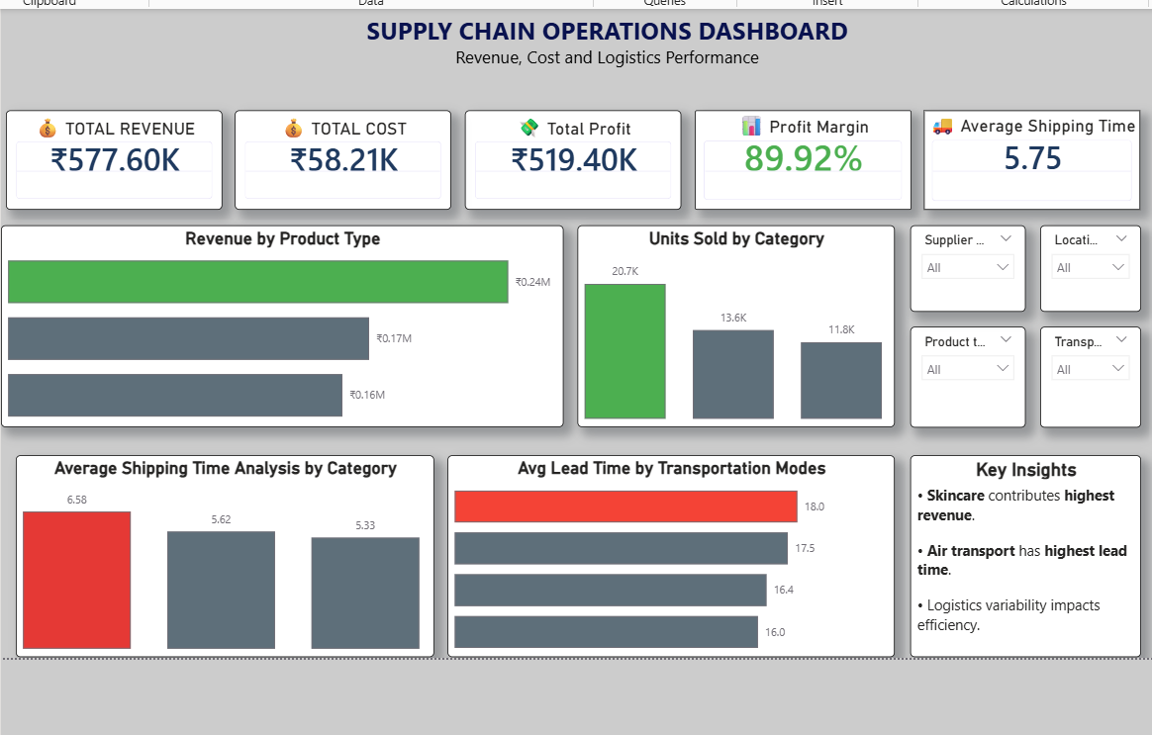
Figure 1: Supply Chain Operations Dashboard

• Air transportation shows the highest lead time.
• Profit margins remain strong.
• Shipping variability impacts operational efficiency.

Supplier Performance Analysis
Supplier 1 demonstrated the fastest delivery performance and the lowest defect rate. Supplier 3 exceeded the average lead time and showed the highest defect rate, placing it in the critical risk category.
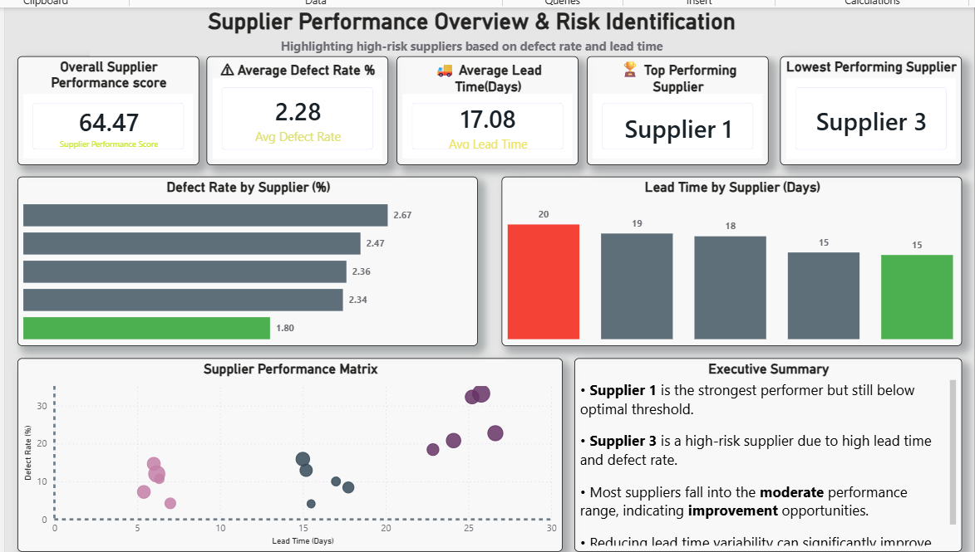
Figure 2: Supplier Performance & Risk Analysis Dashboard

- Supplier 1 delivers ~30% faster with the lowest defect rate, making it ideal for scaling.
- Supplier 3 exceeds the average lead time by ~18% and shows the highest defect rate.
- The majority of suppliers fall in the moderate performance zone

🟢 Bottom Left → Best (Low Time, Low Defects)
🟡 Bottom Right → Fast but Risky Quality
🟡 Top Left → Slow but Reliable
🔴 Top Right → Critical Risk

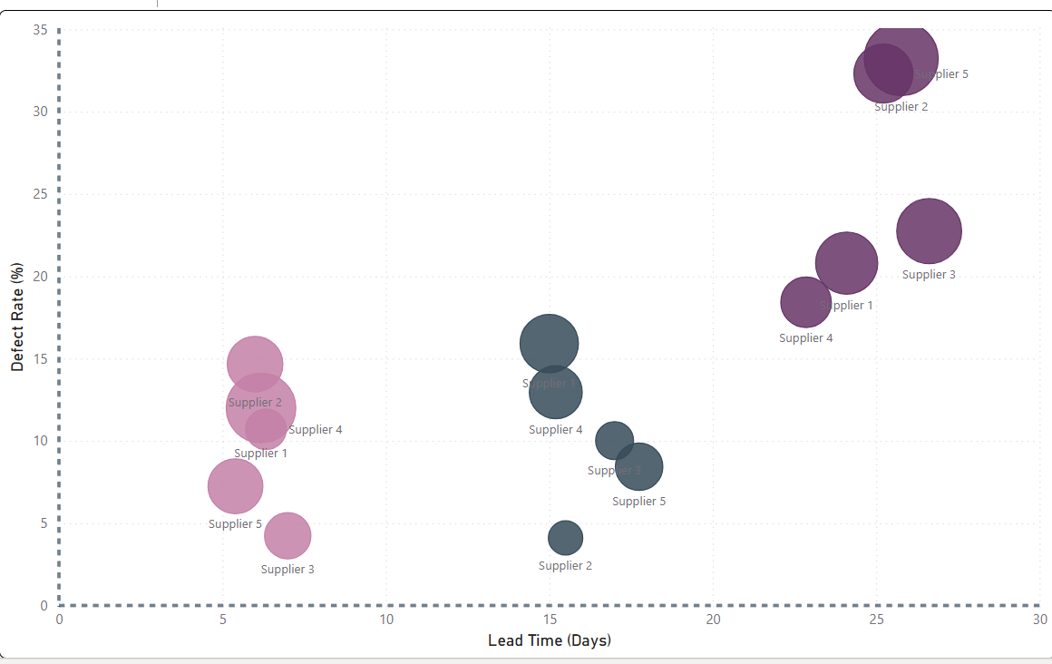
🔴

🟡
🟡

🟢
Figure 3: Supplier Performance & Risk Matrix
Supplier 3 lies in the high-risk quadrant with ~20 days lead time

Recommendations
• Reallocate volume toward high-performing suppliers.
• Reduce dependency on high-risk suppliers.
• Optimize transportation strategies.
• Continuously monitor supplier performance.
• Implement SLA benchmarks for lead time and defect rates.

Business Impact
Optimizing supplier allocation and transportation methods can reduce shipping delays, improve quality consistency, and enhance customer satisfaction.

Roadmap
Phase 1: Identify operational inefficiencies
Phase 2: Optimize suppliers and logistics
Phase 3: Monitor supplier performance continuously

Conclusion
The project demonstrates how Power BI dashboards and business intelligence techniques can support operational decision-making and improve supply chain efficiency.

