MEDICAL DATA HISTORY – SQL PROJECT

REPORT

Author: Devakivada Bhavana Sandhya | Pandala Pravalika Project: Datamine’s SQL Project

Table of Contents

Contents
Table of Contents 2
1. Introduction 4
2. Database Details 4
3. Objectives 4
4. SQL Concepts Used 4
5. Execution Method 5
7. SQL Queries and Explanatio 5
Database Setup and Initial Exploration Queries 5
1.Selecting the Database SQL Query 5
Purpose 5
Explanation 5
Logic 5
Output Meaning 5
2.Checking Available Tables in the Database SQL Query 5
Purpose 6
Explanation 6
Output Meaning 6
Interpretation 6
3.Checking the Structure of the Admissions Table 6
SQL Query 6
Purpose 6
Explanation 6
Output Meaning 6
Column Name Description 6
4. Renaming a Column in the Admissions Table 7
SQL Query 7
Purpose 7
Explanation 7
Logic 7
Note from Execution 7
Error Code: 1142 – ALTER command denied 7
Interpretation 7
Query 1 – Male Patients 8
Query 2 – Patients Without Allergies 8
Query 3 – Names Starting With C 9
Query 4 – Weight Between 100 and 120 9
Query 5 – Replace NULL Allergies 10
Query 6 – Full Name 10
Query 7 – Join Patients with Province 11
Query 8 – Patients Born in 2010 11
Query 9 – Tallest Patient 12
Query 10 – Specific Patient IDs 12
Query 11 – Total Admissions 13
Query 12 – Same Day Admission and Discharge 13
Query 13 – Admissions for Patient 579 14
Query 14 – Unique Cities in Province 14
Query 15 – Height and Weight Condition 15
Query 16 – Unique Birth Years 15
Query 17 – Unique First Names 16
Query 18 – Name Pattern 16
Query 19 – Patients with Dementia 17
Query 20 – Sort by Name Length 17
Query 21 – Count Male and Female 18
Query 22 – Repeated Diagnosis 18
Query 23 – Patients per City 19
Query 24 – Combine Patients and Doctors 19
Query 25 – Most Common Allergies 20
Query 26 – Patients Born in 1970s 20
Query 27 – Name Formatting 21
Query 28 – Province Height Sum 21
Query 29 – Weight Difference 22
Query 30 – Admissions by Day 22
Query 31 – Weight Groups 23
Query 32 – BMI Calculation 23
Query 33 – Epilepsy Patients with Doctor Lisa 24
9. Conclusion 24

Project Overview
This project focuses on analysing healthcare data using Structured Query Language (SQL). The dataset includes information about patients, doctors, hospital admissions, and provinces. The primary goal of this project is to explore the dataset and extract meaningful insights using SQL queries.
Various SQL techniques such as filtering, aggregation, joins, subqueries, and data transformation are applied to understand patient demographics, admission patterns, and medical conditions. The project demonstrates how SQL can be effectively used for healthcare data analysis and decision-making.

Introduction
This project analyzes hospital medical data using SQL queries. The database contains patient, doctor, admission, and province information. The objective is to extract meaningful insights using filtering, grouping, joining, aggregation, and data transformation.A range of SQL methods—including filtering, aggregation, joins, subqueries, and data transformation—are used to analyze patient demographics, admission patterns, and medical conditions.

Database Details
Database Name: project_medical_data_history
Tables Used: patients, doctors, admissions, province_names

Objectives
  - Retrieve patient demographics
  - Analyze admission records
  - Identify repeat diagnoses
  - Calculate BMI and health indicators
  - Perform grouping and aggregation
  - Join multiple tables

SQL Concepts Used
  - SELECT
  - WHERE
  - GROUP BY
  - HAVING
  - JOIN
  - UNION
  - SUBQUERY
  - COUNT

  - SUM
  - MAX
  - MIN
  - CONCAT
  - COALESCE
  - DATE FUNCTIONS
  - CASE STATEMENTS

Execution Method
  - Connected to Datamine’s remote MySQL server
  - Selected the database
  - Verified table structure
  - Executed all required SQL queries
  - Captured result screenshots

- Tools Used Section MySQL Workbench Microsoft Excel Microsoft Word Microsoft PowerPoint

SQL Queries and Explanatio

Database Setup and Initial Exploration Queries
Prior to analysing the medical dataset, a series of initial SQL queries were carried out to choose the database, review the tables present, and examine their structures.

Selecting the Database SQL Query
USE project_medical_data_history;

Purpose
This command selects the project_medical_data_history database so that all subsequent SQL queries will be executed within this database.

Explanation
  - USE is a SQL command used to activate a specific database.
  - project_medical_data_history is the name of the database containing the hospital data.

Logic
Rather than specifying the database name with each table reference, you can select the database once by using the USE command.

Output Meaning
After executing this command, MySQL will run all queries using tables from the
project_medical_data_history database

Checking Available Tables in the Database SQL Query
SHOW TABLES;

Purpose
The purpose of this query is to display all tables present in the selected database.

Explanation
  - SHOW TABLES is a MySQL command used to list all tables stored within the currently selected database.

Output Meaning
The result shows the following tables available in the database:
Tables_in_project_medical_data_history
admissions doctors patients
province_names

Interpretation
Each table stores specific healthcare-related information:
  - patients → Contains patient personal information
  - doctors → Contains doctor details
  - admissions → Contains hospital admission records
  - province_names → Contains province information
These tables are related and can be joined to perform deeper analysis.

Checking the Structure of the Admissions Table

SQL Query
DESC admissions;

Purpose
This query is used to display the structure of the admissions table, including column names, data types, and other attributes.

Explanation
  - DESC stands for DESCRIBE.
  - It shows metadata information about the table.

Output Meaning
The output provides details about columns such as:

Column Name Description
patient_id Unique ID of the patient admission_date Date when the patient was admitted discharge_date Date when the patient was discharged diagnosis Medical condition diagnosed attending_doctor_id ID of the doctor attending the patient Logic
Understanding the table structure helps in writing correct SQL queries for data retrieval and
analysis.

Renaming a Column in the Admissions Table

SQL Query
ALTER TABLE admissions
CHANGE attending_doctor_id doctor_id INT;

Purpose
The purpose of this query is to rename the column attending_doctor_id to doctor_id in the admissions table.

Explanation
Component Meaning
ALTER TABLE Used to modify an existing table admissions Table name
CHANGE Used to rename a column attending_doctor_id Old column name doctor_id New column name
INT Data type of the column

Logic
Renaming the column simplifies the naming convention and makes it easier to perform joins with the doctors table, which also uses doctor_id as the primary identifier.

Note from Execution
During execution, the query returned the following error:

Error Code: 1142 – ALTER command denied
This indicates that the user account connected to the remote database does not have permission to modify the table structure.

Interpretation
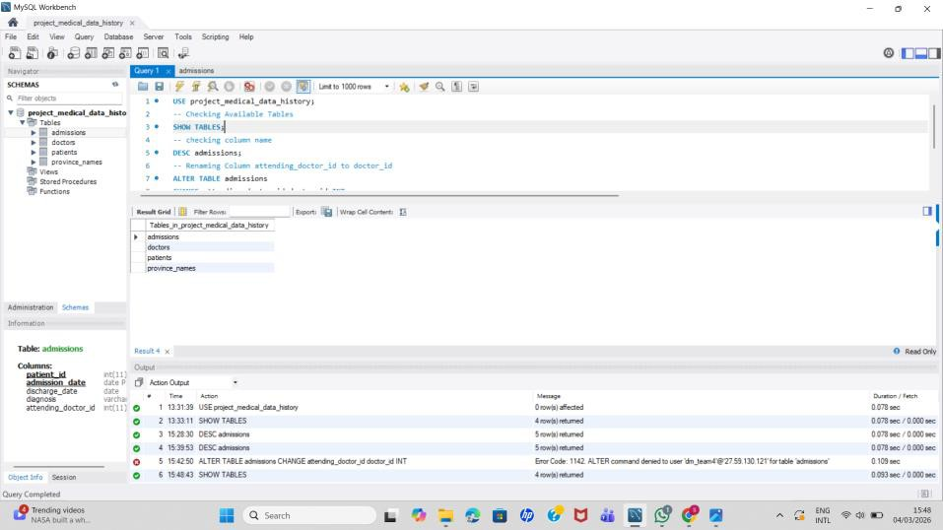
Since the database is hosted on a remote Datamites server, structural changes such as ALTER TABLE are restricted for security reasons.

Figure:1 Database Initialization

Query 1 – Male Patients
SQL Query:
SELECT first_name, last_name, gender FROM patients
WHERE gender = 'M'; Explanation:
Purpose: Retrieve all male patients from the patients table. WHERE clause filters rows where gender equals M.
Output Screenshot:
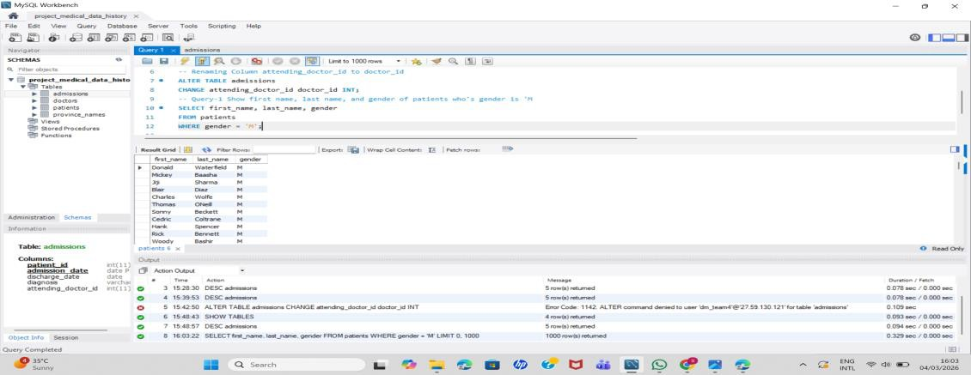

Figure 2: Male Patients Query Result

Query 2 – Patients Without Allergies
SQL Query:
SELECT first_name, last_name FROM patients
WHERE allergies IS NULL; Explanation:
Purpose: Find patients who do not have allergy information recorded. Output Screenshot:
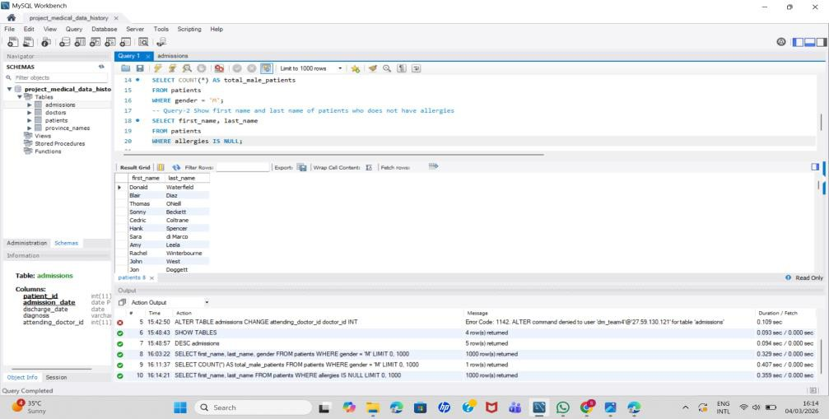

Figure 3: Patients Without Allergies Query Result

Query 3 – Names Starting With C
SQL Query:
SELECT first_name FROM patients
WHERE first_name LIKE 'C%'; Explanation:
Purpose: Retrieve patients whose first name begins with letter C. Output Screenshot:
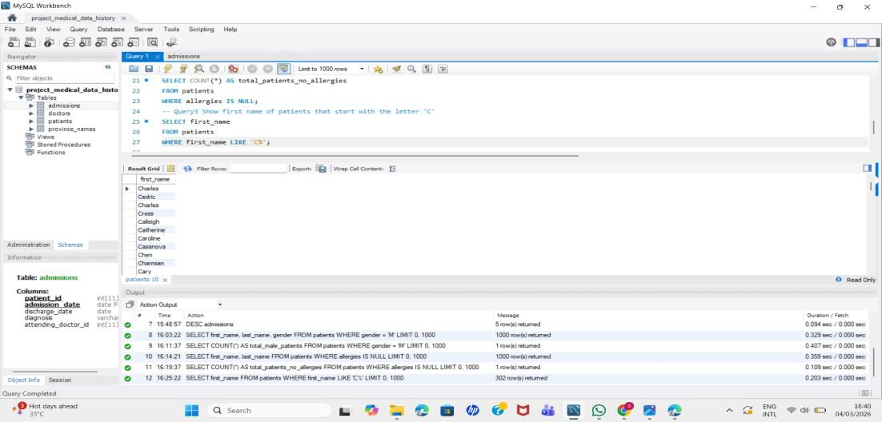

Figure 4: Names Starting with C Query Result

Query 4 – Weight Between 100 and 120
SQL Query:
SELECT first_name, last_name FROM patients
WHERE weight BETWEEN 100 AND 120;
Explanation:
Purpose: Identify patients whose weight falls between 100 and 120. Output Screenshot:
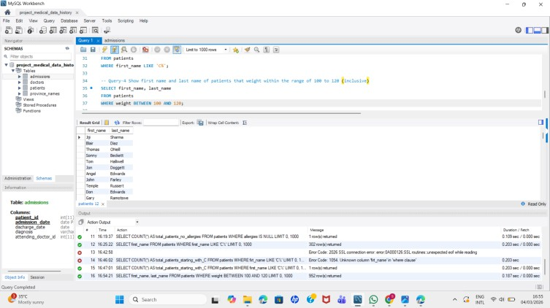
Figure 5: Weight Between 100 and 120 Query Result

Query 5 – Replace NULL Allergies
SQL Query:
SELECT patient_id, first_name, last_name, COALESCE(allergies,'NKA') AS allergies FROM patients;
Explanation:
Purpose: Replace NULL allergy values with 'NKA' (No Known Allergies). Output Screenshot:
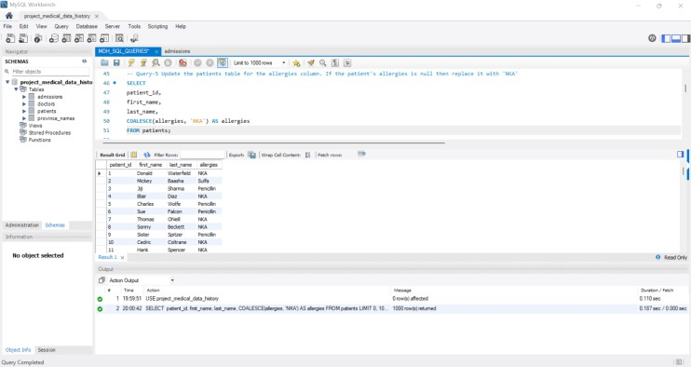

Figure 6: Replace NULL Allergies Query Result

Query 6 – Full Name
SQL Query:
SELECT CONCAT(first_name,' ',last_name) AS full_name FROM patients;
Explanation:
Purpose: Combine first name and last name into a full name column. Output Screenshot:
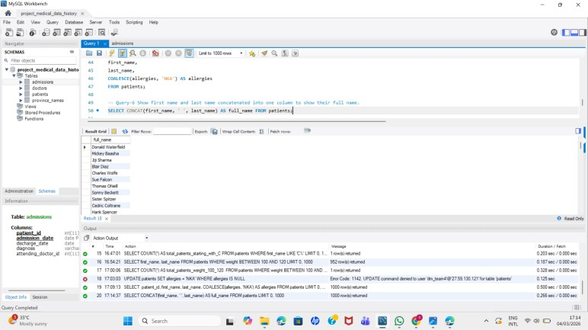

Figure 7: SQL Query 6 Outpu

Query 7 – Join Patients with Province
SQL Query:
SELECT p.first_name, p.last_name, pr.province_name FROM patients p
JOIN province_names pr
ON p.province_id = pr.province_id; Explanation:
Purpose: Display patient names along with their province names. Output Screenshot:
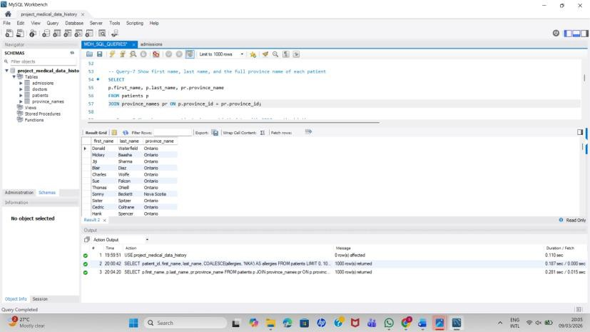
Figure 8: Join Patients with Province Query Result

Query 8 – Patients Born in 2010
SQL Query:
SELECT COUNT(*)
FROM patients
WHERE YEAR(birth_date)=2010; Explanation:
Purpose: Count how many patients were born in the year 2010. Output Screenshot:
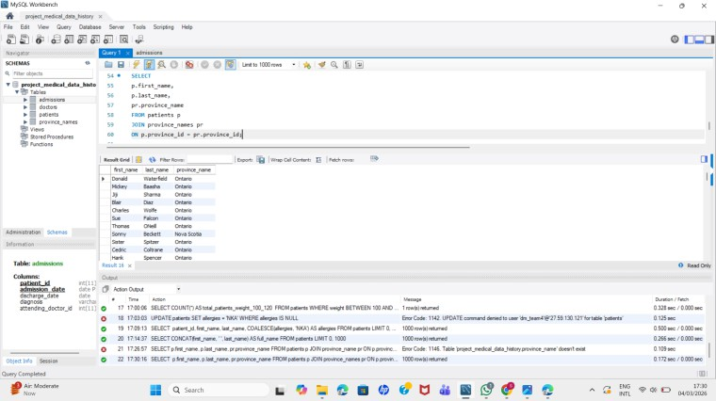
Figure 9: Patients Born in 2010 Query Result

Query 9 – Tallest Patient
SQL Query:
SELECT first_name,last_name,height FROM patients
WHERE height=(SELECT MAX(height) FROM patients); Explanation:
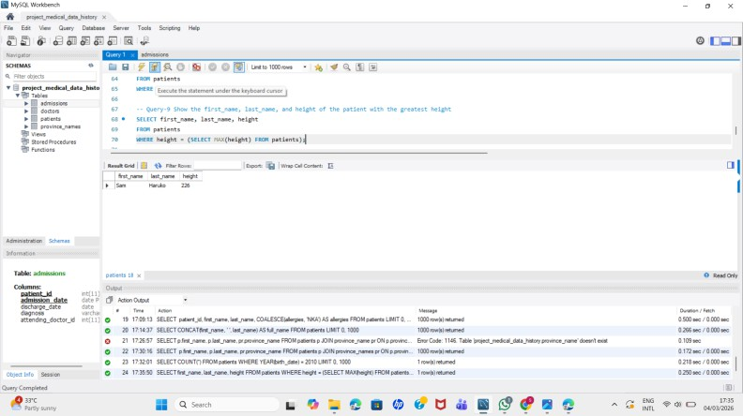
Purpose: Identify the tallest patient using a subquery. Output Screenshot:
Figure 10: Tallest Patient Query Result

Query 10 – Specific Patient IDs
SQL Query:
SELECT *
FROM patients
WHERE patient_id IN (1,45,534,879,1000);
Explanation:
Purpose: Retrieve records for selected patient IDs. Output Screenshot:
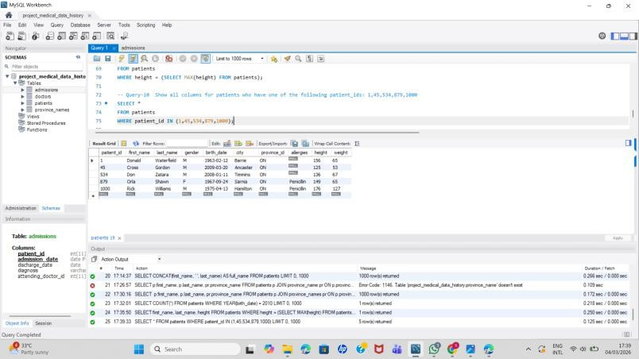
Figure 11: Specific Patient IDs Query Result

Query 11 – Total Admissions
SQL Query:
SELECT COUNT(*) AS total_admissions FROM admissions;
Explanation:
Purpose: Count total hospital admissions. Output Screenshot:
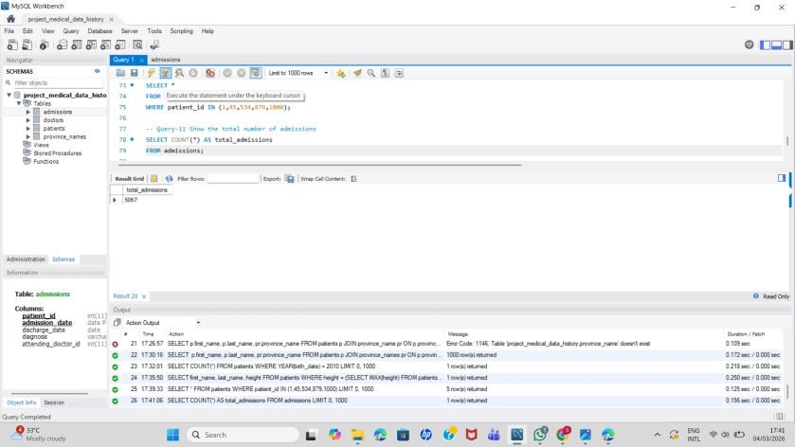
Figure 12: Total Admissions Query Result

Query 12 – Same Day Admission and Discharge
SQL Query:
SELECT *
FROM admissions
WHERE admission_date = discharge_date; Explanation:
Purpose: Identify patients admitted and discharged on the same day. Output Screenshot:
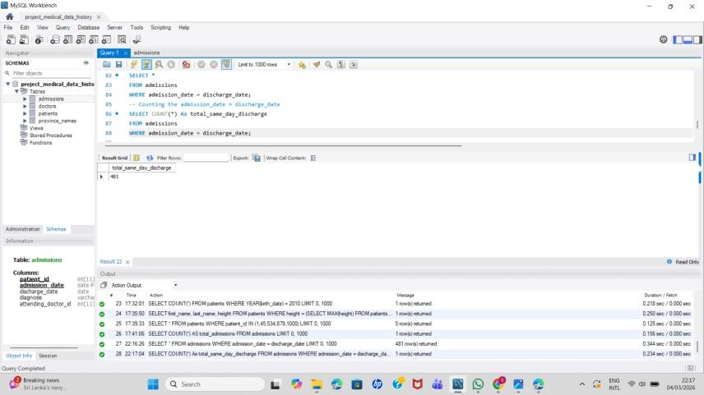
Figure 13: Same Day Admission and Discharge Query Result

Query 13 – Admissions for Patient 579
SQL Query:
SELECT COUNT(*)
FROM admissions WHERE patient_id = 579; Explanation:
Purpose: Count how many times patient 579 was admitted. Output Screenshot:
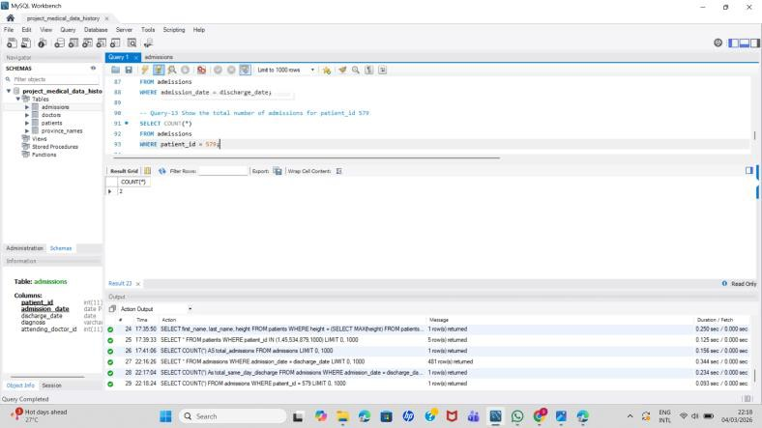
Figure 14: Admissions for Patient 579 Query Result

Query 14 – Unique Cities in Province
SQL Query:
SELECT DISTINCT city
FROM patients
WHERE province_id='NS'; Explanation:
Purpose: Show unique cities in province NS. Output Screenshot:
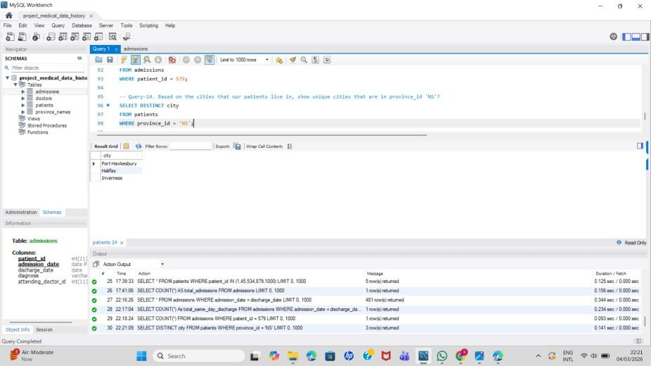

Figure 15: Unique Cities in Province Query Result

Query 15 – Height and Weight Condition
SQL Query:
SELECT first_name,last_name,birth_date FROM patients
WHERE height>160 AND weight>70; Explanation:
Purpose: Retrieve patients taller than 160 cm and heavier than 70 kg. Output Screenshot:
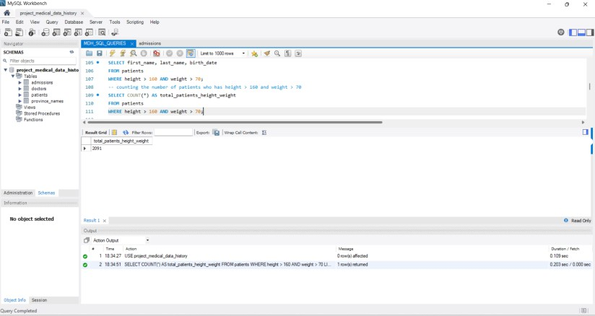
Figure 16: Height and Weight Condition Query Result

Query 16 – Unique Birth Years
SQL Query:
SELECT DISTINCT YEAR(birth_date) FROM patients
ORDER BY YEAR(birth_date); Explanation:
Purpose: Display distinct birth years sorted ascending. Output Screenshot:
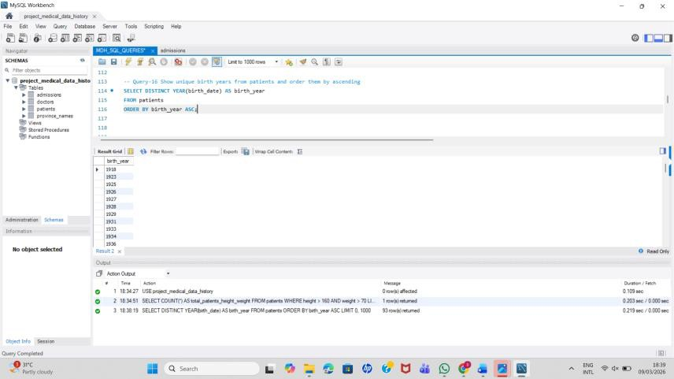
Figure 17: Unique Birth Years Query Result

Query 17 – Unique First Names
SQL Query:
SELECT first_name FROM patients GROUP BY first_name
HAVING COUNT(*)=1;
Explanation:
Purpose: Find names that appear only once in the dataset. Output Screenshot:
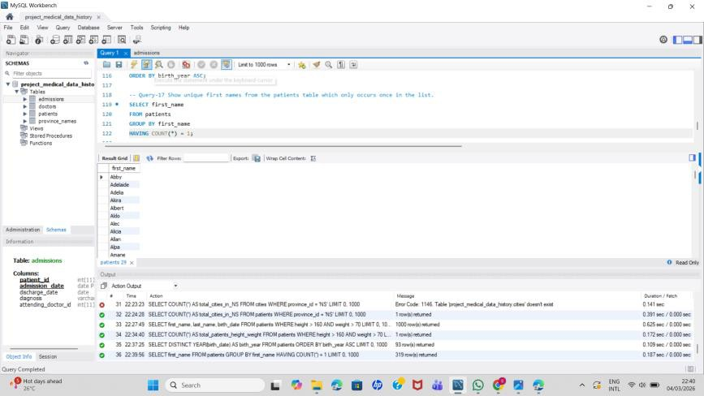

Figure 18: Unique First Names Query Result

Query 18 – Name Pattern
SQL Query: SELECT first_name FROM patients
WHERE first_name LIKE 's%s' AND LENGTH(first_name)>=6; Explanation:
Purpose: Names starting and ending with s with minimum length. Output Screenshot:
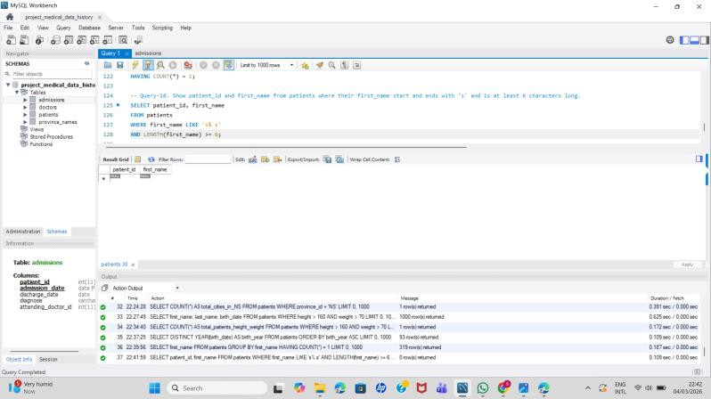
Figure 19: Name Pattern Query Result

Query 19 – Patients with Dementia
SQL Query:
SELECT p.first_name,p.last_name FROM patients p
JOIN admissions a ON p.patient_id=a.patient_id WHERE a.diagnosis='Dementia';
Explanation:
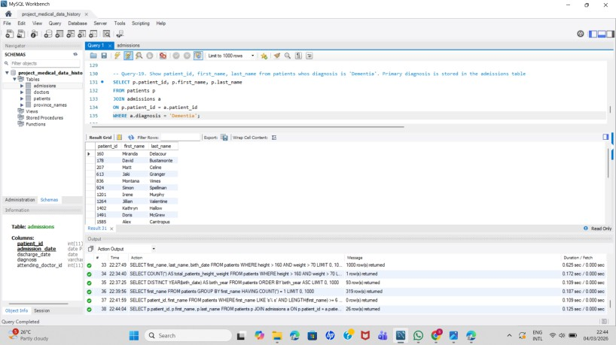
Purpose: Identify patients diagnosed with Dementia. Output Screenshot:
Figure 20: Patients with Dementia Query Result

Query 20 – Sort by Name Length
SQL Query:
SELECT first_name FROM patients
ORDER BY LENGTH(first_name),first_name; Explanation:
Purpose: Sort names by length then alphabetically. Output Screenshot:
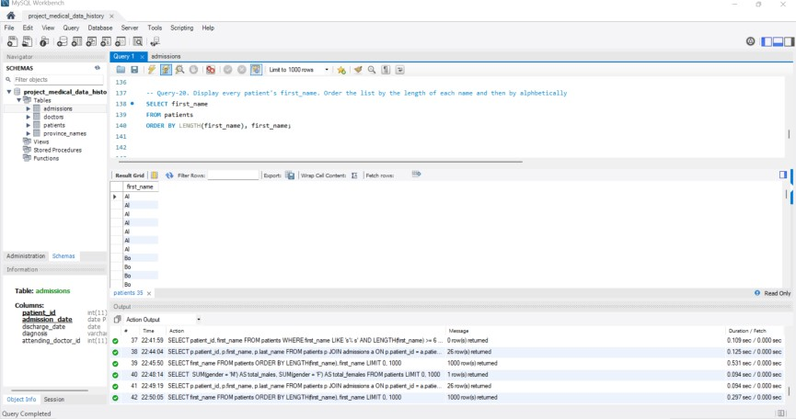
Figure 21: Sort by Name Length Query Result

Query 21 – Count Male and Female
SQL Query:
SELECT
SUM(gender='M') AS total_males, SUM(gender='F') AS total_females FROM patients;
Explanation:
Purpose: Count total male and female patients. Output Screenshot:
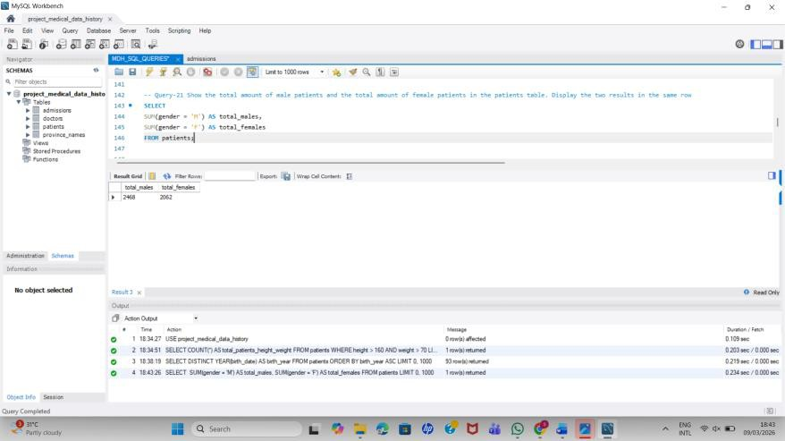
Figure 22: Count Male and Female Query Result

Query 22 – Repeated Diagnosis
SQL Query:
SELECT patient_id,diagnosis FROM admissions
GROUP BY patient_id,diagnosis HAVING COUNT(*)>1;
Explanation:
Purpose: Find patients admitted multiple times for same diagnosis. Output Screenshot:
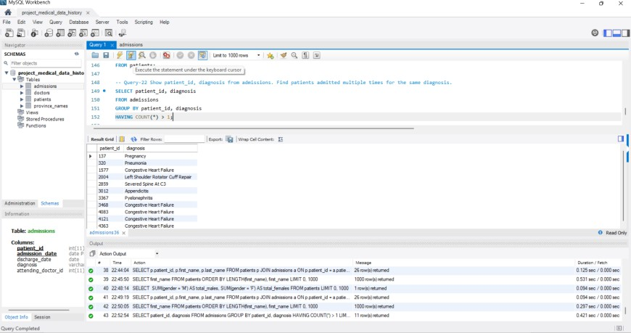
Figure 23: Repeated Diagnosis Query Result

Query 23 – Patients per City
SQL Query:
SELECT city,COUNT(*) AS total_patients FROM patients
GROUP BY city
ORDER BY total_patients DESC; Explanation:
Purpose: Count number of patients in each city. Output Screenshot :
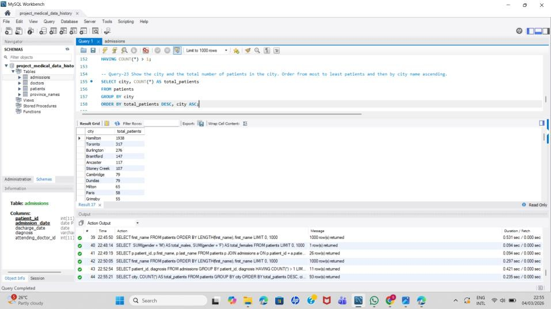
Figure 24: Patients per City Query Result

Query 24 – Combine Patients and Doctors
SQL Query:
SELECT first_name,last_name,'Patient' AS role FROM patients UNION
SELECT first_name,last_name,'Doctor' FROM doctors; Explanation:
Purpose: Combine names of patients and doctors into one result. Output Screenshot:
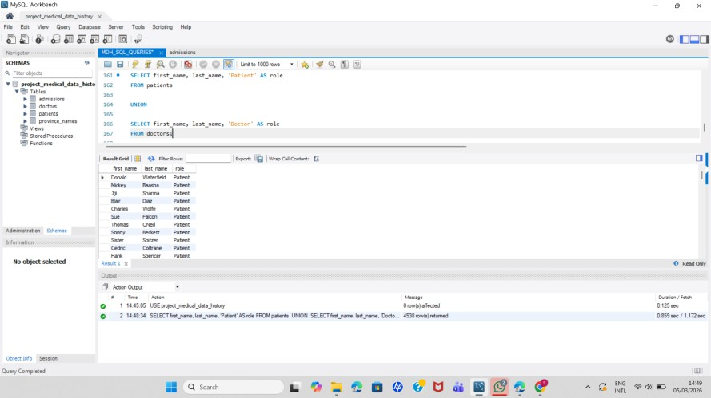
Figure 25: Combine Patients and Doctors Query Result

Query 25 – Most Common Allergies
SQL Query:
SELECT allergies,COUNT(*) AS count_allergy FROM patients
GROUP BY allergies
ORDER BY count_allergy DESC; Explanation:
Purpose: Rank allergies by frequency. Output Screenshot:
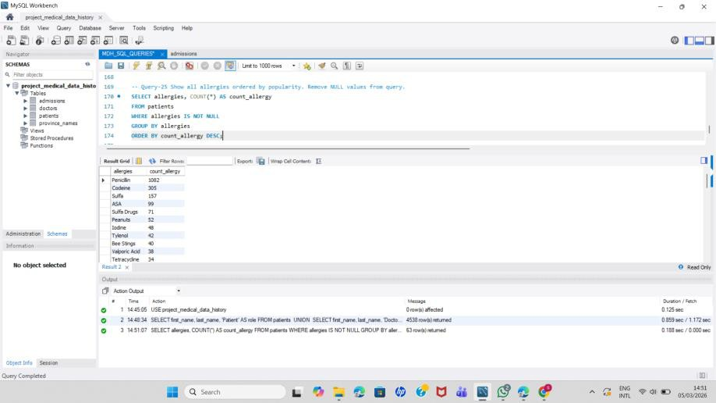
Figure 26: Most Common Allergies Query Result

Query 26 – Patients Born in 1970s
SQL Query:
SELECT *
FROM patients
WHERE birth_date BETWEEN '1970-01-01' AND '1979-12-31';
Explanation:
Purpose: Retrieve patients born in the 1970s. Output Screenshot:
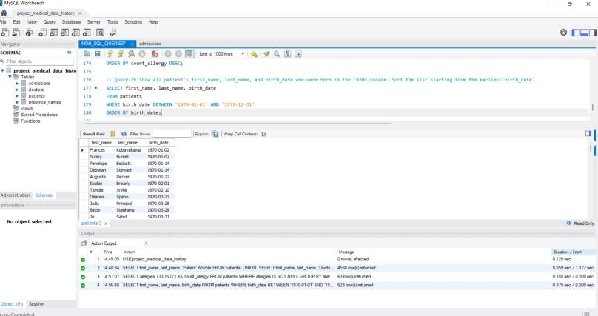
Figure 27: Patients Born in 1970s Query Result

Query 27 – Name Formatting
SQL Query:
SELECT CONCAT(UPPER(last_name),',',LOWER(first_name)) FROM patients
ORDER BY first_name DESC; Explanation:
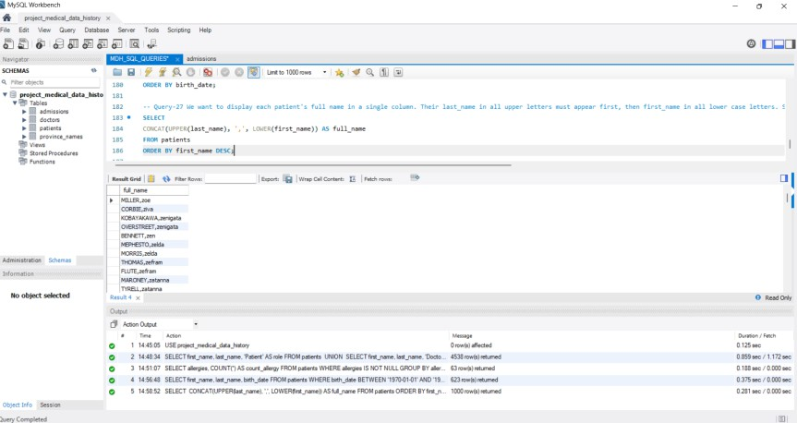
Purpose: Format names for reporting. Output Screenshot:
Figure 28: Name Formatting Query Result

Query 28 – Province Height Sum
SQL Query:
SELECT province_id,SUM(height) FROM patients
GROUP BY province_id HAVING SUM(height)>=7000;
Explanation:
Purpose: Provinces where total height exceeds threshold. Output Screenshot:
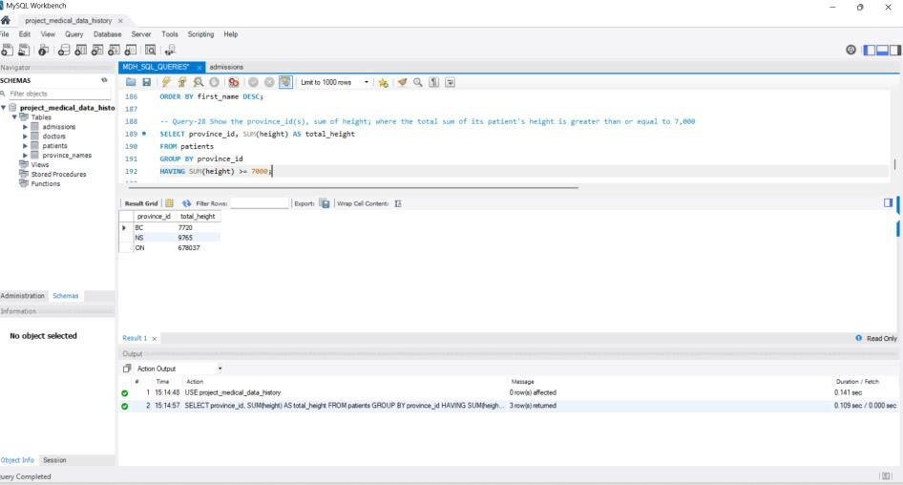
Figure 29: Province Height Sum Query Result

Query 29 – Weight Difference
SQL Query:
SELECT MAX(weight)-MIN(weight) AS weight_difference FROM patients;
Explanation:
Purpose: Difference between heaviest and lightest patient. Output Screenshot:
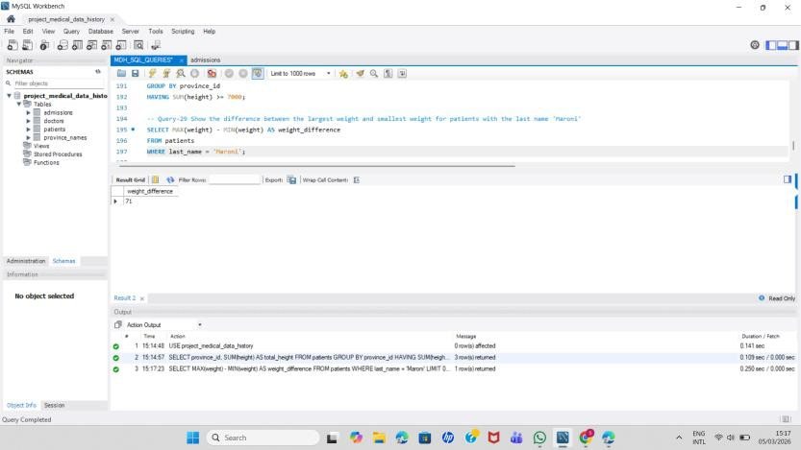
Figure 30: Weight Difference Query Result

Query 30 – Admissions by Day
SQL Query:
SELECT DAY(admission_date),COUNT(*) FROM admissions
GROUP BY DAY(admission_date); Explanation:
Purpose: Count admissions by day of month. Output Screenshot:
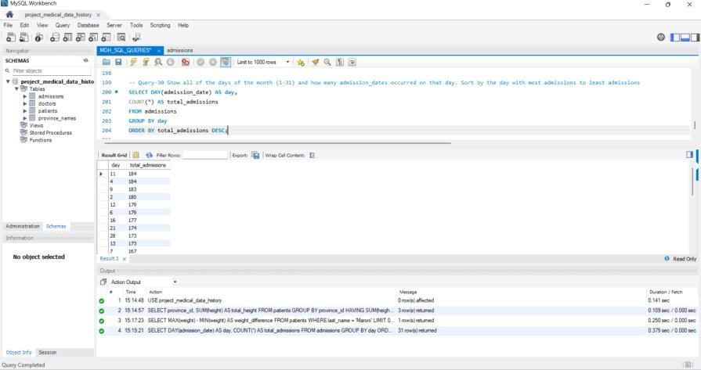
Figure 31: Admissions by Day Query Result

Query 31 – Weight Groups
SQL Query:
SELECT FLOOR(weight/10)*10 AS weight_group, COUNT(*)
FROM patients
GROUP BY weight_group; Explanation:
Purpose: Group patients into weight ranges. Output Screenshot:
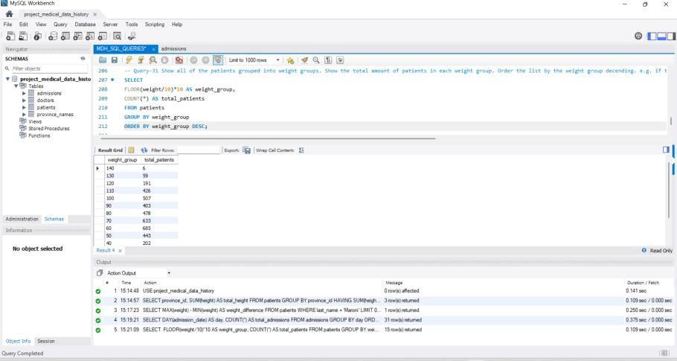

Figure 32: Weight Groups Query Result

Query 32 – BMI Calculation
SQL Query:
SELECT patient_id,
(weight/POWER(height/100,2)) AS BMI FROM patients;
Explanation:
Purpose: Calculate Body Mass Index for each patient. Output Screenshot:
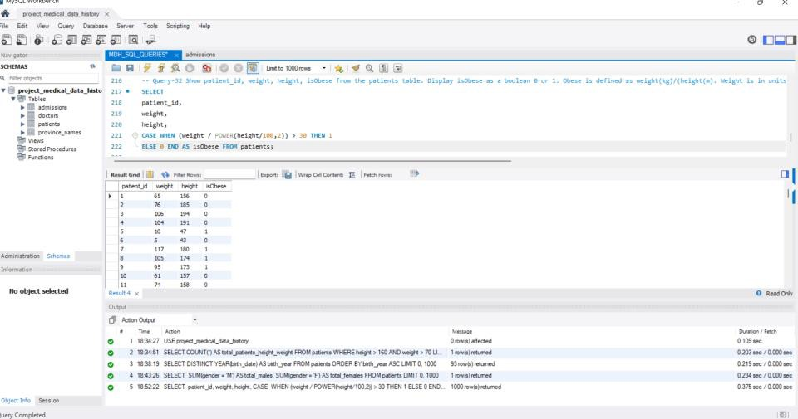
Figure 33: BMI Calculation Query Result

Query 33 – Epilepsy Patients with Doctor Lisa
SQL Query:
SELECT p.first_name,p.last_name,d.specialty FROM patients p
JOIN admissions a ON p.patient_id=a.patient_id JOIN doctors d ON a.doctor_id=d.doctor_id WHERE a.diagnosis='Epilepsy'
AND d.first_name='Lisa'; Explanation:
Purpose: Patients treated by Doctor Lisa for Epilepsy. Output Screenshot :
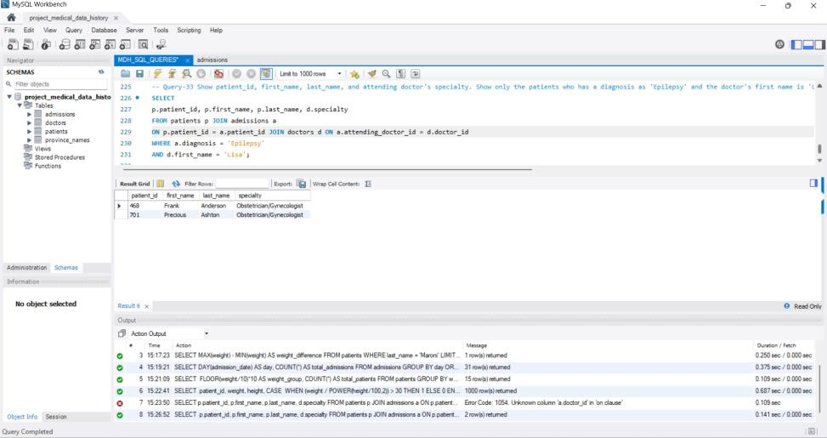

Figure 34: Epilepsy Patients with Doctor Lisa Query Result
- Key Learnings
  - Practical understanding of SQL joins and aggregations.
  - Data cleaning using COALESCE and UPDATE.
  - Query optimization and filtering techniques.
  - Analytical queries using GROUP BY and HAVING.

Conclusion
The Medical Data History SQL project demonstrates the practical application of SQL in analyzing healthcare datasets. Through this project, multiple SQL techniques such as filtering, joins, aggregation, subqueries, and data transformation were implemented to extract meaningful information from the database.

The analysis helped in understanding patient demographics, hospital admission patterns, and medical diagnoses. Additionally, the project strengthened practical SQL skills and improved the ability to work with relational databases for real-world data analysis scenarios.

