JAYPEE INSTITUTE OF INFORMATION TECHNOLOGY
Sector 62, Noida
Department of Computer Science & Engineering
Performance Engineering Lab (17M15CS122)
PROJECT REPORT
Title
Network Protocol Performance Analyzer
Team Members
Name | Enrollment No.
Abhijeet Kumar | 22803029
Viyom Shukla | 22803030
Devang Dixit | 22803031

Submitted To:
Dr. Shikha Jain
Associate Professor
Department of CSE, JIIT Sector 62, Noida.

CHAPTER 1

INTRODUCTION

1.1 Introduction
As network traffic grows, packets must wait in buffers and queues before they can be transmitted or processed. When the arrival rate of packets approaches the capacity of a link or router, queues build up, leading to higher delay, increased packet loss, and reduced throughput. Understanding and modelling this queuing behaviour is therefore essential for designing efficient and reliable communication networks.
The Network Protocol Performance Analyzer is a Python-based application that simulates packet queues, measures key performance metrics, and compares the behaviour of the TCP and UDP transport protocols under increasing load. By combining queuing-theory models with discrete-event simulation, the tool reproduces and validates the behaviour of real networks in a controlled and repeatable way, and presents the results through clear graphs.

1.2 Problem Statement
Analysing network performance purely on real hardware is expensive, difficult to repeat, and hard to scale to many traffic scenarios. Purely analytical models, on the other hand, rely on simplifying assumptions and cannot easily capture the packet-level dynamics of finite buffers and bursty arrivals.
The project aims to develop a modular, reproducible simulation tool that models single-server and multi-server queues, validates the simulated results against closed-form queuing theory, evaluates throughput, delay and packet loss under varying traffic loads, and compares the TCP and UDP transport protocols under congestion.

1.3 Existing System
Traditional approaches to network performance analysis have several limitations:
- Dependence on costly physical testbeds or dedicated hardware.
- Analytical (formula-only) methods that cannot model packet-level detail such as finite buffers.
- Difficulty in repeating experiments under identical conditions.
- Limited comparison between transport protocols under the same load.
- Results that are hard to visualise and interpret.
These limitations reduce the effectiveness of performance studies and make it difficult to explore many design choices quickly.

1.4 Proposed System
The proposed system provides a modular, menu-driven Python application in which packets are generated by a Poisson process, served by one or more servers with exponentially distributed service times, and measured throughout the run. The simulated metrics are compared against the exact results of queuing theory (Little's Law and the Erlang-C formula) to verify correctness, and the reliable behaviour of TCP is compared with the best-effort behaviour of UDP under increasing load. All results are visualised using Matplotlib graphs.

1.5 Objectives
The main objectives of the project are:
- Understand the concept and importance of queuing analysis in computer networks.
- Implement and simulate single-server (M/M/1) and multi-server (M/M/c) queuing models.
- Validate the simulation results against theoretical formulas (Little's Law and Erlang-C).
- Evaluate network performance using throughput, average delay, and packet loss.
- Compare the behaviour of the TCP and UDP protocols under varying traffic loads.
- Identify the queue configuration that delivers the best performance for a given load.

1.6 Scope
The tool can be used by students, teachers and researchers to study queuing behaviour, validate theory against simulation, and understand transport-layer trade-offs. It is delivered as an interactive web application, a menu-driven command-line program, and a self-contained Google Colab notebook, making it accessible for classroom demonstration, self-study and further research.

1.7 Features
The main features of the system include:
- Poisson traffic generation with configurable arrival rate.
- Simulation of M/M/1, M/M/c and finite-capacity M/M/c/K queues.
- Validation of simulation against closed-form queuing theory.
- Computation of throughput, average delay, packet loss and utilisation.
- TCP vs UDP comparison under increasing load.
- Matplotlib visualisation of all results.
- Interactive web dashboard (Streamlit) with live sliders.
- Self-contained Google Colab notebook and reproducible seeded runs.

CHAPTER 2

LITERATURE SURVEY

2.1 Introduction
A literature survey studies existing research, technologies and models relevant to the problem being solved. This chapter reviews queuing theory as applied to computer networks, discrete-event simulation, the technologies used in the project, the gaps in existing approaches, and the proposed solution.

2.2 Queuing Theory in Computer Networks
Queuing theory provides a mathematical framework for analysing systems in which items arrive, wait, and are served. In networks, packets arrive at routers and links and wait in buffers before transmission. Models such as M/M/1 (a single server) and M/M/c (multiple parallel servers) describe how packets arrive, wait and are serviced, and allow key performance measures such as average delay and number in system to be derived analytically using results like Little's Law and the Erlang-C formula.

2.3 Discrete-Event Simulation
Discrete-event simulation models a system as a sequence of events (arrival, start-of-service, departure) occurring at discrete points in time, rather than stepping time in fixed increments. This makes it possible to reproduce packet-level behaviour, including finite buffers and packet drops, that is difficult to capture with closed-form formulas alone. Combining discrete-event simulation with analytical models allows the two to validate each other.

2.4 Technologies Used
The system is built entirely in the Python scientific computing stack.

Python 3.x
A high-level general-purpose language used to develop and integrate the complete simulation system.

SimPy
A process-based discrete-event simulation framework used to model packet arrivals, queues and servers.

NumPy
A numerical computing library used to generate random inter-arrival and service times and to perform array-based calculations.

SciPy / Mathematical Functions
Used, together with Python's math library, to evaluate the closed-form M/M/1 and M/M/c queuing formulas.

Matplotlib
A plotting library used to create graphs and visual representations of the simulation results.

Pandas
A data-analysis library used to organise per-packet statistics and tabulate the collected performance data.

Streamlit
A Python framework used to build the interactive web dashboard that recomputes metrics and graphs live as parameters change.

2.5 Research Gap
Although many performance-analysis approaches exist, several limitations remain:
- Analytical models alone cannot capture packet-level effects such as finite buffers.
- Simulation results are often not validated against theory.
- TCP and UDP are usually studied separately rather than under identical loads.
- Experiments are frequently not reproducible.
- Results are difficult to visualise and share.
These limitations highlight the need for a reproducible, theory-validated simulation tool that also compares transport protocols and visualises the results clearly.

2.6 Proposed Solution
To address the identified gaps, the Network Protocol Performance Analyzer provides:
- Discrete-event simulation of M/M/1, M/M/c and M/M/c/K queues using SimPy.
- Validation of every scenario against Little's Law and the Erlang-C formula.
- Evaluation of throughput, delay, packet loss and utilisation.
- Integrated TCP vs UDP comparison under identical loads.
- Reproducible, seeded runs and clear Matplotlib visualisation.
- Delivery as a web app, a CLI and a Colab notebook.

2.7 Comparison of Existing System and Proposed System
Feature | Existing Approach | Proposed System
Analysis Method | Analytical-only or hardware testbed | Hybrid simulation + theory validation
Queue Models | Limited / single model | M/M/1, M/M/c and M/M/c/K
Validation | Rarely validated | Little's Law & Erlang-C
Protocol Study | TCP and UDP studied separately | Integrated TCP vs UDP comparison
Reproducibility | Low | Seeded, deterministic runs
Visualisation | Limited | Matplotlib graphs & charts
Accessibility | Local only | Web app + CLI + Colab notebook

CHAPTER 3

REQUIREMENT ANALYSIS

3.1 Introduction
Requirement analysis identifies the functional and non-functional requirements of the system and the resources needed to build and run it. This chapter describes what the analyzer must do and the quality attributes it must satisfy.

3.2 Functional Requirements
Functional requirements describe the features and services provided by the system:
- Generate packet arrivals as a Poisson process at a configurable rate.
- Simulate M/M/1, M/M/c and finite-capacity M/M/c/K queues.
- Process packets with exponential service times and drop packets when the buffer is full.
- Collect per-packet statistics (arrival, waiting, sojourn time, served/dropped).
- Compute throughput, average delay, packet loss and utilisation.
- Compare simulated metrics against theoretical queuing formulas.
- Compare TCP and UDP behaviour under varying loads.
- Visualise results as graphs and comparison charts.
- Provide interactive, menu-driven and notebook interfaces.

3.3 Non-Functional Requirements
Non-functional requirements define the quality and performance characteristics of the system.

Performance
- Fast execution of simulations over long simulated durations.
- Efficient handling of large numbers of packets.

Accuracy
- Simulated metrics agree with theory to within a few percent.
- Correct modelling of finite-buffer packet loss.

Reproducibility
- Seeded random number generation for repeatable results.
- Deterministic outputs for the same parameters.

Usability
- Simple sliders and menus for choosing parameters.
- Clear, labelled graphs and tables.

Portability
- Runs on Windows, Linux and macOS.
- Runs in the browser via Streamlit and Google Colab.

3.4 Hardware Requirements
The minimum hardware required to run the application is shown below.
Component | Specification
Processor | Intel Core i3 or above
RAM | 4 GB (8 GB Recommended)
Storage | 2 GB Free Space
Internet | Broadband (for Colab / Streamlit Cloud)

3.5 Software Requirements
Software | Purpose
Windows / Linux / macOS | Operating System
Python 3.x | Core language & integration
SimPy | Discrete-event simulation
NumPy | Random generation & numerics
SciPy / math | Theoretical queuing formulas
Matplotlib | Graphs & visualisation
Pandas | Tabulating performance data
Streamlit | Interactive web dashboard
Jupyter / Google Colab | Notebook execution
VS Code | Development environment
Git & GitHub | Version control & hosting

3.6 User Roles
The platform supports the following user roles:

Student / Presenter
- Run simulations with chosen parameters.
- View validation tables and graphs.
- Demonstrate results interactively.

Researcher / Teacher
- Explore many traffic scenarios.
- Validate theory against simulation.
- Analyse TCP vs UDP behaviour and identify efficient configurations.

3.7 Feasibility Study
A feasibility study was conducted to evaluate the practicality of the proposed system.

Technical Feasibility
All required technologies (Python, SimPy, NumPy, SciPy, Matplotlib, Pandas, Streamlit) are open-source and widely available, making the system technically feasible.

Economic Feasibility
The project uses free, open-source tools and free hosting (GitHub, Streamlit Community Cloud, Google Colab), so there is no software cost, making it economically feasible.

Operational Feasibility
The interactive interfaces require minimal training. Students and teachers can run simulations and interpret the results with ease, making the system operationally feasible.

3.8 System Requirements Summary
Requirement Type | Description
Simulation Engine | SimPy discrete-event simulation
Numerical / Random | NumPy
Theory / Formulas | SciPy and Python math
Data Handling | Pandas
Visualisation | Matplotlib
Web Interface | Streamlit
Deployment | GitHub + Streamlit Cloud + Colab

CHAPTER 4

SYSTEM DESIGN

4.1 Introduction
System design describes the overall structure of the application, how the modules interact, and how data flows through the analysis pipeline. The system is designed as a modular pipeline in which each module is responsible for one stage of the analysis and the modules communicate through simple data structures.

4.2 System Architecture
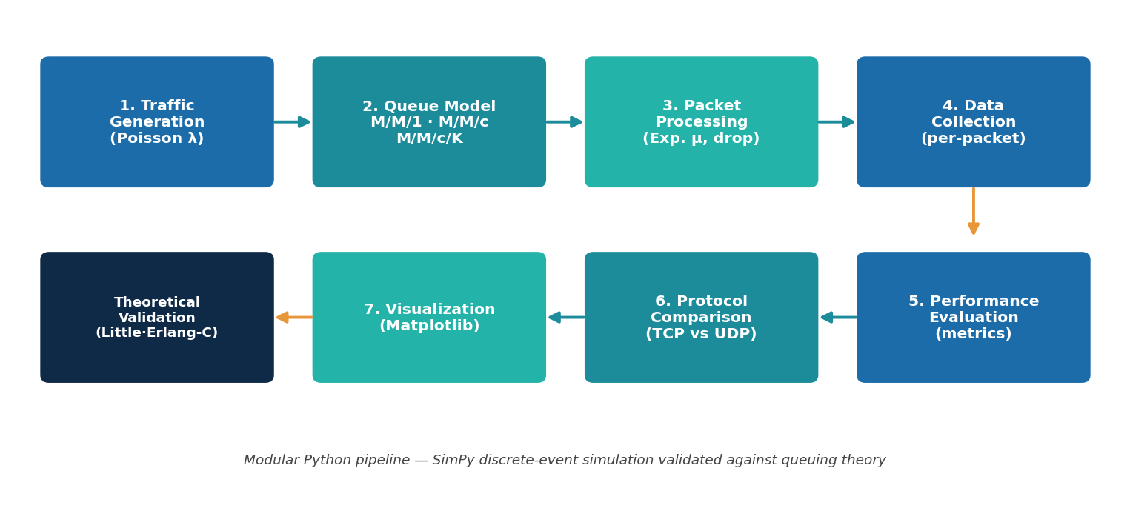
Figure 4.1: Modular pipeline architecture of the Network Protocol Performance Analyzer

Architecture Description
Packets are generated as a Poisson process and passed to the selected queue model, where they are served by one or more servers with exponential service times. Per-packet statistics are collected during the run and used to compute performance metrics, which are validated against closed-form queuing theory. The transport-layer behaviour of TCP and UDP is then analysed under the same loads, and all results are visualised as graphs.

4.3 System Workflow
The workflow follows six stages: (1) traffic generation using a Poisson process at rate lambda; (2) queue modelling using M/M/1, M/M/c or M/M/c/K; (3) packet processing with exponential service at rate mu, dropping packets when the buffer is full; (4) data collection of per-packet statistics; (5) performance evaluation and comparison against theory; and (6) protocol comparison and visualisation.

4.4 Module Description

Traffic Generator Module
Produces exponential inter-arrival and service times, implementing the Poisson arrival process.

Queue Models Module
A single SimPy-based simulator that models M/M/1, M/M/c and M/M/c/K queues using a resource with c servers and an optional finite capacity K.

Theoretical Module
Implements the closed-form formulas (Little's Law, Erlang-C, and the M/M/c/K birth-death solution) used to validate the simulation.

Metrics Module
Converts per-packet data into throughput, delay, packet loss and utilisation, and builds the simulation-vs-theory comparison table.

Protocol Comparison Module
Models the reliable, congestion-controlled behaviour of TCP against the best-effort behaviour of UDP under increasing load.

Visualization Module
Generates all Matplotlib graphs and saves them for reports and presentations.

4.5 Data Design
Instead of a database, the system uses in-memory data structures. Each packet is recorded as a structured object and the collection is stored as a Pandas DataFrame.

Packet Record
Field | Description
pid | Packet identifier
arrival | Arrival time
start_service | Time service began
departure | Departure time
waiting_time | Time spent waiting in queue
sojourn_time | Total time in system
dropped | Whether the packet was dropped
served | Whether the packet was served

Simulation Parameters
Parameter | Description
lambda | Mean arrival rate (packets/s)
mu | Mean service rate per server (packets/s)
c | Number of parallel servers
K | System capacity (finite buffer)
sim_time | Total simulated time (seconds)
seed | Random seed for reproducibility

4.6 User Interface Overview
The system exposes three interfaces instead of a REST API.
Interface | Command | Purpose
Web dashboard | streamlit run app.py | Interactive sliders & live graphs
Command line | python main.py | Menu-driven simulation & reports
Full demo | python main.py --demo | Run everything, save all graphs
Notebook | Colab: Run all | Self-contained cloud execution

4.7 Design Advantages
- Clear separation of simulation, calculation and visualisation logic.
- A single simulator handles all three queue models.
- Easy to extend with new models or metrics.
- Reproducible and testable through seeded runs.

CHAPTER 5

UML DIAGRAMS

5.1 Introduction
Unified Modeling Language (UML) diagrams describe the structure and behaviour of the system. This chapter presents the use case, class, sequence and activity views of the Network Protocol Performance Analyzer.

5.2 Use Case Diagram

Description
The primary actor is the User (student, teacher or researcher). The main use cases are: Configure Parameters (lambda, mu, c, K), Run Simulation, Validate Against Theory, Compare TCP vs UDP, View Graphs, and Run Full Demo. The User interacts with the system through the web dashboard, the command-line menu or the Colab notebook, all of which invoke the same underlying simulation and analysis use cases.

5.3 Class Diagram

Description
The core classes are TrafficGenerator (produces inter-arrival and service times), Packet (holds per-packet timing and status), and QueueSimulator (runs the discrete-event simulation using a SimPy resource). Supporting modules provide functions: the theoretical module (mm1, mmc, mmck, erlang_c, analyse), the metrics module (compute_metrics, compare_with_theory), the protocol-comparison module (compare_protocols) and the visualization module. QueueSimulator aggregates TrafficGenerator and produces a collection of Packet objects.

5.4 Sequence Diagram

Description
On running a scenario, the User supplies parameters to the QueueSimulator. The simulator repeatedly requests inter-arrival times from the TrafficGenerator, creates Packet objects, requests one of the c servers, obtains a service time, and records departure. After the run, the Metrics module computes performance measures, the Theoretical module returns the analytical values, and the comparison table and graphs are returned to the User.

5.5 Activity Diagram

Description
The activity flow starts with parameter input, then loops over packet arrivals: generate arrival, check buffer occupancy, either drop the packet (if full) or enqueue and serve it, and record statistics. When the simulated time ends, the system computes metrics, compares them with theory, performs the TCP-vs-UDP sweep, and produces the graphs before terminating.

CHAPTER 6

IMPLEMENTATION

6.1 Introduction
The system is implemented as a modular, menu-driven Python application in which each module is responsible for one stage of the analysis pipeline. This chapter describes the implementation of each major component.

6.2 Simulation Engine Implementation
The simulation engine is built on SimPy. A resource with capacity c represents the server pool. An arrival process generates packets with exponentially distributed inter-arrival times; each admitted packet requests the resource, is served for an exponentially distributed time, and then departs. If a finite capacity K is set and the system already holds K packets, the arriving packet is dropped to model buffer overflow.

Main Functions
- QueueSimulator.run() — executes the simulation and returns a DataFrame.
- _arrivals() — Poisson arrival process with drop logic.
- _serve() — queue, service and departure of a packet.

6.3 Theoretical Validation Implementation
The theoretical module implements the exact formulas used to validate the simulation: M/M/1 results, the Erlang-C formula and M/M/c results, and the M/M/c/K birth-death solution for blocking probability. A dispatcher function selects the correct model based on the parameters.

6.4 Metrics and Data Collection
During the simulation, statistics are recorded for every packet — arrival time, waiting time, sojourn time, and whether it was served or dropped. The metrics module aggregates these into throughput, average delay, packet loss and utilisation, and builds a side-by-side simulation-versus-theory table with absolute errors.

Main Metrics
Metric | Definition
Throughput | Packets served per second
Average Delay (W) | Mean time in system (waiting + service)
Packet Loss | Fraction of arrivals dropped
Utilisation (rho) | Fraction of time servers are busy

6.5 Protocol Comparison Implementation
The protocol-comparison module sweeps a range of arrival rates and, for each load, derives TCP and UDP behaviour from the finite-buffer simulation. UDP is modelled as best-effort (dropped packets are lost), while TCP is modelled as reliable and congestion-controlled (lost packets are retransmitted, goodput is capped at capacity, and delay grows with load).

6.6 Visualization Implementation
The visualization module uses Matplotlib to produce the load-sweep graphs, the simulation-vs-theory bar chart, the M/M/1-vs-M/M/c comparison, and the three-panel TCP-vs-UDP figure. Each graph is saved as a PNG in the results folder.

6.7 User Interfaces
Three interfaces share the same engine: an interactive Streamlit dashboard with live sliders, a menu-driven command-line program, and a self-contained Google Colab notebook that ends with interactive widgets.

6.8 Deployment Support
The project is version-controlled with Git and hosted on GitHub. The web application is deployed on Streamlit Community Cloud, and the notebook runs directly in Google Colab, so the tool is accessible without any local installation.

CHAPTER 7

TESTING AND RESULTS

7.1 Introduction
Testing verifies that the system behaves correctly and that the simulated results agree with queuing theory. This chapter describes the testing objectives, environment, test cases and the results obtained.

7.2 Testing Objectives
- Verify that each queue model is simulated correctly.
- Confirm that simulated metrics match theoretical predictions.
- Check that finite buffers produce the expected packet loss.
- Validate the TCP-vs-UDP behaviour under load.
- Ensure all interfaces (CLI, web app, notebook) run correctly.

7.3 Test Environment
Component | Configuration
Operating System | Windows 11
Language | Python 3.12
Simulation | SimPy 4.x
Numerics | NumPy, SciPy
Notebook Testing | Jupyter / nbclient
Browser | Google Chrome
Hosting | Streamlit Community Cloud, Google Colab

7.4 Test Cases
Test Case | Expected Result | Status
M/M/1 simulation vs theory | Metrics match within ~2% | Pass
M/M/c simulation vs theory | Matches Erlang-C results | Pass
M/M/c/K finite buffer | Packet loss matches blocking probability | Pass
TCP vs UDP load sweep | Curves follow expected trade-off | Pass
Streamlit web app | Renders; sliders update live | Pass
Colab notebook (Run all) | All cells execute with no errors | Pass

7.5 Validation Results (Simulation vs Theory)
The table below shows measured simulation results against the theoretical predictions for three representative scenarios. The close agreement confirms that the simulation reproduces queuing theory.
Scenario / Metric | Simulation | Theory | Abs. Error
M/M/1 — Utilisation | 0.805 | 0.800 | 0.005
M/M/1 — Throughput (pkt/s) | 8.05 | 8.00 | 0.05
M/M/1 — Avg delay W (s) | 0.512 | 0.500 | 0.012
M/M/2 — Avg delay W (s) | 0.231 | 0.229 | 0.002
M/M/2 — Number in system L | 3.48 | 3.43 | 0.05
M/M/2/6 — Packet loss | 0.110 | 0.113 | 0.003
M/M/2/6 — Throughput (pkt/s) | 16.10 | 15.97 | 0.13

7.6 Output Screens
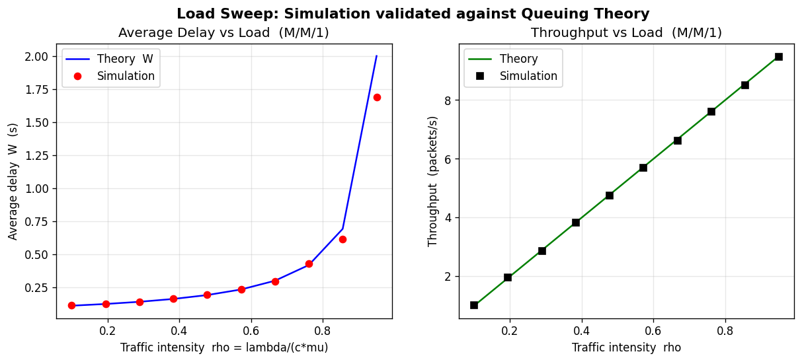
Figure 7.1: Load sweep (M/M/1) — simulation markers on the theoretical curve; delay explodes as rho approaches 1.
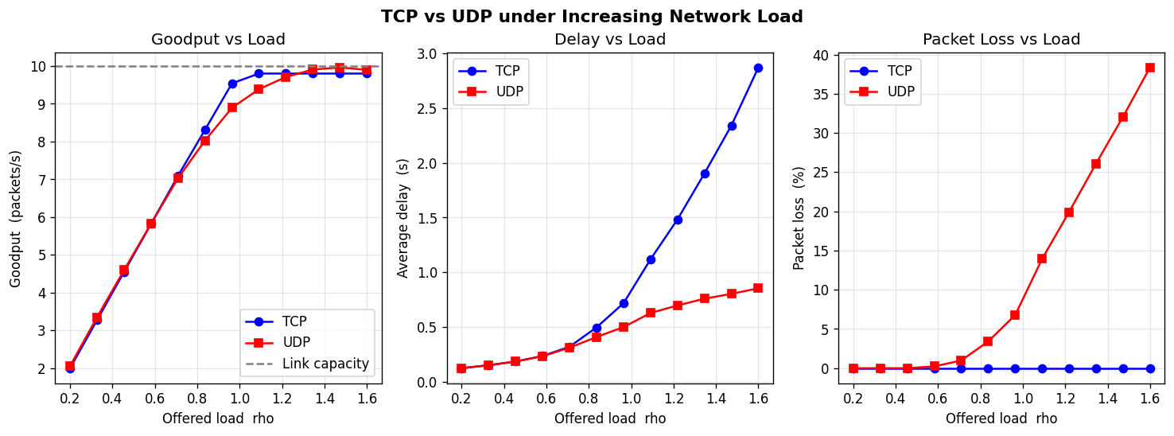
Figure 7.2: TCP vs UDP — goodput, delay and packet loss under increasing load.
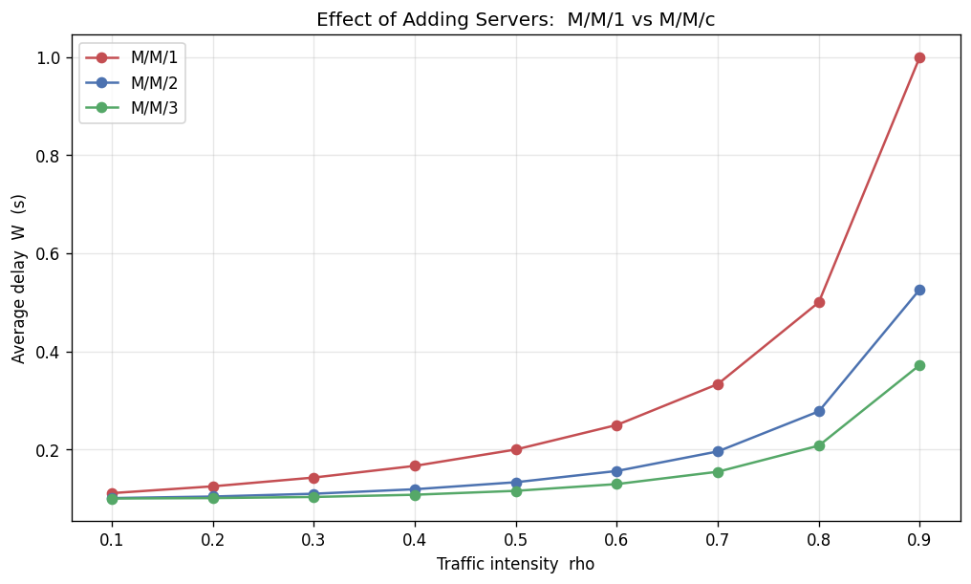
Figure 7.3: Effect of adding servers — M/M/1 vs M/M/c average delay.
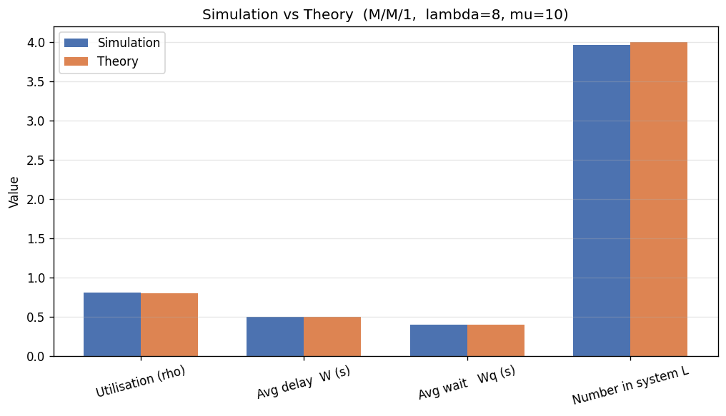
Figure 7.4: Simulation vs theory bar chart for a single scenario.

7.7 Results

Key Results
- Simulation reproduces queuing theory to within about 1–2%.
- Average delay stays low and then rises sharply as rho approaches 1 (the queuing 'knee').
- Adding servers (M/M/c) sharply reduces delay at the same per-server load.
- Under overload, UDP loses a large fraction of packets while TCP recovers all data (~0 loss) at the cost of higher delay.

CHAPTER 8

DEPLOYMENT

8.1 Introduction
Deployment makes the analyzer accessible to users without any local installation. The project is deployed using free, cloud-based services built around its GitHub repository.

8.2 Deployment Architecture
The source code is hosted on GitHub. The interactive web application is deployed on Streamlit Community Cloud, which builds the app directly from the repository and serves it at a public URL. The notebook is opened and executed in Google Colab straight from GitHub. Any change pushed to the repository automatically redeploys the web application.

8.3 Deployment Components
Component | Purpose
GitHub | Source code hosting & version control
Streamlit Community Cloud | Hosts the interactive web app
Google Colab | Runs the self-contained notebook
requirements.txt | Declares Python dependencies
.streamlit/config.toml | App theme and configuration
Git | Change tracking and history

8.4 Deployment Workflow
- Code is committed and pushed to the GitHub repository.
- Streamlit Community Cloud builds the app from requirements.txt.
- The app is served at a public *.streamlit.app URL.
- The Colab notebook is launched from the GitHub link and run end-to-end.
- Subsequent pushes automatically redeploy the web app.

8.5 Advantages of Deployment Strategy
- No local installation required for end users.
- Free hosting for source, web app and notebook.
- Automatic redeployment on every code change.
- Accessible from any device with a browser.

CHAPTER 9

RELIABILITY, FUTURE SCOPE AND CONCLUSION

9.1 Introduction
This chapter discusses the reliability and reproducibility features of the system, its advantages and limitations, the scope for future work, and the overall conclusion of the project.

9.2 Reliability and Reproducibility Features

Seeded Randomness
All random number generation uses an explicit seed, so every run is exactly reproducible.

Theory Validation
Each scenario is automatically cross-checked against closed-form queuing formulas, catching modelling errors.

Deterministic Metrics
For fixed parameters and seed the computed metrics are deterministic and repeatable.

Modular Testing
Each module can be run and verified independently, and the notebook is validated by executing all cells.

Version Control
The complete project history is tracked in Git and hosted on GitHub.

9.3 Advantages of the Proposed System
- Validated against queuing theory (errors within ~1–2%).
- Handles single-server, multi-server and finite-buffer models.
- Provides an integrated TCP vs UDP comparison.
- Reproducible, well-visualised and easy to demonstrate.
- Accessible as a web app, CLI and Colab notebook.

9.4 Limitations
- The TCP-vs-UDP model is a simplified behavioural model, not a full protocol stack.
- Only Markovian (Poisson/exponential) arrivals and service are modelled.
- Very high loads require longer simulation times for accurate averages.
- The web app's free hosting sleeps after inactivity.

9.5 Future Scope
- Support non-Markovian models (M/G/1, G/G/1) and bursty traffic.
- Add priority queues and scheduling policies.
- Integrate a more detailed TCP congestion-control model.
- Extend to network topologies with multiple linked queues.
- Export automated PDF performance reports.

9.6 Conclusion
The Network Protocol Performance Analyzer successfully combines queuing theory with discrete-event simulation to provide an intuitive, validated view of network performance. It simulates M/M/1, M/M/c and M/M/c/K queues, validates the results against Little's Law and the Erlang-C formula, evaluates throughput, delay and packet loss, and compares the TCP and UDP transport protocols under increasing load. The results show that the simulation reproduces theory closely, that adding servers reduces delay, and that TCP trades higher delay for near-zero loss while UDP keeps low delay but loses data under overload. Delivered as a web app, a command-line tool and a Colab notebook, the project offers a practical and reproducible platform for understanding network performance optimisation through queuing analysis.

REFERENCES (IEEE Format)
[1] R. Jain, The Art of Computer Systems Performance Analysis. New York, NY, USA: Wiley, 1991.
[2] L. Kleinrock, Queueing Systems, Volume 1: Theory. New York, NY, USA: Wiley-Interscience, 1975.
[3] A. S. Tanenbaum and D. J. Wetherall, Computer Networks, 5th ed. Boston, MA, USA: Pearson, 2011.
[4] "SimPy Documentation," SimPy. [Online]. Available: https://simpy.readthedocs.io
[5] "NumPy and SciPy Documentation," Python Software Foundation. [Online]. Available: https://numpy.org, https://scipy.org
[6] J. F. Kurose and K. W. Ross, Computer Networking: A Top-Down Approach, 7th ed. Boston, MA, USA: Pearson, 2017.
[7] "Streamlit Documentation," Streamlit. [Online]. Available: https://docs.streamlit.io

