21. Write a program to demonstrate Autoboxing of all primitive datatypes

Anspublic class WrapperExample1

{

public static void main(String[] args) {

int a=20;

char b='a';

boolean d=true;

byte e=10;

short f=20;

long l=40;

float fl=50.0F;

double dl=60;

Integer i=Integer.valueOf(a);

Integer j=a;

System.out.println(a+" "+i+" "+j);

Character c=b;

Boolean g=d;

Byte h=e;

Short k=f;

Long m=l;

Float n=fl;

Double o=dl;

System.out.println(b+" "+c);

System.out.println(d+" "+g);

System.out.println(e+" "+h);

System.out.println(f+" "+k);

System.out.println(l+" "+m);

System.out.println(fl+" "+n);

System.out.println(dl+" "+o);

}

}



22. Write a program to demonstrate Unboxing of Wrapper type Objects

Ans

public class WrapperExample2

{

public static void main(String[] args) {

Integer i=new Integer(3);

int a=i.intValue();

int b=i;

System.out.println(a+" "+i+" "+b);

Character ch=new Character('a');

char c=ch;

Boolean bl=new Boolean(true);

boolean d=bl;

Long l=new Long(40);

long g=l;

Float fl= new Float(50.0F);

float h=fl;

Double dl=new Double(60);

double j=dl;https://www.onlinegdb.com/online_java_compiler#tab-stdin

System.out.println(ch+" "+c);

System.out.println(d+" "+bl);

System.out.println(l+" "+g);

System.out.println(fl+" "+h);

System.out.println(dl+" "+j);

}

}



23.*Write a program to demonstrate toString() method.*

*Ansclass Student{*

*int rollno;*

*String name;*

*String city;*

*Student(int rollno, String name, String city){*

*this.rollno=rollno;*

*this.name=name;*

*this.city=city;*

*}*

*public static void main(String args[]){*

*Student s1=new Student(101,"priya","lndore");*

*Student s2=new Student(102,"prachi","Indore");*

*System.out.println(s1);//compiler writes here s1.toString()*

*System.out.println(s2);//compiler writes here s2.toString()*

*}*

*}*

**

*24.Write a programto print Command line arguments as string.*

*Ans*

public class MyClass

{

public static void main(String[] args) {

for(int i=0;i<args.length;i++)

System.out.println(args[i]);

}

}

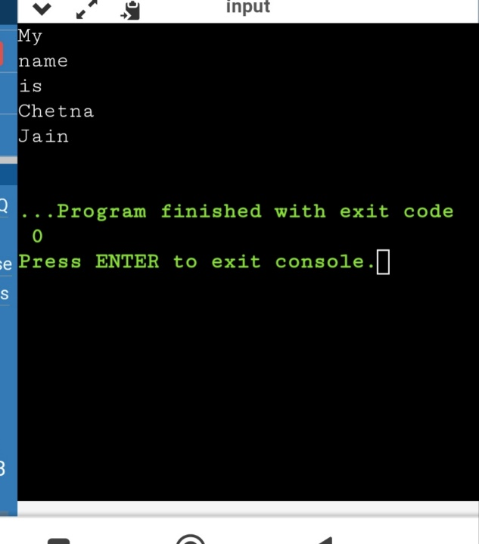



*25.Write a program to print the area and perimeter of a triangle having sides of 3, 4 and 5 units by creating a class named 'Triangle' without any parameter in its constructor.*

*Ans*

*class Triangle{*

*int a,b,c;*

*public double getArea(){*

*double s = (a+b+c)/2.0;*

*return Math.pow((s*(s-a)*(s-b)*(s-c)),.5);*

*}*

*public double getPerimeter(){*

*return (a+b+c);*

*}*

*}*

*class Ans{*

*public static void main(String[] args){*

*Triangle t = new Triangle();*

*t.a = 2;*

*t.b = 5;*

*t.c = 6;*

*System.out.println(t.getArea());*

*System.out.println(t.getPerimeter());*

*}*

*}*

**

*26. Write a program to print the area of two rectangles having sides (4,5) and (5,8) respectively by creating a class named 'Rectangle' with a method named 'Area' which returns the area and length and breadth passed as parameters to its constructor.*

*Ans*

*class Rectangle{*

*int length;*

*int breadth;*

*public Rectangle(int l, int b){*

*length = l;*

*breadth = b;*

*}*

*public int getArea(){*

*return length*breadth;*

*}*

*public int getPerimeter(){*

*return 2*(length+breadth);*

*}*

*}*

*class Ans{*

*public static void main(String[] args){*

*Rectangle a = new Rectangle(4,5);*

*Rectangle b = new Rectangle(5,8);*

*System.out.println("Area : "+a.getArea()+" Perimeter is" +a.getPerimeter());*

*System.out.println("Area : "+b.getArea()+" Perimeter is" +b.getPerimeter());*

*}*

*}*

**

*27. Print the sum, difference and product of two complex numbers by creating a class named 'Complex' with separate methods for each operation whose real and imaginary parts are entered by user.*

*Ans*

*import java.util.*;*

*class Complex{*

*int real;*

*int imag;*

*public Complex(int r, int i){*

*real = r;*

*imag = i;*

*}*

*public static Complex add(Complex a, Complex b){*

*return new Complex((a.real+b.real),(a.imag+b.imag));*

*}*

*public static Complex diff(Complex a, Complex b){*

*return new Complex((a.real-b.real),(a.imag-b.imag));*

*}*

*public static Complex product(Complex a, Complex b){*

*return new Complex(((a.real*b.real)-(a.imag*b.imag)),((a.real*b.imag)+(a.imag*b.real)));*

*}*

*public void printComplex(){*

*if(real == 0 && imag!=0){*

*System.out.println(imag+"i");*

*}*

*else if(imag == 0 && real!=0){*

*System.out.println(real);*

*}*

*else{*

*System.out.println(real+"+"+imag+"i");*

*}*

*}*

*}*

*class Ans{*

*public static void main(String[] args){*

*Complex c = new Complex(4,5);*

*Complex d = new Complex(9,4);*

*Complex e = Complex.add(c,d);*

*Complex f = Complex.diff(c,d);*

*Complex g = Complex.product(c,d);*

*e.printComplex();*

*f.printComplex();*

*g.printComplex();*

*}*

*}*

**