INTERNSHIP REPORT
ON
EXTERNAL AUDIT AT VIBHUTHI CORPORATE ADVISORY CONSULTANCY LLP
Submitted to Bangalore University in partial fulfilment of
Requirement for the award of the degree of Bachelor of Business
Administration



Submitted by
KEERTAN K DEVARAMANI
U03EU23M0068
VI Semester BBA

Under the Guidance of
Asst.Prof. Nikhil Gangadhar



INTERNATIONAL SCHOOL OF MANAGEMENT EXCELLENCE
88, Chembanahalli, Sarjapur Road,
Dommasandra, Bengaluru, Karnataka 562125
2025-26

COLLEGE CERTIFICATE

This is to certify that Shri Keertan K Devaramani, a VI Semester BBA student bearing Register Number U03EUM0068, has successfully completed his internship as an External Audit Intern at Vibuthi Consultants during the period from 13th February to 28th February.

Throughout the internship, he demonstrated outstanding dedication, diligence, and professionalism in carrying out his assigned responsibilities. He showed a strong eagerness to learn and made meaningful contributions toward achieving the objectives of the assignment.

Date :
Signature :

Head of Department Principal

GUIDE CERTIFICATE

This is to certify that Shri/Kumar Keertan K Devaramani of the International School of Management Excellence College has successfully completed the internship at Vibhuti Consultants LLP in the period of (13th February to 28th February). During the internship period Shri/Kumar Keertan K Devaramani demonstrated exceptional dedication, diligence, and professionalism in executing their assigned tasks. They exhibited a keen interest in learning and actively contributed to the project's objectives.

Date:-
Name :
Signature :

COMPANY LETTERHEAD

Date: 13th February 2026
Student Name: Keertan K Devaramani
Student College Address: 88, Chembanahalli, Sarjaur Road, Dommasandra, Bengaluru, Karnataka 562125

Keertan K Devaramani,
We are pleased to inform you that you have been accepted into the internship program at Vibhuti Consultants. We were impressed with your application and believe that you will make a valuable contribution to our team.

Internship Details:
Duration of Internship: from 13th February to 28th February.
Internship — VIBUTHI CONSULTANTS.

Role/Position:
External auditor.
Department: Risk and Compliance.
We look forward to welcoming you to our team and providing you with a valuable learning experience.

Thank you,
Yours Sincerely

COMPANY LETTERHEAR

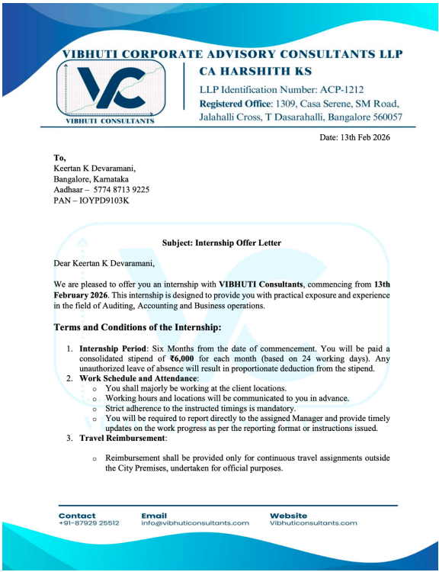



INTERSHIP COMPLETION CERTIFICATE

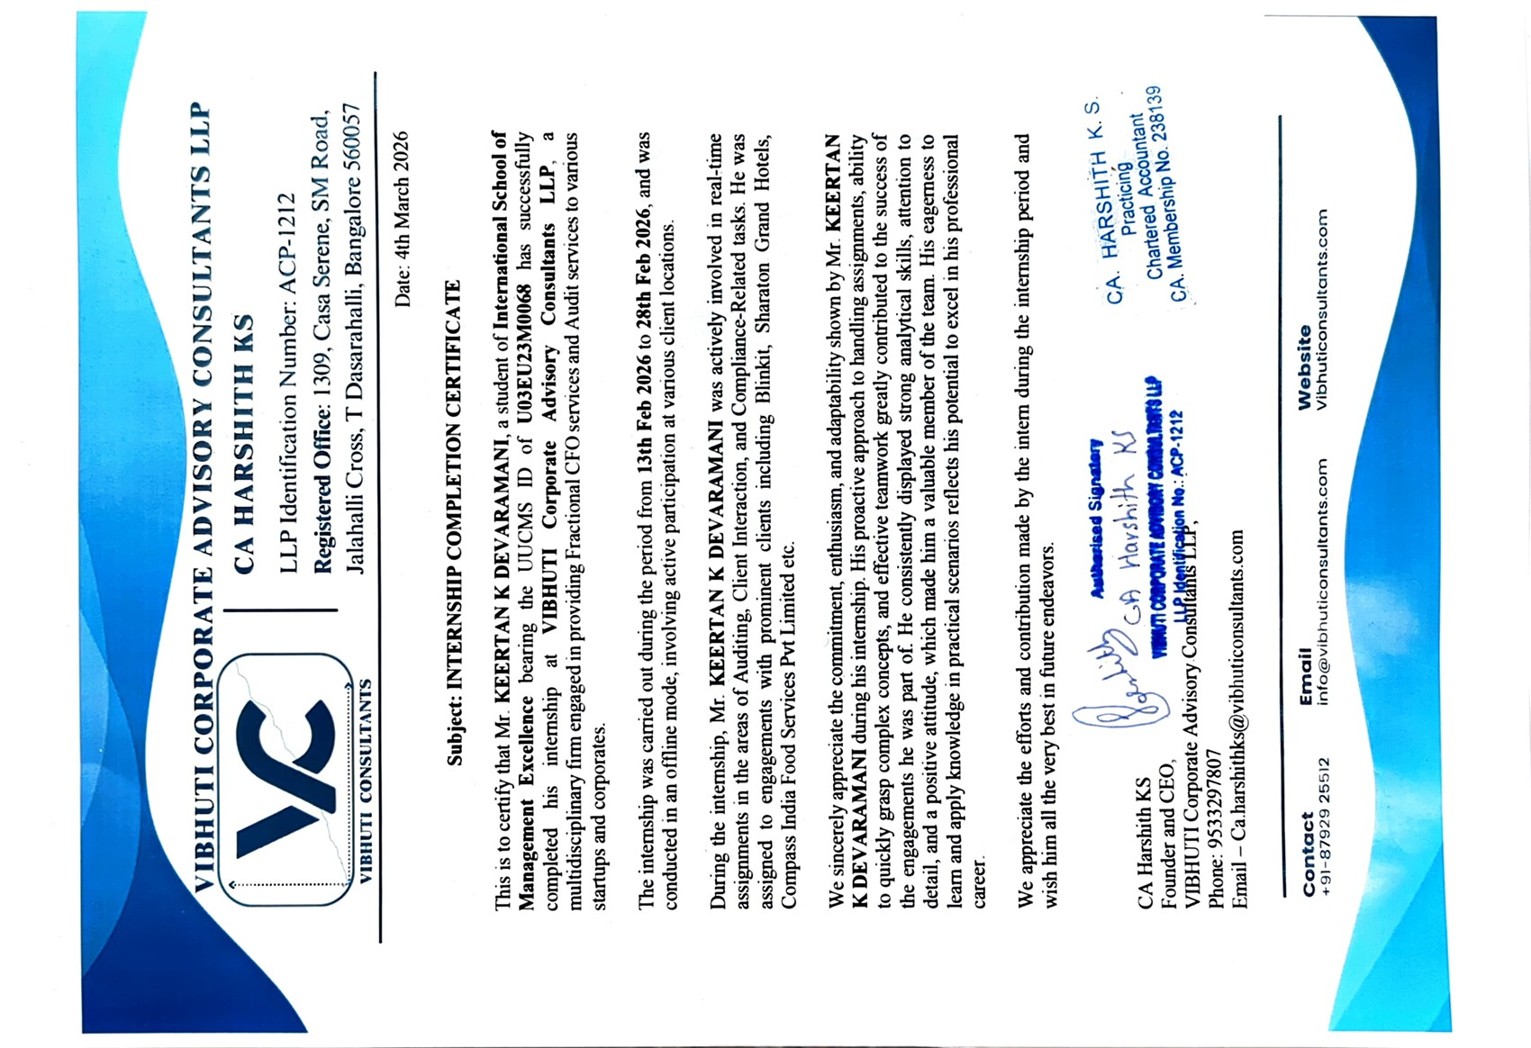

STUDENT DECLARATION

I, Keertan K Devaramani, a student of Bachelor of Business Administration at the International School of Management Excellence, hereby declare that I successfully completed my internship at Vibhuti Consultants from 13th February to 28th February.

During the internship period, I worked across the departments of Auditing, Accounting, and Business Operations, where I performed the tasks assigned to me under proper supervision. The experience gained during this period has enhanced my practical knowledge and professional skills.

I further declare that the information provided above is true and accurate to the best of my knowledge.

Place :
Date :
Signature :

ACKNOWLEDGEMENT

I would like to express my sincere gratitude to everyone who contributed to the successful completion of my internship report.

First and foremost, I extend my heartfelt thanks to my esteemed mentor, Prof. Nikhil, for his constant guidance, support, and encouragement throughout the internship. His valuable insights and mentorship played a significant role in enriching my learning experience.

I am also deeply thankful to the entire team at Vibhuti Consultants for providing me with the opportunity to gain practical exposure. Their cooperation, support, and collaborative work environment made my internship both productive and rewarding.

I would like to convey my appreciation to the International School of Management Excellence and its faculty members for equipping me with the academic foundation necessary to undertake this internship. The knowledge and skills imparted by them enabled me to apply theoretical concepts effectively in a professional setting.

Finally, I am sincerely grateful to my family and friends for their continuous encouragement and unwavering support throughout this period. Their motivation helped me stay focused and overcome challenges during the internship.

This internship has been a valuable learning experience, and I am truly thankful for the knowledge and skills gained, which will serve as a strong foundation for my future career.

TABLE OF CONTENTS
Chapter No | Particulars | Page  No
1 | Introduction  (Focus, Objective, Scope & Limitations.) | 7 – 10
2 | Company / Organization Profile  (Brief History, Services rendered, Core Performance & Organization Chart.) | 11 - 14
3 | Work Experience  (Brief Summary of Work done for all the weeks interned.) | 15 – 22
4 | Observations & Conclusions  (Observations, Conclusions & Information Summary.) | 23 – 28
5 | Internship Information Summary. | 29 – 38
Annexure | Attendance Report | 38 - 40

EXECUTIVE SUMMARY

Introduction
Vibhuti Corporate Advisory Consultants LLP is a professional services firm engaged in providing advisory, audit, accounting, and business consulting services to a diverse range of clients. The firm focuses on delivering practical, compliance-oriented, and value-driven solutions that support organizations in achieving financial transparency, operational efficiency, and regulatory compliance.

The firm offers services across key areas such as statutory and internal audits, financial reporting, accounting support, tax compliance, risk assessment, and business advisory. Through a structured and analytical approach, Vibhuti Corporate Advisory Consultants LLP assists clients in strengthening internal controls, improving financial management practices, and ensuring adherence to applicable laws and standards.
With a client-centric approach, the firm emphasizes accuracy, integrity, and professionalism in all engagements. Its team of qualified professionals works closely with clients to understand their operational challenges and provide tailored solutions that align with their business objectives.
During the internship period, exposure to various departments including auditing, accounting, and business operations provided practical insight into real-world financial processes, compliance frameworks, and corporate advisory practices. The experience contributed significantly to understanding the integration of theoretical concepts with professional application.

This report presents a structured overview of the organization, details of work carried out, discussion of audit engagements, observations and conclusions, challenges faced, and overall learning outcomes. The objective of this report is to analyse the internship experience in a systematic manner and evaluate how effectively it contributed to professional development.
Overall, the internship served as an important step in strengthening technical knowledge, improving analytical ability, and enhancing readiness for a career in auditing and finance.

ABOUT COMPANY

Vibhuti corporate advisory Consultants LLP is a Bengaluru-based professional advisory firm that specializes in finance, taxation, compliance, and strategic business support. Located in one of India’s most dynamic entrepreneurial ecosystems, the firm serves startups, small and medium enterprises (SMEs), and growing businesses that require structured financial management and regulatory guidance. In an increasingly complex business environment, VIBHUTI Consultants positions itself not merely as a compliance service provider, but as a strategic partner supporting sustainable growth.

Bengaluru, often referred to as India’s startup capital, is home to thousands of emerging companies across technology, fintech, SaaS, healthcare, retail, and services. Many of these businesses focus heavily on product development and market expansion, often overlooking financial structure and compliance systems during early stages. VIBHUTI Consultants addresses this gap by offering integrated financial and advisory services that enable businesses to operate efficiently while meeting regulatory standards.

Core Services
The firm provides a comprehensive range of professional services centred around five key areas: financial advisory, taxation, accounting, audit support.

Financial Advisory and Strategic Planning
Financial clarity is fundamental for any business aiming to grow responsibly. VIBHUTI Consultants assists organizations in budgeting, forecasting, cash flow planning, and financial modelling. These services help businesses allocate resources effectively, manage working capital, and prepare structured projections for investors or lenders. By supporting data-driven decision-making, the firm enables clients to plan expansion with greater confidence and control.

Taxation and Compliance
India’s tax framework includes direct taxes, indirect taxes such as GST, and various statutory requirements. Non-compliance can result in penalties, legal complications, and reputational

damage. VIBHUTI Consultants provides taxation advisory, filing support, and compliance management to ensure that businesses meet regulatory obligations on time.

Accounting and Bookkeeping
Accurate financial records form the foundation of transparency and performance analysis. The firm offers bookkeeping, financial statement preparation, payroll support, reconciliations, and management reporting. For startups and SMEs without internal finance departments, outsourced accounting services offer professional expertise while reducing operational costs. Reliable accounting practices improve decision-making and enhance credibility with stakeholders.

Audit and Assurance Support
Audit readiness is critical for businesses seeking funding or institutional partnerships. VIBHUTI Consultants assists companies in strengthening internal controls, reviewing compliance processes, and coordinating audit requirements. By identifying potential risks early and improving documentation systems, the firm helps clients build governance frameworks that support long-term stability.

Commitment to Professional Standards
Trust and confidentiality are central to any advisory relationship. Clients share sensitive financial information and strategic plans, requiring a high level of integrity and professionalism. VIBHUTI Consultants emphasizes ethical practices, transparency, and regulatory adherence in all client engagements.
The leadership’s multidisciplinary expertise in accounting, taxation, and corporate regulations further strengthens the firm’s credibility. Such qualifications enable the delivery of integrated solutions that address financial, legal, and compliance dimensions simultaneously.

Technology and Efficiency
Modern advisory services increasingly rely on digital tools and cloud-based accounting platforms. VIBHUTI Consultants incorporates technology to streamline reporting, reduce
manual errors, and improve efficiency. Real-time data access allows businesses to track performance indicators and financial metrics with greater accuracy.

Digital integration not only improves operational efficiency but also enhances compliance management by ensuring timely filings and accurate documentation. In a data-driven business environment, technology-enabled advisory support provides a significant advantage.

Conclusion
VIBHUTI Consultants represents a modern professional advisory firm dedicated to strengthening financial and compliance systems for businesses in Bengaluru, Karnataka. By offering comprehensive services across financial advisory, taxation, accounting, audit support, the firm supports organizations in achieving structured growth and regulatory stability.

In an increasingly complex and competitive business environment, companies require more than transactional service providers—they need strategic advisors who combine technical expertise with practical insight. VIBHUTI Consultants fulfilment this role by integrating financial discipline with business strategy, empowering enterprises to operate confidently and sustainably.

Discussion/Findings
Discussions :
- Role of Advisory Firms in Business Growth
Consulting firms contribute beyond compliance by supporting strategic decision-making.
- Increasing Regulatory Environment
Businesses require professional guidance due to growing compliance complexity.
- Value of Ethical Practices
Confidentiality and integrity are essential for maintaining client trust.
- Proactive vs Reactive Approach
Structured financial planning prevents future compliance and operational issues.
- Importance of Communication
Clear coordination between consultants and clients ensures timely compliance.

Findings :
- Need for Accurate Bookkeeping :
  - Accurate bookkeeping is fundamental to maintaining reliable financial records and ensuring transparency in business operations.
  - During various audit assignments, it was observed that discrepancies in stock records and asset registers often arise due to delayed entries, improper documentation, or lack of systematic record maintenance.
- Continuous Compliance Requirement :
  - Organizations, especially in regulated sectors such as banking, must continuously adhere to statutory and regulatory requirements.
  - Compliance is not a one-time activity but an ongoing process that involves proper documentation, timely filings, and adherence to financial reporting standards.
- Importance of Cash Flow Management :
  - Effective cash flow management is critical for sustaining daily operations and maintaining financial stability.
  - Even profitable organizations may face operational difficulties if cash inflows and outflows are not properly monitored.
- Technology Improves Efficiency :
  - The exposure to ERP systems such as SAP demonstrated how technology enhances efficiency, accuracy, and transparency in financial reporting.
  - Automated systems reduce manual errors, improve data accessibility, and strengthen internal controls.

CHAPTER 1- INTRODUCTION

CHAPTER 1- INTRODUCTION
Vibhuti Corporate Advisory Consultants LLP is a professional services firm specializing in audit, accounting, taxation, and corporate advisory services. The firm provides comprehensive financial and compliance solutions to businesses across various sectors, supporting them in maintaining transparency, regulatory compliance, and operational efficiency.

The organization operates with a strong emphasis on professional ethics, accuracy, and client-focused service delivery. By offering services such as statutory audits, internal audits, accounting support, financial reporting, and business advisory, the firm assists clients in strengthening internal controls and improving financial decision-making processes.

Location of the Facility
The firm’s office is located in Bangalore, Karnataka, a major commercial and financial hub in India. The strategic location enables the firm to serve a diverse portfolio of clients, including small and medium enterprises, startups, and corporate entities.

Main Emphasis of My Experience
During my internship, the primary emphasis of my experience was on gaining practical exposure in the areas of Auditing, Accounting, and Business Operations.
In Auditing, I observed and assisted in verification procedures, documentation review, and compliance checks, which enhanced my understanding of audit methodologies and internal control systems.

In Accounting, I gained exposure to financial record maintenance, reconciliation processes, and preparation of financial statements.
In Business Operations, I developed an understanding of operational workflows, coordination between departments, and the practical implementation of financial policies.
The internship provided valuable insight into how theoretical concepts learned in B.Com are applied in a real corporate environment. It strengthened my analytical thinking, attention to detail, and professional communication skills.

PROJECT DETAILS

1. Objectives of the Project
The primary objectives of the internship at Vibhuti Corporate Advisory Consultants LLP were:
- To gain practical exposure to auditing, accounting, and business operations in a professional environment.
- To understand the application of accounting principles and audit procedures in real business scenarios.
- To develop analytical and documentation skills required in audit and financial reporting assignments.
- To bridge the gap between theoretical knowledge acquired during B.Com and its practical implementation.

2. Scope of the Project
The scope of the internship covered exposure to:
- Internal and external audit procedures
- Verification and review of financial documents
- Accounting entries and ledger scrutiny
- Operational workflow understanding within a consultancy firm
- The project was limited to supervised assistance and observation-based learning within assigned departments.

3. Methodology Adopted
The methodology followed during the internship included:
- Reviewing financial records such as invoices, vouchers, and ledgers
- Observing internal control mechanisms
- Assisting in preparation of audit documentation and working papers
- Interacting with team members to understand compliance requirements
- Learning was achieved through practical involvement, guided supervision, and observation of professional practices.

4. Tools and Techniques Used
During the internship, exposure was gained to:
- MS Excel for data analysis and reconciliation
- Accounting software for recording and reviewing transactions
- Audit documentation formats and working paper preparation
- Ledger scrutiny and variance analysis techniques
- Bank reconciliation procedures
These tools helped in understanding structured financial analysis and reporting.

5. Learning Outcomes
The internship resulted in the following key outcomes:
- Improved understanding of audit processes and internal control systems
- Enhanced practical knowledge of accounting procedures
- Strengthened analytical and problem-solving skills
- Better documentation and professional communication skills
- Increased awareness of regulatory compliance and financial discipline
Overall, the internship provided practical insight into corporate advisory operations and contributed significantly to professional development.

6. Contributions
The internship resulted in the following key outcomes:
- Improved understanding of audit processes and internal control systems
- Enhanced practical knowledge of accounting procedures
- Strengthened analytical and problem-solving skills
- Better documentation and professional communication skills
- Increased awareness of regulatory compliance and financial discipline
Overall, the internship provided practical insight into corporate advisory operations and contributed significantly to professional development.

CHAPTER 2- PROFILE OF THE ORGANISATION

CHAPTER 2- PROFILE OF THE ORGANISATION
Overview
Vibhuti Corporate Advisory Consultants LLP is a professional services firm based in Bangalore, Karnataka, engaged in providing audit, accounting, taxation, and corporate advisory services. The firm primarily supports small and medium enterprises (SMEs), startups, and growing businesses in maintaining financial discipline, regulatory compliance, and operational efficiency.
The organization operates as a Limited Liability Partnership (LLP), combining professional expertise with structured service delivery.

2. Main Areas of Activities
The core activities of the firm include:
Statutory and Internal Audits – Conducting financial audits to ensure compliance with applicable laws and standards.
Accounting and Bookkeeping Services – Maintaining books of accounts, ledger scrutiny, and financial reporting.
Taxation Services – Assisting clients with GST compliance, income tax filings, and related advisory.
Corporate Advisory – Providing guidance on financial structuring, compliance management, and operational improvements.
Risk and Compliance Services – Supporting businesses in strengthening internal control systems.
The firm focuses on accuracy, compliance, and practical business solutions.

3. Business Model
- The business model of Vibhuti Corporate Advisory Consultants LLP is primarily service-based and relationship-driven.
- Revenue is generated through professional fees charged as per the services.
- The firm builds long-term relationships with clients by offering continuous support.
- It follows a client-centric approach, where services are customized based on the size, nature, and regulatory requirements of each client.

4. Services Offered
The firm offers:
- Audit and assurance services
- Accounting and financial statement preparation
- GST and income tax compliance services
- Financial consulting and advisory
- Business process review and operational support
These services are aimed at ensuring transparency, financial accuracy, and compliance with statutory regulations.

5. Client Base
The client base primarily includes:
- Small and Medium Enterprises (SMEs)
- Startups and emerging businesses
- Retail and service sector entities
- Proprietorships, partnerships, and private limited companies
- The firm caters to businesses that require professional financial oversight but may not have large in-house finance teams.

6. Corporate Philosophy
The firm operates on the principles of:
- Integrity and ethical conduct
- Professional competence
- Accuracy and accountability
- Client confidentiality
- Continuous learning and improvement
- The emphasis is on delivering reliable and compliant financial solutions while maintaining professional standards.

7. Organizational Structure
The firm follows a structured yet compact hierarchical system, which typically includes:
- Partners / Managing Partners

- Senior Associates / Audit Seniors
- Audit and Accounts Executives
- Interns and Trainees
- Decision-making authority rests with the partners, while execution and reporting responsibilities are distributed across team members under supervision.

8. Growth Prospects
With increasing regulatory requirements, GST compliance norms, and demand for financial transparency, the growth prospects for professional advisory firms remain strong.
Vibhuti Corporate Advisory Consultants LLP has potential for expansion through:
Technology integration in accounting and audit processes.

CHAPTER 3- WORK EXPERIENCE

CHAPTER 3- WORK EXPERIENCE
Learning Agreement and Learning Objectives Purpose of internship at the company.
- The purpose of this internship is to bridge the gap between academic knowledge and practical industry exposure. The internship aims to provide hands-on experience in accounting, auditing, financial reporting, internal controls, and business operations within a professional environment.
- Apply theoretical concepts (IFRS, auditing standards, financial analysis) in real-world scenarios .Understand how internal control systems operate in practice. Gain exposure to documentation, compliance, and reporting processes .Develop professional ethics and workplace discipline.

Reasons for Choosing the Particular Company
1. What was the purpose of your internship at the company?
The primary purpose of my internship was to gain practical exposure to audit procedures, asset verification processes, and stock audit assignments across different industries. The internship aimed to bridge the gap between academic knowledge and real-world financial auditing practices.
Through assignments such as fixed asset tagging, SAP audit exposure, and inventory verification at corporate entities, the objective was to understand how audit methodologies are implemented in live business environments and how internal controls are tested in practice.

2. What made you choose that particular company/firm/organization for your internship?
I chose this firm because of its strong involvement in audit assignments across reputed organizations including banks, IT companies, and multinational corporations. The opportunity to participate in diverse audit engagements such as:
- Fixed asset verification at Sheraton Grand Hotel
- Stock audits at Blink it Commerce Pvt Ltd.
- Stock Audit of COMPASS (Amazon development centre, SAP labs, GOC services, Northern Operating services)
- Full inventory audit at CPU Bangalore
provided practical, field-based exposure rather than purely desk-based training. The firm offered hands-on audit assignments across multiple sectors, which aligned with my academic background in BBA and my professional interest in auditing and finance.

3. Describe the specific area(s) of internship or training.
The internship focused on the following specific areas:
- Fixed Asset Audit – Asset tagging and physical verification.
- Stock Audit and Inventory Verification
- Kitchen inventory audits at COMPASS (Amazon development centre, SAP labs, GOC services, Northern Operating services)
- Stock audit at Blink it Commerce Pvt Ltd
- Full inventory verification at CPU Bangalore
- The training emphasized physical verification, reconciliation with records, compliance checks, and documentation of audit findings.

4. In which department(s) of the company was the internship taken? Describe the business unit, its concentration, and objectives.
- The internship was undertaken primarily in the Audit Department, particularly in the External Audit and Stock Audit division.
- Business Unit Concentration:
- Conducting physical verification of assets and inventory
- Evaluating internal controls
- Ensuring accuracy of financial records
- Supporting compliance with statutory and regulatory requirements
- Objectives of the Business Unit:
- To ensure that assets recorded in books physically exist
- To verify stock quantities and prevent misstatements
- To assess compliance with accounting and audit standards
- To reduce risk of financial discrepancies or misreporting
- The department focuses on accuracy, risk detection, and strengthening financial transparency.

5. What responsibilities or assignments were given to you?
During the internship, I was assigned the following responsibilities:
- Conducted fixed asset tagging and physical verification at Sheraton Grand
- Performed stock counting and reconciliation during kitchen inventory audits at COMPASS (Amazon development centre, SAP labs, GOC services, Northern Operating services)
- Assisted in Blink it Commerce Pvt Ltd stock audit procedures.
- Conducted full inventory verification at CPU Bangalore.
Compared physical stock with system records and reported discrepancies under supervision.
Supported preparation of audit working papers and documentation.
These assignments enhanced my practical understanding of audit execution, documentation standards, and internal control evaluation.

EXTERNAL AUDIT INTERNSHIP

DISCUSSION – MAIN BODY OF THE INTERNSHIP REPORT
1. Overview of Internship Engagement
During my internship in the Audit and Assurance Division, I was involved in multiple audit engagements across diverse sectors including IT services, Hotel and multinational corporate offices. The internship provided practical exposure to fixed asset audits, and multiple stock verification assignments.
- The primary focus of my work included:
- Evaluation of internal control systems
- Physical verification of fixed assets and inventory
- Reconciliation of records with physical evidence
- Identification of risks related to misstatement and weak controls
The internship enabled me to apply theoretical audit concepts in real-world professional environments.

2. Fixed Asset Audit – Sheraton Grand Hotel
(Asset Tagging and Physical Verification)
2.1 Objective
To verify the physical existence of fixed assets recorded in the asset register and ensure proper identification and control.

2.2 Work Performed
- Conducted physical verification of assets.
- Cross-checked asset codes, descriptions, and locations with records.
- Tagged unlabelled assets with identification labels.
- Reported discrepancies such as missing or unrecorded assets.

2.3 Audit Significance
This assignment addressed the existence and completeness assertions of fixed assets. It highlighted risks such as asset misappropriation, outdated asset registers, and weak monitoring controls.

3. Stock Audit and Inventory Verification Assignments
Stock Audit – at COMPASS (Amazon development centre, SAP labs, GOC services, Northern Operating services)
Objective
- To verify physical kitchen inventory and reconcile it with recorded balances.
- Work Performed
- Conducted physical counting of inventory items.
- Compared physical quantities with system records.
- Identified shortages or excess stock.
Assisted in documentation.
Audit Significance
Addressed existence and accuracy assertions, emphasizing control over consumable inventory.

3.1 Stock Audit – Amazon development centre (Kitchen Inventory)
Objective
To verify kitchen inventory and ensure proper stock recording.
Work Performed
- Conducted physical verification.
- Matched quantities with stock registers.
- Reported discrepancies.
Audit Significance
Highlighted risks of wastage, pilferage, and improper record maintenance.

3.2 Stock Audit – SAP labs (Kitchen Inventory)
Objective
To validate recorded kitchen inventory through physical verification.
Work Performed
- Conducted stock counting procedures.
- Reconciled physical and recorded quantities.
- Assisted in documentation.
Audit Significance
Emphasized accuracy, documentation standards, and structured corporate inventory controls.

3.3 Stock Audit – GOC services Pvt Ltd (Kitchen Inventory)
Objective
- To ensure physical stock matches recorded inventory balances.
- Work Performed
- Conducted physical verification of stock.
- Compared quantities with system records.
- Reported discrepancies under supervision.
Audit Significance
Reinforced importance of regular verification to prevent misstatement and control weaknesses.

3.4 Stock Audit – Northern Operating services (Kitchen Inventory)
Objective
To ensure physical stock matches recorded inventory balances.
- Work Performed
- Conducted physical verification of stock.
- Compared quantities with system records.
- Reported discrepancies under supervision.
Audit Significance
Reinforced importance of regular verification to prevent misstatement and control weaknesses.

4. Stock Audit – Blink it Commerce Pvt Ltd (Retail Stock)
Objective
To verify retail stock and ensure accuracy of inventory records.
- Conducted physical stock count.
- Cross-verified quantities with inventory records.
- Reported discrepancies.
Audit Significance
Focused on inventory accuracy and control risk, especially in high-volume retail operations.

5. Full Inventory Audit – CPU Bangalore
Objective
- To perform comprehensive verification of all inventory categories.
- Conducted complete physical inventory verification.
- Categorized and documented stock items.
- Reconciled inventory with accounting records.
Audit Significance
Addressed existence, completeness, and valuation risks, providing exposure to large-scale inventory control procedures.

6. Documentation and Working Paper Preparation
- Across all assignments, I assisted in:
- Recording audit observations
- Preparing and organizing working papers
- Maintaining documentation trails
- Reporting discrepancies to supervising auditors
This strengthened my understanding of audit evidence, documentation standards, and professional reporting requirements.

7. Overall Analytical Understanding
The internship significantly enhanced my understanding of:
- Audit assertions (existence, completeness, accuracy, valuation)
- Internal control evaluation
- Risk-based audit approach
- Compliance verification
- Reconciliation procedures
- Industry-specific audit variations
Exposure across multiple industries demonstrated that while audit principles remain consistent, procedures vary depending on regulatory requirements, operational scale, and risk exposure.
Overall, the internship transformed theoretical audit knowledge into practical experience, strengthened my analytical ability, improved attention to detail, and enhanced my understanding of financial risk management and compliance frameworks.

CHAPTER 4 - OBSERVATIONS & CONCLUSIONS

CHAPTER 4 - OBSERVATIONS & CONCLUSIONS
This section summarizes the extent to which the objectives of the internship were achieved and evaluates the overall learning experience in an objective manner.

Observations
The primary objective of the internship was to gain practical exposure to audit procedures, internal control evaluation, and inventory verification across different industries. Based on the assignments undertaken, the following observations were made:
The internship successfully provided hands-on exposure to real-time audit engagements, including fixed asset verification and stock audits.
Physical verification remains a critical audit procedure even in organizations using Excel.
Stock audits revealed that discrepancies may arise from recording delays, operational inefficiencies, or weak control mechanisms, reinforcing the importance of periodic reconciliation. Audit documentation and working papers are essential in supporting conclusions and maintaining accountability within professional engagements.

Conclusion
The objectives of the internship were substantially fulfilled. The exposure to multiple audit environments enabled practical application of theoretical concepts such as audit assertions (existence, completeness, accuracy, valuation), risk assessment, and internal control evaluation.
The internship enhanced technical understanding of:
- Asset control procedures
- Inventory verification methods
- ERP-based financial systems
- Risk-based audit approach
It also contributed to the development of professional skills including attention to detail, documentation discipline, teamwork, and structured analytical thinking.
Overall, the internship provided meaningful industry exposure and strengthened my understanding of audit practices and compliance frameworks.
The learning experience effectively bridged the gap between academic study and professional application, meeting the intended objectives of the training period.

ACHIEVEMENTS AND CONTRIBUTIONS
Achievements
During the internship period, the following key achievements were accomplished:
Successful Participation in Multiple Audit Engagements
Actively contributed to fixed asset audits, and several stock audit assignments across different industries.
Accurate Physical Verification and Reconciliation
Assisted in conducting physical verification of assets and inventory, ensuring alignment between physical stock and recorded balances.
Development of Practical Audit Competency
Gained hands-on understanding of audit assertions such as existence, completeness, accuracy, and valuation, and observed their practical application.
Exposure to Industry Diversity
Worked across , IT services, stores, and corporate environments, enhancing adaptability and sector-specific understanding.
Improved Documentation Skills
Contributed to the preparation and organization of working papers and audit documentation in accordance with professional standards.

Contributions
During the internship, I contributed to the organization in the following ways:
Support in Fixed Asset Tagging and Verification
Assisted in tagging and verifying assets, helping maintain updated and accurate asset records.
Assistance in Stock Audits Across Multiple Locations
Contributed to efficient stock counting and reconciliation processes at various client sites, supporting timely completion of audit assignments.
Support in Audit Documentation
Helped in organizing audit evidence and working papers, ensuring proper documentation and compliance with audit requirements.

Team Coordination and Field Support
Actively participated in field audit teams, supporting supervisors in verification procedures and operational tasks.
Enhancing Efficiency in Field Assignments
By assisting in systematic counting and verification processes, contributed to smoother execution of audit engagements.
Overall, the internship not only strengthened my professional competencies but also allowed me to contribute meaningfully to audit assignments under supervision. The experience enhanced both technical knowledge and practical efficiency in audit-related tasks.

BRIDGING GAP BETWEEN PRACTICAL AND THEORETICAL KNOWLEDGE
The internship played a significant role in connecting theoretical concepts studied in the BBA curriculum with real-world audit practices. While academic learning provides foundational knowledge of accounting principles, audit procedures, and financial reporting standards, practical exposure demonstrated how these concepts are implemented in professional environments.
In theory, audit assertions such as existence, completeness, accuracy, and valuation are studied conceptually. During the internship, these assertions were practically applied through fixed asset verification, stock audits, and reconciliation procedures. For example, physical verification of assets at the Sheraton Grand Hotel directly addressed the existence assertion, while stock audits at various organizations demonstrated how discrepancies affect valuation and financial reporting.
Similarly, academic study of internal controls and risk management was reinforced through observation of ERP-based controls in SAP systems and structured audit processes . The internship clarified how internal control weaknesses can increase audit risk and why documentation and compliance are critical in professional practice.
Theoretical understanding of inventory management and accounting entries was strengthened through hands-on stock counting, reconciliation with system records, and identification of variances. This practical involvement improved my analytical thinking and attention to detail.

Overall, the internship effectively bridged the gap between classroom knowledge and professional application. It transformed abstract concepts into practical skills, enhanced my understanding of audit methodology, and prepared me for real-world financial environments.

IMMERSION IN ADVANCED TECHNOLOGIES AND CORPORATE CULTURE
During the internship, I gained meaningful exposure to advanced technological systems and professional corporate environments, which significantly enhanced my understanding of modern auditing practices.
Exposure to Advanced Technologies
One of the key technological exposures was observing audit procedures in organizations using Enterprise Resource Planning (ERP) systems such as SAP and excel. This provided insight into:
- System-based transaction recording and financial reporting
- Automated controls and data integrity mechanisms
- User access controls and segregation of duties
- Generation and review of system-based audit reports
The experience demonstrated how technology plays a central role in maintaining financial accuracy and strengthening internal control frameworks. It highlighted that modern auditing increasingly relies on data-driven verification rather than solely manual inspection.
Additionally, the use of digital documentation, structured working papers, and systematic reconciliation procedures emphasized the integration of technology in audit efficiency and compliance monitoring.

Understanding Corporate Culture
The internship also provided exposure to structured corporate environments across multinational and regulated institutions. Key observations included:
- Professional communication standards in client interactions
- Strict adherence to timelines and reporting formats
- Emphasis on confidentiality and ethical conduct
- Clear delegation of responsibilities within audit teams
- Collaborative teamwork during field assignments

Working in organizations such as banks and multinational corporations demonstrated the importance of discipline, accountability, and compliance in professional settings.

Overall Impact
The immersion in both advanced technological systems and corporate work culture enhanced my adaptability, professionalism, and technical awareness. It strengthened my ability to function effectively in structured business environments and prepared me for future roles in finance and audit domains.

FINAL THOUGHTS AND CONCLUSION
The internship provided comprehensive exposure to professional auditing practices across multiple industries, including telecommunications, banking, IT services, Hotels and multinational corporate environments. Through active participation in fixed asset audits, SAP system exposure, and extensive stock verification assignments, the internship successfully fulfilled its primary objective of providing practical audit experience.
The experience reinforced the importance of internal controls, accurate documentation, compliance with regulatory standards, and risk-based audit approaches. It became evident that while theoretical knowledge forms the foundation of accounting and auditing, practical execution requires analytical judgment, attention to detail, and professional discipline.
Exposure to ERP systems such as SAP highlighted the increasing reliance on technology in modern auditing. Similarly, participation in field audits demonstrated the continued importance of physical verification procedures in validating financial records. The internship also strengthened my understanding of audit assertions, reconciliation techniques, and working paper preparation. Beyond technical knowledge, the internship enhanced professional competencies such as teamwork, time management, communication, and adaptability in structured corporate environments. Observing different organizational cultures helped me understand the importance of ethics, confidentiality, and accountability in professional practice.
In conclusion, the internship effectively bridged the gap between academic learning and real-world application. It provided meaningful industry exposure, strengthened my analytical capabilities, and prepared me for future roles in auditing and finance. The experience has contributed significantly to both my academic development and professional readiness.

CHAPTER 5 - INTERNSHIP INFORMATION SUMMARY

CHAPTER 5 - INTERNSHIP INFORMATION SUMMARY
Internship Experience
The internship experience was both practical and transformative, providing direct exposure to real-time audit engagements across various industries. It allowed me to move beyond theoretical classroom learning and understand how auditing functions in dynamic business environments.
Through assignments such as fixed asset verification, SAP system exposure, Hotel Audit, and multiple stock audit engagements, I gained hands-on experience in physical verification procedures, reconciliation processes, documentation standards, and internal control evaluation. Working across different sectors helped me understand how audit approaches vary depending on regulatory requirements, operational scale, and risk exposure.

The experience also enhanced my professional competencies. I developed greater attention to detail, analytical thinking, and structured documentation skills. Field audits improved my ability to work in teams, adapt to different client environments, and manage responsibilities under supervision. Observing corporate work culture strengthened my understanding of discipline, confidentiality, and professional ethics.
Overall, the internship was a valuable learning phase that significantly contributed to my technical knowledge, practical exposure, and professional development. It provided clarity regarding audit practices and strengthened my interest in pursuing a career in auditing and finance.

Challenges faced during internship
During the internship, several challenges were encountered, which contributed significantly to my professional growth and learning experience.

1. Adapting to Real-Time Audit Environments
Transitioning from theoretical academic learning to practical audit assignments was initially challenging. Unlike classroom problems, real-world audits require quick understanding of business processes, practical judgment, and immediate application of concepts under time constraints.

2. Understanding Industry-Specific Processes
Since the assignments were across diverse sectors such as Hotels, retail, and multinational corporate offices, each organization had different operational systems and documentation practices. Adapting to varying environments and understanding sector-specific workflows required continuous learning and observation.

3. Handling Large-Scale Inventory Verification
In stock audits, especially during full inventory verification assignments, managing large quantities of items and ensuring accurate counting within limited timeframes was demanding. Maintaining precision while working efficiently required strong concentration and systematic coordination.

4. ERP System Complexity
During SAP audit exposure, understanding system-generated reports and access control mechanisms required familiarity with ERP structures. As a student without prior in-depth ERP experience, interpreting system data initially required additional guidance.

5. Maintaining Documentation Standards
Audit documentation demands high accuracy and structured working papers. Ensuring completeness, clarity, and proper recording of observations under professional standards required careful attention and discipline.

6. Time and Field Coordination
Field audits required punctuality, coordination with team members, and adherence to strict timelines. Adjusting to a professional schedule and maintaining productivity throughout field assignments was an important learning curve.

Overall Learning from Challenges
These challenges enhanced my adaptability, attention to detail, analytical ability, and professional discipline. Each difficulty encountered contributed to developing practical competence and a better understanding of audit procedures and workplace expectations.

Kind of Business Experience Gained
The internship provided practical exposure to diverse business environments and operational frameworks across multiple industries, including Hotels, IT services, retail, and multinational corporate offices.

1. Exposure to Multi-Industry Operations
Working on audit assignments across different sectors helped me understand how business models, operational processes, and control systems vary depending on the nature of the industry. For example:
- Hotel operations emphasized regulatory compliance and structured documentation.
- Retail environments focused on inventory turnover and stock accuracy.
- Corporate offices required systematic control over assets and consumable inventory.
This exposure broadened my understanding of how financial management practices differ across industries.

2. Practical Audit and Compliance Experience
The internship provided hands-on experience in:
- Fixed asset verification and tagging
- Stock audit and inventory reconciliation
- Review of financial documentation
- Exposure to ERP-based systems such as SAP
This strengthened my understanding of compliance procedures, risk assessment, and internal control evaluation in real business settings.

3. Understanding of Internal Control Systems
Through physical verification and reconciliation processes, I gained insight into how businesses implement internal controls to safeguard assets, prevent misstatements, and ensure operational efficiency.

4. Field-Based Professional Experience
Participating in on-site audits helped me understand:
- Client interaction protocol.
- Professional communication standards
- Time management in field assignments
- Team coordination during audit procedures
This provided exposure to real corporate work culture and professional expectations.

5. Development of Analytical and Risk Awareness Skills
The internship enhanced my ability to identify discrepancies, evaluate control weaknesses, and understand potential financial risks. It strengthened my analytical thinking and attention to detail.

Overall Experience
Overall, the internship provided comprehensive business exposure that integrated accounting knowledge, auditing techniques, operational understanding, and professional discipline. The experience significantly improved my practical competence and prepared me for future roles in audit and finance domains.

NEW IDEAS, CONCEPTS OR APPROACHES LEARNED DURING THE INTERNSHIP
The internship provided exposure to several new practical ideas and professional approaches that extended beyond theoretical classroom learning.

1. Risk-Based Audit Approach
One of the key concepts understood during the internship was the risk-based audit approach. Instead of treating all areas equally, audit focus is directed toward areas with higher risk of misstatement, such as inventory-intensive operations or asset-heavy environments. This approach improves efficiency and ensures better resource allocation during audit engagements.

2. Importance of Audit Assertions in Practice
While audit assertions such as existence, completeness, accuracy, and valuation are studied academically, the internship demonstrated how these assertions guide real audit procedures. For example:
Fixed asset tagging addressed the existence assertion.
Stock audits addressed existence, accuracy, and valuation risks.
This practical linkage between theory and procedure was a significant learning outcome.

3. Integration of Technology in Auditing
Exposure to ERP systems such as SAP introduced the concept of IT General Controls (ITGC) and system-based verification. I learned how auditors evaluate automated controls, user access restrictions, and data integrity within enterprise systems.
This highlighted the growing role of technology and data analytics in modern auditing.

4. Internal Control Evaluation Framework
The internship reinforced the idea that effective internal controls reduce audit risk. Observing how organizations maintain documentation, segregation of duties, and approval hierarchies helped me understand the practical implementation of control frameworks.

5. Systematic Documentation and Evidence-Based Reporting
A major professional approach learned was the importance of maintaining structured working papers and audit evidence. Every observation must be supported by documentation. This emphasized accountability, transparency, and professional discipline.

6. Field-Based Audit Execution Approach
Unlike theoretical examples, real audits require:
- Planning before field visits
- Coordinated team execution
- Time-bound verification
- Immediate documentation of findings
This systematic execution approach was a new and valuable professional insight.

Overall Learning
The internship introduced me to practical audit methodologies, risk-oriented thinking, technology-driven controls, and disciplined documentation practices. These new ideas and approaches have strengthened my understanding of modern auditing and enhanced my readiness for future professional roles in finance and assurance.

Experience acquired during the Internship
My internship at Vibhuti Consultancy allowed me to develop a wide range of skills, both technical and interpersonal, that will serve me well in the future.
- Interpersonal Skills: I had the chance to work closely with people from all walks of life, both within and outside the HR team. I learned how to adapt my communication style to suit different individuals, making me a more effective listener and collaborator. These interpersonal skills will be crucial as I advance in my career, especially when working in diverse teams.
- Leadership Skills: Even though my role was not managerial, I had several opportunities to take the lead on smaller projects. For instance, I led an initiative focused on recognizing employee achievements across the company. This helped me improve my decision-making and delegation skills, while learning how to motivate and guide a team toward achieving a common goal.
- Project Management: As I was involved in a variety of projects, I developed strong organizational skills. Managing deadlines, coordinating tasks, and ensuring that all stakeholders were aligned was key to the success of the projects I worked on. I also learned how to track the progress of each project and adjust plans as necessary, which is an essential skill for any future role I take on.
- Time Management: One of the most important skills I honed during this internship was time management. With multiple tasks and deadlines to meet, I became proficient at organizing my time efficiently. I learned to break down large tasks into manageable chunks and set clear priorities, ensuring I stayed on top of my responsibilities without feeling overwhelmed.
- Adaptability: Perhaps the most important skill I developed was adaptability.
- Working in a dynamic, global environment., I had to quickly adjust to new tasks, collaborate with colleagues from different cultures, and respond to changes in project

- scope or timelines. This flexibility is vital in any professional setting and will undoubtedly benefit me in my future career.

Conclusion
My internship at VIBHUTI Consultants was a valuable learning experience that provided practical exposure to the professional world of finance, taxation, accounting, and business advisory.

The internship helped bridge the gap between academic knowledge and real-world application, enabling me to understand how financial concepts are implemented in actual business environments.

During the internship, I gained hands-on experience in areas such as bookkeeping, preparation of financial statements, GST compliance processes, income tax documentation, and client data management. Observing and assisting in compliance procedures helped me understand the importance of accuracy, timelines, and regulatory adherence in professional practice. I also developed a clearer understanding of how startups and SMEs manage their financial operations and reporting systems.

One of the most important learnings was the role of structured financial planning in business growth. I observed how proper documentation, budgeting, and compliance frameworks contribute to building investor confidence and operational stability.

The exposure to Virtual CFO services and advisory discussions enhanced my understanding of strategic financial management beyond routine accounting tasks.

Successful Participation in Multiple Audit Engagements
Actively contributed to fixed asset audits, SAP audit exposure, bank audit procedures, and several stock audit assignments across different industries.

Accurate Physical Verification and Reconciliation
Assisted in conducting physical verification of assets and inventory, ensuring alignment between physical stock and recorded balances.

Development of Practical Audit Competency
Gained hands-on understanding of audit assertions such as existence, completeness, accuracy, and valuation, and observed their practical application.

Exposure to Industry Diversity
Worked across Hotels , IT services, retail, and corporate environments, enhancing adaptability and sector-specific understanding.

Improved Documentation Skills
Contributed to the preparation and organization of working papers and audit documentation in accordance with professional standards.

APPENDICES
ATTENDANCE REPORT

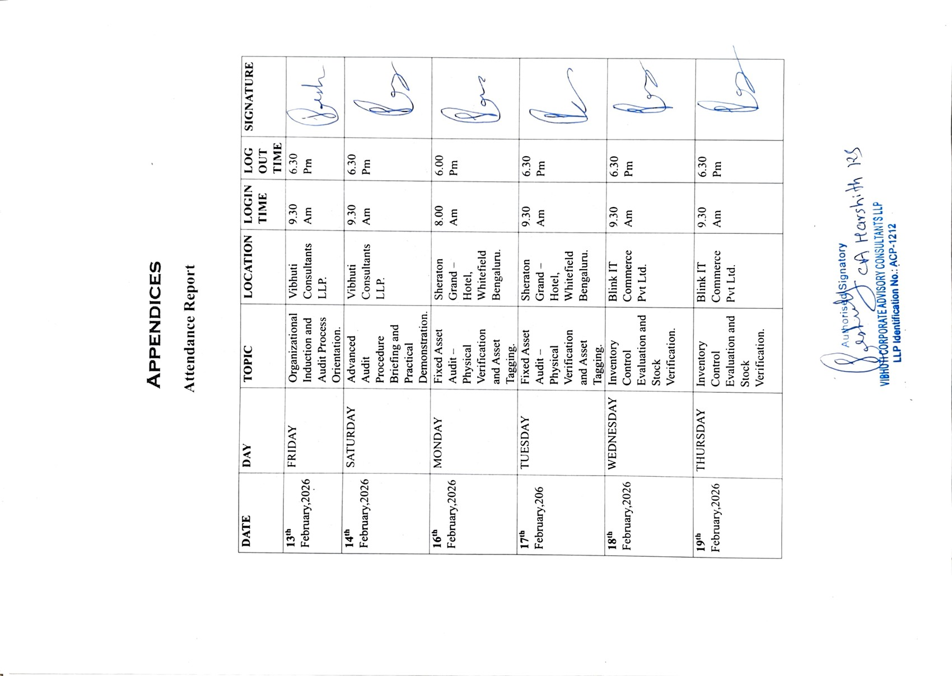

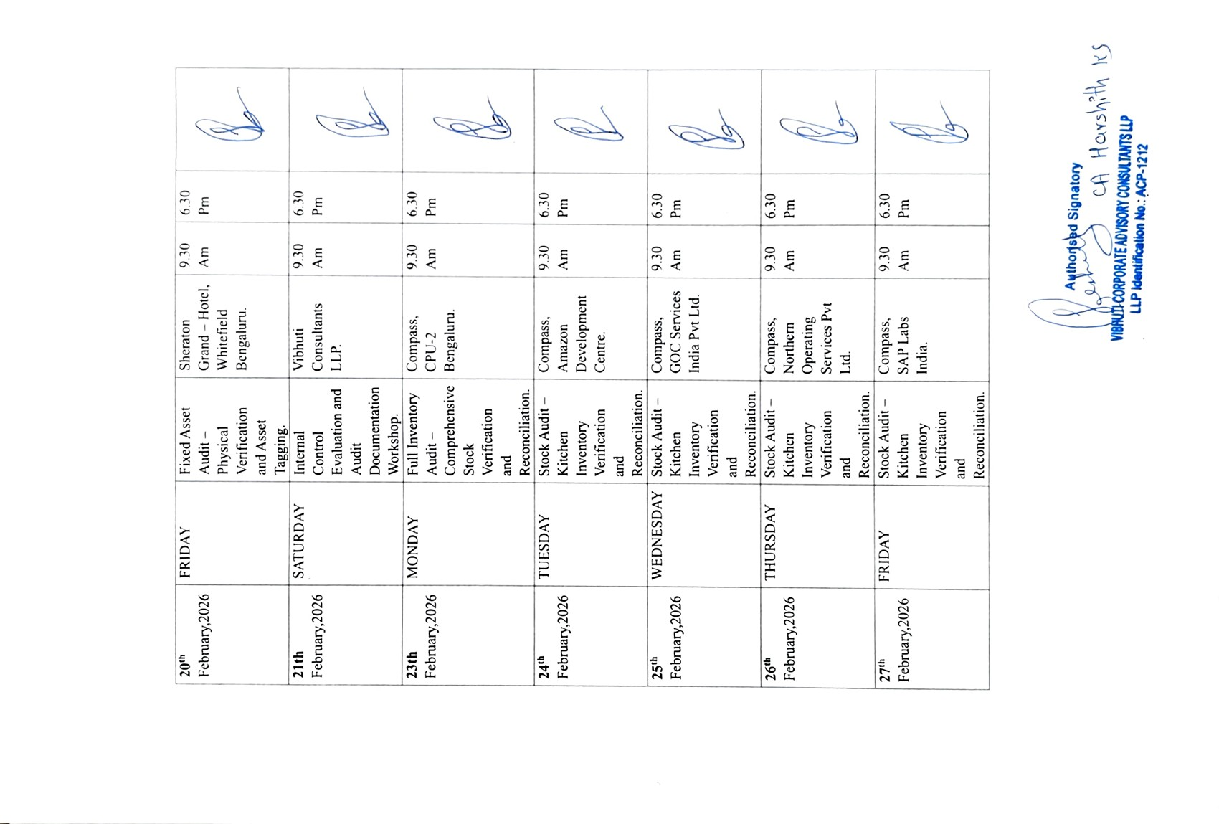



BIBLIOGRAPHY

Sources

VIBHUTI Consultants. (n.d.). Official Website. Retrieved from:
https://www.vibhuticonsultants.com

VIBHUTI Consultants. (n.d.). About Us – Company Overview and Services. Retrieved from
https://www.vibhuticonsultants.com/who-we-are

VIBHUTI Consultants. (n.d.). Services – Financial, Taxation and Compliance Advisory. Retrieved from
https://www.vibhuticonsultants.com/services

VIBHUTI Consultants. (n.d.). Contact Information and Location Details. Retrieved from:
https://www.vibhuticonsultants.com/contact-us

LinkedIn. (n.d.). VIBHUTI Consultants – Company Profile. Retrieved from:
https://www.linkedin.com/company/vibhuti-consultants

Ministry of Corporate Affairs (MCA), Government of India. (n.d.). Corporate Registration Information. Retrieved from:
https://www.mca.gov.in

