**Implement programs for estimating & eliminating trend in time series data – aggregation, smoothing.**

**EX:No.4 DATE:1/02/25**

# AIM:

To Implement programs for estimating & eliminating trend in time series data – aggregation, smoothing..

## OBJECTIVE:

To estimate and remove trends in time-series air pollution data using aggregation and smoothing techniques.

## BACKGROUND:

* Time series data often has trends that affect analysis.
* **Aggregation** (e.g., monthly/yearly averaging) helps identify patterns.
* **Smoothing** (e.g., moving average, exponential smoothing) removes fluctuations.
* Trend elimination improves forecasting and stationarity.

## SCOPE OF THE PROGRAM:

* Load and clean air passengers data
* Apply **aggregation** (monthly/yearly averages) to estimate trends.
* Use **moving average smoothing** to reduce noise.
* Apply **exponential smoothing** to highlight trends

**CODE:**

import pandas as pd

import matplotlib.pyplot as plt

# Load the coin_crypto.csv file

df = pd.read_csv(r"/path/to/coin_crypto.csv")

# Check the first few rows to identify relevant columns

print(df.head())

# Convert the 'Date' column to datetime format (adjust the column name if necessary)

df['Date'] = pd.to_datetime(df['Date'], errors='coerce')

# Set 'Date' as the index

df.set_index('Date', inplace=True)

# Check for any missing values in the dataset

print(df.isnull().sum())

# Assuming there's a 'Price' column (adjust based on actual column name)

df['Price'] = df['Price'].fillna(method='ffill') # Forward-fill missing values

# Aggregation - Monthly & Yearly Average

df_monthly = df['Price'].resample('M').mean()

df_yearly = df['Price'].resample('Y').mean()

# Moving Average Smoothing (Rolling Mean)

df['Moving_Avg'] = df['Price'].rolling(window=12).mean()

# Exponential Smoothing

df['Exp_Smooth'] = df['Price'].ewm(span=12, adjust=False).mean()

# Plot Original vs Aggregated & Smoothed Data

plt.figure(figsize=(12, 6))

plt.plot(df['Price'], label="Original Data", alpha=0.5)

plt.plot(df['Moving_Avg'], label="Moving Avg (12-month)", color='red')

plt.plot(df['Exp_Smooth'], label="Exponential Smoothing", color='green')

plt.xlabel("Date")

plt.ylabel("Price (USD or relevant currency)")

plt.title("Trend Estimation & Elimination using Smoothing")

plt.legend()

plt.show()

# OUTPUT:

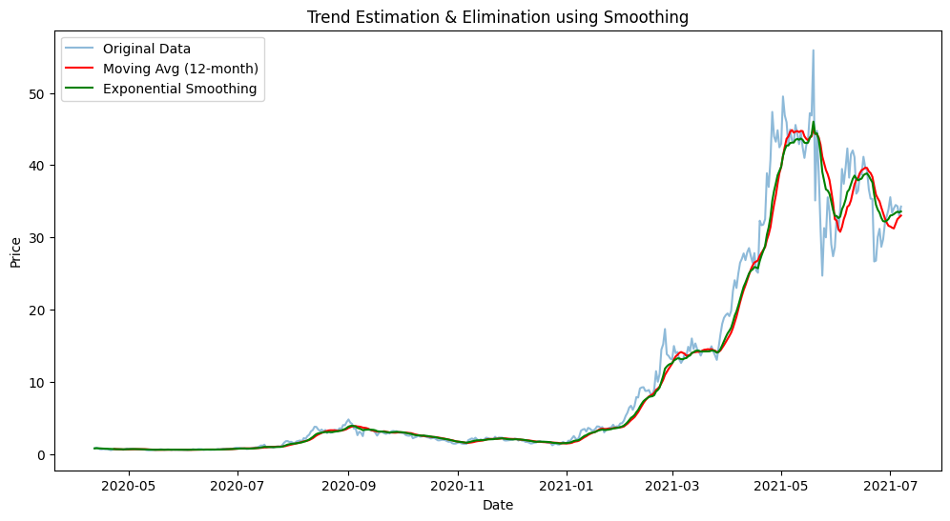

**RESULT:**

Thus, the program using the time series data implementation has been done successfully.