Comparative performance analysis of technical indicators in banking stocks with
LSTM
Devduth C¹. Anjana B S¹. Anju Asokan². Manju B R²
Department of Physics¹, Department of Mathematics²
Amrita Vishwa Vidyapeetham, Amritapuri 690525, Kollam, Kerala, India
Corresponding Author: Dr. Manju B R ( manjubr@am.amrita.edu )

Abstract
The stock market plays a significant role in modern capitalism, providing a platform for companies to raise capital, investors to grow wealth and economies to expand. Accurate stock price forecasting is critical for investors who want to make educated decisions, optimize their portfolios, and manage financial risk efficiently. One of the most popular methods for market prediction is through technical analysis, which uses indicators that are computed based on historical market data. The wide variety of indicators present challenges stock price forecasting as one is unaware of which to use. The study extracted and grouped commonly used overlay and oscillator indicators -RSI, MA, MACD, ADX, ATR, OBV, Stochastic oscillator and Bollinger bands from historic data of two Indian and International banks and found out the best set of indicators for banking stocks by using the Long Short Term Memory (LSTM) model, a type of Recurrent Neural Network (RNN). The performance of indicator groups is evaluated by parameters such as Mean Absolute Error (MAE), Root Mean Square Error (RMSE), and directional correctness. By combining LSTM networks with a carefully selected collection of technical indicators, the study shows that the first set of indicators outperforms the second set regarding the Mean Squared Error (MSE) and Mean Absolute Error (MAE) across all Indian as well as international banks ,except for HDFC Bank, where the second set of indicators exhibited better results. This result offers investors a strong tool for improving price prediction in the stock market and perform appropriate decisions.

Keywords
Stock Market, LSTM, Technical Indicators, Financial Market Dynamics, Machine Learning in Finance, RNN

Introduction
The Stock market is a network of exchanges and marketplaces where shares of publicly listed firms are purchased, sold, and issued. It is an important component of the global economy, allowing firms to obtain funds for expansion and allowing investors to buy shares in these enterprises. Nowadays, most stock dealers depend on Wise Trading Frameworks, which help in price prediction considering different situations and settings, empowering them to make quick business choices.[1] .Several variables impact the stock market's performance, providing vital insights into economic health, market trends, and individual business success. Stock prediction is crucial in the stock market, utilizing various indicators based on historical prices and volume.
Investing in the stock market can be both profitable and risky, especially when it comes to choosing the correct technical indicators to guide trading decisions. Indicators are used to measure current conditions of financial and economic trends. Presently used stock forecasting techniques include time series, technical, and fundamental. Fundamental analysis, which is focused on a company’s own controllable events, is helpful for long-term predictions.
Technical analysis is used to learn patterns from historical data to anticipate the future by making the confident assumption that the learnt pattern can connect to external, unforeseen future events. For making short-term forecasts, technical analysis
is helpful [2] Technical indicators can be utilised to predict and assess financial markets, and they are employed here based on past values and volume.
Such indicators aid in the identification of market trends and behaviours. Technical indicators are computations generated from previous price, volume, or open interest data that traders use to forecast future market changes.
With so many indicators available, each having a particular function and delivering unique insights, determining the best one for a certain market trend can be difficult.

Choosing the proper indication might be challenging due to variations in performance based on market conditions. For example, trend-following indicators like moving averages are more useful in trending
markets, whereas oscillators like the RSI are better suited to rangebound situations.
Lagging indicators, such as moving averages, confirm trends after they have begun, resulting in later entry and exit locations. Leading indicators, such as
the RSI, seek to forecast future movements but may provide erroneous signals. Traders frequently struggle to balance these two sorts of indications.
Finding the right technical indicators in stock market is a difficult step that needs a full knowledge of the current situation, a balance of multiple types of indicators, and an organised strategy to trading.
While a large number of indicators might be difficult, a smart selection based on market circumstances, testing, and simplicity can improve trading efficiency. Through regularly studying and changing, traders may navigate the obstacles of technical analysis and increase their probability for achievement in the equity industry.
Our research adds to this growing area by showing how LSTM models, combined with traditional strategies, significantly improve predictions and provide better trading decisions. We focus on the advantage of LSTM models over traditional analysis, which mainly uses past stock data for predictions and often falls short in forecasting future trends [3]

This journal paper compares stock market performance using technical indicators in Indian and international banks. Two sets of commonly used indicators are compared, with four sets of banks - Indian and International - and their accuracy, their mean square error, and mean absolute error.
Analyses of real-world financial and economic data are a great challenge due to
their high volatility, vastness and other economic and political factors. Recently, the covid19 pandemic has also caused a drastic change in the financial data [4]
The four sets of banks are Housing Development Finance corporation (HDFC), State Bank of India (SBI), JP morgan chase & co (JPM), and Bank of American Corporation (BAC). We grouped four datasets into two groups, with and without indicators, to compare to datasets that do not utilise indicators. For this investigation, we used the most generally used technical indicators.
The first set of indicators combines the Relative Strength Index (RSI),
Moving Average (MA),
Moving Average Convergence/Divergence (MACD) and stochastic gradient descend. We calculated the short exponential moving average (short EMA) and long exponential moving average (long EMA) using the moving average. In addition, we obtained the signal line, the lowest low, and the highest high from the MACD and we obtained %K and %D from stochastic oscillator.
The second set of indicators combines the Average Directional Index (ADX),
Average True Range (ATR), On-balance Volume (OBV) and Bollinger bands. Bolinger bands yielded BB-upper, BB-lower, and BB-middle. For this investigation, we initially gathered HDFC bank datasets from Yahoo Finance, for anyone connected to the financial markets, including professionals and laypeople may find a wealth of services and tools on Yahoo Finance, a comprehensive platform for financial news and data. The datasets spanned from January 1, 2020 to February 9, 2020, and included 1022 data points. Then we incorporate datasets of other banks, including the State Bank of India (SBI) and two major multinational banks, JP Morgan Chase and Co.
(JPM) and Bank of America (BAC), all sourced from Yahoo Finance.
To improve the data quality and the accuracy of our findings, we followed a number of important steps in our technique. For each of the chosen banks, we first gathered significant data sets. In order to guarantee that the data used for our research was accurate and consistent, the data prior treatment step involved eliminating outliers and managing missing values. After calculating the Z-score to find and remove errors, we scaled the data to make the input for the LSTM model more uniform. With rising demand comes rising value and vice versa. Stocks are purchased and sold on the stock market, allowing buyers and sellers to interact and transact business. Many academics and analysts have been attempting to accurately analyse and evaluate equities to foresee their future trends and worth. Technical research is mostly employed for predicting the movements of stocks in the future through examining past and current stock prices.
The stock's price, volume, and supply-demand dynamics are considered [5]
LSTM is one of the best algorithms for stock prediction and it is suited for making predictions because it remembers information over long periods of time and analyses time series data like past stock prices and other financial data.
In particular, LSTM has memory ability because of its gating mechanism, so it is more suitable to forecast financial time series [6] Time series analysis often organises data in standardised time intervals, with the primary goal of understanding or predicting future values in the sequence. Long short-term memory (LSTM) networks have emerged as an important tool in this field. The exceptional capability of the model to identify and analyse for a long-time correlation in information serves as perfect for time series forecasting and analysis.
LSTM revolutionises prediction accuracy and efficiency in turbulent markets, delivering improved price estimates with a reduced errors in root mean squares.
Techniques and procedures utilised for stock market prediction are described in the methodology section. These include the model architecture, training procedure, and data preparation. The tests' findings are shown in the results section, which also highlights how well the LSTM model performs and how accurate it is in predicting stock market movements. Ultimately, the conclusion highlights the most important discoveries, talks about the consequences of the findings, and makes some recommendations for possible future study topics.

Literature Review
For a considerable amount of time, traders have relied on technical indicators as a fundamental tool for analysing stock market trends, momentum, and possible reversals. These indicators can be categorised as momentum indicators, trend indicators, volume indicators, and volatility indicators. Common indicators include the Relative Strength Index (RSI), Moving Average (MA), Moving Average Convergence/divergence (MACD), Stochastic oscillator, Average Directional Index (ADX), Average True Range (ATR), On Balance Volume (OBV) and Bollinger bands.The banking industry poses a distinct challenge to stock prediction models due to its reputation for volatility and susceptibility to fluctuations in the economy. Long Short-Term Memory (LSTM) networks, which is a form of Recurrent Neural Network (RNN) is one of the most recent developments in machine learning, and have shown promise in improving the precision of stock price forecasts due to its ability to capture long-term dependencies and patterns for time series data. (Research show that LSTM models outperform traditional approaches for forecasting stock values due to their ability to manage sequential data well.)

The study titled ‘Deep learning with long short-term memory networks for financial market predictions’by Thomas Fischer and Christopher Krauss (2018) [7] showed that LSTM networks outperformed conventional models when technical indicators were used as input features. The study used Their research emphasised the relevance of incorporating temporal dependencies and nonlinear patterns in stock market data. The study used ten technical indicators as input to predict the future price, however, the selection processes of these ten indicators were not clarified. our study offers a systematic approach to the selection of technical indicators and evaluates the performance of LSTM models with various sets of indicators. By doing this, we hope to give traders and analysts in the banking industry a clearer framework within which to operate and help them make intelligent decisions.

In the survey paper 'Stock Price Prediction Using LSTM, RNN and CNN-Sci: Survey on Modern Deep Learning Models,' by Sreelekshmy Selvin, Vinayakumar R, Gopalakrishnan E.A, Vijay Krishna Menon, Soman K.P [8] , demonstrates the efficacy of using numerous technical indicators for stock market prediction with LSTM networks. According to the survey, indicators such as Moving Averages, Relative Strength Index, and Bollinger Bands, when used together, give a more comprehensive feature set that enhances prediction accuracy. These studies provide empirical evidence that LSTM models can better reflect the intricacies of market behaviour when several indicators are used. Building on this, our research intends to rigorously compare the performance of LSTM models with other sets of technical indicators to find the ideal combination for predicting banking stocks.

Methodology
This paper took four datasets of banks namly HDFC bank, STATE BANK OF INDIA, JPMorgan Chase and Bank of America which was obtained from Yahoo Finance which is a popular portal for viewing historical financial data.
The banking sector is vital to the economic development and stability of any nation Connecting various parts of the economic machinery, the banking sector in India remains central to growth through financial intermediation, fostering productive investments, consumption and credit expansion [9]
The raw CSV dataset consisted of 1022 initial samples which contained the following features -
DATE– dates dd-mm-yy format of days in which the market was open. OPEN -The Price at which trade of the scrip starts. HIGH – The highest price that went at a particular date. LOW -The Lowest price that stock went at a particular date. CLOSE - The Price at which the last trade of the trade session ended, ADJ CLOSE It refers to the closing price inclusive of all applicable splits and dividend distributions, VOLUME – The total number of shares which have been bought or sold in the trading session. These basic features provide detailed information about the performance of the stock in a trading session.
Data preprocessing was done by feature extraction,Outliers Removal and scaling.
Feature extraction:
The study extracted 8 different indicators from the dataset and grouped them into 2 for prediction of stock prices. The indicators extracted were RSI, SMA, MACD, and Stochastic Oscillator in the first group and ADX, ATR, OBV and Bolinger bands in the second group.
RSI (Relative Strength Index) - During technical evaluation, an impulse indicator with values that range from zero to one hundred identifies overbought or oversold market circumstances.
This is the ratio of average gain to the average loss over a period, and a commonly used interval of 14 days was used for the prediction.

𝐴𝑉𝐸𝑅𝐴𝐺𝐸 𝐺𝐴𝐼𝑁
𝑅𝑆 =
𝐴𝑉𝐸𝑅𝐴𝐺𝐸 𝐿𝑂𝑆𝑆

100
𝑅SI = 100 −
1 + 𝑅𝑆

Simple Moving average (SMA) :It is frequently used in technical analysis to smoothen price information by establishing a continually updated mean.
An increasing moving average implies that the security is in an uptrend, whereas a decreasing moving average signals a decline.

SMA= 𝑘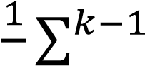 𝑖=0 𝑥𝑡−1

Moving Average Convergence/Divergence (MACD): It is a tool which aids investors to discover trade points of entry for purchasing and selling. This is derived by subtracting the 26- EMA from the 12-period EMA.

MACD = 12−day EMA − 26−dayEMA

Stochastic oscillator: It is a recognised technical tool designed for predicting probable shifts in trends by analysing closing prices compared to the high and low price ranges within a certain time.
⁰⁄0 𝑘 = (𝐻𝑐₁₄−−𝐿¹⁴𝐿₁₄) × 100 (C indicates the most present closing price. L14 = The lowest price traded in the previous 14 trading sessions.H14 is the highest price transacted within the same 14-day period represents the current value of the stochastic indicator)

.Average Directional Index (ADX)- ADX, is used to determine the trend strength. ADX computations use a moving average of price range expansion over time. In this project, we took commonly used interval of 14 bars to compute ADX.

Average True Range (ATR) - ATR is a measure of the volatility of the market through analysing the whole variance in a stock's price over a particular period. ATR does not give direction of price moment but rather indicates the price Volatility. We took commonly used interval of 14 days simple moving average of several genuine range indicators.

On-balance Volume (OBV) -It is a technical momentum indicator that forecasts prices based on volume changes. OBV measures crowd sentiment and can forecast a bullish or negative outcome.

Bollinger bands- It is a technical assessment method which is aided to assess whether the prices are high or low in comparison with one another.
Three lines constitute: an upper, a lower, and a simple moving average (the middle band). Typically, a 20-period SMA has upper and lower bands that are two standard deviations higher or lower, respectively.
Depending on volatility, the underlying assets of bands go wider and narrower.
Outlier detection :

The presence of outliers has deleterious effects on the stock value because the unreliable information may discourage investors from investing in the stock. [10] Process 1:
Indicators RSI, Simple Moving Average, MACD and stochastic uses previous historic prices of 14 days for calculation, the initial samples lacked these indicator values for 14 days prior vales were not considered and therefore such Outlier were removed from Group 1 dataset.
Similarly group 2 indicators
ADX, ATR, OBV and Bollinger Bands also used previous historic interval prices for calculation, some of the initial samples were also removed for group 2 dataset as it lacked values and was considered as outliers.

Z-score computation was also another technique used to detect outliers. The Z-score which is also known as the standard score, calculates the quantity of standard deviations an element is within the average of the dataset. It is used in statistics to understand the position of a value within a dataset, particularly in terms of its relative position within the normal distribution. The formula to calculate the Z-score of a data point xxx is:
The samples which were -3 and +3 standard deviation away from mean was removed and was considered and outliers.
Scaling :
The resultant datasets were scaled because scaling helps improve model performance by speeding up the convergence of the model. Value of 0 indicated lowest value and a value of 1 indicated the highest value.
LSTM were used in both the data groups to find best set of indicators and mean square error value, absolute error value and Accuracy of the model was obtained.

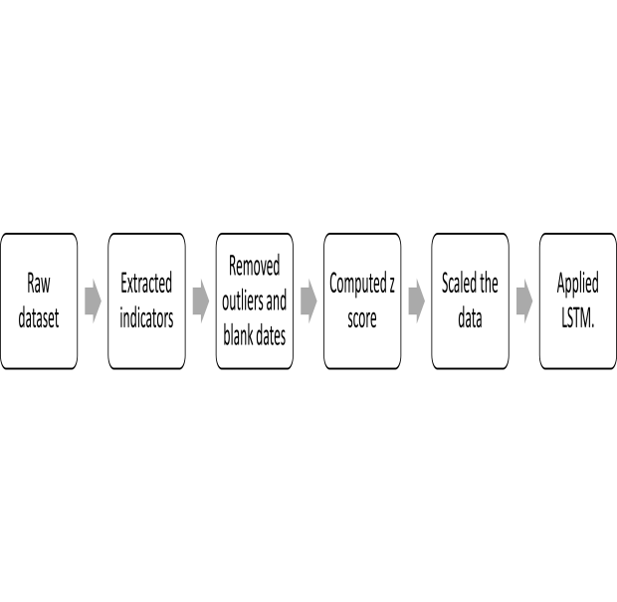

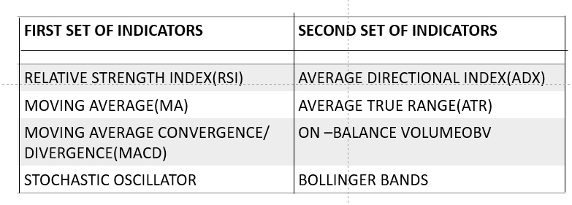

Result

HDFC BANK:

INDICATOR SET 1 | INDICATOR SET 2
Mean Squared Error: 0.00191145345439954 | Mean Squared Error: 0.042442210044070165
Mean Absolute Error: : 0.03534148964468761 | Mean Absolute Error: 0.1962574770602796
Accuracy: 106.01075268817205 | Accuracy: 107.43406593406593

STATE BANK OF INDIA (SBI):

INDICATOR SET 1 | INDICATOR SET 2
Mean Squared Error: 0.0017107751879 709475 | Mean Squared Error: 0.0016630228451 01785
Mean Absolute Error : 0.0356161690047 2729 | Mean Absolute Error: : 0.0318560008905 5014
Accuracy: 109.12429378531 074 | Accuracy: 111.32596685082

JPMORGAN CHASE (JPM) :

INDICATOR SET 1 | INDICATOR SET 2
Mean Squared Error : 0.0006146612921 14226 | Mean Squared Error: 0.0021057277431 27983
Mean Absolute Error: : 0.0195400668827 5639 | Mean Absolute Error: 0.0391920819087 6535
Accuracy: 94.215053763440 86 | Accuracy: 104.56593406593 407

BANK OF AMERIC (BAC):
INDICATOR SET 1 | INDICATOR SET 2
Mean Squared Error : 0.0006036853892 | Mean Squared Error :0.0046049733640
Mean Absolute Error:: 0.0191099611774 | Mean Absolute Error: 0.0512574017161
Accuracy: 96.010928961748 | Accuracy: 64.25

For HDFC Bank, the first set of indicators resulted in lower MSE and MAE compared to second set, indicating more accurate predictions.
However, the accuracy was marginally higher with the second set.
For SBI, the first set of indicators also demonstrated better performance with lower MSE and MAE.
Interestingly, the second set of indicators provided higher accuracy, suggesting that while the predictions were closer to the actual values, the number of correct directional predictions was higher with the second set.

For JPMorgan Chase, the first set of indicators yielded superior performance with much lower MSE and MAE, along with higher accuracy.
For Bank of America, the first set of indicators again provided more accurate predictions, with significantly lower MSE and MAE, and higher accuracy.

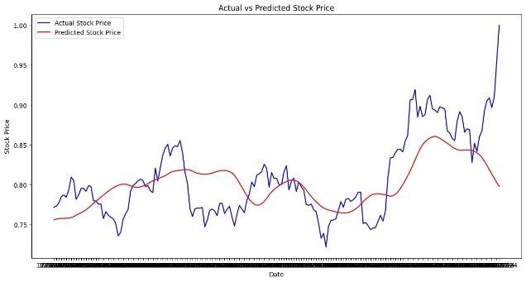
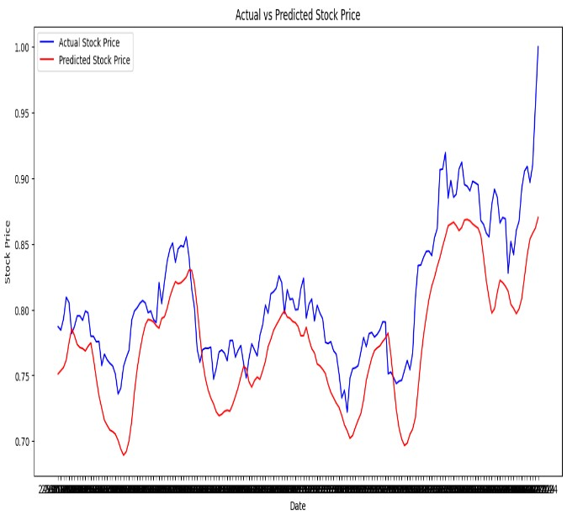
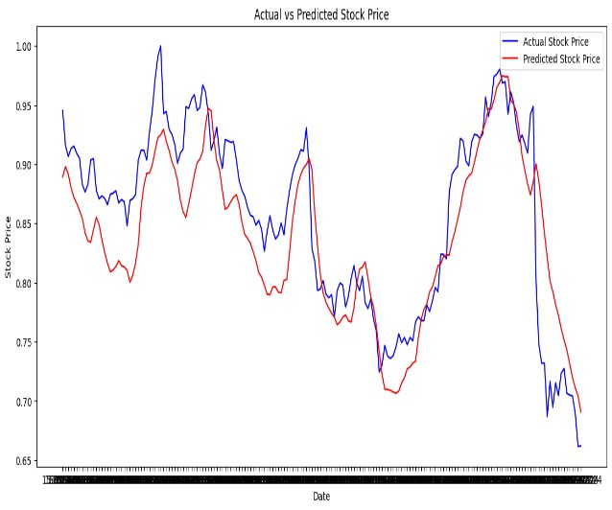
(a)
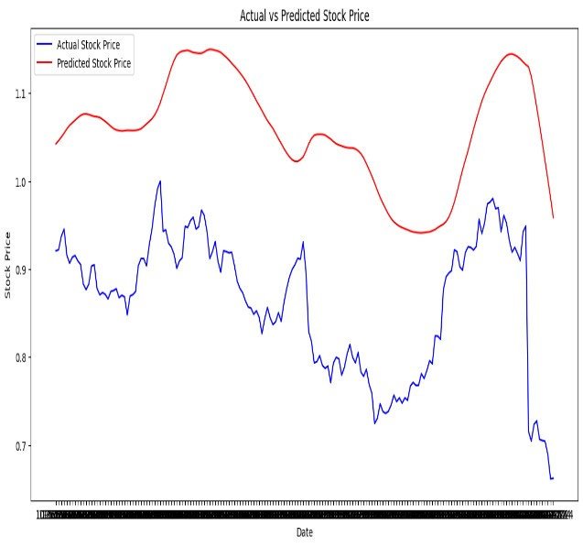
(b)

(d)
(c)

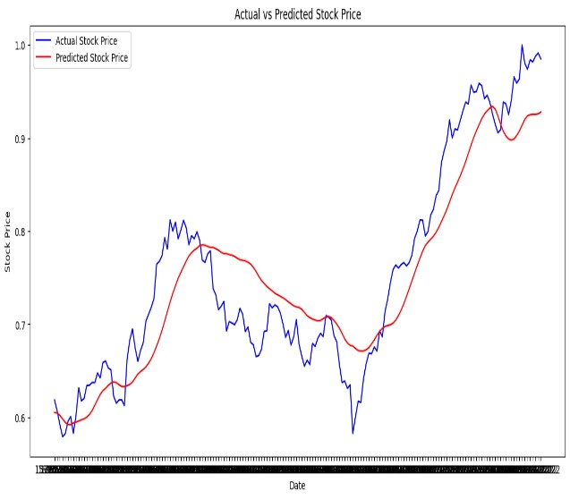
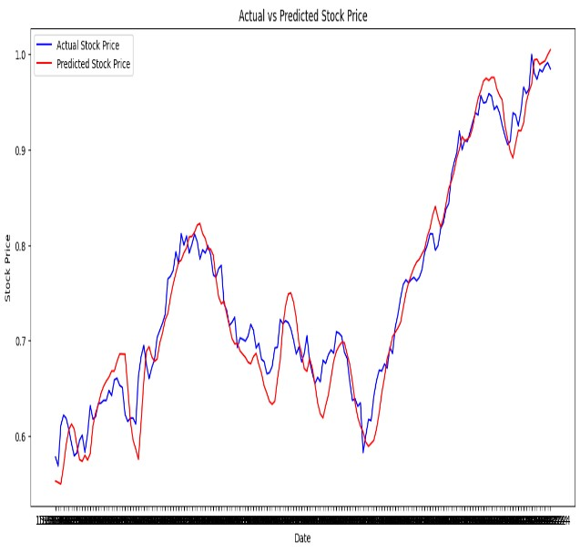
(f)
(e)

Figure 7 BAC-first set of indicators

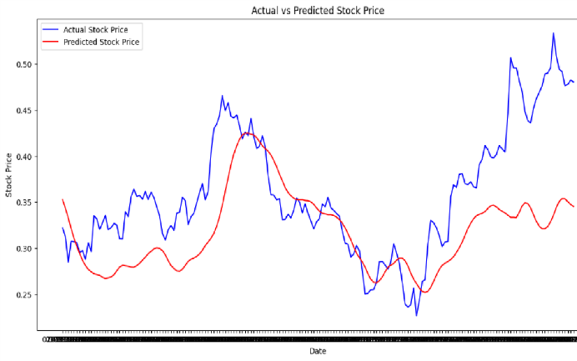
(h)
(g)

Fig : ACTUAL (BLUE) vs PREDICTION(RED) - (a) HDFC INDICATOR SET 1,(b) HDFC INDICATOR SET 2, (c) SBI INDICATOR SET 1 (d) SBI INDICATOR SET 2, (e) JPM INDICATOR SET 1 ,(f) JPM INDICATOR SET 2,(g)BAC INDICATOR SET 1 ,(h) BAC INDICATOR SET 2

CONCLUSION

The study Comparative performance analysis of technical indicators in banking stocks with LSTM shows that the first set of indicators - RSI, SMA, MACD, and Stochastic Oscillator is more successful at forecasting stock prices as compared to the second set of indicators -ADX, ATR, OBV and Bolinger Bands on banking sector .This set consistently produced reduced MSE and MAE, as well as greater accuracy, According to these findings, investors and analysts focused on stock market predictions for banks may get better outcomes by employing the first set of indicators. However, it is also crucial to take into considerate the situation, and unique characteristics of each bank and the economy when selecting the most appropriate technical indicators for analysis.

Acknowledgments: Not applicable.
Funding: Not applicable.
Availability of Data and Materials: Data are publicly available and free to use.
Code Availability: The code used in the work is publicly available and free to use.
Declarations
Conflict of Interest: No conflict of interest.
Ethics Approval: Not applicable.
Consent to Participate: Not applicable.
Consent for Publication: Not applicable.

Reference
[1] Hossen, Arif, et al.
"MACHINE LEARNING MODELS TO PREDICT MARKET MOVEMENTS BASED ON HISTORICAL PRICE DATA AND ECONOMIC INDICATORS." Inte rnational Journal of Central Banking 20.1
(2024).[2]
.[2] Sivadasan, E. T.,
N. Mohana Sundaram, and R.
Santhosh. "Stock market forecasting using deep learning with long shortterm memory and gated recurrent unit." Soft Computing 28.4
(2024): 3267-3282.
[3] Botunac, Ive, Jurica Bosna, and Maja Matetić.
"Optimization of Traditional Stock
Market Strategies Using the LSTM
Hybrid Approach." Inform ation 15.3 (2024):
136.
.[4] Pervez, Asif, and Irfan Ali. "Robust regression analysis in analyzing financial performance of public sector banks: A case study of India."
[5] Data Science 11.2
(2024): 677-
691.[5]
.[6] Agarwal, Harsh, et al. "Predictive Data Analysis: Leveraging RNN and LSTM Techniques for
Time Series
Dataset." Procedia Computer
Science 235 (2024): 979-
989.[6]
.[7] Thomas Fischer and Christopher Krauss “Deep learning with long short-term memory networks for financial market predictions” European Journal of Operational Research, Volume 270, Issue 2, 16 October 2018, Pages 654-669
[8] Sreelekshmy Selvin, Vinayakumar R, Gopalakrishnan E.A, Vijay Krishna Menon and Soman K.P “Stock price prediction using LSTM,

RNN and CNN-sliding window model” 2017 International Conference on Advances in Computing, Communications and Informatics (ICACCI)

[9] Tang, Pan, Cheng Tang, and Keren Wang. "Stock
movement prediction: A multi‐input LSTM
approach." ,Journal of Forecasting (2024)
.
[10] Mbeledogu, Njideka Nkemdilim, Kaodilichukwu Chidi Mbeledogu. "Machine Learning Model for Attenuating Outliers in Stock Data." Internation al Journal of Advanced Engineering Research and management research.

