# Practical No 1

**Aim: Install Selenium IDE; Write a test suite containing minimum 4 test cases for different formats.**

Following are the steps for installing Selenium IDE on Mozilla Firefox.

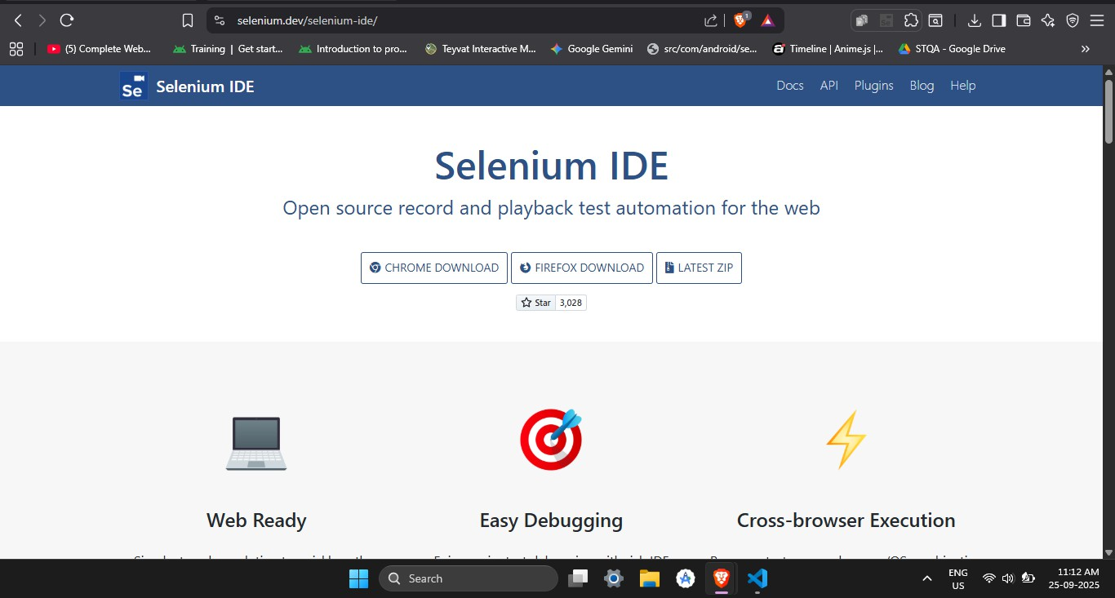

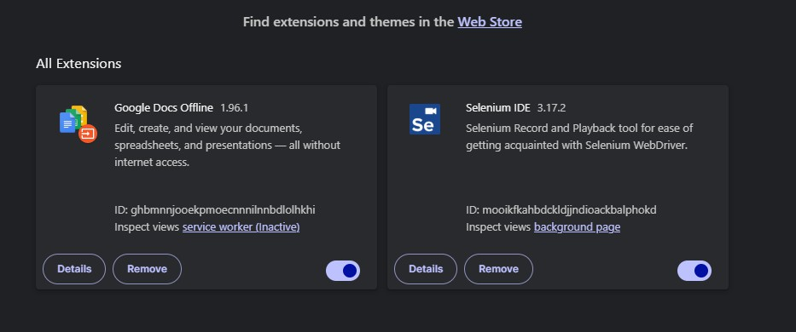1. Add extension to your browser

For https://[www.google.com](http://www.google.com/)

**Step 1**: Open your browser and search for google. Copy and paste the same URL into Selenium IDE, start recording subsequently.

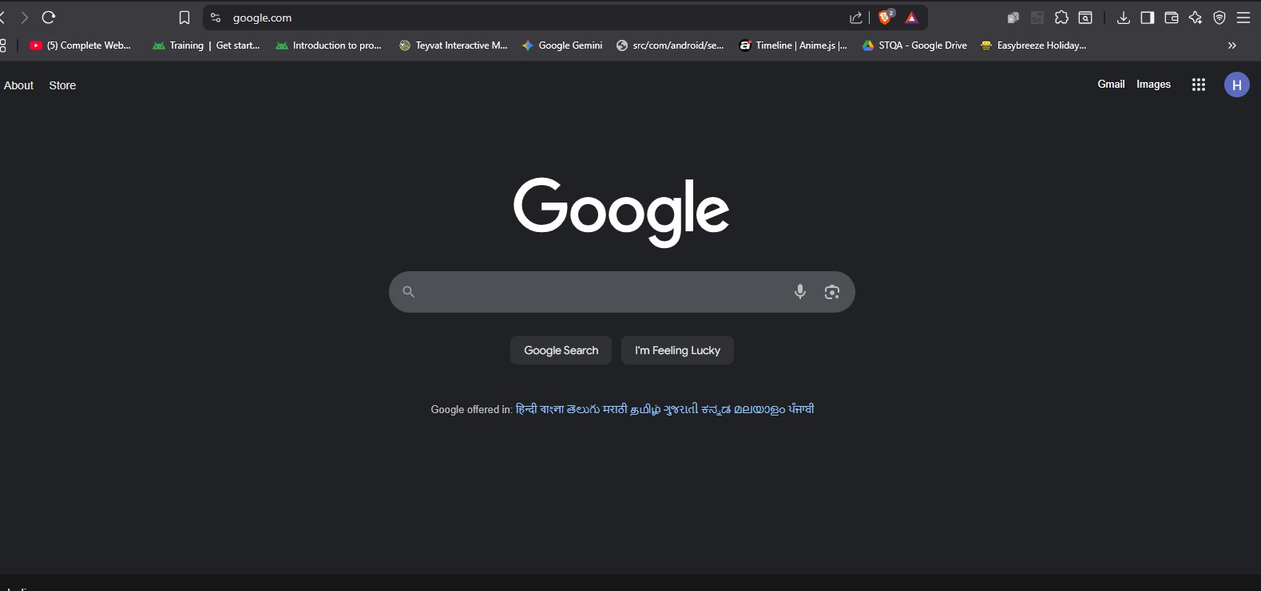

**Step 2**: Navigate through the google website by choosing options like project route, project timeline etc. And test the website by performing actions such as typing, clicking and dragging. After actions are performed click on Menu below the project name and choose Executing and run all tests. Save the Test Case with a name followed by .side suffix.

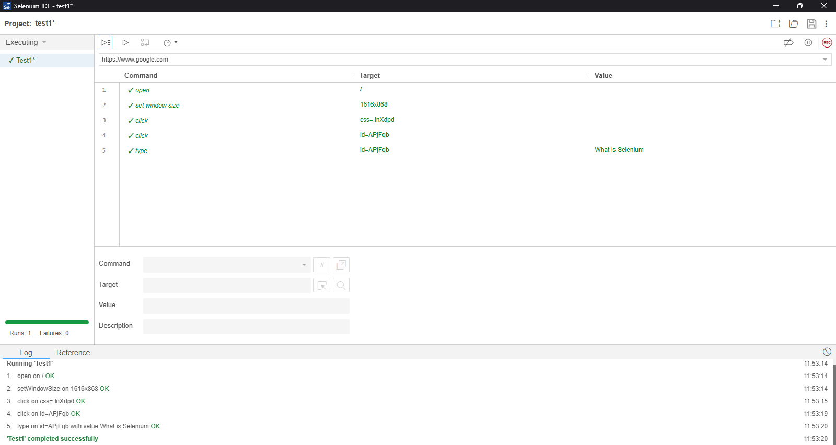

# Practical No 2

**Aim: Conduct a test suite for 2 different websites using Selenium IDE. Perform various actions like clicking links, filling forms, and verifying content.**

For geeksforgeeks.org

1. Open the website and open selenium IDE. Copy the URL and paste it in the given space for further test. Then save & run the test to see the log files.

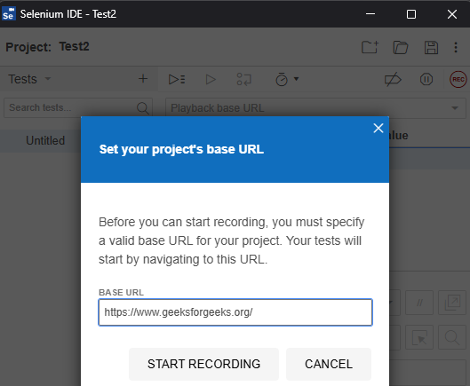

1. After every successful run it gives a message “completed successfully” with green text

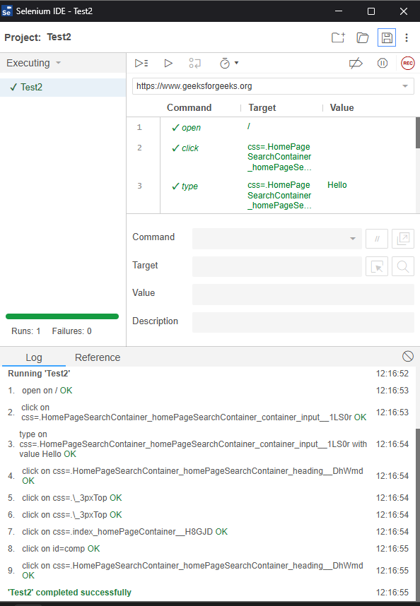highlighted.

1. 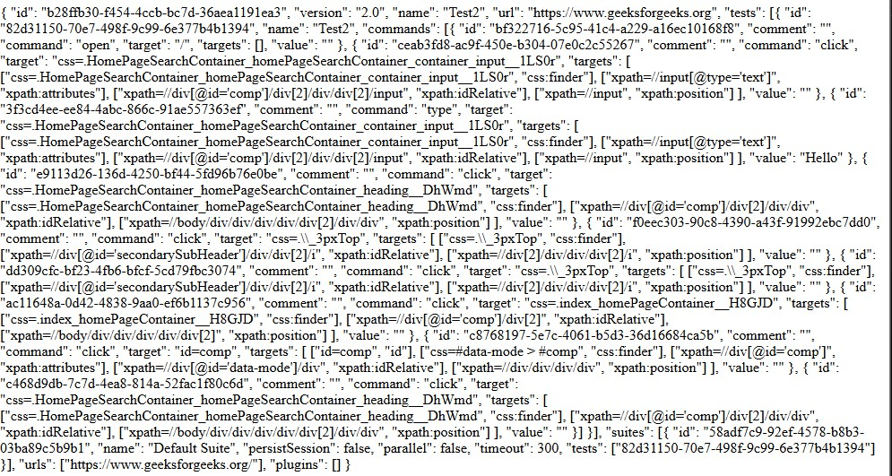Save it in the HTML file and open it on your browser webpage.

# Practical No 3

**Aim: Install Selenium server and demonstrate it using a script in Java/PHP. Steps:** Go to URL- <https://www.eclipse.org/downloads/>

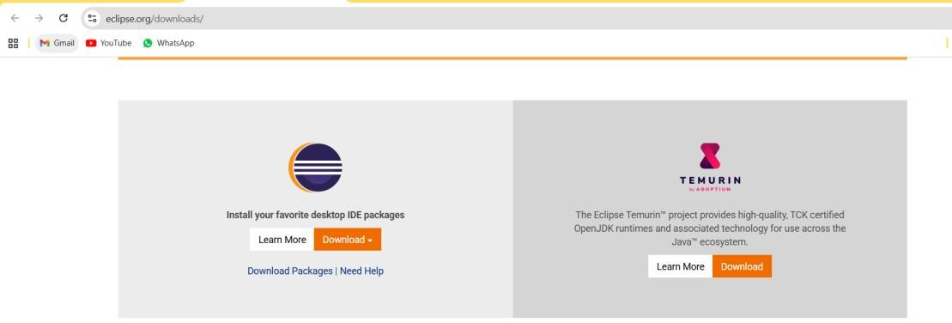

Select **Eclipse IDE for Java Developers** (Click on Windows 64 bit platform)



Next download the IDE

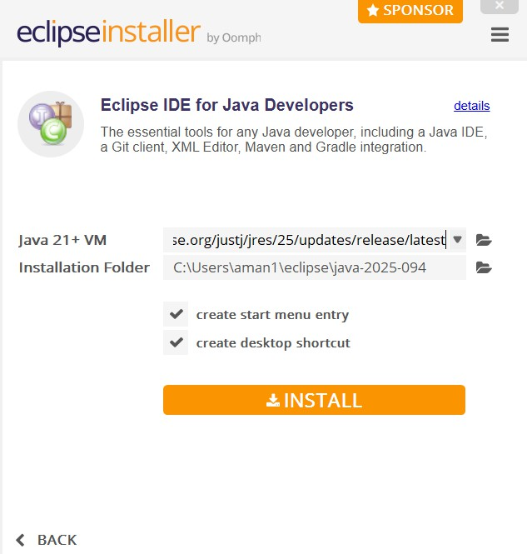

Download Selenium server: <http://seleniumhq.org/download/>

Download Selenium Client driver for Java (from Selenium Client Drivers section)

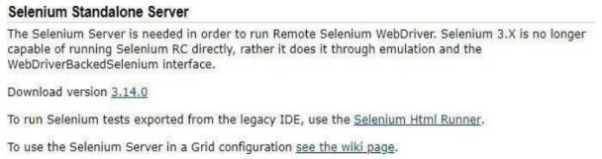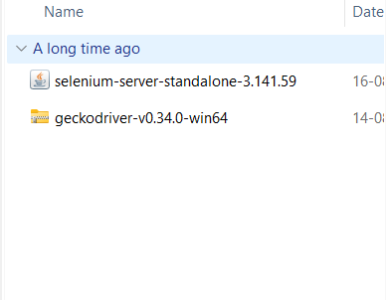

Go to Eclipse –> Click File –> New –> Project (from various options need to select just

“project”)

In Select Wizard –> Click Java –> “Java Project”

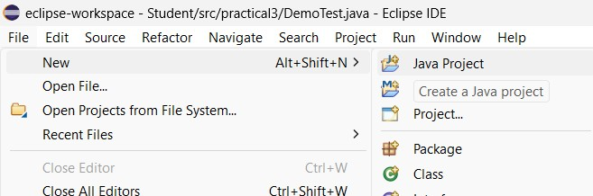

Now we are done with creation of project and need to configure the Selenium Client driver to

this Project Right Click “Student” project

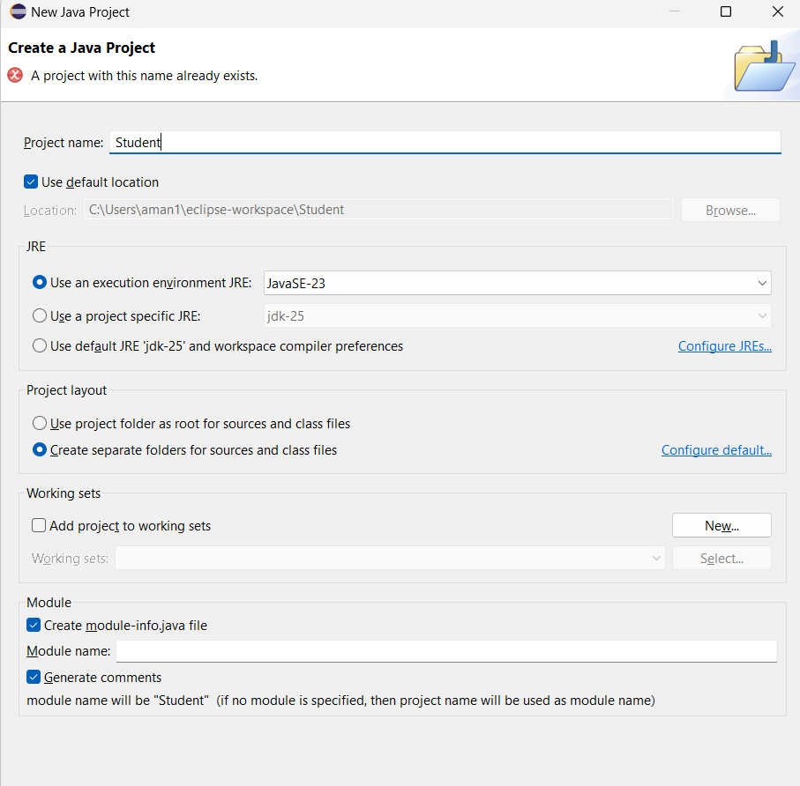

Click “Java Build Path”

Click Libraries tab

Click “Add External JARs” button

Select “Selenium Client Drivers” unzipped in C:Selenium folder (Selenium

Server JAR file should not be added) Click OK

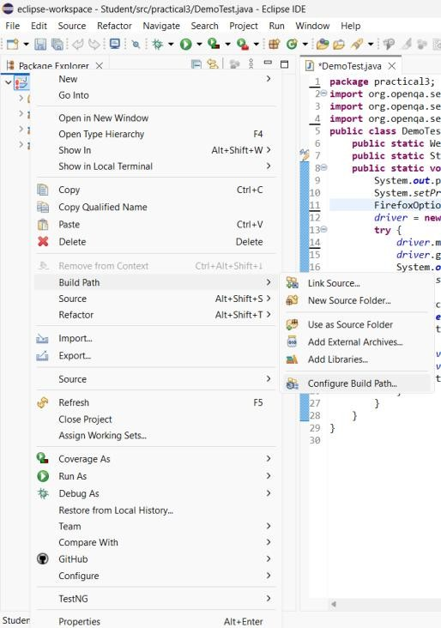

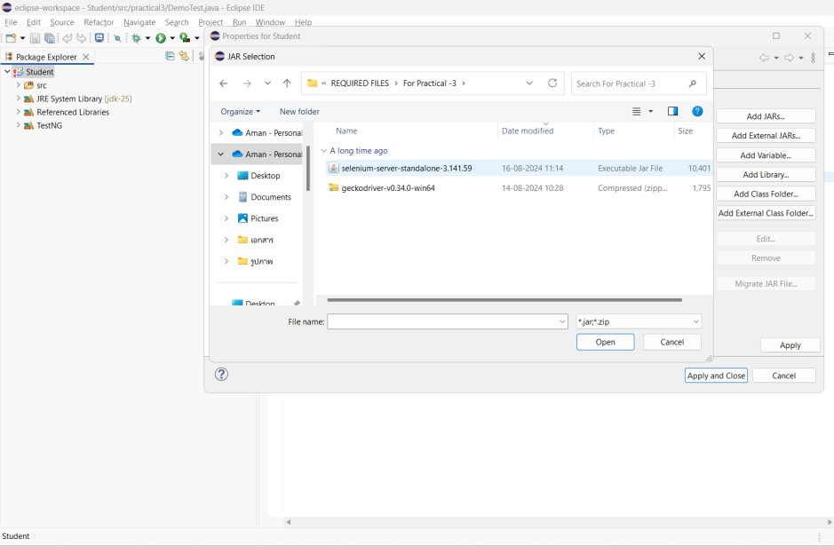

**Program:**

package practical3;

import org.openqa.selenium.WebDriver;

import org.openqa.selenium.firefox.FirefoxDriver; import org.openqa.selenium.firefox.FirefoxOptions; public class DemoTest {

public static WebDriver *driver*;

public static String *geckoPath* = "C:\\Users\\aman1\\OneDrive\\Documents\\geckodriver.exe"; public static void main(String[] args) {

System.*out*.println("Starting Selenium demo..."); System.*setProperty*("webdriver.gecko.driver", *geckoPath*); FirefoxOptions options = new FirefoxOptions();

*driver* = new FirefoxDriver(options); try {

*driver*.manage().window().maximize(); *driver*.get("https:/[/www.facebook.com/](http://www.facebook.com/)"); System.*out*.println("Page title: " + *driver*.getTitle()); Thread.*sleep*(3000);

} catch (Exception ex) { System.*err*.println("Error: " + ex.toString()); ex.printStackTrace();

} finally {

if (*driver* != null) {

*driver*.quit(); System.*out*.println("Driver quit.");

}

}

}

}

**Output:**

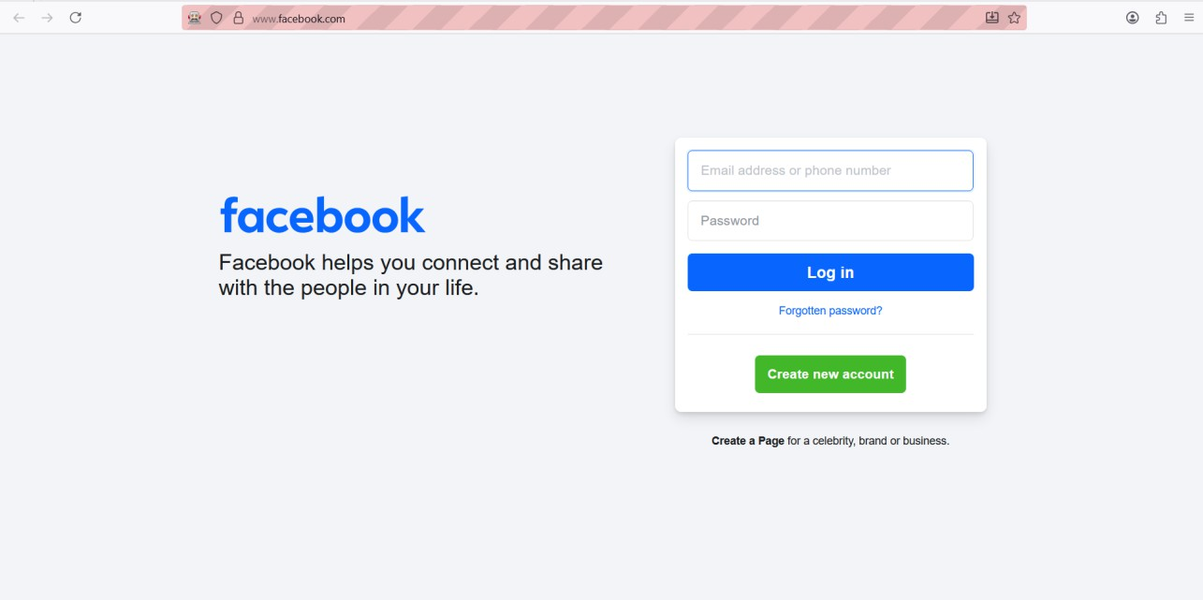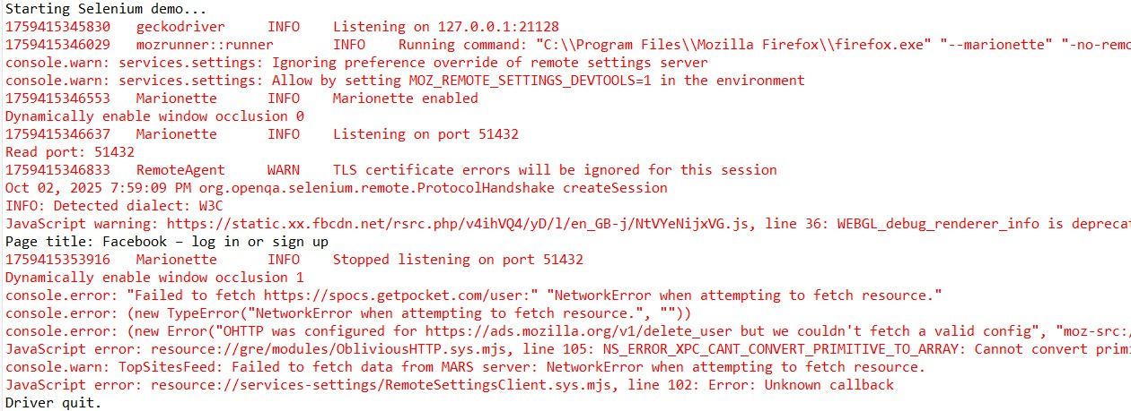

# Practical No 4

**Aim: Write a program using Selenium WebDriver to automate the log in process on a specific webpage. Verify successful login with appropriate assertions.**

**Installation:**

1. Run this command “pip install selenium” in cmd
2. To check installation run “pip show selenium” in cmd

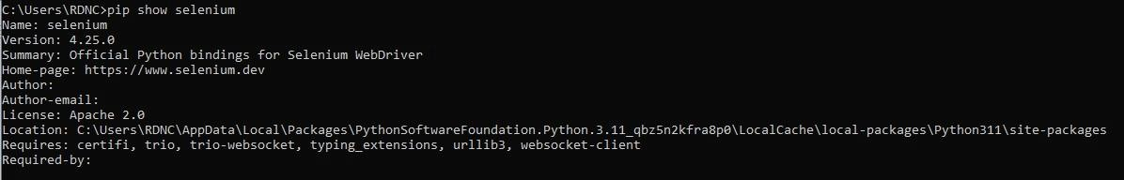

**Program:**

from selenium import webdriver

from selenium.webdriver.chrome.options import Options from selenium.webdriver.common.by import By

from time import sleep options=Options()

options.add_experimental_option("excludeSwitches", ["enable-logging"]) print("Testing started")

driver = webdriver.Chrome(options=options) driver.get("https:/[/www.saucedemo.com/"](http://www.saucedemo.com/)) sleep(3)

title=driver.title print(f"Page title is {title}")

driver.find_element(By.ID, "user-name").send_keys("standard_user") driver.find_element(By.ID, "password").send_keys("secret_sauce") driver.find_element(By.ID, "login-button").click()

sleep(3)

first_item = driver.find_element(By.CLASS_NAME, "inventory_item") assert first_item.is_displayed(), "First inventory item is not displayed"

first_item_name = first_item.find_element(By.CLASS_NAME, "inventory_item_name").text print(f"First item name: {first_item_name}")

print("Test PASSED: Mr. RDNC, your LOGIN is successful and first inventory item is verified")

driver.quit()

**Output:**

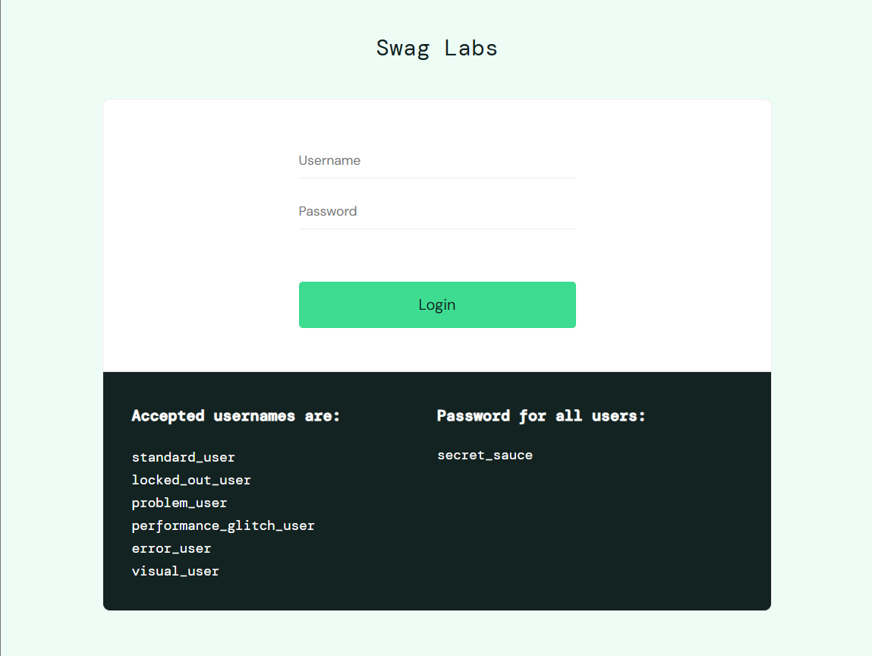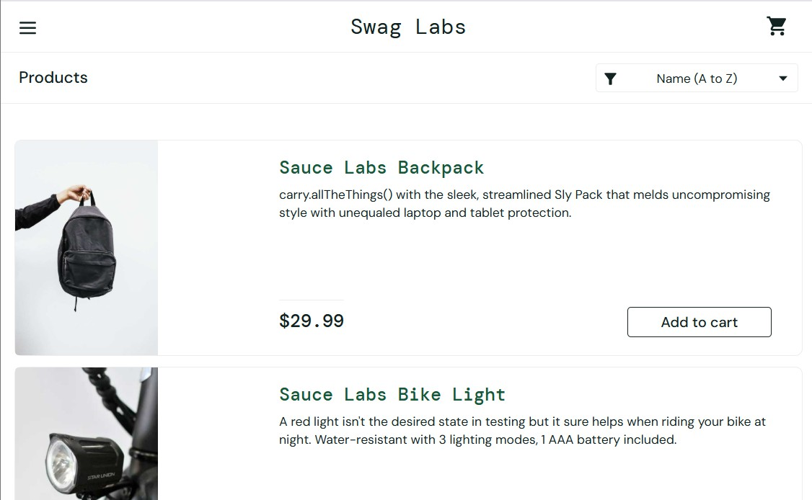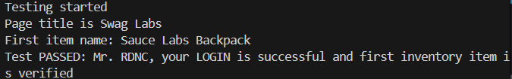

# Practical No 5

**Aim: Write a program using Selenium WebDriver to update 10 student records in an Excel file. Perform data manipulation and verification**

**Program:**

import java.io.File;

import java.io.IOException; import jxl.Sheet;

import jxl.Workbook;

import jxl.read.biff.BiffException; import jxl.write.Number;

import jxl.write.WritableSheet; import jxl.write.WritableWorkbook; import jxl.write.WriteException; import org.testng.annotations.*; public class Studentupdate {

private static final String *INPUT_FILE* = "C:\\Users\\aman1\\OneDrive\\Documents\\student_records.xls"; private static final String *OUTPUT_FILE* =

"C:\\Users\\aman1\\OneDrive\\Documents\\student_records_updateds.xls"; @Test

public void testImportexport1() throws IOException, BiffException, WriteException { File inputWorkbook = new File(*INPUT_FILE*);

Workbook w; try {

w = Workbook.*getWorkbook*(inputWorkbook); Sheet s = w.getSheet(0);

WritableWorkbook copy = Workbook.*createWorkbook*(new File(*OUTPUT_FILE*), w); WritableSheet sheet = copy.getSheet(0);

int studentsAbove60 = 0;

// Process data

for (int i = 1; i <= 10; i++) {

String studentStr = s.getCell(0, i).getContents(); String marksStr = s.getCell(1, i).getContents(); try {

int studentNumber = Integer.*parseInt*(studentStr); int marks = Integer.*parseInt*(marksStr);

int updatedMarks = marks + 10;

// Update the marks in the same column

Number updatedMarksCell = new Number(1, i, updatedMarks); sheet.addCell(updatedMarksCell);

// Check if the original marks are above 60 if (marks > 60) {

studentsAbove60++;

}

System.*out*.println("Record successfully updated for student " + studentNumber + ": " + marks + "-> " + updatedMarks);

} catch (NumberFormatException e) {

System.*out*.println("Invalid data for student in row " + (i + 1) + ": " + studentStr + ", " + marksStr);

}

}

// Write and close copy.write();

copy.close();

w.close();

System.*out*.println("All records successfully updated"); System.*out*.println("Number of students who scored above 60 (before update): " + studentsAbove60);

} catch (IOException | BiffException | WriteException e) { e.printStackTrace();

}

}

}

**Output:**

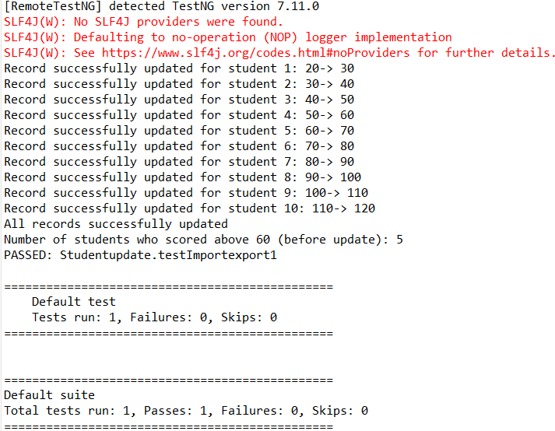

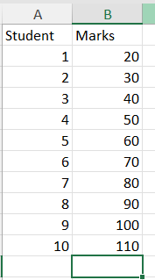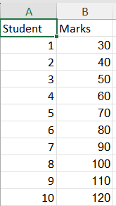**Before: excel file After: excel file**

**Note: I have updated the marks by adding +10 to each student**

# Practical No 6

**Aim: Write a program using Selenium WebDriver to select the number of students who have scored more than 60 in any one subject (or all subjects). Perform data extraction and analysis.**

**Program:**

import java.io.File;

import java.io.IOException; import jxl.Sheet;

import jxl.Workbook;

import jxl.read.biff.BiffException; import org.testng.annotations.*; public class Studentupdate {

private static final String *INPUT_FILE* = "C:\\Users\\aman1\\OneDrive\\Documents\\student_records.xls"; @Test

public void testImportexport1() throws IOException, BiffException { File inputWorkbook = new File(*INPUT_FILE*);

Workbook w; try {

w = Workbook.*getWorkbook*(inputWorkbook); Sheet s = w.getSheet(0);

int studentsAbove60 = 0;

// Process data

for (int i = 1; i <= 10; i++) {

String studentStr = s.getCell(0, i).getContents(); String marksStr = s.getCell(1, i).getContents(); try {

int studentNumber = Integer.*parseInt*(studentStr); int marks = Integer.*parseInt*(marksStr);

// Check if the marks are above 60 if (marks > 60) { studentsAbove60++;

System.*out*.println("Student " + studentNumber + " scored above 60: " + marks);

}

} catch (NumberFormatException e) {

System.*out*.println("Invalid data for student in row " + (i + 1) + ": " + studentStr + ", " + marksStr);

}

}

w.close();

System.*out*.println("Number of students who scored above 60: " + studentsAbove60);

} catch (IOException | BiffException e) { e.printStackTrace();

}

}

}

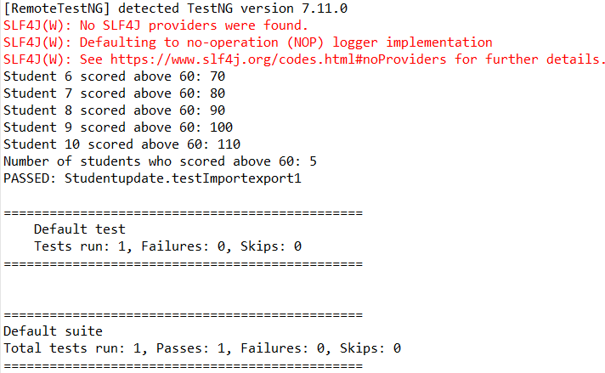**Output:**

# Practical No 7

**Aim: Write a program using Selenium WebDriver to provide the total number of objects present or available on a web page. Perform object identification and counting**

**Program:**

package qqqqqq; import java.util.List;

import java.util.concurrent.TimeUnit; import org.openqa.selenium.By;

import org.openqa.selenium.WebDriver; import org.openqa.selenium.WebElement;

import org.openqa.selenium.firefox.FirefoxDriver; import org.openqa.selenium.firefox.FirefoxOptions;

import org.openqa.selenium.firefox.FirefoxDriverLogLevel; public class llll {

public static void main(String[] args) { System.*setProperty*("webdriver.gecko.driver",

"C:\\Users\\aman1\\OneDrive\\Documents\\geckodriver.exe"); FirefoxOptions options = new FirefoxOptions(); options.setLogLevel(FirefoxDriverLogLevel.*ERROR*); options.addPreference("dom.webnotifications.enabled", false); options.addPreference("dom.push.enabled", false); options.addPreference("media.autoplay.default", 1); options.addPreference("privacy.trackingprotection.enabled", true); WebDriver driver = new FirefoxDriver(options); driver.manage().timeouts().implicitlyWait(30, TimeUnit.*SECONDS*); driver.get("https://wikipedia.com");

List<WebElement> buttons = driver.findElements(By.*tagName*("button")); System.*out*.println("The number of buttons is " + buttons.size()); List<WebElement> inputs = driver.findElements(By.*tagName*("input")); System.*out*.println("The number of input fields is " + inputs.size());

for (WebElement button : buttons) { System.*out*.println("Button text: " + button.getText());

}

for (WebElement input : inputs) {

System.*out*.println("Input type: " + input.getAttribute("type"));

}

driver.quit();

}

}

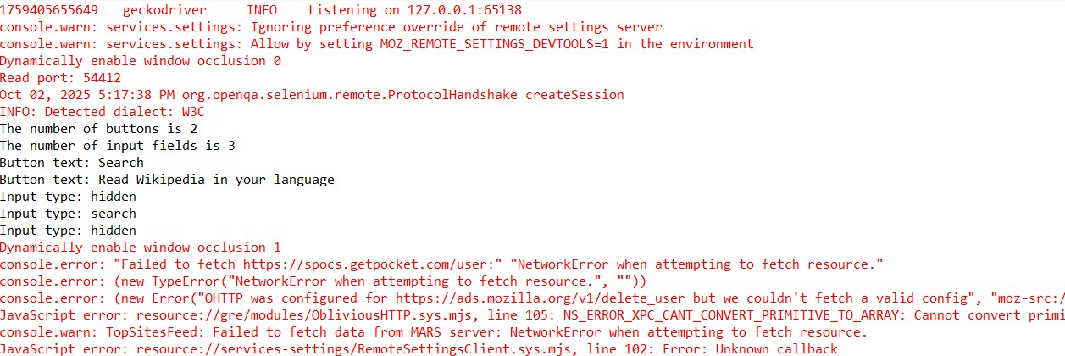**Output:**

# Practical No 8

**Aim: Write a program using Selenium WebDriver to get the number of items in a list or combo box on a web page. Perform element identification and counting.**

**Program:**

package qqqqqq; import java.util.List;

import java.util.concurrent.TimeUnit; import org.openqa.selenium.By;

import org.openqa.selenium.WebDriver; import org.openqa.selenium.WebElement;

import org.openqa.selenium.firefox.FirefoxDriver; public class llll {

@SuppressWarnings("deprecation") public static void main(String[] args) {

System.*setProperty*("webdriver.gecko.driver", "C:\\Users\\aman1\\OneDrive\\Documents\\geckodriver.exe");

// Initialize FirefoxDriver

WebDriver driver = new FirefoxDriver(); String url = "https://wikipedia.com"; driver.get(url);

// Implicit wait

driver.manage().timeouts().implicitlyWait(30, TimeUnit.*SECONDS*); try {

// Locate a combo box (select element)

WebElement comboBox = driver.findElement(By.*cssSelector*("select"));

// Find all options in the combo box

List<WebElement> options = comboBox.findElements(By.*tagName*("option")); System.*out*.println("Number of items in the combo box: " + options.size());

for (WebElement option : options) { System.*out*.println(option.getText());

}

} catch (Exception e) {

System.*out*.println("No combo box found on the page!");

}

// Close the browser driver.close();

}

}

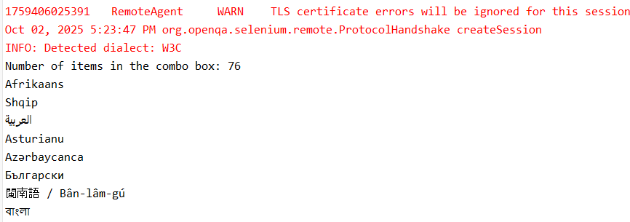**Output:**