Introduction:
Linear Discriminant Analysis or LDA is a dimensionality reduction technique. It is used as a pre-processing step in Machine Learning and applications of pattern classification. The goal of LDA is to project the features in higher dimensional space onto a lower-dimensional space in order to avoid the curse of dimensionality and also reduce resources and dimensional costs.
LDA is a supervised classification technique that is considered a part of crafting competitive machine learning models. This category of dimensionality reduction is used in areas like image recognition and predictive analysis in marketing.

What is Dimensionality Reduction?
The techniques of dimensionality reduction are important in applications of Machine Learning. The main agenda is to remove the redundant and dependent features by changing the dataset onto a lower-dimensional space.
In simple terms, they reduce the dimensions (i.e., variables) in a particular dataset while retaining most of the data.

How to have a practical approach to an LDA model?
- Consider a situation where you have plotted the relationship between two variables where each colour represents a different class. One is shown with a red color and the other with blue.
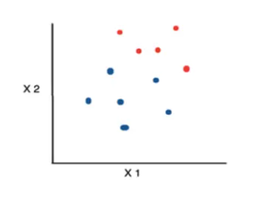

- If you are willing to reduce the number of dimensions to 1, you can just project everything to the x-axis as shown below:

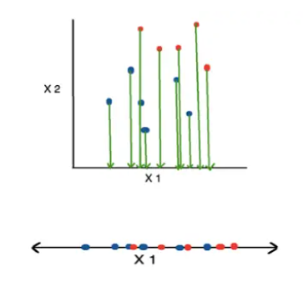

- This approach neglects any helpful information provided by the second feature. However, you can use LDA to plot it.
- The advantage of LDA is that it uses information from both the features to create a new axis which in turn minimizes the variance and maximizes the class distance of the two variables.

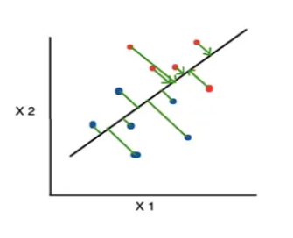

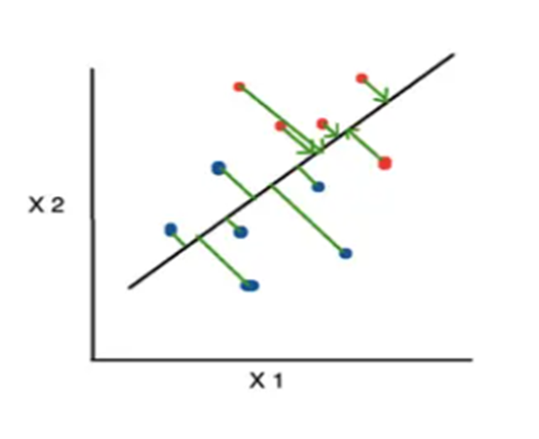

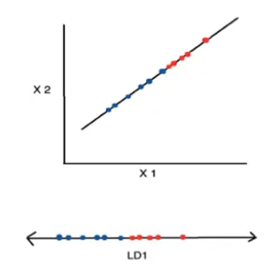

How does LDA work?

LDA focuses primarily on projecting the features in higher-dimensional space to lower dimensions. You can achieve this in three steps:

- Firstly, you need to calculate the separability between classes which is the distance between the mean of different classes. This is called the between-class variance.
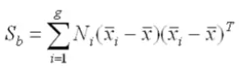

- Secondly, calculate the distance between the mean and sample of each class. It is also called the within-class variance.
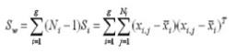

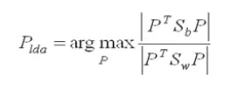
- Finally, construct the lower-dimensional space which maximizes the between-class variance and minimizes the within-class variance. P is considered as the lower-dimensional space projection, also called Fisher’s criterion.

How are LDA models represented?
The representation of LDA is pretty straight-forward. The model consists of the statistical properties of your data that has been calculated for each class. The same properties are calculated over the multivariate Gaussian in the case of multiple variables. The multivariates are means and covariate matrix.
Predictions are made by providing the statistical properties into the LDA equation. The properties are estimated from your data. Finally, the model values are saved to file to create the LDA model.

How do LDA models learn?
- The assumptions made by an LDA model about your data:
  - Each variable in the data is shaped in the form of a bell curve when plotted,i.e. Gaussian.
  - The values of each variable vary around the mean by the same amount on the average, i.e., each attribute has the same variance.

  - The LDA model is able to estimate the mean and variance from your data for each class with the help of these assumptions.
  - The mean value of each input for each of the classes can be calculated by dividing the sum of values by the total number of values:

Mean =Sum(x)/Nk

where Mean = mean value of x for class
N = number of
k = number of
Sum(x) = sum of values of each input x.
- The variance is computed across all the classes as the average of the square of the difference of each value from the mean:

Σ²=Sum((x - M)²)/(N - k)

where Σ² = Variance across all inputs x.
N = number of instances.
k = number of classes.
Sum((x - M)²) = Sum of values of all (x - M)².
M = mean for input x.

How does an LDA model make predictions?
- LDA, i.e., linear discriminant analysis in machine learning, models uses Bayes’ Theorem to estimate probabilities.
- They make predictions based upon the probability that a new input dataset belongs to each class.
- The class which has the highest probability is considered the output class and then the LDA makes a prediction.
- The prediction is made simply by the use of Bayes’ Theorem which estimates the probability of the output class given the input.
- They also make use of the probability of each class and the probability of the data belonging to each class:

P(Y=x|X=x) = [(Plk * fk(x))] / [(sum(PlI * fl(x))]

Where x = input.
k = output class.
Plk = Nk/n or base probability of each class observed in the training data.
It is also called prior probability in Bayes’ Theorem.
fk(x) = estimated probability of x belonging to class k.
- The f(x) is plotted using a Gaussian Distribution function and then it is plugged into the equation above and the result we get is the equation as follows:

Dk(x) = x∗(mean/Σ²) – (mean²/(2*Σ²)) + ln(PIk)

- The Dk(x) is called the discriminant function for class k given input x, mean, Σ² and Plk are all estimated from the data and the class is calculated as having the largest value, will be considered in the output classification.
How to prepare data from LDA?
Some suggestions you should keep in mind while preparing your data to build your LDA model:
- LDA is mainly used in classification problems where you have a categorical output variable. It allows both binary classification and multi-class classification.
- The standard LDA model makes use of the Gaussian Distribution of the input variables. You should check the univariate distributions of each attribute and transform them into a more Gaussian-looking distribution. For example, for the exponential distribution, use log and root function and for skewed distributions use BoxCox.
- Outliers can skew the primitive statistics used to separate classes in LDA, so it is preferable to remove them.
- Since LDA assumes that each input variable has the same variance, it is always better to standardize your data before using an LDA model. Keep the mean to be 0 and the standard deviation to be 1.

Implementation of LDA using scikit-learn:
For implementing LDA using scikit-learn, let’s work with the same wine dataset. You can also obtain it from the UCI machine learning repository.
You can use the predefined class LinearDiscriminant Analysis made available to us by the scikit-learn library to implement LDA rather than implementing from scratch every time:
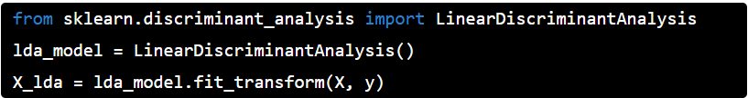

To obtain the variance corresponding to each component, you can access the following property:

we will plot the two LDA component:
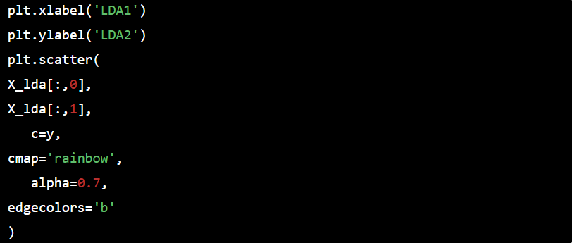
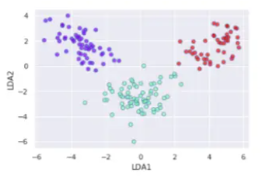
Linear Discriminant Analysis vs PCA:
Below are the differences between LDA and PCA:
- PCA ignores class labels and focuses on finding the principal components that maximizes the variance in a given data. Thus, it is an unsupervised algorithm. On the other hand, LDA is a supervised algorithm that intends to find the linear discriminants that represents those axes which maximize separation between different classes.
- LDA performs better multi-class classification tasks than PCA. However, PCA performs better when the sample size is comparatively small. An example would be comparisons between classification accuracies that are used in image classification.
- Both LDA and PCA are used in case of dimensionality reduction. PCA is first followed by LDA.
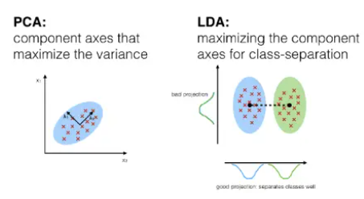

What are the extensions to LDA?
LDA is considered to be a very simple and effective method, especially for classification techniques. Since it is simple and well understood, so it has a lot of extensions and variations:
- Quadratic Discriminant Analysis(QDA) – When there are multiple input variables, each of the class uses its own estimate of variance and covariance.
- Flexible Discriminant Analysis(FDA) – This technique is performed when a non-linear combination of inputs is used as splines.
- Regularized Discriminant Analysis(RDA) – It moderates the influence of various variables in LDA by regularizing the estimate of the covariance.

Applications of LDA:
Some of the practical applications of LDA are listed below:
- Face Recognition – LDA is used in face recognition to reduce the number of attributes to a more manageable number before the actual classification. The dimensions that are generated are a linear combination of pixels that forms a template. These are called Fisher’s faces.
- Medical – You can use LDA to classify the patient disease as mild, moderate or severe. The classification is done upon the various parameters of the patient and his medical trajectory.
- Customer Identification – You can obtain the features of customers by performing a simple question and answer survey. LDA helps in identifying and selecting which describes the properties of a group of customers who are most likely to buy a particular item in a shopping mall.

