
Notes

Program Name-

Course Name- Sem-

Unit Number- Unit Name-

Topic Name-

Introduction- An introductory statement to establish connection with the previous knowledge/lecture/session

Content-

Summary-

Self-Assessment Questions-(Objective/Subjective- Minimum 5 questions)

Introduction:
Principal Component Analysis (PCA) is a valuable technique in statistics and data analysis. It helps simplify complex data by reducing its dimensionality while preserving essential information.
PCA is a very flexible tool and allows analysis of datasets that may contain, for example, multicollinearity, missing values, categorical data, and imprecise measurements. The goal is to extract the important information from the data and to express this information as a set of summary indices called principal components.
Statistically, PCA finds lines, planes and hyper-planes in the K-dimensional space that approximate the data as well as possible in the least squares sense. A line or plane that is the least squares approximation of a set of data points makes the variance of the coordinates on the line or plane as large as possible.
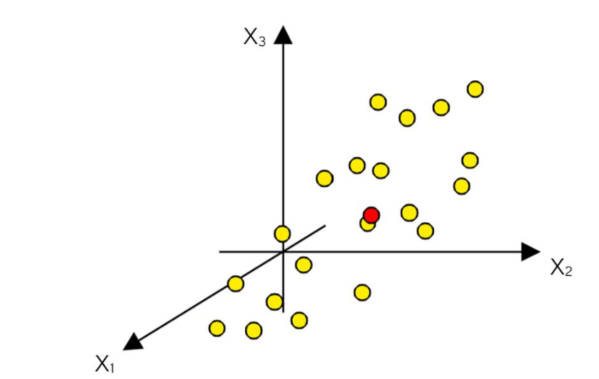

PCA creates a visualization of data that minimizes residual variance in the least squares sense and maximizes the variance of the projection coordinates.

How PCA works:
let’s take a look at how PCA works, using a geometrical approach.
- Consider a matrix X with N rows (or "observations") and K columns (or "variables"). For this matrix, we construct a variable space with as many dimensions as there are variables (see figure below).
- Each variable represents one coordinate axis. For each variable, the length has been standardized according to a scaling criterion, normally by scaling to unit variance. You can find more details on scaling to unit variance in the previous blog post.
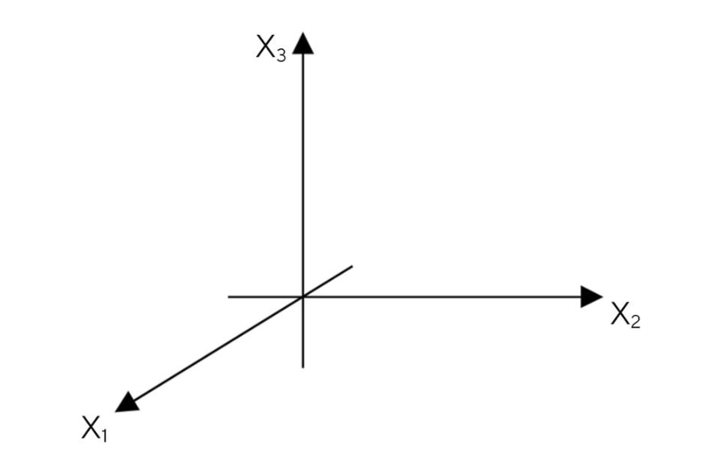

- A K-dimensional variable space. For simplicity, only three variables’ axes are displayed. The “length” of each coordinate axis has been standardized according to a specific criterion, usually unit variance scaling.
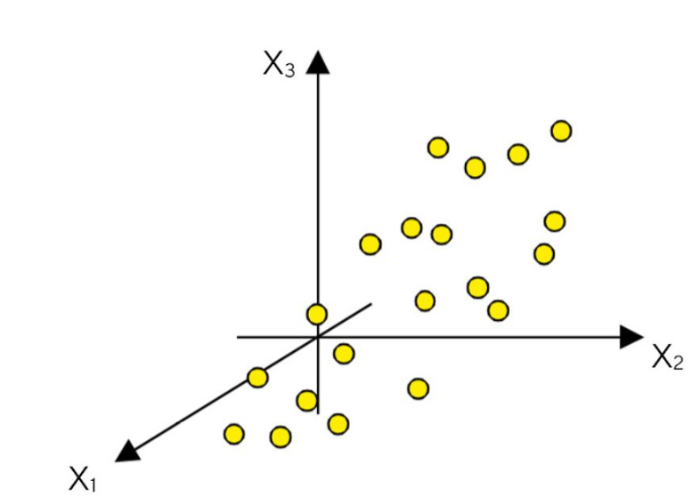
- In the next step, each observation (row) of the X-matrix is placed in the K-dimensional variable space. Consequently, the rows in the data table form a swarm of points in this space.

Mean centering:
- Next, mean-cantering involves the subtraction of the variable averages from the data. The vector of averages corresponds to a point in the K-space.
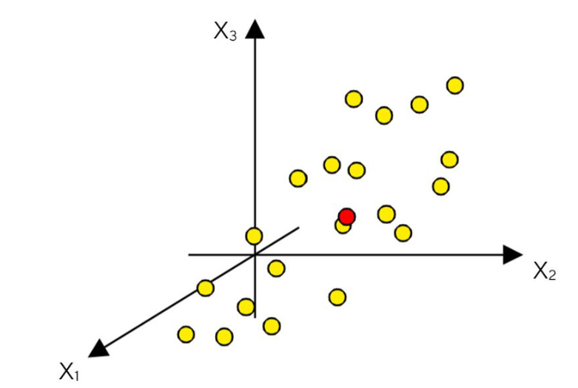
- In the mean-centering procedure, you first compute the variable averages. This vector of averages is interpretable as a point (here in red) in space. The point is situated in the middle of the point swarm (at the center of gravity).
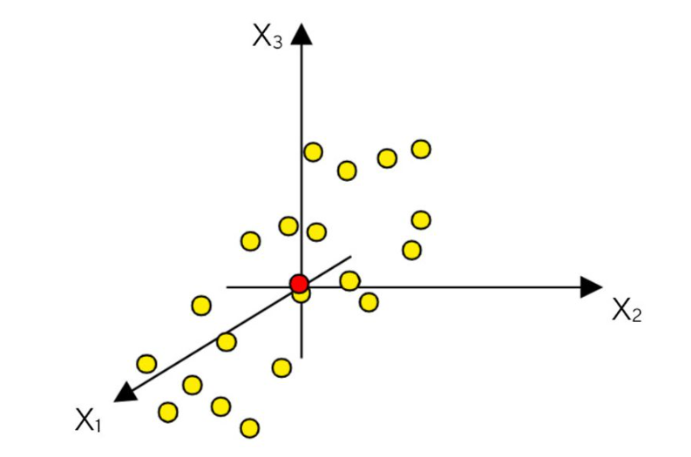
- The subtraction of the averages from the data corresponds to a re-positioning of the coordinate system, such that the average point now is the origin.

- The mean-centering procedure corresponds to moving the origin of the coordinate system to coincide with the average point (here in red).

The first principal component:
- After mean-centering and scaling to unit variance, the data set is ready for computation of the first summary index, the first principal component (PC1).
- This component is the line in the K-dimensional variable space that best approximates the data in the least squares sense.
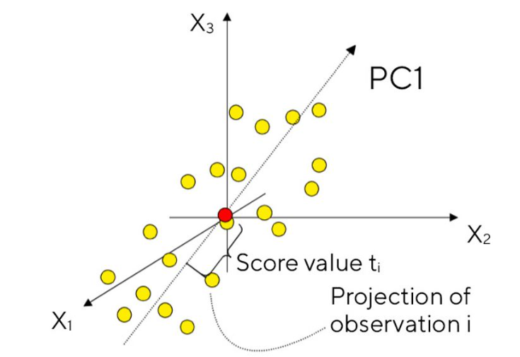
- This line goes through the average point. Each observation (yellow dot) may now be projected onto this line in order to get a coordinate value along the PC-line. This new coordinate value is also known as the score.

- The first principal component (PC1) is the line that best accounts for the shape of the point swarm.
- It represents the maximum variance direction in the data.
- Each observation (yellow dot) may be projected onto this line in order to get a coordinate value along the PC-line. This value is known as a score.

The Second Principal Component:
- Usually, one summary index or principal component is insufficient to model the systematic variation of a data set.
- Thus, a second summary index – a second principal component (PC2) – is calculated.
- The second PC is also represented by a line in the K-dimensional variable space, which is orthogonal to the first PC.
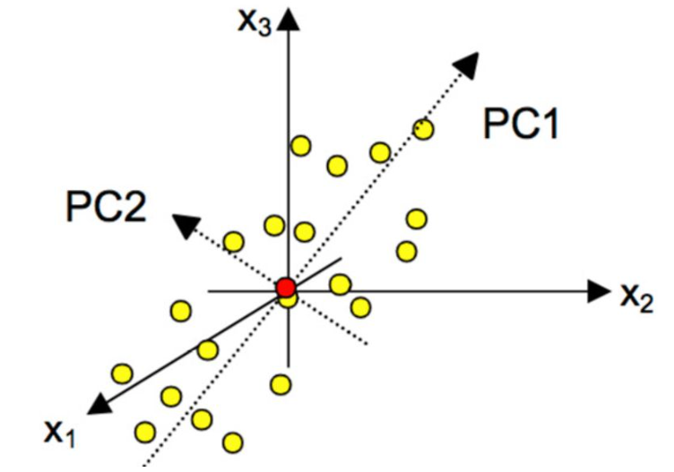
- This line also passes through the average point, and improves the approximation of the X-data as much as possible.

- The second principal component (PC2) is oriented such that it reflects the second largest source of variation in the data while being orthogonal to the first PC. PC2 also passes through the average point.

Two Principal Components Define A Model Plane:
- When two principal components have been derived, they together define a place, a window into the K-dimensional variable space.
- By projecting all the observations onto the low-dimensional sub-space and plotting the results, it is possible to visualize the structure of the investigated data set.
- The coordinate values of the observations on this plane are called scores, and hence the plotting of such a projected configuration is known as a score plot.
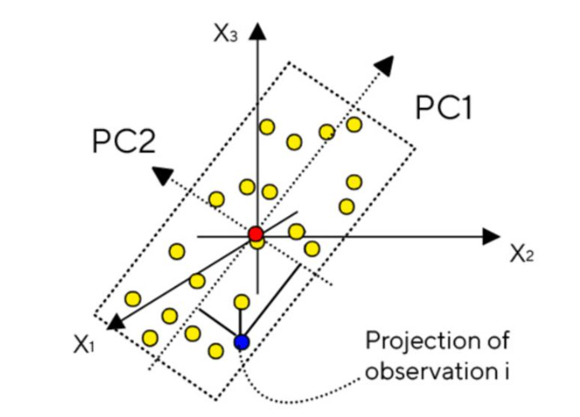

- Two PCs form a plane. This plane is a window into the multidimensional space, which can be visualized graphically.
- Each observation may be projected onto this plane, giving a score for each.

Modeling A Data Set:
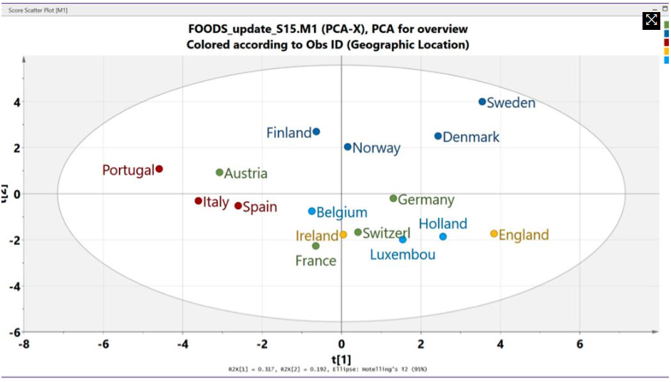
- Now, let’s consider what this looks like using a data set of foods commonly consumed in different European countries.
- The figure above displays the score plot of the first two principal components.
- These scores are called t1 and t2. The score plot is a map of 16 countries.
- Countries close to each other have similar food consumption profiles, whereas those far from each other are dissimilar.
- The Nordic countries (Finland, Norway, Denmark and Sweden) are located together in the upper right-hand corner, thus representing a group of nations with some similarity in food consumption.
- Belgium and Germany are close to the center (origin) of the plot, which indicates they have average properties.
- The PCA score plot of the first two PCs of a data set about food consumption profiles.
- His provides a map of how the countries relate to each other.
- The first component explains 32% of the variation, and the second component 19%. Colored by geographic location (latitude) of the respective capital city.

How to Interpret the Score Plot:
- In a PCA model with two components, that is, a plane in K-space, which variables (food provisions) are responsible for the patterns seen among the observations (countries)?
- We would like to know which variables are influential, and also how the variables are correlated.
- Such knowledge is given by the principal component loadings (graph below). These loading vectors are called p1 and p2.
- The figure below displays the relationships between all 20 variables at the same time.
- Variables contributing similar information are grouped together, that is, they are correlated.
- Crisp bread (crips_br) and frozen fish (Fro_Fish) are examples of two variables that are positively correlated.
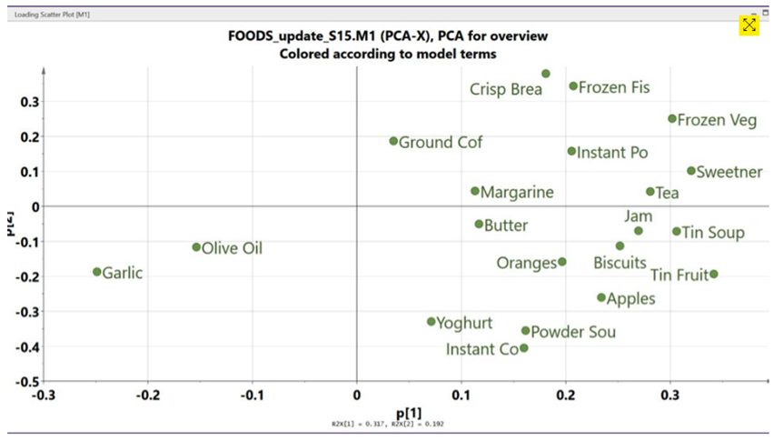
- When the numerical value of one variable increases or decreases, the numerical value of the other variable has a tendency to change in the same way.
- When variables are negatively (“inversely”) correlated, they are positioned on opposite sides of the plot origin, in diagonally 0pposed quadrants.
- For instance, the variables garlic and sweetener are inversely correlated, meaning that when garlic increases, sweetener decreases, and vice versa.

Python Implementation:
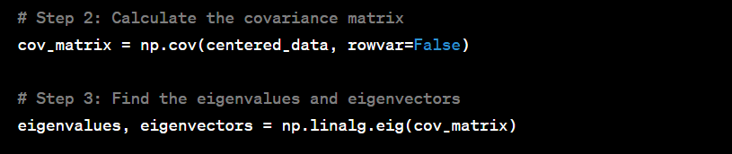
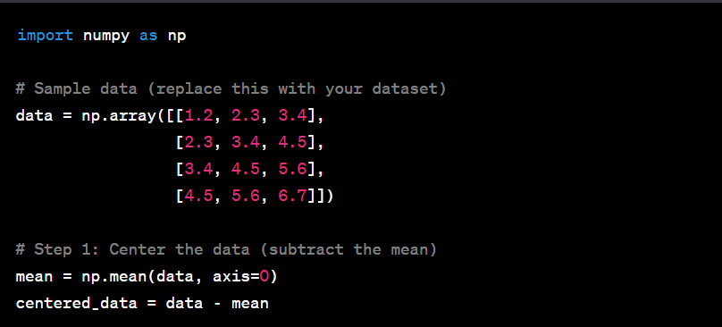

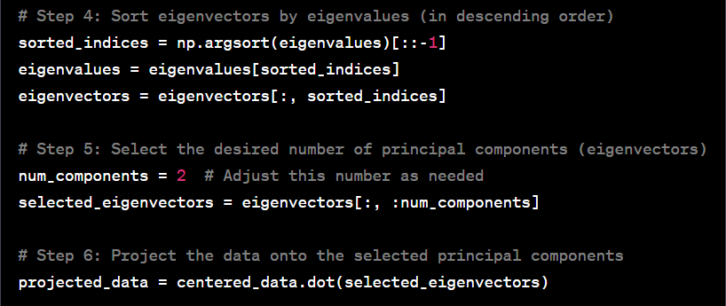
In this example, you'll need to replace the data variable with your own dataset. The code will calculate the principal components and project your data onto them. You can adjust num_components to choose how many principal components to keep.
Remember that this is a basic implementation for learning purposes. In real-world scenarios, it's advisable to use established libraries like scikit-learn for PCA, which offer more features and optimizations.

Parameters:
- n_components : int, float or ‘mle’, default=None

Number of components to keep. if n_components is not set all components are kept:
n_components == min(n_samples, n_features)

If n_components == 'mle' and svd_solver == 'full', Minka’s MLE is used to guess the dimension. Use of n_components == 'mle' will interpret svd_solver == 'auto' as svd_solver == 'full'.

If 0 < n_components < 1 and svd_solver == 'full', select the number of components such that the amount of variance that needs to be explained is greater than the percentage specified by n_components.

If svd_solver == 'arpack', the number of components must be strictly less than the minimum of n_features and n_samples.

Hence, the None case results in:

n_components == min(n_samples, n_features) – 1
- copy : bool, default=True
If False, data passed to fit are overwritten and running fit(X).transform(X) will not yield the expected results, use fit_transform(X) instead.
- Whiten : bool, default=False
When True (False by default) the components_ vectors are multiplied by the square root of n_samples and then divided by the singular values to ensure uncorrelated outputs with unit component-wise variances.

Whitening will remove some information from the transformed signal (the relative variance scales of the components) but can sometime improve the predictive accuracy of the downstream estimators by making their data respect some hard-wired assumptions.

- svd_solver : {‘auto’, ‘full’, ‘arpack’, ‘randomized’}, default=’auto’

- If auto :
The solver is selected by a default policy based on X.shape and n_components: if the input data is larger than 500x500 and the number of components to extract is lower than 80% of the smallest dimension of the data, then the more efficient ‘randomized’ method is enabled. Otherwise the exact full SVD is computed and optionally truncated afterwards.
- If full :
run exact full SVD calling the standard LAPACK solver via scipy.linalg.svd and select the components by postprocessing
- If arpack :
run SVD truncated to n_components calling ARPACK solver via scipy.sparse.linalg.svds. It requires strictly 0 < n_components < min(X.shape)
- If randomized :
run randomized SVD by the method of Halko et al.
- tol : float default=0.0

Tolerance for singular values computed by svd_solver == ‘arpack’. Must be of range [0.0, infinity).
- iterated_power : int or ‘auto’, default=’auto’
Number of iterations for the power method computed by svd_solver == ‘randomized’. Must be of range [0, infinity).
- n_oversamples : int, default=10
This parameter is only relevant when svd_solver="randomized". It corresponds to the additional number of random vectors to sample the range of X so as to ensure proper conditioning. See randomized_svd for more details.
- power_iteration_normalizer : {‘auto’, ‘QR’, ‘LU’, ‘none’}, default=’auto’
Power iteration normalizer for randomized SVD solver. Not used by ARPACK. See randomized_svd for more details.
- random_state : int, RandomState instance or None, default=None
Used when the ‘arpack’ or ‘randomized’ solvers are used. Pass an int for reproducible results across multiple function calls.

