AGRI-PROFIT (A Farm Record and Decision-Support Platform)

BY

ERHABOR ISRAEL ISIMA
2021/1/83967EA

DEPARTMENT OF AGRICULTURAL AND BIORESOURCES ENGINEERING
FEDERAL UNIVERSITY OF TECHNOLOGY
MINNA

AUGUST, 2026

AGRI-PROFIT (A Farm Record and Decision-Support Platform)

BY

ERHABOR ISRAEL ISIMA
2021/1/83967EA

PROJECT SUBMITTED TO THE DEPARTMENT OF AGRICULTURAL AND BIORESOURCES ENGINEERING, SCHOOL OF INFRASTRUCTURE PROCESS ENGINEERING AND TECHNOLOGY, FEDERAL UNIVERSITY OF TECHNOLOGY, MINNA, NIGERIA IN PARTIAL FULFILMENT OF THE REQUIREMENT FOR THE AWARD OF THE DEGREE OF BACHELOR OF ENGINEERING IN AGRICULTURAL AND BIORESOURCES ENGINEERING

AUGUST, 2026
DECLARATION
I hereby declare that this project titled: “AGRI-PROFIT (A Farm Record and Decision-Support Platform)” is a collection of my original project work and it has not been presented for any other qualification anywhere. Information from other sources (published or unpublished) has been duly acknowledged.

ERHABOR, ISRAEL ISIMA

____________________________ _______________________
2021/1/83967EA Signature and Date
Federal University of Technology,
Minna, Nigeria.
DEDICATION
This project is dedicated first to God Almighty. He is my source of strength and inspiration. He gave me perseverance throughout this journey.
I dedicate this project to my Mother. Her love and sacrifices made my education possible. She supported my growth at every stage. I am forever grateful to her.
I dedicate this project to my dear friend, Olu-Arimoro Fadunsayemi Enoch. His contribution to this project was invaluable, in many ways. I thank him for believing in this work. I thank him for standing behind it in ways I cannot fully express.

ACKNOWLEDGEMENTS
I wish to express my profound gratitude to my project supervisor, Engr. Dr. Imologie M. Simeon, for their invaluable guidance, patience, and constructive feedback throughout the course of this project.
My sincere appreciation also goes to the Head of Department, Engr. Prof. P. A. Adeoye and to all the academic and non-academic staff of the Department of Agricultural and Bio resources engineering for their administrative support and for creating an environment conducive to academic growth.
I would also like to thank my friends and family for their unwavering moral and financial support, which has been instrumental in the successful completion of my undergraduate studies. Finally, above all, I thank God for the grace and strength to see this endeavor to fruition.
ABSTRACT
Nigerian smallholder and medium-scale farms keep production and cost records on paper, so the cost of production per crop is rarely known at sale; existing farm management software assumes continuous connectivity and charges per user seat. This work designed, implemented and evaluated AGRI-PROFIT, an offline-first web platform comprising a soft-immutable paired-write ledger in which every operational record posts its financial transaction in a single commit and is corrected only by a linked contra entry, a deterministic decision-support layer computing nine quantities including per-crop gross margin, unit cost of production on two bases and retrospective break-even yield, and a post-harvest drying module applying thin-layer kinetics to the farm’s own records. A design-and-build methodology was adopted, its four-strand evaluation specified in advance. Functional verification at the submitted commit returned 426 collected backend cases — 422 passed, 4 skipped, none failed — at 96% statement coverage over 1,601 statements, with 148 frontend tests across 13 files at 41.84–43.23% statement coverage, and the drying model recovered its designed parameters exactly. For a 100 kg maize harvest dried from 25% to 13% moisture and weighed out at 84 kg, unit cost moves from ₦35.00 to ₦41.67 per kilogram: post-harvest mass loss expressed in money. Under 0.4 Mbps simulated throttling the service worker reduced network transfer on a repeat visit from 139,245 bytes to 127, first paint from 5,661.2 ms to 70.6 ms and largest contentful paint to 1,612.0 ms. Role-based authorisation over three roles and eleven permissions, expiring hashed share tokens, login throttling and credential scrubbing were verified live on the running stack. The yield-forecast tier returned R² 0.9762, MAE 0.2414 t/ha and RMSE 0.4883 t/ha, reproducible to six decimal places, on synthetic data alone; no claim of field-predictive accuracy is made. Measured resource consumption below 205 MiB gives an estimated ₦20,950 per month, or ₦105 per farm at a two-hundred-farm tenancy. The usability evaluation was not conducted and no System Usability Scale score is reported, so that objective is only partly met, and the platform has never been deployed to serve a real user.
TABLE OF CONTENTS
CONTENT PAGE
CHAPTER ONE 1
1.1 Background of the Study 1
1.2 Statement of the Problem 2
1.3 Aim and Objectives 3
1.4 Justification of the Study 5
1.5 Scope and Limitations of the Study 6
CHAPTER TWO 9
2.1 Conceptual Review 9
2.1.1 The Evolution of Farm Record Management 9
2.1.2 Decision-Support Systems (DSS) 10
2.1.3 The Shift from Manual to Digital Agriculture (Agriculture 4.0) 10
2.2 Theoretical Framework 11
2.2.1 Technology Acceptance and Innovation Systems Theories 11
2.2.2 The Theory of Bounded Rationality 11
2.2.3 Socio-Technical Systems Perspective 12
2.3 The Nigerian Context: Precision Agriculture and Mobile Scaling 12
2.4 Empirical Review and Socio-Technical Barriers to Adoption 13
2.4.1 Review of Existing Systems 13
2.4.2 Socio-Technical Barriers to Adoption 13
2.5 Data-Sharing and Stakeholder Trust 14
2.6 Structuring the Decision-Support Prediction Model for AGRI-PROFIT 15
2.6.1 Data Layer and Feature Definition 15
2.6.2 Data Pre-processing 16
2.6.3 A Tiered Modelling Strategy 17
2.6.4 Model Training, Validation, and Evaluation Metrics 18
2.6.5 From Prediction to Decision Support 19
2.7 Post-Harvest Drying Kinetics and the Costing of Marketable Output 19
2.7.1 Thin-Layer Drying Models 20
2.7.2 The Post-Harvest Context in Africa, and the Costing Gap 21
2.8 Gap in Literature 22
CHAPTER THREE —
3.1 Introduction —
3.2 Research and Development Methodology —
3.3 System Requirements Analysis —
3.3.1 Functional Requirements —
3.3.2 Non-Functional Requirements —
3.4 System Architecture —
3.4.1 Overall Architecture —
3.4.2 Technology Stack —
3.5 Data Model Design —
3.6 Module Design —
3.6.1 Offline Operational Logbook —
3.6.2 Financial Ledger Engine —
3.6.3 Reporting —
3.6.4 Mechanisation and Equipment Tracker —
3.6.5 Predictive Decision-Support Engine —
3.6.6 Authentication and Per-Farm Data Boundary —
3.6.7 Tokenised Stakeholder Reporting —
3.6.8 Feature-Phone (USSD/SMS) Data Entry — Designed, Not Implemented —
3.6.9 Post-Harvest Drying Module —
3.6.10 Enterprise Economics Module —
3.7 Security Design —
3.8 Evaluation Methodology —
3.8.1 Functional Verification —
3.8.2 Performance Benchmarking —
3.8.3 Hosting-Cost Analysis —
3.8.4 Usability Evaluation (Heuristic and SUS) —
3.8.5 Designed Field Evaluation (Future Work) —
3.9 Summary —
CHAPTER FOUR —
4.1 Introduction —
4.2 Per-Crop Gross Margin and Enterprise Ranking —
4.3 Unit Cost of Production: Harvested and Marketable Bases —
4.4 Break-Even Yield and Break-Even Price —
4.4.1 Retrospective break-even yield —
4.4.2 Dual break-even price and yield sensitivity —
4.5 Post-Harvest Drying and Marketable Mass —
4.5.1 Verification by designed fixture —
4.5.2 The seeded drying run in full —
4.5.3 Input validation —
4.5.4 Coupling to the financial ledger —
4.6 Enterprise Budget, Cost Structure, Depreciation and Partial Budget —
4.6.1 Cost structure and classification coverage —
4.6.2 The depreciation overlay and fixed-cost allocation —
4.6.3 Partial budget and implementation parity —
4.6.4 Yield baseline —
4.7 Yield Forecast Evaluation —
4.8 The Implemented System in Use —
4.8.1 Deployed components —
4.8.2 Functional inventory —
4.8.3 Components verified visually only —
4.8.4 Live system verification —
4.9 System Verification —
4.10 Response Time and Hosting Cost —
4.11 Security and Deployment Verification —
4.12 Usability Evaluation —
4.13 Results Against the Stated Objectives —
4.14 Limitations —
4.15 Summary —
CHAPTER FIVE —
5.1 Summary —
5.1.1 The Problem, the Approach, and the Procedures Used —
5.1.2 Summary of Findings —
5.1.3 Achievement Against the Research Objectives —
5.2 Conclusion —
5.2.1 Interpretation of the Major Findings —
5.2.2 Comparison with the Literature —
5.2.3 Limitations —
5.2.4 Conclusion —
5.3 Recommendations —
5.3.1 Implications —
5.3.2 Recommendations and Suggestions for Further Studies —
REFERENCES —
APPENDIX A: IMPLEMENTED CAPABILITY INVENTORY —
APPENDIX B: SECURITY, AUTHORISATION AND DEPLOYMENT VERIFICATION EVIDENCE —
APPENDIX C: HOSTING-COST MEASUREMENT AND ESTIMATE —
APPENDIX D: DATA MODEL ENTITY REFERENCE —
APPENDIX E: YIELD MODEL CONFIGURATION AND REPRODUCIBILITY RECORD —
APPENDIX F: SEEDED DRYING RUN IN FULL —
LIST OF TABLES
TABLE PAGE
Table 4.1: The evidential classification applied throughout Chapter Four —
Table 4.2: Per-crop decision support, farm 26, at the baseline commit —
Table 4.3: Unit cost of production, farm 26 —
Table 4.4: Retrospective break-even yield, farm 26 —
Table 4.5: Break-even price, maize and cowpea, farm 26 —
Table 4.6: Yield sensitivity matrix, maize, farm 26 —
Table 4.7: Per-crop drying summary, farm 26 —
Table 4.8: Cost structure, farm 26 —
Table 4.9: Derived fixed-cost overlay, farm 26 —
Table 4.10: Usability evaluation — to be completed from retained instruments —
Table 4.11: Usability issue log — to be completed —
Table 4.12: Evidence and residual gap, by objective —
Table A.1: Implemented capabilities and their reachability —
Table B.1: Security and authorisation verification against the running stack —
Table B.2: Deployment, migration and recovery verification —
Table C.1: Measured container footprint —
Table C.2: Estimated monthly operating cost —
Table C.3: Reasoned cost per farm served —
Table D.1: Principal entities of the AGRI-PROFIT data model —
Table E.1: Yield model as served by the platform —
Table F.1: Maize drying run, farm 26, as computed by the platform —
LIST OF FIGURES
FIGURE PAGE
Figure 3.1: AGRI-PROFIT system architecture 28
Figure 3.2: Entity-relationship diagram of the AGRI-PROFIT data model 31
Figure 3.3: The paired write — sequence of a single record creation 33
Figure 4.1: Per-crop gross margin and enterprise ranking, showing unit cost of production on both the harvested and the marketable basis —
Figure 4.2: Break-even prices for cowpea: ₦530.63 per kilogram to cover cash cost and ₦631.56 to cover total cost, both against the 431 kg marketable mass —
Figure 4.3: Cost structure for an enterprise with no recorded drying run, showing both break-even prices and the operating expense ratio withheld rather than defaulted to zero —
Figure 4.4: Entering a post-harvest drying run: mass in and out, initial and final moisture on a wet basis, and the moisture readings taken during the run —
Figure 4.5: Computed drying result for the maize run: 84.00 kg marketable from 100 kg at 25.0% moisture, 14.08 kg water removed, 2.21 kg process loss, Page model n = 0.7956, k = 0.1316, R² = 0.9981 over three readings, and the safe storage verdict at 13.0% wet basis —
Figure 4.6: Farm level cost structure: 88.3% of ₦598,450 recorded cost classified by cost behaviour, with an operating expense ratio of 68.4% —
Figure 4.7: Equipment register and depreciation basis, with the unrated asset excluded from the charge rather than counted as costing nothing —
Figure 4.8: Profit and loss by activity category, with mechanisation the largest single cost at ₦215,550 —
Figure 4.9: Yield forecast for maize at 800 mm rainfall, 120 kg of nitrogen per hectare and soil pH 6.2: 4.74 t/ha with a likely range of 3.24 to 6.24 t/ha —
Figure 4.10: Farm overview showing net profit of ₦250,100 against revenue of ₦848,550 and operating cost of ₦598,450 —
Figure 4.11: Operational record list for the demonstration farm, ordered by date and filterable by crop and activity —
Figure 4.12: Recording a mechanisation cost, showing the cost classification control and land area entered as free text in the absence of an area field —
Figure 4.13: Record list filtered to mechanisation activities —

CHAPTER ONE

1.0 INTRODUCTION

1.1 Background of the Study
The global agricultural sector faces the unprecedented challenge of increasing food production to sustain a human population projected to approach 10 billion by 2050 (Dayıoğlu & Türker, 2021). To meet these escalating demands while mitigating the adverse impacts of climate change, resource depletion, and environmental degradation, traditional farming methodologies are rapidly shifting towards “Agriculture 4.0” (Abbasi, Martinez, & Ahmad, 2022). This paradigm integrates modern information and communication technologies (ICT), the Internet of Things (IoT), artificial intelligence (AI), and data analytics to optimise agricultural systems (Abiri, Rizan, Balasundram, Shahbazi, & Abdul-Hamid, 2023). At the core of this digital transformation is the necessity for accurate, real-time data collection and on-farm recordkeeping, which serve as the foundation for precision agriculture and operational efficiency (Basir, Buckmaster, Raturi, & Zhang, 2024).
Historically, agricultural practitioners have relied on unstructured, paper-based logbooks or human memory to track operations. While these traditional methods possess inherent provenance, they are highly susceptible to data fragmentation, loss, recall bias, and significant transcription errors (Basir et al., 2024). In response, Farm Management Information Systems (FMIS) evolved from simple digitalised field books into complex platforms designed to collect, process, store, and disseminate data to support human decision-making in farm enterprises (Fountas et al., 2015; Tummers, Kassahun, & Tekinerdogan, 2019). Modern digital recordkeeping platforms streamline administrative burdens, facilitate data interoperability, and enable precise financial tracking and bioprocess monitoring. Empirical adoption studies further establish that uptake of these systems is strongly conditioned by farmers’ education, access to advisory services, and access to rural credit—factors that are unevenly distributed in developing economies (Carrer, de Souza Filho, & Batalha, 2017).
However, the distribution and adoption of these digital agricultural technologies remain highly unequal globally (Javaid, Haleem, Singh, & Suman, 2022; Mhlanga & Ndhlovu, 2023). In Sub-Saharan Africa, including Nigeria, the integration of advanced FMIS faces unique socio-economic and infrastructural barriers. The Nigerian agricultural landscape predominantly comprises smallholder farmers and medium-scale enterprises that frequently lack access to robust technological infrastructure and capital (Abioye et al., 2024). Market analyses attributed to the Global System for Mobile Communications Association (GSMA) report that 68% of Nigerians in rural areas lacked smartphones in 2022, rural ownership standing at 32% against 58% in urban areas. This severe digital divide is primarily exacerbated by high inflation, device-affordability constraints, and pervasive digital illiteracy (Mhlanga & Ndhlovu, 2023). Consequently, while the existing 32% smartphone penetration provides a critical leapfrog opportunity to deploy mobile-based agricultural advisory services, comprehensive digital farm record management remains heavily underutilised. Engineers and software developers must therefore contextualise global digital-farming advancements into localised, accessible platforms. Developing tools that merge farm mechanisation tracking, post-harvest bioprocess monitoring, and financial management into a single decision-support architecture holds the potential to strengthen agricultural productivity in Nigeria.

1.2 Statement of the Problem
Despite the well-documented benefits of digital agriculture, practitioners and engineers in Nigeria face severe bottlenecks in adopting existing Farm Management Information Systems (FMIS) (Tummers et al., 2019). Current commercial FMIS platforms and Enterprise Resource Planning (ERP) systems frequently exhibit high complexity, lack standardised data formats, and impose prohibitive costs that exclude small and medium-scale farmers (Fountas et al., 2015; Giua, Materia, & Camanzi, 2021).
Furthermore, agricultural operations suffer from critical data fragmentation. Farm managers typically maintain Farm Financial Accounts (FFA) entirely separate from their operational and bioprocess records, resulting in duplicated data entry, administrative fatigue, and analytical inefficiencies (Poppe, Vrolijk, & Bosloper, 2023). Because essential metrics such as equipment maintenance schedules, labour inputs, crop-yield data, and financial expenditures are siloed, farmers cannot accurately correlate mechanisation inputs or biological variables with actual financial profitability (Gebresenbet et al., 2023).
Without interoperable, structured data, Nigerian agricultural enterprises cannot deploy predictive analytics or decision-support algorithms to optimise resource utilisation (van Klompenburg, Kassahun, & Catal, 2020). In rural contexts where poor internet connectivity and limited technical training exacerbate these issues, deploying resource-intensive, cloud-heavy ERP solutions proves impractical (Abbasi et al., 2022; Mhlanga & Ndhlovu, 2023). Therefore, a critical gap exists for a localised, unified digital platform AGRI-PROFIT that bridges financial tracking and operational farm data to generate actionable decision support tailored to the specific constraints of Nigerian agriculture.

1.3 Aim and Objectives
Aim
The primary aim of this research is to design, develop, and evaluate AGRI-PROFIT, a secure, integrated farm record management and decision-support platform that overcomes socio-technical adoption barriers to improve resource allocation, mechanisation cost tracking, post-harvest process accounting, and stakeholder data-sharing for Nigerian agricultural enterprises.
Objectives
To achieve this overarching aim, the specific, measurable objectives of the study are:
i. To identify and evaluate the socio-technical barriers specifically data fragmentation, interoperability constraints, and user complexity that systematically hinder the widespread adoption of digital Farm Management Information Systems (FMIS) in the Nigerian context (Carrer et al., 2017; Tummers et al., 2019).
ii. To formulate a conceptual system architecture for the AGRI-PROFIT platform that translates static operational and financial farm records into dynamic, actionable decision-support metrics for costing crop enterprises and for capturing mechanisation and equipment expenditure within the same ledger (Gebresenbet et al., 2023).
iii. To design and integrate a secure data-sharing framework within the platform architecture that standardises yield and profit/loss reporting, serving as a verifiable analytical tool to build operational trust among agricultural banks, investors, and policymakers (Xiong et al., 2020; Abiri et al., 2023).
iv. To implement and empirically evaluate the AGRI-PROFIT platform’s usability, cost-effectiveness, and operational viability within the specific infrastructural constraints of Nigerian smallholder and medium-scale farms.
v. To model the post-harvest drying of harvested produce using established thin-layer drying kinetics, and to couple the resulting moisture, water-balance and marketable-mass outcomes to the farm’s financial record, so that the unit cost of production is expressed against saleable rather than harvested mass (Onwude, Hashim, Janius, Nawi, & Abdan, 2016; Baidhe, Clementson, Senyah, & Hammed, 2024).

1.4 Justification of the Study
The development of the AGRI-PROFIT platform delivers immediate economic and operational benefits to agricultural producers while significantly advancing the discipline of Agricultural and Bio-resources Engineering. For farmers and agribusiness managers, the system addresses the critical need to mitigate administrative burdens and overcome data fragmentation (Poppe et al., 2023). By synthesising operational field records with financial data, AGRI-PROFIT empowers farm managers to transition from intuition-based strategies (Husemann & Novkovic, 2012) to evidence-based precision farming. This transition allows producers to precisely calculate production costs, reduce resource wastage, and maximise gross margins at the specific crop-enterprise level (Basir et al., 2024).
Furthermore, this research specifically addresses the “human element” of digital agriculture by targeting the socio-technical barriers such as poor software interoperability and user complexity that cause existing systems to fail (Carrer et al., 2017; Tummers et al., 2019). By formulating a robust conceptual system architecture, the platform addresses a major macro-economic problem for the agricultural sector: the lack of credible, standardised data required by agricultural banks and investors to approve financing or insurance (Gebresenbet et al., 2023; Xiong et al., 2020).
For Agricultural and Bio-resources Engineers, this research demonstrates the vital intersection of cyber-physical systems, data analytics, and agricultural management, often termed AgInformatics (Dayıoğlu & Türker, 2021). As the Nigerian agricultural sector seeks to modernise, engineers must move beyond designing physical machinery to developing the software infrastructures required to manage those machines efficiently. Developing localised digital tools ensures that Nigeria can sustainably participate in the Agriculture 4.0 revolution, ultimately driving long-term food security and economic resilience (Mhlanga & Ndhlovu, 2023).

1.5 Scope and Limitations of the Study
Scope
This research encompasses the software-engineering lifecycle including system architecture design, coding, and initial deployment of the AGRI-PROFIT platform, tailored specifically for Nigerian agricultural practices. The platform primarily targets core FMIS functionalities: digital operational logbooks, financial-accounting integration, mechanisation and equipment cost tracking, post-harvest drying analysis coupled to the financial record, and decision support for crop enterprises. Livestock enterprises are outside the scope of the current implementation: the activity-category model would extend to them without structural change, but no livestock entity, category, field or metric is implemented, and no livestock capability is claimed anywhere in this work. Within the post-harvest strand the scope is confined to thin-layer drying kinetics, wet- and dry-basis moisture conversion, dry-matter and water balances, safe-storage assessment for those crops whose thresholds are recorded, and the propagation of marketable mass into the unit-cost calculation; no other post-harvest unit operation is modelled.
Limitations
The study acknowledges specific constraints inherent to the operating environment. Given the high capital costs and limited rural network infrastructure in Nigeria, AGRI-PROFIT prioritises manual digital inputs via smartphones or computers rather than relying on fully automated, capital-intensive IoT sensor networks (Abbasi et al., 2022; Basir et al., 2024). In keeping with these realities, offline capability is implemented primarily for the data-entry (write) path, so that farmers can record operations and transactions without connectivity; a service worker additionally serves the application shell and a defined set of previously fetched read endpoints, so that recent results remain readable without a connection, while all computation is performed server-side (Mhlanga & Ndhlovu, 2023). Furthermore, while immutable distributed-ledger (block chain) governance is reviewed in Section 2.5 as a mechanism for stakeholder trust, it is treated in this study as a conceptual design direction and future extension rather than part of the current implementation; within the present scope, secure data-sharing is achieved through authenticated, role-controlled, tokenised standardised reporting. The widespread deployment of the platform also faces infrastructural headwinds; notably, the 68% rural smartphone-usage gap means the initial rollout will inherently target early-adopting smallholders and medium-scale enterprises with existing mobile access, and no feature-phone entry channel is implemented in this release. Finally, the decision-support modules employ deterministic, rule-based computation complemented by a lightweight tree-based ensemble a Random Forest regression rather than advanced deep-learning algorithms, keeping the computational requirement within modest server hosting and accessible mobile clients (van Klompenburg et al., 2020).

CHAPTER TWO

2.0 LITERATURE REVIEW

2.1 Conceptual Review

2.1.1 The Evolution of Farm Record Management
Agricultural data form the foundational basis of modern farm management. Historically, practitioners relied extensively on pen-and-paper methodologies, unstructured logbooks, and human memory to document operational inputs and crop yields. While these traditional, free-form methods possess historical provenance and flexibility, they severely restrict data mobility and are highly susceptible to fragmentation, physical loss, recall bias, and manual transcription errors. The transition toward digital recordkeeping initially introduced rudimentary spreadsheets; however, these lacked automated interoperability and were prone to manipulation.
To address these inefficiencies, Farm Management Information Systems (FMIS) emerged as centralised, planned architectures designed to collect, process, store, and disseminate agricultural data (Fountas et al., 2015). A critical evolutionary flaw, however, occurred in farm administration: the separation of Farm Financial Accounts (FFA) from operational bioprocess records. As Poppe, Vrolijk, and Bosloper (2023) observed, financial accounting and farm-management systems originated from the same historical note-taking practices but diverged into separate software ecosystems as they computerised. This separation forces farmers to duplicate data entry across disjointed systems, increasing administrative burdens and preventing the accurate correlation of agronomic inputs with true financial profitability.

2.1.2 Decision-Support Systems (DSS)
Within agricultural informatics, a Decision-Support System (DSS) does not make isolated operational decisions; rather, it processes heterogeneous metrics—such as weather patterns, soil conditions, market prices, and historical yields—through deterministic rules or statistical and machine-learning models to provide stakeholders with actionable, optimised alternatives (van Klompenburg et al., 2020). By converting complex biological and economic variables into understandable visualisations and predictive estimates, DSS platforms bridge the gap between static farm records and proactive resource management. Recent work demonstrates that such systems can be deployed even for resource-constrained smallholders when the underlying predictive models are deliberately kept inexpensive and mobile-deployable (Olisah, Smith, Smith, Lawrence, & Ojukwu, 2024).

2.1.3 The Shift from Manual to Digital Agriculture (Agriculture 4.0)
The agricultural sector is currently undergoing a disruptive transformation termed “Agriculture 4.0” or digital agriculture. This paradigm shifts farming from intuition-based practices to data-driven precision by integrating the IoT, artificial intelligence, robotics, and big-data analytics. Agriculture 4.0 operates across distinct architectural layers: sensors and IoT devices perform data sensing and connectivity, cloud computing handles large-scale storage, and AI algorithms perform predictive analysis. Because central cloud computing often struggles with latency and high bandwidth requirements in rural areas, modern precision agriculture increasingly utilises Edge Computing, which processes data locally closer to the farm thereby reducing latency and mitigating the vulnerabilities of poor rural internet connectivity (Abiri et al., 2023; Dayıoğlu & Türker, 2021). Mhlanga and Ndhlovu (2023) do not treat edge computing; their contribution to the present argument is the finding that rural deployment in Africa must assume degraded rather than absent infrastructure, which is the constraint AGRI-PROFIT answers at the client rather than at the network edge.

2.2 Theoretical Framework

2.2.1 Technology Acceptance and Innovation Systems Theories
Understanding why agricultural practitioners reject or adopt digital tools requires robust theoretical grounding. The literature frequently employs the Diffusion of Innovations (DOI) theory and the Unified Theory of Acceptance and Use of Technology (UTAUT) to explain that adoption depends heavily on a farmer’s perception of a technology’s relative advantage, usability, and complexity. Empirical FMIS-adoption research operationalises these constructs, showing that education, advisory access, and credit access materially shift the adoption decision (Carrer et al., 2017). Innovation Systems Theory further emphasises that successful digital transformation requires robust collaboration among technology providers, agricultural practitioners, advisory services, and policymakers.

2.2.2 The Theory of Bounded Rationality
Traditional agricultural economics often relies on “rational choice” theory, assuming farmers always act to maximise strict financial utility. However, agent-based modelling of agricultural communities demonstrates that farmers operate under “bounded rationality.” This theory suggests that humans make decisions with limited cognitive and computational capacities; therefore, they seek “satisficing” (satisfactory and sufficient) solutions rather than mathematically optimal ones. Consequently, an effective FMIS must reduce the cognitive load on the farmer by presenting synthesised, clear options rather than overwhelming them with raw, unprocessed big data—a design principle directly reflected in the AGRI-PROFIT decision-support layer.

2.2.3 Socio-Technical Systems Perspective
From a socio-technical perspective, digitalisation fundamentally alters organisational structures, power relations, and rural societal dynamics. Technology adoption does not occur in a vacuum; socio-economic characteristics such as a farmer’s education, age, and existing infrastructural limitations directly constrain the successful integration of digital platforms (Mhlanga & Ndhlovu, 2023). Thus, engineering a farm-management platform requires addressing both the technical architecture and the social realities of the target demographic.

2.3 The Nigerian Context: Precision Agriculture and Mobile Scaling
The deployment of digital agriculture in developing regions heavily relies on mobile-mediated scaling. Unlike developed nations where large-scale autonomous machinery drives Agriculture 4.0, mobile phones provide the most accessible and cost-effective leapfrog technology for Sub-Saharan Africa (Mhlanga & Ndhlovu, 2023). Empirical meta-analyses demonstrate that Mobile Phone-Mediated Scaling of Agricultural Technologies (MPSAT) increases the odds of farmers adopting new agricultural practices, particularly when mobile tools are combined with traditional extension services, which can raise adoption odds by approximately 17%. A longitudinal analysis of precision agriculture in Nigeria identifies three phases: the introductory phase (1990–2005), the experimental phase (2006–2015), and the integration and scale-up phase (2016–2023).
However, scaling digital platforms in Nigeria encounters profound infrastructural bottlenecks. Severe deficits in reliable electricity and digital connectivity in rural farming communities critically hinder the deployment of cloud-heavy agritech. To mitigate these realities, localised deployment strategies must prioritise mobile-first, low-bandwidth software integrated with off-grid or solar-powered infrastructure. Furthermore, national integration policies such as the Food and Agriculture Organization’s (FAO) Digital Village Initiative (DVI) in Nigeria champion centralised, ecosystem co-creation platforms to eliminate middlemen and specifically attract youth involvement through digital innovation.

2.4 Empirical Review and Socio-Technical Barriers to Adoption

2.4.1 Review of Existing Systems
Existing literature thoroughly documents the evolution of FMIS and Enterprise Resource Planning (ERP) systems (Fountas et al., 2015). Currently, commercial ERP software effectively handles internal payroll, invoicing, and supply-chain logistics, but such systems predominantly target large-scale, highly capitalised commercial farms (Carrer et al., 2017). In contrast, smallholder and medium-scale farmers frequently rely on simplistic, unstructured digital methods. While these rudimentary tools offer flexibility, they lack automation, restrict interoperability, and frequently succumb to data corruption.

2.4.2 Socio-Technical Barriers to Adoption
Despite the theoretical benefits of digital agriculture, empirical studies highlight several socio-technical barriers that systematically hinder widespread adoption:
(a) Interoperability and Data Standards: A primary technical roadblock is the absence of standardised data-exchange protocols among heterogeneous agricultural devices and software. Because current platforms operate as isolated silos, farmers face difficulties transferring data between applications, which severely restricts scalability (Tummers et al., 2019).
(b) Data Fragmentation and Administrative Redundancy: Operational field records and Farm Financial Accounts (FFA) traditionally occupy separate workflows, forcing farmers to duplicate data entry across disjointed systems and creating analytical inefficiencies (Poppe et al., 2023).
(c) User Complexity and Digital Illiteracy: Complex interfaces and feature-overloaded software deter adoption. A pronounced digital divide persists; data attributed to the GSMA indicate that 68% of rural Nigerians lack smartphone ownership, compounded by systemic digital illiteracy and high inflation (Mhlanga & Ndhlovu, 2023).
(d) Infrastructural and Economic Constraints: High initial capital costs, unstable electricity, and limited internet connectivity in rural areas render many existing commercial FMIS platforms impractical for resource-constrained smallholders (Mhlanga & Ndhlovu, 2023).

2.5 Data-Sharing and Stakeholder Trust
A critical, often neglected aspect of farm management is the macro-economic necessity of generating verifiable data to secure financing. Historically, the use of ICT could not inherently prevent bias or manipulation in self-reported farm data, leading to a profound lack of trust from agricultural banks, investors, and insurance providers (Gebresenbet et al., 2023).
To overcome this, modern architectures increasingly integrate blockchain technology as a secure data-governance mechanism (Xiong et al., 2020). Blockchain utilises an immutable, distributed digital ledger to store yield data, mechanisation logs, and financial metrics. By locking operational and financial records into a tamper-proof framework, the system provides a constant flow of credible, unaltered data. Consequently, this cryptographically secured transparency allows financial institutions and supply-chain partners to deploy smart contracts, automate insurance pay-outs, and accurately assess agricultural credit risk, fundamentally bridging the gap between rural producers and formal credit networks (Xiong et al., 2020). Within the scope of the present study, however, AGRI-PROFIT operationalises this trust requirement through a more immediately deployable mechanism: authenticated, access-controlled, tokenised standardised reporting. A per-farm data boundary restricts each enterprise’s records to its owner, while read-only, time-limited views expose standardised profit/loss and yield summaries to invited banks or investors. Full distributed-ledger governance is identified as a future extension that can layer tamper-evidence onto this foundation once the core platform is validated.

2.6 Structuring the Decision-Support Prediction Model for AGRI-PROFIT
Building on the conceptual review of decision-support systems (Section 2.1.2), this section establishes the methodological structure that AGRI-PROFIT will follow to convert unified operational and financial records into predictive decision support. The structure is organised as a layered pipeline, deliberately progressing from lightweight deterministic logic to optional data-driven models so that the platform remains viable on accessible mobile processors and under intermittent connectivity (van Klompenburg et al., 2020; Olisah et al., 2024).

2.6.1 Data Layer and Feature Definition
The prediction pipeline begins with the unified data layer that distinguishes AGRI-PROFIT from siloed systems. Operational records (planting and harvest dates, input applications, labour hours, mechanisation usage, and observed yields) and financial records (input costs, sales revenue, and overheads) are automatically and atomically paired at the point of entry—each operation linked to its corresponding financial transaction through a shared activity category rather than maintained as isolated ledgers. This pairing, enforced at the write layer, is what allows operational activity and its financial consequence to be analysed together. From these records, candidate predictor variables are defined. The current release uses four: crop type, together with three agronomic conditions supplied at the point of forecast rainfall, fertiliser applied and soil pH. A wider feature set is specified here as the intended direction of the data layer rather than as a delivered one: cultivated area, season, machine-hours, labour-hours, fuel, location and soil class are not captured by the operational log in this release and are therefore not available to the model. The prediction target in the current release is crop yield alone. Gross margin and profit or loss are not predicted at all; they are computed deterministically from recorded transactions by the Tier 1 engine described below, which is a stronger guarantee than a prediction rather than a weaker one. Recommended input allocation is identified as future work and depends on the wider feature set.

2.6.2 Data Pre-processing
Because smallholder records are typically sparse and inconsistent, a pre-processing stage is essential before any model is trained or applied. This stage handles missing values through imputation, harmonises units and date intervals, removes obvious outliers, and normalises numeric ranges. Olisah et al. (2024) demonstrate that a carefully designed pre-processing pipeline addressing inconsistent year intervals, missing data, and variables inaccessible to smallholders is decisive for prediction quality in Sub-Saharan farming contexts. AGRI-PROFIT adopts this as a design principle for real-farm data; in the current release, in which the forecast tier is trained on clean synthetic data, pre-processing is limited to categorical encoding and pass through of numeric features, with the fuller pipeline described here applying as farms accumulate real records.

2.6.3 A Tiered Modelling Strategy
Rather than committing to a single algorithm, AGRI-PROFIT adopts a tiered modelling strategy that aligns model complexity with available data and device capability:
(a) Tier 1 – Deterministic, rule-based engine (baseline). Transparent financial rules compute, directly from the records, per-crop gross margin and its ranking, unit cost of production on a harvested and on a marketable basis, retrospective break-even yield, and — through the enterprise-economics layer — break-even price on a cash and a total-cost basis. Input thresholds are not computed and are not claimed. This tier requires no training data and is fully explainable, satisfying the bounded-rationality requirement for clear, satisficing recommendations (Section 2.2.2). The computation itself is performed server-side on modest hosting; what survives a loss of connectivity is the readability of its most recent results, which the client holds in a service-worker cache. The tier is therefore available offline, and it does not execute on the device.
(b) Tier 2 – Statistical regression (interpretable prediction). Once sufficient historical records accumulate, multiple linear or regularised regression estimates yield and profitability as functions of the defined features, quantifying the contribution of each input to the outcome.
(c) Tier 3 – Lightweight machine learning (optional, server-assisted). Where data volume permits, tree-based ensembles such as Random Forest and Extreme Gradient Boosting (XGBoost) are indicated, as they consistently achieve strong accuracy on tabular agricultural data at far lower computational cost than deep neural networks (van Klompenburg et al., 2020). The counter-case must be stated: for a Nigerian corn-yield decision-support task, Olisah et al. (2024) report that a carefully tuned deep neural network regressor outperformed the models they compared it against, and that the quality of data pre-processing rather than the model family was decisive. That work is an unpublished preprint, and it is cited in this study for its pre-processing finding and its Sub-Saharan framing rather than as authority for a model choice. The selection of a tree ensemble in the present work is therefore justified on grounds of computational cost and interpretability under the resource constraint of Section 2.2.2, and not on a claim of superior predictive accuracy.
This progression describes a general methodological ladder drawn from the literature. The AGRI-PROFIT platform realises two of its rungs as its implemented two-tier design: the deterministic rule-based tier (Tier 1) and the tree-based Random Forest tier (Tier 3), with the intermediate regression tier (Tier 2) available as an optional future refinement. This ensures the platform delivers value from day one through the deterministic tier, while providing a clear, evidence-based pathway to predictive analytics as the user’s data matures.

2.6.4 Model Training, Validation, and Evaluation Metrics
For the statistical and machine-learning tiers, data are partitioned into training and testing sets using a hold-out split, guarding against over-fitting on small datasets (van Klompenburg et al., 2020). In the current implementation, continuous predictions (yield) are evaluated using the coefficient of determination (R²) and the Mean Absolute Error (MAE); the Root Mean Square Error (RMSE) is a standard complementary measure for such tasks and is additionally reported, and Olisah et al. (2024) propose combining RMSE and MAE into a single robustness measure. For the rule-based tier, evaluation compares system-computed margins against farmers’ actual recorded outcomes to confirm arithmetic fidelity.

2.6.5 From Prediction to Decision Support
The final stage translates computed and predicted values into decision support. The deterministic outputs are presented per crop and ranked by gross margin, so that the least profitable enterprise is visible without searching for it, alongside unit cost of production and the retrospective break-even yield at which each crop would have covered its recorded costs. Two further steps are specified here as the intended direction and are not implemented in the current release: converting these figures into a ranked option set over alternative input mixes, and raising a threshold-based warning as projected cost approaches the break-even point. The reduction of a full ledger to a small number of ranked, satisficing figures is nevertheless the mechanism by which cognitive load is lowered (Section 2.2.2), and the same structured, standardised outputs feed the trusted data-sharing layer described in Section 2.5 (Xiong et al., 2020). Deployment remains mobile-first and low-bandwidth: the deterministic tier requires no training data and runs on modest server hosting, with results delivered to the mobile client, while the optional forecast tier likewise runs server-side and its outputs are synchronised when connectivity is available (Mhlanga & Ndhlovu, 2023).

2.7 Post-Harvest Drying Kinetics and the Costing of Marketable Output
The literature reviewed so far treats the farm record as an accounting and decision-support artefact. A second body of literature, largely disjoint from it, treats what happens to the harvest after it leaves the field. That body is reviewed here because the platform designed in this work implements a post-harvest drying module, and because the quantity a farmer actually sells is not the quantity harvested.

2.7.1 Thin-Layer Drying Models
Drying is the controlling unit operation in cereal and legume post-harvest handling: grain that enters storage above its safe-storage moisture content supports the storage fungi whose growth threshold is an equilibrium relative humidity of about 65%, corresponding to roughly 13% moisture content in cereal grain, and the Food and Agriculture Organization’s post-harvest guidance accordingly specifies drying maize to approximately 13% before storage (Food and Agriculture Organization of the United Nations [FAO], n.d.). Drying is therefore not an optional refinement but the operation that determines whether a harvest survives to be sold.
The kinetics of that operation are conventionally described by thin-layer models, which express the dimensionless moisture ratio of a product as a function of drying time. Three are long established and remain the reference forms. The Newton, or Lewis, model, MR = exp(−kt), treats drying as a first-order process governed by a single rate constant (Lewis, 1921). The Page model, MR = exp(−k·tⁿ), introduces an empirical exponent that accommodates the deviation from first-order behaviour observed in most biological materials (Page, 1949). The Henderson and Pabis model adds a pre-exponential coefficient derived from the first term of the analytical solution to Fick’s second law (Henderson & Pabis, 1961). Onwude, Hashim, Janius, Nawi, and Abdan (2016), in a review of thin-layer modelling of fruits and vegetables, find that semi-theoretical forms of this kind dominate the applied literature precisely because they are fitted from a small number of time-and-mass observations that a practitioner can actually take, and Erbay and Icier (2010) reach the same conclusion for foods generally. Model parameters are recovered by regression on a linearising transform — for the Page model, the double logarithm ln(−ln MR) = ln k + n·ln t — which makes the fit reproducible and inspectable rather than opaque.
The moisture ratio on which these models operate is conventionally defined as MR = (M − Me)/(M0 − Me), where M is the moisture content at time t, M0 the initial moisture content and Me the equilibrium moisture content — the value at which the produce is in balance with the water vapour in the surrounding air, and which varies with both relative humidity and temperature (FAO, 1988; Onwude et al., 2016). The present implementation neglects Me and computes MR as the ratio of current to initial dry-basis moisture content. The simplification is admissible because the platform records no ambient relative humidity from which Me could be obtained, and because Me is small relative to the initial moisture content of a freshly harvested grain; its consequence is that the fitted rate constant and exponent absorb the offset, so the parameters recovered here are internally consistent but are not directly comparable with published values for the same crop and drying method.
Two quantities must be kept distinct in any such analysis, and conflating them is the characteristic error of the domain. The mass of water removed is a water balance computed from the moisture contents and the dry-matter mass, and it is the intended outcome of the process; the difference between inlet and outlet mass is a mass balance that also contains any solid matter lost to spillage, handling or over-drying, and it is a process loss. Wet-basis and dry-basis expressions of moisture content are likewise not interchangeable: moisture content is normally reported on a wet basis, as the weight of moisture divided by the weight of the wet sample, and occasionally on a dry basis, as a proportion of the dry matter, so that 100 kg of grain losing 20 kg of water is at 20 per cent on a wet basis and 25 per cent on a dry basis (FAO, 1988). Grain is typically harvested between 18 and 25 per cent moisture on a wet basis, varying with maturity, season and weather. The dry-matter balance dry matter being conserved through drying is what allows a predicted outlet mass to be computed from an initial mass, an initial moisture and a target moisture.
FAO (1988) states the resulting mass relation as W2 = W1 − W1(M1 − M2)/(100 − M2), where W1 and W2 are the masses before and after drying and M1 and M2 the corresponding wet-basis moisture contents; on that basis 200 kg of produce dried from 32 to 19 per cent yields 167.9 kg. This is the relation by which a harvested mass becomes a marketable mass, and it is the reason a unit cost computed against harvested mass understates the cost of the produce that is actually sold.

2.7.2 The Post-Harvest Context in Africa, and the Costing Gap
Drying is bounded below as well as above. The lower bound is economic over-drying removes saleable mass while the upper bound is biological: a moisture content above which mould and insect activity render the grain un-storable. That ceiling derives from the equilibrium moisture content at the relative humidity above which spoilage organisms become active, taken as 70 per cent, and it is crop-specific. FAO (1988) tabulates equilibrium moisture content at 27 °C and 70 per cent relative humidity for a range of tropical produce: 13.5 per cent for maize and for sorghum, 16.0 per cent for millet, 15.0 per cent for paddy and 13.0 per cent for milled rice, 15.0 per cent for cowpeas, and 7.0 per cent for shelled groundnuts. The spread is instructive: oilseeds sit far below cereals, so a single ceiling applied across a mixed enterprise would be wrong for at least one crop.
Two qualifications attach to any such figure. Storage form matters: because sacks are porous and admit air circulation, bagged grain tolerates one to two per cent higher moisture than grain in bins or containers with non-porous walls, and for maize FAO (1988) gives a safe-storage maximum of 15 per cent for bag storage against 12 per cent for bulk. Temperature matters: for most cereals the equilibrium value falls about 0.5 per cent for every 10 °C rise at the same relative humidity, so a ceiling quoted at one temperature is not a ceiling at another. Grain intended for seed rather than consumption should be held one to two per cent drier still.
Not every crop admits a published ceiling of this kind. Roots and tubers are predominantly stored fresh rather than dried in West African practice: yam is generally stored fresh, with the storage of dehydrated chips relatively limited, and the traditional practice for cassava is to leave roots in the ground until required and process them immediately after harvest, since the root deteriorates within days (FAO, 1998). A moisture ceiling for the dried chip form of these crops therefore describes a storage practice that is not the prevailing one, and the platform reports no safe-storage verdict where no applicable published threshold exists rather than applying a default.
Baidhe, Clementson, Senyah, and Hammed (2024), appraising post-harvest drying and storage operations across Africa, report that inadequate and poorly controlled drying remains a principal determinant of grain quality loss on the continent, and that smallholder practice is dominated by open sun drying whose end point is judged by eye rather than measured. Their finding matters for the present work in a specific way: where the end point is unmeasured, the mass that reaches the store is unknown, and a farmer who has not measured it has no way to know the quantity against which their production costs should be divided.
This is the junction at which the two literatures reviewed in this chapter fail to meet. The drying literature models moisture and mass and stops at the store door; it does not carry its outputs into a cost record. The farm management information systems literature reviewed in Sections 2.1 and 2.4 models the cost record and stops at the field boundary; the marketable mass it divides by is the harvested mass, because that is the only mass its data model holds. Neither body of work treats post-harvest mass reduction as a financial quantity. Enterprise budgeting in agricultural economics supplies the missing vocabulary the classification of cost into variable, fixed and semi-variable behaviour, and the computation of unit cost of production and break-even price against a defined output quantity (Kay, Edwards, & Duffy, 2016) but it assumes the output quantity is given. The contribution of the post-harvest module designed in Chapter Three and evaluated in Chapter Four is that junction: the thin-layer models themselves are long established and are not claimed as novel, but their coupling to the paired financial record, so that the denominator of the unit-cost calculation is the mass that can actually be sold, is not found in the reviewed literature. Objective (v) of Section 1.3 is stated in exactly those terms.

2.8 Gap in Literature
The systematic review of the literature reveals a pronounced bias in the design and deployment of existing FMIS and digital agricultural tools. Most commercially available platforms cater to the operational scale, financial capital, and robust broadband infrastructure typical of developed nations (Carrer et al., 2017; Fountas et al., 2015). Consequently, there is a severe lack of lightweight, localised frameworks tailored specifically for the socio-technical and infrastructural realities of Nigerian agriculture, which remains dominated by smallholders and medium-scale enterprises facing distinct infrastructural deficits (Mhlanga & Ndhlovu, 2023).
Furthermore, while studies acknowledge the chronic problem of data fragmentation between agricultural operations and financial accounting (Poppe et al., 2023), there is a critical scarcity of conceptual system architectures that successfully integrate these disparate data streams within a low-bandwidth, mobile-first platform and convert them into appropriately lightweight predictive decision support (van Klompenburg et al., 2020; Olisah et al., 2024). Finally, current tools focus almost exclusively on internal farm management, neglecting the macro-economic necessity of secure data-sharing protocols such as blockchain to build operational trust with agricultural banks and investors (Xiong et al., 2020). A fourth gap, identified in Section 2.7, is that the thin-layer drying literature and the farm-record literature do not meet: post-harvest mass reduction is modelled as a process quantity and costed nowhere, so the unit cost of production reported by every reviewed system is computed against a mass the farmer no longer possesses (Onwude et al., 2016; Baidhe et al., 2024; Kay et al., 2016). The AGRI-PROFIT platform directly addresses these identified gaps by engineering a unified, socio-technically appropriate system architecture for the Nigerian agricultural sector in which the post-harvest process record and the financial record are the same record.

CHAPTER THREE

3.0 SYSTEM DESIGN AND METHODOLOGY

3.1 Introduction
This chapter presents the design and development methodology adopted for the AGRI-PROFIT platform and the methods used to evaluate it against the aim and objectives established in Chapter One. It describes the research and development approach, the requirements analysis, the overall system architecture, the unified data model, the design of each functional module, the security design, and the evaluation methodology. The chapter is written to describe the target architecture of the platform—that is, the complete system the design specifies—while stating explicitly, where relevant, which capabilities constitute the current release and which are deferred as future work. This distinction is maintained throughout so that the methodology remains an honest account of the system as designed and built.
The four objectives of the study are addressed by distinct but connected methods. Objective 1 (identifying socio-technical barriers) is addressed through the requirements analysis and through the inclusive design of low-barrier data-entry channels. Objective 2 (translating records into decision-support metrics) is addressed through the unified data model and the deterministic decision-support tier. Objective 3 (secure, trusted data-sharing) is addressed through the authentication and per-farm boundary design and the tokenised stakeholder-reporting mechanism. Objective 4 (evaluation of usability, cost-effectiveness, and viability) is addressed through the multi-strand evaluation methodology presented in Section 3.8.

3.2 Research and Development Methodology
The platform was developed using an iterative, incremental methodology consistent with Rapid Application Development (RAD) principles, which are well suited to systems whose requirements are refined through successive prototypes rather than fixed entirely in advance. Development proceeded in short cycles, each producing a working increment that was verified before the next was undertaken. Version control (Git) was used throughout, with each functional increment committed as a discrete, reversible checkpoint, allowing safe experimentation and providing a traceable development history.
Development was assisted by a command-line AI coding agent operating within the project repository, guided by a curated set of engineering skills. The agent produced code increments against explicit, human-reviewed specifications; each increment was inspected, tested, and verified by the researcher before acceptance. This human-in-the-loop arrangement preserved the researcher’s authorship of design decisions while accelerating implementation. Two governing documents a domain context glossary and a product requirements document were maintained under version control to keep terminology, scope, and implementation consistent across the codebase and the written work.

3.3 System Requirements Analysis
Requirements were derived from the problem analysis in Chapters One and Two and organised into functional and non-functional categories. The non-functional requirements are of particular importance because they encode the socio-technical constraints that this study exists to address (Objective 1).

3.3.1 Functional Requirements
The platform is required to: record farm operations and their associated costs as paired entries; refuse the deletion of a posted record and provide correction by a category-preserving contra entry linked to its original; compute profit-and-loss and gross-margin metrics from those records; track equipment, maintenance and depreciation; produce deterministic decision-support metrics per-crop gross margin and ranking, unit cost of production on a harvested and a marketable basis, and retrospective break-even yield from real records; classify recorded cost by economic behaviour and derive from it a fixed-cost overlay, dual break-even prices, a yield-sensitivity matrix, an operating-expense ratio, a partial budget and an Olympic-average yield baseline; model post-harvest drying from recorded mass and moisture observations and carry its marketable output into the unit-cost calculation; provide an optional yield forecast; authenticate users, authorise each request against a named permission, and confine each user’s data to their own farm; and allow a farmer to grant a bank or investor a revocable, expiring, read-only view of standardised reports.

3.3.2 Non-Functional Requirements
(a) Low-bandwidth, mobile-first operation: the interface must be usable on affordable smartphones over constrained networks.
(b) Offline data capture: operations must be recordable without connectivity and synchronised, without loss or duplication, once a connection returns. The requirement is scoped to the write path; offline reading is a separate and weaker guarantee, met by serving previously fetched responses for a defined set of read endpoints from a service-worker cache. No claim is made that all writes, or all reads, work offline.
(c) Security and data isolation: access must be authenticated and each farm’s data isolated from every other.
(d) Accessibility for low-specification devices and feature phones: data entry should be possible through channels that do not presuppose a smartphone or a reliable data connection. This requirement is stated because the barrier it answers is real and quantified in Chapter One, and it is recorded here as a requirement that the present release does not meet. No feature-phone entry channel is implemented; the design for one is given in Section 3.6.8 and it is future work, not delivered work.
(e) Computational feasibility: decision-support processing must run within the resources of accessible mobile processors and modest server hosting.

3.4 System Architecture

3.4.1 Overall Architecture
AGRI-PROFIT adopts a client–server architecture comprising a mobile-first Progressive Web Application (PWA) client and a backend application-programming-interface (API) service. The PWA client is installable on a smartphone and is responsible for data entry, local queuing of records while offline, and presentation of reports and decision-support outputs. The backend exposes a thin HTTP interface over a layered structure in which business logic and database access are separated from the transport layer, promoting testability and maintainability. Data are persisted in a relational database whose schema is managed through versioned migrations.
The arrangement is shown in Figure 3.1. The three tiers correspond to the three containers of the deployment composition, and the external access path at the foot of the figure is the mechanism of Section 3.6.7 by which a lender reaches a report without holding an account.
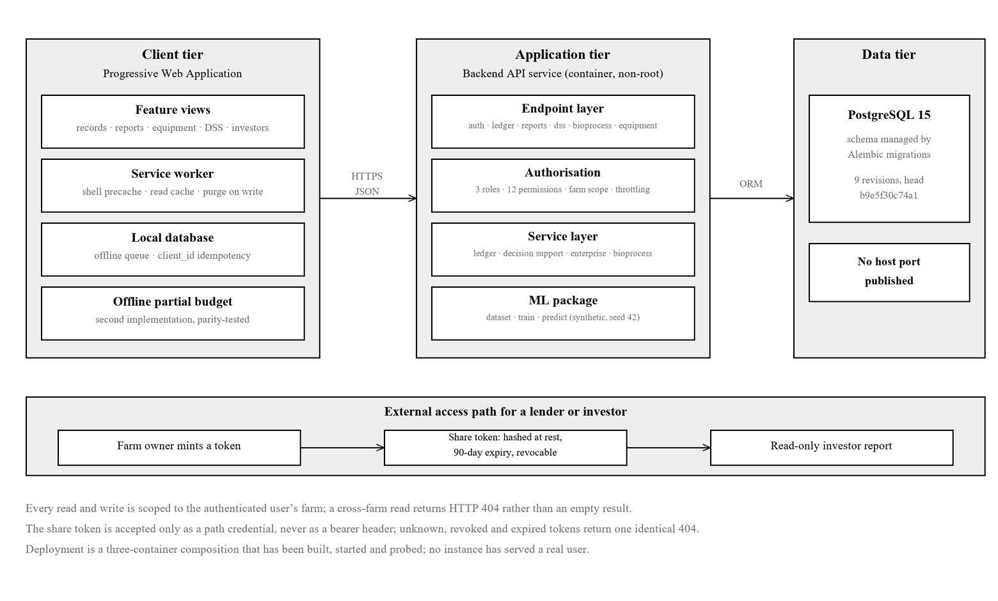
Figure 3.1: AGRI-PROFIT system architecture

3.4.2 Technology Stack
The client is implemented with a modern component-based JavaScript framework compiled to a lightweight bundle, with a local browser database used to queue records for offline-first capture and a service worker providing the pre-cache and the read cache. The backend is implemented in Python using an asynchronous-capable web framework with an object-relational mapper and a migration tool for schema evolution; the route handlers themselves are written synchronously and are executed by the framework in a worker thread pool, which is stated plainly because the platform makes no use of cooperative concurrency and should not be described as though it did. These choices favour a small deployment footprint suitable for modest, low-cost hosting, in keeping with the cost-effectiveness objective.

3.5 Data Model Design
The core design decision of AGRI-PROFIT is the elimination of the historical separation between operational records and financial accounts. Rather than maintaining two independent ledgers, the data model pairs each operation with its financial consequence at the point of entry. An Operational Log (a timestamped record of a physical farm activity) is automatically and atomically paired with a corresponding Financial Transaction, the two being linked through a shared Activity Category. This pairing is enforced at the write layer of the application, so that in normal operation every recorded activity carries its financial effect with it.
The financial ledger is single-entry: each Financial Transaction is classified as either an expense (debit) or revenue (credit) and tagged with an Activity Category, without an enforced double-entry debit/credit pairing. This is a deliberate simplification appropriate to the smallholder context and to the analytical purpose of the platform, and it is stated as such to avoid over-representing the accounting model. A second property of the ledger is equally deliberate and is central to Objective 3: a posted record is soft-immutable. Deletion is refused at the transport layer, and a mistake is corrected by posting a contra entry that preserves the original’s Activity Category and crop and carries a reference to the record it reverses. Both rows then remain visible, the correction is netted into every derived figure, and a second reversal of the same record is rejected. The paired-record design is what allows operational activity and its financial outcome to be analysed together, and it is the structural foundation on which the decision-support tier depends.
The principal entities of the data model are summarised in Table D.1 of Appendix D, and their relationships are shown in Figure 3.2. Two features of that diagram carry the design argument of this section: the one-to-one edge between OperationalLog and FinancialTransaction, which is enforced at the write layer rather than by a database constraint, and the self-reference on FinancialTransaction through which a contra entry is linked to the record it corrects.

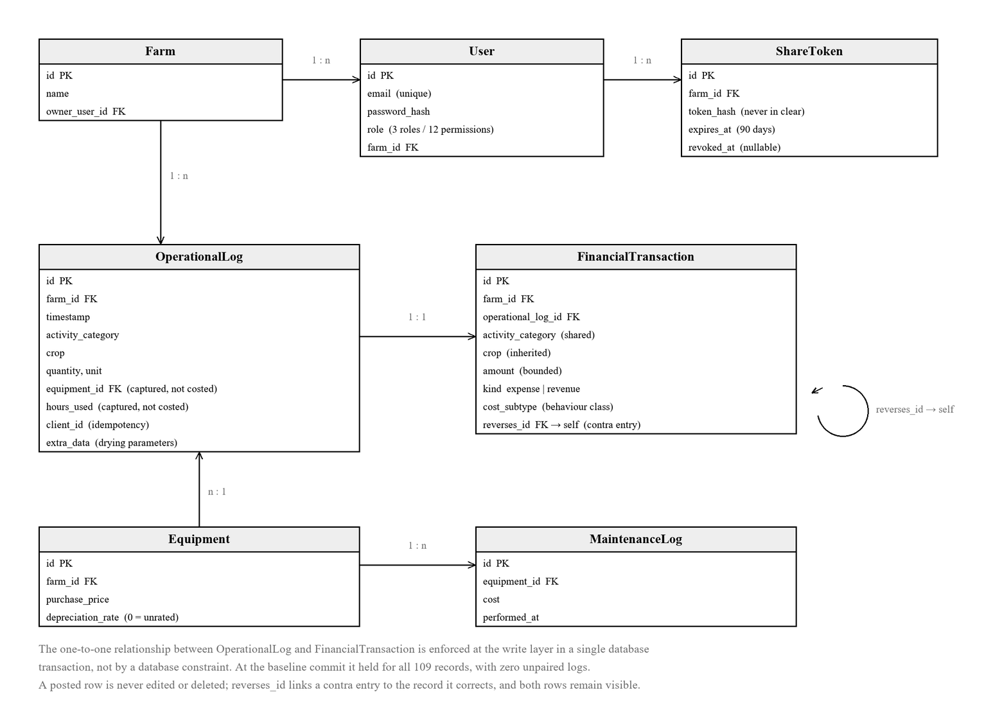
Figure 3.2: Entity-relationship diagram of the AGRI-PROFIT data model

3.6 Module Design
The platform is organised into cohesive modules, each with a defined responsibility. The design of each is described below; where a module is partially realised in the current release, the boundary between built and deferred behaviour is stated explicitly.

3.6.1 Offline Operational Logbook
This module handles data entry for operations, yields, and post-harvest drying runs. To satisfy the offline-capture requirement, records entered without connectivity are queued in a local browser database and synchronised to the backend when a connection is restored. Synchronisation is idempotent: each queued record carries a client-generated identifier, so that replaying the same record for example after a connection is lost mid-entry results in a single stored record rather than a duplicate. The queue is partitioned by identity and cleared on logout, so one user’s pending records cannot be flushed under another’s session. Offline reading is also implemented, and is described here as built rather than as planned: a service worker precaches the application shell and serves a stale-while-revalidate cache over the ledger, reporting and five named decision-support read endpoints, bounded at sixty-four entries and seven days. The cache is purged on every farm-scoped write and on any change of authenticated identity, because a caching layer that survives a correction would make the application misreport its own state. Two endpoints the model-information and prediction routes are deliberately excluded from the cache, since a forecast served from cache would be indistinguishable from a fresh one.

3.6.2 Financial Ledger Engine
This module is the translation layer that creates the paired Financial Transaction for each Operational Log, applying the shared Activity Category, the crop label and an optional tax label, and committing both rows in a single database transaction so that neither can exist without the other. It also enforces the correction discipline described in Section 3.5: deletion of a posted record is refused, a contra entry is created with the original’s category and crop and a link to the record it reverses, a second reversal of the same record is rejected, and a reversal request naming a record belonging to another farm is refused on the same path as any other cross-farm access. Monetary and quantity inputs are bounded at the schema edge, so that a negative, absurd or non-finite value is rejected before it can reach the ledger. The module’s correctness is central to the platform, since all downstream reporting and decision support derive from the ledger it maintains.
Figure 3.3 traces a single record creation through the module. The property the sequence exists to make inspectable is that both rows are written inside one database transaction, so that neither can be committed without the other, and that the correction path shown beneath it never removes a row.
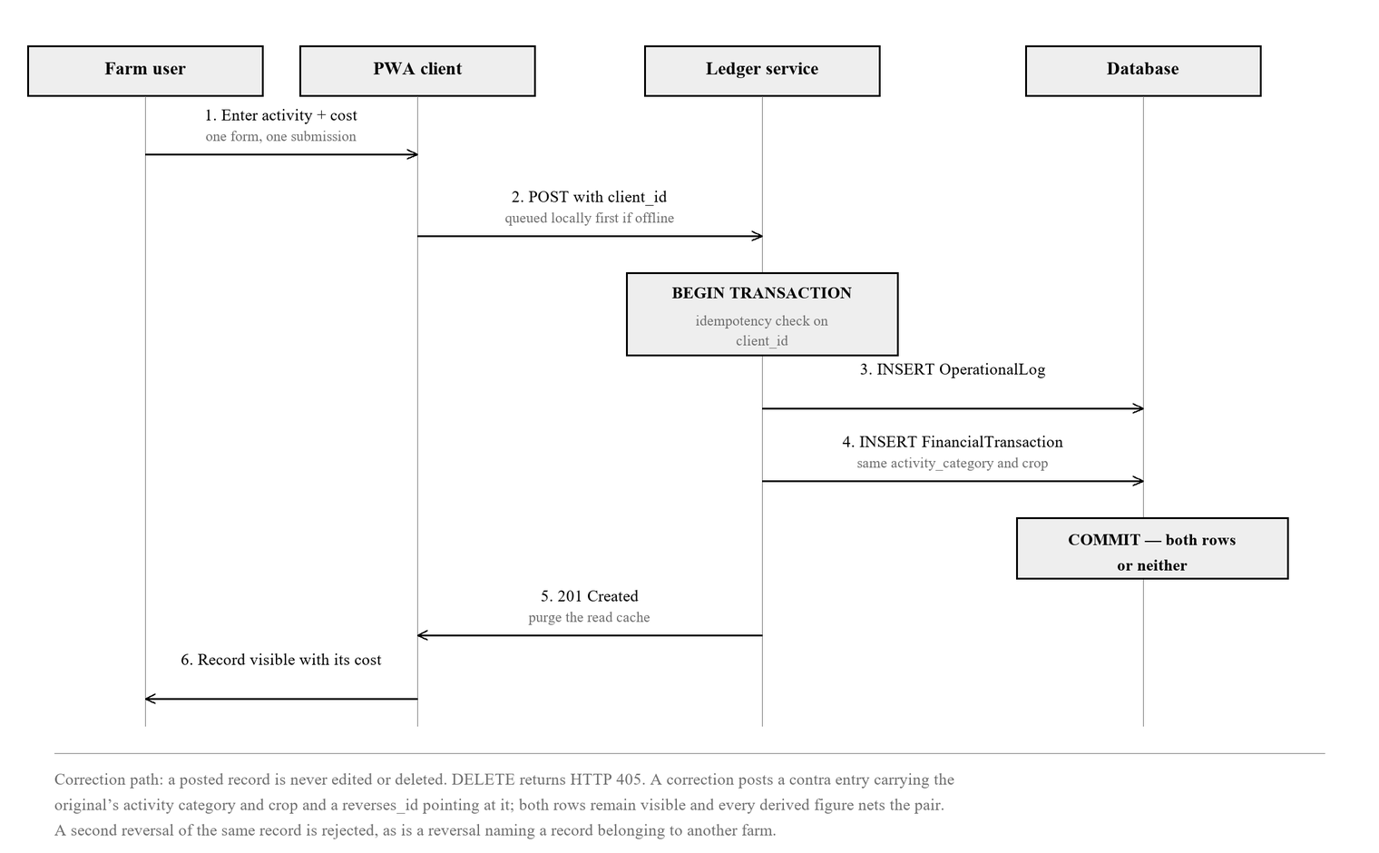
Figure 3.3: The paired write — sequence of a single record creation

3.6.3 Reporting
The reporting module aggregates the ledger into profit-and-loss statements overall, per-category, and monthly and produces a standardised export in comma-separated-values (CSV) format. CSV is the only export format implemented; no PDF or spreadsheet export exists, and none is claimed. This export provides the standardised-reporting basis on which the stakeholder-sharing mechanism (Section 3.6.7) is built.

3.6.4 Mechanisation and Equipment Tracker
This module records equipment acquisition cost, maintenance events, and a per-item rate from which straight-line depreciation is computed (Kay et al., 2016), and records mechanisation usage and fuel as operational entries tagged with the mechanisation activity category, so that machinery costs are captured within the ledger alongside other activities. An equipment record can be corrected after entry through a partial-update path, so that a mistyped depreciation rate is not permanent. Depreciation is not posted to the ledger: it is computed as a derived overlay at report time and allocated to crops in proportion to direct cost, because posting a synthetic depreciation row would require either an unpaired financial entry, which violates the paired-write invariant, or a fabricated operational log describing an event that did not happen.
The calculation is a simplification of conventional machinery costing in three respects, each stated here rather than concealed. First, the annual charge is taken against the full purchase value: conventional practice charges purchase cost less an estimated salvage value over the useful life, with salvage estimated as a published age-and-class factor applied to the new list price of a comparable machine (Johnson, 2020). The platform records only the purchase value and not a list price, so the salvage factor cannot be applied even where the user holds one. Second, the derived charge covers depreciation alone, where conventional ownership cost also includes interest on the average investment and a combined taxes, insurance and housing charge (Johnson, 2020). Third, the charge is not bounded by an implied useful life: no accumulated-depreciation floor is applied and no declining-balance alternative is offered, so an asset retained beyond the life implied by its rate continues to accrue charge indefinitely. A second mechanism compounds this where the reporting period is not specified: the default window is derived from the span of the ledger and widens with each new entry, so the period charge grows as records accumulate. The two are independent the absence of a floor removes the endpoint, the widening window extends the span and a break-even price quoted from a derived window should be pinned by specifying the period explicitly if it is to be held to.
These omissions do not act in a single direction and do not cancel in any principled way. Against a full ownership-cost calculation for a representative tractor, a rate entered as the reciprocal of useful life gives a figure approximately six per cent below the conventional total, while a salvage-adjusted rate gives one approximately forty per cent below it; the unbounded charge pushes in the opposite direction for any asset held past its implied life. The direction and magnitude of the divergence therefore depend on the rate the user supplies and on the age of the asset, and no claim of conservatism is made.
The break-even price on a cash basis and the operating-expense ratio exclude all non-cash charges and are unaffected by any of the above. Only the break-even price on a total-cost basis inherits the divergence. Representative machine performance and salvage parameters, where a user holds them, are published in the machinery-management data standard of the American Society of Agricultural and Biological Engineers (ASABE, 2011).
A per-operation association between an individual activity and a specific equipment item, together with the hours that item was used, is captured and validated at the point of entry but is consumed by no service: the platform produces no machine-hour, utilisation or cost-per-hour figure, and none appears anywhere in this work. The boundary is stated as captured but not costed, and the reasoning is recorded in the project’s third architecture decision record.

3.6.5 Predictive Decision-Support Engine
The decision-support engine follows a two-tier design that deliberately aligns model complexity with available data and device capability (van Klompenburg, Kassahun, & Catal, 2020; Olisah, Smith, Smith, Lawrence, & Ojukwu, 2024).
(a) Tier 1 – Deterministic rule-based tier. Transparent rules compute, directly from the farm’s own Operational Logs and Financial Transactions grouped by Activity Category and crop, nine quantities: per-crop gross margin and its ranking; unit cost of production on a harvested-mass basis; unit cost of production on a marketable-mass basis where a drying run exists; retrospective break-even yield; cost structure classified by economic behaviour with an explicit classification-coverage figure; a derived fixed-cost overlay and its proportional allocation; break-even price on a cash and on a total-cost basis; a yield-sensitivity matrix; and an operating-expense ratio, together with a partial-budget calculator and an Olympic-average yield baseline. This tier requires no training data, runs on modest server hosting, and is fully explainable, providing clear, satisficing decision support consistent with the bounded-rationality principle discussed in Chapter Two. Its governing design rule is that a figure is withheld, with a stated reason, wherever its inputs do not support one, rather than defaulted to a plausible value.
(b) Tier 2 – Statistical yield forecast (optional). A Random Forest regressor produces a yield estimate from agronomic inputs such as rainfall, fertiliser, and soil pH, reporting error measures suited to regression tasks. The forecast is accompanied by a dispersion measure computed across the individual trees of the ensemble, reported as a confidence percentage and as an interval about the ensemble mean. The measure indicates agreement among trees; it is not a calibrated prediction interval, and is reported as such. Established methods for interval estimation from a random forest exist (Meinshausen, 2006; Wager et al., 2014) and are identified in Chapter Five as the route to a calibrated figure. [AUTHOR: rephrase]
An explicit disclosure governs the forecast tier: in the current release, the Random Forest model is trained on representative synthetic data rather than on any individual farm’s own records, and it does not learn or adapt from farm usage. This design choice reflects the reality that a newly deployed farm has insufficient historical data to train a reliable model; retraining on real accumulated records is identified as future work. The deterministic tier, by contrast, operates entirely on the farm’s real records. This distinction is stated plainly to ensure the platform’s analytical claims are not overstated.
For the statistical tier, model quality is expressed using the coefficient of determination (R²), the Mean Absolute Error (MAE) and the Root Mean Square Error (RMSE), the last being a standard complementary measure for continuous prediction tasks in agricultural yield modelling; all three are reported in Section 4.7 (van Klompenburg et al., 2020; Olisah et al., 2024). The training pipeline is seed-deterministic and the dataset carries a recorded cryptographic fingerprint, so that the reported figures can be re-derived rather than taken on trust.

3.6.6 Authentication and Per-Farm Data Boundary
To satisfy the security requirement embedded in the aim and in Objective 3, the platform authenticates users and confines each user’s records to their own farm. Authentication issues a signed token upon login, with passwords stored only in hashed form. Every read and write operation across the ledger, reporting, equipment, and decision-support paths is scoped to the authenticated user’s farm, so that one enterprise’s data cannot be reached by another. The farm/user boundary is introduced through a versioned database migration rather than ad-hoc schema creation, preserving the integrity of the managed schema.

3.6.7 Tokenised Stakeholder Reporting
The trust-building element of Objective 3 is realised through a tokenised, read-only sharing mechanism. A farm owner may mint an opaque token that grants a bank or investor read-only access to that farm’s standardised profit-and-loss and yield summaries, without the recipient holding an account. Four properties of the design are load-bearing. The token is stored only as a hash, so a database disclosure does not yield a usable credential. It expires on a fixed ninety-day horizon as well as being revocable at will, so a link that is forgotten rather than revoked does not remain live indefinitely. It is accepted only as a path credential and not as a bearer authorisation header, so it cannot be replayed against the authenticated interface. And a token that is unknown, revoked or expired resolves to one identical not-found response, so the mechanism cannot be used as an oracle to discover which tokens ever existed. The token cannot be used to write data or to reach any other farm. Within the scope of this study, this authenticated, access-controlled, tokenised reporting is the mechanism by which standardised data is shared with financial stakeholders; immutable distributed-ledger (blockchain) governance, reviewed in Chapter Two, is designed as a future extension that can layer cryptographic tamper-evidence onto this foundation.

3.6.8 Feature-Phone (USSD/SMS) Data Entry — Designed, Not Implemented
The socio-technical barrier at the heart of Objective 1 is that a large proportion of rural Nigerian farmers do not hold a smartphone. The design response to it is an inbound message channel through which a farm activity could be recorded from a feature phone. This section states that design, and states equally plainly that none of it is built. The intended mechanism is an inbound webhook accepting a message consisting of a sender identifier and a short structured text, a parser converting that text into an activity and an amount, a mapping from the sender’s number to a registered farm so that unregistered senders are rejected, and creation of the paired Operational Log and Financial Transaction through the same ledger service the application uses, so that a phone-entered record would be indistinguishable from an app-entered one. The channel would be gateway-agnostic, so that it could be exercised against simulated inbound payloads before any carrier integration. In the release evaluated by this thesis there is no such route, no webhook, no parser, no sender-to-farm mapping, no simulated harness and no test; the navigation entries that once gestured at this channel were removed because no backend supported them. The channel is therefore recorded in Section 5.3 as future work, and no result anywhere in Chapter Four or Chapter Five rests on it. Its absence is the principal limit on the reach of the contribution and is stated as such rather than qualified.

3.6.9 Post-Harvest Drying Module
This module answers Objective (v) and carries the bioprocess engineering content of the platform. It is named the bioprocess module in the source code and its endpoints sit under a bioprocess path; the two names denote the same subsystem and the design term used throughout this thesis is the post-harvest drying module.
A drying run is entered as an Operational Log of the post-harvest category and therefore posts its cost through the same paired write as any other activity. Its own parameters are the mass and moisture content at inlet, the mass and moisture content at outlet, the drying method, and an optional series of time-and-moisture readings taken during the run. From these the module computes, by the relationships reviewed in Section 2.7: conversion between wet-basis and dry-basis moisture content; a dry-matter balance yielding the outlet mass the run should have produced; a water balance giving the mass of water actually removed, held deliberately distinct from the mass difference so that process loss and drying performance are never the same number; a mean drying rate; a safe-storage verdict against a recorded threshold for the crop, returned as an absence rather than as a negative verdict where no threshold is recorded; a rate constant for the Newton model obtained in closed form from the initial and final moisture ratio; and a least-squares fit of the Page model on its linearising transform, ln(−ln MR) = ln k + n·ln t, returning the rate constant k and the exponent n. The Newton constant is computable from the endpoints alone; the Page fit requires at least three usable readings and is withheld, rather than approximated, below that threshold. The thresholds held in the lookup are conservative relative to the published equilibrium values reviewed in Section 2.7, and reconciling each stored constant to a specific published figure per crop is identified in Chapter Five as work outstanding.
The design decision that matters financially is which mass becomes the denominator of the unit-cost calculation. The module uses the mass actually weighed out, not the mass the dry-matter balance predicts, because costing against a predicted mass would charge the farmer’s pricing decision with grain that never reached the store. Every malformed submission — outlet mass exceeding inlet mass, a final moisture not below the initial, non-positive mass, moisture outside the physical range, or readings not in strictly increasing time order — is rejected at the schema edge, and the same rules are mirrored in the client so that an invalid run is refused before it is queued offline rather than retrying forever.

3.6.10 Enterprise Economics Module
This module extends the deterministic tier from margin accounting to cost-behaviour analysis, and supplies the vocabulary of enterprise budgeting reviewed in Section 2.7.2 (Kay, Edwards, & Duffy, 2016). Recorded cost is classified at the schema edge into variable, semi-variable and fixed behaviour; the proportion of cost that carries a subtype is reported as an explicit classification-coverage figure, and the residue is reported as unclassified rather than distributed into a plausible bucket, so that a reader can see how much of the analysis rests on classified data. On that base the module derives the fixed-cost overlay of Section 3.6.4 and allocates it in proportion to direct cost, conventional practice being to allocate fixed cost on a physical base, most commonly cultivated area (Kay et al., 2016; Johnson, 2020), which is unavailable here because no field, plot or area entity exists in the data model; the substitution is stated rather than concealed, since apportioning by direct cost distributes fixed cost toward the enterprise that spent most, and coincides with an area-based allocation only where spending per unit area is uniform across crops; computes a break-even price on a cash basis and a total-cost basis, the two answering different questions and the cash price provably the lower; computes a yield-sensitivity matrix, labelled conditional because every row but the baseline describes a yield that did not occur; computes an operating-expense ratio following the conventional definition of operating expense over gross revenue with non-cash charges excluded (Griffith et al., 2024). The numerator is all cost recorded against the enterprise, whether or not it carries a behaviour classification: cost that was in fact spent is counted, because excluding unclassified cost would understate the ratio in exact proportion to how incomplete the classification is, and a data-quality gap should not be permitted to flatter a headline figure. Interest is excluded because no interest is modelled anywhere in the platform, and the depreciation overlay has no route into the numerator; and computes an Olympic-average yield baseline, which discards the highest and lowest season before averaging and is refused, with the season count stated, below three seasons. A partial-budget calculator evaluates a proposed change by four terms — added revenue, reduced cost, lost revenue and added cost — following the standard method for appraising incremental change in smallholder farming systems (CIMMYT, 1988; Kay et al., 2016) and is implemented twice — once server-side and once in the client, so that it survives offline — with both implementations asserted against a single shared hand-computed fixture.

3.7 Security Design
Security is treated as a first-class requirement because the word “secure” appears in the aim and because Objective 3 depends on stakeholders trusting the platform’s outputs. The design rests on six elements. Authentication issues a signed token over credentials stored only as a hash. Authorisation is role-based: three roles are defined over a table of eleven named permissions, and every request is checked against the permission it requires before any farm-scope check is applied, so that a refusal reports a missing permission and never doubles as an oracle confirming that a record exists. Data isolation confines every read and write on every path to the authenticated user’s farm, a cross-farm read resolving to a not-found response rather than to an empty result. Failed logins are throttled on a fixed budget within a rolling window, the refusal naming no account so that it confirms no email address; the counters are held in process, which means they neither span replicas nor survive a restart, and that residual is named here rather than concealed behind the control. Credential hygiene requires that a share token never appears in any log: the reverse proxy redacts it and the application replaces it with a stable, non-reversible fingerprint that still allows requests to be correlated. Finally, external sharing uses the scoped, revocable, expiring, hash-stored, read-only tokens of Section 3.6.7, which cannot escalate to write access or cross a farm boundary. Together these ensure that data sharing is deliberate and controlled rather than open, which is the precondition for the trust that Objective 3 seeks to establish. What the design does not provide is stated with equal clarity: there is no session revocation within a token’s lifetime, no refresh mechanism, no password reset, no second factor, and no independent security assessment of any of it.

3.8 Evaluation Methodology
Objective 4 requires an empirical evaluation of the platform’s usability, cost-effectiveness and operational viability under Nigerian constraints. A full field deployment with a large sample of smallholder farmers represents the ideal evaluation; however, such a deployment fell outside the time and access constraints of this study and is therefore presented as designed future work (Section 3.8.5). The evaluation specified for this study comprises four complementary strands, each producing evidence that can be reported in the results chapter. A distinction must be drawn here and held throughout: this section states the evaluation as specified, and Chapter Four reports which strands were executed. Three of the four were executed. The usability strand of Section 3.8.4 was specified and its instruments were prepared, and it was not carried out; no usability figure of any kind is reported in this work, and Objective 4 is consequently reported as partly met.

3.8.1 Functional Verification
Each functional requirement is verified against defined test cases using an automated test suite, supplemented by manual walkthroughs of the core workflows. For the deterministic decision-support tier, verification asserts that the computed unit cost of production and gross margin match values calculated by hand from seeded ledger records, confirming arithmetic fidelity. For the offline path, a test confirms that a queued record synchronises exactly once and that replaying the same client identifier yields a single stored record. The outcome of this strand is a requirement-by-requirement statement of pass or fail with the corresponding test evidence.

3.8.2 Performance Benchmarking
Performance under constrained conditions is measured using an automated auditing tool (Lighthouse) run against the production build of the application, with device emulation set to a mobile profile and network throttling applied to approximate a slow mobile connection. The reported measures are the overall performance score together with load-timing metrics First Contentful Paint, Largest Contentful Paint, Total Blocking Time, and Speed Index and the transferred bundle size. To reduce noise, the audit is run several times and the median reported. This strand directly evidences the low-bandwidth claim, and any performance limitation it reveals (for example, the cost of charting libraries) is reported as a concrete finding rather than concealed.

3.8.3 Hosting-Cost Analysis
Cost-effectiveness is evaluated through a desk-based analysis of the projected monthly cost of hosting the platform on a modest cloud or virtual-private-server tier. The analysis estimates the platform’s resource footprint and applies published provider pricing to derive an indicative monthly operating cost, clearly labelled as an estimate. This provides a defensible figure for the viability discussion without requiring a paid production deployment.

3.8.4 Usability Evaluation (Heuristic and SUS)
The usability strand is specified as an expert heuristic evaluation combined with a standardised usability questionnaire, a recognised and citable approach that is appropriate where a large end-user sample is not available (Nielsen & Molich, 1990; Nielsen, 1994). Three to five evaluators comprising the project supervisor and peer would independently perform a fixed set of core tasks (recording an operation with its cost, viewing the profit-and-loss report, generating a yield forecast, and exporting or sharing a report) and then assess the interface against Nielsen’s ten usability heuristics, recording issues with severity ratings. Each evaluator would additionally complete the ten-item System Usability Scale (SUS), which yields a single score between 0 and 100 (Brooke, 1996); with a small evaluator panel the SUS score would be reported as indicative rather than statistically powered. Two procedural controls belong to the method: browser site data must be cleared between evaluators, because the offline queue task deliberately creates queued entries; and the checklist and questionnaire must be completed without the author present, because a self-report instrument administered under the author’s observation is systematically inflated. The instruments for this strand the task script, heuristic checklist and SUS questionnaire were prepared in full and are provided as a separate evaluation pack. The strand was not executed within the period of this study. Section 4.11 reports that absence and reports no figure against these instruments; the tables there are drafted to receive real data and are deliberately left empty.

3.8.5 Designed Field Evaluation (Future Work)
For completeness and to demonstrate methodological awareness, the ideal field evaluation is specified even though it is not executed in this study. It would recruit a representative sample of smallholder and medium-scale farmers, obtain informed consent, provide a short on boarding session, and have participants use the platform for their own record-keeping over a defined period. It would capture task-completion rates, error rates, SUS scores across a larger sample, and qualitative feedback, and would measure real device performance and data usage in the field. This design is presented as the recommended next step beyond the present work.

3.9 Summary
This chapter has set out the methodology by which AGRI-PROFIT was designed, developed and evaluated. It described an iterative, version-controlled development approach with human-reviewed, agent-assisted implementation; a requirements analysis grounded in the socio-technical constraints of Nigerian agriculture, including one requirement the release does not meet; a client–server architecture built around a mobile-first offline-capable client; and a unified data model in which each operation is atomically paired with its financial consequence and corrected only by a linked contra entry. It specified the design of each module: the offline logbook and its read cache, the ledger engine, reporting, the mechanisation and equipment tracker, a two-tier decision-support engine whose deterministic tier computes nine quantities from real records and whose optional forecast tier is transparently trained on synthetic data, authentication and the per-farm boundary, tokenised stakeholder reporting, a designed but unimplemented feature-phone channel, the post-harvest drying module, and the enterprise-economics module. It set out a security design resting on authentication, role-based authorisation, data isolation, throttling, credential hygiene and scoped sharing, and named what that design does not provide. Finally, it presented a four-strand evaluation methodology—functional verification, performance benchmarking, hosting-cost analysis, and heuristic-plus-SUS usability evaluation—of which three were executed and one was not, together with a fully specified field evaluation designed as future work. The results of applying this methodology are presented in Chapter Four.

CHAPTER FOUR

4.0 RESULTS AND ANALYSIS

4.1 Introduction
This chapter reports what the implemented AGRI-PROFIT platform does, measured rather than asserted.
A reporting standard has been applied consistently throughout and is stated at the outset, because it shapes how every result in this chapter should be read. Each claim belongs to exactly one of four classes, and the class is visible wherever the claim is made:
Table 4.1: The evidential classification applied throughout Chapter Four
Class | What it means | What may establish it
Implemented | The code exists and, where stated, is reachable by a user. | Source inspection and the deployed application.
Automatically verified | A named, passing automated test asserts the behaviour. | The test suites only.
Manually inspected | Observed by the researcher, or by a live probe against the running system; no automated test exists. | Live endpoint responses, direct SQL, driven-browser probes, visual inspection.
Numerical result | A measured or computed value with a named command or artefact behind it. | Test and coverage output, live API responses, committed measurement artefacts.

Anything that fits none of these four classes is a limitation. It is reported as such in Section 4.14 and interpreted in Chapter Five, and it is not converted into a result. A second distinction cuts across the classification: implemented means the capability is present in the system; verified means it is supported by a named test, command or reproducible check; and validated in practice means it has been demonstrated with real users, in field conditions, or in production operation. The first two are claimed wherever the evidence supports them; the third is claimed nowhere, because no strand of this evaluation establishes it.
The reporting baseline. Every figure, table and screenshot in this chapter is produced from a single implementation state: commit 8a29ee0aeed4d00b4caf9e58854821e80b6d403d on the main branch, dated 31 August 2026, referred to throughout as the baseline commit. Demonstration figures are read from the seeded demonstration farm, farm 26, signed in as its own user; the live database holds several other farms, and no figure in this chapter is read from any of them. The figures presented in Chapter Three are design diagrams of the architecture, the data model and the paired write; they are author-drawn representations of the design and are not evidence captures.
Section 4.13 draws the strands together against the four objectives of Chapter One and the fifth objective added for the post-harvest strand; Section 4.14 states the limitations of the results themselves. Discussion of what the results mean for the wider problem, and the recommendations that follow from them, are reserved for Chapter Five.

4.2 Per-Crop Gross Margin and Enterprise Ranking
Objective 2 concerns the conversion of recorded farm activity into decision-relevant financial information. The deterministic tier is exactly that conversion: it computes from the ledger the platform actually holds, with no model, no estimation and no external data. This section reports its output against the seeded demonstration farm at the baseline commit. Every figure is a live API response, and every one is traceable to the records that produced it.
Table 4.2: Per-crop decision support, farm 26, at the baseline commit
Rank | Crop | Revenue (₦) | Expenses (₦) | Gross margin (₦) | Yield | Marketable mass
1 | Cowpea | 624,950 | 267,700 | 357,250 | 480 kg | 431 kg
2 | Cassava | 178,600 | 94,400 | 84,200 | 1,880 kg | —
3 | Maize | 45,000 | 3,500 | 41,500 | 100 kg | 84 kg
4 | Tomato | 0 | 112,900 | −112,900 | none | —
5 | Sorghum | 0 | 119,950 | −119,950 | none | —
 | Farm total | 848,550 | 598,450 | 250,100

Table 4.2 gives the ranked per-crop position of the demonstration farm. Four properties of this output matter to the argument, and each is pinned by a named test irrespective of the seeded amounts.
First, the ordering is computed rather than incidental. Crops are sorted by descending gross margin with alphabetical tie-breaking, and the test is constructed so that an alphabetical sort cannot pass it by coincidence. Note that the ranking is by margin, not by scale: cassava earns nearly four times maize’s revenue and returns roughly twice its margin, while maize returns ₦41,500 on ₦3,500 of recorded cost. Ranking and efficiency are different questions, and the platform answers the first.
Second, a loss is displayed as a loss. Tomato and sorghum carry recorded input costs and no sale, and both report negative margins rather than being suppressed or shown as zero. The loss-making enterprise is precisely the one a farmer most needs to see, and a system that quietly omits it would fail at the point of greatest value.
Third, the figures are the ledger, not a projection. Each is the sum of transactions carrying that crop’s category, with reversed pairs netted — at farm level and per crop as well.
Fourth, the yield column is unit-aware. Where a crop’s harvests were recorded in incompatible units the platform returns a null rather than an arithmetically invalid sum. Farm 26 is unit-clean, so each crop here reports a single unit; the wider database is not, which is why the behaviour exists.
The magnitudes in Table 4.2 cannot be set against published Nigerian gross margins, and the reason is not a matter of which studies were consulted. Farm-management studies report gross margin per hectare, because area is the denominator against which enterprises are conventionally compared. The platform holds no field, plot or area entity (Section 3.6.10), so the margins reported here are absolute figures for the enterprises as recorded, with no denominator to normalise them. Only the ordering may be compared, not the magnitudes. The absence of an area entity is therefore not only an obstacle to allocating fixed cost on a physical base; it is what prevents this chapter’s margins from being benchmarked against published farm-management results at all.
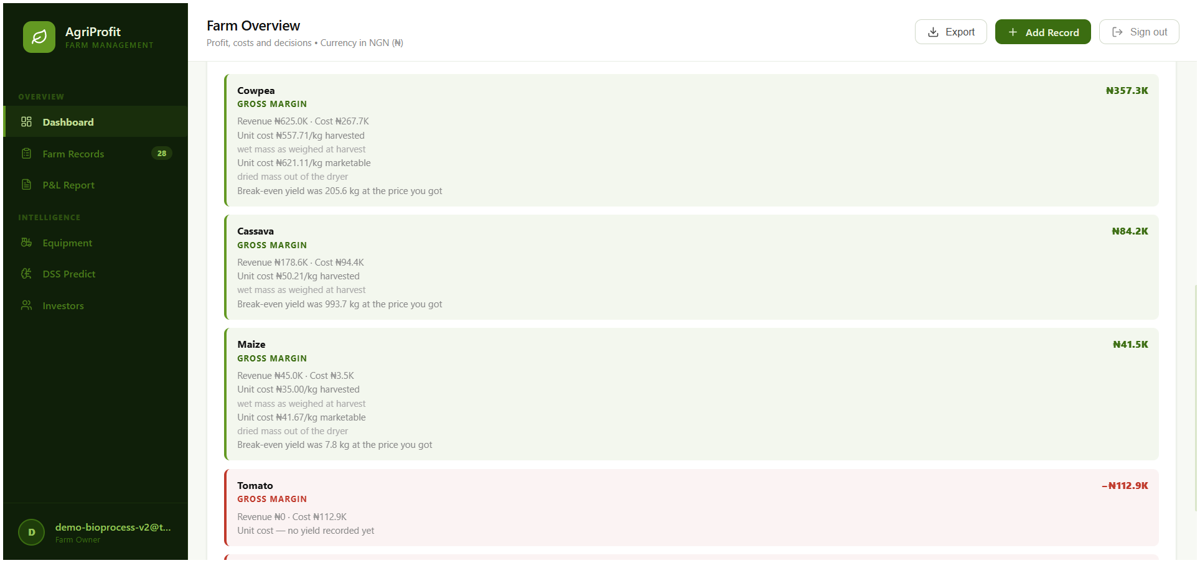
Figure 4.1: Per-crop gross margin and enterprise ranking, showing unit cost of production on both the harvested and the marketable basis

4.3 Unit Cost of Production: Harvested and Marketable Bases
Unit cost is the figure most directly connected to the pricing decision a farmer faces at the farm gate. The platform computes it as attributed cost divided by output, and — this being the point at which the record-keeping layer meets the process-engineering layer — it distinguishes the mass that left the field from the mass that can actually be sold.
Table 4.3: Unit cost of production, farm 26
Crop | Cost basis | Denominator | Unit cost | What it answers
Maize | Harvest (wet) mass | 100 kg | ₦35.00 / kg | What the crop cost to produce in the field
Maize | Marketable mass | 84 kg | ₦41.67 / kg | What each saleable kilogram must recover at the gate
Cowpea | Harvest (wet) mass | 480 kg | ₦557.71 / kg | What the crop cost to produce in the field
Cowpea | Marketable mass | 431 kg | ₦621.11 / kg | What each saleable kilogram must recover at the gate
Cassava | Harvest mass | 1,880 kg | ₦50.21 / kg | No drying run recorded, so no marketable basis exists

The 19% difference between ₦35.00 and ₦41.67 is post-harvest mass reduction expressed in money. A farmer pricing against the wet-basis figure would be pricing against a mass that no longer exists and would under-recover by ₦6.67 on every kilogram sold. The same pattern appears on cowpea, where the two bases differ by ₦63.40 per kilogram. The two crops differ in how much the basis matters, and the difference is not arbitrary. Maize was dried from 25.0% to 13.0% moisture on a wet basis, removing twelve percentage points; cowpea from 18.0% to 11.5%, removing six and a half. The shift in unit cost follows: 19.05% for maize against 11.37% for cowpea. A platform that applied a single correction factor across enterprises would overstate the adjustment for one crop and understate it for the other. This is the argument for computing the marketable basis from each run's own moisture record rather than assuming a typical loss.
Two reporting decisions inside those figures are themselves results. The marketable denominator is the mass actually weighed out, not the mass the dry-matter balance predicts. For the maize run those two differ: from 100 kg at 25% moisture the dry matter is 75.0 kg, which at 13% final moisture should weigh 86.21 kg, against 84 kg observed. Costing against the predicted 86.21 kg would give ₦40.60 per kilogram and would charge the farmer’s pricing decision with grain that never reached the store. Costing against the observed 84 kg is the conservative and correct choice, and it is the one the platform makes. And where no drying run exists, as with cassava, the marketable figure is withheld rather than defaulted to the harvest mass — the two are not the same quantity, and reporting one as the other would be a silent error.
The same reporting decision applies to cowpea. Its dry-matter balance predicts an outlet mass of 444.75 kg against 431.0 kg observed, a process loss of 13.75 kg or 3.09% — below the five per cent threshold at which the platform raises a data-quality warning. Costing against the predicted mass would give ₦601.92 per kilogram; the platform uses the observed 431.0 kg and reports ₦621.11. Both predicted masses are quoted here rounded, while the costing divides by the unrounded value. In both crops the conservative denominator is the one the farmer can actually carry to market.

4.4 Break-Even Yield and Break-Even Price

4.4.1 Retrospective break-even yield
Break-even yield reports the output at which a crop would have covered its recorded costs at the price actually achieved. It is deliberately retrospective, and the interface says so by rendering it in the past tense, because the platform holds no forward price forecast and must not imply one.
Table 4.4: Retrospective break-even yield, farm 26
Crop | Recorded cost (₦) | Realised price (₦/kg) | Break-even yield | Actual yield
Maize | 3,500 | 450.00 | 7.78 kg | 100 kg
Cassava | 94,400 | 95.00 | 993.68 kg | 1,880 kg
Cowpea | 267,700 | 1,302.00 | 205.61 kg | 480 kg
Tomato | 112,900 | none realised | null | none
Sorghum | 119,950 | none realised | null | none

Table 4.4 sets each crop’s recorded cost and realised price against the output that would have covered them. The maize record covered its recorded cash costs within the first eight kilograms sold. The nulls are as informative as the numbers: where no sale has been recorded there is no realised price, and a break-even yield computed against a price that does not exist would be arithmetic dressed as advice. The figure is likewise withheld where no yield has been recorded, where the sale that established the price has since been reversed, and where no cost has been attributed to the crop — in that last case an arithmetically valid break-even yield of zero kilograms would communicate a false completeness to a user whose actual situation is that they have not recorded their costs. All four null cases are asserted by named tests.

4.4.2 Dual break-even price and yield sensitivity
Two break-even prices are computed for each enterprise with a recorded marketable mass: one covering cash cost, one covering total cost.
Table 4.5: Break-even price, maize and cowpea, farm 26
Quantity | Maize | Cowpea
Variable and semi-variable cost | ₦3,500.00 | ₦228,700.00
Total recorded cost | ₦3,500.00 | ₦267,700.00
Allocated fixed cost | ₦58.88 | ₦4,503.86
Total cost | ₦3,558.88 | ₦272,203.86
Marketable mass | 84 kg | 431 kg
Break-even price to cover cash cost | ₦41.67 / kg marketable | ₦530.63 / kg marketable
Break-even price to cover total cost | ₦42.37 / kg marketable | ₦631.56 / kg marketable

Table 4.5 reports both, together with the quantities from which each is derived. Two prices are reported rather than one because they answer different questions: what the farmer must obtain this season to avoid a cash loss, and what must be obtained to cover the wear on the assets used as well. The cash price is provably strictly lower than the total price, which is asserted directly by test, including in the edge case of full classification coverage and no overlay. Both are withheld entirely where no marketable mass exists, because a price per kilogram of nothing is undefined (Figure 4.3). The gap between the two prices is not the same quantity in both crops. For maize, at full classification coverage and with no recorded fixed cost, the ₦0.70 difference is the depreciation overlay alone. For cowpea the difference is ₦100.94 per marketable kilogram, and depreciation is the smallest part of it. The overlay contributes ₦10.45; the ₦18,000 of recorded fixed cost contributes ₦41.76; and the ₦21,000 of cost recorded without a subtype contributes ₦48.72. The last of these sits inside the total figure and outside the cash one because the platform will not assign a behaviour it was not given. A wider gap between the two prices is therefore not by itself evidence of a heavier asset base: it may equally record how much of the enterprise’s cost was entered without saying what kind it was. Both the prices and the three contributions are quoted rounded to the kobo, while the difference and its decomposition are computed from the unrounded values.
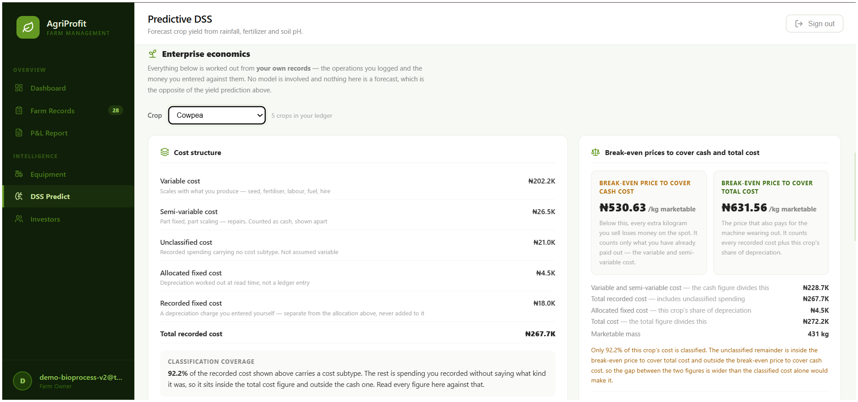
Figure 4.2: Break-even prices for cowpea: ₦530.63 per kilogram to cover cash cost and ₦631.56 to cover total cost, both against the 431 kg marketable mass
Table 4.6: Yield sensitivity matrix, maize, farm 26
Yield scenario | Marketable mass | Break-even price, cash | Break-even price, total
75% of recorded | 63.0 kg | ₦55.56 / kg | ₦56.49 / kg
90% | 75.6 kg | ₦46.30 / kg | ₦47.08 / kg
100% (baseline) | 84.0 kg | ₦41.67 / kg | ₦42.37 / kg
110% | 92.4 kg | ₦37.88 / kg | ₦38.52 / kg
125% | 105.0 kg | ₦33.33 / kg | ₦33.89 / kg

Table 4.6 gives the sensitivity matrix across five yield scenarios. The matrix is labelled conditional in the response and in the interface, because every row other than the baseline describes a yield that did not occur. It answers the planning question the deterministic tier is otherwise silent on: how much the required price moves if the harvest disappoints. A quarter shortfall in marketable mass raises the cash break-even price by a third.
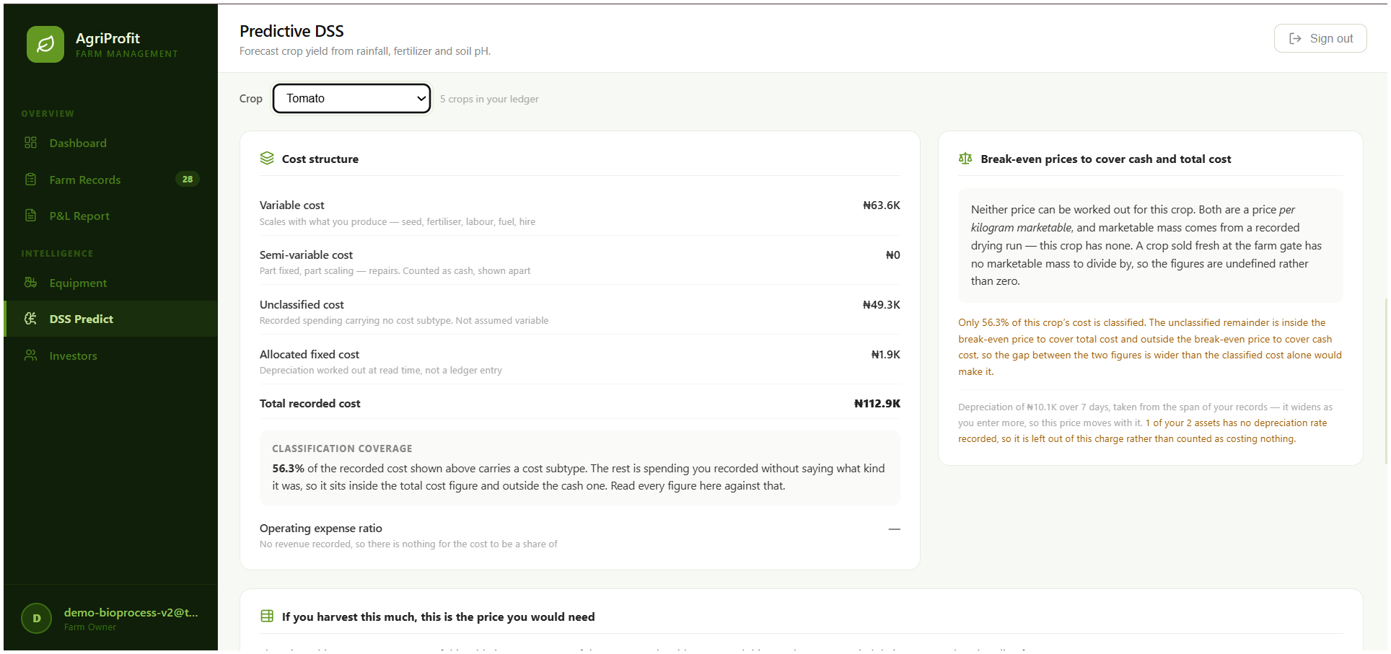
Figure 4.3: Cost structure for an enterprise with no recorded drying run, showing both break-even prices and the operating expense ratio withheld rather than defaulted to zero

4.5 Post-Harvest Drying and Marketable Mass
The post-harvest module implements thin-layer drying kinetics: conversion between wet-basis and dry-basis moisture content, a dry-matter balance determining marketable output, a water balance, safe-storage assessment, and the fitting of two established thin-layer models to an observed moisture series. It carries the bioprocess engineering content of the platform.

4.5.1 Verification by designed fixture
A drying model can only be shown to be correct by recovering parameters known in advance, so the module is verified by hand-calculated fixture rather than by demonstration. Eleven service-level tests pass and the service stands at 100% statement coverage. The properties established are:
(a) Exact recovery of the Page model. The Page model, MR = exp(−k·tⁿ), is linearised by the double logarithm ln(−ln MR) = ln k + n·ln t and its parameters recovered by least-squares regression on that transform. A moisture-ratio series generated from an initial moisture content of 30.0% wet basis with known parameters k = 0.30 and n = 0.75 is recovered to those values within a relative tolerance of 1×10⁻⁴, which establishes that the linearisation, the regression and the back-transformation from ln k to k are each correct — the whole of the fitting path.
(b) The water balance is not a mass difference. A dedicated fixture asserts that the mass of water removed and the process loss are distinct quantities and fails if they are ever made equal. The distinction is the specific error the module exists to prevent: water leaving the grain is the intended outcome of the process, whereas solid matter leaving the system is a loss.
(c) A clean-balance control. A second fixture is constructed so that observed outlet mass equals the mass the dry-matter balance predicts, giving zero process loss, which isolates the balance itself from the loss accounting layered on it.
(d) Insufficient and out-of-range readings. A fit is refused rather than attempted below three readings, and readings outside the physical moisture band are dropped.
(e) Safe storage is null, never false, for an unknown crop. An unrecognised crop has no threshold, and the platform reports the absence of a threshold rather than a negative verdict.
(f) Basis conversion round-trips. Wet-basis to dry-basis and back returns the original value.

4.5.2 The seeded drying run in full

Table 4.7: Per-crop drying summary, farm 26
Crop | Runs | Mass in | Marketable mass | Water removed | Mean drying rate | Mean Newton k (solar dryer) | Safe-storage share
Cowpea | 1 | 480.0 kg | 431.0 kg | 36.84 kg | 2.631 kg/h | 0.03745 | 1.0
Maize | 1 | 100.0 kg | 84.0 kg | 14.08 kg | 1.408 kg/h | 0.08023 | 1.0

Table F.1 of Appendix F reports the seeded maize run in full, quantity by quantity, and Table 4.7 aggregates both seeded runs by crop. The two runs are internally consistent in a way that is worth noting: the maize run, which removes a larger proportion of its initial moisture, returns a Newton rate constant roughly twice the cowpea run’s under the same drying method, and the cowpea run’s higher absolute drying rate reflects its larger batch rather than a faster process. Both are reported per crop rather than pooled, because a mean rate constant across crops with different initial moistures would not describe anything physical.
One point about the Page fit is recorded because an earlier draft of this chapter left it open. The fit requires intermediate time-and-moisture readings, and the readings on the seeded runs were supplied by the seed script. At the baseline commit the drying entry form does capture such readings: the drying fields component provides repeatable optional reading rows, the client-side drying rules validate them before the record is queued, and the drying-curve component plots them (Figure 4.4). A run entered through the interface with three or more readings therefore reaches the backend with a series on which the Page model is fitted, and a run entered without them correctly receives no Page fit rather than a fabricated one.
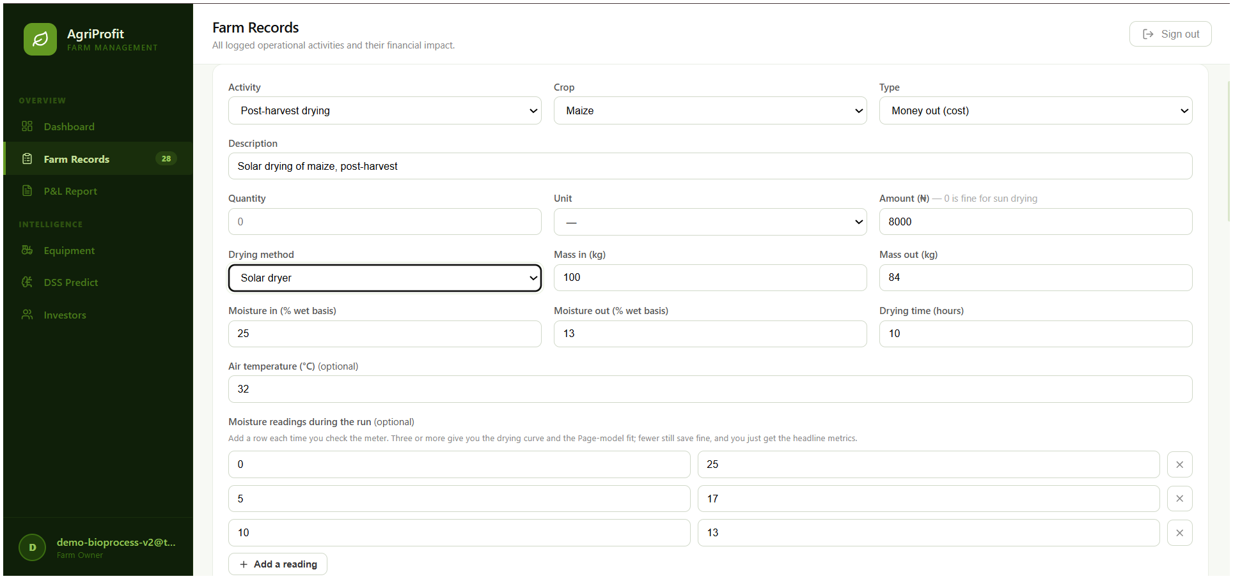
Figure 4.4: Entering a post-harvest drying run: mass in and out, initial and final moisture on a wet basis, and the moisture readings taken during the run
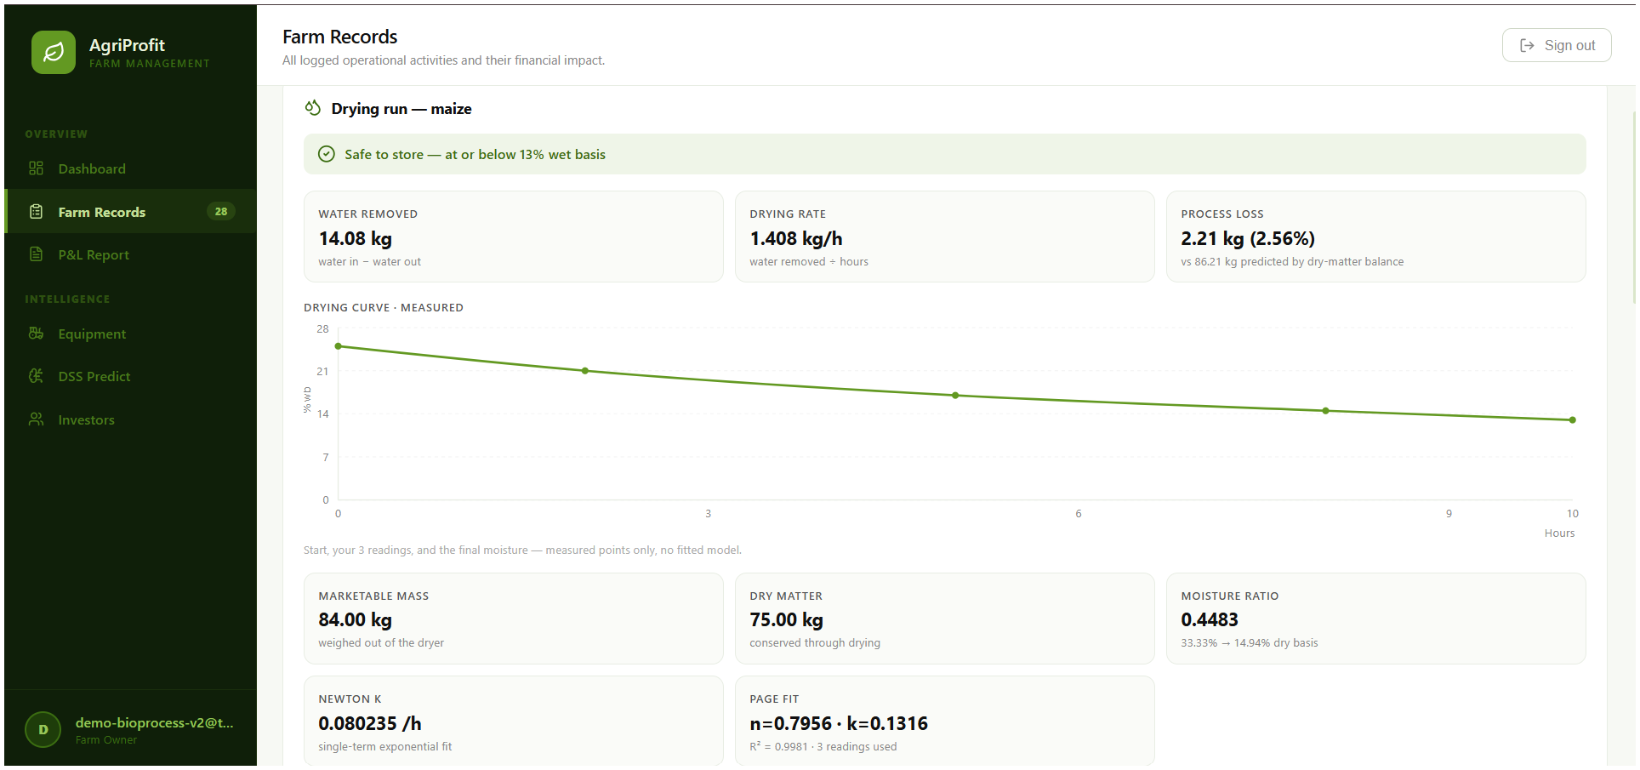
Figure 4.5: Computed drying result for the maize run: 84.00 kg marketable from 100 kg at 25.0% moisture, 14.08 kg water removed, 2.21 kg process loss, Page model n = 0.7956, k = 0.1316, R² = 0.9981 over three readings, and the safe storage verdict at 13.0% wet basis

4.5.3 Input validation
Every malformed drying submission is rejected at the schema edge with HTTP 422, and never with a server error. Eight API tests cover outlet mass exceeding inlet mass, a final moisture not below the initial, non-positive mass, moisture outside the physical range, readings not in strictly increasing time order, and readings outside the moisture band. Twenty client-side tests mirror the same rules in the browser, so an invalid run is refused before it is queued as well as after it is sent. This matters for the offline path in particular: a record that the API will always reject, but that the client accepts and queues, would retry forever.

4.5.4 Coupling to the financial ledger
The engineering significance of this module is not the kinetics in isolation — the models are long established — but that its output enters the financial record. A drying run is recorded as an operational activity like any other, so it posts its cost to the ledger through the same paired write as a fertiliser application, and its computed marketable output becomes the denominator of the unit-cost figure in Table 4.3. The chain from a moisture measurement to a price per marketable kilogram — 100 kg at 25% moisture, dried to 13%, weighed out at 84 kg, costed at ₦41.67 rather than ₦35.00 — is computed by the platform without manual intervention at any step. Access control and reversal handling travel with it: a drying run belonging to another farm returns HTTP 404, and a reversed run is excluded from the summary.

4.6 Enterprise Budget, Cost Structure, Depreciation and Partial Budget
Objective (ii) requires that mechanisation and equipment expenditure be captured within the same ledger as the operational record, and costed there. The enterprise-economics layer extends the deterministic tier from margin accounting to cost-behaviour analysis. All figures are live responses from farm 26 at the baseline commit.

4.6.1 Cost structure and classification coverage
Table 4.8: Cost structure, farm 26
Bucket | Maize (₦) | Whole farm (₦)
Variable cost | 3,500 | 483,650
Semi-variable cost | 0 | 26,500
Recorded fixed cost | 0 | 18,000
Unclassified cost | 0 | 70,300
Total recorded cost | 3,500 | 598,450
Cash cost (variable + semi-variable) | 3,500 | 510,150
Classification coverage | 100% | 88.25%
Revenue | 45,000 | 848,550
Cash operating cost | 3,500 | 580,450
Operating-expense ratio | 7.78% | 68.40%

Table 4.8 gives the cost structure for maize and for the farm as a whole, bucket by bucket. Classification coverage is itself the substantive result. It states what proportion of recorded cost carries a cost subtype, and it is reported rather than hidden because every downstream figure inherits its incompleteness. At farm level 11.75% of recorded cost is unclassified — two mechanisation logs entered without cost parameters — and the platform reports that as unclassified rather than defaulting it into a bucket. An unclassified cost sits inside the total and outside the cash figure, so a reader can see exactly how much of the analysis rests on classified data. The maize enterprise, at 100% coverage, is the case where the figures can be read without that reservation.
The operating-expense ratio excludes the depreciation overlay of Section 4.6.2 and excludes any recorded depreciation charge, both of which are non-cash; it is a measure of how much of each naira of revenue is consumed by cash operating cost. Maize consumes 7.78 kobo in the naira; the farm as a whole consumes 68.40 (Figure 4.6).
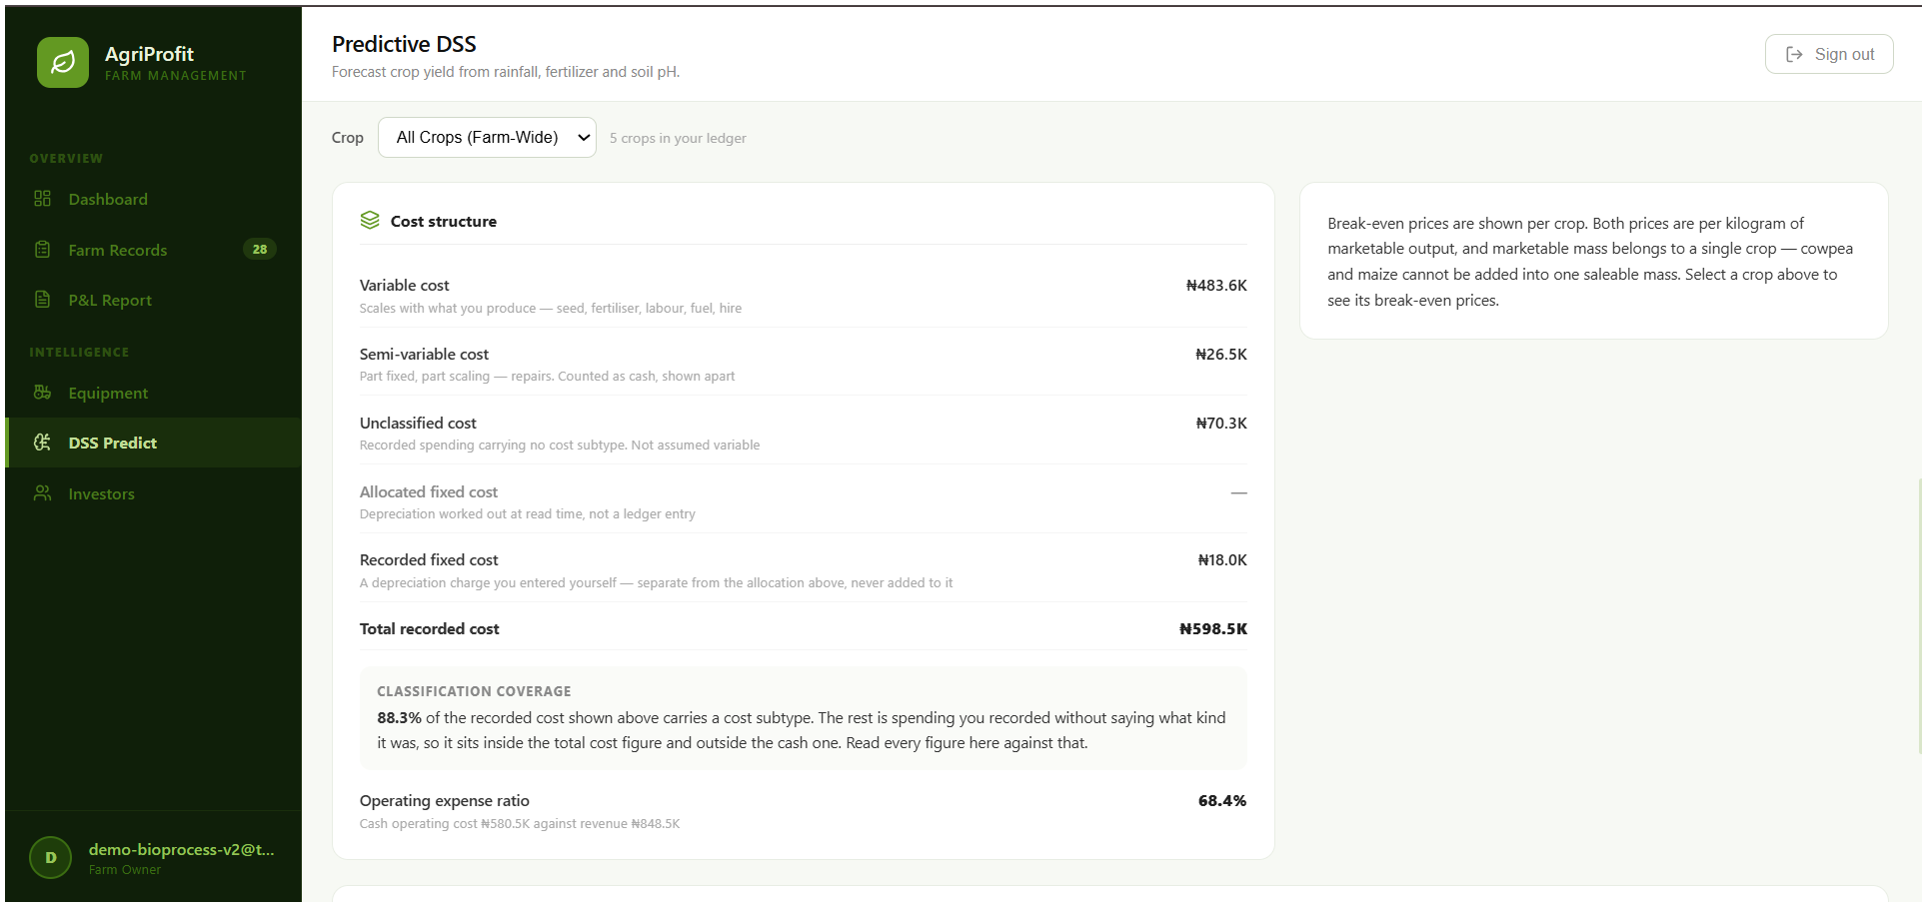
Figure 4.6: Farm level cost structure: 88.3% of ₦598,450 recorded cost classified by cost behaviour, with an operating expense ratio of 68.4%

4.6.2 The depreciation overlay and fixed-cost allocation
Depreciation is computed as a derived overlay at report time and is never posted to the ledger. The reasoning is recorded in an architecture decision record and is worth restating because it is a design result rather than an arithmetic one: posting a synthetic depreciation row would require either an unpaired entry, which violates the paired-write invariant that the whole ledger design rests on, or a fabricated operational log describing an event that did not happen. Neither is acceptable in a ledger whose claim is that every row records something a farmer did. The overlay is therefore computed, transparent and recomputable, in the same way as every other derived figure on the platform.
Table 4.9: Derived fixed-cost overlay, farm 26
Quantity | Value
Reporting period | 7.0 days, derived from the ledger span
Period fixed cost (depreciation overlay) | ₦10,068.49
Equipment records | 2
Equipment without a usable depreciation rate | 1
Total direct cost, all crops (the allocation base) | ₦598,450
Fixed cost allocated to maize | ₦58.88

Table 4.9 reports the derived overlay and the allocation computed from it. Three properties are asserted by test. A zero depreciation rate counts as unrated and is reported in the unrated count, never as a zero charge — so a partial overlay is visible as partial rather than being read as a small true fixed cost (Figure 4.7). The allocation is proportional to direct cost and is computed farm-wide before any crop filter is applied, so the same figure cannot change according to how it was requested. And where the total direct cost is zero, every share and every allocation is undefined rather than being split evenly, on the reasoning that an even split invents an allocation base that does not exist.
Two simplifications ride along and are stated rather than hidden: the method is straight-line with no salvage value and no accumulated-depreciation floor, so an asset held past its implied life keeps charging and the overlay is an upper bound. The reporting window may also be pinned explicitly rather than derived, which is a reproducibility measure: a derived span widens every time a log is entered, and a figure quoted from a widening window cannot be re-derived afterwards. That is not hypothetical for the figures reported here. The seven-day window in Table 4.9 is the span between the earliest and latest records on this farm, and it is seven days only because the cowpea records of 24 August joined the maize records of 18 August; before they were entered the span was a single day. Every fixed-cost figure in this chapter is therefore stated against the ledger as it stood at the baseline and would move if further activity were recorded. Had a record been entered on 30 August, the window would widen to thirteen days, the period fixed cost would rise from ₦10,068.49 to ₦18,698.63, and the total break-even price would move from ₦42.37 to ₦42.97 for maize and from ₦631.56 to ₦640.52 for cowpea. The cash prices would not move at all. A farmer who logs one late operation changes his own total-cost break-even prices without intending to.
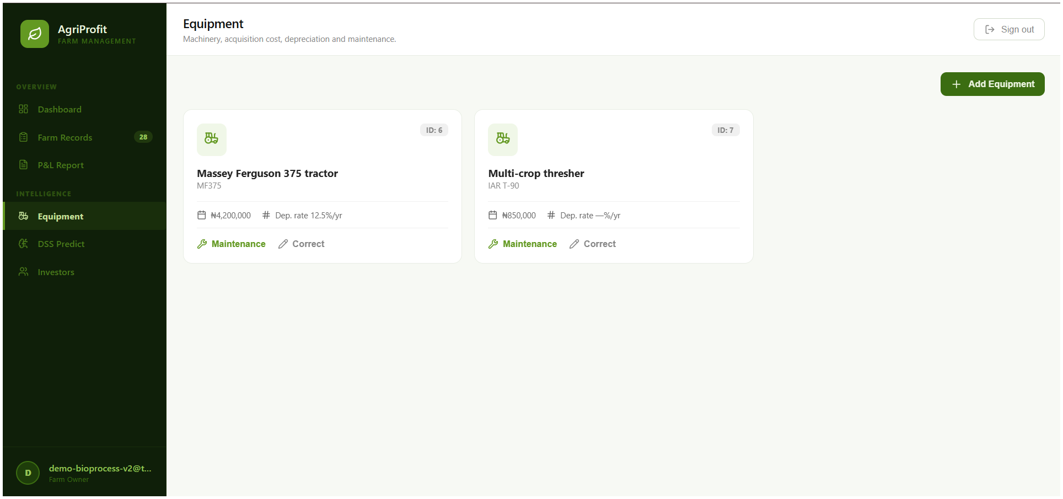
Figure 4.7: Equipment register and depreciation basis, with the unrated asset excluded from the charge rather than counted as costing nothing

4.6.3 Partial budget and implementation parity
The partial-budget calculator evaluates a proposed change by four terms — added revenue, reduced cost, lost revenue and added cost — and returns the signed net change. A probe with added revenue ₦120,000, reduced cost ₦15,000, no lost revenue and added cost ₦90,000 returned benefits of ₦135,000 against costs of ₦90,000 for a net change of +₦45,000. The four inputs were chosen for the probe and are not seeded data; the route is stateless and wrote nothing.
The result of interest here is not the arithmetic but the parity. The partial budget is implemented twice — once in the backend service and once in the client, so that it remains available offline — and two implementations of the same formula are an invitation to divergence. Eight cases were hand-computed, placed in a single shared fixture read verbatim by both suites, and asserted against both implementations. They agreed on all eight on the first run; no divergence was found. The cases include a negative result whose sign is asserted separately from its magnitude, an exact zero that must not be returned as negative zero, kobo-level precision, and a transposition trap that swaps a pair of terms.
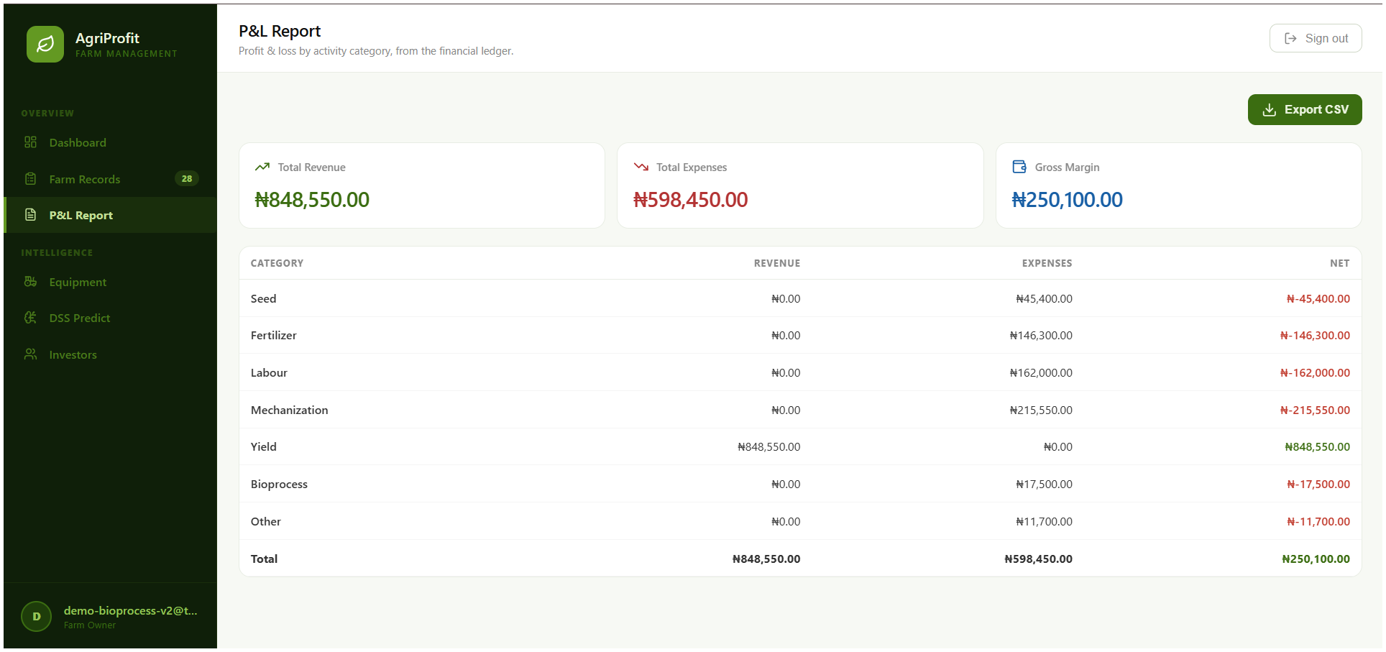
Figure 4.8: Profit and loss by activity category, with mechanisation the largest single cost at ₦215,550

4.6.4 Yield baseline
The Olympic-average yield baseline discards the highest and lowest season before averaging, and requires at least three seasons. Queried for maize on farm 26 it returns no Olympic average, a grand average of 100.0 kg, a season count of 1, and the stated reason that an Olympic average needs at least three seasons and this crop has one. That is the result: the demonstration farm holds a single season, and the platform says so rather than averaging what it has. The season count is reported in every branch of the response, including the branches that return no average, so that a null is never read without the count that explains it — one season and ten seasons are different reasons for the same null.
This endpoint is implemented, covered by ten tests, and reachable: the yield-baseline panel is rendered within the enterprise-economics view, so the figure and its stated reason are visible to a user. An earlier draft of this chapter reported the baseline as computed, verified, served and invisible; that finding is withdrawn, and all six enterprise-economics endpoints are reachable in the interface at the baseline commit. Two findings carried by earlier drafts of Table A.1 of Appendix A have been withdrawn: the Olympic-average yield baseline and the entry form’s crop list were both reported as implemented-but-unreachable, and both are reachable at the baseline commit.

4.7 Yield Forecast Evaluation
These figures are an in-distribution result on synthetic data and nothing more. The training data was generated from a parameterised agronomic relationship and the model was then fitted to that generated data, so an R² of 0.9762 measures how well the Random Forest recovers a relationship that was constructed to be recoverable. It is evidence that the machine-learning pipeline is correctly implemented — that features are encoded, the model fitted, and predictions served end to end — and it is not evidence that the model predicts Nigerian smallholder yields. No claim of field-predictive accuracy is made anywhere in this thesis.
Three further reservations are recorded because they bound the claim further.
First, the model is not validated against any real observation. Nothing establishes the synthetic data’s correspondence to Nigerian conditions or the fitted model’s accuracy outside its own distribution. What the suite does establish is that a model exists, that its inputs are validated, that a forecast is returned, and that the whole pipeline is seed-deterministic. Accuracy in the field is a different question and this work does not answer it.
Second — and this reverses a claim carried by an earlier draft — the artefact is reproducible from the repository. The generation seed, the split seed and the estimator seed are all fixed; the generated dataset carries the recorded SHA-256 fingerprint given in Table E.1 of Appendix E; and the three reported metrics were re-derived for this chapter by regenerating the dataset and refitting the pipeline from source, rather than by reading the sidecar file the training run wrote. The re-derived values agree with the recorded values to six decimal places. Eighteen tests in the reproducibility module assert the property, and agreement was additionally recorded across two Python versions, 3.14.5 and 3.11.15, with differing patch versions of the dataframe library. The earlier claim that regenerating the model would produce different figures was wrong, and it understated the rigour of the project’s own pipeline.
Third, the root-mean-square error is computed and reported: 0.4883 t/ha, measured 0.488334 over the held-out split. Chapter Three states that RMSE is a standard complementary measure for continuous prediction tasks in agricultural yield modelling, and all three measures — R² 0.9762, MAE 0.2414 t/ha and RMSE 0.4883 t/ha — are reported together. The earlier record of a missing RMSE is closed.
Three properties of this tier bear on its use rather than its construction.
The first is the width of the interval. A forecast for maize at 800 mm rainfall, 120 kg of nitrogen per hectare and soil pH 6.2 returns 4.74 t/ha with a likely range of 3.24 to 6.24 t/ha (Figure 4.9), a span of roughly a third either side of the point estimate. That width is not a defect to be narrowed in presentation. It is what the ensemble’s internal disagreement amounts to, and reporting it beside the point estimate is what prevents a farmer from reading a single number as a promise. The interval and the coefficient of determination answer different questions: R² 0.9762 describes how closely the model reproduces the surface it was generated from, and the interval describes how much the constituent trees disagree about a single case.
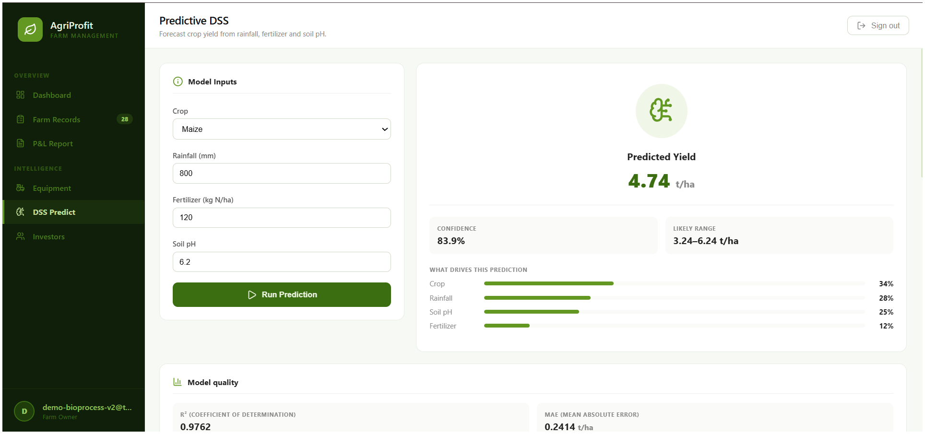
Figure 4.9: Yield forecast for maize at 800 mm rainfall, 120 kg of nitrogen per hectare and soil pH 6.2: 4.74 t/ha with a likely range of 3.24 to 6.24 t/ha
The second is that the tier cannot be compared against the platform’s own deterministic baseline, and the reason is structural. The Olympic-average baseline is an absolute mass per season, expressed in the unit the yield was logged in; the forecast target is an intensity, tonnes per hectare. No area term exists anywhere in the baseline path, because the data model holds no field, plot or area entity (Section 3.6.10), so the recorded 100.0 kg of maize has no denominator to divide by. The two figures the platform produces about yield are therefore not commensurable.
The third is coverage. The model’s crop vocabulary is maize, rice, sorghum, soybean and cassava. Cowpea and tomato are absent, and because crop is one-hot encoded they are not inaccurate inputs but unrepresentable ones. Of the five enterprises in the demonstration ledger, three can be forecast and two cannot — and the two that cannot include cowpea, the largest enterprise on the farm by revenue, recorded cost and gross margin.
What the platform does do with these figures is report them honestly in the interface. Three display states are distinguished: metrics unavailable while loading; an explicit statement that the model has not been trained, where that is the case; and the figures with their disclosure where a trained model exists. The untrained case is deliberately not rendered as R² 0.0000, because a zero reads to a user as a very poor model rather than as no model. All three states are asserted by test at the endpoint level, though the rendered states themselves are manually inspected only.

4.8 The Implemented System in Use
This section reports what exists. No verification claim is attached to anything in it; verification is the subject of Section 4.9. The separation is deliberate, because “the platform does X” and “the platform is proven to do X” are different statements, and conflating them is the most common way a results chapter overstates its evidence.

4.8.1 Deployed components
AGRI-PROFIT is a working end-to-end application rather than a prototype or a mockup. It runs as a three-container Docker composition: a FastAPI backend service, a PostgreSQL 15 database whose schema is managed by Alembic migrations, and a static server for the built Progressive Web Application. The backend is organised into an endpoint layer (authentication, ledger, reports, decision support, bioprocess, equipment and investor sharing), a service layer carrying the business logic (ledger, decision support, enterprise economics, bioprocess, reports, sharing, authentication and equipment), a model and schema layer, and a machine-learning package holding dataset generation, training and prediction. The frontend is organised by feature — farm records, decision support, dashboard, authentication and investor sharing — over a library layer providing the local database, the synchronisation queue, queue ownership, authentication token handling and the read cache, with a Workbox service worker and precache.
The application serves six authenticated routes dashboard, records, reports, equipment, decision support and investors and one unauthenticated public route for a shared investor report reached by token.
At the baseline commit the live database held 14 farms, 13 users, 109 operational logs, 109 financial transactions, 3 equipment records, 1 maintenance log and 10 share tokens, with the schema at Alembic revision b9e5f30c74a1. A direct query for operational logs carrying no paired financial transaction returned zero rows. The one-to-one correspondence between operational logs and financial transactions is not a coincidence of the sample: it is the paired-write invariant of Section 3.5 visible in the data, every operational record having posted its financial transaction in the same commit.
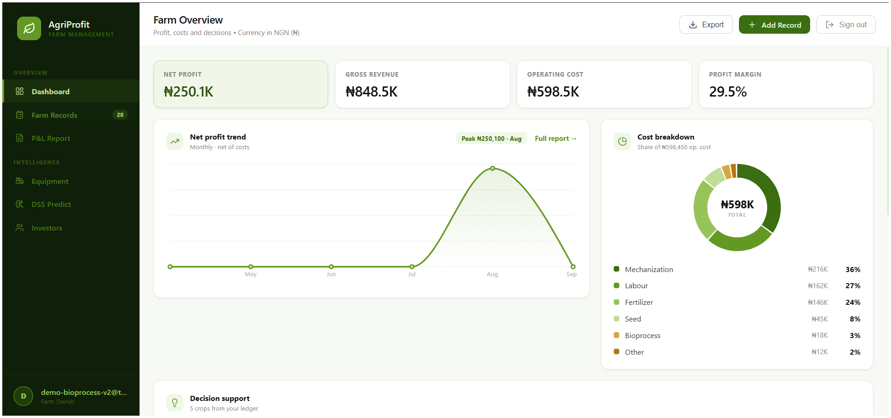
Figure 4.10: Farm overview showing net profit of ₦250,100 against revenue of ₦848,550 and operating cost of ₦598,450

4.8.2 Functional inventory

Two entries in that inventory bound what the thesis may claim. The first records that per-operation equipment attribution is captured but costed nowhere, so no machine-hour or cost-per-hour figure exists. The second records an endpoint that is built, typed and served, and that no interface component calls.
This section reports evidence obtained by observation rather than by automated test. It is weaker evidence, and it is separated from Section 4.9 for that reason. It is nonetheless evidence, and reporting it separately is what allows Section 4.9 to be read as strictly as it is written.
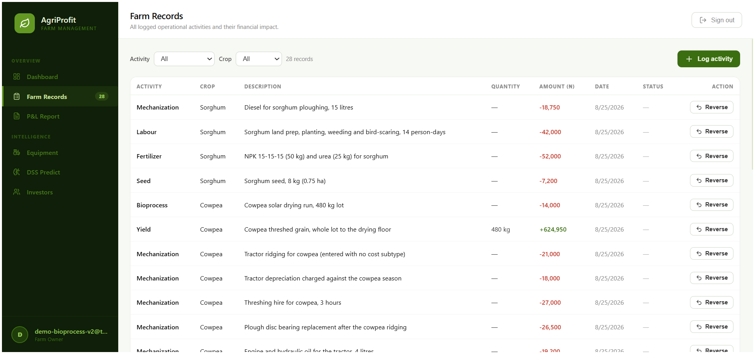
Figure 4.11: Operational record list for the demonstration farm, ordered by date and filterable by crop and activity
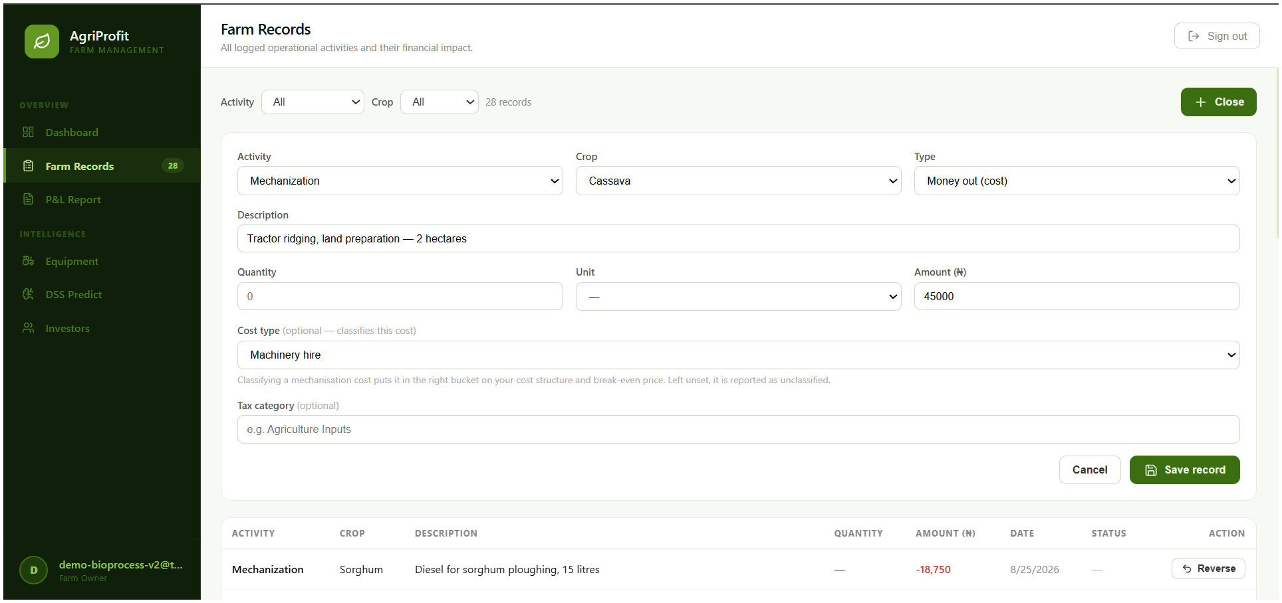
Figure 4.12: Recording a mechanisation cost, showing the cost classification control and land area entered as free text in the absence of an area field
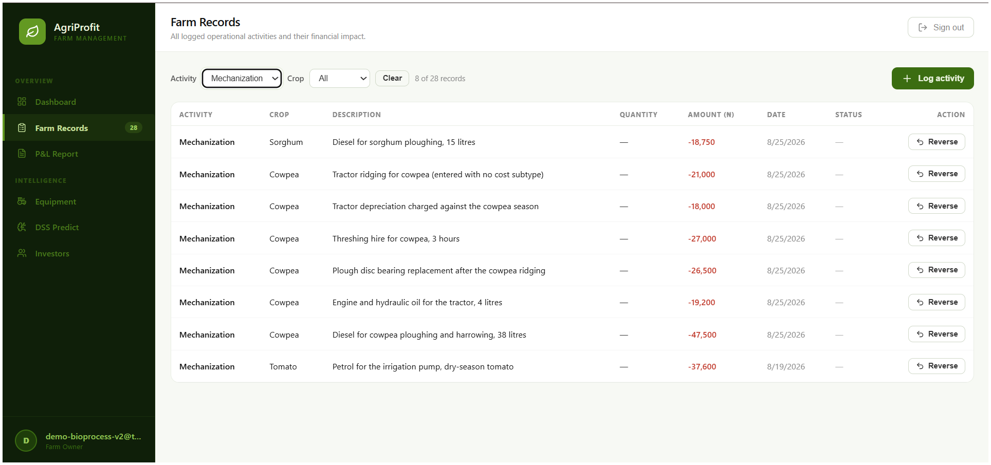
Figure 4.13: Record list filtered to mechanisation activities

4.8.3 Components verified visually only
The drying-curve chart component has no automated test and 0% coverage. Its visual rendering correctness is established by manual inspection alone, and no claim of automated coverage is made for it anywhere in this thesis. The distinction is material because the drying calculations the chart displays are fully covered: the bioprocess service is at 100%, the client-side drying rules are covered by 20 tests, and the drying API outputs — detail, summary, validation and reversal handling — are covered by the test block. What is not covered is the drawing of the picture.
The same status applies to the wider page and form layer, which is listed here so that no reader infers coverage from the screenshots presented in this chapter: the record creation form, the records page, the drying entry fields, the drying result panel, the login page, the decision-support prediction page, the investor pages, the application shell, and the hook that wraps the fully tested crop-option module. All are implemented, all are reachable, and none is exercised by an automated test.

4.8.4 Live system verification
Every endpoint on which this chapter’s figures depend was exercised against the running stack and returned HTTP 200: the decision-support breakdown, the model information endpoint, the bioprocess summary and detail endpoints, and all five enterprise-economics routes. No probe returned a non-2xx response. The authenticated probes were performed as the seeded demonstration farm’s own user, and the responses are the source of every figure in Sections 4.2 to 4.7.
Two further live checks were performed and are reported because they bear on data integrity rather than on functionality. First, after the verification-artefact cleanup that preceded the freeze, the database state was confirmed by direct SQL: the transient verification farms and their logs were absent, and every seeded and demonstration record was unchanged. Second, the backend answered an unauthenticated request to a protected route with HTTP 401 and a root request with HTTP 200, with no error appearing in its log after the deletion.

4.9 System Verification
Section 3.8.1 specifies verification of the implemented functionality against the requirements of Chapter Three by means of an automated test suite. Each functional requirement is verified against defined test cases using an automated test suite, supplemented by manual walkthroughs of the core workflows. The suite runs against the real application rather than against mocks: the backend cases exercise the FastAPI application through its test client with a real database session, and the frontend cases exercise the shipped modules, including a genuine IndexedDB implementation.
The behaviours reported in this chapter are those on which the design argument of Chapter Three depends. Each is asserted by at least one named passing test. For the deterministic decision-support tier, verification asserts that the computed unit cost of production and gross margin match values calculated by hand from seeded ledger records, confirming arithmetic fidelity. The cash price is provably strictly lower than the total price, which is asserted directly by test, including in the edge case of full classification coverage and no overlay.
A drying model can only be shown to be correct by recovering parameters known in advance, so the module is verified by hand-calculated fixture rather than by demonstration. A dedicated fixture asserts that the mass of water removed and the process loss are distinct quantities and fails if they are ever made equal. For the forecasting tier, what the suite does establish is that a model exists, that its inputs are validated, that a forecast is returned, and that the whole pipeline is seed-deterministic. Accuracy in the field is a different question and this work does not answer it.
The type check, the lint and the production build are clean. Two limitations bound what the suite establishes. The page and form components are implemented, are reachable, and none is exercised by an automated test. Backend tests run on SQLite while production runs PostgreSQL; only the migration chain was executed against a real PostgreSQL server.

4.10 Response Time and Hosting Cost
Section 3.8.2 specifies a Lighthouse audit of the production build under mobile emulation and network throttling.
Between the first and second navigation of the same flow, on an identical 0.4 Mbps simulated link, first paint fell from 5,661.2 ms to 70.6 ms — a factor of eighty — and network transfer fell from 139,245 bytes over eight requests to 127 bytes over seven.
Objective 4 requires an assessment of cost-effectiveness. A production deployment was outside the scope of this study, so operating cost is estimated rather than incurred. The estimate is anchored on the platform’s measured resource consumption rather than on assumption, and is labelled an estimate wherever it appears.

4.11 Security and Deployment Verification
Objective 3 is answered by mechanisms whose evidence has not so far been reported in this chapter. This section reports it. Every result below was obtained by probing the running production composition at the baseline commit, not by reading source; each is therefore manually inspected evidence of a live system, supported in most cases by named automated tests.
Table B.1 of Appendix B lists each property, the probe that exercised it, and the result. Three properties in that table are design results rather than test results, and are worth stating separately. The permission check precedes the farm-scope check, so a user who lacks a permission receives the same refusal whether or not the record they named exists; a refusal is therefore never an oracle confirming existence. Unknown, revoked and expired share tokens all resolve to one identical not-found response, for the same reason. And the login refusal names no account, so a failed attempt confirms no email address. Each of these is a decision to give the attacker less information than the honest user loses by it.
Two residuals are recorded rather than concealed behind the controls. The rate-limit counters are held in process: they do not span replicas and they do not survive a restart, and both were observed directly. And there is no session revocation within a token’s lifetime, no refresh mechanism, no password reset and no second factor. The boundary these results establish is that the mechanisms behave as designed under the probes applied to them by their author. No independent security assessment, penetration test or threat model was conducted, and that is the single most important thing this thesis does not know about its own security posture.
Table B.2 of Appendix B records the deployment, migration and recovery checks and their outcomes. The distinction that these results establish, and that must be carried into Chapter Five, is between a deployment path that has been demonstrated and a deployment that has been performed. This work has the first and not the second. The production composition builds, starts and answers its probes; the migration chain runs and rolls back against a real PostgreSQL server; a backup was taken and restored with every row count matching and the paired-write invariant intact. No instance serves a real user, no certificate has been issued for a real hostname, and there is no observability of any kind — no metrics, no tracing, no alerting, the containers logging to standard output only. Nor is any continuous-integration result recorded for the baseline commit: the workflow is defined and the substance of its jobs was executed locally, which is what Section 4.9 reports, and no claim that the pipeline passed is made anywhere in this work.

4.12 Usability Evaluation
Section 3.8.4 specifies a usability evaluation combining observed task performance, heuristic inspection against Nielsen’s ten heuristics, and the System Usability Scale, with a panel of three to five evaluators.
The instrument for this strand exists and the results do not. The project holds a complete facilitator run-sheet and a three-part evaluation pack — a task script, a heuristic checklist and the ten-item SUS questionnaire — and the frozen evidence base contains no completed instrument of any kind: no scored SUS forms, no filled heuristic checklists, no session notes, no participant records and no scans or photographs. This section is therefore drafted to receive real data and reports no figure that no retained instrument supports.
Table 4.10: Usability evaluation — to be completed from retained instruments
Measure | Evaluator 1 | Evaluator 2 | Evaluator 3 | Panel
Tasks completed | — | — | — | —
Mean ease rating (1–5) | — | — | — | —
Session duration | — | — | — | —
Mean heuristic compliance (1–5) | — | — | — | —
SUS score (0–100) | — | — | — | —

Author’s note — what must exist before each cell is filled. SUS is scored by the standard procedure: odd-numbered items score (response − 1), even-numbered items score (5 − response), the ten adjusted scores are summed to a total out of 40, and the total is multiplied by 2.5 to give a score from 0 to 100. It is not a percentage. Report the mean with the individual scores beside it and label it indicative rather than statistically representative, since SUS is understood to be unstable below roughly a dozen respondents and the specified panel is three to five. Merge the issue logs, deduplicate, and keep the highest severity any evaluator assigned to each issue. Photograph or scan every completed sheet: these are the raw instruments an examiner may ask to see. State the panel at its true size — a panel smaller than the method specifies is a limitation, and a panel reported larger than it was is misconduct.
Table 4.10 is the instrument prepared to receive the panel’s scores and Table 4.11 the issue log that would accompany them; both are deliberately empty, and neither has been populated. Two procedural points are recorded now because they belong to the method rather than to the results. First, browser site data must be cleared between evaluators. This is a validity control rather than a courtesy: the offline queue task deliberately creates queued entries, and the identity partitioning of that queue protects against cross-account flushing within the application, but a shared browser profile would still carry one evaluator’s session state into the next. Second, the heuristic checklist and the SUS questionnaire must be completed without the author present, because a self-report instrument administered under the author’s observation is systematically inflated.
Table 4.11: Usability issue log — to be completed
# | Finding | Source | Severity | Disposition
1 | —

Because this strand is outstanding, Objective 4 is reported as partially met in Section 4.13, and no claim of a usability finding, a task-completion measurement, a SUS score or a comparison against paper-based practice appears anywhere in this thesis.

4.13 Results Against the Stated Objectives
Table 4.12: Evidence and residual gap, by objective
Objective | What the evidence shows | Evidence class | Residual gap
1. Identify and evaluate the socio-technical barriers hindering FMIS adoption in Nigeria | The barriers identified in Chapters One and Two — fragmentation, interoperability, complexity, connectivity and cost — were carried into the non-functional requirements of Section 3.3.2 and answered by specific implemented mechanisms: the paired write against fragmentation (109 logs, 109 transactions, 0 unpaired), the offline queue and service worker against connectivity, and the fixed-instance cost profile against cost | Implemented; numerical (Sections 4.8, 4.10; Appendices A and C) | Partially achieved. The barriers are established from the literature and answered by design; no empirical barrier study with Nigerian farmers was conducted, and none is claimed. The feature-phone channel that would address the rural device gap is not implemented in any form
2. Convert operational and financial records into actionable decision-support metrics | Nine deterministic quantities computed from a live ledger and each pinned by named tests; the decision-support and enterprise-economics services at 100% statement coverage; all six enterprise endpoints reachable in the interface; two independent partial-budget implementations agreeing on eight hand-computed cases | Automatically verified; numerical (Sections 4.2 to 4.6) | Achieved as arithmetic. Demonstrated on one seeded farm rather than a season of real records, so the agronomic relevance of the figures is unevaluated. The forecast tier is trained on synthetic data
3. Design and integrate a secure data-sharing framework to build stakeholder trust | Signed-token authentication over hashed credentials; role-based authorisation over 3 roles and 11 permissions with the permission check preceding the scope check; per-farm isolation returning 404; share tokens revocable, expiring at 90 days, hashed at rest, refused as bearer credentials, and resolving unknown, revoked and expired to one identical response; raw tokens absent from all three logs; login throttling; monetary input bounds; deletion refused with correction by linked contra entry | Automatically verified and probed live (Section 4.11; Appendix B) | Achieved as implementation and internal verification. Not validated in practice: no independent security assessment, penetration test or threat model. No session revocation, refresh, password reset or second factor. The ledger is audit-trailed, not cryptographically tamper-evident
4. Evaluate usability, cost-effectiveness and operational viability under Nigerian constraints | Three of four specified strands executed: functional verification (426 collected backend cases, 422 passed, 4 skipped, 0 failed, at 96% statement coverage, with 148 frontend tests at 41.84–43.23%, plus three sets of negative controls and a migration chain run against real PostgreSQL); performance benchmarking across two network conditions with cold and warm cache and driven-browser attribution; and a hosting-cost analysis anchored on a measured footprint | Numerical; manually inspected (Sections 4.8 to 4.11) | Partially achieved. The usability strand was specified and not executed (Section 4.12), so no SUS score, heuristic rating or task-completion measurement exists. Performance is simulated throttling against a local server; tenancy figures are reasoned, not load-tested; hosting cost is estimated, not incurred; and the deployment path has been exercised but never run for a real user
5. Model post-harvest drying and couple its output to the financial record | The Page and Newton models recovered from a designed fixture to within 1×10⁻⁴; water removed held distinct from process loss by a test that fails if they are ever equated; safe storage returned as an absence rather than a negative verdict for an unrecognised crop; and a maize run of 100 kg at 25% moisture dried to 13% and weighed out at 84 kg moving unit cost of production from ₦35.00 to ₦41.67 per marketable kilogram, computed end to end without manual intervention | Automatically verified; numerical (Section 4.5) | Achieved as a demonstrated computation on seeded runs. No drying trial was conducted with real produce, no dryer was instrumented, and the thin-layer models themselves are long established and are not claimed as a contribution — their coupling to the financial record is

4.14 Limitations
The following bound what the results above may be taken to show. They are stated here so that Chapter Five interprets them rather than rediscovering them. An implementation limitation is something the system does not do. An evaluation limitation is something the system may well do that this study did not measure. The distinction matters: the absence of a usability study does not make the interface unusable, the absence of load testing does not show the platform cannot scale, a synthetic evaluation does not make the model worthless, and the absence of a security assessment does not mean authentication and authorisation do not exist.
Verification gaps — evaluation limitations. There are no component tests for the page and form layer, including the drying-curve chart. The local-database migration is proven against an in-memory IndexedDB implementation rather than a real browser, so browser-specific storage eviction, quota behaviour and vendor bugs are out of its reach. Backend tests run on SQLite while production runs PostgreSQL; only the migration chain was executed against a real PostgreSQL server. Concurrency is measured on SQLite and inferred for PostgreSQL. There is no end-to-end browser test of the offline-to-online transition, the service-worker lifecycle or the installation path. The frontend suite is not timing-robust under machine contention. There has been no independent security review, no penetration test, no threat model, and no load, stress or soak testing. And no continuous-integration run result is recorded for the baseline commit.
Data-state limitations. The live database holds eleven unidentified exploratory farms from development, deliberately left in place rather than deleted on an assumption, and two farms share the name “Demo Farm” — only farm 26 carries the seeded data, which is why no figure in this chapter is taken from a farm-list view. Machine hours are populated on three of eight mechanisation logs. Two components of the hosting footprint — the static server and the container runtime — were not sampled at all, so the total is part-measured and part-assumed.
Documentation gaps. Two citations that were outstanding in the implementation are now resolved and are attributed in Chapter Two: the cost-behaviour taxonomy to the enterprise-budgeting literature of agricultural economics (Kay, Edwards, & Duffy, 2016), and the safe-storage moisture ceilings to post-harvest handling guidance (FAO, n.d.; Baidhe et al., 2024).
Validation gaps. Nothing here is validated in practice: the production path of Section 4.11 has been built, started, probed, backed up and restored, and no instance has ever served a real user on a real domain on a departmental host. That is a smaller and more accurate claim than the flat statement that the system has never been deployed, and it is the one the evidence supports.

4.15 Summary
The type check, the lint and the production build are clean. The paired write, the soft-immutability constraint and the linked contra entry behave as designed; offline queue identity partitioning, logout cleanup and the local-database migration are each asserted by named tests; and same-farm idempotency holds sequentially and under a genuine two-thread race. Coverage is concentrated where it matters — every module that serves a request is fully or almost fully covered — and its distribution is reported rather than averaged away.
The deterministic decision-support layer computes per-crop margin and ranking, unit cost on both a harvest and a marketable basis, retrospective break-even yield, both break-even prices, a sensitivity matrix, an operating-expense ratio, an Olympic-average yield baseline and a partial budget from a live ledger, netting reversed pairs at farm level and per crop alike, and withholds each figure where its inputs are insufficient rather than substituting a plausible default. All six enterprise endpoints are reachable in the interface. Two independent implementations of the partial budget agree on eight hand-computed cases. The post-harvest module recovers known thin-layer parameters — k = 0.30 and n = 0.75 — to within one part in ten thousand, keeps water removed distinct from matter lost, and connects a moisture measurement to a price per marketable kilogram in a single computed chain, moving maize from ₦35.00 to ₦41.67 per kilogram, a 19% difference that is post-harvest mass reduction expressed in money.
Under simulated throttling re-measured at the baseline, the service worker reduces network transfer on a repeat visit from 139,245 bytes over eight requests to 127 bytes over seven the residue being the manifest icon, a measured defect and reduces first paint by a factor of about eighty, from 5,661.2 ms to 70.6 ms, though time to main content improves by a factor of about three and a half, and that is the figure a user experiences. Measured resource consumption places the two exercised containers at 178.9 to 202.8 MiB, supporting an estimated $15.40, approximately ₦20,950, per month and a reasoned cost per farm falling to ₦105 at a two-hundred-farm tenancy a cost structure that scales in the opposite direction to the per-seat licensing identified in Chapter One as excluding this user.
The security and tenancy boundary is exercised as well as asserted: three roles over eleven named permissions refuse a worker the farm’s financial picture and refuse a manager the power to disclose it; share links expire at ninety days, are stored only as hashes, and revoke to a verdict indistinguishable from that for a token that never existed; the raw token reaches none of the three logs that record its request; failed logins are throttled; the migration chain runs and rolls back against real PostgreSQL; and a backup was taken and restored with every row count matching and the paired-write invariant intact. Against all of that, the yield forecast is an in-distribution result on synthetic data, R² 0.9762, MAE 0.2414 t/ha, RMSE 0.4883 t/ha, reproducible to six decimal places and evidence about the pipeline rather than about Nigerian yields; the platform has a production path that has been demonstrated but has never served a real user; no independent security assessment exists; and the usability strand was specified and not executed, leaving Objective 4 partly met. Chapter Five interprets these results against the problem set out in Chapter One, states the platform’s limitations in full, and sets out what would be required to take it from a verified prototype to a deployed system.

CHAPTER FIVE

5.0 SUMMARY, CONCLUSION AND RECOMMENDATIONS

5.1 Summary

5.1.1 The Problem, the Approach, and the Procedures Used
This study began from a documented separation. Nigerian smallholder and medium-scale farms keep their production records and their cost records apart, commonly on paper, commonly in different books, so that the cost of producing a crop is rarely known at the moment the crop is sold. The farm management information systems that would close that gap were designed for a different farm: they assume continuous connectivity, they charge per user seat, and they present a complexity that the literature reviewed in Chapter Two identifies as a barrier in its own right. The specific consequence, and the one this work exists to address, is that a farmer who cannot join an operational record to its financial consequence cannot know what any enterprise on the farm actually earns.
The approach was to remove the separation rather than to manage it. Where an integrative design synchronises two records, AGRI-PROFIT posts one: every operational log commits its paired financial transaction in the same database transaction, and a posted record is corrected not by editing it but by a linked contra entry that preserves the original’s category and crop. On that record the platform computes a deterministic decision-support tier, nine quantities derived from the farm’s own ledger with no model and no external data, and, separately and optionally, a forecast tier. A post-harvest drying module applies established thin-layer kinetics to the farm’s own drying runs and carries their marketable output into the unit-cost calculation, so that what a farmer costs against is the mass that can actually be sold. The client is an offline-first progressive web application; sharing with a lender is a revocable, expiring, read-only token.
The procedures used were those specified in Chapter Three and reported in Chapter Four. Development was iterative and version-controlled, with human-reviewed, agent-assisted implementation. The evaluation was specified in advance as four strands: functional verification by automated test suite with hand-computed fixtures and negative controls; performance benchmarking by Lighthouse under mobile emulation and simulated network throttling; a hosting-cost analysis anchored on a measured container footprint; and a heuristic-plus-System-Usability-Scale evaluation with a small expert panel. Three of the four were executed. The fourth, usability, was specified, its instruments were prepared in full, and it was not carried out. A fifth body of evidence, not among the four strands as originally specified, was obtained by probing the running production composition directly and is reported in Section 4.11. All evidence in this work is measured at a single implementation state: commit 8a29ee0aeed4d00b4caf9e58854821e80b6d403d on the main branch, dated 31 August 2026, referred to as the baseline commit. Where a measurement was taken at an earlier commit it is attributed at the point of use.
Two commitments carried over from Chapter Four govern this chapter as well. Nothing is interpreted that was not first evidenced: where an interpretation rests on a result, the result is the one reported in Chapter Four and not a stronger version of it. And where the evidence does not reach a conclusion the reader might expect, most consequentially on whether the platform would help a real farmer, that is stated as a limit on the work rather than bridged by argument.

5.1.2 Summary of Findings
The evaluation returned findings in seven areas.
Structural integrity of the record. At the baseline commit the live database held 109 operational logs and 109 financial transactions, and a direct query for operational logs carrying no paired transaction returned zero rows. The one-to-one correspondence is not a property of the sample but the paired-write invariant made visible in the data, and it is the single most quotable structural result of the work.
Functional verification. Each functional requirement was verified against defined test cases using an automated test suite, supplemented by manual walkthroughs of the core workflows (Section 4.9). The migration module was separately executed in full against PostgreSQL 15.18.
Decision support. The deterministic tier computes nine quantities from the farm’s own ledger with no model and no external data, and all six enterprise-economics endpoints are reachable in the interface. The platform withholds a figure wherever its inputs do not support one, and 88.25% of recorded cost at farm level carries a cost subtype, the residual 11.75% being reported as unclassified rather than distributed into a plausible bucket.
Post-harvest coupling. A maize harvest of 100 kg at 25% moisture, dried to 13% and weighed out at 84 kg against a dry-matter prediction of 86.21 kg, moved the unit cost of production from ₦35.00 to ₦41.67 per marketable kilogram — a 19% difference, being post-harvest mass reduction expressed in money. The Page and Newton models were recovered from a designed fixture at k = 0.30 and n = 0.75 to within one part in ten thousand.
Forecasting. A 200-estimator Random Forest over 6,000 synthetic samples returned R² 0.9762, MAE 0.2414 t/ha and RMSE 0.4883 t/ha, reproducible to six decimal places across two Python versions from a dataset carrying a recorded SHA-256 fingerprint. That figure measures the recovery of a constructed relationship. It is evidence that the machine-learning pipeline is correctly implemented end to end; it is not evidence about Nigerian yields, and the model learns from no farm’s records.
Operation under constraint. Under simulated slow-3G throttling a cold load transfers 139,245 bytes over eight requests and reaches first paint at 5,661.2 ms; a warm load transfers 127 bytes over seven requests and reaches first paint at 70.6 ms. Two exercised containers consume 178.9 to 202.8 MiB, supporting an estimated $15.40, approximately ₦20,950, per month and a reasoned ₦105 per farm per month at a two-hundred-farm tenancy.
Security and the deployment path. Role-based authorisation over three roles and eleven named permissions was exercised live, with the permission check preceding the farm-scope check so that a refusal is never an existence oracle; login throttling returned 429 on the eleventh failure within the window without naming an account; share tokens were verified to expire at ninety days, to be stored only as hashes, to be refused as bearer credentials, and to resolve unknown, revoked and expired alike to one identical response; the raw token reached none of the three logs recording its request; monetary bounds rejected four out-of-range inputs; and a backup was taken and restored with every row count matching. The production composition was built, started and probed with seven of seven checks passing. No instance has served a real user.
The usability strand of the specified evaluation was not executed. No System Usability Scale score, heuristic-severity rating, task-completion measurement or evaluator finding is reported anywhere in this work.

5.2 Conclusion

5.2.1 Interpretation of the Major Findings
The paired write is the structural contribution, and it is visible in the data. The literature identifies the separation of farm financial accounts from operational records as a historical accident with continuing costs: duplicated entry, administrative fatigue, and the impossibility of correlating agronomic inputs with financial outcome (Poppe et al., 2023; Fountas et al., 2015). Most responses to it are integrative, two systems and a synchronisation path between them. AGRI-PROFIT’s response is different in kind: there is only one write, and it posts both records in a single commit, so the two cannot drift because they were never separate. The finding that makes this more than an assertion is arithmetic. At the baseline commit the database held exactly as many financial transactions as operational logs 109 of each, with zero unpaired at Alembic revision b9e5f30c74a1. There is no reconciliation step in the platform because there is nothing to reconcile, and the correlation the literature describes as unavailable is not computed but inherent: every cost already carries the activity that incurred it and the crop it was incurred against. The cost of this design is equally real and is stated in Chapter Three: the ledger is single-entry, so it is an analytical instrument rather than a bookkeeping system in the accounting sense. That is the right trade for the target user, whose alternative is not double-entry software but paper, and it should not be presented as anything else.
The drying-to-price chain is the engineering contribution. The result most specific to agricultural and bioresources engineering is the computed chain running from a moisture measurement to a price. A maize harvest weighed in at 100 kg and 25% moisture, dried to 13%, weighed out at 84 kg, and the unit cost of production moved from ₦35.00 to ₦41.67 per kilogram. The 19% difference is post-harvest mass reduction expressed in money, and a farmer pricing on the wet-basis figure would under-recover ₦6.67 on every kilogram sold. Three properties make this a result rather than an illustration. First, the chain is computed end to end without manual intervention: the drying run is an operational log like any other, so it posts its cost through the same paired write, and its computed marketable output becomes the denominator of the unit-cost figure. Second, the denominator is the mass actually weighed out rather than the mass the dry-matter balance predicts — 84 kg against 86.21 kg — which is the conservative choice and charges the pricing decision only with grain that reached the store. Third, the distinction the module is most likely to get wrong is guarded by a test that fails if it is ever collapsed: water removed is a water balance, not a mass difference, and conflating them would make process loss and drying performance the same number. One refinement must travel with the ₦41.67 figure now that the demonstration farm owns a depreciating asset. For maize that figure is also the break-even price on a cash basis: the enterprise carries no unclassified cost and no recorded fixed cost, so its cash cost and its recorded cost are the same quantity, and both give ₦41.67. On a total-cost basis, once maize takes its ₦58.88 share of the farm-wide depreciation overlay, the figure is ₦42.37. Cowpea is the contrasting case on the same farm, where the two diverge. The two answer different questions, what must be obtained this season to avoid a cash loss, and what must be obtained to cover the wear on the assets used as well and neither should be quoted as though it were the other. Break-even yield, in kilograms and retrospective, is a third quantity again and is never to be conflated with either price. This junction is the answer to the question of what makes the platform an agricultural engineering artefact rather than a bookkeeping application. The thin-layer models themselves are long established and are not the contribution; their coupling to the financial record is.

5.2.2 Comparison with the Literature
[AUTHOR: bridge needed]
On the modelling ladder. Van Klompenburg, Kassahun, and Catal (2020) find tree-based ensembles to perform strongly on tabular agricultural data at far lower computational cost than deep networks, and the implemented forecast tier follows that finding with a 200-estimator Random Forest. Chapter one scoped the statistical tier as lightweight modelling, and the implementation went one step up the modelling ladder to an ensemble of regression trees; that is a defensible design decision rather than a drift, and it is taken on the grounds of cost and interpretability that van Klompenburg et al. establish. The counter-case is recorded rather than suppressed: Olisah et al. (2024), working on Nigerian corn-yield prediction for smallholder decision support, report that a carefully tuned deep neural network regressor outperformed the models they compared it against and that the quality of pre-processing was decisive. Their work is an unpublished preprint and is cited here for its pre-processing finding rather than as authority for a model choice; the implemented tier deliberately does not yet exercise that finding, because it is trained on clean synthetic data for which the pre-processing pipeline they describe has nothing to do. That is the correct reading of the R² of 0.9762 reported in Chapter Four: it is the recovery of a constructed relationship, and the moment the platform trains on real farm records the pre-processing problem those authors identify becomes the central one. All three regression measures are reported R² 0.9762, MAE 0.2414 t/ha and RMSE 0.4883 t/ha and all three are reproducible to six decimal places from the recorded seed, so what is unproven is the model’s relevance and not the integrity of the procedure that produced it.
On post-harvest drying. The thin-layer models the platform fits are those established by Lewis (1921) and Page (1949) and reviewed by Onwude et al. (2016); nothing in the kinetics is new, and no claim to the contrary is made. What the reviewed literature does not do is carry those outputs into a cost record. Baidhe, Clementson, Senyah, and Hammed (2024) report that inadequate and unmeasured drying remains a principal determinant of grain quality loss across Africa, and that smallholder practice judges the end point by eye; the enterprise-budgeting literature (Kay, Edwards, & Duffy, 2016) supplies the cost-behaviour taxonomy and the unit-cost formulation but assumes the output quantity is given. This work joins the two, and the ₦35.00-to-₦41.67 result is what the junction produces. That is the contribution claimed for Objective (v), stated at its true size: a demonstrated computation on seeded runs, not a validated finding about Nigerian maize.

5.2.3 Limitations
[AUTHOR: bridge needed]
Data evaluation. Every figure in Chapter Four derives from a single seeded demonstration farm. There has been no field trial and no real farmer data. The seeded records were constructed to exercise the platform’s analytical paths, so they are not a sample of Nigerian farm practice, and no inference about typical costs, margins or yields should be drawn from them.
The forecast tier implementation and evaluation. The yield model is trained on synthetic data and is not validated against any real observation; it learns from no farm’s records and does not adapt from use. Its reported quality measures the recovery of a constructed relationship. It is, however, reproducible: the pipeline is seed-deterministic, the dataset carries a recorded fingerprint, and the three metrics were re-derived to six decimal places at the baseline by regenerating and refitting rather than by reading the sidecar. What is unproven is the model’s relevance, not the integrity of the procedure. The claim that the artefact was not reproducible from the repository, carried by an earlier draft, was wrong and understated the project’s own rigour. No claim of field-predictive accuracy is made, and the model should not be relied upon for a planting or input decision in its present state.
The decision-support outputs as advice evaluation. The arithmetic of the deterministic tier is verified to an unusual degree. Whether acting on it improves an outcome is untested, and on synthetic training data and one seeded farm it is untestable here. The platform computes what a farm’s records imply; it does not know whether what they imply is good agronomy.
Machinery ownership cost implementation. The depreciation overlay omits salvage value, interest on the average investment, and the combined taxes, insurance and housing charge that conventional machinery costing includes, and applies no accumulated-depreciation floor, so an asset retained beyond its implied useful life continues to accrue charge without limit. The resulting divergence from a full ownership-cost figure depends on the depreciation rate the user supplies and is not consistently in one direction, so the break-even price on a total-cost basis should be read as indicative rather than as a costed figure. The break-even price on a cash basis and the operating-expense ratio are unaffected, both excluding non-cash charges.
Safe-storage thresholds implementation. Safe-storage thresholds are recorded for nine crops, and the values held are conservative relative to the published equilibrium moisture contents reviewed in Section 2.7. Reconciling each stored constant to a specific published figure per crop is outstanding work rather than completed work. Its practical exposure in this study is limited: the crops exercised in the demonstration data are maize, rice, sorghum, cowpea, cassava and tomato, and no result reported in Chapter Four depends on a threshold for which no applicable published source was located. Where no threshold exists for a crop the platform returns no verdict rather than a default, so an unassessed crop is visibly unassessed rather than silently passed.
Correctness defects implementation. Two are known and were reported in Section 4.14: a mistaken reversal cannot itself be rolled back, only compensated by a new unlinked entry, and a stale-revalidation window in the service worker is reasoned but unreproduced and is therefore a hypothesis rather than a defect. Neither touches the correctness of a figure the platform reports. Two further limitations of the same kind stand: per-operation equipment attribution is captured but costed nowhere, so no machine-hour, utilisation or cost-per-hour figure exists anywhere in this work, and the bioprocess summary endpoint has a typed client method and no caller. Three defects carried in earlier drafts are gone: the per-crop reversal-netting report was incorrect and is withdrawn, and unbounded monetary fields and the missing equipment edit path were both closed and verified. The residual set is materially smaller than the one this thesis previously carried, and the reason is worth stating plainly the defects were found by the project’s own audit and closed before submission rather than being discovered by an examiner.

5.2.4 Conclusion
This study set out to design, develop and evaluate AGRI-PROFIT, an offline-first farm record and decision-support platform for Nigerian smallholder and medium-scale enterprises, in response to a documented separation between operational and financial farm records and to the infrastructural and economic conditions that make existing farm management systems inaccessible to that user.
[AUTHOR: bridge needed]
What the work does not establish is equally definite. There has been no field trial, no real farmer data and no user evaluation; the usability strand of the specified evaluation is outstanding and Objective (IV) is therefore partially achieved. The forecast tier is trained on synthetic data and its reported accuracy is the recovery of a constructed relationship, not a claim about Nigerian yields. The data boundary is proven by tests and by probing a running stack, not by an independent security assessment, and the ledger is audit-trailed rather than cryptographically tamper-evident. The performance figures are modelled throttling against a local server rather than a field measurement. The feature-phone channel that would reach the 68% is not implemented in any form. And while the platform has a production deployment path that has been built, started, probed, backed up and restored, it has never been deployed to serve a real user, on a real domain, on a departmental host which is a smaller claim than an earlier draft of this chapter made, and it is the one the evidence supports.
The contribution, stated at its true size, is a verified prototype: an architecture in which the operational and financial record cannot drift apart, a decision-support layer that is arithmetically correct and honest about the limits of its inputs, and a demonstration that post-harvest process measurements can be carried through to a pricing decision automatically. To those this work adds a methodological result it did not set out to find that a defect read out of code without being reproduced is not a defect which is the reason its own correctness claims are tied to commands that were run. Whether that architecture changes what a Nigerian farmer earns is the question this work makes answerable and does not answer. The route to answering it is set out in Section 5.3, and it begins with putting the platform in front of its users.

5.3 Recommendations

5.3.1 Implications
For the smallholder and medium-scale farmer. The implication of the drying-to-price chain is specific and actionable: a farmer pricing against harvest mass is pricing against a mass that no longer exists. For the demonstration record the error is ₦6.67 on every kilogram, or 19%, and it is invisible without the moisture and mass figures the platform makes it trivial to record. More generally, the platform’s outputs are of a kind a paper logbook cannot produce at all not because the arithmetic is difficult, but because it requires operational and financial records to be joined at the point of entry, which paper does not do.
For lenders, investors and cooperatives. A read-only, revocable, expiring, standardised report drawn from a ledger that refuses deletion is a materially different artefact from a farmer’s own summary of their year. It is not cryptographically verifiable and should not be presented as such, but it changes the question a lender asks from “do I believe this figure?” to “do I believe this platform’s boundary?” and the latter is at least assessable. The cost structure compounds this: at ₦105 per farm per month at a two-hundred-farm tenancy, the natural adopter is an organisation serving many farms, which is also the party a lender would rather deal with.
For agricultural and bioresources engineering practice. The work is an instance of a general pattern worth naming: post-harvest process parameters that engineers already measure moisture content, mass in and out, drying time become financially decision-relevant the moment they are joined to a cost record. The engineering content of this platform is not the thin-layer models but that junction. The same pattern would extend to any process with a measurable yield loss: milling, threshing, storage shrinkage, or any conversion where the mass that leaves is not the mass that entered.
For low-resource FMIS design generally. Three design positions in this work appear to generalise. Pairing the operational and financial write removes a class of reconciliation problem rather than managing it. Withholding a figure whose inputs are insufficient is safer than defaulting it, and costs little to implement. And a service-worker precache converts a bandwidth problem into a first-visit problem, which is a much smaller problem provided every write path explicitly invalidates the read cache, because the same layer will otherwise make the application lie about its own state.
For evaluation practice. A fourth position generalises from the retraction: an audit that reads code and does not run it produces hypotheses, not findings, and a project that records those hypotheses as defects will carry them into its own thesis. The countermeasure is cheap execute the path, and cite the command rather than the file.

5.3.2 Recommendations and Suggestions for Further Studies
[AUTHOR: bridge needed]
(a) Retrain the forecast tier on accumulated real records once farms have a season of history, at which point the pre-processing pipeline described by Olisah et al. (2024) imputation, unit harmonisation, interval reconciliation and outlier handling becomes the substantive work rather than a design principle.
(b) Consume the captured equipment identifier and machine hours to produce cost-per-hour and utilisation figures, which the data model already stores and no service currently reads. Any such figure must be bounded by the fact that machine hours are populated on three of eight seeded mechanisation logs, so a rate computed today would be a rate over an unknown fraction of use.
That data is precisely the input required by the conventional cost-per-hour and cost-per-area method: total annual machine cost divided by annual hours of use, then divided by field capacity in area per hour (Johnson, 2020). Implementing it requires three additions to the data model a new list price per equipment item, so that a published salvage factor can be applied; an annual-use figure; and consumption of the per-operation hours-used field already captured together with the interest and taxes-insurance-housing components omitted from the present ownership calculation. Published parameters for useful life, salvage and repair factors are available by machine class (ASABE, 2011). The work is bounded, the method is published, and these three additions are additive rather than structural. The area entity discussed in Section 4.2 is the exception: adding it would change the shape of the model rather than extend it.
(c) Extend the post-harvest module beyond drying, to any unit operation with a measurable mass loss, and conduct a real drying trial with instrumented equipment so that the fitted kinetics describe a process that was observed rather than seeded.
(d) Implement the feature-phone entry channel against a live carrier gateway. Nothing of this channel exists today, so this is construction rather than extension, and it is the mechanism that would take the platform’s reach beyond the 32% of rural Nigerians who own a smartphone.
(e) Execute the field evaluation designed in Section 3.8.5 a representative sample of smallholder and medium-scale farmers using the platform for their own records over a defined period, with task-completion rates, System Usability Scale scores across a larger sample, qualitative feedback, and real device and data-usage measurement. This is the study that would answer the question this work makes answerable and does not answer.

REFERENCES
Abbasi, R., Martinez, P., & Ahmad, R. (2022). The digitization of agricultural industry — A systematic literature review on agriculture 4.0. Smart Agricultural Technology, 2, Article 100042. https://doi.org/10.1016/j.atech.2022.100042
Abioye, D. O., Popoola, O., Akande, A., Fadare, D. A., Omitoyin, S. A., Yinusa, B., & Kolade, O. O. (2024). Farmers’ willingness to adopt digital application tools in Ogun State, Nigeria. Journal of Strategy and Management. Advance online publication. https://doi.org/10.1108/JSMA-06-2023-0135
Abiri, R., Rizan, N., Balasundram, S. K., Shahbazi, A. B., & Abdul-Hamid, H. (2023). Application of digital technologies for ensuring agricultural productivity. Heliyon, 9(12), Article e22601. https://doi.org/10.1016/j.heliyon.2023.e22601
ASABE. (2011). Agricultural machinery management data (ASAE D497.7, R2025). American Society of Agricultural and Biological Engineers.
Baidhe, E., Clementson, C. L., Senyah, J., & Hammed, A. (2024). Appraisal of post-harvest drying and storage operations in Africa: Perspectives on enhancing grain quality. AgriEngineering, 6(3), 3030–3057. https://doi.org/10.3390/agriengineering6030174
Basir, M. S., Buckmaster, D. R., Raturi, A., & Zhang, Y. (2024). From pen and paper to digital precision: A comprehensive review of on-farm recordkeeping. Precision Agriculture, 25(6), 2643–2682. https://doi.org/10.1007/s11119-024-10172-7
Brooke, J. (1996). SUS: A “quick and dirty” usability scale. In P. W. Jordan, B. Thomas, B. A. Weerdmeester, & I. L. McClelland (Eds.), Usability evaluation in industry (pp. 189–194). Taylor & Francis.
Carrer, M. J., de Souza Filho, H. M., & Batalha, M. O. (2017). Factors influencing the adoption of farm management information systems (FMIS) by Brazilian citrus farmers. Computers and Electronics in Agriculture, 138, 11–19. https://doi.org/10.1016/j.compag.2017.04.004
CIMMYT. (1988). From agronomic data to farmer recommendations: An economics training manual (Rev. ed.). International Maize and Wheat Improvement Center.
Dayıoğlu, M. A., & Türker, U. (2021). Digital transformation for sustainable future — Agriculture 4.0: A review. Journal of Agricultural Sciences, 27(4), 373–399. https://doi.org/10.15832/ankutbd.986431
Erbay, Z., & Icier, F. (2010). A review of thin layer drying of foods: Theory, modeling, and experimental results. Critical Reviews in Food Science and Nutrition, 50(5), 441–464. https://doi.org/10.1080/10408390802437063
Food and Agriculture Organization of the United Nations. (n.d.). Maize: Post-harvest operations (Post-harvest Compendium). FAO. https://www.fao.org/fileadmin/user_upload/inpho/docs/Post_Harvest_Compendium_-_MAIZE.pdf
Food and Agriculture Organization of the United Nations. (1988). Farm structures in tropical climates: A textbook for structural engineering and design (L. P. Bengtsson & J. H. Whitaker, Eds.). FAO. https://www.fao.org/4/s1250e/S1250E00.htm
Food and Agriculture Organization of the United Nations. (1998). Storage and processing of roots and tubers in the tropics (A. Diop, Author; D. J. B. Calverley, Ed.). Agro-industries and Post-Harvest Management Service, Agricultural Support Systems Division, FAO. https://www.fao.org/4/x5415e/x5415e00.htm
Fountas, S., Carli, G., Sørensen, C. G., Tsiropoulos, Z., Cavalaris, C., Vatsanidou, A., Liakos, B., Canavari, M., Wiebensohn, J., & Tisserye, B. (2015). Farm management information systems: Current situation and future perspectives. Computers and Electronics in Agriculture, 115, 40–50. https://doi.org/10.1016/j.compag.2015.05.011
Gebresenbet, G., Bosona, T., Patterson, D., Persson, H., Fischer, B., Mandaluniz, N., Chirici, G., Zacepins, A., Komasilovs, V., Pitulac, T., & Nasirahmadi, A. (2023). A concept for application of integrated digital technologies to enhance future smart agricultural systems. Smart Agricultural Technology, 5, Article 100255. https://doi.org/10.1016/j.atech.2023.100255
Giua, C., Materia, V. C., & Camanzi, L. (2021). Management information system adoption at the farm level: Evidence from the literature. British Food Journal, 123(3), 884–909. https://doi.org/10.1108/BFJ-05-2020-0420
Griffith, C., Mills, B., Kim, K., & Johnson, J. (2024). Farm financial analysis series: Ratios to measure farm financial health (Publication 3712). Mississippi State University Extension Service. https://extension.msstate.edu/sites/default/files/publications/P3712_web.pdf
Henderson, S. M., & Pabis, S. (1961). Grain drying theory I: Temperature effect on drying coefficient. Journal of Agricultural Engineering Research, 6(3), 169–174.
Husemann, C., & Novković, N. (2012). The model of farm management information system: A case study of a diversified German farm. DETUROPE — The Central European Journal of Regional Development and Tourism, 4(1), 76–90.
Javaid, M., Haleem, A., Singh, R. P., & Suman, R. (2022). Enhancing smart farming through the applications of Agriculture 4.0 technologies. International Journal of Intelligent Networks, 3, 150–164. https://doi.org/10.1016/j.ijin.2022.09.004
Johnson, J. (2020). Farm machinery cost calculations (Publication 3543). Mississippi State University Extension Service. https://www.agecon.msstate.edu/whatwedo/budgets.php
Kay, R. D., Edwards, W. M., & Duffy, P. A. (2016). Farm management (8th ed.). McGraw-Hill Education.
Lewis, W. K. (1921). The rate of drying of solid materials. Journal of Industrial and Engineering Chemistry, 13(5), 427–432. https://doi.org/10.1021/ie50137a021
Meinshausen, N. (2006). Quantile regression forests. Journal of Machine Learning Research, 7, 983–999.
Mhlanga, D., & Ndhlovu, E. (2023). Digital technology adoption in the agriculture sector: Challenges and complexities in Africa. Human Behavior and Emerging Technologies, 2023, Article 6951879. https://doi.org/10.1155/2023/6951879
Nielsen, J. (1994). Heuristic evaluation. In J. Nielsen & R. L. Mack (Eds.), Usability inspection methods (pp. 25–62). John Wiley & Sons.
Nielsen, J., & Molich, R. (1990). Heuristic evaluation of user interfaces. In Proceedings of the SIGCHI Conference on Human Factors in Computing Systems (pp. 249–256). Association for Computing Machinery. https://doi.org/10.1145/97243.97281
Olisah, C. C., Smith, L., Smith, M., Lawrence, M. O., & Ojukwu, O. (2024). Corn yield prediction model with deep neural networks for smallholder farmer decision support system (arXiv:2401.03768) [Preprint]. arXiv. https://doi.org/10.48550/arXiv.2401.03768
Onwude, D. I., Hashim, N., Janius, R. B., Nawi, N. M., & Abdan, K. (2016). Modeling the thin-layer drying of fruits and vegetables: A review. Comprehensive Reviews in Food Science and Food Safety, 15(3), 599–618. https://doi.org/10.1111/1541-4337.12196
Page, G. E. (1949). Factors influencing the maximum rates of air drying shelled corn in thin layers [Master’s thesis, Purdue University].
Poppe, K., Vrolijk, H., & Bosloper, I. (2023). Integration of farm financial accounting and farm management information systems for better sustainability reporting. Electronics, 12(6), Article 1485. https://doi.org/10.3390/electronics12061485
Tummers, J., Kassahun, A., & Tekinerdogan, B. (2019). Obstacles and features of farm management information systems: A systematic literature review. Computers and Electronics in Agriculture, 157, 189–204. https://doi.org/10.1016/j.compag.2018.12.044
van Klompenburg, T., Kassahun, A., & Catal, C. (2020). Crop yield prediction using machine learning: A systematic literature review. Computers and Electronics in Agriculture, 177, Article 105709. https://doi.org/10.1016/j.compag.2020.105709
Wager, S., Hastie, T., & Efron, B. (2014). Confidence intervals for random forests: The jackknife and the infinitesimal jackknife. Journal of Machine Learning Research, 15(1), 1625–1651.
Xiong, H., Dalhaus, T., Wang, P., & Huang, J. (2020). Blockchain technology for agriculture: Applications and rationale. Frontiers in Blockchain, 3, Article 7. https://doi.org/10.3389/fbloc.2020.00007

APPENDIX A

IMPLEMENTED CAPABILITY INVENTORY
Table A.1: Implemented capabilities and their reachability
# | Capability | Status
1 | Offline-first operational logbook: local queue, automatic synchronisation on reconnect, and client-generated identifier for idempotency. | Implemented and reachable
2 | Financial ledger engine: every operational log posts its paired transaction in one commit; per-crop revenue and expense; profit-and-loss with monthly breakdown and CSV export. | Implemented and reachable
3 | Ledger integrity: records are soft-immutable; deletion is refused with HTTP 405; corrections are made by category-preserving contra entry linked through reverses_id; double reversal and cross-farm tampering are rejected. | Implemented and reachable
4 | Deterministic decision support (Tier 1): unit cost of production on two bases, per-crop gross margin and ranking, retrospective break-even yield, both break-even prices, sensitivity matrix, operating-expense ratio, and partial budget. | Implemented and reachable
5 | Predictive decision support (Tier 2): Random Forest yield forecast with a confidence band derived from the spread of the forest's trees. | Implemented and reachable
6 | Enterprise economics: cost-behaviour classification at the schema edge, derived fixed-cost overlay with depreciation, and proportional allocation of fixed cost to crops. | Implemented and reachable
7 | Post-harvest drying: Page and Newton model fitting, wet↔dry basis conversion, water balance, safe-storage lookup, per-crop aggregation, and drying-aware unit costs. | Implemented and reachable
8 | Identity and per-farm data boundary: signed-token authentication with hashed passwords; every query is farm-scoped; a cross-farm read returns HTTP 404. | Implemented and reachable
9 | Tokenised stakeholder sharing: revocable read-only link with tokens stored hashed at rest. | Implemented and reachable
10 | Mechanisation and equipment tracker: equipment, maintenance logs, and depreciation rate. | Implemented and reachable
11 | Olympic-average yield baseline: discards the highest and lowest season before averaging; refused below three seasons, with the season count stated in every branch. | Implemented and reachable. Rendered by the yield-baseline panel within the enterprise-economics view.
12 | Runtime crop list on the entry form: selectable crops are merged at runtime from the farm's own recorded crops and the forecast model's crops. | Implemented and reachable. Every crop that holds a ledger can be entered through the form.
13 | Per-operation equipment attribution and machine hours. | Captured but not costed. equipment_id and hours_used are validated and stored but read by no service. No cost-per-hour, utilisation, or machine-rate figure exists anywhere in the platform, and none is reported in this thesis.
14 | Role-based authorisation: three roles over a table of eleven named permissions; the permission check precedes the farm-scope check, so a refusal never doubles as an existence oracle. | Implemented and verified live on the running stack.
15 | Login throttling: a fixed failure budget within a rolling window; the refusal names no account. | Implemented and verified live.
16 | Share-token expiry and credential hygiene: ninety-day expiry, hashed at rest, refused as a bearer credential, and unknown, revoked, and expired tokens all resolve to one identical response. | Implemented and verified live.
17 | Monetary and quantity input bounds: enforced at the schema edge. | Implemented and verified live. Negative, absurd, and non-finite values are rejected.
18 | Equipment correction: a partial-update path that stamps a modification time only when a value actually changes. | Implemented and verified live.
19 | Post-harvest drying readings capture: repeatable time-and-moisture rows on the entry form, validated client-side and plotted. | Implemented and reachable. A Page fit can be obtained from a run entered through the interface.
20 | Bioprocess summary endpoint (GET /bioprocess/summary). | Implemented, not consumed. The endpoint and its typed client method exist, but no component calls them.

APPENDIX B

SECURITY, AUTHORISATION AND DEPLOYMENT VERIFICATION EVIDENCE
Table B.1: Security and authorisation verification against the running stack
Property verified | Probe | Result
Role-based authorisation | Live matrix over 3 roles and 11 named permissions on the running stack | Each role admitted exactly its permitted routes; the 403 body names only the missing permission
Privilege ceiling | POST /dss/train issued as the farm owner | 403 — no role may retrain the model
Per-farm isolation | Cross-farm read on the enterprise-economics and bioprocess detail routes | 404, not an empty result, so the boundary is not an existence oracle
Login throttling | Repeated failed logins against one account | 10 failures returned 401; the 11th returned 429 with Retry-After: 896. Budget is 10 failures per 900 s; the refusal names no account
Share-token expiry | Token lifetime inspected against its creation time | 90-day expiry, verified to the second
Share-token storage | Database inspection | Stored only as a hash; no clear-text token at rest
Share-token misuse | Token presented as an Authorization bearer credential | 401 — the token is accepted only as a path credential
Share-token revocation | Revoked, unknown and expired tokens each requested | All three returned an identical 404
Unauthenticated report | Public investor report fetched with a live token | 200, returning the netted figures
Credential hygiene | Raw token searched for across all three request logs | Absent from every log; replaced by a stable 12-hex non-reversible fingerprint that still correlates requests
Monetary input bounds | Amounts of −1,000,000, 2,000,000,000, Infinity and NaN submitted | 422 on each; a valid amount returned 201
Equipment correction | PATCH on an equipment record, and a no-op PATCH | 200 with a modification time stamped; the no-op left the modification time unchanged, so a non-correction is not recorded. An out-of-range depreciation rate returned 422
Ledger immutability | DELETE on a posted operational log | 405 — deletion is refused outright
Table B.2: Deployment, migration and recovery verification
Check | Result
Production composition | 3 services started and reported healthy
Live probes | 7 of 7 passed
Container privilege | Both application containers run non-root (backend uid 1000, frontend uid 101)
Database exposure | The database container publishes no host port
Configuration | The production composition renders from .env.example alone; no signing-key literal is committed and no environment file is tracked; the optional TLS edge profile renders
Migration chain | 9 revisions, single head b9e5f30c74a1, every revision defining both directions
Migration against PostgreSQL | The migration module, which holds the four locally-skipped tests among its twelve, was executed in full against PostgreSQL 15.18 on 29 August 2026: 12 of 12 passed, including the schema-versus-models drift check and a rollback-and-reapply
Backup and restore | Executed with the project’s own scripts: a 28,164-byte dump, 8 tables with data, every row count matched on restore, alembic_version b9e5f30c74a1, 0 unpaired operational logs, the live database untouched
TLS for a real domain | Not performed. Automatic certificate issuance has never run against a real hostname
Observability | None. No metrics, no tracing, no alerting; containers log to standard output only
Continuous integration | No run result is recorded for the baseline commit

APPENDIX C

HOSTING-COST MEASUREMENT AND ESTIMATE
Table C.1: Measured container footprint
Component | Measured memory | Note
FastAPI backend | 145.5–161.5 MiB | At rest, ≈0.2% CPU. Includes the Python runtime, the framework, the ORM, numpy, scikit-learn and the fitted model
PostgreSQL 15 | 33.4–41.3 MiB | At rest, ≈0.0% CPU, against the seeded dataset
Measured subtotal | 178.9–202.8 MiB | The two containers exercised during sampling
Static file server | Not measured | Not running during sampling; a Node process serving a built bundle would add on the order of 50–80 MiB, a lightweight static server closer to 15 MiB
Host OS and container runtime | Not measured | Conventionally 300–400 MiB
Table C.2: Estimated monthly operating cost
Line item | USD / month | NGN / month
Instance (2 GB RAM, 50 GB SSD) | $12.00 | ₦16,327
Automated snapshot backups (≈20% of instance) | $2.40 | ₦3,265
Domain name (amortised) | $1.00 | ₦1,361
TLS certificate | $0.00 | ₦0
Estimated total | $15.40 | ≈ ₦20,950
Table C.3: Reasoned cost per farm served
Farms per instance | NGN / farm / month | Assumption
50 | ₦419 | Early pilot
100 | ₦210 | Small cooperative
200 | ₦105 | Conservative single-instance capacity
500 | ₦42 | Upper bound before single-instance limits bind

APPENDIX D

DATA MODEL ENTITY REFERENCE
Table D.1: Principal entities of the AGRI-PROFIT data model
Entity | Role in the model
Operational Log | Timestamped physical farm activity; the primary unit of operational entry.
Financial Transaction | Expense or revenue record paired with an Operational Log via a shared Activity Category.
Equipment | Machinery tracked for acquisition cost, depreciation, and maintenance.
Maintenance Log | A service or repair event recorded against a specific Equipment item.
Farm / User | Ownership boundary; scopes all records to a single enterprise (security design).
Share Token | A revocable, expiring, read-only grant of access to one farm's standardised reports; stored only as a hash, never in clear.
Reversal link (reverses_id) | A self-reference on Financial Transaction identifying the record a contra entry corrects; the mechanism by which the ledger is corrected without deletion.
Crop attribute | A free-text crop label carried on the Operational Log and inherited by its paired Financial Transaction; the grouping key for all per-crop decision support.
Client identifier (client_id) | A client-generated identifier carried by every queued record, giving the offline synchronisation path its idempotency.
Drying run attributes | Mass in and out, initial and final moisture content, drying method, and optional time-and-moisture readings, recorded on an Operational Log of the post-harvest category.
Role and permissions | The authorisation attributes on User; each request is checked against a named permission before any farm-scope check is applied.

APPENDIX E

YIELD MODEL CONFIGURATION AND REPRODUCIBILITY RECORD
Table E.1: Yield model as served by the platform
Property | Value
Model | Pipeline (one-hot encoder + Random Forest regressor)
Estimators | 200
Training samples | 6,000, synthetically generated
Features | Rainfall, fertiliser used, soil pH, crop
Crops | Maize, rice, sorghum, soybean, cassava
Target | Yield, t/ha
Coefficient of determination (R²) | 0.9762
Mean absolute error (MAE) | 0.2414 t/ha
Feature importances | Crop 0.3445; rainfall 0.2845; soil pH 0.2479; fertiliser 0.1231
Trained | 1 July 2026
Root mean square error (RMSE) | 0.4883 t/ha (0.488334)
Real farmer records used in training | None. Zero.
Dataset fingerprint | sha256 a461b884afc9fafda953ff90cc2f75eb0d8608f2e58ad9d206fc215d7b6ba5bf
Seeds | Generation seed 42; split test_size 0.2, split_random_state 42; model random_state 42
Reproducibility | Re-derived by regenerating the dataset and refitting, not read from the sidecar; agreement to six decimal places; 18 reproducibility tests pass; agreement recorded across Python 3.14.5 and 3.11.15

APPENDIX F

SEEDED DRYING RUN IN FULL
Table F.1: Maize drying run, farm 26, as computed by the platform
Quantity | Value
Method | Solar dryer
Inlet mass | 100.0 kg at 25.0% moisture, wet basis
Outlet mass observed | 84.0 kg at 13.0% moisture, wet basis
Drying time | 10.0 h
Dry matter | 75.0 kg
Expected outlet mass from the dry-matter balance | 86.21 kg
Process loss | 2.21 kg (2.56%) — below the 5% data-quality threshold
Water removed (water balance) | 14.08 kg
Mean drying rate | 1.408 kg/h
Specific drying rate | 0.01877 kg water / kg dry matter / h
Moisture, dry basis | 33.33% → 14.94%
Moisture ratio, final | 0.4483
Newton (Lewis) rate constant, k | 0.08023 h⁻¹
Page model | n = 0.7956, k = 0.1316, linear r² = 0.9981 over 3 readings, 0 dropped
Safe-storage verdict | Safe, against the 13.0% wet-basis maize threshold

