**Seminar 3**

**Group A2**

**Yufeng Deng Yuanqing Wang**

**Task 1**

1.1 Feature Selection & Model Development

First, we calculated the correlation coefficient between each variable. From figure 1.1 we can see that the correlation values between TC-LDL, HDL-APOA1, WBC-NEU are almost 1, which means these pairs are highly linearly related, leading to multicollinearity. We used Elastic Net to simplify the model and reduce the probability of multicollinearity.

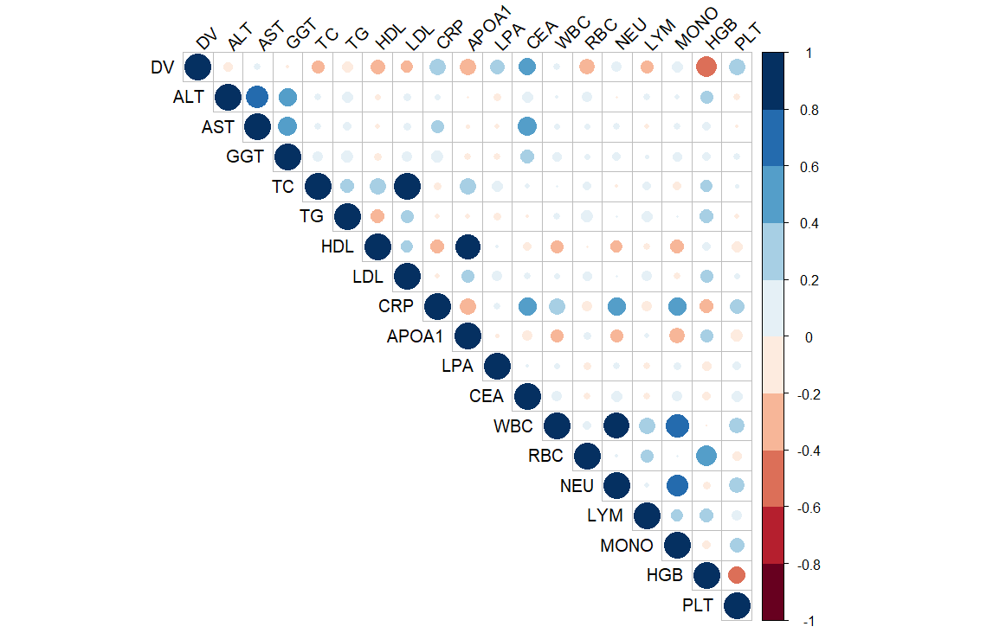

Figure 1.1 Correlation Matrix

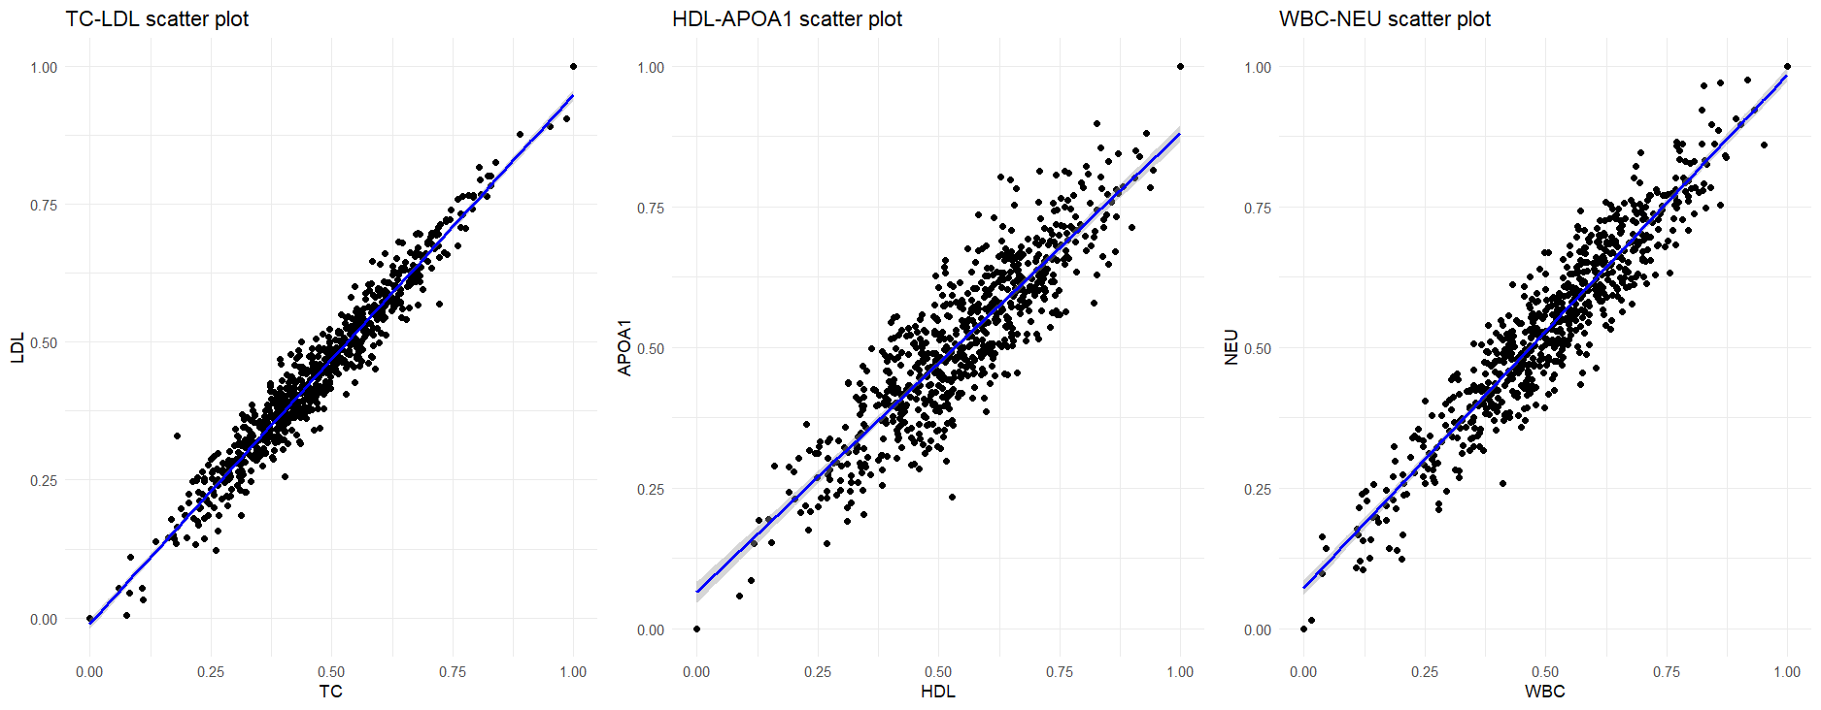

Figure 1.2 Linear Relationship

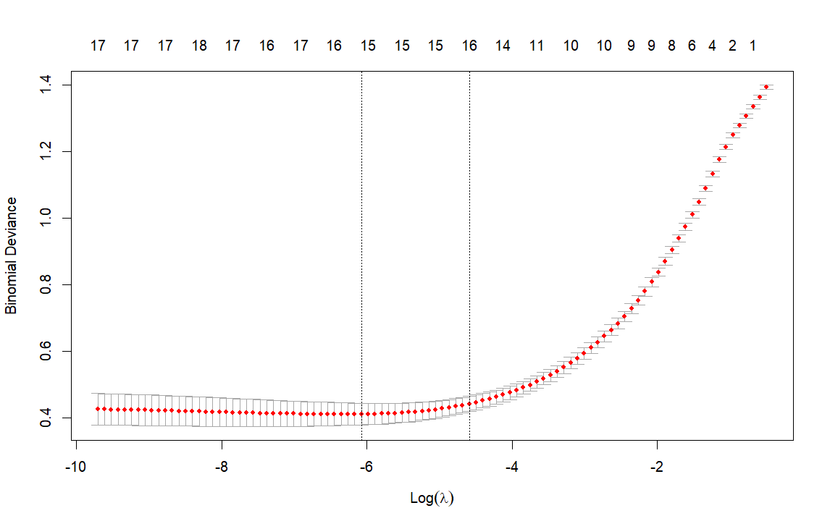

Figure 1.3 Cross Validation of Elastic Net

We used the package ‘glmnet’ to implement Elastic Net. Figure 1.3 shows how does it find the best lambda value, which is 0.002294098 in this case. After Regression, the coefficients are shown in Table 1.1. It obvious that the regression deleted the features GGT, TC and CRP, and gave other features weight coefficients. Using this result, we constructed a linear model to do the binary classification task.

Table 1.1 Coefficients of Elastic Net

|  |  |
| --- | --- |
| Feature | Coefficient |
| Intercept | 0.1096291 |
| ALT | -0.2006522 |
| AST | -0.3814531 |
| GGT | 0 |
| TC | 0 |
| TG | -0.1771271 |
| HDL | -1.2138212 |
| LDL | -0.8198785 |
| CRP | 0 |
| APOA1 | -0.1409414 |
| LPA | 1.6898303 |
| CEA | 2.5336365 |
| WBC | -0.1975546 |
| RBC | 0.1212922 |
| NEU | -0.2468349 |
| LYM | -0.8486259 |
| MONO | 0.2116491 |
| HGB | -2.5728811 |
| PLT | 0.7236508 |

1.2 Diagnose Model Performance.

We calculated several Evaluation Metrics of the prediction of our model and compared them with the prediction of the linear model without feature selection. Table 1.2 shows the results, and we can see that with Elastic Net, all the Metrics of the linear model increased.

Table 1.2 Evaluation Metrics of the prediction (transform threshold is 0.5)

|  |  |  |
| --- | --- | --- |
| Metrics | Before Elastic Net | After Elastic Net |
| Accuracy | 0.8832 | 0.9112 |
| Precision | 0.8558 | 0.8846 |
| Recall | 0.8990 | 0.9293 |
| F1 | 0.8768 | 0.9064 |

1.3 Threshold Value

In diagnosis, detecting a CRC patient as a healthy person (False Negative) is more costly than detecting a healthy person as a CRC patient (False Positive). So, thresholds may need to be biased to increase the Recall rates to reduce the likelihood of False Negative. To achieve that, we can lower the threshold of the transform fromprobability to binary class. For instance, when we turn the threshold from 0.5 (default) to 0.3, the Recall rate of our model will increase from 0.9293 to 0.9596.

1.4 Clinical Implementation

In clinical implementation, doctors can check the coefficients of the model like the Table 1.1, and they can decide to manually delete a feature by considering other information, and they also can modify the value based on their knowledge, because this model is simple and easy to explain. On the other hand, if we know a certain patient’s information, we can select the data from patients with similar physical conditions to increase the performance of the model. This may involve privacy risk, so the hospitals need to consider of it and develop a reasonable system to protect the data.

**Task 2**

1. Analyze trends in CRC stage

We checked the dataset, the number of people in each stage is equal, all are 50. The distributions of Age are different among all the stages. From Table 2.1 and Figure 2.1, we can briefly tell that the trend is people detected in later stage are older. That means when getting older, the probability of late-stage detection increases. For others, the values are shown in Table 2.2 ~ 2.4 and Figure 2.2 ~ 2.4. We applied Chi-square tests for these categorical variables. And we concluded that All the three variables have statistically significant association with the stage.

Table 2.1 Age distribution by Stage

|  |  |  |  |  |
| --- | --- | --- | --- | --- |
| Stage | Mean Age | SD Age | Min Age | Max Age |
| 1 | 26.1 | 3.78 | 21 | 37 |
| 2 | 29.4 | 3.56 | 22 | 37 |
| 3 | 31.9 | 3.77 | 23 | 39 |
| 4 | 36.0 | 3.78 | 28 | 43 |

Figure 2.1 Age distribution by Stage

Regarding racial distribution, we found that the sample primarily consists of White individuals. We noted that ethnic minorities (Black and Asian populations) appear to have a higher proportion of late-stage diagnoses. Concerning the impact of lifestyle, we discovered that individuals living alone are more likely to receive late-stage diagnoses compared to those with partners. We believe this may be related to Mutual care between partners. In terms of tumor location characteristics, we observed that rectal cancer cases show a relatively high proportion of late-stage diagnoses. We found that right-sided colon cancers have a slightly better early detection rate compared to left-sided colon cancers.

Table 2.2 Stage distribution by Lifestyle

|  |  |  |
| --- | --- | --- |
| Stage | Alone | Partnered |
| 1 | 20 | 30 |
| 2 | 21 | 29 |
| 3 | 27 | 23 |
| 4 | 29 | 21 |

Figure 2.2 Stage distribution by Lifestyle

Table 2.3 Stage distribution by Ethnicity

|  |  |  |  |
| --- | --- | --- | --- |
| Stage | Asian | Black | White |
| 1 | 1 | 9 | 40 |
| 2 | 3 | 6 | 41 |
| 3 | 4 | 9 | 37 |
| 4 | 5 | 12 | 33 |

Figure 2.3 Stage distribution by Ethnicity

Table 2.4 Stage distribution by Site

|  |  |  |  |
| --- | --- | --- | --- |
| Stage | Left | Rectum | Right |
| 1 | 10 | 14 | 26 |
| 2 | 21 | 13 | 16 |
| 3 | 19 | 14 | 17 |
| 4 | 16 | 16 | 18 |

Figure 2.4 Stage distribution by Site

2. Recommendations based on the data analysis

According to the Age impact, we recommend strengthening early screening efforts for CRC and lowering the screening starting age to 20-25 years old. Besides, we strongly recommend to regularly visit young people for diagnosis, especially for those living alone. In terms of public health strategies, we advocate developing targeted health education for ethnic minorities and considering racial differences in healthcare resource allocation. For researchers, we suggest conducting in-depth research on disease mechanisms in young populations and different mechanisms among different cancer site.

**Task 3**

First, plot the change in log concentration over time by sex as a classification, observing its trend and linearity, as shown in the Figure3.1.

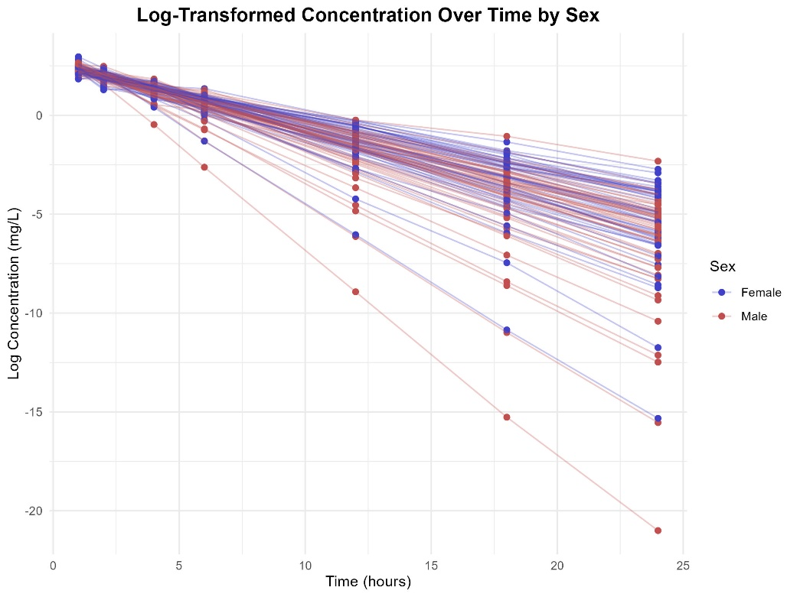

Figure3.1 Log Concentration Over Time

Through observation, it is evident that the linearity is significant. Furthermore, we use a linear mixed-effects model to analyze and evaluate the impact of various variables on the concentration-time change.

# Build the mixed-effects model with Time, BW, SEX, and AGE as fixed effects, considering random slopes and intercepts

model <- lmer(log_DV ~ Time + Bw + Sex + Age + (1 + Time | ID), data = data)

# Display model summary to examine the significance of each fixed effect

summary(model)

This code constructs a linear mixed-effects model that incorporates both fixed and random effects, where Time, BW (body weight), SEX (gender), and AGE (age) are treated as fixed effects to assess their impact on log concentration (log_DV). Additionally, ID (each patient) is included as a random effect, allowing for individual variability in concentration changes and enhancing the model’s fit by accounting for patient-specific deviations in log concentration trends.

Linear mixed model fit by REML [‘lmerMod’]

Formula: log_DV ~ Time + Bw + Sex + Age + (1 + Time | ID)

Data: data

REML criterion at convergence: 176.9

Scaled residuals:

Min 1Q Median 3Q Max

-3.8127 -0.5423 0.0664 0.5912 2.6855

Random effects:

Groups Name Variance Std.Dev. Corr

ID (Intercept) 0.06575 0.2564

Time 0.01596 0.1263 -0.91

Residual 0.02526 0.1589

Number of obs: 700, groups: ID, 100

Fixed effects:

Estimate Std. Error t value

(Intercept) 2.914043 0.326073 8.937

Time -0.364388 0.012654 -28.796

Bw -0.004297 0.003186 -1.349

Sex 0.019690 0.031036 0.634

Age 0.002266 0.003490 0.649

Correlation of Fixed Effects:

(Intr) Time Bw Sex

Time -0.072

Bw -0.769 0.000

Sex 0.345 0.000 -0.460

Age -0.617 0.000 -0.019 -0.041

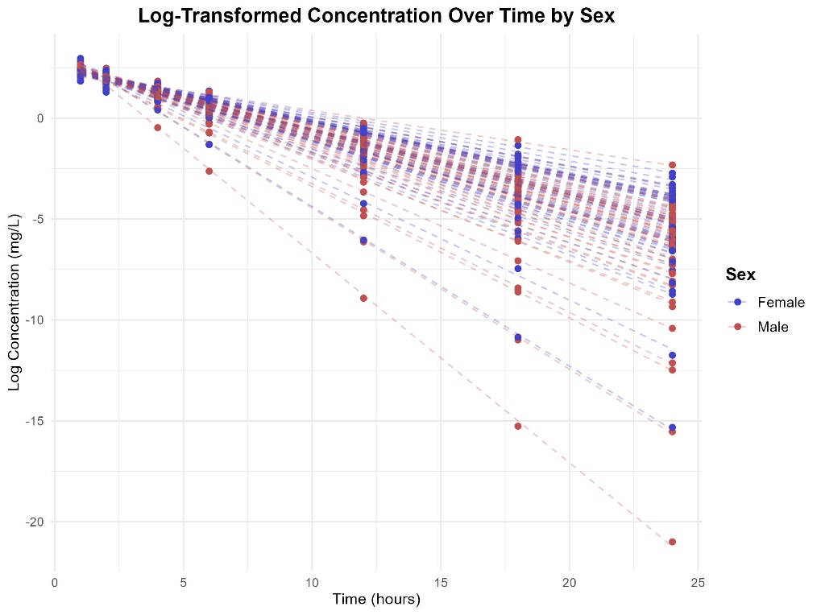

Figure3.2 Fitted Log-Concentration Model

The analysis of the linear mixed-effects model reveals that time has a significant impact on changes in log-transformed concentration. The fixed effects show an estimate of −0.36438 for time, with high statistical significance (p < 0.001), indicating that concentration decreases significantly over time. In contrast, the effects of body weight, sex, and age are not significant (p > 0.05), suggesting that their direct influence on concentration changes is minimal or potentially obscured by other factors. Additionally, the intercept estimate of 2.914043 reflects a relatively high average log concentration at the initial time point.

The random effects highlight substantial variability in concentration change patterns across individuals. There is a strong negative correlation (−0.91) between the random effects of the intercept and time, indicating that individuals with higher baseline concentrations tend to have lower slopes over time. Variance analysis shows that the variance of the intercept is 0.06575, while that of time is 0.01596, suggesting that inter-individual differences are primarily manifested in baseline levels, with smaller variability in time effects. The residual variance of 0.02526 indicates that the model fits the data well, with minimal unexplained error.

In conclusion, the model effectively captures inter-individual differences through random effects and identifies time as the primary driver of concentration changes. This demonstrates the model’s robustness in characterizing the relationship between time and concentration, while also suggesting that the effects of other variables may require further investigation to uncover their potential roles.

**Task 4**

For this task, we used the built-in R libraries **survival** and **survminer**.

library(survival)

library(survminer)

The survival package in R is a fundamental tool for survival analysis, providing functions for the estimation and modeling of survival data. It supports Kaplan-Meier estimation, Cox proportional hazards models, and parametric survival models (e.g., Weibull). The package is widely used for analyzing time-to-event data, particularly in clinical research and epidemiology. Key functions include Surv() for creating survival objects, survfit() for estimating survival curves, and coxph() for fitting Cox regression models.

The survminer package is an extension designed for visualizing survival analysis results. It integrates well with the survival package and offers various functions for creating high-quality survival plots, such as Kaplan-Meier curves and Cox model diagnostics. The ggsurvplot() function is a key tool for visualizing survival curves, and other functions help assess the proportional hazards assumption and generate diagnostic plots for survival models.

data <- read.csv("data_task4.csv")

surv_obj <- Surv(time = data$Time, event = data$Status)

surv_diff <- survdiff(surv_obj ~ Group, data = data)

print(surv_diff)

cox_model <- coxph(surv_obj ~ Group, data = data)

summary(cox_model)

fit <- survfit(surv_obj ~ Group, data = data)

ggsurvplot(fit, data = data, pval = TRUE,

           xlab = "Time (Months)", ylab = "Survival Probability",

           legend.labs = c("Control", "Treatment"),

           legend.title = "Group")

Then, we obtain the following results.

Call:

survdiff(formula = surv_obj ~ Group, data = data)

N Observed Expected (O-E)^2/E (O-E)^2/V

Group=Control 100 73 90.6 3.43 9.53

Group=Treatment 100 72 54.4 5.72 9.53

Chisq= 9.5 on 1 degrees of freedom, p= 0.002

Call:

coxph(formula = surv_obj ~ Group, data = data)

n= 200, number of events= 145

coef exp(coef) se(coef) z Pr(>|z|)

GroupTreatment 0.5204 1.6828 0.1703 3.055 0.00225 **

---

Signif. codes: 0 ‘***’ 0.001 ‘**’ 0.01 ‘*’ 0.05 ‘.’ 0.1 ‘ ‘ 1

exp(coef) exp(-coef) lower .95 upper .95

GroupTreatment 1.683 0.5943 1.205 2.35

Concordance= 0.573 (se = 0.023 )

Likelihood ratio test= 9.26 on 1 df, p=0.002

Wald test = 9.34 on 1 df, p=0.002

Score (logrank) test = 9.53 on 1 df, p=0.002

The survival analysis results show a statistically significant difference in survival between the Control and Treatment groups. The log-rank test (Chi-square = 9.5, p = 0.002) indicates that the two groups exhibit significantly different survival profiles.

In the Cox proportional hazards model, the Hazard Ratio (HR) is a key metric that quantifies the relative risk of death for individuals in the treatment group compared to those in the control group. Specifically, HR = 1.683 indicates that the treatment group has a 68.3% higher risk of death compared to the control group, and this result is statistically significant (p = 0.00225). The 95% Confidence Interval (CI) of [1.205, 2.350] confirms that this finding is reliable, as the interval does not include 1, suggesting a statistically significant increased risk in the treatment group.

The Concordance Index (C-index), which measures the model’s ability to rank individuals based on their survival times correctly, is 0.573. This suggests that the predictive ability of the Cox model is moderate, slightly better than random chance. While the model can rank individuals by their survival probabilities, its practical predictive performance may be limited due to factors such as sample size, covariate selection, and data variability.

Further analysis reveals that the survival curves support these findings. The control group consistently shows better survival rates compared to the treatment group. For example, at 12 months, the survival rate for the control group is approximately 70%, while the treatment group’s rate is only 55%. These observations align with the Cox model’s conclusion that the treatment group faces a higher risk of death.

While the experimental treatment may have other effects, its impact on survival is detrimental, as it is associated with an increased risk of death compared to the control group. This highlights the need for a thorough reassessment of the treatment’s safety and efficacy in future clinical trials.

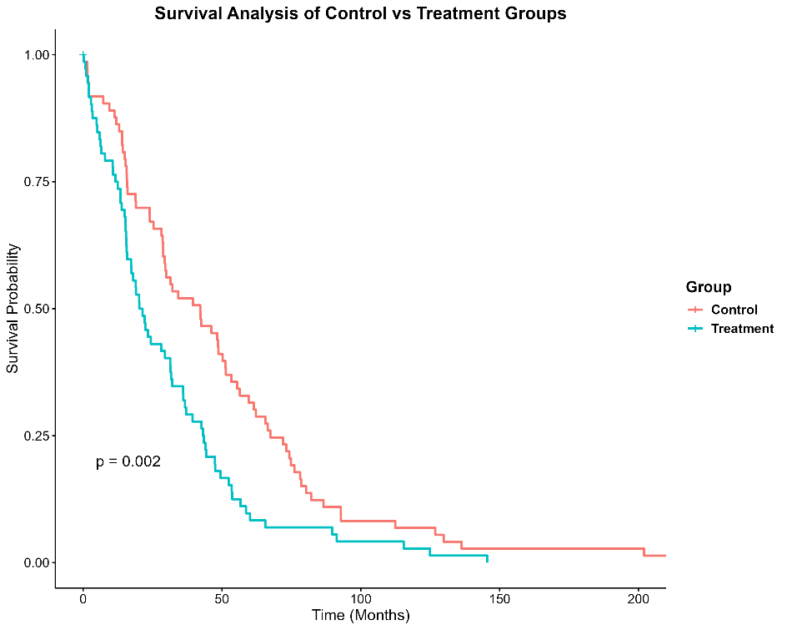

Figure 4.1 Survival Analysis of Control and Treatment Group

Despite the significant survival difference observed in the log-rank test, the Cox model indicates that the Treatment group has a higher risk of death. This suggests that the experimental treatment may not improve overall survival compared to the control. As shown in the Figure 4.1, the Control group has better survival rates at the same time points, with a significantly lower risk of death. In contrast, the Treatment group exhibits a higher risk of death. This result suggests that the experimental treatment may not have significantly improved patient survival, and it may even be worse than the Control group.