SECURECHAT: A Secure Messaging Application with TLS, Authentication, and Anti-Replay

Programming and Algorithms 2 — Coursework 2 (Individual)
Student: Basanta Lamichhane Poudel (GitHub: DEcode-001)

Acknowledgements
I am grateful to my module leader and peers for guidance and feedback throughout this project.

Abstract
This project implements a secure, multi-threaded localhost messaging system with TLS transport, certificate pinning, user authentication (salted PBKDF2), anti-replay counters, and token-bucket rate limiting. A CLI and a simple Tkinter GUI are provided, alongside unit tests, a Gantt timeline, and architecture diagrams. Results show successful authenticated messaging, replay rejection, and rate limiting under load. Future work includes moving to mTLS, certificate lifecycle automation, and group message encryption at rest.

Table of Contents
[Generate TOC via Word References]

Table of Figures
Figure 1: Concept Diagram
Figure 2: Runtime Architecture
Figure 3: Coursework Execution Timeline (Gantt)

List of Abbreviations
TLS: Transport Layer Security
PBKDF2: Password-Based Key Derivation Function 2
MITM: Man-In-The-Middle
GUI: Graphical User Interface
CLI: Command Line Interface

Chapter 1: Introduction
Background and Motivation ...
Problem Statement and Scope ...
Objectives ...

Chapter 2: Literature Review
Discuss related work on TLS, certificate pinning, PBKDF2, token-bucket rate limiting. [Add APA 7].

Chapter 3: Methodology

3.1 Design
Concept Diagram and Runtime Architecture are included below.
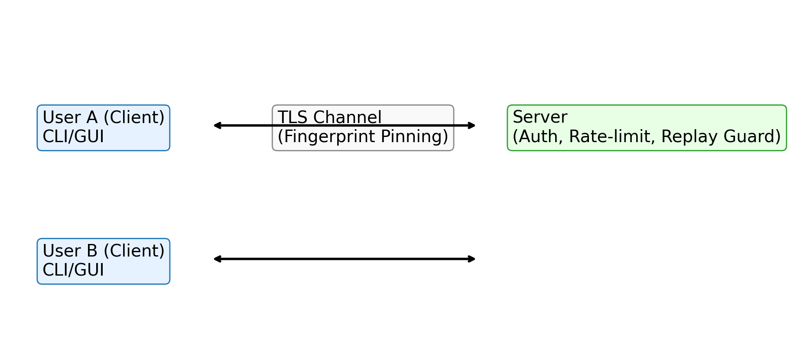
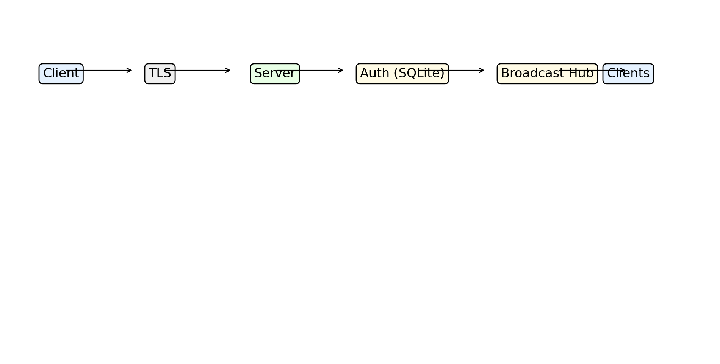
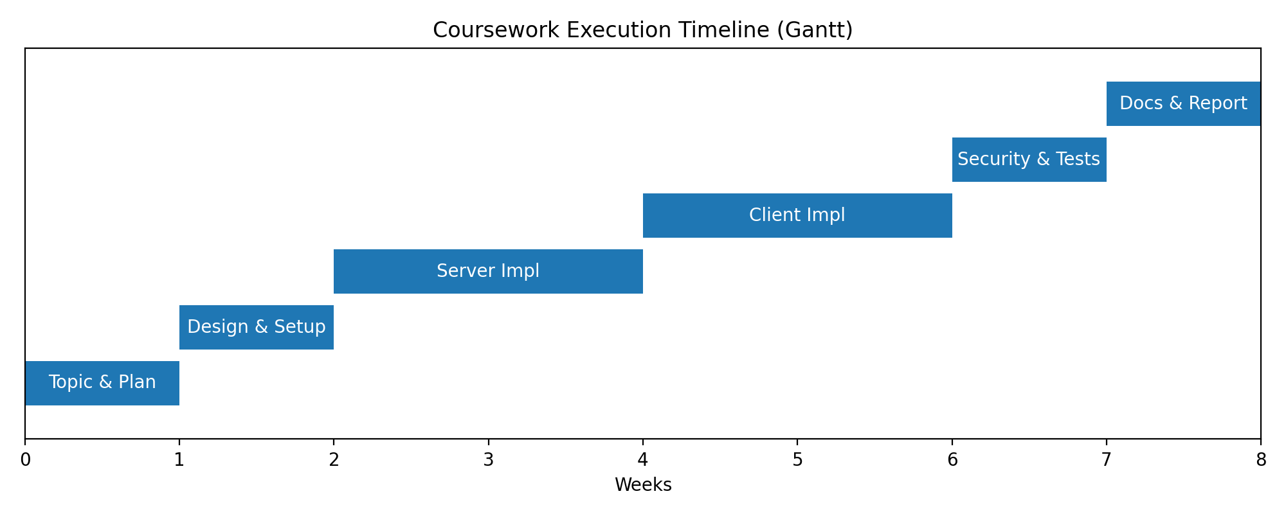

3.2 Algorithm
1) Server start; load TLS keypair; listen on TCP. 2) Client connects via TLS and pins fingerprint. 3) Client sends auth frame; server verifies salted hash in SQLite. 4) On success, client sends chat messages with monotonically increasing counters. 5) Server enforces counter and rate limits, broadcasting messages to others. 6) Sessions end on disconnect.

3.3 Tools and Technologies
Python 3.x (ssl, sqlite3, tkinter), SQLite, python-docx (report), matplotlib (diagrams, Gantt).

3.4 Execution Timeline (Gantt Chart)
See Figure 3.

3.5 Procedure

3.5.1 Experimental Setup
1) Install Python 3.x on Windows. 2) Generate self-signed cert via scripts/generate_cert.ps1. 3) Initialize DB and users. 4) Run server and clients per README. 5) Use run_demo.ps1 to auto-produce logs and screenshots.

3.5.2 Code Explanation
Key modules: src/server.py (TLS server, auth, replay, rate limiting), src/client_cli.py and src/client_gui.py (clients with pinning), src/common.py (PBKDF2, token bucket, message framing).

Chapter 4: Results and Analysis
Screenshots: see artifacts/ss_server.log.png, ss_client1.log.png, ss_client2.log.png. Results demonstrate successful authentication, chat broadcast, rate limiting under burst, and replay rejection when counters are manipulated (testable via custom inputs).

Chapter 5: Conclusion and Future Improvement
The system meets coursework objectives with a working TLS transport, authentication, anti-replay, and DoS mitigation. Future improvements: mutual TLS, rotating certificates and pinned fingerprints, message encryption at rest, and richer GUI with accessibility features.

References
[Insert APA 7 references here]

Appendix
Full code listings and additional screenshots.

