NAME :- Devam Thakar

Roll No. :- FPMCA053A
Subject :- AI/ML
Practical 1 :- Prolog

Q. The Background Facts:
There are four men: Ram, Dev, Suresh, and Raj.
There are four women: Sita, Sheetal, Jaya, and Shanti.
Ram and Sita are the parents of both Dev and Sheetal.
Raj and Shanti are the parents of Sita, Jaya, and Suresh.
The Task: Based strictly on the facts provided above, create appropriate rules to identify the following:
Who is the Uncle of Dev?
Who is the Aunt of Sheetal?
Explain the biological relationship between Raj and Dev (even though a specific rule for it isn't in the code, use the parent facts to trace it).
Code :-
male(ram).
male(dev).
male(suresh).
male(raj).

female(sita).
female(sheetal).
female(jaya).
female(shanti).

parent(ram, dev).
parent(ram, sheetal).
parent(sita, dev).
parent(sita, sheetal).
parent(raj, sita).
parent(raj, jaya).
parent(raj, suresh).
parent(shanti, sita).
parent(shanti, jaya).
parent(shanti, suresh).
sibling(X, Y) :-
parent(P, X),
parent(P, Y),
X \= Y.
aunt(A, N) :-
female(A),
sibling(A, P),
parent(P, N).
uncle(U, N) :-
male(U),
sibling(U, P),
parent(P, N).
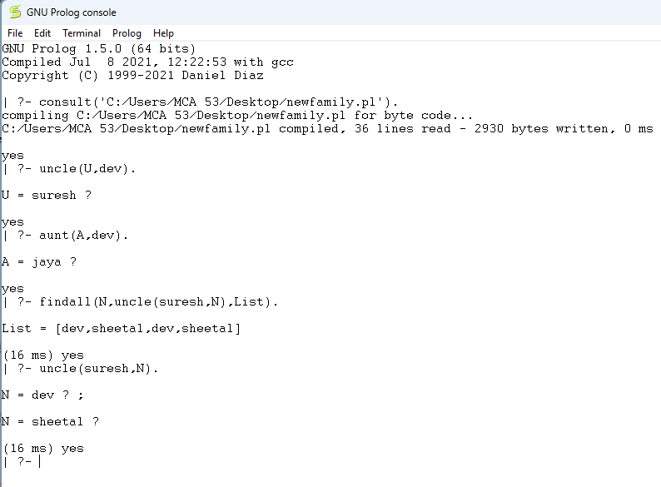
Q. Find factorial and greatest number using Prolog
Code:-
factorial(0, 1).
factorial(N, Result) :-
N > 0,
NextN is N - 1,
factorial(NextN, SubResult),
Result is N * SubResult.

greatest(A,B,Max):-
A >= B -> Max = A; Max = B.
Output :-
