Name : Devam Thakar
Roll : FPMCA053A
Subject : DevOps
Practical 3

Create a file in your code editor index.html
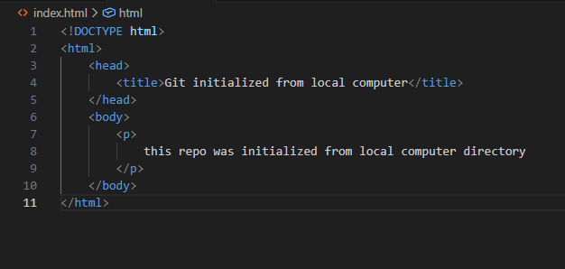
Step 1: Initialize and Local Commit
First, you turned your local folder into a Git repository and saved your progress.
Bash
git init .
git add .
git commit -m "Initial commit from local computer"
Step 2: Link to GitHub (Remote)
Create a github repo with readme.md file on github.
Bash
# Add the remote URL
git remote add origin https://github.com/DEvHavker/local-git-repo.git

# Verify the connection
git remote -v
Step 3: Push to GitHub
You pushed your local master branch to GitHub and set it as the default upstream.
Bash
git push -u origin master
Step 4: Synchronizing Branches
GitHub often creates a main branch by default, while local Git often uses master. You fetched the remote data and attempted to reconcile them.
Bash
# Update local knowledge of what's on GitHub
git fetch origin

# Merge the remote main branch into your current branch
git merge origin/main --allow-unrelated-histories
Screenshots :
