
Design Pack
With conceptual, logical and physical examples
Month 201X
Created by:
Contents
Document purpose and use 3
1 Conceptual design 6
1.1 Problem statement / service description 6
1.2 Goals and drivers 6
1.3 Stakeholder / location and actor viewpoints 7
1.4 Options appraisal 8
1.5 Recommended option conceptual design 9
2 Logical design 11
2.1 High-level solution concept view 11
2.2 Business context viewpoints 12
2.3 Capability to application map 13
2.4 Data architecture 14
2.5 Design requirements, assumptions, constraints, risks and issues 15
3 Physical design 17
3.1 High Level Design (HLD) 17
3.2 API design 20
3.3 Infrastructure / network topology 21
3.4 Disaster recovery, logging, audit and error handling 23
3.5 Service management and support 23
3.6 Architectural / design decisions 24
3.7 Document references 24
4 Annexes 25
4.1 Useful references 25
4.2 Glossary of terms 26
4.3 Document control 27

Document purpose and use
This document is published by Technology Directorate’s Architecture team and provides the basis for solution architecture and design. You should use this in conjunction with guidance in the Architecture wiki (specifically the how to create a design pack page) and from your Architecture Partner. Examples are available in the architecture repository.
A design pack provides an overview of the scope, deliverables and complexities of implementing change in an IT system landscape. It should provide enough information for all interested or required parties to understand the changes needed and any new or improved functionality which the change will deliver. It should be useful in any delivery context, be that a digital, data or technology service.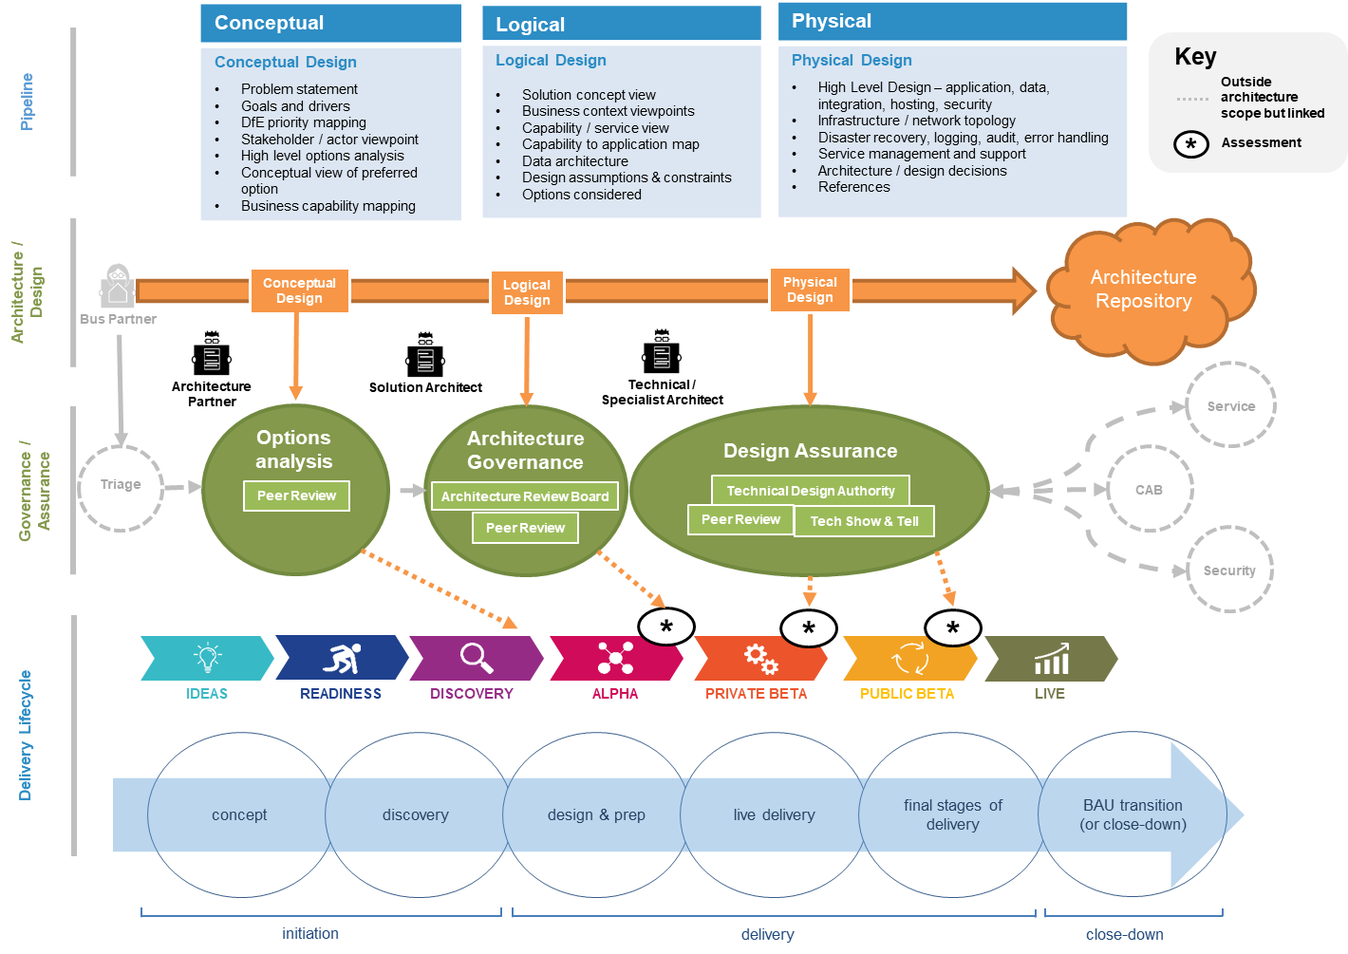
The design pack is represented by the orange arrow on the diagram, with different stages of delivery broadly in line with delivery phases. Above all, a design pack should move the design process forward, enabling effective review and assurance of impending change. It should be a living, breathing artefact, that is continually updated by the project or service team, in collaboration with an Architecture Partner.
It is important to remember that this document should be used as a template and adapted as necessary. Only certain views are necessary in order to ensure effective governance and assurance against IT strategy and technical standards.
You must discuss the development of a design pack with your Architecture Partner and adapt appropriately.
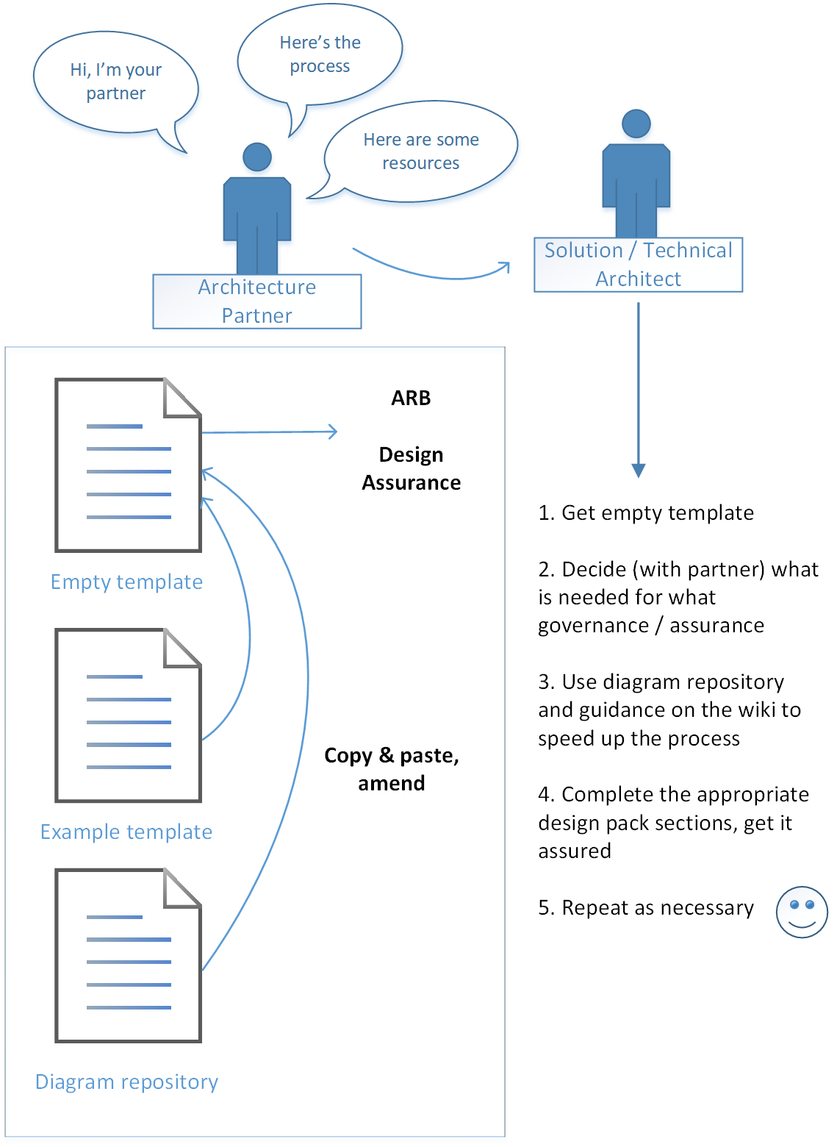
The picture above provides a visual representation of the design pack completion process.
There are 3 main sections – Conceptual, Logical and Physical design. The table below provides a guide to what sections are most relevant at various stages of the delivery lifecycle and associated governance.

 |  |  |  |  | Governance / Assurance
Section |  | Why | Peer review |  | ARB | Service Assessment | Design Assurance
Conceptual design |  | Provide a high level view of options analysis. Provide an indication of architectural changes to deliver the goals | Mandatory |  | N/A | N/A | N/A
Logical design |  | Provide an indication of architectural changes to deliver the objectives logical level. This should include functional composition, component breakdown and logical data models. | Mandatory:  Peer review/ ARB |  |  | Service assessment team determines if this mandatory by alpha
Physical Design |  | Provide a view of the solution detail and implementation at a physical level. Includes component or application interactions, integrations, process and data flow, security and identity and access implementation. |  |  |  | Service assessment team determines if this mandatory by private beta | Mandatory  TDA; Tech show & tell; Peer review

Remember to delete the ‘document purpose and use’ section once you’ve completed your design pack.

Conceptual design

Problem statement / service description
Provide a brief description of the service, programme or project and problem that needs to be solved. This may include or link into the goals of the programme, project or service, categorised by:
- Business capabilities
- Business service and process
- Organisation
- Technology
- User needs

Goals and drivers
This viewpoint is used to communicate the motivations for change, what the main principles, constraints, drivers are and how they drive towards meeting the stakeholder goals / user need.
Figure 1 - Example goals and drivers viewpoint

Stakeholder / location and actor viewpoints
The stakeholder / location viewpoint articulates who the key stakeholders are at a high level. Use it to check that the necessary parties have been engaged in user research and requirements gathering. It is often necessary to extend this view to add in goals, drivers and/or stakeholder-to-business context. Examples of how these dimensions can be added to goals and drivers can be seen in example architecture diagrams.
Depending on the project lifecycle it may be more relevant to use a “context diagram” that shows both stakeholders (people) and software systems.
Figure 2- Example stakeholder viewpoint

It may also be helpful to include an actor co-operation view - see the example architecture diagrams.

Options analysis
Describe what options have been considered and what the recommended approach is. Options analysis and conceptual design will be peer reviewed, usually at the end of discovery / start of alpha.
Item | Option 1 Do nothing | Option 2 - Name | Option 3 - Name | Option 4 - Name
Alignment to EA principles | Poor | Sub optimal | Good | Good
Strategic fit | Good | Good | Poor | Good
Fit to requirements
Pros
Cons
Timescale
Year 1 cost
5 Year total cost of ownership
Risk rating
Recommend |  |  |  | 
Figure 3 - Example table of delivery options

Alignment to EA Principles and strategic fit
Provide a brief description of how each option aligns with the DfE EA Principles and the wider technology strategies.

Fit to requirements
Provide high level requirements and if the option can meet these.

Pros and cons
Provide the relative pros and cons of each option and rationale for the recommended option.

Timescales
Provide a conceptual timescale or roadmap for each option.

Costs
Provide indicative costs for each option.
Option | Estimated days | Day rate | Number of users | Monthly charge rate per user | Year 1 estimate | Year 2 estimate | Year 5 estimate
Item 1 |  | £ |  | £ | £ | £ | £
Item 2 |  | £ |  | £ | £ | £ | £
Item 3 |  | £ |  | £ | £ | £ | £
Option 1 indicative total |  | £ |  | £ | £ | £ | £
Figure 4 - Example of an indicative cost model

Benefits and risks
Provide further information on benefits and risks of each option.

Recommendation
Provide a recommendation from all options considered.

Recommended option conceptual design
Provide a brief conceptual design (preferably a diagram) of the recommended option for consideration. This should be peer reviewed.
The conceptul design can be provided using a business capability / service view
The Business Capability Model provides a high level view of departmental capability.The business capabilities / service view provides what business capabilities are impacted by the architectural change being considered. This could be a simple view of business capabilities or a mapping of capabilities to applications / services.
The following example shows how a digital service in a beta phase relates to business capabilities and to a much wider programme of future service deliveries.
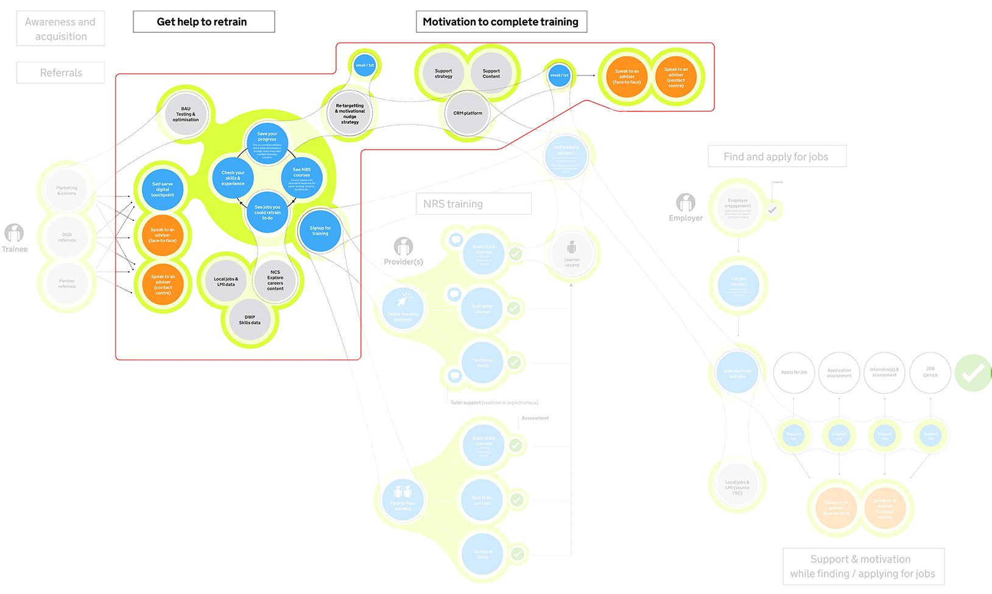
Key
User need

Product Gov. needs to build

Capability Gov.needs to build

Service goal

Sits outside the service

Figure 5 - Example service / capability map

Logical design
Not all views will be relevant in the context of every project / service - discuss with your Architecture Partner what is most appropriate to include.

High-level solution concept view
The solution concept diagram is a high-level view that shows scope and additionally provides a view of impacted parties. It can be articulated in the context of a service, application or any other relevant context. The diagram should show the high level business processes being affected or requested. The context level in the diagram depends on the needs of the service or project. If appropriate, it may be helpful to articulate elements of the as-is solution and transition to new solution concepts.
This view is often helpful to illustrate how a logical concept would be architected end-to-end. It can be helpful to aid understanding for senior or non-technical stakeholders and can be used in procurement engagements to articulate what outcome the department is seeking. This view is often extended as the service and its design matures into logical and physical states.
Figure 6 - Example high-level solution concept view

Business context viewpoints
The business context viewpoint takes the concept view down a level in detail. Two examples are given below of how to articulate a lower level of detail. Neither are mandatory, but if included these should be adapted to suit the context of the conceptual design.
The following example shows how internal and external components are interfaced and how users interact with them:

Figure 7 - Example internal and external component interfaces
The following example shows how applications and services relate to business functions and business objects:
Figure 8 - Example application / service viewpoint

Capability to application map
The business capability to application map is used to understand where capabilities are implemented in applications. This common view is important for any systems / service rationalisation or significant investment decision. It is particularly important where standardisation is a key business goal in order to determine the optimal set of applications.
Figure 9 - Example business capability to application map

Data architecture
This shows the key data involved and their relationships with other data, represented by a high-level Entity Relationship Diagram (ERD) or similar. This will be iterated throughout the delivery lifecycle.
The key questions this view should address are:
- How will the data architecture of the estate be impacted by the project?
- What data related capabilities fall within the scope of the project?
- What data sources (which cover both those within an application and those that are not) are expected to fall within the scope of the project?
It should also address which of the Department for Education’s (DfE) major entities fall within the scope of the service (for example Learner, Provider, Employer, Learning Aim, Qualification, Teacher, Apprenticeship).
The following example shows an ERD that encapsulates the high level data requirements of the solution and their relationships to other data elements:

Figure 10 - Example Entity Relationship Diagram (ERD)

2.5 Design requirements, assumptions, constraints, risks and issues
The purpose of this section is to describe:
- any design assumptions which have been made in developing the proposed solution
- any business or technology constraints that need to be considered which may influence the decisions made when defining the architecture
- any functional / non-functional requirements that significantly impact the architecture or design. A reference to user stories or business requirements is helpful.

You may want to use these example tables:
Ref. | Priority | Status | Summary statement
BR.01 | Must | Assumed
BR.02 | Should | Specified
Figure 11 - Example table of business requirements
Ref. | Priority | Status | Summary statement
FR.01 | Must | Assumed
FR.02 | Should | Specified
Figure 12 - Example table of functional requirements

Ref. | Priority | Status | Summary statement
A.01 | Must | Assumed
A.02 | Should | Specified
Figure 13 - Example table of assumptions
Ref. | Priority | Status | Summary statement
C.01 | Must | Assumed
C.02 | Should | Specified
Figure 14 - Example table of constraints

Ref. | Description | Risk  (H/M/L) | Impact  (H/M/L) | Owner | Mitigation
R.01 |  | H | H
R.02 |  | M | L
Figure 15 - Example table of risks

Ref. | Description
I.01
I.02
Figure 16 - Example table of issues

3 Physical design
You should work with your Architecture Partner to determine which of the following elements are most relevant for your design. It’s useful to include narrative with each diagram, to further explain the design elements.

High Level Design (HLD)
High-level designs can be written from a number of perspectives. Use your best judgement and work with your Architecture Partner to decide which views are most appropriate.
A non-exhaustive list of example perspectives follows.

Application
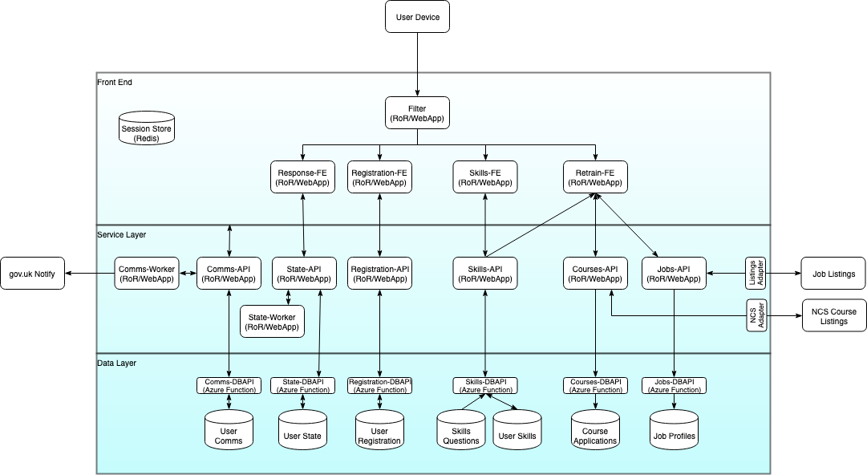

Adaptor
Application
Azure Function
External component
Key
Figure 17 - Example application HLD, with clear layering of technical components and integration of vertical micro-services

Data / physical ERD
Figure 18 - Example of a more detailed level of ERD, showing actual data entities, their parameters and relationships

Integration
If the service / solution integrates with other services / solutions, this needs to be explained clearly. There are a number of different ways to integrate - for example analytical data, transactional, public / internal Application Programming Interfaces (APIs), Secure File Transfer Protocol (sFTP). Any orchestration also needs to be articulated.

Figure 19 - Example clearly illustrates how 3 applications are integrated via an API gateway and an orchestration layer

3.1.4 Hosting
Provide sufficient narrative to describe the selected hosting platform and environments created to support the service. Example environments include, production, pre-production, development, test.
The level of detail needed will differ depending on the service design - from low: Software as a Service (SaaS), through medium: Platform as a Service (PaaS), to high: Infrastructure as a Service (IaaS).
Hosting vendor, geographic region(s) and logical / billing structures selected (subscriptions / tenancies) should all be included here. These can be visually represented in this section, or incorporated into the infrastructure view(s) below.

3.1.5 Security
The example below shows a security view, which should address what security controls are being proposed and how they protect the service and associated information assets. Details should be included on data encryption (at rest and in transit), plus appropriate identity and access management – see separate section below.

Figure 20 - Example showing a physical design focused on security implementation

3.1.5.1 Identity and Access Management
A specific view (and narrative) explaining how the solution implements identity and access management. Designs should follow standard DfE IdAM patterns and use strategic platforms wherever possible.

API design
Where appropriate, integration should be loosely coupled. The strategic default should be RESTful APIs published and managed via the DfE API gateway, more commonly known as the Enterprise API Management (EAPIM) service hosted on the “Cloud Infrastructure Platform (CIP)” Azure tenancy.
Designs should follow standard API integration patterns. The API design viewpoint below articulates the high level design of any APIs within the solution - use it to:

- Check that APIs are aligned with the strategy and standards
- Show that APIs have been designed in a way that implements a gateway pattern
- Show that APIs are published to the correct instance of the DfE API management platform
- Demonstrate that all APIs are implemented in a way that makes them re-usable and secure (for example, how they adopt the layered approach as illustrated in the DfE API strategy).

Figure 21 - Example showing DfE Integrration Patterns: Back Ends for Frnt Ends (Decomposition of API Gateway pattern)

Infrastructure / network topology
For infrastructure / network related projects or services, this section is mandatory and forms the majority of the physical design. Discuss this with your Architecture Partner, if you are unsure.

The examples below depict a set of detailed views of infrastructure artefacts considering connectivity, infrastructure, performance and monitoring, in order to explain the infrastructure solution from an implementation perspective.
Figure 22 - Example showing how application components relate to a network / firewall configuration
Figure 23 - Example showing a low-level network diagram (most useful for network projects)

Disaster recovery, logging, audit and error handling
This section should confirm how the design ensures the solution is resilient and robust, including descriptions of how:
- disaster recovery will take place and timescales for this
- the design addresses event logging, audit and alerting

Service management and support
Describe how the service, application(s) and components will be managed and supported. If necessary, specify the anticipated support changes throughout the delivery lifecycle, for example alpha phase will be supported by the development team, post beta will be supported by DfE DevOps.

This section may also contain information on how the service meets the accessibility needs of its users.

Architectural / design decisions
Date | Decision description | Options and outcomes
 | For example, IaaS over PaaS | For example considered IaaS, PaaS, SaaS options, IaaS selected for segregation of sensitive data and expediency.

Document references
Where documentation already exists, provide links in the table below, or provide a summary of the scope of this document.
Document | Link
For example, Project Initiation Documentation (or equivalent)
For example, project mandate
For example, stakeholder map
For example, project backlog / user stories
For example, external references

Annexes

Useful references
- DfE Enterprise Architecture Principles
- DfE Business Capability Model
- DfE architecture repository
- Example architecture diagrams
- API Strategy and Integration patterns
- DfE IdAM strategy and patterns
- DfE technical standards
- GDS Technology Code of Practice
- DfE technology service offer
- Reference Non-Functional Requirement (NFRs)
- Departmental Security Assurance Model (DSAM) process
- Departmental security architecture principles
- Service Management processes

Glossary of terms
- Application Programming Interface (API) - a set of functions and procedures allowing the creation of applications that access the features or data of an operating system, application, or other service
- Cloud Infrastructure Platform (CIP) - refers to the hardware and software components -- such as servers, storage, a network and virtualization software -- that are needed to support the computing requirements of a cloud computing model.
- Entity Relationship Diagram (ERD) - a snapshot of data structures. An ERD shows entities (tables) in a database and relationships between tables within that database
- High Level Design (HLD) – explains the architecture that would be used for developing a solution, providing an overview of an entire system, identifying the main components that would be developed for the solution, product(s) and their interfaces. In contrast, low-level design further exposes the logical detailed design of each of these elements for technical implementers.
- Identity and Access Management (IDaM) - is the combination of technical systems, policies and processes that create, define, and govern the utilization, and safeguarding of identity information, as well as managing the relationship between an entity, and the resources to which access is needed
- Infrastructure as a Services (IaaS) - is a form of cloud computing that provides virtualized computing resources over the internet.
- Platform as a Service (PaaS) - is a complete development and deployment environment in the cloud, with resources that enable you to deliver everything from simple cloud-based apps to sophisticated, cloud-enabled enterprise applications
- RESTful API - is an API that uses HTTP requests to GET, PUT, POST and DELETE data.
- Secure File Transfer Protocol (sFTP) - a network protocol used for secure file transfer over secure shell
- Software as a Service (SaaS) - a software licensing and delivery model in which software is licensed on a subscription basis and is centrally hosted

Document control

Expiry or review date
We will review this design pack [quarterly/yearly/upon significant design change].

Version control
Version | Date issued | Brief summary of change | Name
2 | 02/07/2019 | High level options analysis added | Monica Beaton
3 | 01/10/2019 | Conceptual design added | Monica Beaton

Document approval
Name | Role | Date

