1. 16–17 year old with no location
Given a 16–17 year old wants to see what courses exist
When they skip the location
And enter “maths” and “computing” as interests
And select “Level 1 or 2 (GCSEs)”
And confirm they are 16–17
Then the search results should show entry-level relevant courses and apprenticeships, not degree programmes.
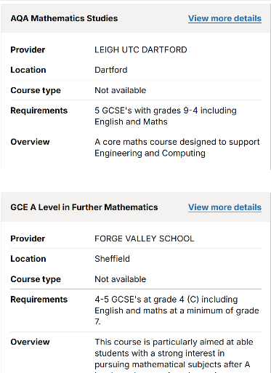
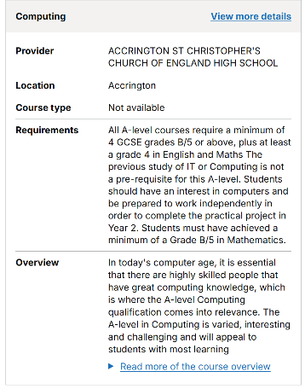
Results
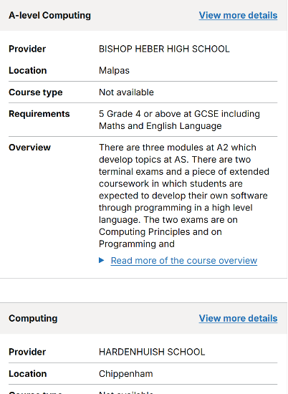

Comments
Pass – The results provided are relevant and appropriately matched to the user’s needs. However, on page 4 there is one course that appears out of place: Uniformed Public Services Level 2 First Certificate. Additionally, no apprenticeship results were returned on the results page.

2. 16–17 unsure what they want
Given a young person doesn’t know what to study
When they skip location and leave all interests blank
And select “Get skills and experience”
And confirm age 16–17
Then they should see general foundation and basic skills options, not random high-level or unrelated courses.

Results
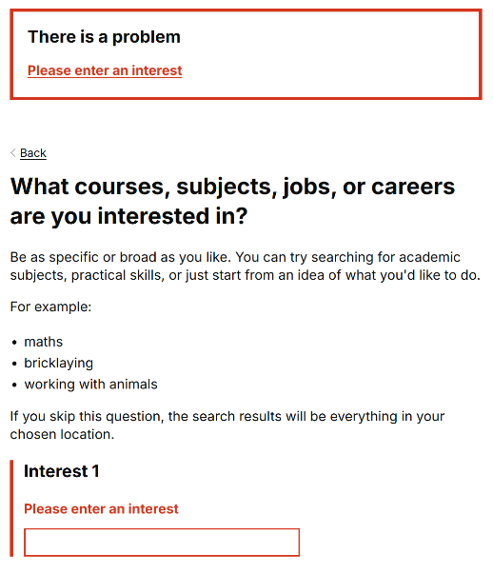

Comments
Pass- If a user does not enter a location the user cannot move past the interest page as they would need to enter at least one. So, this is a pass as the page is supposed to prompt the user to enter an interest.

3. 17-year-old with broad interests
Given a young person wants something related to “helping people”
When they enter “helping people, children” as interests
And select all qualification levels
And confirm age 16–17
Then the results should prioritise realistic Level 3 and early-career courses, not over-rank Level 7 degrees.
Results
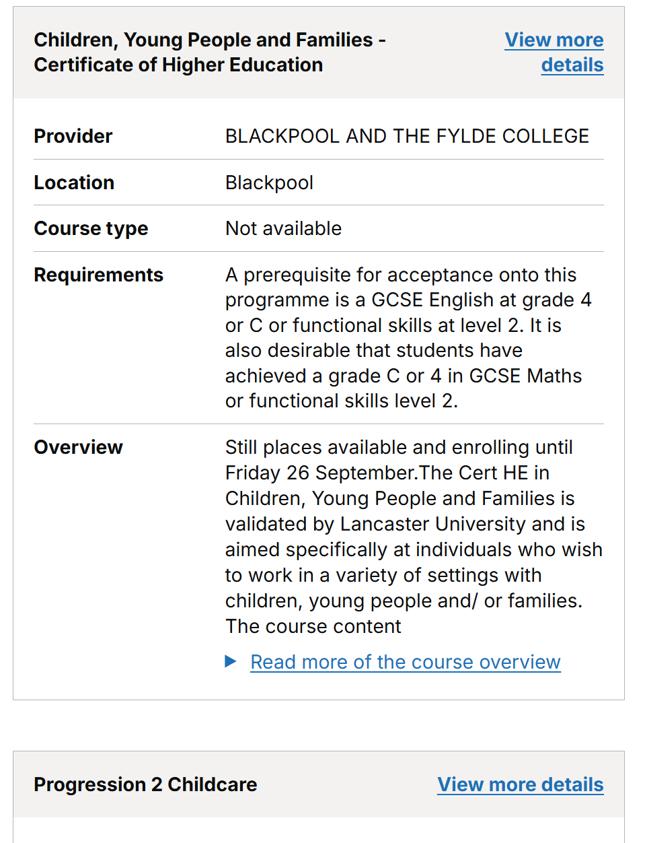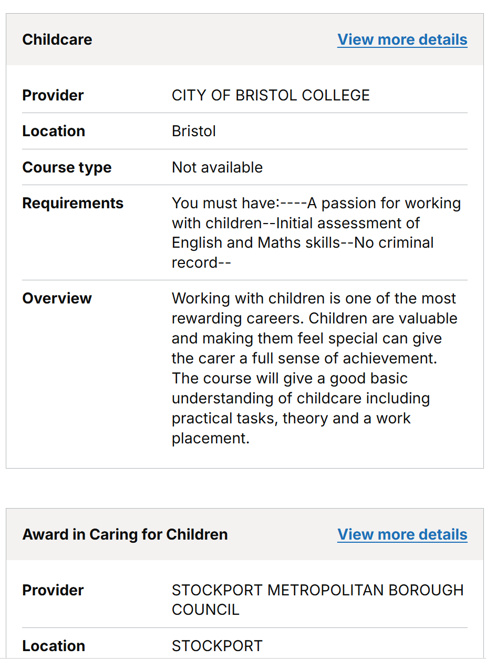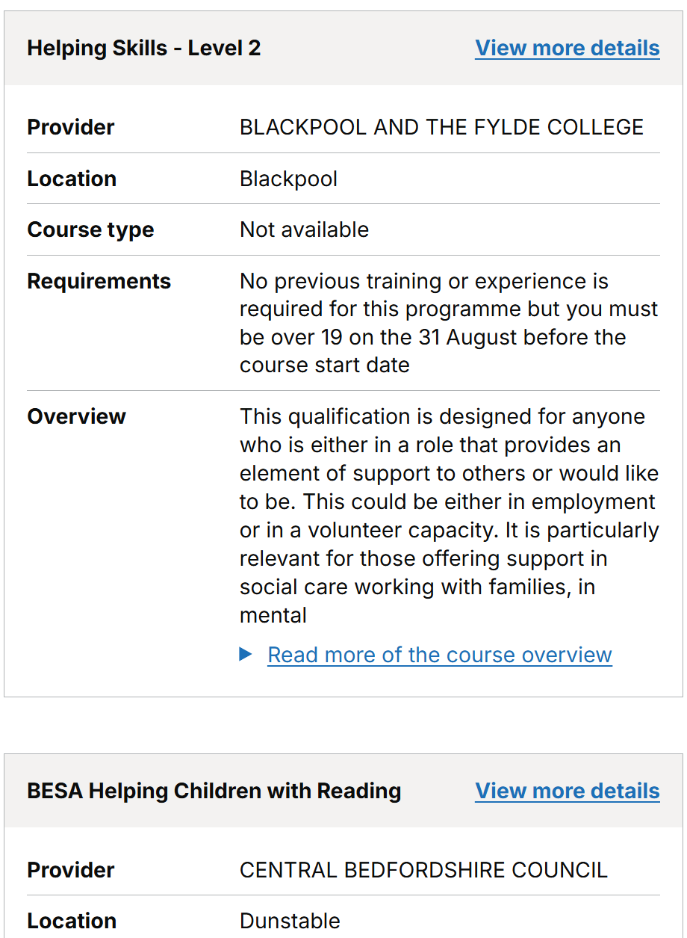
Comments
Pass- The results show entry level and course up to level 3, the results that are provided are relevant to what the user has inputted as their interests. Level 7 degrees has not appeared in the results

4. 18-year-old resitting GCSEs
Given an 18-year-old wants to improve their GCSEs
When they enter a small rural location
And set interests to “maths, English”
And choose Level 1 and 2
And confirm age 18
Then they should see GCSE/functional skills opportunities and appropriate apprenticeships, not irrelevant high-level programmes.
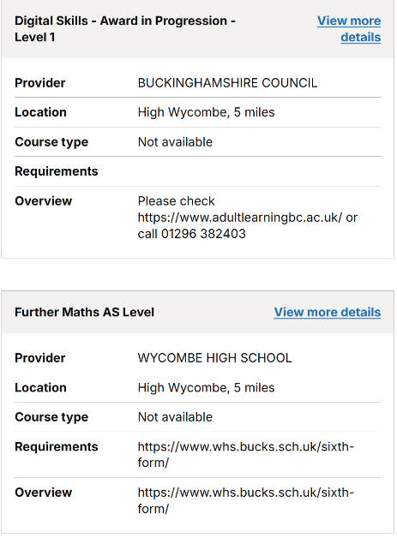
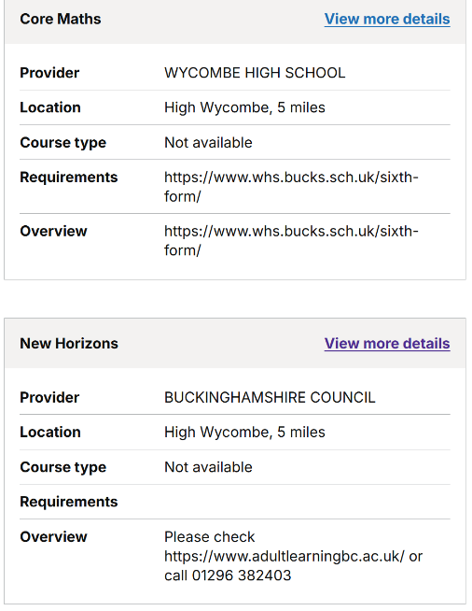
Results

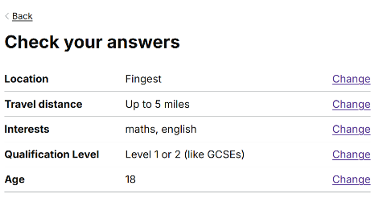

Comments
Fail- The user is able to see the functional skills and GCSE courses though as they are wanting to resit their GCSE’s these results should appear towards the top rather than the bottom of the page.

5. 18-year-old aiming for apprenticeships
Given an 18-year-old wants a software apprenticeship
When they enter a city location
And type “software developer”
And pick Level 3 only
And confirm age 18
Then apprenticeships and vocational digital routes should appear before degree-only results.
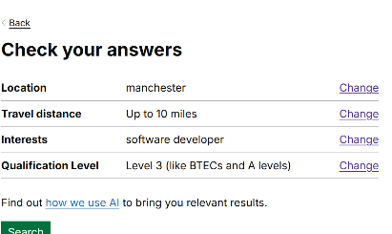
Results
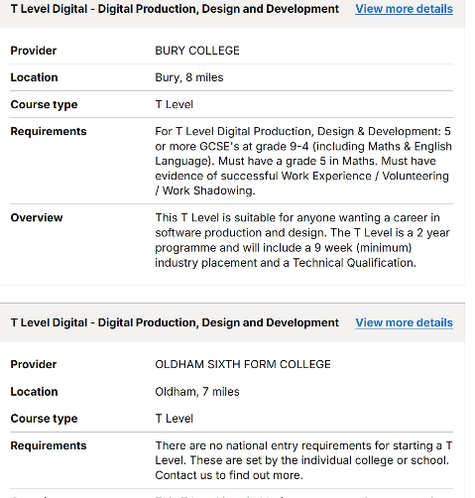

Comments
Semi Fail: The journey does not give the option to click the age 18, however the results give vocational digital routes and apprenticeships
6. Parent filling it in for child
Given a parent enters their own postcode
When they enter “hair and beauty” as the interest
And choose Level 1 and 2
And confirm age 16–17
Then results should reflect the postcode entered, without assuming where the young person actually lives.

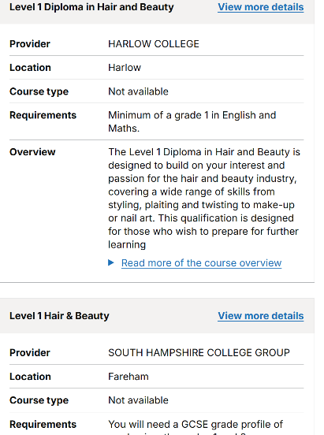
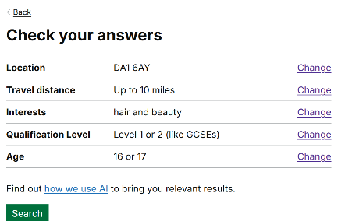

Comments
Fail: The postcode was a Dartford postcode and the results that came up was locations like Southampton, Wolverhampton. The location was not relevant to the postcode that was input.

7. Parent with low digital confidence
Given a parent writes interests as a full sentence
When they type “my son likes cars and engines”
And pick “Get skills and experience”
And confirm age 16–17
Then the system should still show automotive-related entry-level options.

8. Parent searching degree options
Given a parent wants degree-level options only
When they enter “medicine” as the interest
And only select Level 4–7
And reach Search (no age step)
Then the results should prioritise degrees and HE pathways, not GCSE resits.
Results
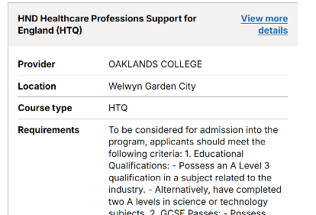
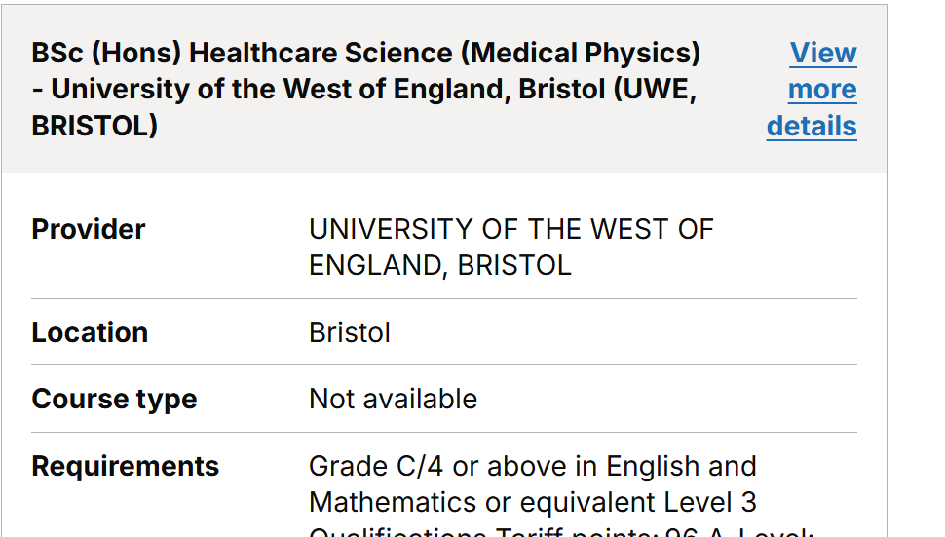
Comments
Pass: The results that came up were degrees and HE pathways which was relevant to the search conducted.

9. Teacher searching for a cohort
Given a teacher is exploring options for students
When they enter a school postcode
And type “construction, bricklaying”
And select all qualification levels
And enter their own age (25+)
Then the results should show a sensible range across levels, not courses tailored only to the teacher’s age.

Results
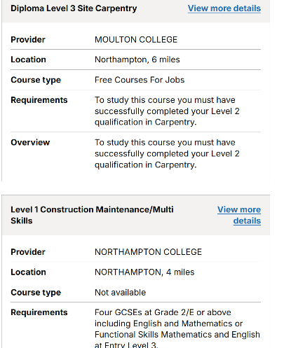
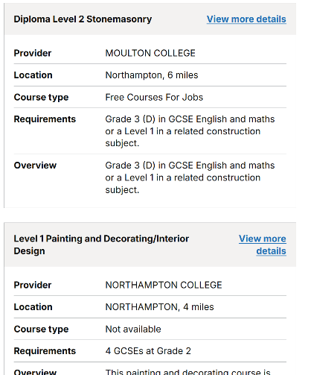

Comments
Pass: The results displayed results across all levels.

10. Teacher using no location
Given a teacher wants to see national ESOL options
When they skip location
And enter “ESOL”
And select all levels
And confirm an adult age
Then results should show ESOL provision across England, without assuming local-only availability.
Results
Pass: The results displayed ESOL results across the whole of England

11. Carer supporting a 25+ with low confidence
Given a carer is searching for someone returning to work
When they enter a postcode
And type “basic computer skills”
And select “Get skills and experience” + “Level 1 or 2”
And confirm age 25+
Then relevant short courses should show first.
Results
Pass: Results displayed are showing short courses that are related to basic computer skills.

12. Adult returner with a past degree
Given an adult has a degree but wants retraining
When they enter “data analyst”
And select only Level 4–7
And skip age
Then results should show conversion courses, HE modules, and higher apprenticeships—not foundation courses.
Results
Pass: The results show results relevant to the user which are HE courses and courses relevant to the users past experience.

13. Adult wanting only online options
Given an adult can only study from home
When they leave location blank
And enter “online only bookkeeping course”
And choose Level 3
And confirm age 25+
Then results should primarily show online courses.
Results
Fail: Only one online course came up and that was placed 4th down the results page. The user only wanted to view online courses and they were not able to view that.

14. Adult with strict distance limits
Given an adult needs something very close
When they enter their small-town postcode
And type “healthcare assistant”
And select Level 1/2
And confirm age 25+
Then the system should prefer nearby courses rather than far-away colleges.
Results
Postcode used -BN18 9AG
Fail: No relevant courses came up for the adult with strict distance limit. No courses were relevant to Healthcare assistant.

15. Young person entering interest in non-English script
Given a user enters an interest using a different script
When they enter Kannada text
And choose Level 1 or 2
And confirm age 18
Then the system should produce meaningful results or a helpful no-results message, not an error.
Results

16. Teen searching “good money”
Given a teen wants well-paid careers
When they type “jobs that pay well”
And pick Level 3 and Level 4–7
And confirm age 16–17
Then AI should suggest realistic fields (digital, engineering, healthcare) without guaranteeing salaries.
Results
Semi-Fail: The courses produced are not linking to courses that are specific (Spanish), but once you go onto the second page apprenticeships start to come up and more relevant courses that are tailored to a job start to come up

17. Teen with niche hobby
Given a teen loves anime drawing
When they type “drawing anime”
And select all levels
And confirm age 18
Then the system should suggest creative and illustration courses.
Results
Pass: Relevant courses have come up for the user that are tailored to illustration

18. Teen with unrealistic level selection
Given a 16-year-old types “PhD physics”
When they only select entry-level qualifications
And confirm age 16–17
Then results should show stepping-stone pathways (A-levels, Level 3 science), not actual PhDs.
Results
Semi pass: The results are coming up as btec applied science courses, however no alevel recommendations has come up like A level physics

19. Parent searching with SEN mention
Given a parent enters “autism friendly courses, learning support”
When they choose Level 1/2
And confirm age 16–17
Then results should highlight providers mentioning support needs without showing discriminatory or fabricated information.
Results
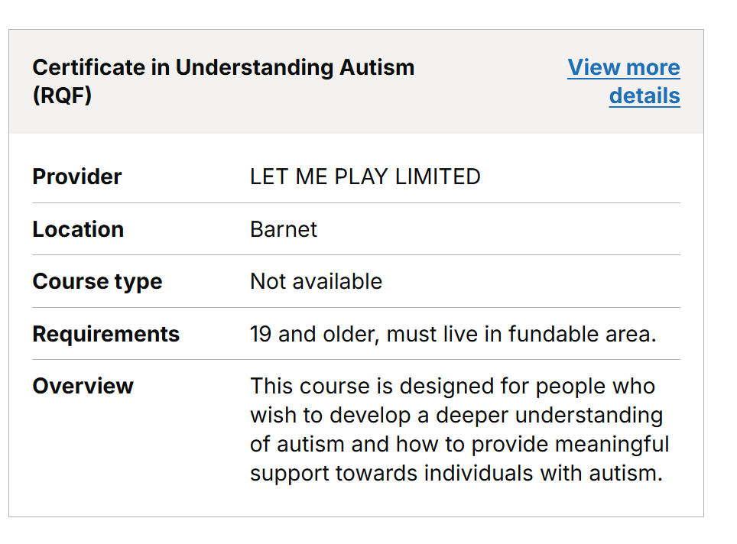
Fail: The search was to find courses that are autism friendly not a course that teaches about autism. But all of the results were learning about autism rather than courses that are tailored to a child with autism.

20. Carer using only a job title
Given a carer searching for someone older
When they type “nurse”
And choose Level 3 + Level 4–7
And confirm age 25+
Then a mix of vocational health and proper HE pathways should appear.
Results
Pass: The results are showing HE courses and vocational health courses which the user is looking for.

21. Adult picking all levels because they don’t know
Given an adult unsure of their qualification level
When they select all four levels
And type “English” as the interest
And confirm age 25+
Then results should emphasise adult literacy and re-entry courses before postgraduate linguistics.
Results
Pass: The results was tailored to what the user asked and they were able to see courses for English and not postgraduate courses we to be seen.

22. Young person selects no qualification levels
Given a young person forgets to select a qualification level
When they enter “games design”
And continue
Then the system should either show a clear validation message, or (if allowed) still return sensible mixed-level results.
Results
Pass: The user was able to see relevant courses to games design there are a clear indication of mixed levels from entry level to diploma.

23. Parent uses “Change” link
Given a parent completes the whole journey
When they click “Change” on the Check Answers page
And change the interest from “medicine” to “law”
Then the updated subject should drive the new results with no leftover bias from the old interest.
Results
Pass: Once the interests had changed to law the results page only displayed courses that are relevant to law.

24. Teacher searching for a specific provider
Given a teacher wants a specific college
When they type “courses at [provider name]”
And select multiple levels
And confirm age 25+
Then results should show that provider’s courses across all data sources where present.
Results
Pass: The results show a mixture of courses from Tyne coast college within the results list every single course is not from tyne coast college there may be another college embedded in the results.

25. Border town location
Given someone near the England/Scotland border enters a local postcode
When they search for “plumbing”
And select Level 2 + 3
And confirm age 18
Then only England-eligible courses should appear, with no incorrect Scottish options.
Results
Pass: The user put in a TD4 postcode and was only able to see results from courses that are only on England.

26. Adult typing contradictory phrase (“short degree”)
Given an adult wants a quick retraining path
When they type “short degree course in coding”
And select Level 3 and Level 4–7
And confirm age 25+
Then results should include short HE modules, bootcamps, and relevant apprenticeships—not just full three-year degrees.
Results
Pass: The results show a mixture of different courses for the user to do and not just 3 year degrees.

27. Teen choosing a far-away location intentionally
Given a young person wants to move to a different city
When they type a location far from home
And enter “music production”
And choose Level 3
And confirm age 16–17
Then results should be based strictly on the entered location, not their actual one.
Results
Pass: The results are coming through as far away as possible the user had inputted blackpool and over 30 miles and the courses given were relevant to the course they want and as far away as possible.

28. Parent entering emotional description
Given a parent types “my daughter needs something gentle to start with”
When they select “Get skills and experience”
And confirm age 16–17
Then the system should show confidence-building or introductory courses where available.
Results
Fail: None of the courses that came up were relevant to confidence building or introductory courses, the courses that came up were early start, confident active child.

29. Adult returner wanting trade work but selecting low levels
Given an adult wants to become an electrician
When they only select “Get skills and experience”
And confirm age 25+
Then results should show realistic first steps (pre-apprenticeship, functional skills) instead of fully qualified pathways.
Results
Semi pass: The first result was an apprenticeship however the rest of the results was pathways into being an electrician

30. User uses “Search again”
Given any user completes a journey
When they click “Search again”
And drastically change their interest (e.g. nurse → plumber)
Then the new results should fully reflect the updated interest and reset relevance appropriately.

31. Teen selects interests which may be complicated
Given a 16–17-year-old user is unsure about their future
When they select high-level interests like “Quantum Computing” or “Cyber Security” without understanding them
Then the results should show beginner-friendly or foundational pathways, not just advanced or degree-level routes.
Pass: The user was able to see beginner friendly courses as they have no experience.

32. Teen uses emojis as interests
Given a teen communicates mostly with emojis
When they type 🎨 ✨ 💅 in the interest box
And select Level 2 and 3
And confirm age 16–17
Then the system should interpret this as art/beauty/creative themes rather than erroring.
Pass: the system provides courses like hairdressing, body art, art and design which is tailored to what the user inputted.

33. Teen mixes emojis + words
Given a teen mixes text and emojis
When they type “healthcare 👩‍⚕️”
And select Level 2 and 3
And confirm age 17
Then results should map to healthcare courses.
Pass: the user was able to view courses linked to healthcare

34. User enters misspellings
Given a user isn’t confident in spelling
When they enter “enjinering” or “apprentiship”
And select Level 3
Then the system should still identify engineering/apprenticeship meaningfully.
Pass: the user is able to get relevant results that are linked to what they searched even though they didn’t spell it correctly

35. User writes interests like a social media
Given a teen writes like on social media
When they type “idk maybe makeup?? help lol”
And select Level 2
Then results should reflect beauty/creative pathways and ignore filler word
Pass: the user is still able to see courses related to hair and makeup

36. User writes interests in voice-to-text style
Given a user uses voice-to-text
When the text comes out as “I want to do something with I.T. full stop maybe coding comma not sure”
Then irrelevant words should be ignored, and coding/IT should surface.

37. User mixes languages accidentally
Given a multilingual user switches mid-sentence
When they type “I want to do enfermería course”
And select Level 3
Then AI should detect “nursing” and provide health-related options.
Pass: the AI was able to detect the switch in language and was able to bring up courses like Access to HE diploma (nursing and midwifery)

