SCHEDULE 2: SPECIFICATION & MONITORING
APPRENTICESHIPS CARRY-IN SPECIFICATION
Definitions
“Agreement Allocation” | Means the value of Funding allocated to the College under this Agreement and as set out in the Funding Agreement contained in Schedule 3 (Payments).
“Exceptional Learning Support” | Means  Learning support funding to meet the costs of putting in place a reasonable adjustment for a Learner who requires more than £19,000 in a Funding Year.  The College must submit a claim form for Exceptional Learning Support as detailed at  Exceptional learning support - cost form - GOV.UK (www.gov.uk)
“Find a learning aim” | Means  Find a learning aim (submit-learner-data.service.gov.uk)  Means general, technical, and non-regulated learning as defined in the Funding Rules and associated documents.
“Funding Rules” | Means  Apprenticeship Funding Rules  Apprenticeship funding rules - GOV.UK (www.gov.uk)  Funding Model 35  Apprenticeship funding rules - GOV.UK (www.gov.uk)  Funding Model 36  Apprenticeship funding rules - GOV.UK (www.gov.uk)  Funding Model 81  Apprenticeship funding rules - GOV.UK (www.gov.uk)
“Funding Model 35” | All ESFA funded apprenticeship framework programmes started before 1 May 2017 are recorded on Funding Model 35 on the ILR
“Funding Model 36” | All ESFA funded apprenticeship programmes started on or after 1 May 2017 are recorded on Funding Model 36 on the ILR; this includes frameworks and standards
“Funding Model 81” | All ESFA funded apprenticeship standards programmes started before 1 May 2017 are recorded on Funding Model 81 on the ILR
“Funding Rates & Formula” | Means  Funding Model 35 and Funding Model 81  Funding_rates_and_formula_2016_to_2017_v2.pdf (publishing.service.gov.uk)  Funding Model 36  Apprenticeship technical funding guide - GOV.UK (www.gov.uk)
“Learning Support” | Means  Funding to enable providers to put in place a reasonable adjustment, set out in the Equality Act 2010, for Learners with an identified learning difficulty and/or disability to achieve their learning goal.
“matrix Standard” | Means  Main home - The matrix Standard
“Off the Job Training Policy” | Means  Apprenticeships: off-the-job training - GOV.UK (www.gov.uk)

Summary of Service
- An Apprenticeship is a job with an accompanying skills development programme. Through their apprenticeship, learners gain the technical knowledge, practical experience and wider skills they need for their immediate job and future career. This is gained through a wide mix of learning in the workplace, formal off-the- job training and by the opportunity to practice new skills in a real work environment.
- Apprenticeships carry-in supports delivery of apprenticeship frameworks or apprenticeship standards for Learners who started their Apprenticeship:
  - before 1st May 2017 or;
  - between 1st May 2017 and 31st March 2018 with non-levy paying employers;
- Apprenticeship frameworks commenced before 1st May 2017 are funded via Funding Model 35 on the ILR.
- Apprenticeship standards commenced before 1st May 2017 are funded via Funding Model 81 on the ILR through the trailblazer pilot.
- All Apprenticeships commenced on or after 1st May 2017 are funded via Funding Model 36 on the ILR.
- These apprenticeships do not include procured higher level apprenticeships.
- Funding is for the 2024 to 2025 Funding Year.
- New Learner starts are prohibited under this Agreement, unless they are legitimately restarts according to the funding rules and technical guidance.
- The legal basis for this Service is 100 (1A) Apprenticeships, Skills, Children, and Learning Act 2009.

Service Commencement and Duration
- Apprenticeships Carry-in Services Start Date: 1st August 2024.
- Apprenticeships Carry-in Expiry Date: 31st October 2025 (for final data submission).

Service Requirements
Recruitment
- The College will not recruit new Learners to this Service.
- Subject to budget availability funding for Learners with a planned end date after 31st July 2025 will be made available in a subsequent agreement.
Outputs
- The College will deliver the eligible Apprenticeships from the Find a learning aim as set out in the Funding Rules and, where appropriate, to the requirements set by the Awarding Organisations and Institute for Apprenticeships between 1st August 2024 and 31st July 2025.
- The College will take steps to ensure as many Learners as possible complete their programme. The Department will monitor the achievement rate.
- The College should apply the Funding Rules in place at the time of Learner recruitment throughout the Learner’s period of study.
- The College will take steps to ensure they spend the allocated Funding in the Funding Year.
- The College will maintain evidence of the delivery of the Service as set out in the Funding Rules.
- The College must deliver the off-the-job-training as set out in the Funding Rules and Off-the-Job Training Policy.
- In addition to the obligations set out in Clause 27 (Subcontracting), the College will adhere to the additional obligations in the Funding Rules.
- Documents to evidence Apprenticeship delivery used for European Social Fund (“ESF”) match funding must be retained by the College for a minimum of three years after the European Commission has made its final payment. For 2014-20 ESF Programme this is until at least 31st December 2034.
- The College must follow the ESF match funding rules as set out in the Funding Rules.
- Confirmation of the document destroy date will be notified in writing by the Department. Without prejudice to any of the other rights under the Agreement to recover funds, the Department will be entitled to recover from the College any sums which it is required to repay to the ESF as a result of the College’s failure to comply with Paragraphs 21 and 22 in this Schedule.
- The College must provide high quality and easily accessible information and advice in helping individuals to understand the opportunities and support available to them about education, training or connected matters (including employment);
  - Where one of the main objectives of the Provision to be provided under this Agreement is to deliver information and advice, the College will have to have or attain the matrix Standard accreditation within the Funding Year; and
  - If the information and advice is embedded as part of the delivery of the Provision, the College must work towards achieving the matrix Standard accreditation within the Funding Year.
  - Where the Provision is delivered by a Subcontractor on behalf of the College, the requirements set out in sub-paragraphs 24.a and 24.b must be applied to the Subcontractor. This does not apply where the College retains responsibility for the delivery of information and advice to the Learners.
  - Once achieved, matrix Standard accreditation is valid for three years. The College must continue to demonstrate their continuous improvement via annual continuous improvement checks with the matrix Standard assessor.
- The College will support eligible Learners by using Learning Support and Exceptional Learning Support where applicable as set out in the Funding Rules.
- In delivering the Provision, the College will comply with the Funding Rules.
- The College must ensure that the Learner spends at least 50% of their working hours in England.
- The College will deliver the Service in a way that ensures:
  - Value for money;
  - The protection of public funds;
  - The effective delivery of a high-quality service for Learners appropriate to their needs; and
  - Meets the public benefit test.

Apprenticeship Carry-in Provision Administration
- Where the Service is continued from the 2023 to 2024 Funding Year, the College must migrate data for continuing learners from 2023 to 2024 ILR to the 2024 to 2025 ILR. The College must submit this data in the first ILR Data return for 2024 to 2025, as set out in Appendix B – Migration Specification of the ILR specification 2024 to 2025.
- The College will submit Learner data to the Department to comply with Clause 5 (Submission of Learner Data) of the Agreement.
- The College must complete the Learner's Apprenticeship on or before the planned end date in the data submitted in the ILR. Where the College misses this date, the Department may consider this a breach of agreement.
- The College must keep the Department informed of any changes to their bank details.
The Department
- The Department will monitor the Provision as set out in Schedule 2B, Apprenticeship Carry-in Monitoring.
- The Department will pay for the Provision as set out in Schedule 3: Payment, Apprenticeship Carry-in.
- The Department will pay for Exceptional Learning Support as set out in Schedule 3: Payment - Apprenticeship Carry-in.

SCHEDULE 2B: MONITORING
APPRENTICESHIP CARRY-IN MONITORING
Monitoring of ILR Submission
- The Department will monitor and review the data submitted under Clause 5 (Submission of Learner Data) of this Agreement as part of its assurance work in accordance with the requirements set out in “Financial Assurance: Monitoring post-16 funding for 2024 to 2025” at Financial assurance: monitoring post-16 funding - GOV.UK (www.gov.uk).
- The Department will publish monitoring reports via View your education data. The College must access the monitoring reports every month and amend any errors for the next submission by taking the actions specified in the report user guide.
- If the Department notifies the College that it has not complied with the reporting requirements set out in Paragraph 2 above, the College must correct data or supply the Department with any evidence as requested by the Department within the period specified in the notice. This evidence can include digital copies of documents such as Learner Files, commitment statements or employer declarations. Annotated spreadsheets or notes are not acceptable as evidence.
- Failure to comply with the reporting requirements in Paragraphs 2 and 3 above will constitute a material breach of agreement and the Department may, at its discretion, exercise its rights under Clause 31 (Withholding, Suspension and Repayment of Funding) and/or Clause 32 (Termination) of the Agreement.
- Where data is incorrect in the final data submission of the Funding Year the Department will recover the payments associated with the incorrect data.

Apprenticeship Carry-in Performance Management
- The Department will review the performance of the Services as set out in the Funding Rules. Where the performance of the Service is below the published tolerances and thresholds, the Department will reduce the Agreement Allocation in line with the Apprenticeship Performance Management Rules.

Apprenticeships Carry-in Reconciliation
- The Department will restrict payment under this Agreement against the Financial and Funding Years set out in Schedule 3: Payment, Apprenticeships Carry-in.
- Where the delivery within a Financial Year fails to meet the delivery profile or where the delivery within a Financial Year would result in the overall Agreement Allocation being exceeded, the Department reserves the right at its absolute discretion to vary the Agreement accordingly to balance funding and delivery in the respective years by means of a variation (i.e. “paying for capping”).
- Reconciliation payments or recoveries may extend beyond the Agreement.

Apprentice Feedback
- The Department may, at any time during the Agreement, monitor whether the College has a policy and process in place which is acceptable to the Department and available to the Department on request, to gather and act upon Apprentice feedback, including feedback from Apprentices who did not complete their Apprenticeship, to improve the experience of Apprentices in general while they are on the College’s programmes, and to support more general improvements.
- The College must ensure that apprentices are aware of the process and the College shall use apprentice feedback to ensure training programmes meet apprentices’ needs. The College must arrange for and operate a plan to deliver continuous improvement in relation to the training, and should include aggregated apprentice feedback to inform that plan.

Apprenticeship Accountability Framework
- The Department will monitor the performance of the College in accordance with the Apprenticeship Accountability Framework. An outline of the Apprenticeship Accountability Framework is set out at Annex 1 of this Schedule 2B: Monitoring.
- The Department reserves the right, at any reasonable time, and as it may deem necessary to require the College at its own cost to obtain a report by an independent accountant of the Department’s choice on any issue in connection with the Apprenticeship Accountability Framework.
- The College must act in accordance with any requests made by the Department under the Apprenticeship Accountability Framework.
- In addition to the provisions set out in Clause 5.1.5 (Submission of Learner Data) of the Agreement the Department reserves the right to take any action under the Apprenticeship Accountability Framework.
- The Department reserves the right to terminate this Agreement with immediate effect by giving notice in writing if the Department assesses that the Services delivered under this Agreement, are below any performance expectations set out in the Apprenticeship Accountability Framework to the extent to which it amounts to a material breach.

ANNEX 1 – APPRENTICESHIP ACCOUNTABILITY FRAMEWORK

- Introduction
  - The Department has published the Apprenticeship Accountability Framework at Apprenticeship training provider accountability framework - GOV.UK (www.gov.uk).
  - The Apprenticeship Accountability Framework consists of Quality Indicators and Supplementary Indicators.
- Quality Indicators
  - The Quality Indicators are informed through OFSTED Inspections and the Department intervention regime as set out in Clause 17 (Intervention) of this Agreement and the College oversight: support and intervention - GOV.UK (www.gov.uk) policy and include (but are not limited to) the following:
    - the College’s own achievement rates and, where relevant, compared with other suppliers delivering similar standards or in similar sectors;
    - the College’s own retention rates and, where relevant, compared with other suppliers delivering similar standards or in similar sectors;
    - Employer ratings of the College; and
    - Apprentice ratings of the College.
- Supplementary Indicators
  - The Department will also take into account, amongst others, the following Supplementary Indicators:
    - off-the-job training data (planned and actual hours);
    - withdrawal rates and/or volumes;
    - the number of Apprentices that are beyond the planned end date of their Apprenticeship;
    - unusual changes in the College’s delivery pattern of Apprenticeships;
    - the volume and duration of which breaks in learning occur in the Apprenticeships delivered by the College; and
    - the timeliness with which Apprentices are registered with an End Point Assessment Organisation.
- Apprentice Data Timeliness and Compliance
  - The College must comply with Clause 5 (Submission of Learner Data) of this Agreement in relation to the prompt and accurate submission of Learner Data to the Department.
- Interventions
  - The Department will continually monitor the Indicators set out in the Apprenticeship Accountability Agreement and may contact the College at any point in the academic year to discuss these. Intervention can be taken at any point in the academic year following any such management conversation.
  - For the avoidance of doubt, where the Department is of the view based on consideration of the Quality Indicators and Supplementary Indicators that the College is underperforming, the Department may take one or more of the following measures:
    - Require the College to attend one or more meetings with the Department;
    - Require the College to complete specified modules of the Apprenticeship Workforce Development Programme;
    - Require the College to agree with the Department milestones and targets to be achieved within a fixed period in relation to specific quality and/or supplementary indicators;
    - Serve on the College a notice that details one or more failures and requires the College to rectify the failure(s) specified within a given timeframe;
    - Inform OFSTED of concerns that the Department has about the College;
    - Restrict the College from delivering specific Standards;
    - Require the College to cease to use a named Subcontractor by a specified date;
    - Withhold or suspend the payment of Funding in accordance with the terms of this Agreement;
    - Terminate the Agreement if any of the grounds set out in Clause 32 (Termination) apply, which may also lead to the removal of the College from the Apprenticeship Provider and Assessment Register.
- How the Department will take decisions to intervene based on the Quality Indicators and the Supplementary Indicators
  - The Apprenticeship Accountability Framework as referred to at Paragraph 1.1 will set out the trigger points that the Department may, at its discretion, choose to intervene.
  - The Department will rate the performance of the College in relation to Quality Indicators and Supplementary Indicators green, amber or red and will consider taking the intervention action as set out in the Supplementary Indicators and Quality Indicators diagrams below:
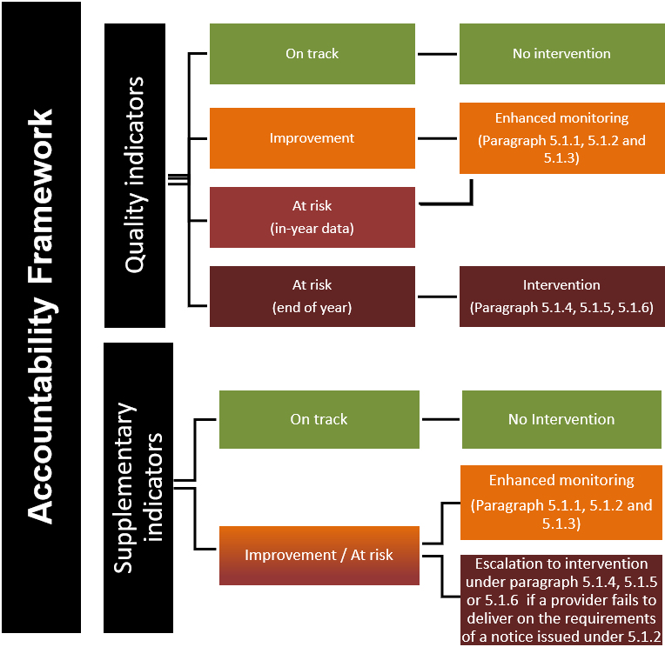
  - In taking the decision as to what intervention, if any, to take, the Department shall act in accordance with the Apprenticeship Accountability Framework and take into account one or more of the following factors and/or any other factors that the Department considers to be relevant:
    - Whether it is a Quality Indicator or a Supplementary Indicator that the College has failed to meet;
    - Whether the data for the relevant Quality Indicator or Supplementary Indictor is in-year data or the final outturn for the relevant academic year;
    - In relation to the Quality Indicators and Supplementary Indicators, whether there are any specific circumstances that the Department considers are relevant to the College’s performance;
    - Previous performance and track record of the College including in relation to the prompt and accurate submission of Learner Data as set out at Paragraph 4.1.

