Supplementary Materials

Plasma Metabolites Enable Rapid Prediction of Gut Microbiome Health

Ramanujam Ramaswamy¹, Angelica Moran^{1,2}, Sabrina Imam³, Antonio Hernandez¹, Amber Rose¹, Jessica Little¹, David Moran¹, Ashley Sidebottom¹, Victoria Burgo¹, Shanna Banogon¹, Huaiying Lin¹, Mark D’Souza¹, Jinyue Wang³, Olatoyosi M Odenike³, Christopher J Lehmann³, Krysta S. Wolfe³, Bhakti Patel³, and Eric G. Pamer^{1,4}

¹Duchossois Family Institute, University of Chicago, Chicago, IL 60637, USA

²Department of Pathology, University of Chicago Medicine, Chicago, IL 60637, USA

³Department of Medicine, University of Chicago Medicine, Chicago, IL, United States
⁴Department of Medicine, Section of Infectious Disease and Global Health, University of Chicago Medicine, 5841 S. Maryland Ave., Chicago, IL 60637, USA; Duchossois Family Institute, Biological Sciences Division, University of Chicago, 900 E. 57th St, Chicago, IL 60637, USA. Electronic address: egpamer@bsd.uchicago.edu

Supplementary Table Legends

Table S1. AML discovery cohort sample characteristics. Clinical and demographic characteristics of acute myeloid leukemia (AML) patients and samples included in the discovery cohort.

Table S2. Healthy donor sample ids

Table S3. MICU validation cohort sample characteristics. Clinical and demographic characteristics of medical intensive care unit (MICU) patients included in the validation cohort.

Table S4. Metabolite panel. Complete list of 115 metabolites measured across bile acid, tryptophan, and short-chain fatty acid panels for both fecal and plasma samples.

Table S5. Diversity prediction model performance. Random forest regression performance metrics for diversity metrics across fecal and plasma samples.

Table S6. Bacterial family prediction model performance. Random forest classification performance metrics for all bacterial families identified.

Table S7. MICU validation cohort diversity predictions. Sample-level predicted versus actual Shannon diversity values for all MICU validation samples.

Table S8. MICU validation cohort commensal predictions. Sample-level predicted versus actual presence/absence for Lachnospiraceae, Oscillospiraceae, and Bacteroidaceae in MICU validation samples.

Table S9. Univariate Cox regression for all metabolites and SOFA score. Cox proportional hazards regression results for each metabolite and SOFA score, adjusted for age, sex, and BMI.

Supplementary Figures

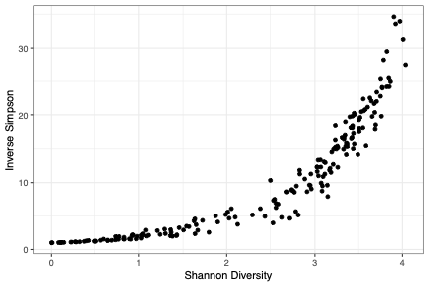
Figure S1. Diversity metrics and feature importance. (a) Correlation between Shannon diversity and Inverse Simpson diversity across all samples.

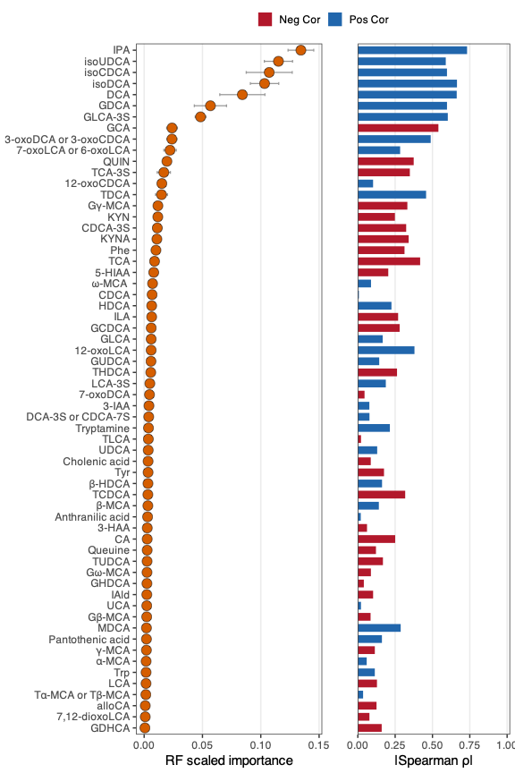

Figure S2. Feature importances for diversity prediction. Scaled permutation importance and spearman correlation (all 62 metabolites) for prediction of Shannon diversity in plasma.
(a)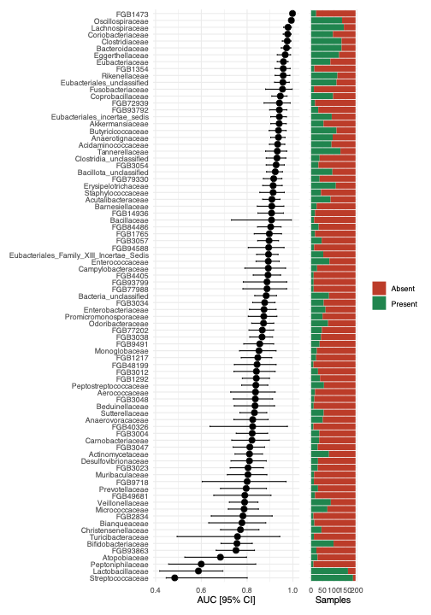

(b)
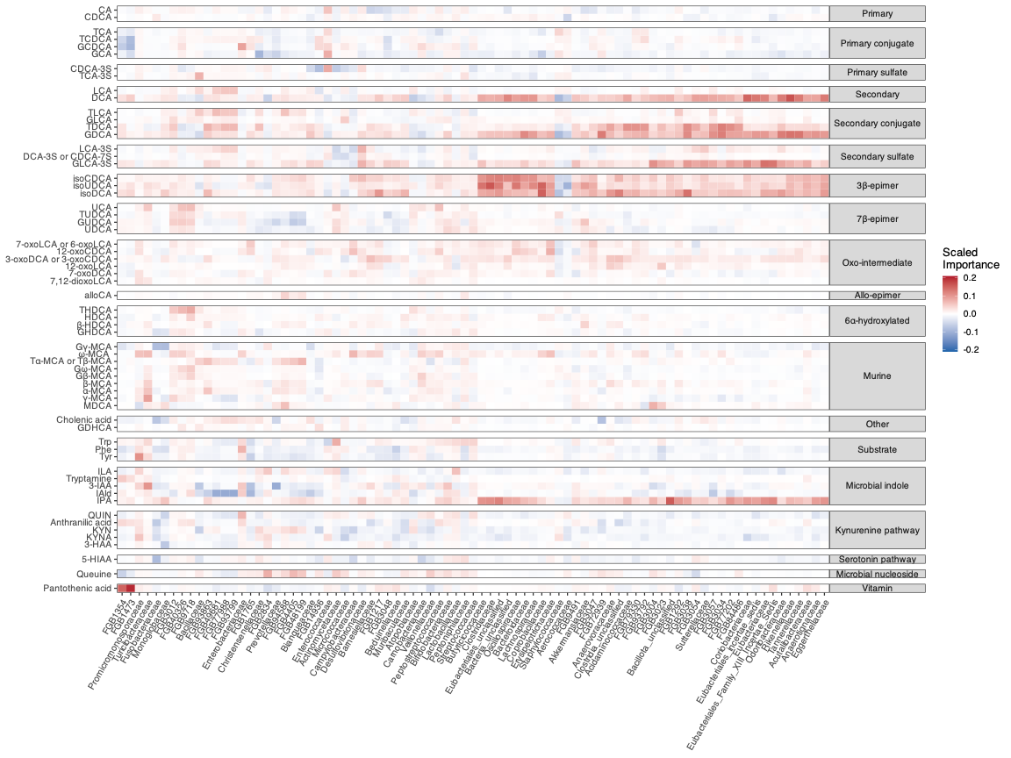
Figure S3. Bacterial family prediction across all taxa. (a) Classification performance (AUC) for all bacterial families evaluated, plotted against prevalence in the AML discovery cohort. (b) Feature importance heatmap showing scaled permutation importance across all bacterial families (columns) and metabolites (rows). Direction is decided based on Cliff’s delta; intensity indicates scaled permutation importance; rows and columns clustered using hierarchical clustering.

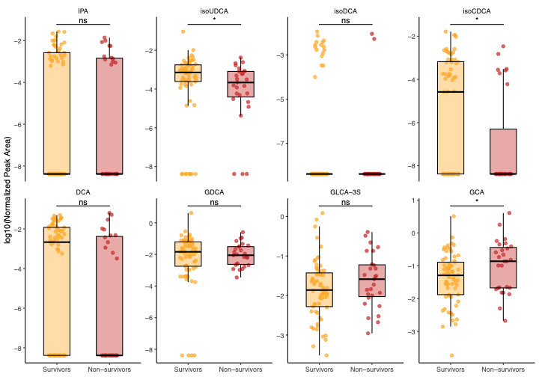

Figure S4. Metabolite distributions by MICU mortality. Plasma concentrations of the 8-metabolite panel stratified by survival status in MICU validation cohort. Boxplots show median and interquartile range; individual samples shown as points. P-values from Wilcoxon rank-sum test.

