Detection of Fileless Malware
(a) pslist and psscan
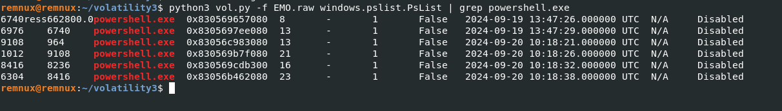
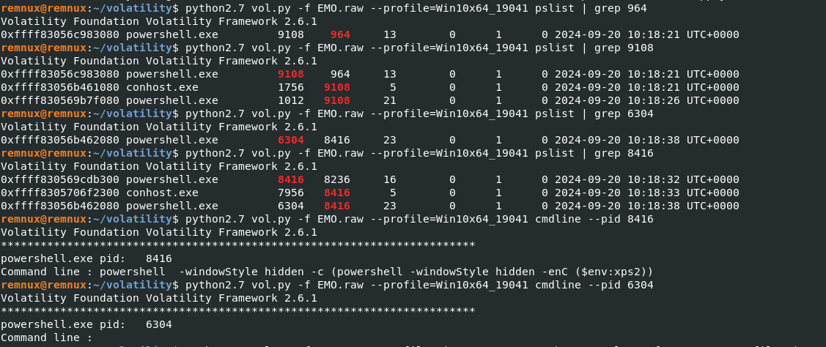
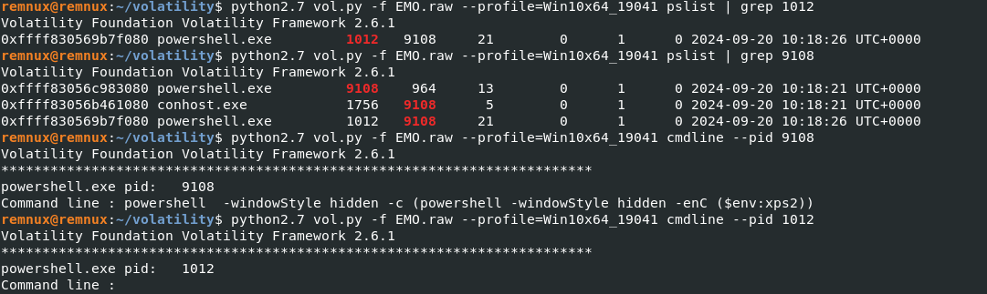
We utilized the psscan and pslist plugins to analyze process IDs, as well as parent and child processes. We identified multiple instances of powershell.exe running from C:\Windows\System32\WindowsPowerShell\v1.0\powershell.exe, all executed with the -windowStyle hidden flag, making them invisible to the user. This behavior raised suspicions, leading us to track these processes further.
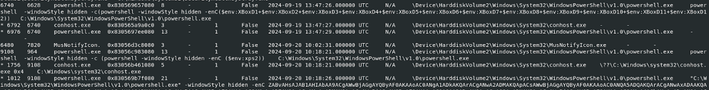
The commands being executed were base64 encoded, indicative of potential persistence mechanisms or remote code execution commonly used in malware and fileless attacks. While the normal execution of PowerShell generates a conhost.exe process to handle command interactions, the hidden mode employed here suppresses the visibility of the PowerShell windows, allowing the processes to run unnoticed in the background. The persistence of these PowerShell and conhost.exe processes, combined with their hidden execution, strongly suggests that the system may be compromised. Notably, the output from psscan revealed that obfuscated code was executed within PowerShell under process ID 6304, warranting further investigation.

(b) malfind
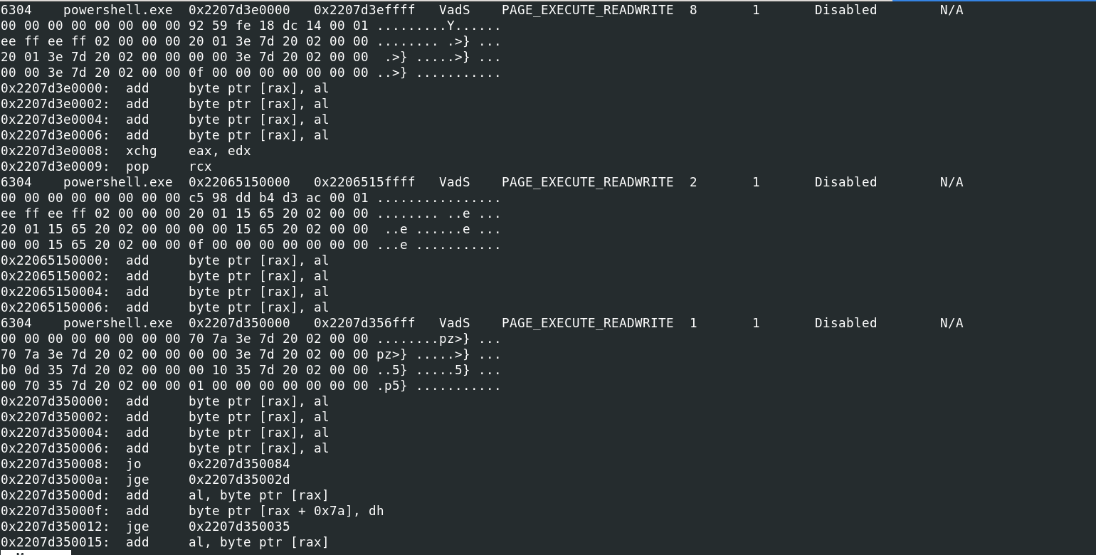

Using the malfind plugin, we detected several suspicious PowerShell processes (PIDs 6304, 8416, 1012, and 9108) and examined their memory regions. We focused on areas with PAGE_EXECUTE_READWRITE permissions, which can indicate malicious activity due to their ability to both execute and modify code. The presence of instructions like pop rcx and jmp rax suggests exploitation techniques are being employed.

(c) Dlls used by suspicious process
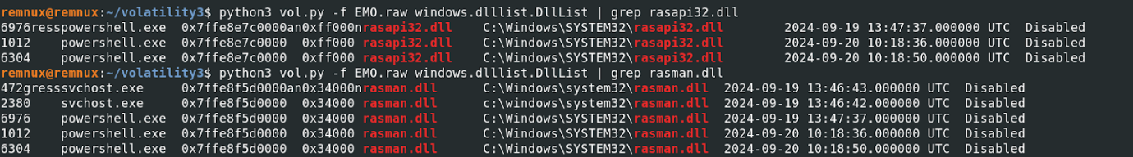
Using the dllist command, we observed that the suspicious PowerShell processes (PIDs 6304 and 1012) are utilizing rasapi32.dll and rasman.dll, which are associated with the Remote Access Service. Although these DLLs are legitimate, their presence indicates potential for remote management or access, which could be exploited for malicious purposes.

(d) filescan
Using the dlllist and filescan plugin, we were unable to locate any suspicious executable files in unusual locations associated with the suspicious processes on the hard disk. This indicated that the malicious process did not rely on or drop any executable files. Instead, it operated entirely in memory, utilizing legitimate system tools to execute its operations. This behavior suggests that the malware exhibited fileless characteristics. To confirm its malicious nature, we proceeded with additional plugins to gather more evidence.

(e) Handle activities of suspicious process
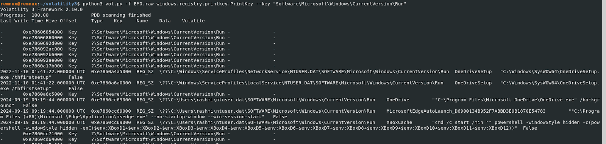
We used the handles plugin to inspect the handles of the suspicious processes, revealing their interactions with files and registry keys. The printkey plugin helped us identify a Run key entry that executes a hidden PowerShell command on system startup, utilizing cmd /c start /min to run it in the background. This command concatenates multiple environment variables and executes the payload with the -enC flag, indicating base64 encoding. These techniques suggest the presence of fileless malware leveraging PowerShell for persistence and execution.

(f) Privileges of suspicious process
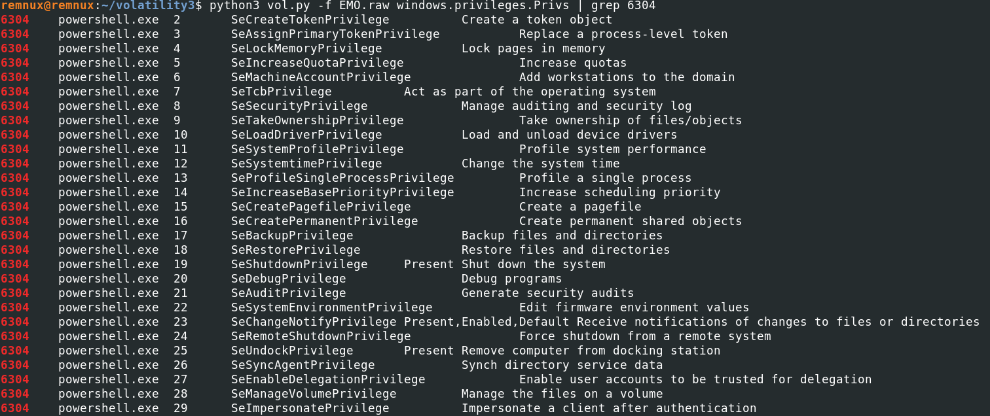
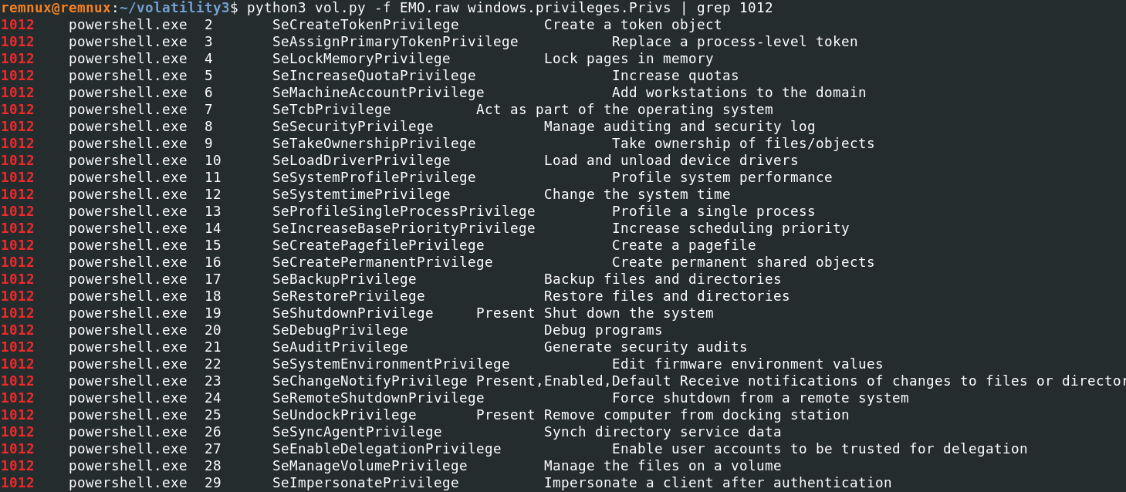
Both processes (PID 6304 and PID 1012) represent potentially high-risk instances of powershell.exe with extensive system privileges.

We can utilize the cmdline.CmdLine plugin of Volatility to delve deeper into the investigation and track the specific commands the code was attempting to execute.
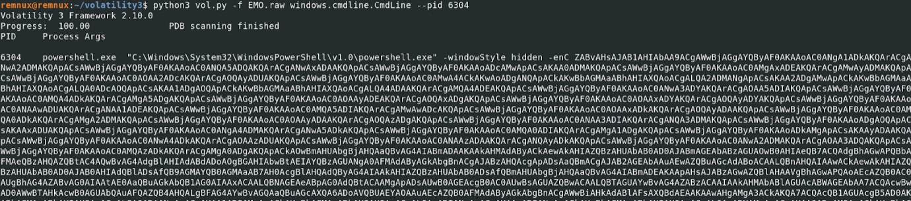
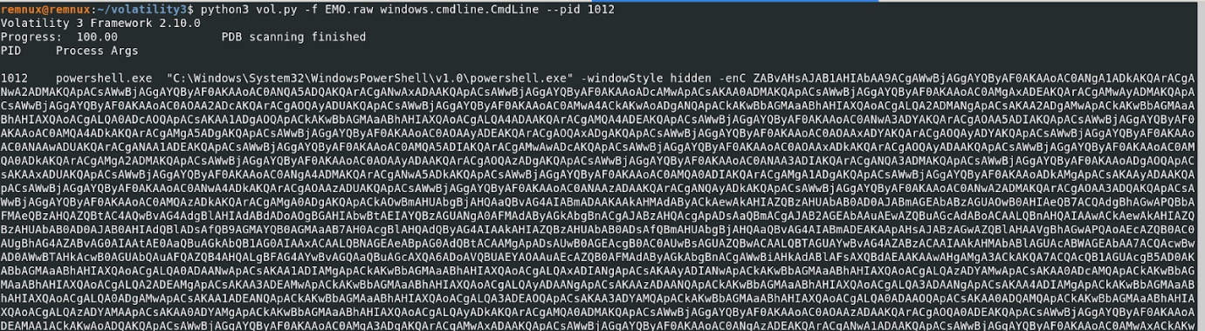
By using the cmdline plugin, we can retrieve the executed commands, revealing that both processes (PID 6304 and PID 1012) are running highly obfuscated commands.
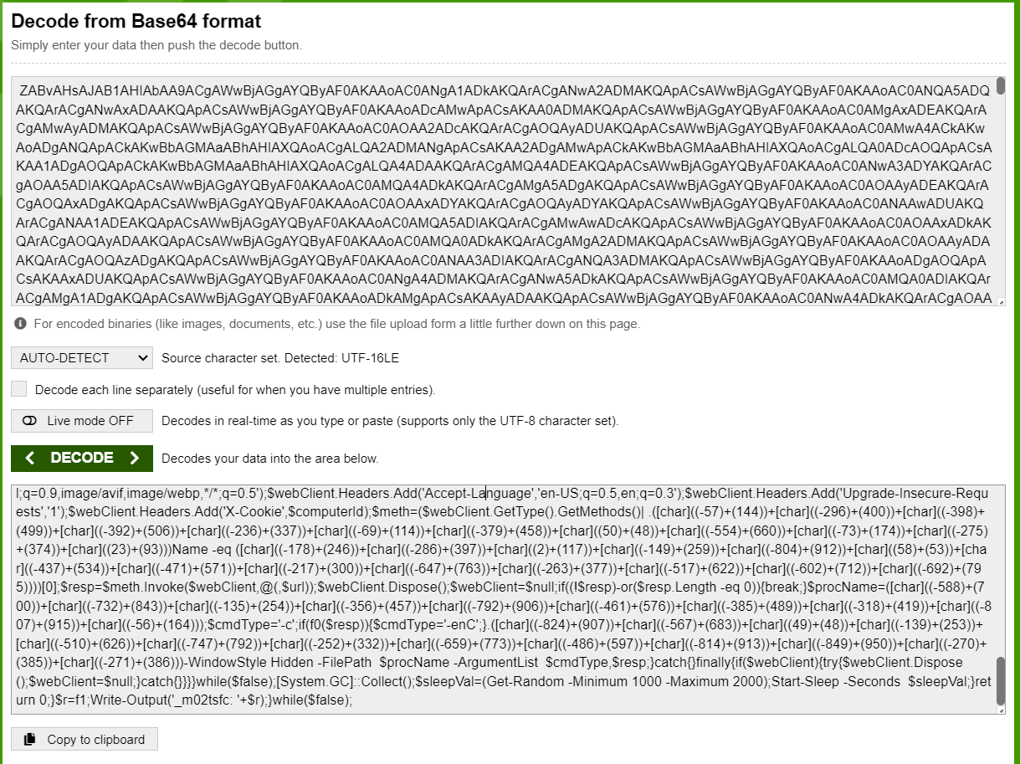
Major observations from One-Step Decoding
• Dynamic URL Construction: Obfuscates URLs using [char] expressions.
• Key Functions:
- f0: Checks Base64 encoding.
- f1: Introduces random delays.
• System Data Collection: Gathers and hashes system information for a unique identifier.
• Web Requests: Sends HTTP requests with custom headers for potential data exfiltration.
• Payload Execution: Executes Base64-encoded responses with PowerShell flags.
• Infinite Loop: Runs indefinitely with sleep intervals.
To conclude, we searched for files dropped by the suspicious processes on the hard disk. In the absence of such files, we proceeded to evaluate the remaining suspicious processes based on the algorithm, which included DLL anomalies, suspicious handle activity, elevated privileges, and signature matches with the ClamAV database. Additionally, we examined the command line outputs and performed one-step decoding of the executed scripts. Since three of these conditions were met, we confidently flagged this malware as fileless.
link to the complete output and explanations: memory_forensics/Emotet

