Our approach also includes a stage of detection of fileless malware where we perform memory analysis using our proposed algorithm of Fileless Malware Detection using the volatility tool. Below are some output snapshots that give us an idea of presence of fileless malware utilizing volatility plugins.
Detection of File-based Malware
(a) pslist
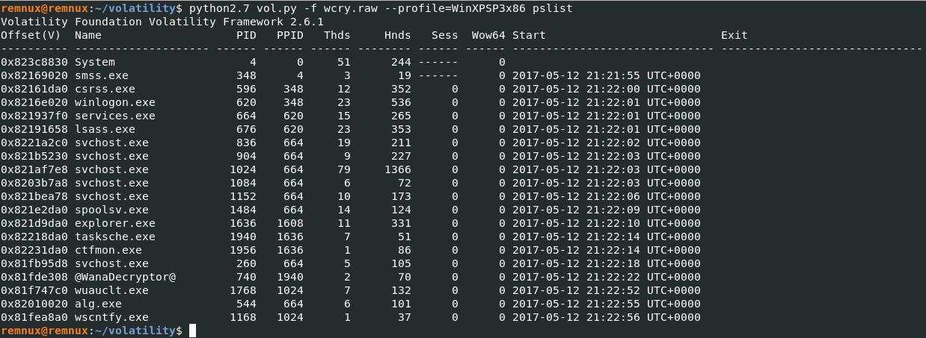
The output from the pslist command shows that the process @WanaDecryptor@ (PID 740) is identified as the WannaCry ransomware. It was launched by a suspicious parent process, tasksche.exe (PID 1940), which appears to be mimicking the legitimate taskschd.exe (Task Scheduler) process. The misspelling suggests malicious intent, making it likely that this process is responsible for initiating the ransomware. Other system processes such as System, smss.exe, csrss.exe, winlogon.exe, lsass.exe, and explorer.exe are legitimate and do not seem to be directly associated with the ransomware infection.

(b) psscan
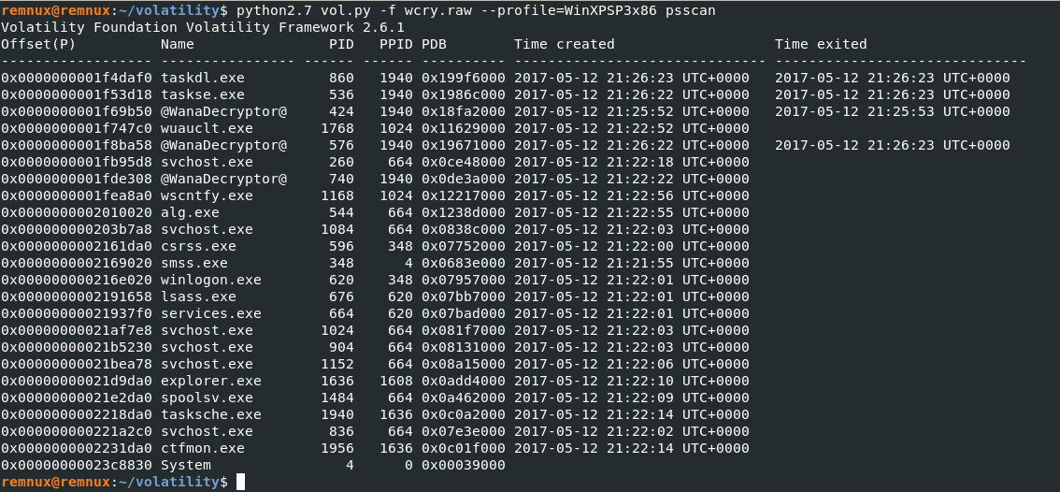
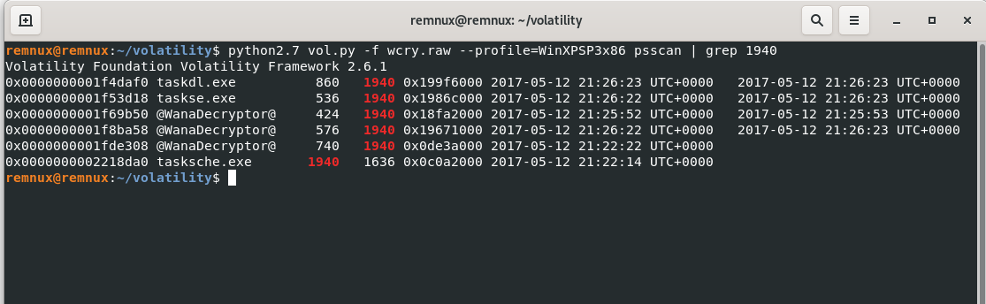
The psscan output indicates that PID 1940 (tasksche.exe) acts as the parent process for several short-lived processes linked to the WannaCry ransomware, including taskdl.exe, taskske.exe, and multiple instances of @WanaDecryptor@. These processes were rapidly created and terminated, behavior consistent with typical ransomware operations such as file encryption and the display of ransom demands

(d) filescan
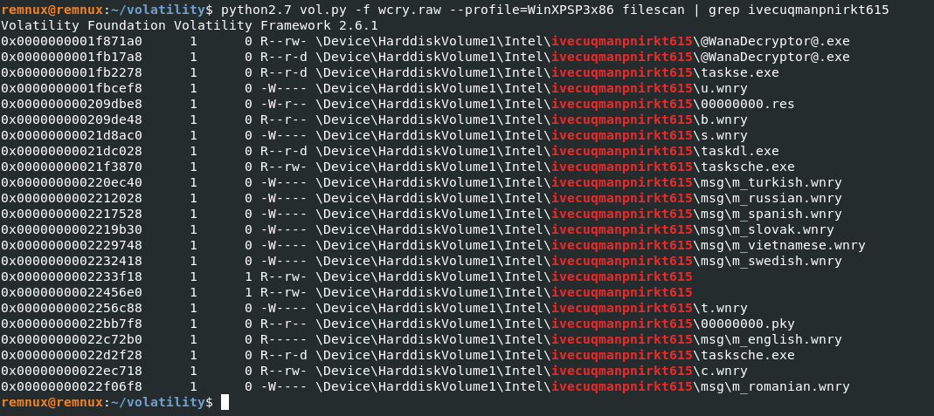

find DLLs linked to potentially suspicious processes. Next, review the file paths of these DLLs to check for anything unusual. If you locate any suspicious executables on the hard disk, record their file paths. Then, use these file paths to run a filescan and obtain the memory location of the executable. Finally, dump the files from memory for further analysis.
The output from the dlllist and filescan command confirms that the WannaCry ransomware is file-based malware, as its components are stored on the hard disk. Suspicious files such as @WanaDecryptor@.exe (used to display the ransom note), taskse.exe, taskdl.exe, tasksche.exe, and various .wnry files (indicating encrypted data) are present on the hard disk,
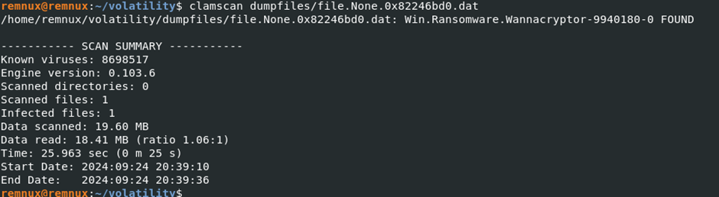
We compared the files' signatures against ClamAV's database, confirming they are flagged as infected with the WannaCry ransomware signature.

