

Form start

End of form

Form start

End of form

**The situation in the morning**

**A new lockdown must be well justified**

By [Mathieu von Rohr](https://www.spiegel.de/impressum/autor-8a88df66-0001-0003-0000-000000005881), Head of Department Abroad

Dear reader, good morning,

today we look at what new measures Angela Merkel and the prime ministers are adopting. We look at Donald Trump's money woes in the election campaign - and also deal with Friedrich Merz and Kim Kardashian.

10/28/2020, 05:40 PM

**This time we need better reasons**

Today is the **day of decisions**: German Chancellor [Angela Merkel is](https://www.spiegel.de/thema/angela_merkel/) pushing for new measures against the Corona pandemic, and she is discussing the issue with the prime ministers of the German **states in** a **federal-state switch** today. [According to a poll,](https://www.spiegel.de/politik/deutschland/coronakrise-mehrheit-der-deutschen-haelt-lockdown-fuer-notwendig-umfrage-a-816eea88-66fa-4175-93ba-0abacc7d6484) a **majority of Germans are in favor of a new "lockdown"** (an imprecise term because Germany has not had curfews before - but it seems to be catching on).

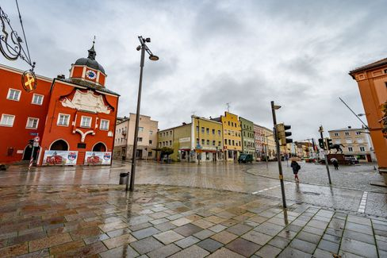

In Pfarrkirchen, Bavaria, the second lockdown is already here

Photo: Armin Weigel / dpa

Scientists have proposed various types of lockdowns: the ["breakwater"](https://www.spiegel.de/politik/deutschland/corona-pandemie-karl-lauterbach-wirbt-fuer-wellenbrecher-shutdown-a-6f0358fc-e2b0-4747-be11-6ba5f69772db) (**everything closed for two weeks**; preferred by Drosten and, according to media reports, Merkel) or a gradual variant: In the first step, **only people from two households would be** allowed to meet in **one apartment.** A maximum of 15 participants would be allowed at funerals, weddings and baptisms. As expected, some state leaders are in favor of quick and decisive action (Markus Söder, Bavaria), some position themselves in the middle (Armin Laschet, North Rhine-Westphalia), and [some are stubborn and don](https://www.spiegel.de/politik/deutschland/corona-krise-bodo-ramelow-kritisiert-entscheidungen-von-bund-und-laendern-a-085e84e6-f40a-4826-b19f-39bb4979e249)'t want to close anything (Bodo Ramelow, Thuringia).

The Corona figures are developing so dramatically that **new measures are urgently needed** - **but they must also be well justified.** If, for example, restaurants had to be closed again, that would really mean the end for large parts of the industry this time - but there is no data so far to prove that many people become infected in restaurants. This time, the **courts** will take a more critical look at what is decided by regulation - and, if necessary, overrule rules if good justification is lacking. For **democratic legitimacy,** but also for **legal certainty,** it would therefore make sense for **parliaments to** come back into play in this phase of the pandemic.

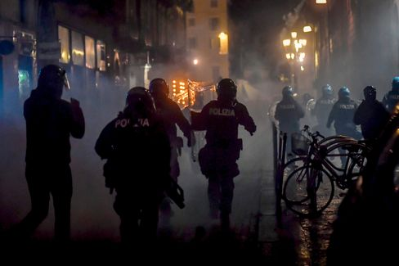

Police officers and demonstrators clash during a protest in Turin

Photo: Claudio Furlan / AP

In **Italy**, where the population has so far been very disciplined in following all the rules, there are [street protests for the first time against the latest restrictions](https://www.spiegel.de/politik/ausland/corona-massnahmen-in-italien-ausschreitungen-bei-protesten-in-turin-a-67ac2178-4d12-47ef-a0da-16c31c6ffc01) (a kind of lockdown from 6 p.m.). In **France,** President **Emmanuel Macron** has announced a televised address for 8 p.m. tonight. It is quite possible that France (where the numbers are much more dramatic), will be in a new, real lockdown as early as tomorrow.

* [Bars to close, schools to stay open: Federal government urges drastic Corona measures in November](https://www.spiegel.de/politik/deutschland/corona-massnahmen-in-deutschland-bars-sollen-schliessen-die-schulen-offen-bleiben-a-312e9267-a0aa-411f-aed4-aa5db6b87c70)

**Trump replays 2016**

It feels like time travel, we're back in 2016. [Donald Trump](https://www.spiegel.de/thema/donald_trump/) and his aides are increasingly talking about **Hillary Clinton** - a woman who hasn't held political office in eight years - during their campaign appearances. The president, who is [far behind in the polls,](https://projects.fivethirtyeight.com/polls/president-general/national/) is betting everything on the northeastern states of **Pennsylvania, Michigan, Wisconsin and Ohio in the** final stretch. Back then, four years ago, that strategy surprisingly worked.

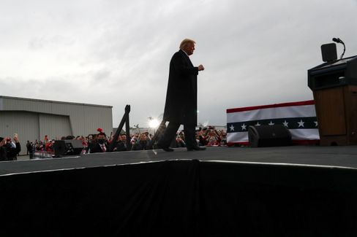

Trump in Martinsburg, Pennsylvania

Photo: LEAH MILLIS / REUTERS

And this time? While Joe Biden is swimming in money, the president is running out. He is putting what money he has left primarily into the northeastern states that helped him win four years ago. But will it help him win that he talks about Hillary Clinton and downplays [the Corona pandemic](https://twitter.com/Acosta/status/1321178584082452480) during his appearances?

That Trump is betting everything on Pennsylvania is understandable: He practically can't win without that state - and neither can Joe Biden, for that matter. I recommend [this very instructive tool from the US data website FiveThirtyEight](https://projects.fivethirtyeight.com/trump-biden-election-map/?cid=abcnews), which allows you to run through various scenarios for the election outcome yourself. How it will turn out in reality, we will see.

And [here you can subscribe to our newsletter "The State of the Union - USA 2020,"](https://www.spiegel.de/thema/die-lage-usa-2020/) which will provide you with daily stories and assessments from our team of eleven reporters in the U.S. from today until the election - and will come weekly thereafter.

**Recommendation: Election coverage from Florida**

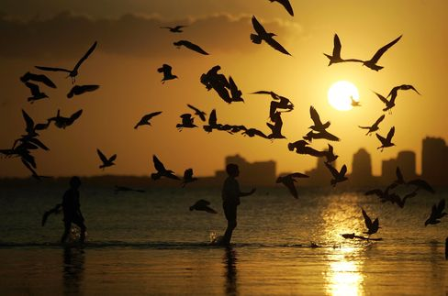

Symbol image Florida

Photo: Joe Raedle/ Getty Images

Another important swing state is Florida with its 29 electoral votes - Trump must not lose it either. But here, too, he must tremble. This is due in particular to a voter group that is particularly well represented here in the sunny south and has traditionally voted reliably Republican: retirees. Our reporter Alexandra Rojkov visited "The Villages" retirement community in Florida this week - and here nothing is the way it used to be: **many retirees have had enough of Donald Trump**, not least because of his failure in the Corona pandemic. Read their report here:

* [Retiree uprising in Florida: In the golf cart against Trump](https://www.spiegel.de/politik/ausland/florida-vor-der-us-wahl-2020-rentner-aufstand-gegen-donald-trump-a-0053e3ec-2389-431f-bcda-5f8c3a696df7)

**All against Merz**

The **Left Party** has now also canceled its **party conference** planned for the weekend - as the CDU did the day before. This somewhat invalidates the fears of CDU candidate **Friedrich Merz** that the "establishment" had robbed him of his certain victory in December. Merz has done himself no favors with his **conspiracy theory,** and criticism is raining down on him from all sides.

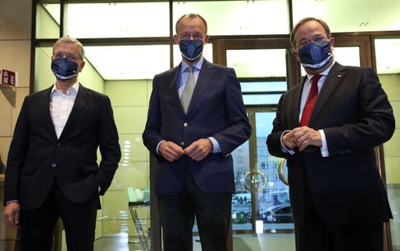

Roettgen, Merz and Laschet at an appearance in Berlin on October 17

Photo: ADAM BERRY/POOL/EPA-EFE/Shutterstock

The conservative **"Frankfurter Allgemeine Zeitung" is** obviously fed up with him. In the front-page commentary [today, Jasper von Altenbockum writes](https://www.faz.net/aktuell/politik/inland/kommentar-ueber-die-cdu-merz-spaltet-die-partei-17022903.html): "All of this is victimhood, populism, narcissism, and frothing at the mouth all rolled into one. There are enough statesmen in the world of this sort. Does the CDU, does Germany need someone like this at the top? Merz has turned the choice of CDU chairman into this one question: what type of party leader and candidate for chancellor do we want?"

But Armin Laschet, of all people, defends his opponent - with the sentence: ["Comparing Merz to Trump is completely out of place](https://www.spiegel.de/politik/deutschland/cdu-armin-laschet-verteidigt-friedrich-merz-vor-trump-vergleich-a-6dff2ce0-6249-4d86-aa7b-8b2783e07bd2). Repeating a comparison in order to contradict it is an elegant way to remind people once again - or is that now a conspiracy theory?

* [Attack à la Trump: Merz hits Merz](https://www.spiegel.de/politik/deutschland/friedrich-merz-gegen-cdu-fuehrung-attacke-a-la-donald-trump-a-2f04f2ee-70a0-4b0b-a59e-ff02d117d78f)

**Winner of the day...**



Kim Kardashian

Photo: Willy Sanjuan/ dpa

...is **Kim Kardashian**, who told the common people on Twitter about the celebration of her 40th birthday. Under the hashtag #humbled, [she posted glamorous pictures and wrote](https://twitter.com/KimKardashian/status/1321151217482014726): "After two weeks of multiple health checks and asking everyone to quarantine themselves, I surprised my closest inner circle with a trip to a private island where for a brief moment we could just pretend everything was normal."

She is "humbly reminded of how privileged" her life is: "We danced, rode bikes, swam near whales, kayaked, watched a movie on the beach and so much more."

We wonder why more people don't just jet off to a private island instead of going into breakwater lockdown, and hereby award Kim Kardashian the title of "Marie Antoinette of the Corona Pandemic."

External content

[Read more in our privacy policy.](https://www.spiegel.de/datenschutz-spiegel)

**The latest news from the night**

* **120 years in prison for self-help guru Keith Raniere:** He allegedly used the self-help group he founded, Nxivm, to sexually exploit women. [Now the sentence has been announced for Keith Raniere, to whom a well-known U.S. actress was also addicted](https://www.spiegel.de/panorama/justiz/sekte-nxivm-120-jahre-haft-fuer-selbsthilfe-guru-keith-raniere-a-36dbb129-e1b0-4c14-99b0-bd503cbdd54c)
* **Website of Trump's election campaign briefly hacked:** Unknown persons have manipulated the website of Donald Trump's election campaign and demanded payment of a cryptocurrency. [Now the search is on for the perpetrators](https://www.spiegel.de/politik/ausland/donald-trump-website-von-wahlkampagne-kurzzeitig-gehackt-a-c817102f-0192-4e96-acfa-29eff7429585)
* **Gladbach squander victory against Real Madrid in injury time**: They had Real Madrid on the brink of defeat, but then Casemiro scored in injury time: Borussia Mönchengladbach could not bring a lead in the Champions League to the finish. [Again](https://www.spiegel.de/sport/fussball/borussia-moenchengladbach-spielt-nur-remis-gegen-real-madrid-in-der-champions-league-a-ac0861db-db39-43c7-ac43-786e4f8085a7)