Form start

End of form

Form start

End of form

**The situation in the morning**

**A new lockdown must be well-founded**

By [Mathieu von Rohr](https://www.spiegel.de/impressum/autor-8a88df66-0001-0003-0000-000000005881), Head of DepartmentAbroad

Dear Reader, Good Morning,

today we are dealing with the question of what new measures Angela Merkel and the Prime Ministers are adopting. We look at Donald Trump's money woes during the campaign - and also look at Friedrich Merz and Kim Kardashian.

10/28/2020, 5:40 AM

**This time we need better reasons**

Today is the **day of decisions:**German Chancellor Angela [Merkel](https://www.spiegel.de/thema/angela_merkel/) is pushing for new measures against the Corona pandemic, she is discussing this today in a **federal-state meeting** with the prime ministers. [According to one poll,](https://www.spiegel.de/politik/deutschland/coronakrise-mehrheit-der-deutschen-haelt-lockdown-fuer-notwendig-umfrage-a-816eea88-66fa-4175-93ba-0abacc7d6484) a majority of Germans are in favour of a **new "lockdown"** (an imprecise term, because Germany has not had any curfews so far - but it seems to be prevailing).

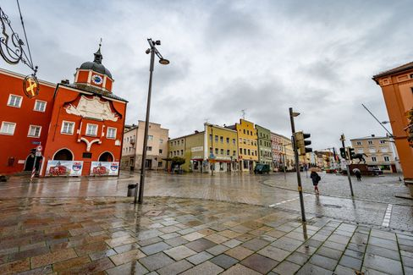

In the Bavarian parish church the second lockdown is already there

Photo: Armin Weigel / dpa

Scientists have proposed different types of lockdowns: the ["wavebreaker"](https://www.spiegel.de/politik/deutschland/corona-pandemie-karl-lauterbach-wirbt-fuer-wellenbrecher-shutdown-a-6f0358fc-e2b0-4747-be11-6ba5f69772db) (for**two weeks all too;**preferably from Drosten and according to media reports from Merkel) or a step-by-step variant: In the first step, only people from two households are allowed to meet **in an apartment.** At funerals, weddings, baptisms, a maximum of 15 participants would be allowed. As expected, some country leaders are in favour of quick and decisive action (Markus Söder, Bavaria), some position themselves in the middle (Armin Laschet, NRW), [some give themselves stubbornand](https://www.spiegel.de/politik/deutschland/corona-krise-bodo-ramelow-kritisiert-entscheidungen-von-bund-und-laendern-a-085e84e6-f40a-4826-b19f-39bb4979e249) and do not want to close anything at all (Bodo Ramelow, Thuringia).

The Corona figures are developing so dramatically that new measures are **urgently needed** - but they must also **be well-founded.** If, for example, restaurants had to be closed again, this time it really meant the end for large parts of the industry - but there is still a lack of data to prove that many people are infected in restaurants. This time, the **courts** will examine more critically what is decided by the regulation - and, if necessary, override rules if there is no good justification. It would therefore make sense for **democratic legitimacy,**but also for legal **certainty,** if **parliaments** were to come back into play at this stage of the pandemic.

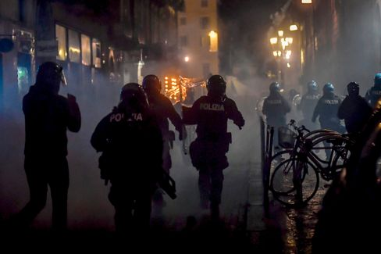

Police and demonstrators clash during a protest in Turin

Photo: Claudio Furlan / AP

In **Italy,**where the population has so far followed all the rules in a very disciplined manner, there are street protests against the [recent restrictions](https://www.spiegel.de/politik/ausland/corona-massnahmen-in-italien-ausschreitungen-bei-protesten-in-turin-a-67ac2178-4d12-47ef-a0da-16c31c6ffc01) (a kind of lockdown from 6 p.m.). In **France,** President **Emmanuel Macron** has announced a televised address tonight at 8 p.m. It is quite possible that France (where the figures are much more dramatic) will be in a new, real lockdown as of tomorrow.

* [Bars to close, schools to remain open: Federal government urges drastic Corona measures in November](https://www.spiegel.de/politik/deutschland/corona-massnahmen-in-deutschland-bars-sollen-schliessen-die-schulen-offen-bleiben-a-312e9267-a0aa-411f-aed4-aa5db6b87c70)

**Trump plays after 2016**

It feels like a journey through time, we're back in 2016. [Donald Trump](https://www.spiegel.de/thema/donald_trump/) and his aides are increasingly talking about **Hillary Clinton** - a woman who has nabed no political office in eight years - during her campaign appearances. The president, who [according to the polls is far behind,](https://projects.fivethirtyeight.com/polls/president-general/national/)is betting everything on the northeastern states of **Pennsylvania, Michigan, Wisconsin and Ohio**in the last fewmeters. Back then, four years ago, this strategy came to a surprise.



Trump in Martinsburg, Pennsylvania

Photograph: LEAH MILLIS / REUTERS

And this time? While Joe Biden floats in money, the president runs out of money. He puts the remaining money mainly in the northeastern states that helped him win four years ago. But does it help him win, that he talks about Hillary Clinton in his appearances and [plays down the Corona pandemic?](https://twitter.com/Acosta/status/1321178584082452480)

It's understandable that Trump is betting everything on Pennsylvania: He can't win without this state - and Joe Biden, by the way, can't. I recommend [this very instructive tool from the US data website FiveThirtyEight](https://projects.fivethirtyeight.com/trump-biden-election-map/?cid=abcnews), with which you can play through different scenarios for the election outcome yourself. We will see how it actually comes about.

And [here you can subscribe to our newsletter "The Situation - USA 2020",](https://www.spiegel.de/thema/die-lage-usa-2020/) which provides them with daily stories and assessments of our eleven-person team of reporters in the USA from today until the election - and then comes weekly.

**Recommendation: Election reporting from Florida**

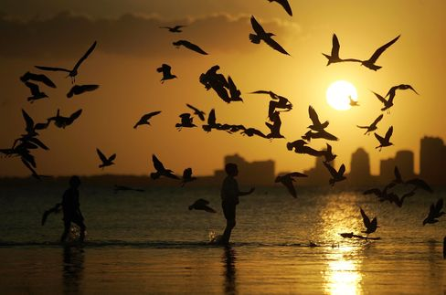

Symbol image Florida

Photograph: Joe Raedle/ Getty Images

Another important swing state is Florida with its 29 electoral votes - trump, too, must not lose it. But he must also tremble here. This is especially due to a group of voters who are particularly numerous here in the sunny south and who have traditionally voted reliably Republican: the pensioners. Our reporter Alexandra Rojkov visited the retirement community "The Villages" in Florida this week - and here's nothing like it used to be: **Many retirees are fed up with Donald Trump,**not least because of his failure in the Corona pandemic. Read your report here:

* [Pensioner uprising in Florida: In the gulf against Trump](https://www.spiegel.de/politik/ausland/florida-vor-der-us-wahl-2020-rentner-aufstand-gegen-donald-trump-a-0053e3ec-2389-431f-bcda-5f8c3a696df7)

**All vs. Merz**

The **Left Party** has now also cancelled its **party congress** planned for the weekend - as the CDU had done the day before. This somewhat refutes the fears of the CDU candidate Friedrich **Merz**thatthe "establishment" had robbed him of his certain victory in December. With his conspiracy theory, Merz has done himself no favours, the criticism from all sides slams into him.

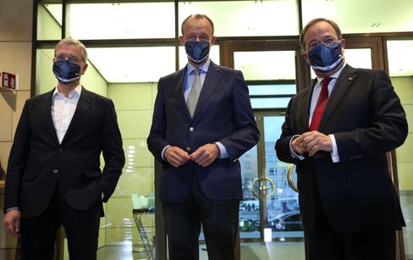

Roettgen, Merz and Laschet performing in Berlin on 17 October

Photograph: ADAM BERRY/POOL/EPA-EFE/Shutterstock

The conservative **"Frankfurter Allgemeine Zeitung"** is obviously fed up with him. In the front page commentary [Jasper von Altenbockum writes today:](https://www.faz.net/aktuell/politik/inland/kommentar-ueber-die-cdu-merz-spaltet-die-partei-17022903.html)"This is all victimism, populism, narcissism, foaming in one. There are enough statesmen in the world of this variety. Does the CDU need such a top-class Party? Merz has made the election of the CDU chairman on this one question: What type of party leader and chancellor candidate do we want?"

Armin Laschet defends his opponent for this - with the sentence: ["Comparing Merz with Trump is completely out of place"](https://www.spiegel.de/politik/deutschland/cdu-armin-laschet-verteidigt-friedrich-merz-vor-trump-vergleich-a-6dff2ce0-6249-4d86-aa7b-8b2783e07bd2). Repeating a comparison to contradict him is an elegant way to remind you of it - or is it now a conspiracy theory?

* [Attack a la Trump: Merz beats Merz](https://www.spiegel.de/politik/deutschland/friedrich-merz-gegen-cdu-fuehrung-attacke-a-la-donald-trump-a-2f04f2ee-70a0-4b0b-a59e-ff02d117d78f)

**Winner of the day...**

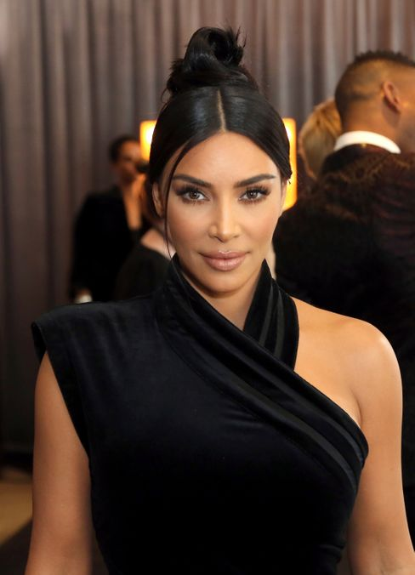

Kim Kardashian

Photo: Willy Sanjuan/ dpa

... **Kim Kardashian**, who told the common people on Twitter about the celebration ofher 40th birthday. Under the hashtag #humbled (i.e.: #demütig), [she posted glamorous pictures, writing:](https://twitter.com/KimKardashian/status/1321151217482014726)'After two weeks of several health checks and a plea for everyone to go into quarantine, I surprised my closest inner circle with a trip to a private island where we could just pretend for a brief moment that everything was normal.'

She was "humbly reminded of how privileged" her life was: "We danced, rode bikes, swam near whales, went kayaking, watched a movie on the beach and so much more."

We wonder why more people don't just take to a private island on private jets instead of going into the breakwater lockdown, and give Kim Kardashian the title "Marie Antoinette of the Corona Pandemic."

External content

[Read more in our privacy policy.](https://www.spiegel.de/datenschutz-spiegel)

**The latest news from the night**

* **120 years in prison for self-help guru Keith Raniere:** He allegedly used the self-help group Nxivm, which he founded, to sexually exploit women. [Now the sentence has been announced for Keith Raniere, who also had fallen for a well-known US actress](https://www.spiegel.de/panorama/justiz/sekte-nxivm-120-jahre-haft-fuer-selbsthilfe-guru-keith-raniere-a-36dbb129-e1b0-4c14-99b0-bd503cbdd54c)
* **Website of Trump's campaign briefly hacked:** Unknown people have manipulated the website of Donald Trump's campaign and demanded payment of a cryptocurrency. [Searches are now underway for the perpetrators](https://www.spiegel.de/politik/ausland/donald-trump-website-von-wahlkampagne-kurzzeitig-gehackt-a-c817102f-0192-4e96-acfa-29eff7429585)
* **Gladbach squandered victory against Real Madrid in extra-time:**they had Real Madrid on the verge of defeat, but then Casemiro scored in extra time: Borussia Mönchengladbach could not take a champions League lead. [Again](https://www.spiegel.de/sport/fussball/borussia-moenchengladbach-spielt-nur-remis-gegen-real-madrid-in-der-champions-league-a-ac0861db-db39-43c7-ac43-786e4f8085a7)