

Subscribe to DeepL Pro to edit this document.  
Visit www.DeepL.com/Pro for more information.

**The situation in the morning**

**"National effort" - the efforts of politics and their consequences**

By [Susanne Beyer](https://www.spiegel.de/impressum/autor-77cf5313-0001-0003-0000-000000001532), Writer at SPIEGEL's Capital Office

Dear reader, good morning,

today we look at what we can learn from the new Corona resolutions and what the roundtable of chancellor and prime ministers can in turn learn from the criticism of them. We also look at the consequences of the resolutions for the economy, and we find a single reason to rejoice.

29.10.2020, 05.45 hrs

**Corona I. - Much criticism of decisions by chancellor and prime ministers**

It's customary to start thinking about Christmas at the end of October, and the first cinnamon stars are already on display in stores. But in the past 24 hours, there has been an exaggerated amount of talk about Christmas: holding out the **prospect of a reasonably normal holiday** - including a reasonably normal pre-Christmas business - became a rhetorical device to promote **understanding for the tough Corona measures that** the committee of chancellor and prime ministers decided on yesterday, and which the chancellor called a **"national effort,"** with the emphasis on "national," if only to make it clear that this time she succeeded in preventing individual prime ministers from backing out.

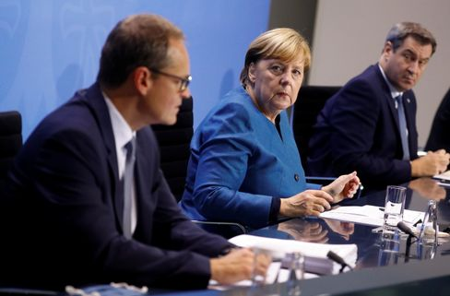

Angela Merkel with Berlin's Mayor Michael Müller and Bavarian Prime Minister Markus Söder

Photo: Fabrizio Bensch / dpa

From November 2, only **members of two households will be** allowed to meet in public - a maximum of ten people. Non-essential **private trips** and **visits from relatives are** to be avoided**, catering businesses will have to close, as will beauty salons, massage practices and tattoo studios**. **Professional sports are** to be held only without spectators, and **amateur sports operations** are to be discontinued altogether. **Theaters, operas and concert halls, also casinos, gambling halls, betting shops and brothels will have to close**, as will **cinemas, amusement parks and trade fairs, and also hotels,** at least for tourists.

While the chancellor and the prime ministers may have been in agreement this time, some of the reactions outside the committee were harsh. Scientists and doctors around the virologist **Hendrik Streeck** think it would be wrong to shut down public life again anyway. **Restaurateurs complained** that they had really taken care of everything, purchased air purification filters, implemented hygiene concepts - and now this. **Theater managers sent out open letters**: "We think it's wrong to ban cultural events.

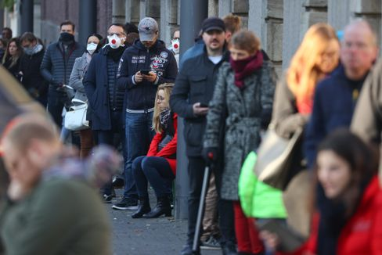

People in front of a Corona test center in Frankfurt

Photo: KAI PFAFFENBACH/ REUTERS

In fact, restaurants, cinemas and theaters where responsible rules apply and are adhered to have so far **hardly proved to be hotbeds of infection** - to have done everything but not achieved the goal after all is always frustrating. But even if it is really unfair for many individuals, it has now become clear in recent weeks that the rule thicket had become too impenetrable, offered too many loopholes, that the conditions of a cold season require a tougher, clearer crackdown. The calculation (number of infections measured against the utilization of intensive care beds) was simple - it could not go on like this.

Taking the measures, limiting them in time - to one month - and ensuring financial compensation are all the right things to do. However, if the figures should now come down again, **the time gained** must be **used to carefully examine the arguments of the critics** and then, if necessary, to take other paths from December onwards.

* [Corona measures: These restrictions apply from Monday](https://www.spiegel.de/politik/deutschland/corona-krisengipfel-beschliesst-massive-einschraenkungen-ab-montag-a-da1173bc-9728-4930-9eef-92975f075210)

**Corona II - The economy is in for a terrible November**

Although it is reasonable to hope that the infection situation will improve in the course of the next few weeks - it had already worked once in the spring, albeit at higher temperatures - it is already clear that **November will be terrible.** The great wave of bankruptcies had so far failed to materialize in Germany, and the economy had been able to recover a little over the summer, but the new situation will have consequences.

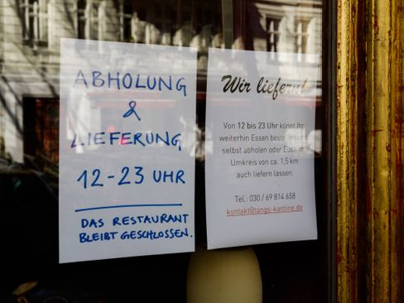

Closed cafe in Berlin

Photo: Carsten Thesing / imago images/Carsten Thesing

**"There is no longer a good scenario, it's just a question of how bad it will get,"** write my colleagues **Simon Book, Markus Dettmer and Michael Sauga in** the business section of the new issue of SPIEGEL, which this time **will be** published tomorrow and will be available online from midday today. The return of the pandemic could destroy tens of thousands of economic livelihoods. **50,000 stores could close, fears the German Trade Association (HDE)**. Christmas can no longer be good at all, a half-limited disaster would be the goal.

* [Merkel and the prime ministers: Four weeks against the wave](https://www.spiegel.de/politik/deutschland/corona-angela-merkel-und-die-ministerpraesidenten-beschliessen-shutdown-light-a-2ecb7ed1-87ea-4fc1-85d5-8e563431d968)

**Corona III - Special EU summit: Will the heads of state and government achieve cohesion this time?**

For tonight, EU Council President **Charles Michel** has called a special virtual summit so that **heads of state and government** can coordinate their **efforts to combat the corona crisis.** Almost all **EU countries are experiencing peak levels of** infection. France's President **Emmanuel Macron** announced exit restrictions again yesterday in a speech to the nation, in his words, **"a brutal braking maneuver**.**"** Michel hopes for progress especially in testing strategy and contact tracing.

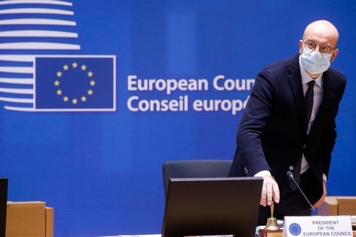

EU Council President Charles Michel

Photo: POOL THIERRY ROGE / imago images/Reporters

What will matter at tonight's meeting is not so much individual measures, but above all whether it is possible to establish **cohesion in principle.** The competencies for border protection and public health do not lie in the EU anyway, but with the member states or even in their regions. But the Council President's attempt to work informally to ensure that the EU presents a better image in these weeks than it did in the spring, when, for example, borders were closed without a vote, cannot do any harm. Impressions go a long way. The impression in the spring was devastating.

* [Plan against the virus: Corona test for the EU](https://www.spiegel.de/ausland/coronakrise-wie-die-eu-die-die-pandemie-einheitlich-bekaempfen-will-a-1a3bb0d7-fe23-4acc-80e0-e4fbb0cb4b58)

**Winner of the day...**

...is the city of **Chemnitz**. That there would still be news pictures like those from the city in the Ore Mountains yesterday was quite astonishing: jubilation, tears of joy and in the background "Freude schöner Götterfunken" when the **European selection jury for the "European Capital of Culture 2025"** announced that it was **recommending the** Saxon city **as the title winner**.

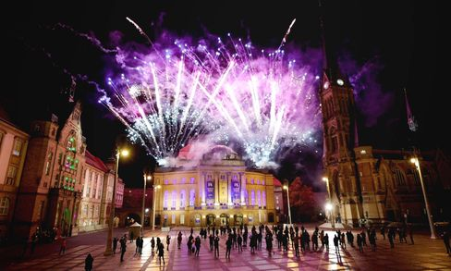

Theaterplatz in Chemnitz during the announcement of the selection jury

Photo: Harry Haertel / imago images/HärtelPRESS

Two years ago, there had been days of right-wing extremist riots in the city, and it rightly looked bad for the bid. But the city has done a lot to show that it wants to get rid of its bad reputation and is serious about it; it has earned its chance. Unlike Dresden, which also applied and was eliminated a long time ago, Chemnitz is not exactly full of culture, **the city has to have it freshly made**. Well, here goes, good luck.

* [Jury recommendation: Chemnitz to become European Capital of Culture in 2025](https://www.spiegel.de/kultur/chemnitz-wird-2025-kulturhauptstadt-europas-empfehlung-der-jury-a-a71b2db4-5ed4-4cf4-b9c8-5e351ee6e433)

**The latest news from the night**

* **U.S. indicts eight alleged Chinese agents:** They allegedly "harassed, stalked and coerced" Chinese dissidents in the U.S: Justice authorities indict eight alleged agents. [The prosecutor speaks of the first case of its kind](https://www.spiegel.de/ausland/usa-klagen-acht-angebliche-chinesische-agenten-wegen-einschuechterung-von-dissidenten-an-a-142fdd39-ab1d-4d95-810c-63e8bcec3d35)
* **Thousands of federal police to monitor compliance with Corona rules:** Interior Minister Seehofer wants to deploy federal police in hotspots and major cities to enforce Corona measures. [The quarantine obligation is also to be checked more closely](https://www.spiegel.de/politik/deutschland/corona-regeln-tausende-bundespolizisten-sollen-einhaltung-kontrollieren-a-4aa8545e-ed9e-4c8b-bace-a26953fbe23b)
* **Hanover light rail drags passenger a hundred meters:** He reached into the carriage to pick something up - that's when the door closed: In Hanover, a man was seriously injured by a light rail train. [The police investigates](https://www.spiegel.de/panorama/stadtbahn-hannover-schleift-fahrgast-hundert-meter-mit-a-233da5a8-14da-4afb-a54e-0a2971fffd8e)