**The location in the morning**

**"National effort" - the efforts of politics and their consequences**

By [Susanne Beyer](https://www.spiegel.de/impressum/autor-77cf5313-0001-0003-0000-000000001532), author in the SPIEGEL capital office

Dear reader, good morning,

today we are looking at what we can learn from the new Corona decisions and what the chancellor-prime minister's round can learn from the criticism of them. We are also looking at the consequences of the decisions for the economy, and we find only one reason to rejoice.

29.10.2020, 05.45 a.m.

**Corona I. - Much criticism of decisions of chancellor and prime minister**

It is common to start thinking about Christmas at the end of October, as the first cinnamon stars are already out in the shops. But in the past 24 hours, there has been an exaggerated amount of talk about Christmas: the prospect of a **reasonably normal celebration** - also a reasonably normal pre-Christmas business - has become a rhetorical means of promoting **understanding for the harsh corona measures** that the committee of chancellors and prime ministers decided on yesterday, and which the chancellor called a **"national effort",** with an emphasis on "national", if only to make it clear that this time she has succeeded in preventing individual prime ministers from pulling out.

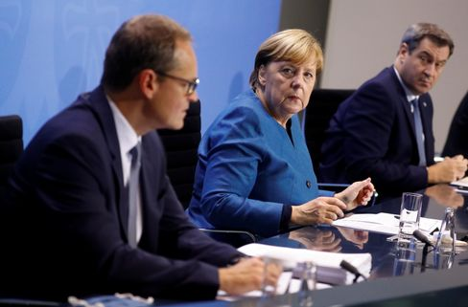

Angela Merkel with Berlin's Mayor Michael Müller and The Bavarian Prime Minister Markus Söder

Photo: Fabrizio Bensch / dpa

From 2 November, only **members of two households** will be allowed to meet in public – a maximum of ten people. Unnecessary **private trips** and visits by **relatives** should be avoided,**restaurants must close, as well as beauty salons, massage practices and tattoo parlors.** **Professional sports** should only take place without spectators, the amateur sports **operation** will be completely discontinued. **Theatres, operas and concert halls, including casinos, gambling halls, betting centres and brothels, must close,**as must **cinemas, amusement parks and fairs and also hotels,**at least for tourists.

The Chancellor and the prime ministers may have been in agreement this time, but the reactions outside the committee were sometimes harsh. Scientists and doctors around the virologist **Hendrik Streeck** consider it wrong to shut down public life again anyway. **Restaurateurs complained**that they had really taken care of everything, purchased air purification filters, implemented hygiene concepts – and now that. **Theatre bosses sent out open letters:**"We think it is wrong to ban cultural events."

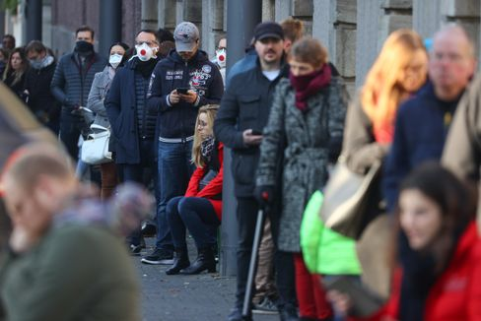

People in front of a corona test center in Frankfurt

Photo: KAI PFAFFENBACH/ REUTERS

In fact, restaurants, cinemas and theatres where responsible rules apply and are observed have so far hardly proved to be **centres of infection** – everything has been done, but not having achieved the goal is always frustrating. But even if it is really unfair for many individuals, the past few weeks have shown that the undergrowth of rules had become too impenetrable, offered too many loopholes, that the conditions of a cold season require a tougher, clearer crackdown. The calculation (infection events measured by the utilization of the intensive care beds) was simple – it could not go on like this.

It is right to take the measures, to limit them in time – to one month – and to provide financial compensation. But if the numbers should now go down again, the time gained must **be used to carefully examine the arguments of the critics** and then, if necessary, to go other ways from December.

* [Corona measures: These restrictions apply from Monday](https://www.spiegel.de/politik/deutschland/corona-krisengipfel-beschliesst-massive-einschraenkungen-ab-montag-a-da1173bc-9728-4930-9eef-92975f075210)

**Corona II . - The economy is facing a terrible November**

That the infection situation is likely to improve in the course of the next few weeks is a well-founded hope - it had already worked once in the spring, but at higher temperatures - but already now it is clear: **November will be terrible.** The great wave of bankruptcies had so far failed to materialize in Germany, the economy had been able to recover a little over the summer, but the new situation will have consequences.

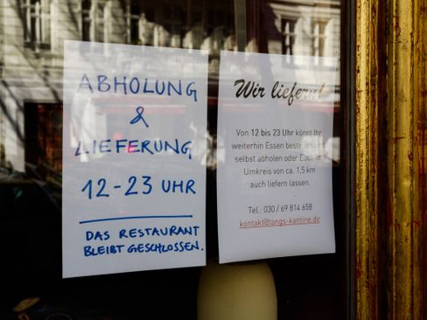

Closed café in Berlin

Photo: Carsten Thesing / imago images/Carsten Thesing

**"There is no longer a good scenario, it's just a question of how bad it will be,"**write my colleagues Simon **Book, Markus Dettmer and Michael Sauga** in the economic section of the new SPIEGEL issue, which this time will be published tomorrow and will be available online from noon today. The return of the pandemic could destroy tens of thousands of economic livelihoods. **50,000 shops could close, fears the German Trade Association (HDE).** Christmas can no longer be good, a reasonably limited disaster would be the goal.

* [Merkel and the prime ministers: Four weeks against the wave](https://www.spiegel.de/politik/deutschland/corona-angela-merkel-und-die-ministerpraesidenten-beschliessen-shutdown-light-a-2ecb7ed1-87ea-4fc1-85d5-8e563431d968)

**Corona III - Special SUMMIT of the EU: Will the heads of state and government manage to stick together this time?**

Eu Council President Charles **Michel** has convened a special virtual summit for this evening so that the heads of state and government can coordinate **their efforts to combat the corona crisis.** Almost all **EU countries have record high levels of** infections. French President **Emmanuel Macron** announced yesterday in a speech to the nation again exit restrictions, in his words: **"a brutal braking maneuver"**. Michel hopes for progress, especially on testing strategy and contact tracing.

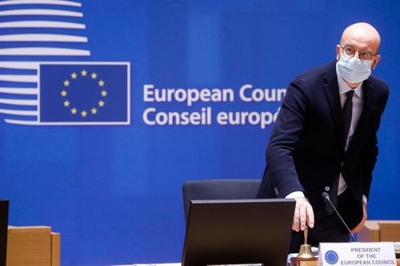

EU Council President Charles Michel

Photo: POOL THIERRY ROGE / imago images/Reporters

At this evening's meeting, it will be less a matter of individual measures than of whether we succeed in establishing **solidarity in principle.**  In any case, the competences for border protection and public health do not lie in the EU, but with the Member States or even in their regions. However, the attempt by the President-in-Office of the Council to work informally to ensure that the EU presents a better picture in these weeks than it did in the spring, when, for example, borders were closed without a vote, cannot do any harm. Impressions make a big difference. The impression in the spring was devastating.

* [Plan against the virus: Corona test for the EU](https://www.spiegel.de/ausland/coronakrise-wie-die-eu-die-die-pandemie-einheitlich-bekaempfen-will-a-1a3bb0d7-fe23-4acc-80e0-e4fbb0cb4b58)

**Winner of the day...**

... is the city **of Chemnitz**. The fact that yesterday there would still be news pictures like the one from the city in the Ore Mountains, was quite amazing: jubilation, tears of joy and in the background "joy of beautiful sparks of gods", when the **European selection jury for the "European Capital of Culture 2025"** has announced that it recommends the Saxon city as a **title winner.**

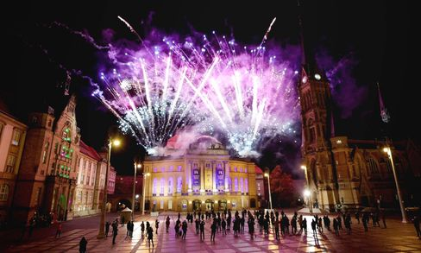

Theaterplatz in Chemnitz during the announcement of the selection jury

Photo: Harry Haertel / imago images/HärtelPRESS

Two years ago, there had been days of right-wing extremist riots in the city, and it rightly looked bad for the application. But the city has done a lot to show that it wants to get rid of its bad reputation, is serious about it; it deserves its chance. Unlike Dresden, which had also applied and had long since been eliminated, Chemnitz is not exactly full of culture, **the city must have it freshly produced.** Well then let's go, good luck.

* [Jury recommendation: Chemnitz to become European Capital of Culture in 2025](https://www.spiegel.de/kultur/chemnitz-wird-2025-kulturhauptstadt-europas-empfehlung-der-jury-a-a71b2db4-5ed4-4cf4-b9c8-5e351ee6e433)

**The latest news from the night**

* **US accuses eight alleged Chinese agents:** They are alleged to have "harassed, persecuted and coerced" Chinese dissidents in the US: The judicial authorities are accusing eight alleged agents. [The prosecutor speaks of the first case of this kind](https://www.spiegel.de/ausland/usa-klagen-acht-angebliche-chinesische-agenten-wegen-einschuechterung-von-dissidenten-an-a-142fdd39-ab1d-4d95-810c-63e8bcec3d35)
* **Thousands of federal police officers are to monitor compliance with the Corona rules:** Interior Minister Seehofer wants to use the Federal Police in hotspots and large cities to enforce the Corona measures. [The quarantine obligation is also to be reviewed more closely](https://www.spiegel.de/politik/deutschland/corona-regeln-tausende-bundespolizisten-sollen-einhaltung-kontrollieren-a-4aa8545e-ed9e-4c8b-bace-a26953fbe23b)
* **Stadtbahn Hannover drags passengers a hundred meters:** He reached into the wagon to pick something up - then the door closed: In Hanover, a man was seriously injured by a light rail. [The police are investigating](https://www.spiegel.de/panorama/stadtbahn-hannover-schleift-fahrgast-hundert-meter-mit-a-233da5a8-14da-4afb-a54e-0a2971fffd8e)