

Subscribe to DeepL Pro to edit this document.  
Visit www.DeepL.com/Pro for more information.

**The situation in the morning**

**Christmas is too much**

By [Markus Feldenkirchen](https://www.spiegel.de/impressum/autor-843a42fd-0001-0003-0000-000000001992), Writer at SPIEGEL's Capital Office

Dear reader, good morning,

Today we deal with the Christmas agitation of German politics. The energetic final spurt of the US President. And the precarious situation of the CDU.

30.10.2020, 05.57 o'clock

**Christmas is too much**

To keep Germany quiet from Monday, numerous state cabinets are meeting today. They are to decide on the **new Corona measures** agreed on Wednesday. There will also be special sessions of several state parliaments and government statements by various prime ministers. [The "Lockdown Light" will be translated into ordinances today.](https://www.spiegel.de/politik/deutschland/corona-angela-merkel-und-die-ministerpraesidenten-beschliessen-shutdown-light-a-2ecb7ed1-87ea-4fc1-85d5-8e563431d968)

I think the strategy of severely shutting down parts of our social life for a clearly defined period of time (the month of November) is appropriate given the high incidence of infection. The Robert Koch Institute reported [more than 18,600 new infections](https://www.spiegel.de/wissenschaft/medizin/coronavirus-robert-koch-institut-meldet-mehr-als-18-600-neue-faelle-a-cc82cc64-5e4e-4858-8908-1eb18ed08007) on Friday morning compared to Thursday. **What bothers me is the rationale**: Angela Merkel, Markus Söder, Armin Laschet and Co. are talking incessantly these days about: **"Christmas"**. They are doing all this now so that they can at least have a nice Christmas! With all my love for the festive season, I consider this form of motivation to be undercomplex.

How about: "We want to prevent the death of many fellow human beings! We want to prevent the loss of jobs - by stepping on the brakes for a short time now, so that we don't languish socially and economically for months with high infection rates and permanent concern about overloading the health care system." That would be a more logical motivation than the currently rampant Christmas sentiment. And I say that as an avowed Catholic.

* [This is how the shutdown negotiations went: After 90 minutes, there was already agreement](https://www.spiegel.de/politik/deutschland/coronavirus-so-wurde-der-shutdown-plan-verhandelt-a-d921caf6-41de-4a50-be53-54435b0f36df)

**Donald the grasshopper**

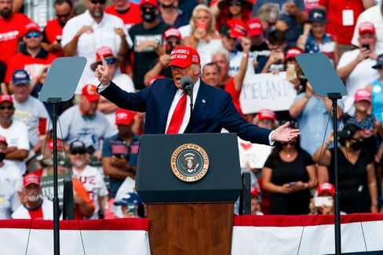

Donald Trump at yesterday's campaign rally in Florida

Photo: Ivy Ceballo / imago images/ZUMA Wire

In the final days **before next Tuesday's presidential election,** Donald Trump is tromping around the country like Flip the grasshopper. Or rather, through the **swing states**. These are the few US states that matter in presidential elections. In all the other states, Republicans and Democrats could run a scarecrow as a presidential candidate - it wouldn't change the outcome. Yesterday in Florida, Trump wants to appear today in Michigan, Wisconsin and Minnesota. In [any case,](https://www.spiegel.de/ausland/donald-trump-setzt-im-us-wahlkampf-auf-den-sieg-in-letzter-minute-a-9f90e211-d241-4980-9f4f-e720fb451325) he is [not](https://www.spiegel.de/ausland/donald-trump-setzt-im-us-wahlkampf-auf-den-sieg-in-letzter-minute-a-9f90e211-d241-4980-9f4f-e720fb451325) lacking in vigor in [the final spurt for political survival](https://www.spiegel.de/ausland/donald-trump-setzt-im-us-wahlkampf-auf-den-sieg-in-letzter-minute-a-9f90e211-d241-4980-9f4f-e720fb451325).

Yesterday, he was also able to announce positive news on his own behalf. The fact that the U.S. economy grew more strongly in the third quarter of this year than ever before shows how well he is doing this country. That's how he celebrated himself. Of course, he omitted to mention that his **abstruse Corona management** had previously contributed to the dramatic slump in the economy.

To be on the safe side, I continue to assume that Trump will be re-elected. Anything else would be a pleasant surprise.

* [Hate, culture war, discord: What remains of Trump - even if he has to go](https://www.spiegel.de/ausland/donald-trump-was-von-ihm-bleibt-selbst-wenn-er-gehen-muss-a-00000000-0002-0001-0000-000173743533)

**"Markus Söder takes a relaxed view".**

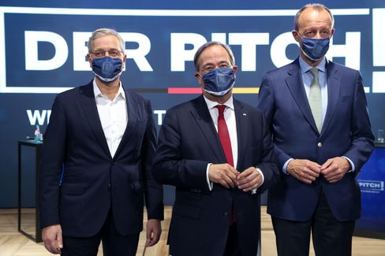

The three candidates for CDU party chair: Röttgen, Laschet and Merz

Photo: ADAM BERRY/POOL/EPA-EFE/Shutterstock

The fact that the candidates for the **CDU party chair are** not really green to each other [has been](https://www.spiegel.de/politik/deutschland/friedrich-merz-nach-absage-von-cdu-parteitag-der-wuetende-kandidat-a-eab90881-6efc-49f4-bc3c-fe17dbd02264) obvious at least [since Friedrich Merz's venomous statement](https://www.spiegel.de/politik/deutschland/friedrich-merz-nach-absage-von-cdu-parteitag-der-wuetende-kandidat-a-eab90881-6efc-49f4-bc3c-fe17dbd02264) after the CDU party conference planned for Dec. 4 was canceled. "I have clear indications that Armin Laschet has issued the motto: He needs more time to improve his performance. After all, I'm clearly leading in all the polls. If things were different, there would certainly still have been an election this year," Merz explained in an interview with Die Welt and [later tweeted his quote to the world himself](https://twitter.com/_FriedrichMerz/status/1320776592143142914) - so that everyone would know.

My colleagues Florian Gathmann, Christoph Hickmann and Veit Medick have now reconstructed **how the meeting between the three candidates and the party leadership took place last Sunday**. In a sense, the text is the prequel to Merz's eruption and exposes the mutual distrust of those who want to lead the party and the country in the future. And the helplessness of those who are still supposed to lead the CDU but can no longer do so. If what is currently happening didn't have a certain entertainment value, one could almost feel sorry for the CDU. "I don't do anything with the press," Merz said at the end of the five-hour meeting, which ended without a peaceful agreement. And followed up with a threat. If Laschet blabs from the meeting or knocks down stakes, "then I'll follow suit."

"As long as we don't have a chairman, we as the CDU can**'t propose a candidate for chancellor,**" Norbert Röttgen is reported to have said at Sunday's meeting. "Markus Söder is looking at this in a very relaxed way." Röttgen is probably right.

Incidentally, the last time the CDU staggered around plucked and leaderless (between 2000 and 2002), it left the **chancellorship to** the leader of **its sister party, the CSU**. Edmund Stoiber lost, the CDU recovered and, under Angela Merkel's leadership, established a long era of female chancellors.

* [CDU summit: Five hours of self-destruction - the minutes](https://www.spiegel.de/politik/deutschland/cdu-machtkampf-fuenf-stunden-selbstzerstoerung-das-protokoll-a-00000000-0002-0001-0000-000173743552)

**Winner of the day...**

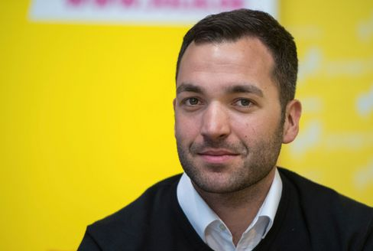

FDP politician Konstantin Kuhle, 2018

Photo: Monika Skolimowska/ dpa

...is the FDP politician **Konstantin Kuhle**. After the cruel knife attack by an Islamist terrorist in Nice, which claimed the lives of three people and seriously injured others, interior expert Kuhle spontaneously announced a memorial gathering in front of the French Embassy on Pariser Platz. Many people followed the call for a minute's silence to mourn the victims of Islamist terror in Nice, Paris or Dresden. Among them, according to a public announcement, was Juso leader Kevin Kühnert, who had recently complained in a [guest article for SPIEGEL](https://www.spiegel.de/politik/deutschland/kevin-kuehnert-ueber-islamismus-die-politische-linke-sollte-ihr-schweigen-beenden-a-5133948b-bac7-490a-a56a-a42d87a62532) that the political left in Germany unfortunately found no words for Islamist terror. And that it had to "deal with this blind spot. At any rate, Kühnert is not the reason for this.

**The latest news from the night**

* **Walmart clears guns and ammunition from shelves ahead of US election:** "For the safety of employees and customers"**:** A few days before the U.S. election, Walmart is removing all guns from its store shelves. [But you can still buy them](https://www.spiegel.de/wirtschaft/unternehmen/walmart-raeumt-vor-us-wahl-waffen-und-munition-aus-den-regalen-a-b3c1e436-76b8-4062-bf7b-1303ed262c78)
* **Scarlett Johansson got married:** an intimate ceremony respecting the Corona rules: The actress and US comedian Colin Jost said yes - [and used the occasion for a fundraising appeal](https://www.spiegel.de/panorama/leute/scarlett-johansson-und-colin-jost-haben-geheiratet-jost-married-a-7a85f4a8-c615-40e7-9a48-a8a78144248c)
* **Dude, there's still room for improvement:** On the old slot of "Neo Magazin Royale," Ariane Alter isn't even trying to succeed Jan Böhmermann. ["Late Night Alter" has a new approach, but less ambition.](https://www.spiegel.de/kultur/tv/late-night-alter-neues-format-bei-zdfneo-da-ist-noch-luft-nach-oben-a-10c3f1b9-a527-4a00-b61d-84125d4e169a)