**The location in the morning**

**It's too much Christmas**

By [Markus Feldenkirchen](https://www.spiegel.de/impressum/autor-843a42fd-0001-0003-0000-000000001992), author in the SPIEGEL capital office

Dear reader, good morning,

today we are dealing with the Christmas turmergy of German politics. The energetic final spurt of the US president. And the precarious situation of the CDU.

10-30-2020, 05:57 AM

**It's too much Christmas**

In order to silence Germany from Monday, numerous state cabinets are meeting today. They are to adopt the **new corona measures** agreed on Wednesday. In addition, there are special sessions of several state parliaments and government statements by various prime ministers. [The "lockdown light" is now being converted into regulations.](https://www.spiegel.de/politik/deutschland/corona-angela-merkel-und-die-ministerpraesidenten-beschliessen-shutdown-light-a-2ecb7ed1-87ea-4fc1-85d5-8e563431d968)

I believe that the strategy of greatly shutting down parts of our social life for a clearly defined period of time (the month of November) is appropriate in view of the high level of infection. The Robert Koch Institute reported [more than 18,600 new infections](https://www.spiegel.de/wissenschaft/medizin/coronavirus-robert-koch-institut-meldet-mehr-als-18-600-neue-faelle-a-cc82cc64-5e4e-4858-8908-1eb18ed08007) on Friday morning compared to Thursday. **What bothers me is the reasoning:**Angela Merkel, Markus Söder, Armin Laschet and Co. are constantly talking about **'Christmas'**thesedays. Do all this now to at least be able to celebrate Christmas! With all the love for the feast: I consider this form of motivation to be under-complex.

How about: "We want to prevent the death of many fellow human beings! We want to prevent the loss of jobs - by stepping on the brakes for a moment, so as not to languing socially and economically for months with high infection rates and permanent concern about overloading the health system." That would be a more logical motivation than the currently rampant Christmas emotion. And I say that as an avowed Catholic.

* [This is how the shutdown negotiations went: After 90 minutes, there was already agreement](https://www.spiegel.de/politik/deutschland/coronavirus-so-wurde-der-shutdown-plan-verhandelt-a-d921caf6-41de-4a50-be53-54435b0f36df)

**Donald the Grasshopper**

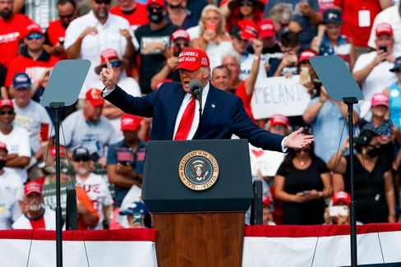

Donald Trump at yesterday's campaign rally in Florida

Photo: Ivy Ceballo / imago images/ZUMA Wire

In the last days **before the presidential election next Tuesday,** Donald Trump is tingling through the country like Flip, the grasshopper. Or better: through the **Swing States.** These are the few US states that matter in presidential elections. In all the other states, Republicans and Democrats could also run for president with a scarecrow - it wouldn't change the result. Yesterday in Florida, Trump wants to perform today in Michigan, Wisconsin and Minnesota. In any case, he does not lack enthusiasm [in the final sprint for political survival.](https://www.spiegel.de/ausland/donald-trump-setzt-im-us-wahlkampf-auf-den-sieg-in-letzter-minute-a-9f90e211-d241-4980-9f4f-e720fb451325)

Yesterday he was also able to announce positive news on his own behalf. The fact that the US economy grew faster than ever before in the third quarter of this year shows how well he is doing this country. So he celebrated himself. Of course, he omitted the hint that his **abstruse Corona management** had previously contributed to the dramatic slump in the economy.

As a precaution, I continue to assume that Trump will be re-elected. Anything else would then be a pleasant surprise.

* [Hate, culture war, discord: what remains of Trump - even if he has to go](https://www.spiegel.de/ausland/donald-trump-was-von-ihm-bleibt-selbst-wenn-er-gehen-muss-a-00000000-0002-0001-0000-000173743533)

**"Markus Söder takes a relaxed look at it"**

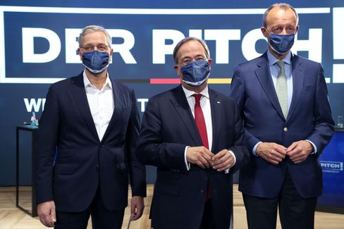

The three candidates for the CDU party chairmanship: Röttgen, Laschet and Merz

Photo: ADAM BERRY/POOL/EPA-EFE/Shutterstock

The fact that the candidates for the **CDU party chairmanship**  are not really green has been obvious at the latest since [the poisonous statement of Friedrich Merz,](https://www.spiegel.de/politik/deutschland/friedrich-merz-nach-absage-von-cdu-parteitag-der-wuetende-kandidat-a-eab90881-6efc-49f4-bc3c-fe17dbd02264)  after the CDU party congress planned for 4 December was cancelled. "I have clear indications that Armin Laschet has issued the motto: He needs more time to improve his performance. I also lead clearly in all polls. If it were different, there would certainly have been another election this year," Merz explained in an interview with "Welt" and  [later tweeted his quote himself into the world](https://twitter.com/_FriedrichMerz/status/1320776592143142914) - so that everyone would get it.

My colleagues Florian Gathmann, Christoph Hickmann and Veit Medick have now reconstructed **how the meeting of the three candidates with the party leadership took place last Sunday.** The text is, in a way, the prehistory to Merz's eruption and reveals the mutual mistrust of those who want to lead the party and the country in the future. And the helplessness of those who are still supposed to lead the CDU, but can no longer do so. If what is currently happening did not have a certain entertainment value, the CDU could almost feel sorry for you. "I don't do anything with the press," Merz said at the end of the five-hour meeting, which ended without a peaceful agreement. And pushed a threat behind. If Laschet from the meeting chatter or picks up pegs, "then I'll follow suit".

"As long as we do not have a chairman, we as the CDU cannot **propose a candidate for chancellor,"**NorbertRöttgen is said to have said at the meeting on Sunday. Markus Söder takes a relaxed look at it." Röttgen is probably right.

By the way, the last time the CDU was plucked and staggered around leaderless (between 2000 and 2002), the chairman **of the sister party CSU**was left to run forchancellor. Edmund Stoiber lost, the CDU rallied again and established a long chancellor era under Angela Merkel's leadership.

* [CDU summit: Five hours of self-destruction - the protocol](https://www.spiegel.de/politik/deutschland/cdu-machtkampf-fuenf-stunden-selbstzerstoerung-das-protokoll-a-00000000-0002-0001-0000-000173743552)

**Winner of the day...**

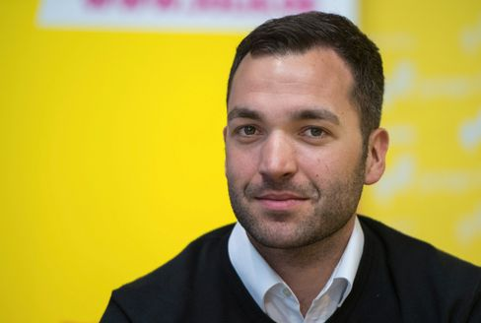

FDP politician Konstantin Kuhle, 2018

Photo: Monika Skolimowska/ dpa

... is the FDP politician **Konstantin Kuhle**. After the gruesome knife attack by an Islamist terrorist in Nice, which killed three people and seriously injured others, interior expert Kuhle spontaneously announced a memorial meeting in front of the French Embassy on Pariser Platz. Many people responded to the call for a minute's silence to mourn the victims of Islamist terror in Nice, Paris or Dresden. Among them, after a public announcement, was Juso chief Kevin Kühnert, who had recently complained in a [guest article for DER SPIEGEL](https://www.spiegel.de/politik/deutschland/kevin-kuehnert-ueber-islamismus-die-politische-linke-sollte-ihr-schweigen-beenden-a-5133948b-bac7-490a-a56a-a42d87a62532) that the political left in Germany unfortunately could not find words for Islamist terror. And had to "deal with this blind spot". In any case, kühnert does not fail this occupation.

**The latest news from the night**

* **Walmart removes weapons and ammunition from the shelves before US election:** "For the safety of employees and customers": A few days before the ballot in the USA, Walmart removes all weapons from its sales rooms. [But you can still buy them](https://www.spiegel.de/wirtschaft/unternehmen/walmart-raeumt-vor-us-wahl-waffen-und-munition-aus-den-regalen-a-b3c1e436-76b8-4062-bf7b-1303ed262c78)
* **Scarlett Johansson got married:** An intimate ceremony taking into account the Corona rules: The actress and the US comedian Colin Jost have said yes - and took the opportunity for a call for [donations](https://www.spiegel.de/panorama/leute/scarlett-johansson-und-colin-jost-haben-geheiratet-jost-married-a-7a85f4a8-c615-40e7-9a48-a8a78144248c)
* **Age, there is still room for improvement:** On the old broadcasting site of "Neo Magazin Royale", Ariane Alter does not even try to succeed Jan Böhmermann. ["Late Night Alter" has a new approach, but less claim](https://www.spiegel.de/kultur/tv/late-night-alter-neues-format-bei-zdfneo-da-ist-noch-luft-nach-oben-a-10c3f1b9-a527-4a00-b61d-84125d4e169a)