

Subscribe to DeepL Pro to edit this document.  
Visit www.DeepL.com/Pro for more information.

**The situation in the morning**

**The denunciator: a nasty bogeyman**

By [Markus Feldenkirchen](https://www.spiegel.de/impressum/autor-843a42fd-0001-0003-0000-000000001992), Writer at SPIEGEL's Capital Office

Dear reader, good morning,

Today we are dealing with the late opening of a regional airport. The self-criticism of Wolfgang Schäuble. And a particularly unpleasant contemporary: the denunciator.

10/31/2020, 06:49 PM

**Berlin opens an airport - exclusively for Berlin and Brandenburg**

Two days ago, I landed once again in Berlin-Tegel. It was a strange feeling, a touch of parting pain. Because for all the disadvantages it had, I liked this airport. It was somehow cuddly. Tegel exuded the charm of the untimely. Long since retired, it had to wait nine years for its replacement.

Today, the **breakdown airport BER** finally opens. **But does it live up to the promises made by many?**

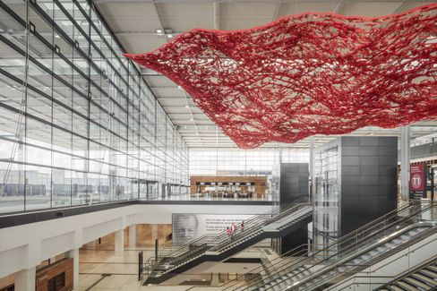

BER Airport: Wide World - or Provincial Airport?

Photo: Marcus Bredt / GMP

The new Berlin airport was always associated with the **dream** that it could **finally connect the capital to the big wide world**. There were hardly any intercontinental flights from Tegel. BER was supposed to become **another German hub**, alongside Frankfurt and Munich. But nothing is likely to come of it, analyze my colleagues **Dinah Deckstein**, **Claus Hecking** and **Martin U. Müller**. There is exactly one long-haul connection at the start - and, strictly speaking, it is not one at all. The gate for the Airbus A380 was built for nothing anyway. Airbus has long since declared that it will cease production of the mega-jet. **"BER will be an airport for Berlin and Brandenburg,"** Müller believes. "**Nothing more."**

* Berlin-Brandenburg Airport: [The would-be hub](https://www.spiegel.de/wirtschaft/unternehmen/flughafen-berlin-brandenburg-ber-die-drehscheibe-die-keine-ist-a-00738e3a-0736-48cc-9f99-c31bb90863e9)

**Climate rescue or freedom?**

My colleague Jonas Schaible and I met with activist **Luisa Neubauer** and Bundestag President **Wolfgang Schäuble to** discuss the **climate crisis:** What is the fault of the Schäuble generation? Is the Neubauer generation overdoing it?

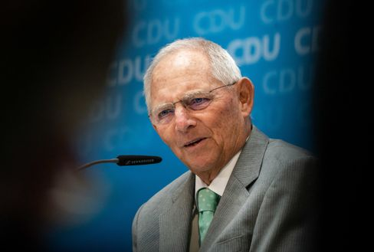

Wolfgang Schäuble

Photo: Michael Kappeler/DPA

Schäuble, you have to hand it to him, was extremely self-critical. **"We overdid it with capitalism,"** he admitted, for example.

What I found most exciting were their statements on the problem that democratic processes are often laborious and slow, too slow perhaps to stop climate change. **"When faced with the alternative of pushing something through quickly or slowly, I tend to favor slow,"** Schäuble said. **"Because the price of acting quickly is the loss of freedom."**

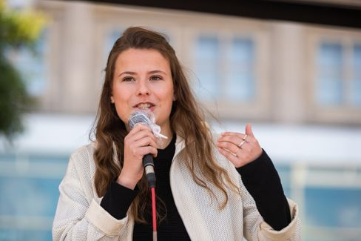

Luisa Neubauer

Photo: Christoph Soeder / dpa

Neubauer strongly disagreed: **"The price for slow action is an escalating climate crisis. And nothing will rob us of more freedoms than this crisis. The slower we are, the greater the destruction, the greater the restriction of freedom in the end."** The fatal thing is: **both are right in some ways.**

* Bundestag president meets climate activist: ["If Ms. Neubauer says yes now, it's nonsense"](https://www.spiegel.de/politik/deutschland/luisa-neubauer-und-wolfgang-schaeuble-ueber-die-schuld-der-aelteren-generation-am-klimawandel-a-00000000-0002-0001-0000-000173621997)

**Who rides the tiger**

For the past two years, **Islamabad** has been ruled by a man whom the world actually knows as a sports ace and cricket world champion, a kind of Franz Beckenbauer of the subcontinent: **Imran Khan**. At some point, the Oxford student had enough of the playboy life in London. He went into politics to free Pakistanis from poverty and corruption. That was 24 years ago. Now Khan has reached the top.

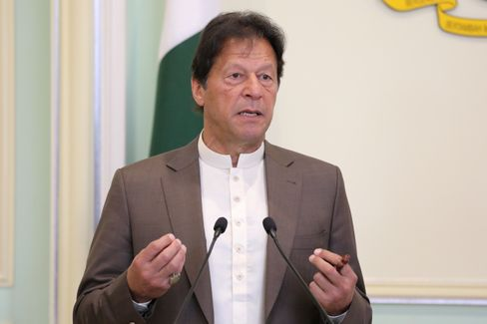

 Imran Khan

Photo: LIM HUEY TENG / REUTERS

My colleague Susanne Koelbl met **a strained prime minister in** Islamabad who is wrestling **with all kinds of demons at the same time**: with the **powerful army generals who** are playing their own sinister game with him and keeping the country firmly in their grip. With the **opposition,** which has conspired against him since Khan threatened to put their leaders behind bars for pathological kleptocracy. Besides, the nuclear state with its 220 million inhabitants is actually **broke**. And then there's neighbor and **arch-enemy India**, a country for which Khan has drastic words in the interview: "India has the most extreme, racist government in the subcontinent and is a threat to its neighbors, even China." It is, he says, "a fascist state inspired by the Nazis in the twenties and thirties."

Ruling Pakistan, they say, is like riding a tiger. Kahn is currently experiencing this. But he is determined to stay on top for longer.

* Pakistan's PM Khan: ["India is a fascist state inspired by the Nazis".](https://www.spiegel.de/ausland/pakistans-premier-imran-khan-indien-ist-ein-faschistischer-staat-inspiriert-von-den-nazis-a-00000000-0002-0001-0000-000173743587)

**Loser of the day...**

...are **all denunciators in Germany**. Today I'm referring in particular to that unpleasant contemporary who sat diagonally behind **Armin Laschet on** a **plane from Cologne to Berlin a** few days ago. (No, it was not Friedrich Merz). He secretly took a picture of Laschet, whose mask was only dangling from his left ear at the moment the picture was taken. Later, he sent the photograph to the "Bild" newspaper.

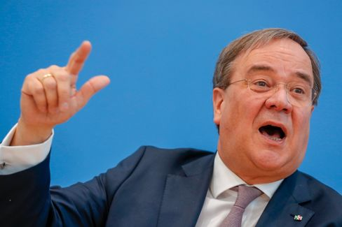

Armin Laschet

Photo: Odd Andersen / AFP

What kind of character do you have to have to do something like that? In **the Rhineland, there is a nice term for such types: fieser Möpp**. The fact that the "Bild" newspaper, which usually likes to complain harshly about denunciators, presented the photo on its front page didn't make matters any better.

**The latest news from the night**

* **Azerbaijan reports further territorial gains - exchange of dead agreed**: Armenia and Azerbaijan appear to have made minimal headway in the Nagorno-Karabakh conflict during negotiations in Switzerland. [Meanwhile, Baku claims the conquest of new territory in the conflict region](https://www.spiegel.de/ausland/bergkarabach-aserbaidschan-meldet-nach-friedensgespraechen-weitere-gebietsgewinne-a-21023c1a-b7bc-4420-90dc-569c24f4e500)
* **Tens of thousands of Poles demonstrate again against stricter abortion law**: In Warsaw, thousands have again taken to the streets against a tightening of abortion law. [Meanwhile, President Duda announced changes to the planned law](https://www.spiegel.de/ausland/polen-zehntausende-demonstrieren-erneut-gegen-strikteres-abtreibungsrecht-a-0fffb4bb-df01-4edc-b436-e5be6ebbe1f9)
* **Judge stops U.S. plans to** ban **TikTok in November:** Donald Trump wanted to ban the app TikTok from November 12. However, nothing will come of this for the time being: [a court in Pennsylvania has issued a temporary injunction](https://www.spiegel.de/netzwelt/apps/tiktok-richterin-stoppt-us-plaene-fuer-aus-von-app-im-november-a-8f6cfcdb-7744-4427-96b4-69716b4706c3)