**The location in the morning**

**The informer: a nasty möpp**

By [Markus Feldenkirchen](https://www.spiegel.de/impressum/autor-843a42fd-0001-0003-0000-000000001992), author in the SPIEGEL capital office

Dear reader, good morning,

today we are dealing with the late opening of a regional airport. Der Selbstkritik von Wolfgang Schäuble. And a particularly unpleasant contemporary: the informer.

10-31-2020, 06:49 AM

**Berlin opens an airport – exclusively for Berlin and Brandenburg**

Two days ago I landed again in Berlin-Tegel. It was a strange feeling, a touch of parting pain. Because for all the drawbacks it had, I liked this airport. He was kind of cuddly. Tegel exuded the charm of the untimely. Long at the airport retirement age, he had to wait nine years for his replacement.

Today, the **breakdown airport BER** is finally opened. **But does he keep what many of him have promised?**

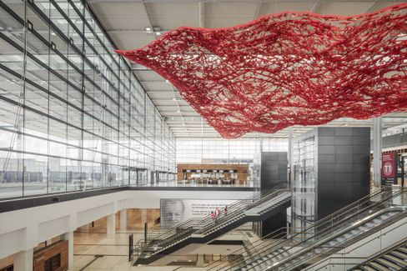

BER Airport: Wide world – or provincial airport?

Photo: Marcus Bredt / GMP

With the new Berlin airport was always connected **the dream,** he could finally connect the capital to the big wide **world.** There were hardly any intercontinental flights from Tegel. BER was to become **another German hub,** alongside Frankfurt and Munich. But nothing should come of it, my colleagues **Dinah Deckstein**, Claus **Hecking** and **Martin U. Müller**analyze. There is exactly one long-distance connection at the start – and strictly speaking, it is not one at all. The gate for the Airbus A380 was built for free anyway. Airbus has long since declared that it will stop production of the megajet. **"BER will be an airport for Berlin and Brandenburg,"**müller believes. "Nothing**more."**

* Berlin-Brandenburg Airport: [The wannabe hub](https://www.spiegel.de/wirtschaft/unternehmen/flughafen-berlin-brandenburg-ber-die-drehscheibe-die-keine-ist-a-00738e3a-0736-48cc-9f99-c31bb90863e9)

**Climate rescue or freedom?**

My colleague Jonas Schaible and I met with the activist **Luisa Neubauer** and Bundestag President Wolfgang **Schäuble** to discuss the climate **crisis:** What is the fault of the Schäuble generation? Is the Neubauer generation exaggerating?

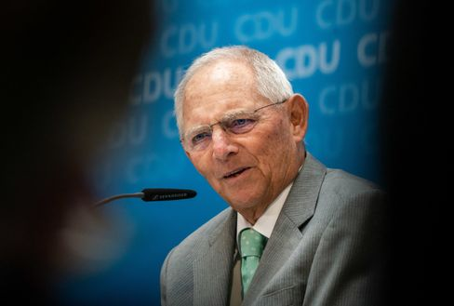

Wolfgang Schäuble

Photo: Michael Kappeler/DPA

Schäuble, you have to leave that to him, was extremely self-critical. **'We have exaggerated capitalism',**he admitted, for example.

What I found most exciting were the statements of the two on the problem that democratic processes are often laborious and slow, perhaps too slow to stop climate change. **"If I am faced with the alternative of implementing something quickly or slowly, I am more in favour of slow,"**said Schäuble. **"Because the price of acting quickly is the loss of freedom."**

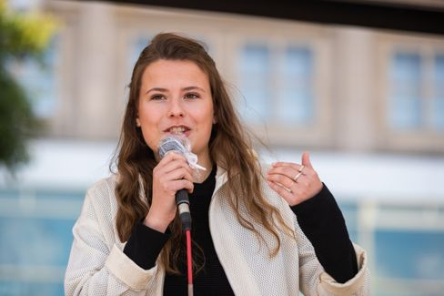

Luisa Neubauer

Photo: Christoph Soeder / dpa

Neubauer strongly disagreed: **"The price of slow action is an escalating climate crisis. And nothing will rob us of more freedom than this crisis. The slower we are, the greater the destruction, the greater the restriction of freedom in the end."** The fatal thing is that both are right in some **respects.**

* Bundestag President meets climate activist: ["If Mrs. Neubauer now says yes, it's nonsense"](https://www.spiegel.de/politik/deutschland/luisa-neubauer-und-wolfgang-schaeuble-ueber-die-schuld-der-aelteren-generation-am-klimawandel-a-00000000-0002-0001-0000-000173621997)

**Who rides the tiger**

For two years , a man has ruled **Islamabad**, whom the world actually knows as a sports ace and cricket world champion , a kind of Franz Beckenbauer of the subcontinent : **Imran Khan**. At some point, the Oxford pupil had had enough of Playboy life in London. He entered politics to rid Pakistanis of poverty and corruption. That was 24 years ago. Now the Khan has reached the top.

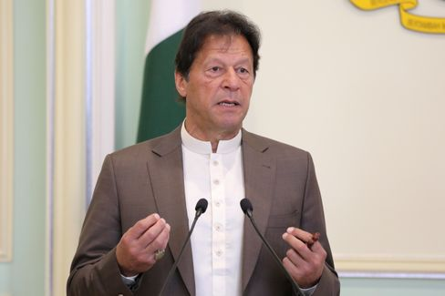

Imran Khan

Photo: LIM HUEY TENG / REUTERS

My colleague Susanne Koelbl met **a hard-working prime minister**in Islamabad who is struggling with all kindsof demons at the same **time:** with the powerful army **generals**who are playing their own dark game with him and keeping the country firmly undercontrol. With the **opposition**thathas conspired against him since Khan threatened to put their leaders behind bars for pathological kleptocracy. In addition, the nuclear state with its 220 million inhabitants is actually **bankrupt.** And then there's neighbor and **arch-enemy India,**a country for which Khan finds drastic words in the interview: "India has the most extreme, racist government on the subcontinent and is a threat to its neighbors, even China." It is "a fascist state, inspired by the Nazis in the twenties and thirties".

Governing Pakistan, it is said, is riding like a tiger. Kahn is experiencing this. But he is determined to stay up even longer.

* Pakistan's Prime Minister Khan: ["India is a fascist state inspired by the Nazis"](https://www.spiegel.de/ausland/pakistans-premier-imran-khan-indien-ist-ein-faschistischer-staat-inspiriert-von-den-nazis-a-00000000-0002-0001-0000-000173743587)

**Loser of the day...**

... are **all informers in Germany.** Today I am referring above all to the unpleasant contemporary who, a few days ago, sat diagonally behind **Armin Laschet**  on a plane from Cologne to **Berlin.** (No, it wasn't Friedrich Merz). He secretly photographed Laschet, whose mask dangled only on his left ear at the moment of the shot. Later he sent the recording to the "Bild" newspaper.

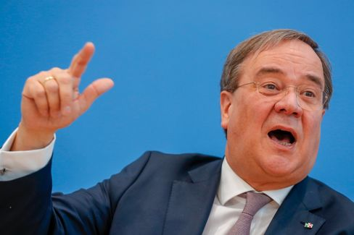

Armin Laschet

Photo: Odd Andersen / AFP

How do you have to be characterful to do something like this? **In the Rhineland there is a nice term for such types: nasty möpp**. The fact that the "Bild" newspaper, which otherwise likes to complain sharply about informers, presented the photo on its front page did not make things any better.

**The latest news from the night**

* **Azerbaijan reports further territorial gains – exchange of dead**agreed: During negotiations in Switzerland, Armenia and Azerbaijan have apparently come minimally closer together in the Nagorno-Karabakh conflict. [Baku, meanwhile, claims the conquest of new areas in the conflict region](https://www.spiegel.de/ausland/bergkarabach-aserbaidschan-meldet-nach-friedensgespraechen-weitere-gebietsgewinne-a-21023c1a-b7bc-4420-90dc-569c24f4e500)
* **Tens of thousands of Poles are demonstrating again against stricter abortion**rights: thousands have once again taken to the streets in Warsaw against a tightening of abortion rights. [President Duda, meanwhile, announced changes to the proposed law](https://www.spiegel.de/ausland/polen-zehntausende-demonstrieren-erneut-gegen-strikteres-abtreibungsrecht-a-0fffb4bb-df01-4edc-b436-e5be6ebbe1f9)
* **Judge stops US plans to shut down TikTok in November:** Donald Trump wanted to ban the TikTok app from November 12. But nothing will come of it for now: [A court in Pennsylvania has issued an injunction](https://www.spiegel.de/netzwelt/apps/tiktok-richterin-stoppt-us-plaene-fuer-aus-von-app-im-november-a-8f6cfcdb-7744-4427-96b4-69716b4706c3)