

Subscribe to DeepL Pro to edit this document.  
Visit www.DeepL.com/Pro for more information.

**The situation in the morning**

**Germany drives down again**

By [Sebastian Fischer](https://www.spiegel.de/impressum/autor-9c4e5259-0001-0003-0000-000000000166), Head of SPIEGEL's Capital Bureau

Dear reader, good morning,

what a week it will be! What kind of week is it going to be? Exclamation marks, question marks, all justified. Today we're looking at the approaching US elections and the beginning of the Corona Shutdown in Germany.

02.11.2020, 05.48 o'clock

**The decision of the year**

This week, on Tuesday, Americans have a choice between a democracy destroyer and a democracy preserver. All of us, **the whole world, will be shaped by the outcome of this election**. We cannot participate.

It still sounds surreal: the country that brought us democracy an age ago is now seriously wrestling with this alternative: destroyer Donald Trump versus preserver Joe Biden. That Trump has any realistic chance of remaining in office still defies **political rationality,** despite so many illuminating explanations.

And the chance is always realistic.

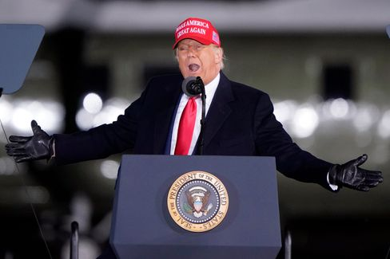

Trump in North Carolina on Nov. 1

Photo: Chris Carlson / AP

The clear lead in the polls that Biden enjoys nationwide and in key swing states two days before the election is, after all, a **purely virtual lead**. According to the latest New York Times survey, Biden is ahead of Trump in Pennsylvania, Wisconsin, Florida and Arizona. Trump won all four against Hillary Clinton in 2016, paving the way for his victory.

Are they now putting him on the losing track? But would he accept defeat at all?

Over the weekend, the president sought to sow renewed [distrust with regard to the electoral process and absentee ballots](https://www.spiegel.de/ausland/us-wahlen-donald-trump-prophezeit-chaotisches-durcheinander-a-ef3f3484-7a3b-42ab-8534-005b1ee478e9): "The whole world and our country will wait and wait and wait to know who won, you will wait for weeks." Nov. 3 will come and go, he said, and there will be no way to know: "And you will have **chaotic confusion** in our country."

More than 90 million Americans have already cast their votes - that's already two-thirds of the total number of votes cast in 2016. A **record turnout** is to be expected. But record is relative: if 65 percent of eligible voters cast their ballots, that would already be a record by US standards.

* [Presidential Elections in the USA: Another Four Years of Trump?](https://www.spiegel.de/wirtschaft/wahlen-in-den-usa-halten-wir-vier-weitere-jahre-donald-trump-aus-a-a70ed0f3-0e92-40da-a919-79e7e7af5eb4)

**Will Trump stay if Biden comes?**

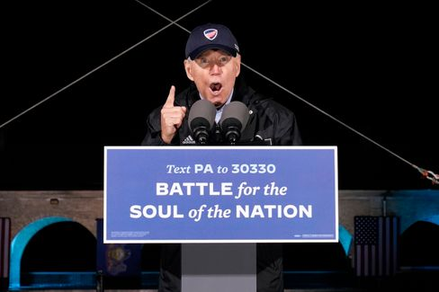

Joe Biden in Philadelphia on Nov. 1

Photo: Andrew Harnik / dpa

If **Joe Biden** wins, he will not be able to simply put the country back on the old track. Even if he promises to do so and may see Trump only as an aberration of history. In fact, Biden would not be able to pick up where Barack Obama left off four years ago - but **would have to follow Trump**.

That's why I would like to recommend our current [SPIEGEL cover story](https://www.spiegel.de/ausland/donald-trump-was-von-ihm-bleibt-selbst-wenn-er-gehen-muss-a-00000000-0002-0001-0000-000173743533): What remains of Trump - even if he has to go. After all, Trump is not the sole cause of the division of the nation, but **a symptom of a profound crisis that will** not disappear when Trump leaves.

And there's something else: We humans tend to get used to everything. That ensures our survival, but it also sometimes makes us blind. **We have gotten used to Trump**, to his hatred, his stupidity, his racism.

The great U.S. storyteller Philip Roth wrote of the "terror of the unforeseen" in his book "Conspiracy Against America," which imagines a presidency of the aviator and Nazi Charles Lindbergh in the 1940s. In the historical retrospect such unforeseen events would be unfortunately represented as inevitable, one event follows the other chronologically. In other words, there is a tendency to rationalize away the disruptions. A disaster, Roth writes, then simply becomes a narrative. We should never forget the Trump disaster.

* [Hate, culture war, discord: what remains of Trump](https://www.spiegel.de/ausland/donald-trump-was-von-ihm-bleibt-selbst-wenn-er-gehen-muss-a-00000000-0002-0001-0000-000173743533) [-](https://www.spiegel.de/ausland/donald-trump-anhaenger-rammen-joe-bidens-wahlkampffahrzeug-fbi-ermittelt-a-930dc76f-cbd9-4565-9918-2955f4ecbc7c) [even if he has to go](https://www.spiegel.de/ausland/donald-trump-was-von-ihm-bleibt-selbst-wenn-er-gehen-muss-a-00000000-0002-0001-0000-000173743533)

**Closed society**

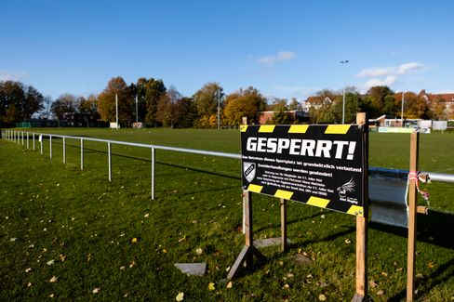

Barrier sign in front of Kiel sports field: Partial shutdown in Germany begins today

Photo: Frank Molter / dpa

Starting today, we all face big decisions in small ways every day in our country as well: [The second shutdown in the fight against the coronavirus](https://www.spiegel.de/wissenschaft/coronavirus-news-am-sonntag-zweiter-lockdown-kostet-wirtschaft-19-milliarden-euro-und-600-000-jobs-a-2d897a43-cfca-43a8-bfd3-251dbc977281) begins, and it is **expected to last until the end of the month**. How many will comply? And how large will the minority still be in the future that has partly gambled away the initial successes in the past months with its unsolidary behavior?

While the first wave in spring was still a natural disaster to which society, science and politics had to find (new) answers, the second wave is primarily **man-made**. Because we knew what we should and should not have done.

This last weekend before the shutdown was not all encouragement. At the entrance to my house, for example, there was a note from a club: they wanted to have another party and apologized for the loud noise.

Probably the volume is the least of our problems.

Knocking one more out before we're all back in it. If every day counts, as the saying goes, this is a richly stupid strategy. And it illustrates once again that our current problem is man-made. The bigger the ego, the bigger the crisis.

Apart from schools and daycare centers, supermarkets and stores (and, of all things, church services), everything is now being shut down again. Because the regionally specific measures of the past weeks did not take effect, the only hope left is for this more general, so-called **breakwater model.**

Is that fair? No, it isn't. It can't be at all. Because now dedicated female entrepreneurs, artists and restaurant owners are also paying the bill for the fact that we all failed to get it right together. You can read the details of the individual measures [here](https://www.spiegel.de/politik/deutschland/shutdown-diese-massnahmen-gelten-ab-montag-a-bcda226e-72d0-41b8-b363-417acd7726c4).

I would also like to take this opportunity to recommend an exciting **SPIEGEL book project to** you: **Lockdown**" is being published today - 21 authors from various departments have recounted and analyzed in detail the political crisis fighting in the first phase, such as tangible conflicts between ministries - and at the end posed the question of what politics, what we as a society can learn from it for the future. And what that means in terms of the rolling second wave.

**Loser of the day...**

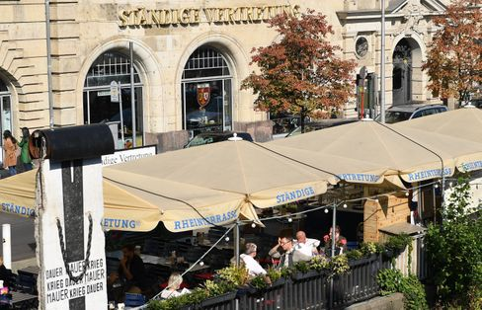

"Permanent Representation" in Berlin (archive photo)

Photo: Britta Pedersen / dpa

...is the **StäV**. The Berlin Kölsch pub "Ständige Vertretung" near the Friedrichstraße train station does not want to host Angela Merkel, Olaf Scholz, the Governing Mayor Michael Müller, Bavaria's Prime Minister Markus Söder and others (anymore) because of the Corona shutdown. [Politicians are banned from the house.](https://www.spiegel.de/politik/deutschland/berlin-staendige-vertretung-erteilt-merkel-scholz-und-anderen-politikern-hausverbot-a-3b0c39b4-6e93-47f8-9a0d-fd76b889babd) Of course, firstly, this is difficult under shutdown conditions anyway, secondly, it is not known whether Merkel and Co. had planned to visit the location at all in the near or distant future, and thirdly, it is perhaps not so expedient for a store that advertises that political celebrities drop in now and then to ban political celebrities.

**The latest news from the night**

* **Spahn swears Germans in for "months of restrictions":** The measures take effect from Monday - and they are considerable: Before the new escalation in the fight against the virus, the health minister finds clear words: [The country is facing a hard time according to Jens Spahn](https://www.spiegel.de/politik/deutschland/jens-spahn-schwoert-deutsche-wegen-corona-krise-auf-monate-der-einschraenkungen-ein-a-71e2889d-8b0d-4f16-af7d-11715f7ef556)
* **Trump supporters ram Biden's campaign vehicle** - **FBI investigates:** Dangerous situation in Texas: supporters of Donald Trump have attacked the column of challenger Joe Biden. [From the White House came praise and ridicule - the federal police intervenes](https://www.spiegel.de/ausland/donald-trump-anhaenger-rammen-joe-bidens-wahlkampffahrzeug-fbi-ermittelt-a-930dc76f-cbd9-4565-9918-2955f4ecbc7c)
* **"Nobody is planning anything at the moment":** Anne Will asks about the sense and nonsense of the restrictions in the second shutdown. [Markus Söder apologizes in advance](https://www.spiegel.de/kultur/tv/anne-will-zu-aktuellen-corona-einschraenkungen-kein-mensch-plant-im-moment-irgendwas-a-ff1d9f67-5c39-430f-94a8-f97c9d6f7b36) [-](https://www.spiegel.de/ausland/donald-trump-anhaenger-rammen-joe-bidens-wahlkampffahrzeug-fbi-ermittelt-a-930dc76f-cbd9-4565-9918-2955f4ecbc7c) [and trumpeter Till Brönner worries about the struggling cultural sector.](https://www.spiegel.de/kultur/tv/anne-will-zu-aktuellen-corona-einschraenkungen-kein-mensch-plant-im-moment-irgendwas-a-ff1d9f67-5c39-430f-94a8-f97c9d6f7b36)