**The location in the morning**

**Germany goes down again**

By [Sebastian Fischer](https://www.spiegel.de/impressum/autor-9c4e5259-0001-0003-0000-000000000166), Head of the SPIEGEL CapitalOffice

Dear reader, good morning,

what a week that will be! What kind of week will that be? Exclamation marks, question marks, everything justified. Today we are dealing with the approaching US elections and the beginning corona shutdown in Germany.

11-02-2020, 05:48 AM

**The decision of the year**

This week, on Tuesday, Americans have a choice between a democracy destroyer and a democracy preserver. All of us, **the whole world will be shaped by the outcome of this election.** We cannot go along with it.

It still sounds surreal: the country that brought us democracy a human age ago is now seriously wrestling with this alternative: destroyer Donald Trump against keeper Joe Biden. The fact that Trump has a realistic chance of remaining in office at all still eludes **political rationality**despite so many illuminating explanatoryapproaches.

And the opportunity is always realistic.

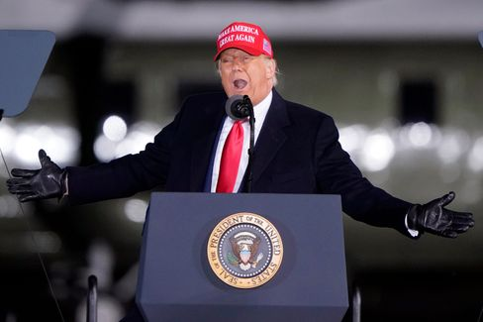

Trump in North Carolina on November 1

Photo: Chris Carlson / AP

The clear lead in the polls, which Biden can register nationwide and in important swing states two days before the election, is now a **purely virtual lead.** According to the latest survey by the "New York Times", Biden is ahead of Trump in Pennsylvania, Wisconsin, Florida and Arizona. Trump had won all four against Hillary Clinton in 2016, paving the way for him to victory.

Are they now putting him on the losing road? But would he accept defeat at all?

Over the weekend, the president sought to sow renewed distrust with regard to [the electoral process and absentee ballots:](https://www.spiegel.de/ausland/us-wahlen-donald-trump-prophezeit-chaotisches-durcheinander-a-ef3f3484-7a3b-42ab-8534-005b1ee478e9) "The whole world and our country will wait and wait to find out who won, you will wait for weeks." November 3rd will come and go, and you won't know: "And you're going to have **chaotic mess** in our country."

In the meantime, more than 90 million Americans have already cast their votes – that is already two-thirds of the total number of votes in 2016. A **record turnout** is to be expected. Record is relative: If 65 percent of eligible voters voted, that would already be a record by US standards.

* [Presidential elections in the USA: Another four years of Trump?](https://www.spiegel.de/wirtschaft/wahlen-in-den-usa-halten-wir-vier-weitere-jahre-donald-trump-aus-a-a70ed0f3-0e92-40da-a919-79e7e7af5eb4)

**Will Trump stay when Biden arrives?**

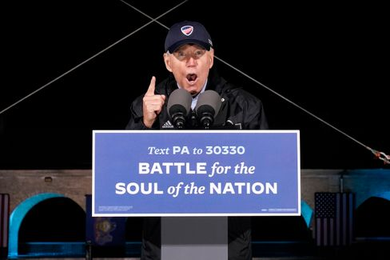

Joe Biden in Philadelphia on November 1

Photo: Andrew Harnik / dpa

If **Joe Biden** wins, he won't be able to simply put the country back on track. Even if he promises to do so and may see Trump only as an aberration of history. In fact, Biden wouldn't be able to pick up where Barack Obama left off four years ago – but would have to connect with **Trump**.

That's why I would like to recommend our current [SPIEGEL cover story:](https://www.spiegel.de/ausland/donald-trump-was-von-ihm-bleibt-selbst-wenn-er-gehen-muss-a-00000000-0002-0001-0000-000173743533) What remains of Trump – even if he has to go. Trump is not only the cause of the division of the nation, but **a symptom of a deep crisis**that does not disappear when Trumpdisappears.

And there is something else: we humans tend to get used to everything. This ensures our survival, but it also makes us blind sometimes. **We've gotten used to Trump**- to his hatred, his stupidity, his racism.

The great US narrator Philip Roth wrote about the "terror of the unforeseen" in his book "Conspiracy against America", which imagines a presidency of the aviator and Nazi Charles Lindbergh in the forties. In historical retrospect, such unforeseen events would unfortunately be presented as inevitable, one event follows another chronologically. In other words, there is a tend to rationalize away the fractures. A disaster, writes Roth, then simply becomes a narrative. We should never forget the Trump disaster.

* [Hate, culture war, discord: what remains of Trump - even if he has to go](https://www.spiegel.de/ausland/donald-trump-was-von-ihm-bleibt-selbst-wenn-er-gehen-muss-a-00000000-0002-0001-0000-000173743533)

**coterie**

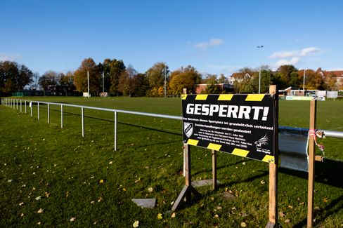

Barrier sign in front of Kiel sports field: Today begins the partial shutdown in Germany

Photo: Frank Molter / dpa

As of today, we are all faced with big decisions every day on a small scale in our country: [The second shutdown in the fight against the coronavirus](https://www.spiegel.de/wissenschaft/coronavirus-news-am-sonntag-zweiter-lockdown-kostet-wirtschaft-19-milliarden-euro-und-600-000-jobs-a-2d897a43-cfca-43a8-bfd3-251dbc977281) begins, it is expected to apply until the end of the **month.** How many will stick to it? And how big will the minority still be in the future, which in recent months has partly gambled away the initial successes with its lack of solidarity?

While the first wave in the spring was still a natural disaster to which society, science and politics had to find (new) answers, the second wave is primarily **man-made.** Because we knew what to do and what not to do.

This last weekend before the shutdown wasn't just encouraging. At my house entrance, for example, hung a note from a club: You want to party again and apologize for the volume.

Probably the volume is our least problem.

Knock one out again before we all sit in it again. If every day counts, as the saying goes, that's a rather stupid strategy. And it illustrates once again that our current problem is man-made. The bigger the ego, the bigger the crisis.

Except for schools and day-care centres as well as supermarkets and shops (and worship services of all places), everything is now being shut down again. Because the regionally specific measures of the past few weeks did not work, all that remains is the hope for this more general, so-called **breakwater model.**

Is that fair? No, it's not. It can't be. Because now also committed entrepreneurs, artists, restaurant owners are paying the bill for the fact that we all failed to do it together. The details of the individual measures can be found [here](https://www.spiegel.de/politik/deutschland/shutdown-diese-massnahmen-gelten-ab-montag-a-bcda226e-72d0-41b8-b363-417acd7726c4).

In addition, I would like to recommend an exciting **SPIEGEL book project** to you at this point: **"Lockdown"** is published today – 21 authors from various departments have retold and analyzed the political crisis management in detail in the first phase, such as tangible conflicts between the ministries – and at the end asked the question what politics, what we as a society can learn from it for the future. And what that means with regard to the rolling second wave.

**Loser of the day...**

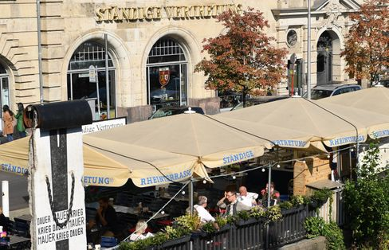

"Permanent Representation" in Berlin (archive image)

Photo: Britta Pedersen / dpa

... is the **StäV**. The Berlin Kölsch pub "Permanent Representation" near friedrichstraße station does not want to host Angela Merkel, Olaf Scholz, governing mayor Michael Müller, Bavaria's Prime Minister Markus Söder and others (anymore) because of the corona shutdown. [House ban for the politicians.](https://www.spiegel.de/politik/deutschland/berlin-staendige-vertretung-erteilt-merkel-scholz-und-anderen-politikern-hausverbot-a-3b0c39b4-6e93-47f8-9a0d-fd76b889babd) Of course, this is difficult anyway under shutdown conditions, secondly, it is not known whether Merkel and Co. had planned a visit to the locality at all in the near or distant future, and thirdly, it is perhaps not so expedient for a shop that advertises that political celebrities occasionally stop by.

**The latest news from the night**

* **Spahn swears to Germans on "months of restrictions":** The measures will take effect from Monday – and they are considerable: Before the new escalation in the fight against the virus, the health minister finds clear words: [According to Jens Spahn, the country is facing a hard time](https://www.spiegel.de/politik/deutschland/jens-spahn-schwoert-deutsche-wegen-corona-krise-auf-monate-der-einschraenkungen-ein-a-71e2889d-8b0d-4f16-af7d-11715f7ef556)
* **Trump supporters ram Biden's campaign vehicle** -  **FBI investigates:**  Dangerous situation in Texas: Fans of Donald Trump have attacked the column of challenger Joe Biden. [Praise and ridicule came from the White House – the federal police intervene](https://www.spiegel.de/ausland/donald-trump-anhaenger-rammen-joe-bidens-wahlkampffahrzeug-fbi-ermittelt-a-930dc76f-cbd9-4565-9918-2955f4ecbc7c)
* **"No one is planning anything at the moment":** Anne Will asks about the sense and nonsense of the restrictions in the second shutdown. [Markus Söder apologizes in advance - and trumpeter Till Brönner worries about the starving cultural industry](https://www.spiegel.de/kultur/tv/anne-will-zu-aktuellen-corona-einschraenkungen-kein-mensch-plant-im-moment-irgendwas-a-ff1d9f67-5c39-430f-94a8-f97c9d6f7b36)