

Subscribe to DeepL Pro to edit this document.  
Visit www.DeepL.com/Pro for more information.

**The situation in the morning**

**What do you choose, America?**

By [Sebastian Fischer](https://www.spiegel.de/impressum/autor-9c4e5259-0001-0003-0000-000000000166), Head of SPIEGEL's Capital Bureau

Dear reader, good morning,

Today we look at Election Day in the USA, the consequences of a possible defeat for Donald Trump, the terrorist attack in Vienna and new turmoil in the battle for the CDU presidency.

03.11.2020, 05.40 hrs

**Terrorist attack in Vienna**

Terrible scenes in Austria's capital: on Monday evening, [shots were fired at six crime scenes in the city center](https://www.spiegel.de/ausland/wien-tote-und-verletzte-nach-attacke-in-oesterreich-a-595a4284-9080-4f11-99cc-cd092ee77599). According to Vienna police, there are so far two dead passers-by and 15 people injured, some seriously.

A perpetrator with a rifle had been shot. He is also said to have been carrying a pistol and a machete. **At least one other perpetrator is still on the run,** said Interior Minister Karl Nehammer. He called on the population to stay at home for the time being, with compulsory schooling suspended. The entire center was cordoned off during the night, soldiers were deployed to support the police.

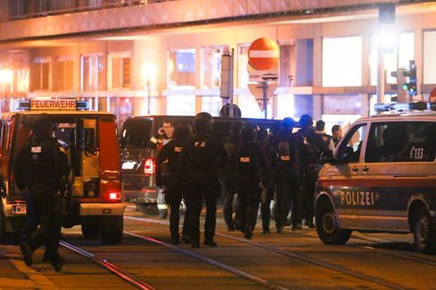

Heavily armed forces in Vienna on Monday evening

Photo: Ronald Zak / dpa

The first shots were fired in Seitenstettengasse, a busy street in the center. A synagogue is also located there. **"Indiscriminate shots have been fired at people in the pubs,"** said Vienna Mayor Michael Ludwig - especially at people who had been out in beer gardens. Austria's Chancellor Sebastian Kurz called it a "disgusting terrorist attack." In the early morning, the authorities want to inform about the status of the investigation.

* [Terror in Austria: dead and seriously injured in Vienna attack](https://www.spiegel.de/ausland/wien-schuesse-in-der-innenstadt-medienberichte-sprechen-von-angriff-auf-synagoge-a-6a0a9f7c-a940-4394-a7f9-71ab9cdd8ff4)

**What's at stake in America today**

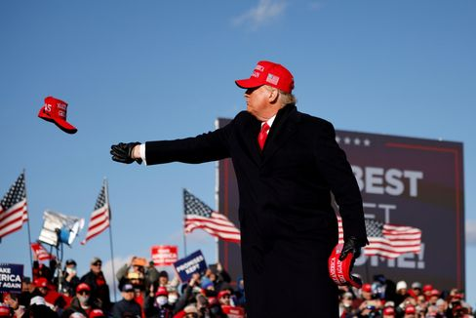

US President Trump in the final spurt of the election campaign

Photo: CARLOS BARRIA / REUTERS

Almost exactly eight years ago, I witnessed **political triumph - and failure - in** Chicago. At 5:30 in the morning, 15,000 of the president's supporters cheered Barack Obama's re-election to the strains of "Do You Love Me" at his election party in an exhibition hall. The magic of victory. Shortly before, Mitt Romney had conceded defeat in Boston.

It was a **glimpse into the engine room of the republic**. It was not so much the frenetic cheering around me that gave me goose bumps, but the almost sacred democratic choreography: one man's victory was another man's failure, then the congratulations by telephone, the public admission of defeat in a *concession speech*, finally the winner's appearance.

Of course, at that time the country had long since been divided, and **the infiltration of the Republican Party by radicals was in full swing** - all factors that would later make the Trump presidency possible. But Romney and Obama still confirmed this Democratic ideal in their dealings with each other.

**What will happen now on the coming election night?** [Joe Biden is clearly ahead in some polls.](https://www.spiegel.de/ausland/us-wahl-2020-die-wichtigsten-umfragen-im-rennen-donald-trump-vs-joe-biden-a-b15ff300-1ea7-4bdf-8685-952dc1e56f57) But what does that mean? And: Should Donald Trump actually lose, will he concede defeat?

I don't think it's just a matter of whether he loses.

**But how he loses.**

In the last few days, Trump has once again sown mistrust in the election process. He is alleging fraud before the votes are even counted. He has announced in the perhaps decisive, contested **battleground state of Pennsylvania** that his lawyers will take over "as soon as this election is through."

It is this scenario that could become the **stress test of American democracy:** Trump needs Pennsylvania to secure the necessary majority of the Electoral College. But if it's close, the decision may not be made for a few days - not until the absentee ballots have been counted. **But what if Trump is ahead on election night in Pennsylvania** - and declares himself the winner of the election to preempt alleged fraud by Democrats in the absentee ballot? Charles M. Blow, a columnist for The New York Times, writes, "Trump will then look at his burning country and warm himself by the fire."

Sounds like a banana republic or the Third World. But don't the last four years offer enough reasons to expect the unexpected?

But there may be a way out. And it lies in the south.

* [Poll just before election: Biden leads in key swing state of Florida](https://www.spiegel.de/ausland/biden-liegt-im-wichtigen-swing-state-florida-vor-trump-a-bd0ddb89-8bd4-44ff-8220-be3c449c2300)

**All eyes on Florida**

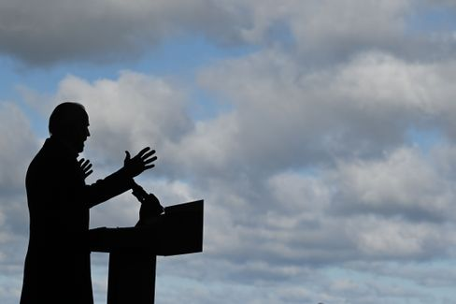

Candidate Biden

Photo: JIM WATSON / AFP

The "Sunshine State" [is the big prize in this election](https://www.spiegel.de/ausland/countdown-zur-us-wahl-aus-florida-die-mutter-aller-swing-states-a-3639c239-50d1-4fa0-b20c-47189d78722d). **If Biden takes Florida, it will be hard to take away his victory.** If Trump wins Florida, he is not through yet, but has a more realistic chance of winning overall.

The advantage of Florida is that the counting of absentee ballots begins weeks before election day, unlike in Pennsylvania. **A reliable result can therefore be expected on election night.** This means that Biden can win without Florida. But with Florida, it would make it more complicated for Trump not to recognize a possible Biden victory.

During the course of the day and on election night, we will provide you with extensive and in-depth information on SPIEGEL.de. Our U.S. correspondents Roland Nelles and Marc Pitzke, for example, look at the possible **scenarios for the outcome of the election** - and take a detailed look at the role of Florida.

That night, our reporters report from **Washington**, the nation's capital, **Florida**, **Pennsylvania, Michigan** and **California.**

**Then, starting at 7 p.m.**, **our live show begins.** We'll be talking to experts, first-time voters, artists like U.S. writer Jonathan Safran Foer. **From 4:30 a.m. on Wednesday morning**, my colleagues Rachelle Pouplier and Britta Sandberg will welcome you to the morning show with projections, assessments and many conversations with colleagues and politicians. By the way, our LAGE in the morning will be a live chat on Wednesday: Starting at 6 a.m., we LAGE authors will talk about the consequences of this election.

* [Hate, culture war, discord: What remains of Trump - even if he has to go](https://www.spiegel.de/ausland/donald-trump-was-von-ihm-bleibt-selbst-wenn-er-gehen-muss-a-00000000-0002-0001-0000-000173743533)

**SPIEGEL climate conference in livestream**

And another note on our own behalf: Today, starting at 4 p.m., we'll be streaming our climate conference on SPIEGEL.de. Among other things, we'll be asking **CSU leader Markus Söder** and Economics Minister **Peter Altmaier** about climate policy, and there will be panels with business leaders like **Lufthansa CEO Carsten Spohr,** scientists like **Ottmar Edenhofer**, politicians like **Green Party leader Annalena Baerbock** and climate activists like **Luisa Neubauer**. All info, schedules and guests can be found [here](https://www.spiegel.de/klimakonferenz).

**Winner of the day...**

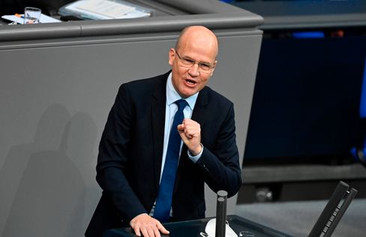

Parliamentary group leader Brinkhaus in the Bundestag

Photo: TOBIAS SCHWARZ / AFP

...is **Ralph Brinkhaus. In** a brilliant speech in the Bundestag last week, the CDU/CSU parliamentary group leader defended the government's anti-Corona shutdown ("It's about proving that we as an open, democratic, pluralistic society can also get a grip on this pandemic") and is now even being talked about as a **replacement candidate for the CDU presidency** and thus also for the chancellorship.

There are many personalities in the party who are suitable for "the highest top offices," "and faction leader Ralph Brinkhaus is certainly one of them," [Thuringia's CDU leader Christian Hirte told SPIEGEL.](https://www.spiegel.de/politik/deutschland/cdu-vorsitz-christian-hirte-bringt-ralph-brinkhaus-ins-spiel-a-668d1739-a6b7-410c-b616-c21336d8b331)

Now a shepherd does not yet make a candidate, but even the still-chairwoman [Annegret Kramp-Karrenbauer had recently](https://www.spiegel.de/politik/deutschland/cdu-annegret-kramp-karrenbauer-ruft-friedrich-merz-und-armin-laschet-zur-ordnung-a-0bfacc78-98ee-4dcc-9f6a-2ba3721adb14) warned the bickering trio of candidates Merz-Laschet-Röttgen in [an interview with SPIEGEL](https://www.spiegel.de/politik/deutschland/cdu-annegret-kramp-karrenbauer-ruft-friedrich-merz-und-armin-laschet-zur-ordnung-a-0bfacc78-98ee-4dcc-9f6a-2ba3721adb14): "The more ruinous the competition is conducted, the more some will perhaps ask themselves the question about other candidates as a reflex to this discussion."

Let's wait and see. In any case, the Junge Union is today presenting the **results of its member survey on the party chairmanship**, which the JU leader Tilman Kuban considers binding for himself, but not for his association. So the winner would then already have one vote for sure.

**The latest news from the night**

* **"We are still in the fight":** top politicians have condemned the terrorist attack in Vienna, which is still ongoing, and pledged their support. [EU Council President Charles Michel called the act a cowardly act against life](https://www.spiegel.de/ausland/wien-politiker-bekunden-beileid-nach-terroranschlag-sind-nach-wie-vor-im-kampf-a-5a8bfd73-1e24-472c-ba5f-9dd9b4137b24)
* **Biden ahead of Trump in key swing state Florida:** Florida could become one of the election-deciding states - and a clear lead is emerging for Joe Biden. [Just a short time ago, he and Donald Trump were tied there](https://www.spiegel.de/ausland/biden-liegt-im-wichtigen-swing-state-florida-vor-trump-a-bd0ddb89-8bd4-44ff-8220-be3c449c2300)
* **VW has to recall 218,000 Jettas in the USA:** In the worst case, leaking fuel could lead to a fire: [Due to defects in the Jetta, Volkswagen is recalling a large number of vehicles to workshops in the U.S.](https://www.spiegel.de/auto/vw-muss-in-den-usa-218-000-jetta-wegen-benzinlecks-zurueckrufen-a-66614d33-00da-430f-a70c-04728ef03447)