**The location in the morning**

**What do you choose, America?**

By [Sebastian Fischer](https://www.spiegel.de/impressum/autor-9c4e5259-0001-0003-0000-000000000166), Head of the SPIEGEL CapitalOffice

Dear reader, good morning,

today we are dealing with election day in the USA, the consequences of a possible defeat of Donald Trump, the terrorist attack in Vienna and new turmoil in the fight for the CDU chairmanship.

03.11.2020, 05.40 a.m.

**Terrorist attack in Vienna**

Terrible scenes in Austria 's capital: On Monday evening [, shots were fired at six crime scenes in the city center](https://www.spiegel.de/ausland/wien-tote-und-verletzte-nach-attacke-in-oesterreich-a-595a4284-9080-4f11-99cc-cd092ee77599). According to the Vienna police, there are so far two dead passers-by and 15 people, some of them seriously injured.

An offender with a rifle was shot. He is also said to have carried a pistol and a machete. **At least one other perpetrator is still on the run,**said Interior Minister Karl Nehammer. He called on the population to stay at home for the time being, compulsory schooling is suspended. The entire center was sealed off during the night, soldiers were deployed to support the police.

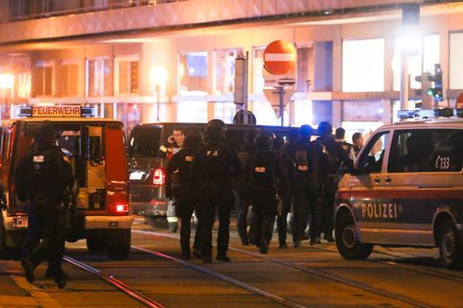

Heavily armed emergency forces on Monday evening in Vienna

Photo: Ronald Zak / dpa

The first shots were fired in Seitenstettengasse, a busy street in the center. There is also a synagogue there. **"It was shot indiscriminately at people in the restaurants,"**said Vienna's mayor Michael Ludwig – especially at people who had been in beer gardens. Austrian Chancellor Sebastian Kurz spoke of a "repugnant terrorist attack". In the early morning, the authorities want to inform about the status of the investigation.

* [Terror in Austria: Dead and seriously injured in attack in Vienna](https://www.spiegel.de/ausland/wien-schuesse-in-der-innenstadt-medienberichte-sprechen-von-angriff-auf-synagoge-a-6a0a9f7c-a940-4394-a7f9-71ab9cdd8ff4)

**What's at stake in America today**

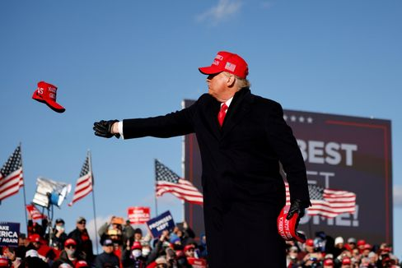

US President Trump in the final spurt of the election campaign

Photo: CARLOS BARRIA / REUTERS

Almost exactly eight years ago, I witnessed **political triumph – and failure –**inChicago. At half past six in the morning, 15,000 supporters of the president cheered the re-election of Barack Obama at his election party in an exhibition hall under the sounds of "Do You Love Me." The magic of victory. Shortly before, Mitt Romney had conceded defeat in Boston.

It was a **look into the engine room of the Republic.** Goose bumps caused me not so much the frenetic jubilation around me, but the almost sacral democratic choreography: one's victory was the other's failure, then the congratulations by telephone, the public admission of defeat in a concession *speech,*finally the appearance of the winner.

Of course, at that time the country was long divided, **the infiltration of the Republican Party by the radicals in full swing** – all factors that would later make the Trump presidency possible. But Romney and Obama still confirmed this democratic ideal in their dealings with each other.

**So what will happen next night?** [Joe Biden is sometimes well ahead in polls.](https://www.spiegel.de/ausland/us-wahl-2020-die-wichtigsten-umfragen-im-rennen-donald-trump-vs-joe-biden-a-b15ff300-1ea7-4bdf-8685-952dc1e56f57) But what does that mean? And: Should Donald Trump actually lose, will he admit defeat?

It's probably not just a matter of whether he loses.

**But how he loses.**

Because Trump has once again sown mistrust in the election process in recent days. He insinuates fraud before the votes are even counted. He has announced in the perhaps crucial, embattled **battleground state** of Pennsylvania that his lawyers will take over "as soon as this election is through."

It is this scenario that could become **the stress test of American democracy:** Trump needs Pennsylvania to secure the necessary majority of the electoral college. If it gets tight, however, the decision may not be made until a few days from now – only when the postal votes have been counted. **But what if Trump is ahead on election night in Pennsylvania** – and declares himself the winner of the election in order to forestall alleged fraud by the Democrats in the postal vote? Charles M. Blow, columnist for the "New York Times," writes, "Trump will then look at his burning land and warm himself by the fire."

Sounds like banana republic or third world. But do the last four years not offer enough reasons to reckon with the unforeseen?

But there may be a way out. And it's in the south.

* [Poll just before the election: Biden is ahead in the important swing state of Florida](https://www.spiegel.de/ausland/biden-liegt-im-wichtigen-swing-state-florida-vor-trump-a-bd0ddb89-8bd4-44ff-8220-be3c449c2300)

**All eyes on Florida**

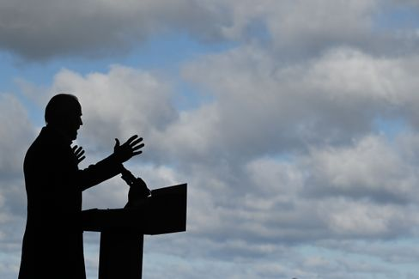

Candidate Biden

Photo: JIM WATSON / AFP

The "Sunshine State" [is the big prize in this choice.](https://www.spiegel.de/ausland/countdown-zur-us-wahl-aus-florida-die-mutter-aller-swing-states-a-3639c239-50d1-4fa0-b20c-47189d78722d) **If Biden wins Florida, the victory is probably hard to take away from him.** If Trump wins Florida, he is not through yet, but has a more realistic chance of winning the overall victory.

The advantage of Florida is that the counting of absentee ballots begins weeks before election day, unlike in Pennsylvania. **A reliable result on election night is therefore to be expected.** In other words, Biden can win without Florida. But with Florida, he would make it more complicated for Trump not to acknowledge a possible Biden victory.

In the course of the day and on election night, we will inform you extensively and profoundly on SPIEGEL.de. Our US correspondents Roland Nelles and Marc Pitzke, for example, deal with the possible **scenarios for the outcome of the election** – and go into detail about Florida's role.

During the night , our reporters report from the capital **, Washington**, **Florida**, **Pennsylvania**, **Michigan**  and **California**.

**From 19 clock then starts our live**show. We talk to experts, first-time voters, artists such as the US writer Jonathan Safran Foer. **From 4.30 a.m. on Wednesday morning,** my colleagues Rachelle Pouplier and Britta Sandberg will welcome you to the early show with projections, assessments and many colleagues and politician discussions. By the way, our LAGE in the morning will become a live chat on Wednesday: We LAGE authors will talk about the consequences of this election from 6 o'clock.

* [Hate, culture war, discord: what remains of Trump – even if he has to go](https://www.spiegel.de/ausland/donald-trump-was-von-ihm-bleibt-selbst-wenn-er-gehen-muss-a-00000000-0002-0001-0000-000173743533)

**SPIEGEL climate conference in live stream**

And another note on our own behalf: Today from 4 p.m. we stream our climate conference on SPIEGEL.de. Among other things , we ask **CSU chief Markus Söder** and Economics Minister Peter **Altmaier** about climate policy , there are panels with business leaders such as **Lufthansa CEO Carsten Spohr**, scientists such as **Ottmar Edenhofer**, politicians such as Greens leader **Annalena Baerbock** and climate activists such as **Luisa Neubauer**. All information, schedules and guests can be found [here](https://www.spiegel.de/klimakonferenz).

**Winner of the day...**

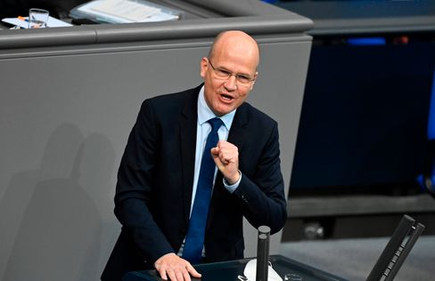

Bundestag group leader Brinkhaus in the Bundestag

Photo: TOBIAS SCHWARZ / AFP

... is **Ralph Brinkhaus.** In a brilliant speech in the Bundestag last week, the head of the Union Bundestag group defended the government's anti-corona shutdown ("It's about us as an open, democratic, plural society proving that we can get this pandemic under control") and is now even being discussed as a replacement candidate for the CDU **chairmanship**  and thus also the chancellor candidacy.

There are many personalities in the party who are suitable for "the highest top offices", "certainly the bundestag group chairman Ralph Brinkhaus is one of them," [Thuringia's CDU chief Christian Hirte told DER SPIEGEL](https://www.spiegel.de/politik/deutschland/cdu-vorsitz-christian-hirte-bringt-ralph-brinkhaus-ins-spiel-a-668d1739-a6b7-410c-b616-c21336d8b331).

Now a shepherd is not yet making candidates, but even [annegret Kramp-Karrenbauer,](https://www.spiegel.de/politik/deutschland/cdu-annegret-kramp-karrenbauer-ruft-friedrich-merz-und-armin-laschet-zur-ordnung-a-0bfacc78-98ee-4dcc-9f6a-2ba3721adb14) who is still chairwoman, recently warned the quarrelling trio of candidates Merz-Laschet-Röttgen in the SPIEGEL interview: "The more ruinous the competition is conducted, the more some will perhaps ask themselves the question of other applicants as a reflex to this discussion."

Let's wait and see. In any case, the Junge Union today presents the result of its member survey on the **party chairmanship,** which the JU chief Tilman Kuban considers binding for himself, but not for his association. So the winner would certainly have a vote.

**The latest news from the night**

* **"We are still in the fight":** Top politicians have condemned the ongoing terrorist attack in Vienna and pledged their support. [EU Council President Charles Michel called the act a cowardly act against life](https://www.spiegel.de/ausland/wien-politiker-bekunden-beileid-nach-terroranschlag-sind-nach-wie-vor-im-kampf-a-5a8bfd73-1e24-472c-ba5f-9dd9b4137b24)
* **Biden is ahead of Trump in the important swing state of Florida:** Florida could become one of the decisive states for the election – and a clear lead for Joe Biden is emerging. [Only recently, he and Donald Trump had been on an equal footing there](https://www.spiegel.de/ausland/biden-liegt-im-wichtigen-swing-state-florida-vor-trump-a-bd0ddb89-8bd4-44ff-8220-be3c449c2300)
* **VW has to recall 218,000 Jettas in the USA:** Leaking fuel could lead to a fire in the worst case: Due to [defects in the Jetta, Volkswagen orders vehicles to the workshops on](https://www.spiegel.de/auto/vw-muss-in-den-usa-218-000-jetta-wegen-benzinlecks-zurueckrufen-a-66614d33-00da-430f-a70c-04728ef03447) a large scale in the USA