

Subscribe to DeepL Pro to edit this document.  
Visit www.DeepL.com/Pro for more information.

**The situation in the morning**

**Biden backs America, Trump backs courts**

By [Sebastian Fischer](https://www.spiegel.de/impressum/autor-9c4e5259-0001-0003-0000-000000000166), Head of SPIEGEL's Capital Bureau

Dear reader, good morning,

Today we look at the US election, the consequences of Trumpism, the Bundeswehr in the Corona crisis and Sahra Wagenknecht.

05.11.2020, 06.29 hrs

**Only one state left Biden**

Welcome to Day 2 after the US elections. Joe Biden is ahead of Trump in the *popular vote with* around 72 million votes, **breaking Barack Obama's record** - never before in US history has a presidential candidate won more votes than Biden this year.

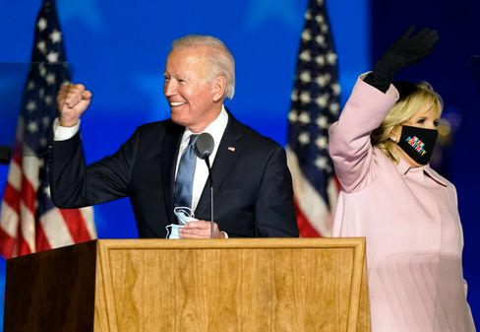

Candidate Biden, wife Jill Biden

Photo: Andrew Harnik / dpa

The only thing is that the total number of votes does not matter, and it has not yet been decided who will lead America in the future. **But you may not have to wait another day** until the last absentee ballots are counted in Pennsylvania.

Because Biden is only one state short of victory - and as things stand, that no longer has to be Pennsylvania.

Voilà, **a few numbers for** breakfast:

* If Biden's narrow lead in **Arizona** holds - and it can be assumed it will at this point - then the challenger currently has **264** Electoral College **votes** secured. He is just 6 short of a majority. Trump currently has **214**.
* The southern state of **Georgia** (16 electoral votes) and **Nevada** in the West (6) could soon declare a winner. In Nevada, Biden is narrowly ahead; in Georgia, Trump's lead is melting - and the absentee ballots to be counted are trending in favor of Biden.
* Then the big prize: **Pennsylvania** (20), where Biden was born 77 years ago. If Trump wins Georgia, Nevada and North Carolina (15), then it would be 264 to 251 for Biden - and the election would be decided in Pennsylvania, but possibly not until Friday. There, Trump is currently ahead by around 200,000 votes, but hundreds of thousands of absentee ballots are still missing, for example from the Pittsburgh region, and - you guessed it - the majority of them are predictably in favor of Biden.
* [US election 2020: Joe Biden needs one more state](https://www.spiegel.de/ausland/us-wahl-2020-joe-biden-braucht-noch-einen-staat-zum-sieg-a-d4f3eb3e-e6cd-434d-b911-2542be743ad5)

**And Trump like this?**

Since declaring victory on election night against his better judgment and now having already lost crucial states (Wisconsin, Michigan), the President has been looking for **alternative paths to electoral victory** through the courts.

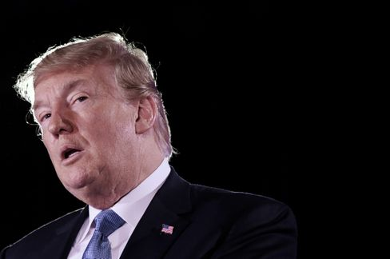

President Trump

Photo: OLIVIER DOULIERY/ AFP

Our U.S. correspondent [Roland Nelles comments aptly](https://www.spiegel.de/ausland/trumps-vorschnelle-siegeserklaerung-der-antidemokrat-a-37092f3f-7160-456b-905c-396c6b2ffb30): "It all seems like **the plot of a second-rate autocrat** who needs a fallback position to argue a possible defeat. One wonders: what's the point? Why can't the man just wait and win - or lose - in an honest way?"

Yes, what is this?

In Georgia, for example, where he is leading by a narrow margin, Trump is suing to stop the counting. Reason: According to one observer, **53 ballots that arrived too late in** one municipality were added to the pile of ballots that arrived on time. In Pennsylvania, Trump's people want the count suspended until their election observers can get supposedly better access. In Wisconsin, Team Trump is calling for a recount because of the close election outcome. And so on.

* [Are U.S. courts stopping the recount? "Trump's announcement is bluster"](https://www.spiegel.de/ausland/us-wahl-donald-trumps-ankuendigung-ist-getoese-der-yale-jurist-samuel-moyn-im-interview-a-4af39789-c210-4b07-88c6-d7acf00fe00c)

**What will become of Trumpism?**

Whether Trump loses or not, the hatred and division he has sown in this country will continue to flourish. **After all, it's fertile ground**. Trump is only a symptom of the precarious situation in which the former leading power of the West finds itself.

If, after four years with a racist and liar in the White House, nearly 70 million Americans vote for this person - what does that say about the state of the country? Again, **Trump has gained votes compared to 2016 - not lost them**.

Publicist Paul Krugman noted that Biden always talks about Americans being different from Trump and his policies ("that's not who we are"). But he says it should mean that the majority of Americans are not like that - and Biden may end up just ahead by five percentage points in the overall vote. **"It turns out,"** Krugman opines, **"that many of us are like that."** So is Trump.

* [Minutes of the Fateful Election: America on a day that will change the world](https://www.spiegel.de/ausland/us-wahl-amerika-am-tag-der-die-welt-veraendern-wird-reportage-a-8ecaf565-6347-494b-99f5-3eba3f9717ed)

**Antiviral combat mission**

Today, the Bundeswehr is providing information about its anti-Corona mission. Martin Schelleis, a lieutenant general in the German Air Force with the military-prosaic title of "National Territorial Commander," is responsible for the roughly 15,000 soldiers who can help fight Corona at home - if they are asked.

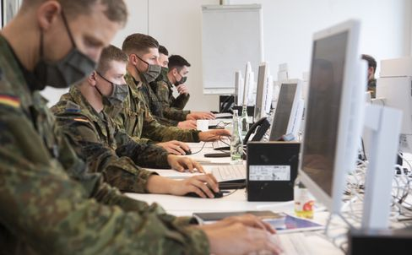

Soldiers help track Corona infection chains in Hanover region

Photo: Julian Stratenschulte / Julian Stratenschulte / picture alliance / dpa

In fact, the military is urgently needed. The Robert Koch Institute (RKI) has received more than three dozen shortage reports from health offices. Currently, according to the Ministry of Defense, 5350 soldiers are on duty, helping with contact tracing at the offices or corona testing.

Most recently, even **Berlin's problem district Friedrichshain-Kreuzberg gave** up its resistance to a deployment of the Bundeswehr. Since Wednesday, the district leaders (7-day incidence: 245), hit hard by the second wave, have been letting themselves be helped. For weeks, the Left and the Greens had prevented this. Now paramedics are to take cuts.

**What does Sahra Wagenknecht actually do?**

They can't really work with her anymore, but they can't work without her either: The Left Party and its political star, Sahra Wagenknecht, have become **estranged**; a year ago, the 51-year-old resigned from the chairmanship of the parliamentary group. Wagenknecht's central accusation paraphrased: **The left cares too much about big-city hipsters and gender stars and too little about workers and the unemployed.**

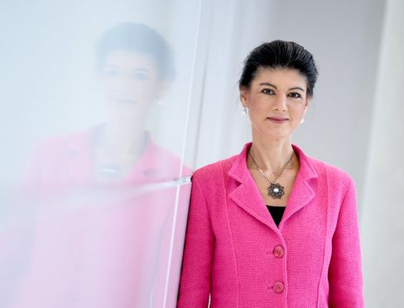

Left-wing politician Wagenknecht

Photo: Britta Pedersen / dpa

Last weekend, her eternal opponent Katja Kipping should also have been replaced as party leader. But the party conference planned in Erfurt had to be postponed because of Corona. However, the designated new chairpersons - Janine Wissler and Susanne Henning-Wellsow - are not considered Wagenknecht buddies either. So what to do?

"What role can, should, and does she still want to play in a party in which, as before, hardly anyone can match her popularity, but from which she is obviously alienating herself?" my colleagues Kevin Hagen and Jonas Schaible ask today in **an enigmatic piece on Sahra Wagenknecht** and her party that I would like to recommend to you.

* [Left-wing politician Wagenknecht: The Sahra factor](https://www.spiegel.de/politik/deutschland/sahra-wagenknecht-und-die-linke-star-im-schatten-a-0a6d42d4-aa00-4e20-a82c-a85e4fca106e)

**Winner of the day ...**

... is CDU member of the Bundestag **Elisabeth Motschmann**. As a member of the Foreign Affairs Committee, she clearly condemned Trump's attempts to stop a democratic election: "President Donald Trump's hasty declaration of victory is illegal and dangerous. **It is an ultimate attack on the core of democracy: the election.**"

Her party colleague and **CDU presidential candidate Friedrich Merz takes a** different view. From him, the appeal to stay out of it can be heard. But Motschmann is of course right. This is about the core of democracy. Without free choice, everything is nothing.

**The latest news from the night**

* **"My short-term memory is shot":** Michael J. Fox is open about his Parkinson's disease - now he has spoken about recent health setbacks. [His memory has suffered considerably, he says. But he still has one hobby](https://www.spiegel.de/panorama/leute/michael-j-fox-schauspieler-spricht-ueber-verlust-von-kurzzeitgedaechtnis-a-dbf76c54-79c7-4721-83ca-7bb7385eff1c)
* **First full throttle, then slow gear:** With three goals, Borussia Dortmund decided the game at Club Brugge after just half an hour. This allowed the team to save energy - [it will need it on Saturday against FC Bayern](https://www.spiegel.de/sport/fussball/borussia-dortmund-siegt-in-der-champions-league-schnell-erledigt-kraft-gespart-a-fef85133-185d-451b-9713-700bb93f8831)
* **Children's doors, tilting technology, food bowls for the dog:** cargo bikes are becoming increasingly sophisticated - and more powerful. The segment is also booming because of the Corona pandemic. [Manufacturers offer many new models for 2021](https://www.spiegel.de/auto/fahrberichte/lastenrad-boom-die-cargobike-neuheiten-fuer-2021-a-b6a72088-1640-436a-8b7a-532f1f48f162)