**The location in the morning**

**Biden bets on America, Trump on the courts**

By [Sebastian Fischer](https://www.spiegel.de/impressum/autor-9c4e5259-0001-0003-0000-000000000166), Head of the SPIEGEL CapitalOffice

Dear reader, good morning,

today we deal with the US election, the consequences of Trumpism, the Bundeswehr in the corona crisis and Sahra Wagenknecht.

05.11.2020, 06:29 AM

**Only one state missing Biden**

Welcome to Day 2 after the U.S. elections. Although Joe Biden is a good 3.5 million ahead of Trump in the popular *vote* with around 72 million votes and has thus broken the record of Barack Obama – never before in US history **has** a presidential candidate won more votes than Biden this year.

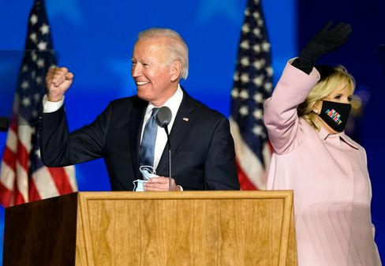

Candidate Biden, Wife Jill Biden

Photo: Andrew Harnik / dpa

The only thing is that, as is well known, the total number of votes does not matter, and it is not yet clear who will be at the head of America in the future. **But you may not have to wait another day**until the lastabsentee ballots are counted in Pennsylvania as well.

Because Biden only needs one state to win – and as things stand, that doesn't have to be Pennsylvania anymore.

Voilà, **a few numbers** for breakfast:

* If Biden's narrow lead in **Arizona** holds – and that is to be expected at this point – then the challenger currently has **264 votes** in the electoral college. Only 6 to the majority are missing. Trump currently comes to **214**.
* The southern state of **Georgia** (16 votes) and **Nevada** in the west (6) could soon declare a winner. In Nevada, Biden is just ahead, in Georgia, Trump's lead is melting — and the absentee ballots to be counted are trending for Biden.
* Then the big prize: **Pennsylvania** (20), where Biden was born 77 years ago. If Trump wins Georgia, Nevada and North Carolina (15), then it would be 264 to 251 for Biden – and in Pennsylvania the election would be decided, but possibly not until Friday. Although Trump is currently ahead there with around 200,000 votes, there are still hundreds of thousands of absentee ballots missing, for example from the Pittsburgh region, and they are – you guessed it – foreseeably majority pro Biden.
* [US election 2020: Joe Biden still needs a state](https://www.spiegel.de/ausland/us-wahl-2020-joe-biden-braucht-noch-einen-staat-zum-sieg-a-d4f3eb3e-e6cd-434d-b911-2542be743ad5)

**And Trump so?**

Ever since the president declared his victory against his better judgment on election night and has now lost crucial states (Wisconsin, Michigan), he has been looking for **alternative ways to win** the courts.

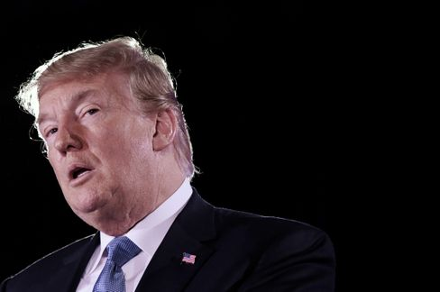

President Trump

Photo: OLIVIER DOULIERY/ AFP

Our US correspondent [Roland Nelles aptly comments:](https://www.spiegel.de/ausland/trumps-vorschnelle-siegeserklaerung-der-antidemokrat-a-37092f3f-7160-456b-905c-396c6b2ffb30)"This all seems like the plot of a **second-rate autocrat**who needs a fallback position to anticipate a possible defeat. One wonders: what's the point? Why can't the man just wait and win in an honest way – or lose?"

Yes, what's the point?

In Georgia, for example, where he narrowly leads, Trump is suing for a halt to counting. Reason: According to an observer, **53 ballot papers that arrived too late** in a municipality were added to the pile of election documents that arrived on time. In Pennsylvania, Trump's people want the count to be suspended until their election observers supposedly get better access. In Wisconsin, Team Trump is calling for a recount because of the close election outcome. And so on.

* [Will U.S. courts stop the count? "Trump's announcement is bluster"](https://www.spiegel.de/ausland/us-wahl-donald-trumps-ankuendigung-ist-getoese-der-yale-jurist-samuel-moyn-im-interview-a-4af39789-c210-4b07-88c6-d7acf00fe00c)

**What will become of Trumpism?**

Whether Trump loses or not, the hatred and division he has sown in this country will continue to flourish. **Because it is fertile soil.** Trump is only a symptom of the precarious situation in which the former leading power of the West finds itself.

When, after four years with a racist and liar in the White House, nearly 70 million Americans vote for this person, what does that say about the state of the country? Again, **Trump won votes compared to 2016 – not lost.**

Publicist Paul Krugman noted that Biden always talks about Americans being different from Trump and his policies ("that's not who we are"). But it must be said that the majority of Americans are not like that – and Biden will perhaps be just five percentage points ahead in the overall votes in the end. **"It turns out,"**says Krugman, **"that many of us are like that."** Just like Trump.

* [Protocol of the Fateful Election: America on a Day That Will Change the World](https://www.spiegel.de/ausland/us-wahl-amerika-am-tag-der-die-welt-veraendern-wird-reportage-a-8ecaf565-6347-494b-99f5-3eba3f9717ed)

**Antiviral combat order**

Today, the Bundeswehr is informing about its anti-corona mission. Martin Schelleis, Lieutenant General of the Air Force with the military-prosaic title "National Territorial Commander", is responsible for the approximately 15,000 soldiers who can help combat coronavirus at home – if they are asked to do so.

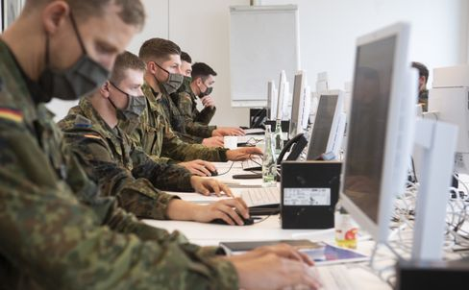

Soldiers help in the Hanover region to track corona infection chains

Photo: Julian Stratenschulte / Julian Stratenschulte / picture alliance / dpa

Indeed, the military is desperately needed. The Robert Koch Institute (RKI) has more than three dozen bottleneck reports from health authorities. Currently, according to the Ministry of Defense, 5350 soldiers are deployed, helping with contact tracing at the offices or the corona tests.

Recently, even the problem district of **Friedrichshain-Kreuzberg** in Berlin has given up the resistance against a deployment of the Bundeswehr. Since Wednesday, the district leaders hard hit by the second wave (7-day incidence: 245) have been helped. For weeks, the left and the Greens had prevented this. Now medical soldiers are to take swabs.

**What does Sahra Wagenknecht actually do?**

They can no longer really work with her, but albeit not without her: the leftists and their political star Sahra Wagenknecht **have become estranged,**a year ago the 51-year-old resigned from the bundestag group chairmanship. Wagenknecht's central reproach paraphrases: **the left cares too much about big city hepsters and gender stars and too little about workers and the unemployed.**

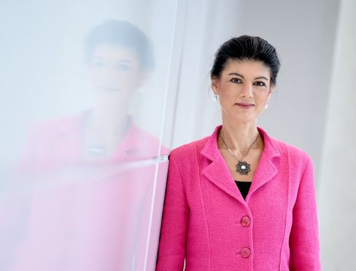

Left-wing politician Wagenknecht

Photo: Britta Pedersen / dpa

Last weekend, her eternal opponent Katja Kipping should also have been replaced as party leader. But the party congress planned in Erfurt had to be postponed because of Corona. However, the designated new chairmen – Janine Wissler and Susanne Henning-Wellsow – are not considered Wagenknecht buddies either. So what to do?

"What role can, should and does it still want to play in a party in which hardly anyone can keep up with its popularity, but from which it is obviously alienated?", my colleagues Kevin Hagen and Jonas Schaible ask today **in an enigmatic piece about Sahra Wagenknecht** and her party, which I would like to recommend to you.

* [Left-wing politician Wagenknecht: The Sahra factor](https://www.spiegel.de/politik/deutschland/sahra-wagenknecht-und-die-linke-star-im-schatten-a-0a6d42d4-aa00-4e20-a82c-a85e4fca106e)

**Winner of the day ...**

... is the CDU member of the Bundestag **Elisabeth Motschmann**. As a member of the Foreign Affairs Committee, she has clearly condemned Trump's attempts to stop a Democratic election: "President Donald Trump's hasty declaration of victories is unlawful and dangerous. **This is an ultimate attack on the core of democracy: the**election."

Her party friend and **CDU chairmanship candidate Friedrich Merz** behaves differently. From him the appeal to keep out can be heard. But Motschmann is of course right. This is the core of democracy. Without free choice, everything is nothing.

**The latest news from the night**

* **"My short-term memory is over":** Michael J. Fox is openly dealing with his Parkinson's disease – now he has talked about recent health setbacks. [His memory had suffered considerably. But a hobby remains for him](https://www.spiegel.de/panorama/leute/michael-j-fox-schauspieler-spricht-ueber-verlust-von-kurzzeitgedaechtnis-a-dbf76c54-79c7-4721-83ca-7bb7385eff1c)
* **First full throttle, then gentle:** With three goals, Borussia Dortmund decided the game at Club Brugge after half an hour. This allowed the team to save energy – they will need it on Saturday against FC [Bayern](https://www.spiegel.de/sport/fussball/borussia-dortmund-siegt-in-der-champions-league-schnell-erledigt-kraft-gespart-a-fef85133-185d-451b-9713-700bb93f8831)
* **Children's doors, tilting technology, feeding bowl for the dog:** cargo bikes are becoming more and more sophisticated – and more powerful. The segment is also booming because of the corona pandemic. [Manufacturers offer many new models for 2021](https://www.spiegel.de/auto/fahrberichte/lastenrad-boom-die-cargobike-neuheiten-fuer-2021-a-b6a72088-1640-436a-8b7a-532f1f48f162)