

Subscribe to DeepL Pro to edit this document.  
Visit www.DeepL.com/Pro for more information.

**The situation in the morning**

**Why there's a lot to be said for Biden now**

By [Sebastian Fischer](https://www.spiegel.de/impressum/autor-9c4e5259-0001-0003-0000-000000000166), Head of SPIEGEL's Capital Bureau

Dear reader, good morning,

today we look at the (hoped-for) finale of the decision between U.S. President Donald Trump and challenger Joe Biden, the restraint of the federal government, and a virtual CDU party convention.

06.11.2020, 05.38 o'clock

**Progress is a snail**

Yes, indeed, they are still counting. And hour by hour, the race is heating up more. It all comes down to four states now: **Georgia, Pennsylvania, Arizona and Nevada**.

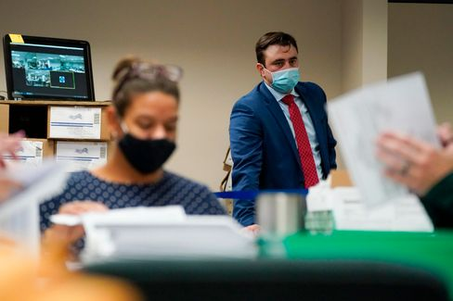

A Republican election observer at vote count in Pennsylvania

Photo: Mary Altaffer / AP

In Arizona (11 Electoral College votes) and Nevada (6), **Joe Biden is narrowly ahead**; in Georgia (16) and Pennsylvania (20), he has continued to make up ground over the past few hours, and **the President's lead is melting** (Pennsylvania) or has **already melted away** (Georgia).

Biden (253 votes out of 270 so far) now has **several paths to success**, Donald Trump (214) **only one**. And that leads through **Pennsylvania**. There, they have counted through the night, are nearing the end, and Trump's former 10-percentage-point lead has fallen to less than one percentage point.

Trump's legal attacks on continuing the count **have so far been inconsequential**. The count continues.

* [State of the Count: Here's how things stand in key states](https://www.spiegel.de/ausland/us-wahl-stand-der-auszaehlungen-joe-biden-holt-in-mehreren-staaten-auf-a-d638279f-eee4-4a3d-9c9e-4ca0ef8b29d7)

**The bizarre president, part two**

While you were sleeping, after two days of being on camera, Donald Trump spoke out at the White House. It was **a continuation of his slanted, anti-democratic performance on election night**. "If you count the legal votes, I won hands down," he claimed. And more nonsense.

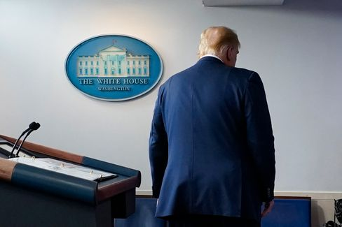

President Trump

Photo: Evan Vucci / AP

Trump seemed more muted in his lying this time than he did two days ago, tired and weary. **They were the words of an autocrat, but the sound of a loser**.

Presidential niece Mary Trump, who published a tell-all book about her uncle before the election, commented, "This is what it looks like when a loser loses."

Biden, on the other hand, struggled a few hours earlier with his running mate, Kamala Harris, to make as presidential an appearance as possible. Democracy is sometimes a bit messy, Biden said, **"sometimes it takes a little patience**.**"** But that patience, he said, has been rewarded in a good 240 years of the U.S. "with a system of government that is the envy of the world."

Well, not so recently. But we stay tuned.

* [US election: Trump again makes baseless accusations of fraud](https://www.spiegel.de/ausland/us-wahl-2020-donald-trump-behauptet-erneut-gewonnen-zu-haben-a-8dea65e4-4ab1-45c1-bacb-cf923bf05615)

**How to respond to the anti-democrat?**

Trump's appearance on election night, when he told lies, was not **met with a major response from the Chancellor's Office.** It can be assumed that this will also be the case with his appearance last night.

Two days ago, Angela Merkel announced through her government spokesman Steffen Seibert that the German government had confidence "in the democratic tradition and in the institutions of the rule of law" in America. As long as there is no final result, the government is following **"everything closely**", but it does not comment on it.

The chancellor will probably continue to keep quiet until the winner has been determined. Why get involved in skirmishes before then?

**Yes, why not?**

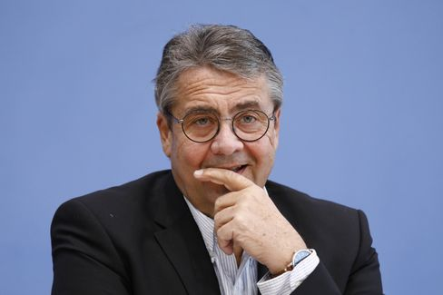

Ex-Foreign Minister Gabriel

Photo: M. Popov / imago images/Metodi Popov

German restraint is now sparking criticism. Former SPD leader and ex-Foreign Minister **Sigmar Gabriel is** demanding that the German government take a clear position on the U.S. election: "We should make it clear that the legitimacy of governments for us depends on their **accepting the basic principles of democracy**, and that is majority and minority," he told SPIEGEL.

He said the German government is certainly allowed to speak out publicly. "You don't have to link that with attacks on Donald Trump," said Gabriel, who is now head of the Atlantic Bridge, "but that we assume that all democracies feel bound by these principles **is already an appropriate comment.**"

* [U.S. Election: Sigmar Gabriel Demands Clear Positioning of the German Government](https://www.spiegel.de/politik/us-wahl-sigmar-gabriel-verlangt-klare-positionierung-der-bundesregierung-a-9a6063ef-0b34-47a1-8111-b7a6a484b18d)

**Christian Digital Union**

At the Christian Union, they would finally like to elect their new party chairman. But because, firstly, the country is already **firmly in the grip of the Corona pandemic** again and, secondly, the CDU hasn't had much of a go at **digitization so** far, they now have to improvise. After all, a candidate for chancellor will be needed soon. And how on earth is the CDU supposed to enter into negotiations with the CSU if it doesn't even have a new chairman yet?

My colleagues Florian Gathmann and Veit Medick write today about the CDU's latest idea: delegates are to meet virtually in January for a **digital party conference** and **elect the** party leader and the rest of the executive committee **online**. At the end, all election results would then have to be confirmed once again in a **final written vote**, i.e. by postal ballot.

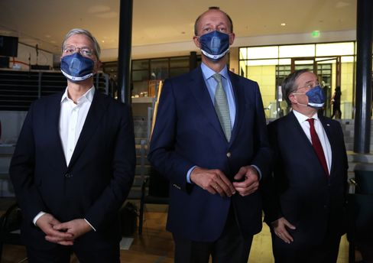

Candidates Röttgen, Merz. Laschet

Photo: Adam Berry / Getty Images

But now the crucial question: **Would that be legally secure?** After all, this is not about, say, the chairmanship of the FDP. It's about a position that could propel the holder into the chancellor's office. The CDU/CSU parliamentary group has asked the Ministry of the Interior for an assessment - and according to SPIEGEL information, they are already working on the matter. We're keeping our fingers crossed.

By the way: **The three CDU chairmanship candidates have a full program today**. Friedrich Merz is presenting his **book on the election campaign** via a zoom conference (virtual!): "Neue Zeit. New Responsibility. It will be presented by Christian Lindner (pardon, FDP leader is of course an important position after all). In the afternoon, Merz and his rival Armin Laschet will meet at the congress of the Local Politics Association of the CDU and CSU (again, virtual!), whose motto is similar to Merz's book title: "Shaping structural change.

The CDU day concludes with a round of introductions of **Merz, Laschet and competitor Norbert Röttgen at the Saxon Union** in Chemnitz - the party base is allowed to ask questions (virtually, of course).

* [Digital party conference: CDU wants clarification from the Ministry of the Interior for its chair election](https://www.spiegel.de/politik/deutschland/cdu-parteitag-mit-wahl-des-vorsitzenden-innenministerium-soll-rechtssicherheit-bestaetigen-a-c7ffdaa5-9152-4a00-b5b9-b3ef959c25c3)

**Winner of the day...**

...is **Mike Mohring**. The 48-year-old, who was replaced as Thuringia's CDU leader after the 2019 election debacle and its no less debaclysmic consequences, is being given **a second political chance.**

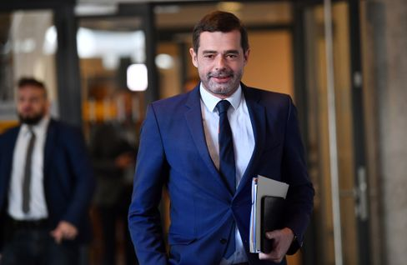

CDU politician Mohring (in March)

Photo: Martin Schutt/ DPA

His CDU nominated him as a **candidate for the Bundestag** in one of Thuringia's eight constituencies, which includes Jena. Mohring defeated the previous member of the Bundestag, Johannes Selle, by 23 votes to 15. According to SPIEGEL information, however, the Selle camp is now considering contesting the election.

Seems kind of familiar these days.

**The latest news from the night**

* **More than 70 dead due to tropical storm "Eta":** Extreme rainfall has triggered landslides and floods in Guatemala, Nicaragua, Costa Rica and Panama. [Dozens of people have already died, the number of victims could rise further](https://www.spiegel.de/panorama/gesellschaft/guatemala-nicaragua-costa-rica-und-panama-dutzende-tote-durch-tropensturm-eta-a-716dbe00-a2a2-408f-92f5-7dc7a9122e03)
* **Fingerprint obligation on identity cards is coming:** Two fingerprints, digital photos, an "X" on the passport for people who do not assign themselves to a gender: [The Bundestag has passed changes for ID cards and passports](https://www.spiegel.de/politik/deutschland/personalausweis-bundestag-beschliesst-aenderungen-fingerabdruck-pflicht-kommt-a-314b8525-51b0-4585-91e2-c45a5fe72bc6)
* **Barricaded in the ministry:** Because of a Corona contact, Annegret Kramp-Karrenbauer went into quarantine at the beginning of the week. [But instead of isolating herself at home, the defense minister is sitting in her ministry. Is she allowed to do that?](https://www.spiegel.de/politik/deutschland/verbarrikadiert-im-ministerium-a-1113e0c0-0e47-4ede-8e8b-4d2fe9c0b0a6)