**The location in the morning**

**Why there's a lot to be said for Biden now**

By [Sebastian Fischer](https://www.spiegel.de/impressum/autor-9c4e5259-0001-0003-0000-000000000166), Head of the SPIEGEL CapitalOffice

Dear reader, good morning,

today we deal with the (hopefully) final of the decision between US President Donald Trump and challenger Joe Biden, the restraint of the federal government and a virtual CDU party congress.

11-06-2020, 05:38 AM

**Progress is a snail**

Yes, indeed, they still count. And hour after hour, the race comes to a head. Everything now depends on four states: **Georgia, Pennsylvania, Arizona and**Nevada.

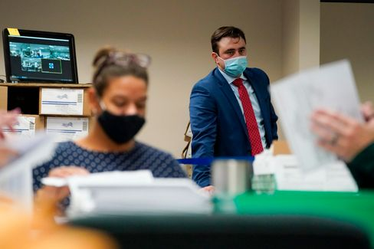

A Republican election observer at vote count in Pennsylvania

Photo: Mary Altaffer / AP

In Arizona (11 votes in the electoral college) and Nevada (6), **Joe Biden**is justahead, in Georgia (16) and Pennsylvania (20) he has caught up over the last few hours,  **the president's lead** is melting (Pennsylvania) or has already **melted down** (Georgia).

Biden (so far 253 votes out of 270 safe) now has **several paths to success**, Donald Trump(214) **only one**more. And that leads over **Pennsylvania.** There they have counted the night, are nearing the end and Trump's former 10-percentage-point lead has fallen to less than one percentage point.

Trump 's legal attacks on the continuation of the count **have so far had no consequences**. It continues to be counted.

* [Status of the counts: This is how it is in the key states](https://www.spiegel.de/ausland/us-wahl-stand-der-auszaehlungen-joe-biden-holt-in-mehreren-staaten-auf-a-d638279f-eee4-4a3d-9c9e-4ca0ef8b29d7)

**The Bizarre President, Part Two**

While you were sleeping, after two days of camera abstinence, Donald Trump spoke out at the White House. It was **the continuation of his oblique, anti-democratic appearance on election night**. "If you count the legal votes, I easily won," he claimed. And yet another nonsense.

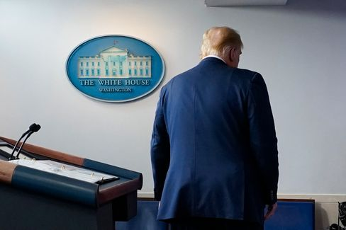

President Trump

Photo: Evan Vucci /AP

Trump looked duller when lying this time than two days ago, tired and beaten off. **It was the words of an autocrat, but the sound of a loser.**

Presidential niece Mary Trump, who had published a book of revelations about her uncle before the election, commented: "This is what it looks like when a loser loses."

Biden, on the other hand, struggled a few hours earlier with his running mate Kamala Harris to make as presidential an appearance as possible. Democracy is sometimes a bit chaotic, Biden said, **"sometimes it takes a bit of patience."** But this patience has been rewarded in a good 240 years in the USA "with a system of government that attracts the envy of the world".

Well, not so recently. But we'll keep at it.

* [US election: Trump again makes baseless accusations of fraud](https://www.spiegel.de/ausland/us-wahl-2020-donald-trump-behauptet-erneut-gewonnen-zu-haben-a-8dea65e4-4ab1-45c1-bacb-cf923bf05615)

**How to react to the anti-democrats?**

Even Trump 's appearance as a lie on election night remained **without much response from the Chancellery**. It can be assumed that this will remain the case with his performance from last night.

Two days ago, Angela Merkel, through her government spokesman Steffen Seibert alone, had it said that the Federal Government had confidence "in the democratic tradition and in the institutions of the rule of law" of America. As long as there is no final result, the government **is "following everything closely"**, but it is not commenting on it.

It is likely that the Chancellor will continue to remain silent until the winner has been determined. Why get involved in skirmishes beforehand.

**Yes why not?**

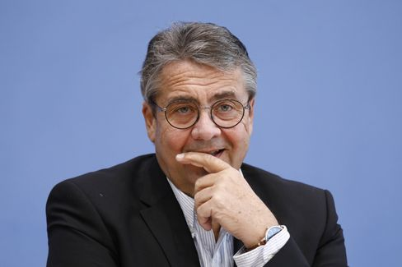

Former Foreign Minister Gabriel

Photo: M. Popow / imago images/Metodi Popow

Germany's reticence is now ignited by criticism. Former SPD [Social Democratic Party of Germany] chief and former Foreign Minister **Sigmar Gabriel** demands a clear position from the Federal Government on the US election: "We should make it clear that the legitimacy of governments for us depends on their **accepting the basic principles of democracy,**and that is majority and minority," he told DER SPIEGEL.

The Federal Government is certainly allowed to express itself publicly. "You don't have to associate that with attacks on Donald Trump," said Gabriel, who is now head of Atlantikbrücke, "but the fact that we assume that all democracies feel bound by these principles is an appropriateremark."

* [US election: Sigmar Gabriel demands clear positioning of the Federal Government](https://www.spiegel.de/politik/us-wahl-sigmar-gabriel-verlangt-klare-positionierung-der-bundesregierung-a-9a6063ef-0b34-47a1-8111-b7a6a484b18d)

**Christian-Digital Union**

In the Christian Union, they would finally like to elect their new party chairman. But firstly, because the country is already **firmly in the grip of the corona pandemic** again and, secondly, the CDU has not had it that way with **digitization**  so far, it is now necessary to improvise. After all, there will soon be a need for a chancellor candidate. And how is the CDU supposed to enter into negotiations with the CSU if it does not even have a new chairman?

My colleagues Florian Gathmann and Veit Medick write today about the CDU's latest idea: The delegates should meet virtually in January for the **digital party congress** and elect the party leader and the rest of the executive board **online.** In the end, all election results would then have to be confirmed again in a **written final vote,** i.e. by postal vote.

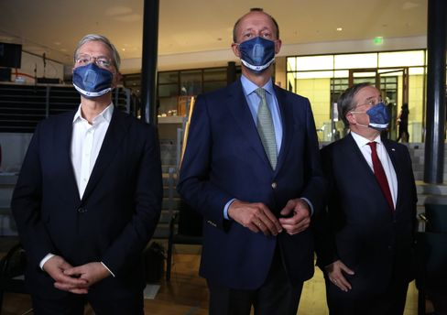

Candidates Röttgen, Merz. Laschet

Photo: Adam Berry/Getty Images

But now the crucial question: **would that be legally certain?** After all, this is not about, shall we say, the FDP chairmanship. But a position that could promote the holder to the chancellery. The Union bundestag group has asked the Interior Ministry for an assessment – and according to SPIEGEL information, they are already working on the matter there. We keep our fingers crossed.

By the way: **The three CDU chairmanship candidates have a full program today.** Friedrich Merz presents his **book on the election campaign**via Zoom conference (virtually!)"Neue Zeit. New responsibility". It is presented by Christian Lindner (sorry, FDP leader is of course an important position). In the afternoon, Merz and rival Armin Laschet meet at the congress of the local political association of cdu and csu (again virtual!), whose motto can compete with merz's book title: "Shaping structural change."

The CDU day concludes with a round of introductions by **Merz, Laschet and competitor Norbert Röttgen at the Saxon Union** in Chemnitz - the party base is allowed to ask questions (of course: virtually).

* [Digital party congress: CDU wants clarification from the Interior Ministry for its election of the chairman](https://www.spiegel.de/politik/deutschland/cdu-parteitag-mit-wahl-des-vorsitzenden-innenministerium-soll-rechtssicherheit-bestaetigen-a-c7ffdaa5-9152-4a00-b5b9-b3ef959c25c3)

**Winner of the day...**

... is **Mike Mohring.** The 48-year-old , who was replaced as Thuringian CDU chief after the 2019 election debacle and the no less debacular consequences , will be given a second political **chance**.

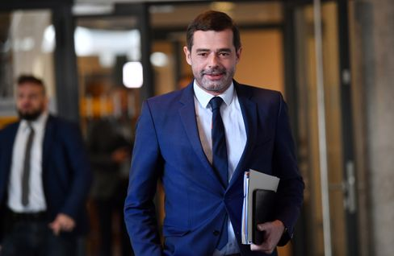

CDU politician Mohring (in March)

Photo: Martin Schutt/ DPA

His CDU nominated him as a **Bundestag candidate** in one of the eight Thuringian constituencies, which includes Jena, among others. Mohring beat the former Member of the Bundestag Johannes Selle by 23 votes to 15. According to SPIEGEL information, however, there are now considerations in the Selle camp to contest the election.

Seems kind of familiar to me these days.

**The latest news from the night**

* **More than 70 dead due to tropical storm "Eta":** Extremely high rainfall has triggered landslides and floods in Guatemala, Nicaragua, Costa Rica and Panama. [Dozens of people have already died, the number of victims could continue to rise](https://www.spiegel.de/panorama/gesellschaft/guatemala-nicaragua-costa-rica-und-panama-dutzende-tote-durch-tropensturm-eta-a-716dbe00-a2a2-408f-92f5-7dc7a9122e03)
* **Fingerprinting obligation on identity card comes:** Two fingerprints, digital photos, an "X" on the passport for people who do not assign themselves to any gender: [The Bundestag has decided on changes for identity cards and passports](https://www.spiegel.de/politik/deutschland/personalausweis-bundestag-beschliesst-aenderungen-fingerabdruck-pflicht-kommt-a-314b8525-51b0-4585-91e2-c45a5fe72bc6)
* **Barricaded in the ministry:** Due to a corona contact, Annegret Kramp-Karrenbauer went into quarantine earlier this week. [But instead of isolating herself at home, the defense minister sits in her ministry. Is it allowed to do so?](https://www.spiegel.de/politik/deutschland/verbarrikadiert-im-ministerium-a-1113e0c0-0e47-4ede-8e8b-4d2fe9c0b0a6)