

Subscribe to DeepL Pro to edit this document.  
Visit www.DeepL.com/Pro for more information.

**The situation in the morning**

**Can Biden reunite the United States?**

By [Sebastian Fischer](https://www.spiegel.de/impressum/autor-9c4e5259-0001-0003-0000-000000000166), Head of SPIEGEL's Capital Bureau

Dear reader, good morning,

Today we look at the likely winner of the U.S. presidential election and his problems, a broken party, and an outsider who could become head of the CDU.

07.11.2020, 07.28 hrs

**How long do we have to wait now...**

...until better times start again? Welcome to Day 4 after the US election night. The final winner has still not been determined. Counting continues. Every vote counts. At the same time, it is also clear: There is **hardly any realistic chance of victory for incumbent Donald Trump**.

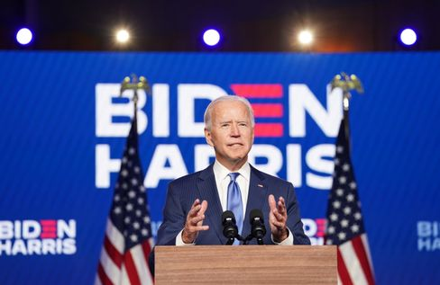

Candidate Biden at his Wilmington appearance.

Photo: KEVIN LAMARQUE / REUTERS

Last night, **Joe Biden stepped out in front of the public with running mate Kamala Harris** and gave - yes, how to put it - sort of a light version of an *Acceptance Speech*, with the handbrake on.

Biden was confident of victory and called on his countrymen to be patient until every vote had really been counted. His appearance was a blessing. Prudent and presidential.

What exactly do the numbers say at this hour? It**'s 253 to 214 for Joe Biden** in the Electoral College, needing 270 to win. The challenger is ahead in **Nevada** (6 electoral votes), **Arizona** (11) and **Pennsylvania** (20) by 20,000 to 30,000 votes each. In **Georgia** (16), Biden's lead is only a few thousand votes, so there will likely be a recount there in the end. But Biden would not be dependent on the outcome of the recount in Georgia; the other states would also be enough for him, should he win them.

**In Trump's case, desperation has apparently grown in the last few hours**. The anti-democrat is sowing conspiracy narratives about the allegedly "stolen election" among his supporters again and again, not wanting to leave the White House. His son Donald Trump Junior recommended Daddy to **go to "total war"** via Twitter before.

With that in mind, be sure to read **our cover story on Trump the** squatter [here.](https://www.spiegel.de/ausland/donald-trump-nach-der-us-wahl-der-hausbesetzer-a-00000000-0002-0001-0000-000173898741)

By the way, all attempts by Team Trump to take legal action against the vote count have **failed** so far. They will soon have to whisper it to him in his environment: Game over.

* [Trump's Dirty Fight for the Oval Office: The Squatter](https://www.spiegel.de/ausland/donald-trump-nach-der-us-wahl-der-hausbesetzer-a-00000000-0002-0001-0000-000173898741)

**What's next?**

This U.S. election was and is historic in so many dimensions.

* She is expected to unseat **an anti-democrat and racist**.
* With around 74 million votes, challenger Joe Biden clearly won the *popular vote* and garnered **more votes than any candidate ever before** - also because of the very high voter turnout.
* However, Donald Trump is now in second place in this statistic, with nearly half the country behind the man, **who still made significant gains compared to 2016**.
* It will likely make a traditional centrist Democrat president who has known how to forge **compromises with Republicans for** decades. But does this Republican Party still exist, with which Joe Biden once compromised?
* Americans voted Trump out, **but Trumpism is here to stay**. Read the editorial by my colleague Mathieu von Rohr [here.](https://www.spiegel.de/ausland/usa-nach-der-wahl-der-trumpismus-bleibt-auch-ohne-trump-a-00000000-0002-0001-0000-000173898740)

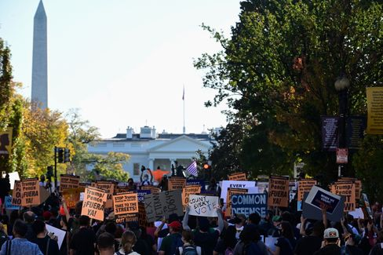

Protests outside the White House after the US election

Photo: ERIN SCOTT / REUTERS

So if it comes to pass, it will be a **bittersweet victory for Joe Biden**. Ahead of him lies the most difficult task of any president since the end of World War II. Making a divided, even torn, country fit for politics again; restoring the trust of international partners; fighting the Corona pandemic; combating the economic crisis; fighting racism; combating climate change.

Biden was there as vice president in January 2009 when the shining winner Barack Obama lost his sparkle when he took over the country from predecessor George W. Bush: Financial crisis, real estate crisis, auto industry on the brink of collapse, terrorist threat, failed Iraq war.

But all that is nothing compared to all the challenges that the 77-year-old Biden must now be facing. And Trump still has **about two and a half months left in the White House** before the possible handover of office **in** January. He may be a *lame duck* politically, but he still has all the instruments of presidential power at his disposal.

* [White House battle: Biden hopes to declare victory Saturday](https://www.spiegel.de/ausland/joe-biden-hofft-am-samstag-seinen-wahlsieg-zu-verkuenden-a-a96cea5e-4394-4091-8fa9-7c5d76a21ac6)

**What are Republicans - and their supporters - doing?**

Under Trump, the Republican Party has given up on itself. Infiltrated in previous years by the radical right-wing Tea Party movement, it had already been shot to pieces when Donald Trump arrived.

This party has allowed itself to become the **vehicle of an autocrat.** The Trump years were a test of character for the party of Lincoln - and it blew it. A few upstanding Republicans, like former presidential candidate Mitt Romney, have defended democracy and political decency. The vast majority of their elected officials did not.

And now? **We should not assume that the party will now shake itself up and emancipate itself from Trump.** The poison of Trumpism has seeped into this traditional party, and Biden will have a hard time compromising with it.

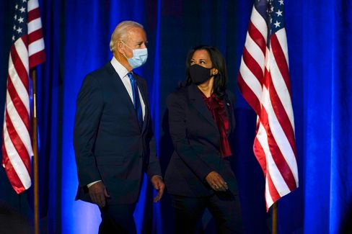

Candidates Biden, Harris

Photo: Carolyn Kaster / AP

The majority ratios in the future Senate will be decisive; one third of the total of 100 seats were up for grabs in Tuesday's election. **At the moment, the balance is 48 to 48**, with the Republicans likely to win two more seats. That leaves another two. And these are - of all things - the two seats of Georgia, which is already in contention (see above). Both will be decided in a runoff election in January. Should it then be 50:50, **the vote of the U.S. vice president will decide in the** event of a stalemate in the Senate. And that, in turn, could be Kamala Harris.

And the voters? Or is it better to say the Trump fan base in view of the polarization? They will go **cold turkey in the** coming months. That could have unpleasant consequences.

Biden and his vice president, Kamala Harris, will have little access to these people for now.

Should they even be looking for that? Yes, because **not all Trump voters are the same**. There are the conspiracy nuts, the right-wing extremists: You don't integrate people like that, you fight them. But half of Americans are not right-wing extremists. Countless numbers have been misled by Trump, the Republicans, and the propaganda media.

Biden already appealed to these people in his recent late-night appearance, saying, **"We may be adversaries, but we are not enemies. We are all Americans."** He said he would work just as hard as president for those who did not vote for him. "We have to get past the anger and the demonizations," he said - that won't be easy.

* [Wages of shamelessness **- –** The election result is not as disastrous for Republicans as it seems.](https://www.spiegel.de/ausland/republikaner-nach-donald-trump-lohn-der-schamlosigkeit-a-04553b30-0efe-44fd-a0ff-cae8058bfb2b)

**Will Röttgen now become CDU leader?**

During the election drama in the U.S., one politician can be seen moving to the forefront in Germany: Norbert Röttgen. The chairman of the Foreign Affairs Committee in the Bundestag is a candidate for the CDU presidency - **until now he was considered to have no chance.**

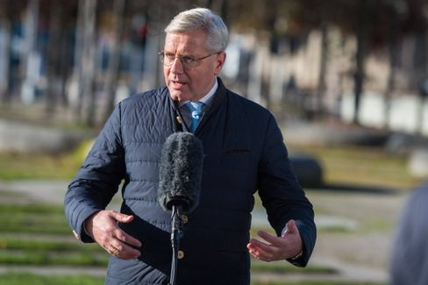

CDU politician Röttgen

Photo: Christian Spicker / imago images/Christian Spicker

But now his expertise is in demand, and what's more, his opposing candidates **Friedrich Merz** and **Armin Laschet** recently engaged in an unsavory battle to move the CDU party conference to Corona times.

**Röttgen recognized his opportunity, played the conciliator** - and is already perceived by some as the candidate of balance. My colleagues Florian Gathmann, Christoph Hickmann and Veit Medick describe the situation as follows: "The fact that Röttgen is suddenly playing the conciliator is also getting on the nerves **of** some in the party. Many in the CDU still remember well how often he gave the impression of being smarter than everyone else." He has never shied away from power struggles, and years ago, for example, he snatched the district chairmanship from a flatmate.

And yet, Röttgen as party leader would **still** have **an attractive advantage for** many in the CDU base. Colleagues write that he would probably be the only Christian Democrat who could hand over the chancellor candidacy to **CSU leader Markus Söder,** who is popular with the CDU people, without losing face.

* [CDU outsider catches up: Can Norbert Röttgen become party leader after all?](https://www.spiegel.de/politik/deutschland/cdu-kann-norbert-roettgen-etwas-doch-parteivorsitzender-werden-a-00000000-0002-0001-0000-000173898765)

**Winner of the day ...**

... today (maybe tomorrow) will be **Joe Biden** and **Kamala Harris**.

**The latest news from the night**

* **Head of the Office for the Protection of the Constitution suspended after attack in Vienna**: The terrorist attack in Vienna has personnel consequences: The head of Vienna's Office for the Protection of the Constitution vacates his post for the time being. [Austria's Interior Minister Admits Further Failures by the Authorities](https://www.spiegel.de/ausland/wien-verfassungsschutzchef-erich-zwettler-nach-terroranschlag-suspendiert-a-fb0f89ca-0cc3-4ce3-b5c5-d9a5698ec266)
* **Number of dead and missing due to storm "Eta" rises to about 200**: More than a hundred people have died in landslides and floods triggered by a tropical storm in Central America. [In Guatemala, an entire village was buried](https://www.spiegel.de/panorama/gesellschaft/eta-zahl-der-toten-und-vermissten-nach-tropensturm-in-zentralamerika-steigt-auf-170-a-de98effc-1635-4444-bb53-aadc293fc8e1)
* **Child's body recovered from river in Lower Saxony - Suspicion of manslaughter against mother**: A mother disappears from the hospital in Rotenburg with her four-year-old son. Hours later, the boy lies dead in the Wümme. [Now the public prosecutor's office is investigating the 40-year-old woman](https://www.spiegel.de/panorama/justiz/rotenburg-in-niedersachsen-kinderleiche-aus-fluss-geborgen-totschlagsverdacht-gegen-mutter-a-0502b75d-8eb6-4717-8cbe-f9c06b709675)