**The location in the morning**

**Can Biden reunite the United States?**

By [Sebastian Fischer](https://www.spiegel.de/impressum/autor-9c4e5259-0001-0003-0000-000000000166), Head of the SPIEGEL CapitalOffice

Dear reader, good morning,

today we are dealing with the likely winner of the US presidential election and his problems, with a broken party and an outsider who could become CDU chief.

11-07-2020, 07:28 AM

**How long do we have to wait...**

... until better times start again? Welcome to Day 4 after U.S. Election Night. The final winner has still not been determined. It continues to be counted. Every vote counts. At the same time , it is also clear that there is hardly any realistic chance of **a victory for incumbent Donald Trump**.

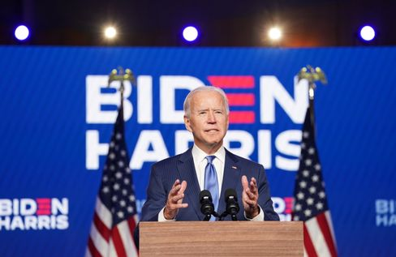

Candidate Biden at his appearance in Wilmington

Photo: KEVIN LAMARQUE / REUTERS

Last night, **Joe Biden appeared before the public with vice-candidate Kamala Harris**  and – yes, how can you say – gave a kind of light version of an acceptance *speech,*  with the handbrake on.

Biden was certain of victory and called on his compatriots to be patient until every vote was counted. His performance was: a blessing. Level-headed and presidential.

What exactly do the figures say at the moment? **It's 253 to 214 for Joe Biden** in the Electoral College, 270 are needed for a win. The challenger is ahead in **Nevada**  (6 votes), **Arizona**  (11) and **Pennsylvania**  (20) with 20,000 to 30,000 votes each. In **Georgia**  (16), Biden's lead is only a few thousand votes, so there will probably be a recount there in the end. But Biden would not be dependent on the result of the recount in Georgia, the other states would also be enough for him if he fetched them.

**With Trump , despair has apparently grown in the last few hours**. The anti-Democrat is sowing conspiracy narratives about the alleged "stolen election" among his supporters again and again, not wanting to leave the White House. His son Donald Trump Junior previously recommended Daddy via Twitter to  **go to "total war"**.

[In](https://www.spiegel.de/ausland/donald-trump-nach-der-us-wahl-der-hausbesetzer-a-00000000-0002-0001-0000-000173898741) this context, be sure to read our cover story about **Trump, the squatter**.

By the way , all attempts by Team Trump to take legal action against the counting of votes have so far **failed**. In his environment, they will soon have to whisper it to him: Game Over.

* [Trump's Dirty Battle for the Oval Office: The Squatter](https://www.spiegel.de/ausland/donald-trump-nach-der-us-wahl-der-hausbesetzer-a-00000000-0002-0001-0000-000173898741)

**What's coming?**

This U.S. election was and is historic in so many dimensions.

* She is expected to **remove an anti-democrat and racist from office**.
* Challenger Joe Biden has clearly won the *popular vote* with around 74 million votes and has won more votes than any candidate **ever before** – also because of the very high turnout.
* However, Donald Trump is now in 2nd place in this statistic.Almost half of the country is behind this man, **who was able to increase significantly compared to 2016.**
* It will probably make a traditional centrist Democrat president who has been compromising **with republicans** for decades. But does this Republican Party still exist, with which Joe Biden once compromised?
* Americans have voted Trump out, **but Trumpism will remain.** Read the editorial by my colleague Mathieu von Rohr here.

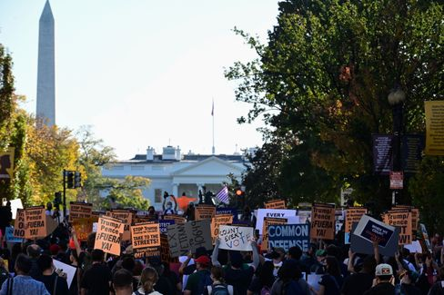

Protests in front of the White House after the US election

Photo: ERIN SCOTT / REUTERS

So if that happens, it will be a **bittersweet victory for Joe Biden.** He has ahead of him the most difficult task of a president since the end of the Second World War. Making a divided, even torn country capable of politics again; restore the confidence of international partners; fight the corona pandemic; combat the economic crisis; fight racism; fight climate change.

Biden served as vice president in January 2009, when the beaming winner Barack Obama passed off the blast when he took over the country from predecessor George W. Bush: the financial crisis, the housing crisis, the auto industry from collapse, the threat of terrorism, the failed Iraq war.

But none of that is against all the challenges that the 77-year-old Biden is now facing. And Trump will remain in the **White House for about two and a half months**until the possible handover of office in January. He may be a *lame duck* politically, but he still has all the instruments of power of a president.

* [Battle for the White House: Biden hopes to announce his victory on Saturday](https://www.spiegel.de/ausland/joe-biden-hofft-am-samstag-seinen-wahlsieg-zu-verkuenden-a-a96cea5e-4394-4091-8fa9-7c5d76a21ac6)

**What are the Republicans – and their supporters – doing?**

Under Trump, the Republican Party has abandoned itself. In previous years, infiltrated by the far-right Tea Party movement, it was already shot when Donald Trump came.

This party has allowed itself to be made **the vehicle of an autocrat.** The Trump years were a test of character for Lincoln's party – and it has forgiven it. Few upstanding Republicans like former presidential candidate Mitt Romney have defended democracy and political deeds. The vast majority of their elected representatives do not.

And now? **We should not assume that the party will now shake itself vigorously and then emancipate itself from Trump.** The poison of Trumpism has seeped into this traditional party, with which Biden will find it difficult to compromise.

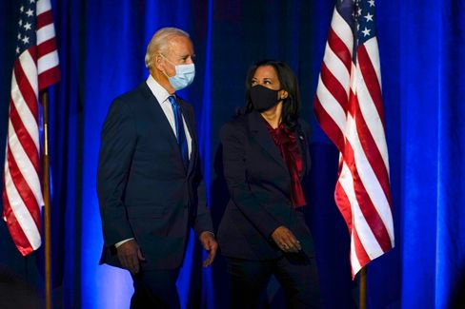

Candidates Biden, Harris

Photo: Carolyn Kaster / AP

The majority ratios in the future Senate will be decisive, with a third of the 100 seats to be allocated in Tuesday's election. **At the moment it is 48 to 48**, the Republicans are expected to win two more seats. That leaves another two. And these are – of all things – the two seats of the already embattled Georgia (see above). Both will be decided in a runoff election in January. If it is then 50:50, **the vote of the US vice president decides** in a stalemate in the Senate. And that, in turn, could be Kamala Harris.

And the voters? Or, in view of polarization, do we have to say better: the Trump fanbase? The will be set in the coming months **on cold withdrawal.** This can have unpleasant consequences.

Biden and his vice president Kamala Harris are unlikely to have access to these people for the time being.

Should they even look for it? Yes, because **Trump voters are not the same as Trump voters.** There are the conspiracy narrators, the right-wing extremists: you don't integrate people like that, you fight them. But half of Americans are not right-wing extremists. Countless have been led behind the spruce by Trump, the Republicans, the propaganda media.

Biden appealed to these people in his most recent appearance that night: **"We may be adversaries, but we are not enemies. We're all Americans."** As president, he will work just as hard for those who did not vote for him. "We have to leave the anger and the demonization behind us," he said – it won't be easy.

* [Reward of shamelessness **–**](https://www.spiegel.de/ausland/republikaner-nach-donald-trump-lohn-der-schamlosigkeit-a-04553b30-0efe-44fd-a0ff-cae8058bfb2b)  [The election result is not as disastrous as it seems for the Republicans.](https://www.spiegel.de/ausland/republikaner-nach-donald-trump-lohn-der-schamlosigkeit-a-04553b30-0efe-44fd-a0ff-cae8058bfb2b)

**Will Röttgen now become CDU chief?**

During the election drama in the USA, it can be observed how a politician in Germany moves to the fore: Norbert Röttgen. The chairman of the Foreign Affairs Committee in the Bundestag is a candidate for the CDU chairmanship – **until now he was considered to have no chance.**

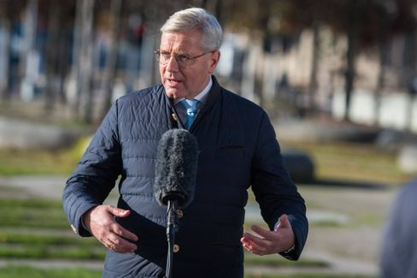

CDU politician Röttgen

Photo: Christian Spicker / imago images/Christian Spicker

But now his expertise is in demand, and in addition, his opponents **Friedrich Merz** and **Armin Laschet** recently fought an unsavory battle over the postponement of the CDU party congress in corona times.

**Röttgen recognized his chance, gave the conciliatory** – and is already perceived by some as a candidate of compensation. My colleagues Florian Gathmann, Christoph Hickmann and Veit Medick describe the situation as follows: "The fact that Röttgen suddenly plays the conciliator, however, is also **on the biscuit**of some in theparty. Many in the CDU still remember well how often he gave the impression of being smarter than everyone else." He also never shied away from power struggles, for example, years ago snatched away the district chairmanship of a shared flatmate.

And yet: Röttgen as party leader would **still**have an attractive advantage for many at the CDUbase. His colleagues write that he would probably be the only Christian Democrat who could leave the chancellor candidacy to **CSU chief Markus Söder,** who is popular with the CDU people, without losing face.

* [CDU outsider is catching up: Can Norbert Röttgen become party leader after all?](https://www.spiegel.de/politik/deutschland/cdu-kann-norbert-roettgen-etwas-doch-parteivorsitzender-werden-a-00000000-0002-0001-0000-000173898765)

**Winner of the day ...**

... will be today (maybe tomorrow) **Joe Biden** and **Kamala Harris.**

**The latest news from the night**

* **Head of the Office for the Protection of the Constitution suspended after attack in Vienna: The terrorist attack in**Vienna has personnel consequences: The head of the Vienna Office for the Protection of the Constitution vacates his post for the time being. [Austria's Interior Minister admits further omissions by the authorities](https://www.spiegel.de/ausland/wien-verfassungsschutzchef-erich-zwettler-nach-terroranschlag-suspendiert-a-fb0f89ca-0cc3-4ce3-b5c5-d9a5698ec266)
* **Number of dead and missing due to storm "Eta" rises to about 200:**Landslides and floods caused by a tropical storm have killed more than a hundred people in Central America. [In Guatemala, an entire village was buried](https://www.spiegel.de/panorama/gesellschaft/eta-zahl-der-toten-und-vermissten-nach-tropensturm-in-zentralamerika-steigt-auf-170-a-de98effc-1635-4444-bb53-aadc293fc8e1)
* **Children's body recovered from river in Lower Saxony – suspected manslaughter against**mother: A mother disappears from the hospital in Rotenburg with her four-year-old son. Hours later, the boy lies dead in the Wümme. [Now the public prosecutor's office is investigating the 40-year-old](https://www.spiegel.de/panorama/justiz/rotenburg-in-niedersachsen-kinderleiche-aus-fluss-geborgen-totschlagsverdacht-gegen-mutter-a-0502b75d-8eb6-4717-8cbe-f9c06b709675)