

Subscribe to DeepL Pro to edit this document.  
Visit www.DeepL.com/Pro for more information.

**The situation in the morning**

**Trump's days of defiance**

By [Dirk Kurbjuweit](https://www.spiegel.de/impressum/autor-d6a694ab-0001-0003-0000-000000001319), author at SPIEGEL's capital office

Dear reader, good morning,

today we're looking at hardball in the U.S., lawsuits against masks in Germany, revolutionary Robert Blum, and the salt shaker.

09.11.2020, 05.36 o'clock

**The hour of the judges I**

Even losers can do a lot of damage, legally. This is the path **Donald Trump** has taken. From today on, he wants to [have](https://www.spiegel.de/ausland/us-wahl-2020-die-usa-zwischen-joe-biden-und-donald-trump-a-118fcb1b-ce70-4d78-9652-a24f433789f4) his lawyers [increasingly run against the election results](https://www.spiegel.de/ausland/us-wahl-2020-die-usa-zwischen-joe-biden-und-donald-trump-a-118fcb1b-ce70-4d78-9652-a24f433789f4). That is his right, even if there is no evidence so far that Trump was cheated, as he claims.

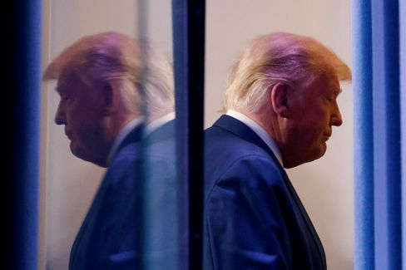

Donald Trump

Photo: CARLOS BARRIA / REUTERS

The question is whether one should exhaust one's options to the last. Democracy scholars Steven Levitsky and Daniel Ziblatt have pointed out that democracies also rely on **"institutional omission."** "It's an act of willful self-restraint - we don't fully exhaust the power we are legally entitled to."

Trump's fight may help his ego, though that seems puny with each day of defiance, but it hampers the transition, clawing at the legitimacy and thus the power of the future president. Trump's actions go against the spirit of the Constitution by mercilessly using it for his own purposes. This is called "**constitutional** hardball." Levitsky and Ziblatt: "In any failing or failed democracy, constitutional hardball is found in abundance."

It's not over, the battle for U.S. democracy continues. Now it comes down to the judges.

* [Resistance to US election results: Trump's man for the rough stuff](https://www.spiegel.de/ausland/richard-grenell-donald-trumps-mann-fuers-grobe-a-2bec8d33-7a8b-4ded-844d-e9bb7b00fdb7)

**The hour of the judges II**

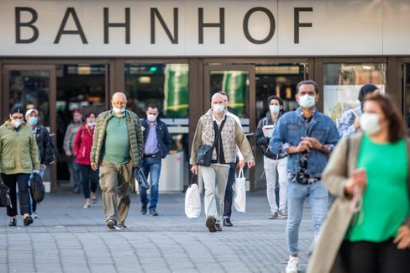

People with masks in Düsseldorf (April 2020)

Photo: Marcel Kusch/ DPA

A kind of "constitutional hardball" is also taking place in Germany these days, albeit with less drama. An administrative court is expected to decide today whether the **mandatory mask requirement** is permissible **for the Düsseldorf city area.** Citizens are challenging this requirement with urgent applications.

There have recently been some rulings that have overturned political decisions in the fight against Corona, [the ban on accommodation in Baden-Württemberg](https://www.spiegel.de/politik/deutschland/corona-gericht-kippt-beherbergungsverbot-in-baden-wuerttemberg-a-7fd414c8-f59d-458d-9479-f1a4720e0761) or [the](https://www.spiegel.de/politik/deutschland/corona-bestimmungen-gericht-kippt-berliner-sperrstunde-a-0c6b23db-f9c1-42b1-bba1-1c6b7ad85197) curfew [for some Berlin landlords.](https://www.spiegel.de/politik/deutschland/corona-bestimmungen-gericht-kippt-berliner-sperrstunde-a-0c6b23db-f9c1-42b1-bba1-1c6b7ad85197) There will be more lawsuits, more rulings. That's what the rule of law is for; in case of doubt, it also protects the interests of the individual against the majority. I will always defend this principle, but I would find it appropriate that one or the other could bring himself to refrain from filing a lawsuit, so that we can see whether the political decisions can help this country out of the crisis. It's not that bad to wear a mask.

Otherwise, it just depends on the judges.

* [Pandemic simulation: these are the scenarios for the Corona winter](https://www.spiegel.de/wissenschaft/medizin/corona-in-deutschland-das-sind-die-szenarien-fuer-den-winter-a-00000000-0002-0001-0000-000173898802)

**Early morning death**

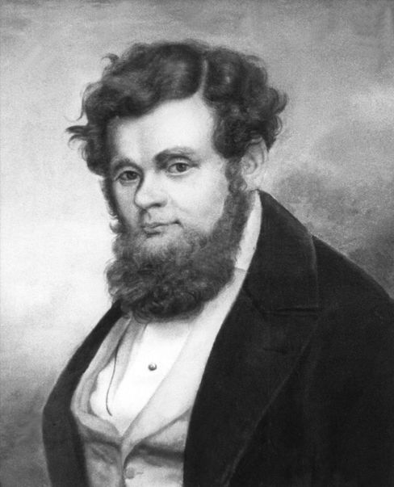

Robert Blum (undated archive photo)

Photo: DPA

On November 9, 1848, **Robert Blum** was awakened at five in the morning. At six o'clock he stood before a firing squad. His last words are said to have been these: "I die for freedom, may the fatherland remember me." Today, this wish shall finally come true, at least a little bit. Federal President **Frank-Walter Steinmeier** will inaugurate the new **Robert Blum Hall in** Bellevue Palace; art on the history of German democracy hangs on the walls.

Blum was one of the early German democrats, born in Cologne on November 10, 1807. He learned the trade of a brass founder, making buckles or hinges from brass. He later worked at the theater in Leipzig, led the 1848 revolution there, and entered the Paulskirchen parliament in Frankfurt as a deputy. Soon he went to Vienna because the revolution there seemed more promising, was arrested and executed. After that, the Germans forgot about him. They had a hard time with the topic of democracy for a long time.

All the nicer that the Federal President is honoring it with a hall in the palace from today on, especially since November 9 also **stands for two other German revolutions**, that of 1918 and [that of the fall of 1989 in the GDR](https://www.spiegel.de/geschichte/9-november-1989-nacht-des-mauerfalls-wir-fluten-jetzt-a-1191238.html). And, of course, for the anti-Semitic atrocities perpetrated by Germans, the Reichspogromnacht of 1938.

* [Freedom fighter Blum: The martyr of 1848](https://www.spiegel.de/wissenschaft/mensch/wiener-oktoberrevolution-1848-robert-blum-stirbt-als-freiheitskaempfer-a-972580.html)

**List of losses I: The salt shaker**

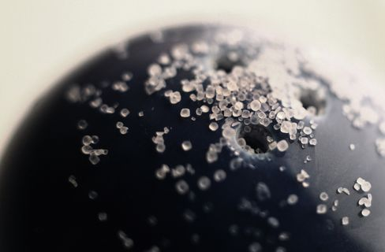

Fear of smear infections: The salt shaker has disappeared from many restaurant

Photo: Karl-Josef Hildenbrand/ dpa

**There is a** book by the writer **Judith Schalansky** called **"Directory of some losses"**. I am borrowing these beautiful words and will **write** daily this week **about things or phenomena that have been lost to us in the pandemic.**

In the past, the salt shaker was on every table in many restaurants. It wasn't the expensive restaurants, certainly not the ones with stars. If you were to ask for a salt shaker at Tim Raue in Berlin or at GästeHaus Klaus Erfort in Saarbrücken, the chef would probably deprive himself (perhaps the guest as well).

Salt shakers were more likely to be found at the pizza Italian, the Greek or the German Corner. They were useful to cover up the weaknesses of the kitchen, or helped the coarse palate to taste. On the other hand, salt is not considered to be very good for health, which is why the country's top health guru, politician Karl Lauterbach, never eats salt. When I was once with him in the restaurant Facil (2 stars), he asked for saltless dishes, but then found out already during the first course through discomfort that the chef had cheated a pinch of salt under him, which almost led to the self-denial of the chef.

Now salt shakers have disappeared from many restaurants for fear of smear infections. [The suspected first German Corona outbreak](https://www.spiegel.de/wissenschaft/medizin/erster-corona-fall-in-deutschland-die-unglueckliche-reise-von-patientin-0-a-2096d364-dcd8-4ec8-98ca-7a8ca1d63524) at the Webasto company probably had something to do with a salt shaker. Should this loss lead to all cooks trying harder and us living healthier, the loss of the salt shaker is not really a loss.

**The latest news from the night**

* **Joe Biden's first big battle:** 130,000 cases a day - Corona has the USA firmly in its grip. How will Joe Biden address the crisis when he takes over the White House? [Already, he is unveiling his task force](https://www.spiegel.de/ausland/joe-bidens-erste-grosse-schlacht-gewaehlter-us-praesident-gegen-coronavirus-a-83f72d92-0c42-4ee4-aeb8-46fcdca6da04)
* **"Up to 40 percent of the population is at risk":** Infection figures are skyrocketing in Germany. [For Health Minister Jens Spahn, this is also linked to the age structure - and the affluent lifestyle](https://www.spiegel.de/wissenschaft/medizin/jens-spahn-sieht-bis-40-prozent-der-bevoelkerung-als-risikogruppe-fuer-corona-a-e60b80f4-19a2-47d3-b7de-1d37cac2dab8)
* **Orbán threatens to veto EU budget, says report:** Those who dismantle the rule of law will soon receive less EU money - something that Hungary, among others, does not like at all. [According to a media report, head of government Viktor Orbán will now clearly](https://www.spiegel.de/ausland/viktor-orban-droht-laut-bericht-mit-ungarns-veto-gegen-eu-haushalt-a-5dd6744d-cb08-4591-a052-80c8b3aec218)